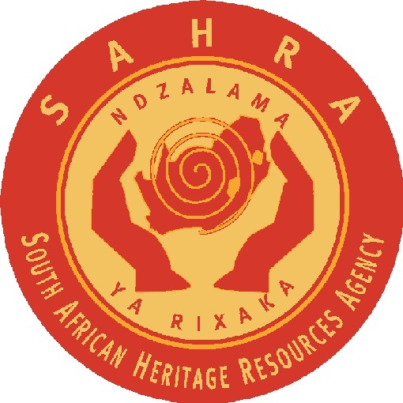

**SOUTH AFRICAN HERITAGE**

**RESOURCES AGENCY**

**111 HARRINGTON STREET, CAPE TOWN, 8001**

**PO BOX 4637, CAPE TOWN, 8000**

**TEL: (021) 462 4502 FAX: (021) 462 4509**

3/4/2/1/4/243

**TEMPORARY EXPORT PERMIT**

No. 80/11/03/002/62

Issued under Sections 32 and 35(4) of the National Heritage Resources Act, Act No. 25 of 1999. Permission is hereby given:

to: Dr R Smith (ID: 5101025066102),

of: IZIKO South African Museum, P O Box 61, Cape Town, 8000,

for: the temporary export of *Owenetta* (very small skull with lower jaw and 1st cervical vertebra) and *Akkedops bremneri* (tiny skull with articulated lower jaw. Also possible humerus on right side of skull and separate femur (very tiny),

from: IZIKO South African Museum, Cape Town, Western Cape Province,

to: Dr S Modesto,

of: Department of Biology, University College of Cape Brenton, P.O. Box 5300, Sydney, Nova Scotia, BIP 6L2, Canada,

for: morphological study.

The following conditions apply:

1. The objects or specimens must be clearly marked with accession numbers.

2. The material must be carefully packed and all packaging must be clearly marked with the accession numbers, the name of the site, and the name and address of the permit holder or the IZIKO: South African Museum.

3. The material must be hand carried or sent via a reputable professional courier service unless written instructions to the contrary have been received from the repository, IZIKO: South African Museum.

4. The material may not be loaned to any person or institution other than Dr S Modesto without the consent of SAHRA.

5. The material shall be returned to South Africa on or before 01 May 2012 at the expense of Dr S Modesto).

6. SAHRA must be notified in writing of the return of the material, and a report on the activities undertaken in terms of this permit must be lodged with SAHRA before 01 May 2012.

7. Copies of all papers or publications resulting from this permit must be lodged with SAHRA.

8. SAHRA shall not be liable for any losses, damages or injuries to persons or properties as a result of any activities in connection with this permit.

9. SAHRA reserves the right to cancel this permit by notice to the permit holder.

This permit is valid until 01 May 2012.

for CHIEF EXECUTIVE OFFICER . . . . . . . . . . . . . . . . . . . . . . . . . . . . .

Date: 06 April 2011 Place: Cape Town