The South African Heritage Resources Agency

19 August 2022

Dear Sir

Request for Extension of Reburial Permit ID:3328 and Case ID 14655

Baobab Mining and Exploration (Pty) Ltd (‘’the Company’’) is the holder of the mining right for coal in terms of the provisions of Mineral and Petroleum Resources Development Act 28 of 2002 as amended on the farm Daru 889 MS and Tanga 648 MS (‘’the farms’’) and others. The Company also has a valid environmental authorisation granted in terms of National Environmental Management Act Environmental Impact Assessment Regulation 2010 authorising commencement of listed activities.

During the environmental impact assessment for the area on the farms several archaeological sites and three unknown graves where identified. The identified graves are within the mining footprint of the West pit. The west pit is an area were the Makhado Mining is planned to commence under the project known as Makhado Phase1.

In 2020 the Company applied to the South African Heritage Agency (SAHRA) in terms of the provision of section 36(3) of the National Heritage Resource Act (Act 25 of 1999 for the exhumation graves and reburial of the remains of the unknown graves. SAHRA issued a permit under Case 14655 /Permit ID 3157 with a validity period of 1 year ending on 08 October 2021.An application for the extension of the permit for one-year period was granted on 30 September 2021 for a period of 1 year ending 30 September 2022 under Case ID :14655/Permit 3328 attached hereto as. Annexure A.

The construction of the Makhado Project has not yet commenced arising from challenges and delays in finalising the funding package for the project for the following reasons:
- The global and national impact of the COVID-19 pandemic resulting in an economic slowdown in the mining industry
- The negative perception of international investor community of South Africa, due to its low economic growth, absence of regulatory certainty, and economic decline
- The global transition from fossil fuels, and the lack of investor appetite for the funding of coal mining operations, however this has recently changed due to the supply constrains from geopolitical tension and global gas shortages.
- The investment requirement (size of the transaction) is not sufficient to justify or warrant a deviation from the current trend.
These challenges have led to the delays in the commencement of the Makhado Project and a resultant delay in the commencement of the process of exhumation and reburial as outlined in our application.

The Company is making progress to ensure the commencement of Makhado project.

We therefore wish to apply to a 12-month extension of the permit to provide us with the additional time to complete the funding process, and commence with the exhumation and reburial.

We thank you for your kind co-operation in this matter.

Sincerely
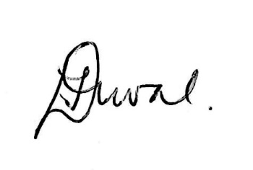
Florence Duval
Director: Baobab Mining and Exploration (Pty) Ltd

