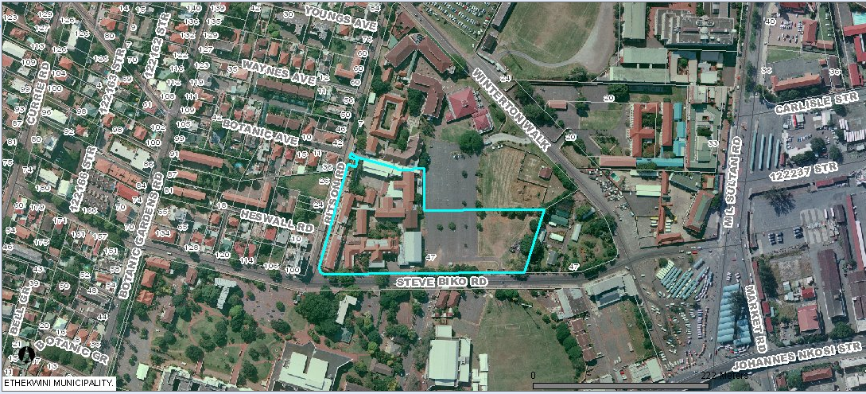

47 STEVE BIKO ROAD – BEREA
Durban University of Technology – Drama Department
Amafa application July 2013 – Area of Public Participation : approx. 100m radius
Lindsay Napier Architect

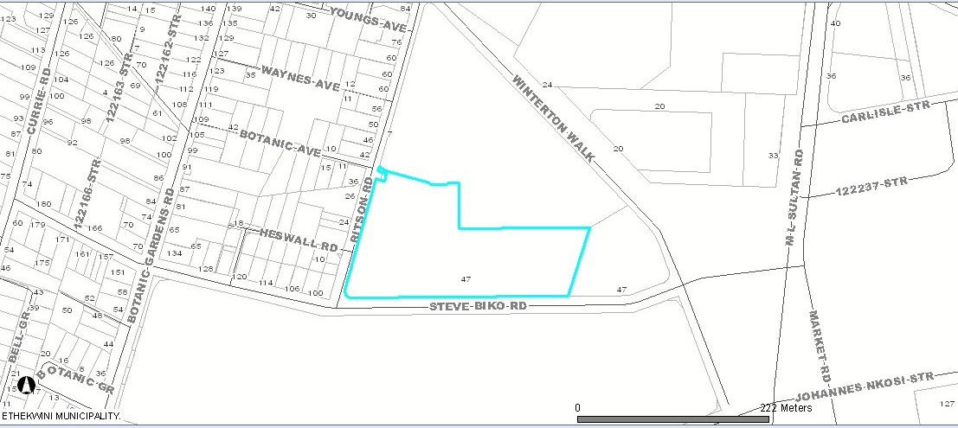

47 STEVE BIKO ROAD – BEREA
Durban University of Technology – Drama Department
Amafa application July 2013 – Area of Public Participation : approx. 100m radius
Lindsay Napier Architect

