NOTICE OF INTENT
to submit an application in terms of the National Environmental Management Act, 1998 (Act No. 107 of 1998) and the 2014 Environmental Impact Assessment Regulations; and/or the National Environmental Management: Waste Act, 2008 (Act No. 59 of 2008), and/or the National Exemption Regulations.
This Notice of Intent is submitted in order to request the Department to provide informed guidance to the proponent and Environmental Assessment Practitioner (EAP) on the process to be followed.

PROJECT TITLE
The proposed establishment of a Raisin processing and packaging facility on Erf 151, Blaauwskop Settlement, Keimoes, Northern Cape Province

PRE-APPLICATION CONSULTATION
Request a pre-application consultation meeting with the Department:
Do you intend to request a pre-application consultation meeting with the Department? | YES | NO

Background information
Name of proponent: | Orange River Wine Cellar
RSA Identity/ Passport Number: | N/A
Name of contact person for applicant (if other): | Altus Theron
RSA Identity/ Passport Number:
Company/ Trading name (if any): | Orange River Wine Cellar
Company Registration Number: | 1966/000002/24
Postal address: | P.O. Box 544
 | Upington | Postal code: |  |  | 8800
Telephone: | (054) 337 8800 | Cell: |  |  | +27 83 275 3026
E-mail: | altus@owk.co.za | Fax: |  |  | (054) 332 4408
Company of Environmental Assessment Practitioner (EAP): | EnviroAfrica cc
EAP name: | Clinton Geyser
Postal address: | P. O. Box 5367,
 | Helderberg |  | Postal code: |  |  | 7446
Telephone: | ( 021) 8511616 |  | Cell:
E-mail: | clinton@enviroafrica.co.za |  | Fax: |  |  | 086 512 0154
EAP Qualifications: | Clinton Geyser: BSc; BSc (Hons); MSc  Bernard de Witt: B.Sc. Forestry (Stellenbosch); B.A. (Hons) Public Administration (Stellenbosch); National Diploma in Parks and Recreation Management; EIA Short course (UCT); ISO 14001 Auditors course (SABS)
EAP registrations/Associations: | Bernard de Witt: AIAI-SA
Name of landowner: | Orange River Wine Cellar
Name of contact person for landowner (if other): | Altus Theron
Postal address: | P.O. Box 544
 | Upington |  | Postal code: |  |  | 8800
Telephone: | (054) 337 8800 |  | Cell: |  |  | +27 83 275 3026
Name of Person in control of the land: | Altus Theron
Name of contact person for person in control of the land: | Altus Theron
Postal address: | P.O. Box 544
 | Upington |  | Postal code: |  |  | 8800
Telephone: | (054) 337 8800 |  | Cell: |  |  | +27 83 275 3026
E-mail: | altus@owk.co.za |  | Fax: |  |  | +27 86 610 1920
Note: In instances where there is more than one landowner or person in control of the land, a list of landowners/persons in control of the land, with their contact details, will be attached to the back of this form.

Municipality : | Kai !Garib local Municipality
Property location of all proposed sites: | Erf 151, Blaauwskop Settlement, Keimoes, Northern Cape Province
Farm/Erf name(s) & number(s) (including portion) of all proposed sites: | Erf 151, Blaauwskop Settlement, Keimoes, Northern Cape Province
Property size(s) (m²) of all proposed sites: | 298 729 m²
Development footprint size(s) in m²: | 33 266 m²
Coordinates of all proposed sites: | Latitude (S) |  |  | Longitude (E)
 | 28º 39ʹ 02ʺ |  |  | 21º 06ʹ 41ʺ
Note: Coordinates provided in degrees, minutes and seconds using the Hartebeesthoek94 WGS84 co-ordinate system. Where numerous properties/sites are involved (e.g. linear activities), a list of property descriptions and street addresses will be attached to this form.

Street address of all proposed sites: | Erf 151, Blaauwskop Settlement, Keimoes, Northern Cape Province
Magisterial District or Town: | ZF Mgcawu District Municipality - Kai !Garib local Municipality
Closest City/Town: | Keimoes | Distance | Approximately 14(km)
Current zoning of all proposed sites: | Agricultural zone II

PROJECT DESCRIPTION
2.1 Will the proposed application be subjected to Basic Assessment? | YES | NO
2.2 Will the proposed application be subjected to Scoping and EIR? | YES | NO
2.3 Provide a detailed description of the proposed project, its associated infrastructure, and the availability of bulk services. A clear, accurate and comprehensive description will obviate any requests for additional information by the Department.
The activity is for the establishment of a Raisin processing and packaging facility on the Kanoneiland premises of Orange River Cellars.
This will include the construction and installation of infrastructure as well as the required services and utilities to accommodate production of 8000 to 16 000 tons per annum.
It is proposed that there should be a:
-Pre-clean Line (6 tons/h)
-Wet Processing Line (6 tons/h)
-Bulk Packaging Line (6 tons/h)
On the property there will be bulk raw material stores constructed that have the capacity to store 2664 raisin bin positions and 7 bins high. Buildings will be constructed for process and packaging, fumigation facilities, bin processing, admin, ablution and a workshop for forklift repairs and security facilities.
The goal of sustainability is essential in the design of the facility.
The following elements are implemented to reach such goals:
  - 75 kWp Photovoltaic Panels are included in the Capex (+-550 sqm)
  - Natural Light is used where possible
  - Solar + Heat Pumps for heated water
  - Thermal Insulation for wall- and roof panels
  - 100% of Effluent regenerated to recyclable process-water and irrigation
The town of Upington is located centrally within the Northern Cape Province. The involved property of Orange River Wine Cellar is located adjacent to the R359 national road approximately 25km south west of Upington and approximately 15km northeast from Keimoes. The proposed site is located off the R359 to the east with GPS Coordinates: 28°39'0.97"S, 21° 6'52.48"E.

The influx of people, due to the steep increase in employment opportunities is beneficial in this area.
The proposed development will contribute positively to the land value of the involved property, as well as that of surrounding farms.
Civil & Electrical services for the proposed development:
Access to the site will be obtained from the existing R359 that is adjacent to the proposed site and already used for access to the property.

2.4 Land use description
2.4.1 Describe the current land use of the proposed site(s) for the activity and the types of ground cover present
The current land use of Erf 151 is agricultural zoned. The erven is already used for agricultural purposes with a large area not developed or used. There are natural furrows present on the erven with a few existing buildings that has a footprint of 2746m².
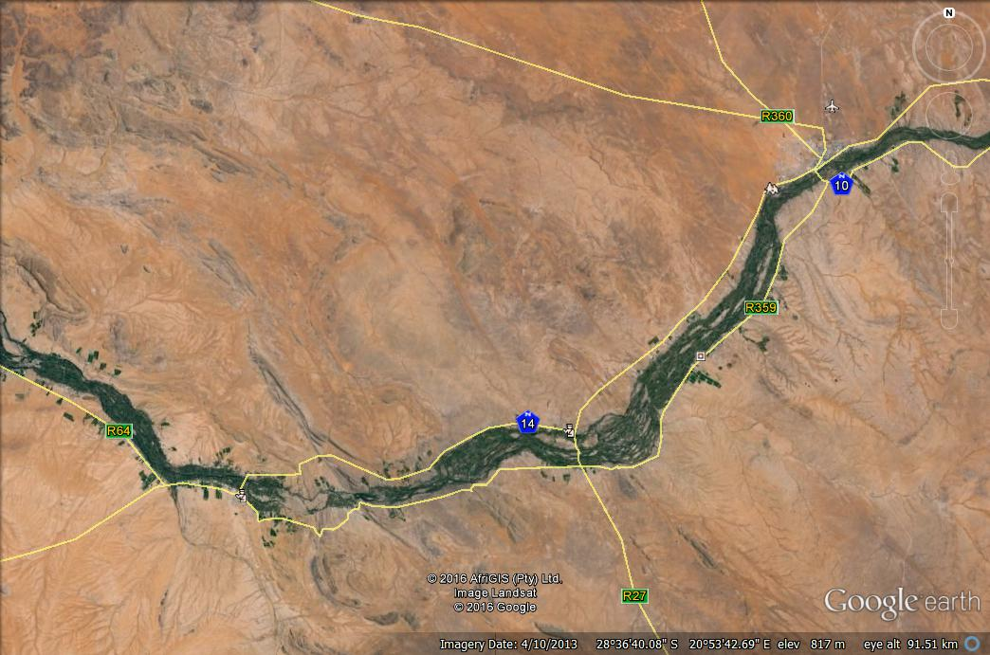
Upington
Kakamas
The Site
Keimoes
Figure 1: Google Earth image of the proposed site location.
Figure 2: Proposed site footprint in yellow and the natural furrows in blue.

2.4.2 Describe the surrounding land uses
The surrounding area is agricultural zoned and used for that purpose and mainly for grape vines. Because of the Orange River, this area is ideal for grape and citrus production and therefore these are the main farming activities along the banks of the Orange river. See figures 2 & 3 for the current and surrounding land use.
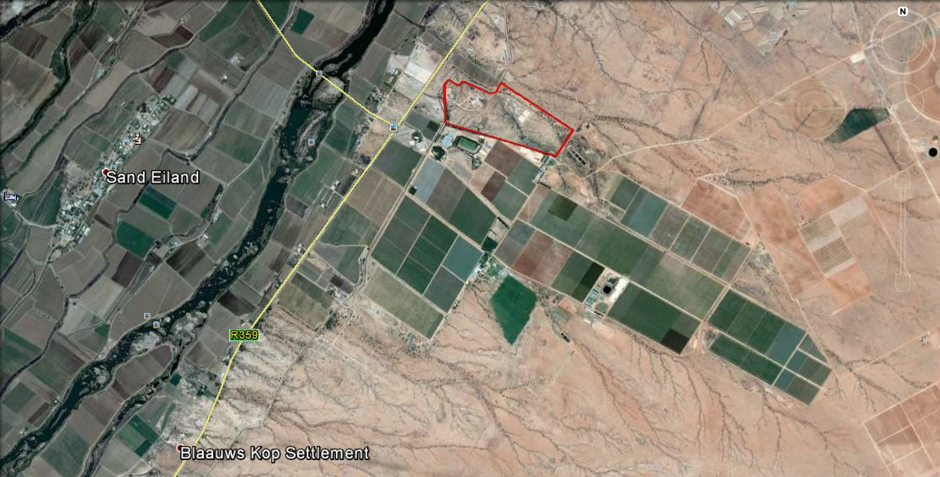
The Site
Figure 3: Arial image of the site, illustrating the surrounding land use.

ACTIVITIES THAT WILL BE APPLIED FOR
All activities listed in GN No. R. 983, GN No. R. 984 and GN No. R. 985 that are associated with the proposed project must be provided below.
Activity No(s): | Provide the relevant Basic Assessment Listed Activity(ies) as set out in Listing Notice 1 (GN No. R. 983)
8 | The development and related operation of hatcheries or agri-industrial facilities outside industrial complexes where the development footprint covers an area of 2 000 square metres or more.  Development of agri-industrial facilities larger than 2 000 m2
12 | The development of;  (i) canals exceeding 100 square metres in size;  (ii) channels exceeding 100 square metres in size;  (iii) bridges exceeding 100 square metres in size;  (iv) dams, where the dam, including infrastructure and water surface area, exceeds 100 square metres in size;  (v) weirs, where the weir, including infrastructure and water surface area, exceeds 100 square metres in size;  (vi) bulk storm water outlet structures exceeding 100 square metres in size;  (vii) marinas exceeding 100 square metres in size;  (viii) jetties exceeding 100 square metres in size;  (ix) slipways exceeding 100 square metres in size;  (x) buildings exceeding 100 square metres in size;  (xi) boardwalks exceeding 100 square metres in size; or  (xii) infrastructure or structures with a physical footprint of 100 square metres or more;  where such development occurs;  (a) within a watercourse;  (b) in front of a development setback; or  (c) if no development setback exists, within 32 metres of a watercourse, measured from the edge of a watercourse;  Excluding:  (aa) the development of infrastructure or structures within existing ports or harbours that will not increase the development footprint of the port or harbour;  (bb) where such development activities are related to the development of a port or harbour, in which case activity 26 in Listing Notice 2 of 2014 applies;  (cc) activities listed in activity 14 in Listing Notice 2 of 2014 or activity 14 in Listing Notice 3 of 2014, in which case that activity applies;  (dd) where such development occurs within an urban area; or  (ee) where such development occurs within existing roads or road reserves.  Development within a 32 m of a watercourse
19 | The infilling or depositing of any material of more than 5 cubic metres into, or the dredging, excavation, removal or moving of soil, sand, shells, shell grit, pebbles or rock of more than 5 cubic metres from;  (i) a watercourse;  (ii) the seashore; or  (iii) the littoral active zone, an estuary or a distance of 100 metres inland of the high-water mark of the sea or an estuary, whichever distance is the greater, but excluding where such infilling, depositing , dredging, excavation, removal or moving;  (a) will occur behind a development setback;  (b) is for maintenance purposes undertaken in accordance with a maintenance management plan; or  (c) falls within the ambit of activity 21 in this Notice, in which case that activity applies.  Excavation or infilling of >5m3 within a watercourse
24 | The development of;  (i) a road for which an environmental authorisation was obtained for the route determination in terms of activity 5 in Government Notice 387 of 2006 or activity 18 in Government Notice 545 of 2010; or  (ii) a road with a reserve wider than 13,5 meters, or where no reserve exists where the road is wider than 8 metres;  but excluding;  (a) roads which are identified and included in activity 27 in Listing Notice 2 of 2014; or  (b) roads where the entire road falls within an urban area.  Development of a road wider than 8 m
27 | The clearance of an area of 1 hectares or more, but less than 20 hectares of indigenous vegetation, except where such clearance of indigenous vegetation is required for;  (i) the undertaking of a linear activity; or  (ii) maintenance purposes undertaken in accordance with a maintenance management plan.  Clearance of > 1 ha but < 20 ha of indigenous vegetation.
28 | Residential, mixed, retail, commercial, industrial or institutional developments where such land was used for agriculture or afforestation on or after 01 April 1998 and where such development:  (i) will occur inside an urban area, where the total land to be developed is bigger than 5 hectares; or  (ii) will occur outside an urban area, where the total land to be developed is bigger than 1 hectare;  excluding where such land has already been developed for residential, mixed, retail, commercial, industrial or institutional purposes.  Industrial developments of > 1 ha on land used for agriculture.
43 | The expansion and related operation of hatcheries or agri-industrial facilities outside industrial complexes, where the development footprint of the hatcheries or agri-industrial facilities will be increased by 2 000 square metres or more.  Expansion of agri-industrial facilities by 2 000 m2 or more.
Activity No(s): | Provide the relevant Basic Assessment Listed Activity(ies) as set out in Listing Notice 3 (GN No. R. 985)
2 | The development of reservoirs for bulk water supply with a capacity of more than 250 cubic metres.  Western Cape:  i) A protected area identified in terms of NEMPAA, excluding conservancies;  ii) In areas containing indigenous vegetation;  or  iii) In urban areas:  (aa) Areas zoned for use as public open space; or  (bb) Areas designated for conservation use in Spatial Development Frameworks adopted by the competent authority, or zoned for a conservation purpose.  Development of a reservoir larger than 250 m3.
4 | The development of a road wider than 4 metres with a reserve less than 13.5 metres.  Development of a road wider than 4 m.
Activity No(s): | Provide the relevant Scoping and EIR Listed Activity(ies) as set out in Listing Notice 2 (GN No. R. 984)
 | N/A (department to please advise if otherwise)
Activity No(s): | Provide the relevant Category A Waste Management Activity(ies) as set out in List of Waste Management Activities (GN No. R. 921)
 | N/A (department to please advise if otherwise)
Activity No(s): | Provide the relevant Category B Waste Management Activity(ies) as set out in List of Waste Management Activities (GN No. R. 921)
 | N/A (department to please advise if otherwise)
Note: Confirmation is requested from the Department that the above listed activities are applicable, and if not, which activities should be excluded or included.

OTHER APPLICATIONS
4.1 Intended Applications in terms of the National Environmental Management Act (“NEMA”) & specific environmental management Acts (“SEMAs”)
Does the proposed project require an application for a waste management license in terms of the National Environmental Management: Waste Act, 2008 (Act No. 59 of 2008)?  Note: Ensure that the correct application fees have been paid (refer to section 1 above). | YES | NO
If yes, has an application been submitted to the licensing authority? | Yes | No
Does the proposed project require an application for a water use license in terms of the National Water Act, 1998 (Act No. 36 of 1998)? | YES | NO
If yes, has an application been submitted to the licensing authority? | Yes | No
Does the proposed project require an application for an Atmospheric Emission License in terms of the National Environmental Management: Air Quality Act, 2004 (Act No. 39 of 2004)? | YES | NO
If yes, has an application been submitted to the licensing authority? | Yes | No
Does the proposed project require an application in terms of the National Environmental Management: Integrated Coastal Management Act (NEM: ICMA)? | YES | NO
If yes, has an application been submitted to the relevant competent authority? | Yes | No
If yes, provide more details of the application submitted/to be submitted in terms of the NEM: ICMA:

4.2 Heritage Impact Assessment

Section 38 of the Act states as follows:

38. (1) Subject to the provisions of subsections (7), (8) and (9), any person who intends to undertake a development categorised as-

(a) the construction of a road, wall, powerline, pipeline, canal or other similar form of linear development or barrier exceeding 300m in length;
(b) the construction of a bridge or similar structure exceeding 50m in length;
(c) any development or other activity which will change the character of a site-
(i) exceeding 5 000 m2 in extent; or
(ii) involving three or more existing erven or subdivisions thereof; or
(iii) involving three or more erven or divisions thereof which have been consolidated within the past five years; or
(iv) the costs of which will exceed a sum set in terms of regulations by SAHRA or a provincial heritage resources authority;
(d) the re-zoning of a site exceeding 10 000 m2 in extent; or
(e) any other category of development provided for in regulations by SAHRA or a provincial heritage resources authority, must at the very earliest stages of initiating such a development, notify the responsible heritage resources authority and furnish it with details regarding the location, nature and extent of the proposed development.

Does the proposed development constitute the undertaking of any of the categories of development set out in Section 38(1) of the National Heritage Resources Act? | YES | NO
If yes, please explain:
38. (1) Subject to the provisions of subsections (7), (8) and (9), any person who intends to undertake a development categorised as-
(a) the construction of a road, wall, powerline, pipeline, canal or other similar form of linear development or barrier exceeding 300m in length;

The deparment is requested to please advise on the above mentioned, please refer to the information provided in this Notice form as well as to the attached civil services report.

planning context
Is the activity permitted in terms of the property’s existing land use rights? | YES | NO | Please explain

PUBLIC PARTICIPATION
6.1 Public participation undertaken/or to be undertaken prior to the submission of the Application Form
Summary of the public participation to be undertaken/ or has been undertaken.
Initial Notification letters has been sent to I&Aps (State Organs/Local Municipality/owners of adjacent properties) on 10/03/2015
An Advertisement in local newspaper, Die Gemsbok (13/03/2015)
Posters/Notice Boards were placed at the proposed site and public spaces in the area.

6.2 List of State departments consulted/to be consulted
List of all the State departments that will be/have been consulted, including the name and contact details of the relevant official.
NC Department of Agriculture & Land Reform
Directorate Forestry Management
Department of Water Affairs- Northern Cape
Department of Environment and Nature Conservation
SANRAL

LISTS OF APPENDENCIES

