Key features observed during the site inspection conducted on 06 July 2023 for the proposed Rudolph Solar PV 1 near Viljoenskroon, Free State province:

Plate 1: The site (taken towards the north)

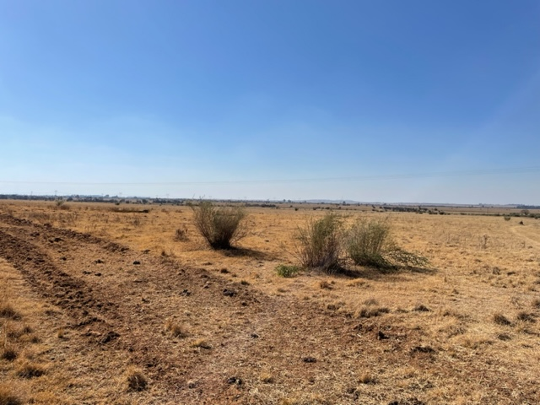

Plate 2: The site (taken towards the north east)
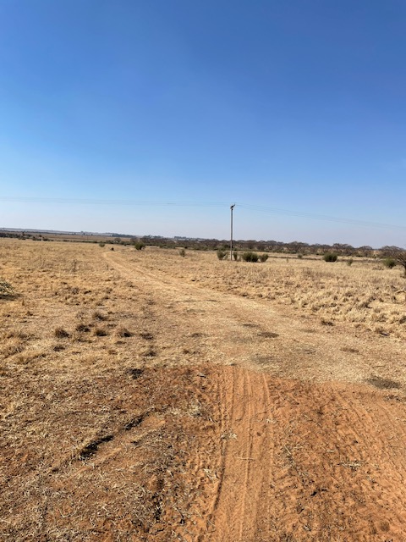

Plate 3: The site (taken towards the east).
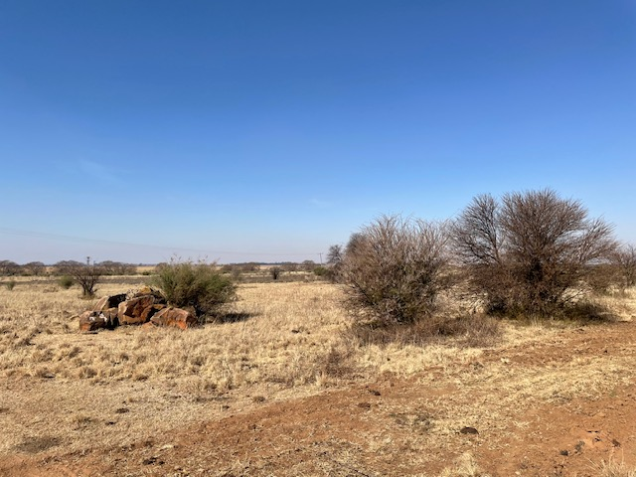

Plate 4: The site (taken towards the south east).
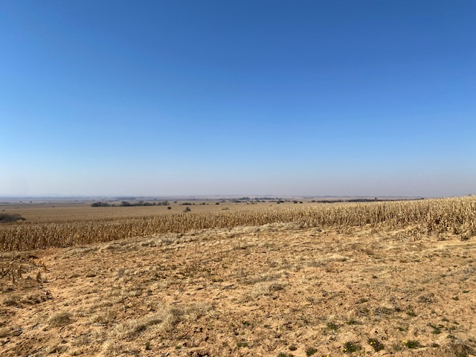

Plate 5: The site (taken towards the south).
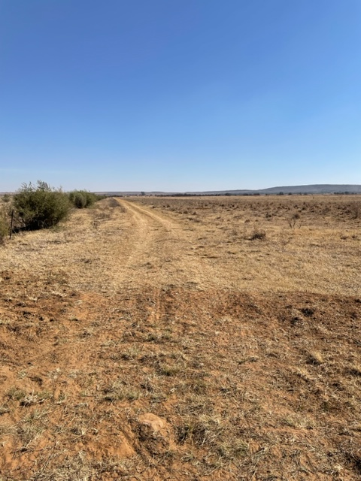

Plate 6: The site (taken towards the south west).
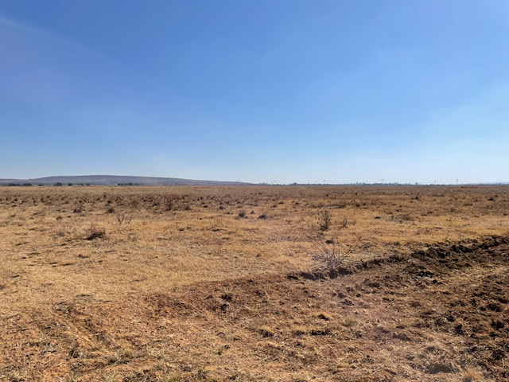

Plate 7: The site (taken towards the west).
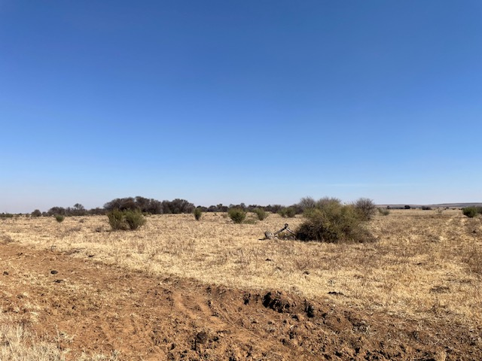

Plate 8: The site (taken towards the north west).
