ANNEEXTURE 2
PHOTOGRAPHS
As you can see from the pictures that was taken off the roof, that it was replaced and the new barge boards around the roof are similar to the previous boards. That gives the building appearance of having a flat roof. See pictures 2, 3, 4 and 5.
Picture no 7 and 8 was taken from the top floor, showing part of the new roof.
The rest of the pictures are self explanirtory.
Photo 1:
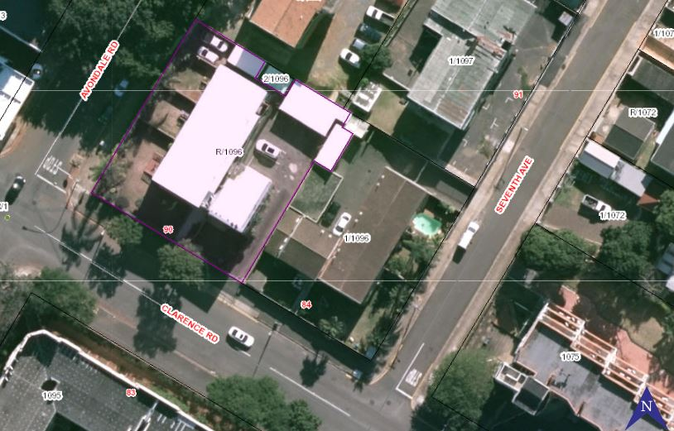

Photo 2
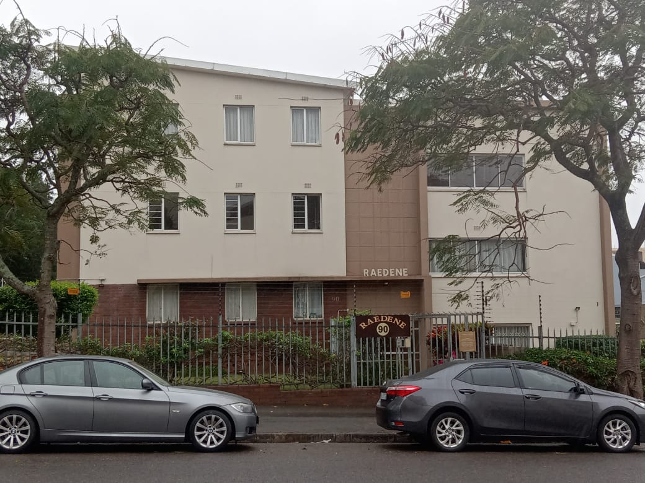

Photo 3
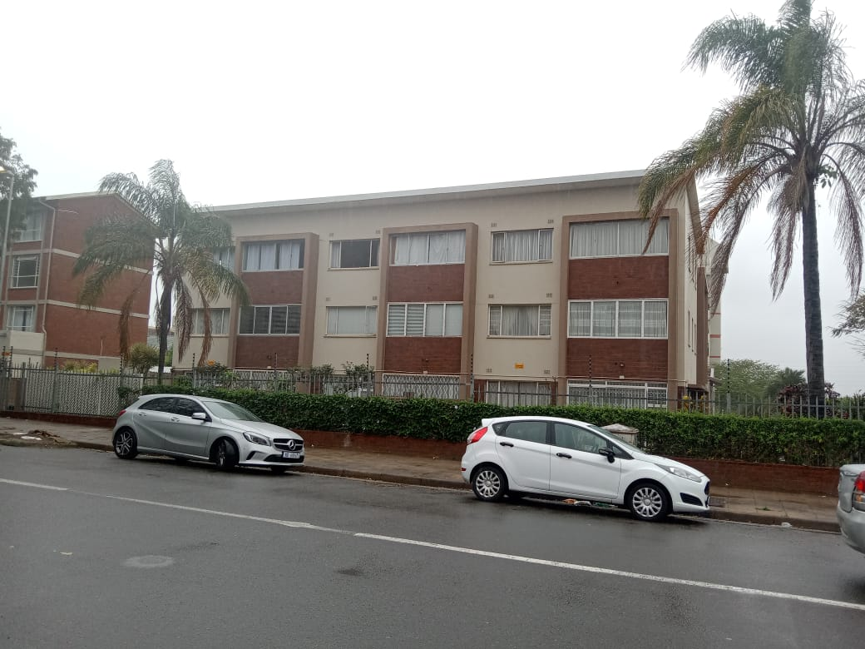

Photo 4
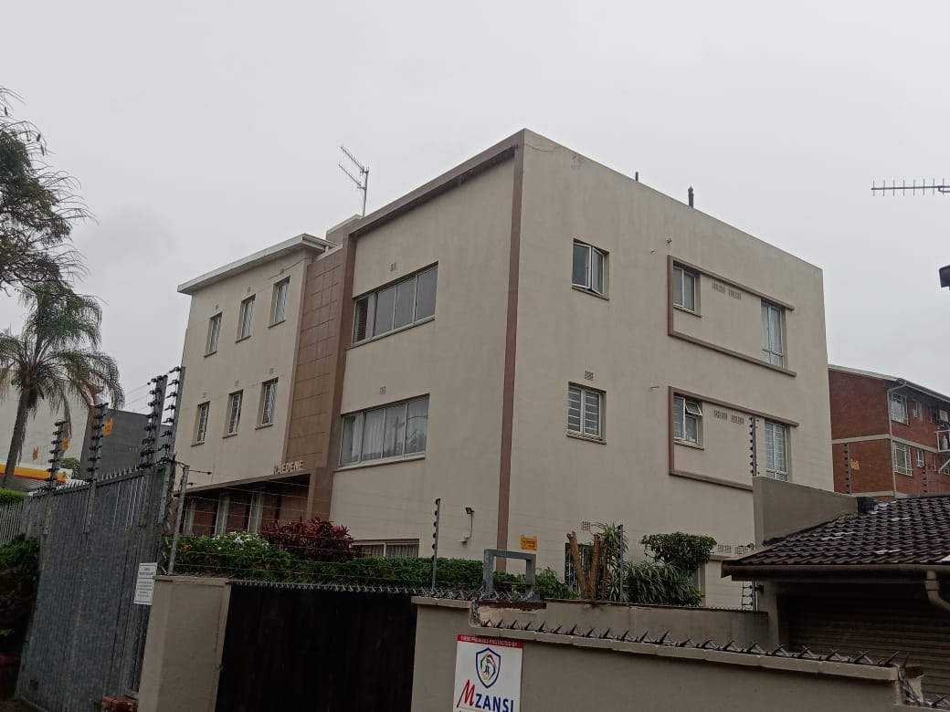

Photo 5
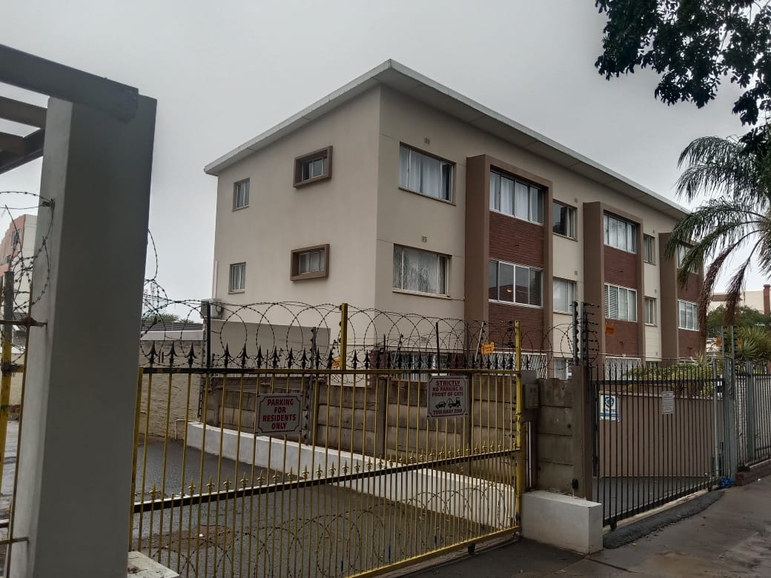

Photo 6
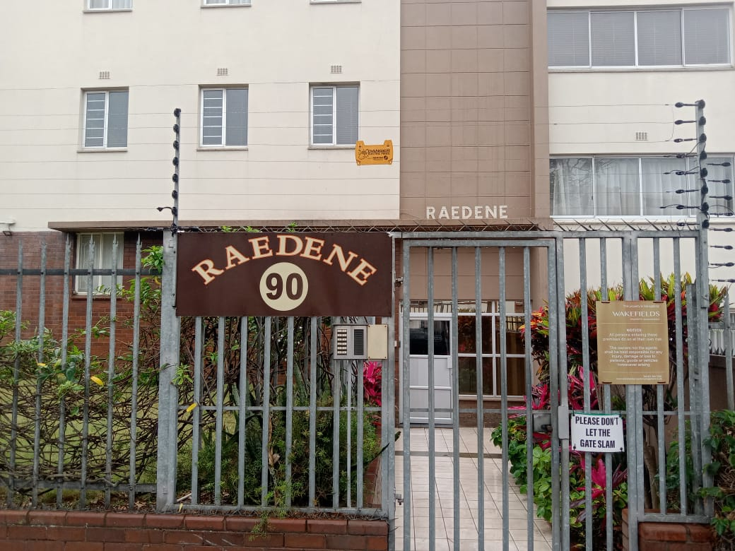

Photo 7
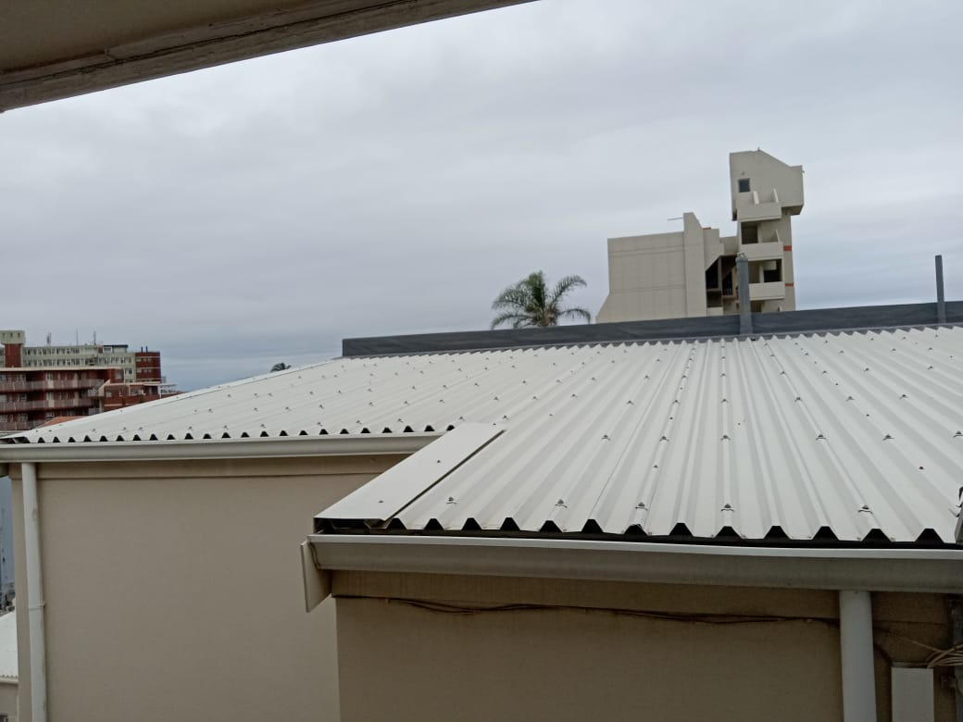

Photo 8
