Proposed development of a 10 MW Solar Energy facility on the Farm Liverpool 543 KQ Portion 2 at Koedoeskop, Limpopo

DESKTOP STUDY REPORT
PALAEONTOLOGY

Compiled by: Dr JF Durand (Sci.Nat.)

For:

Jonk Begin Environmental Services
Allied Power
Main Street 1
Koedoeskop
0361
bothadp@gmail.com

11 September 2013

Table of Contents:

1. Introduction……………………………………………………………………........ 3
2. Terms of reference for the report……………………………………………….....4
3. Details of study area and the type of assessment……………………………… 7
4. Geological setting of the study area ………………………………………………8
5. Palaeontology of the area……………….……………………............................ 9
6. Conclusion and Recommendations………… …………………………………..9

List of Figures:

Figure 1: Google Earth photo indicating the study area in the yellow polygon …..7

Figure 2: Geological Map of the study area and surroundings (adapted from the 2426 THABAZIMBI 1:250 000 Geology Map, Council for Geoscience, 1978)…...8

Figure 3: Fossiliferous cave breccia at the field research station of the University of the Witwatersrand in Makopane Valley from which fossils have to be removed still………………………………………………………………………………………...9

Figure 4: 24° 54.631'S 27° 29.620'E looking southwest…………………………..11

Figure 5: 24° 54.663'S 27° 29.474'E looking south………………………………..11

Figure 6: 24° 54.663'S 27° 29.474'E looking southwest…………………………..12

Figure 7: Banded ironstone found at 24° 54.909'S 27° 29.776'E………………...12

1. Introduction

The palaeontological heritage of South Africa is unsurpassed and can only be described in superlatives. The South African palaeontological record gives us insight in i.a. the origin of life, dinosaurs and humans. Fossils are also used to identify rock strata and determine the geological context of the geological formations and the chronostratigraphy of Southern Africa.

The first evidence of tectonic plate movement was discovered after studying the distribution of Karoo-age fossils in South Africa and other continents and subcontinents such as India, Antarctica, South America and Australia. Fossils are also used to study evolutionary relationships, sedimentary processes and palaeoenvironments.

The Heritage Act of South Africa stipulates that fossils and fossil sites may not be altered or destroyed. The purpose of this document is to detail the probability of finding fossils in the study area which may be impacted by the proposed development.

2. Terms of reference for the report
According to the South African Heritage Resources Act (Act 25 of 1999) (Republic of South Africa, 1999), certain clauses are relevant to palaeontological aspects for a terrain suitability assessment.
- Subsection 35(4) No person may, without a permit issued by the responsible heritage resources authority-
- (a) destroy, damage, excavate, alter, deface or otherwise disturb any archaeological or palaeontological site or any meteorite;
  - (b) destroy, damage, excavate, remove from its original position, collect or own any archaeological or palaeontological material or object or any meteorite;
  - (c) trade in, sell for private gain, export or attempt to export from the republic any category of archaeological or palaeontological material or object, or any meteorite; or
  - (d) bring onto or use at an archaeological or palaeontological site any excavation equipment or any equipment which assist with the detection or recovery of metals or archaeological material or objects, or use such equipment for the recovery of meteorites.
- Subsection 35(5) When the responsible heritage resources authority has reasonable cause to believe that any activity or development which will destroy, damage or alter any archaeological or palaeontological site is under way, and where no application for a permit has been submitted and no heritage resources management procedures in terms of section 38 has been followed, it may-
- (a) serve on the owner or occupier of the site or on the person undertaking such development an order for the development to cease immediately for such period as is specified in the order;
- (b) carry out an investigation for the purpose of obtaining information on whether or not an archaeological or palaeontological site exists and whether mitigation is necessary;
- (c) if mitigation is deemed by the heritage resources authority to be necessary, assist the person on whom the order has been served under paragraph (a) to apply for a permit as required in subsection (4); and
- (d) recover the costs of such investigation form the owner or occupier of the land on which it is believed an archaeological or palaeontological site is located or from the person proposing to undertake the development if no application for a permit is received within two weeks of the order being served.
South Africa’s unique and non-renewable palaeontological heritage is protected in terms of the NHRA. According to this act, heritage resources may not be excavated, damaged, destroyed or otherwise impacted by any development without prior assessment and without a permit from the relevant heritage resources authority.
As areas are developed and landscapes are modified, heritage resources, including palaeontological resources, are threatened. As such, both the environmental and heritage legislation require that development activities must be preceded by an assessment of the impact undertaken by qualified professionals. Palaeontological Impact Assessments (PIAs) are specialist reports that form part of the wider heritage component of:
- Heritage Impact Assessments (HIAs) called for in terms of Section 38 of the National Heritage Resources Act, Act No. 25, 1999 by a heritage resources authority.
- Environmental Impact Assessment process as required in terms of other legislation listed in s. 38(8) of NHRA;
- Environmental Management Plans (EMPs) required by the Department of Mineral Resources.

HIAs are intended to ensure that all heritage resources are protected, and where it is not possible to preserve them in situ, appropriate mitigation measures are applied. An HIA is a comprehensive study that comprises a palaeontological, archaeological, built environment, living heritage, etc specialist studies. Palaeontologists must acknowledge this and ensure that they collaborate with other heritage practitioners. Where palaeontologists are engaged for the entire HIA, they must refer heritage components for which they do not have expertise on to appropriate specialists. Where they are engaged specifically for the palaeontology, they must draw the attention of environmental consultants and developers to the need for assessment of other aspects of heritage. In this sense, Palaeontological Impact Assessments that are part of Heritage Impact Assessments are similar to specialist reports that form part of the EIA reports.
The standards and procedures discussed here are therefore meant to guide the conduct of PIAs and specialists undertaking such studies must adhere to them.
The process of assessment for the palaeontological (PIA) specialist components of heritage impact assessments, involves:

Scoping stage in line with regulation 28 of the National Environmental Management Act (No. 107 of 1998) Regulations on Environmental Impact Assessment. This involves an initial assessment where the specialist evaluates the scope of the project (based, for example, on NID/BIDs) and advises on the form and extent of the assessment process. At this stage the palaeontologist may also decide to compile a Letter of Recommendation for Exemption from further Palaeontological Studies. This letter will state that there is little or no likelihood that any significant fossil resources will be impacted by the development. This letter should present a reasoned case for exemption, supported by consultation of the relevant geological maps and key literature.

A Palaeontological Desktop Study – the palaeontologist will investigate available resources (geological maps, scientific literature, previous impact assessment reports, institutional fossil collections, satellite images or aerial photos , etc) to inform an assessment of fossil heritage and/or exposure of potentially fossiliferous rocks within the study area. A Desktop studies will conclude whether a further field assessment is warranted or not. Where further studies are required, the desktop study would normally be an integral part of a field assessment of relevant palaeontological resources.

A Phase 1 Palaeontological Impact Assessment is generally warranted where rock units of high palaeontological sensitivity are concerned, levels of bedrock exposure within the study area are adequate; large-scale projects with high potential heritage impact are planned; and where the distribution and nature of fossil remains in the proposed project area is unknown. In the recommendations of Phase 1, the specialist will inform whether further monitoring and mitigation are necessary. The Phase 1 should identify the rock units and significant fossil heritage resources present, or by inference likely to be present, within the study area, assess the palaeontological significance of these rock units, fossil sites or other fossil heritage, comment on the impact of the development on palaeontological heritage resources and make recommendations for their mitigation or conservation, or for any further specialist studies that are required in order to adequately assess the nature, distribution and conservation value of palaeontological resources within the study area.

A Phase 2 Palaeontological Mitigation involves planning the protection of significant fossil sites, rock units or other palaeontological resources and/or the recording and sampling of fossil heritage that might be lost during development, together with pertinent geological data. The mitigation may take place before and / or during the construction phase of development. The specialist will require a Phase 2 mitigation permit from the relevant Heritage Resources Authority before Phase 2 may be implemented.

A ‘Phase 3’ Palaeontological Site Conservation and Management Plan may be required in cases where the site is so important that development will not be allowed, or where development is to co-exist with the resource. Developers may be required to enhance the value of the sites retained on their properties with appropriate interpretive material or displays as a way of promoting access of such resources to the public.

The assessment reports will be assessed by the relevant heritage resources authority, and depending on which piece of legislation triggered the study, a response will be given in the form of a Review Comment or Record of Decision (ROD). In the case of PIAs that are part of EIAs or EMPs, the heritage resources authority will issue a comment or a record of decision that may be forwarded to the consultant or developer, relevant government department or heritage practitioner and where feasible to all three.

3. Details of study area and the type of assessment:

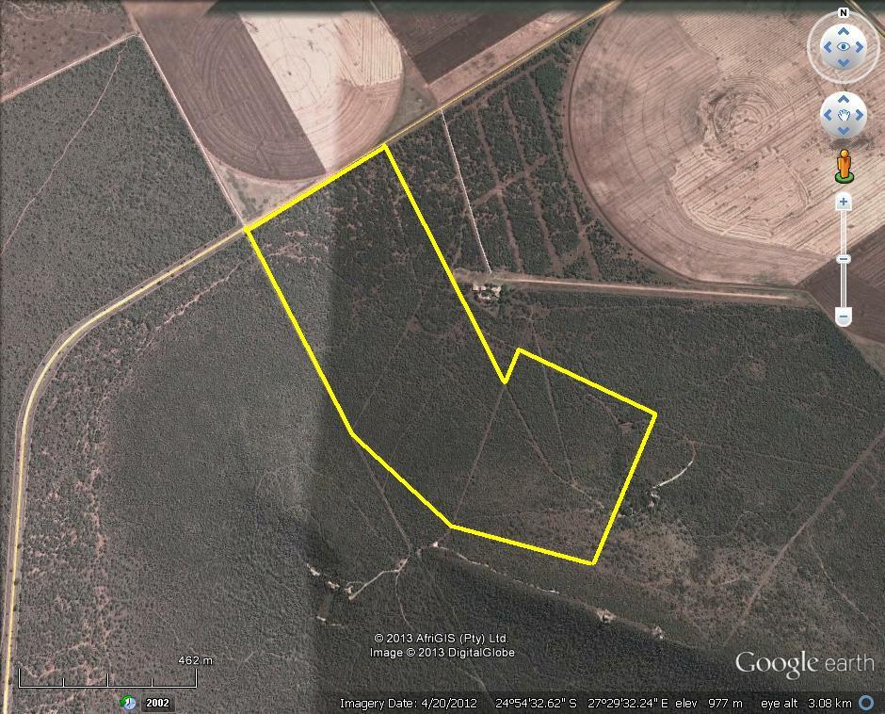
Figure 1: Google Earth photo indicating the study area in the yellow polygon

The study area lies west of the township Koedoeskop, approximately 36km south of Thabazimbi in the Limpopo Province.

Geomorphologically the study area lies on the slope of a hill. The soil has a red colour due to the underlying iron-rich rocks. The slope is covered in typical Bushveld vegetation. The adjacent flat areas to the north and east of the study area with deeper soils are under cultivation (see Fig.1).

The site was visited and the relevant literature and geological maps for the study area in which the development is proposed to take place, have been studied for a desktop study.
4. Geological setting of the study area

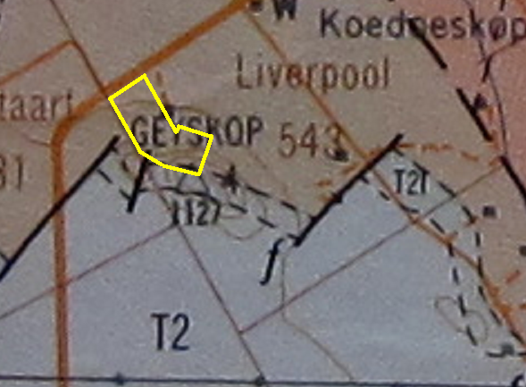
[The study area is indicated by the yellow polygon]

Figure 2: Geological Map of the study area and surroundings (adapted from the 2426 THABAZIMBI 1:250 000 Geology Map, Council for Geoscience, 1978)

GEOLOGICAL LEGEND

3Gl | Course-grained granite |  | Nebo Granite | Lebowa Granite Suite |  | Bushveld Igneous Complex
T3tS | Shale (ferruginous) and hornfels – locally with conglomerate and quartzite near base and higher up |  | Pretoria Group |  | Transvaal Supergroup
T2l | Banded ironstone, locally with shaly dolomitic limestone at top | Penge Formation | Chuniespoort Group
T2 | Dolomite, chert, shale, locally with interbedded quartzite | Malmani Subgroup

The study site is largely situated on Pretoria Group sediments while the southern margin overlaps the Penge Formation of the Chuniespoort Group (Fig.2). These late Archaean to early Proterozoic Transvaal Supergroup metamorphosized sediments consist mostly of iron-rich mudrock (Figs. 4-7) (Eriksson et al., 2006).
6. Palaeontological heritage of southern Limpopo

The 2.6 – 2.4 Ga Chuniespoort Group consists largely of stromatolitic dolomite and limestone. Stromatolites and caves are common in this geological unit in places such as the Cradle of Humankind towards the south and Makopane Valley towards the east (see Fig.3) of the study area. The fossils and artefacts of this region play an important role in the understanding of human origins, early human evolution and technological development (MacFadden, 1980; Mason, 1988; Maguire, 1992). The scientific, educational and economic importance of these fossils which are found in petrified Plio-Pleistocene cave infills in the dolomite of the Chuniespoort Group necessitated this study.

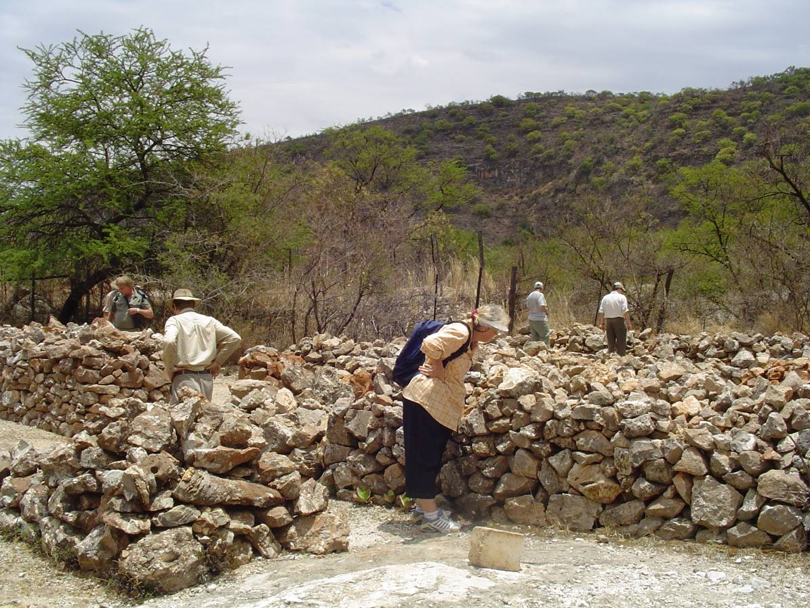

Figure 3: Fossiliferous cave breccia at the field research station of the University of the Witwatersrand in Makopane Valley from which fossils have to be removed still.

References:

Eriksson, P.G.; Altermann, W. & Hatzer, F.J., (2006) The Transvaal Supergroup and its precursors. In: Johnson, M.R.; Anhauysser, C.R. & Thomas, R.J. (Eds.) The Geology of South Africa. Johannesburg: Geological Society of South Africa.

Geological Survey (1978) Thabazimbi 2426 1: 250 000 Geology Map.

Maguire, J.M. (1992) A guide to the palaeontological and archaeological sites of the Makapansgat Valley. South African Society for Amateur Palaeontologists, Pretoria.

Mason, R.J. (1988) Cave of Hearths Makapansgat. Occasional Paper 21 Archaeological Research Unit, University of the Witwatersrand, Johannesburg.

McFadden, P.L. (1980) An overview of palaeomagnetic chronology with special reference to the South African hominid sites. Palaeontologia africana 23:75-98.

6. Site visit:

The study site was visited on 4 September 2013.

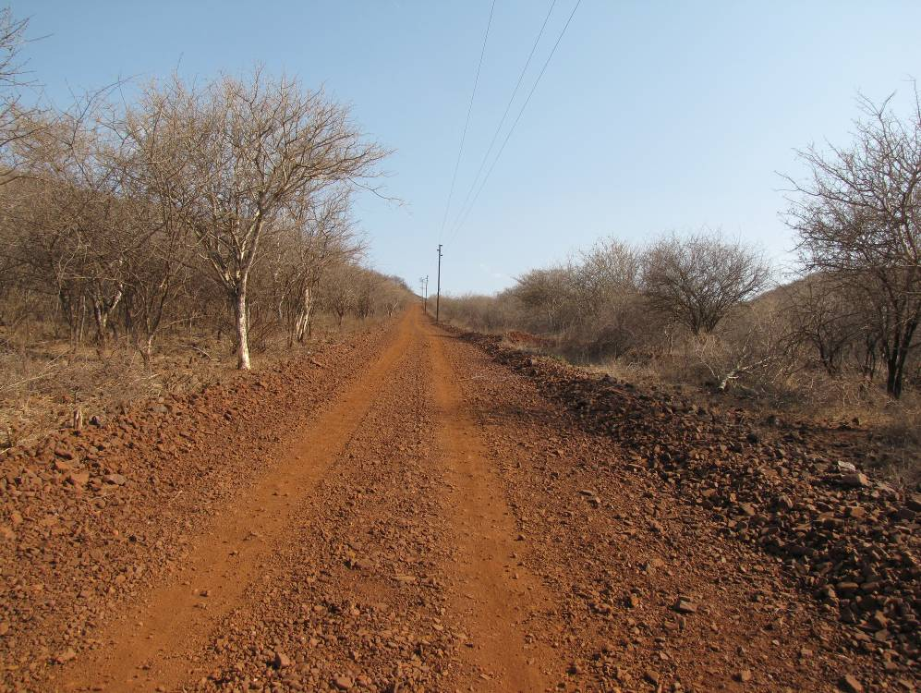
Figure 4: 24° 54.631'S 27° 29.620'E looking southwest

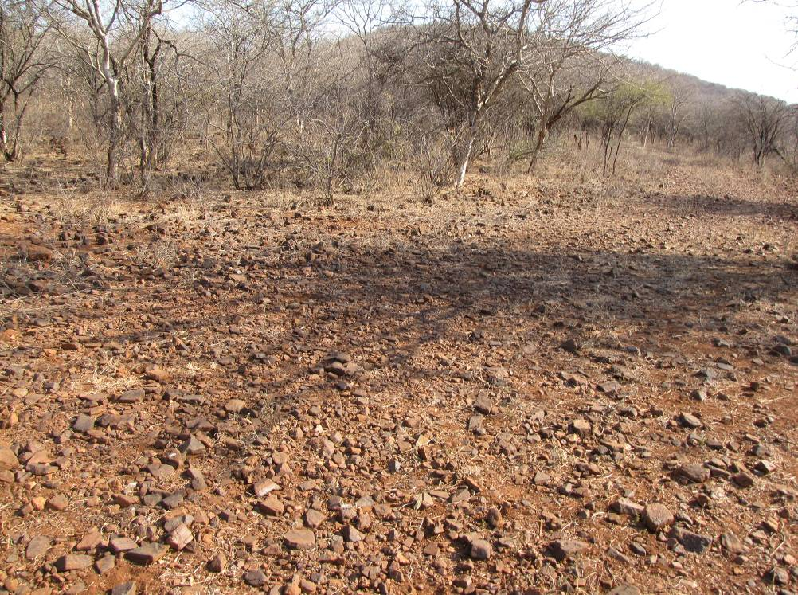
Figure 5: 24° 54.663'S 27° 29.474'E looking south
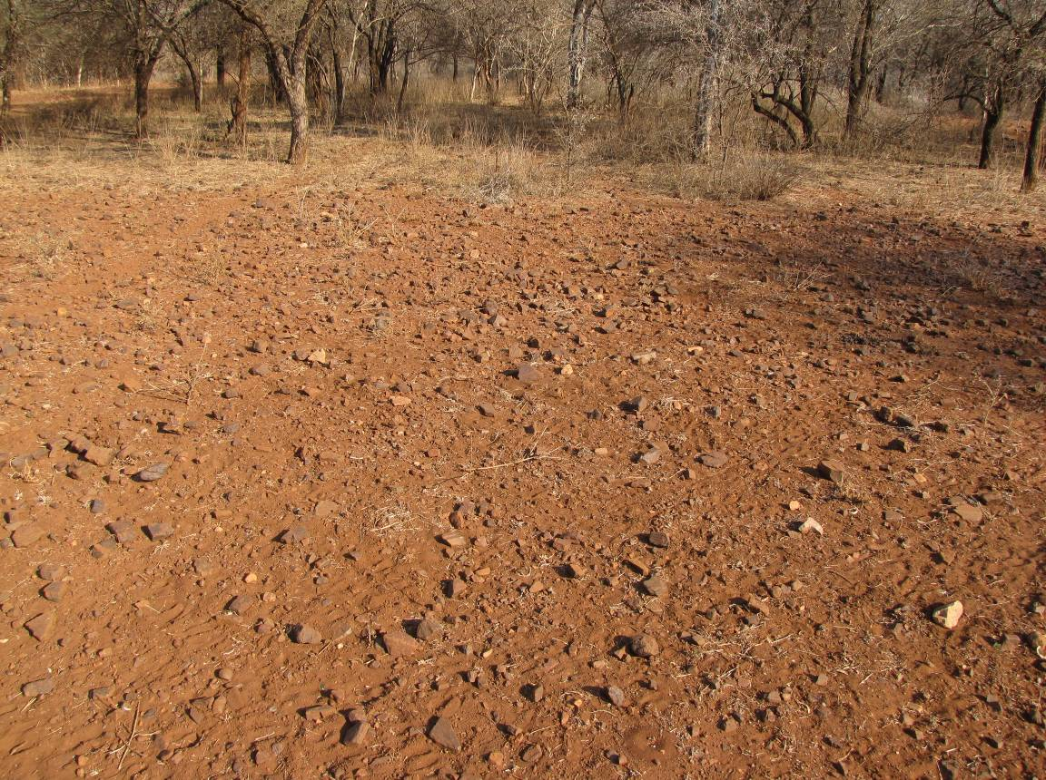
Figure 6: 24° 54.663'S 27° 29.474'E looking southwest
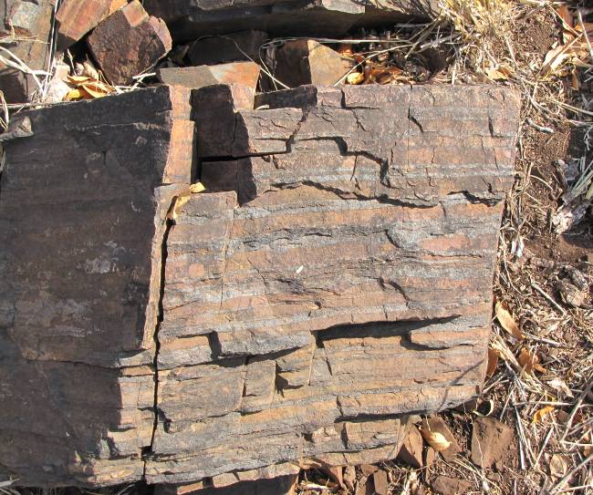
The area is dominated by red-brown, iron-rich rocks underlying the largest part of the study area. These rocks form part of the ferruginous shales of the Pretoria Group (Figs.4-6).

The finely-laminated banded ironstone found along the southern border of the study area form part of the Chuniespoort Group (Fig.7). The hill bordering the southern part of the study area consists of this banded ironstone.

Figure 7: Banded ironstone found at 24° 54.909'S 27° 29.776'E

The Malmani Subgroup dolomite does not occur in the study area. No fossils were found in the study area. .
7. Conclusion and recommendations:

Due to the improbability of fossils occurring in the study area it is recommended that the project should be exempted from further palaeontological studies.


Palaeontological specialist:
Dr JF Durand (Sci. Nat.)
BSc Botany & Zoology (RAU), BSc Zoology (WITS), Museology Dipl. (UP),
Higher Education Diploma (RAU), PhD Palaeontology (WITS)

Experience:
Palaeontological assessments:
- Urban development in Cradle of Humankind World Heritage Site (Gauteng): Letamo, Honingklip, Windgat, Sundowners, Ekutheni
- Urban development at Goose Bay, Vereeniging, Gauteng
- Upgrade of R21 between N12 and Hans Strydom Drive, Gauteng
- Vele Colliery, Limpopo Province
- De Wildt 50 MW Solar Power Station, Gauteng
- 10 MW PV Plant Potchefstroom, North West Province
- Omega 342 50MW Solar Power Station, Viljoenskroon, Free State
- Solar power plant, Bethal, Mpumalanga
- Diamond mine on Endora, Limpopo Province
- Development at Tubatse Ext.15, Limpopo Province
- Manganese mine south of Hotazel, Northern Cape
- Wind energy facility at Cookhouse, Eastern Cape
- Eskom power line, Dumo, KwaZulu-Natal
- Eskom Gamma-Omega 765KV transmission line, Western Cape
- Eskom 44KV power line at Elandspruit near Middleburg, Mpumalanga
- Limestone mining on the farms Buffelskraal 554 KQ Portion1 and Krokodilkraal 545 KQ, Limpopo Province

Palaeontological research:
- Gauteng: Wonder Cave
- KwaZulu/Natal: Newcastle, Mooi River, Rosetta, Impendle, Himeville Underberg, Polela & Howick Districts, Sani Pass
- Eastern Cape: Cradock District, Algoa Basin
- Western Cape: Clanwilliam District
- Free State: Memel & Warden Districts
- Limpopo Province: Nyalaland (KNP), Vhembe Reserve, Pont Drift
- Zimbabwe: Sentinel Ranch, Nottingham

