Appendix A: Site Plan(s)

N
Appendix A1: Aerial Map showing the location of the proposed Mahambuma/Tatiyane, Phenyane,Phethu and Kwasitholane Causewaysanthe surrounding land uses (Source: Google Earth).

Figure 2: Aerial Map showing the location of the proposed Mabedlana River Bridge and the surrounding land uses (Source: Google Earth)

Appendix A2: Topographical Map showing the location of the causeways along the P736 Road and the surrounding land uses (2731DC).

Appendix B: Photographs

Mahambuma

Site Photographs
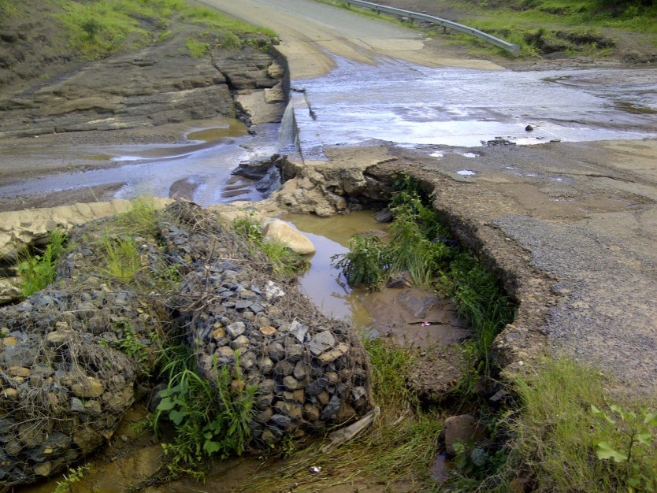

Appendix C: Facility Illustration(s)

Appendix D: Specialist Reports
(None)
Appendix E: Comments and Responses Report

APPENDIX E - COMMENTS AND RESPONSES REPORT

- INTRODUCTION

In order to fulfil the necessary public participation required as part of the Basic Assessment process, the following methods of stakeholder engagement were conducted:

  - Newspaper Advertisements

Newspaper adverts were published in the Zululand Observer (in English and Zulu) on Thursday 31 January 2013. The purpose of the adverts was to inform the general public of the proposed development. Copies of the adverts are included in this Appendix.

  - Site Notice Boards

Site notice boards in English and Zulu were placed onsite on Thursday 31 January 2013.

The purpose of the notice boards is to inform neighbors and passers-by of the proposed development. Copies of the notice boards and photos of them on site are included in this Appendix.

  - I&APs with Special Needs
The 2010 Environmental Regulations require the EAP to use reasonable alternative methods to include those I&APs who are desiring of but unable to participate in the process due to—
(i) illiteracy;
(ii) disability; or
(iii) any other disadvantage.

In order to include these people in the environmental assessment process, the EAP requested the local Chief to conduct a community meeting at which the information contained in the Background Information Document was relayed to community members. Meeting attendees were encouraged to relay the information they heard at the meeting to community members who could not attend the meeting. Community members were requested to tell the Chief of their comments or queries. The Chief was requested to relay these comments and queries to the EAP.

  - Written Notification to Authorities and Neighbours

    - Interested and Affected Parties
A list of Interested and Affected Parties (I&APs) was compiled. This included all relevant authorities, Government Departments, the local Municipality, relevant conservation bodies and NGO's. This list was regularly updated to include those I&APs responding to the newspaper adverts and site notice boards. A copy of the I&AP list is included in this Appendix.

    - Background Information Documents
Background Information Documents (BID) in English and Zulu were compiled and circulated to all I&APs, by hand, post, fax, or email from 09 January 2013. The purpose of the BID was to provide some preliminary information on the proposed development and its location, as well as to explain the Basic assessment process. Furthermore, the BID invited preliminary comments from the I&APs. A copy of the BID is included in this Appendix.

Table 1: Comments received in response to the bid, site posters and newspaper advert and the responses given.

I&AP | COMMENT | RESPONSE
Carolyn Schwegman, WESSA, 18 February 2013: | - Thank you for notifying WESSA of the DoT project. WESSA does not wish to register as an I&AP and we do not require further information.  - We trust that site specific EMPr’s, with method statements, for each bridge will be developed to ensure damage and water pollution is avoided, and in places where plants, such as Aloes are present, plant rescue and relocation will be undertaken. | - Noted.  - An Environmental Management Program (EMPr) has been developed to ensure that environmental damage is kept to an absolute minimum throughout the various phases of the development.  As a part of the EMPr, all plants will be stockpiled for use in the rehabilitation of the site. The sites are all degraded and infected with Alien vegetation, however, should any valuable indigenous plants be found, they will be relocated to a suitable location.
Nompumelelo Mdlalose, DWA, 14 January 2013: | - Are all the causeways existing, or is the establishment of new ones planned?  - Where will water for construction be sourced from?  - The Department awaits further documentation to comment. | - Three are new and one is existing.  - Water will be sourced from the river.  - Noted.
Roy Ryan, Department of Transport, 22 April 2013: | - In connection with the abovementioned proposed causeways and the expansion of an existing causeway, I have to inform you that the Minister as the Controlling Authority as defined in the KZN Roads Act No. 4 of 2001, has in terms of Section 13 of the said Act, has no objections to the Background Information Document as follows.  - All structures and services are to be approved and placed in consultation with and to the satisfaction of this Cost Centre Manger, Pietermaritzburg Tel: 033 387 2320.  - In view of the proposed causeways development shown on figure 1 this Department requires the applicant to consult with our Bridge Office, Chief Engineer, Mr D. Bryan Tel: 033 355 0542.  - All costs incurred, as a result of these requirements shall be borne entirely by the developer.  - This approval shall not exempt the applicant from the provisions of any other law. | - Noted.  - The Applicant and Engineers have been informed of this.  - This has been communicated to the Applicant and Engineers.  - This has been communicated to the Applicant and Engineers.  - Noted.

  - Circulation of Draft Basic Assessment Report for comment
Copies of this Draft Basic Assessment Report have been circulated to the following I&APs for review and comment:

Siyabonga Dlamini – Zululand District Municipality;
SN Biyela – Nongoma Local Municipality;
N Myeni – Department of Agriculture;
Andy Blackmore – Ezemvelo KZN Wildlife;
Weziwe Tshabalala – AMAFA; and
Nompumelelo Mdlalose – Department of Water Affairs.

A copy has also been sent to Sandile Hlabisa at the Nongoma Department of Transport to give to the Local Nkosi.

All registered I&APs were notified of the availability of this report and their opportunity to comment. I&APs have been given 40 days to comment on the Report.

Appendix E1 – Newspaper Adverts

GREEN DOOR ENVIRONMENTAL

NOTICE OF ENVIRONMENTAL

IMPACT ASSESSMENT PROCESS

Notice is given in terms of Regulation 54 of the Environmental Impact Assessment (EIA) Regulations 2010, under Section 24(5), 24M and 44 of the National Environmental Management Act (Act No 107 of 1998), published in Government Notice No. R. 543 of 2010, of the intent to carry out the following activity:

The Department of Transport proposes to establish three causeways and to expand an existing causeway along the P736 Road, Nongoma, KwaZulu-Natal.

The proposed development triggers Listed Activities published under Government Notice No R. 544, thus a Basic Assessment process is required.

Persons wishing to register as an interested and / or affected party should notify: Roxanne Oelofse of Green Door Environmental, Block H, Quarry Office Park, 400 Old Howick Road, Hilton, P O Box 11, Hilton, 3245. Tel: 033 343 4176, Fax 033 343 4201, E-mail: info@greendoorgroup.co.za.

To be included in the list of interested and affected parties, please ensure that your contact details and preliminary comments reach the abovementioned Environmental Assessment Practitioner within 14 days of this notice

GREEN DOOR ENVIRONMENTAL

ISAZISO SE-ENVIRONMENTAL IMPACT ASSESSMENT PROCESS

Isaziso sikhishwe ukulandela imithetho, ewunombolo 54 ye Environmental Impact Assessment (EIA) 2010, ngaphansi kwa 24 (s) 24M. kanye 44 ye National Environmental Management Act (Act No. 107 of 1998); ebhalwe ezazisweni zettulumeni No. R543 of 2010, ngenhloso yokwenza lemisebenzi elendeleysi.

Umnyango wezokuthutha usungula ukwakha imigwaqo eyizindlela kanye nokunweba umgaqo u P736, Nongoma, KwaZulu Natali.

Lentuthuko esungiliwe ibhelwe yonke imisebenzi ezowenziwa ngaphansi kwezaziso zahulumeni No. R544. Kodwa kusedingeka iBasic Assessment Process.

Abantu abafisa ukubhalisa ngengabantu abathintekile noma abazothinteka ngenxa yalesiphakamiso bayacelwa ukuba bazise uRoxanne Oelofse wakwaGreen Door Environmental, Block H, Quarry Office Park, 400 Old Howick Road, Hilton, ku P.O. Box 11, eHilton, 3245. Ucingo: 033 343 4176, Isikhahlamezi: 033 343 4201, I e-mail: info@greendoorgroup.co.za.

Ukubalwa njengengxenye yalabo abathintekile, sicela uqinisekise ukuthi imininingwane otholakala kuyo, kanye novo lwakho lufika kuloMhloli-Mvelo (Environmental Assessment Practitioner – EAP).

Appendix E2 – Site Information Posters

Appendix E3: Photos of Site Information Posters
PHOTOS OF SITE POSTERS

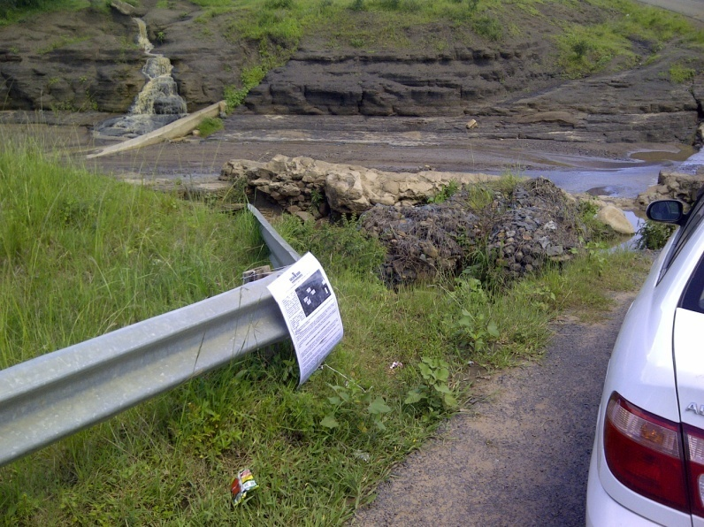
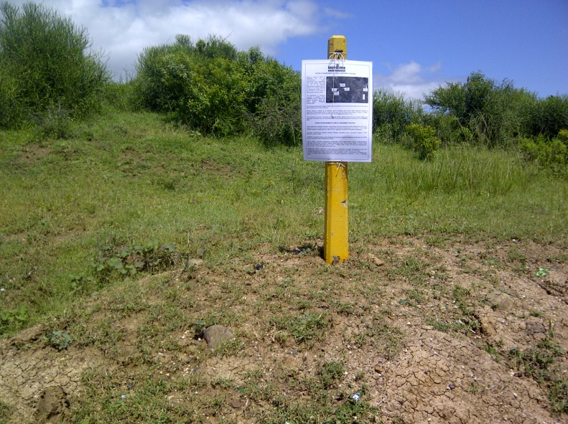

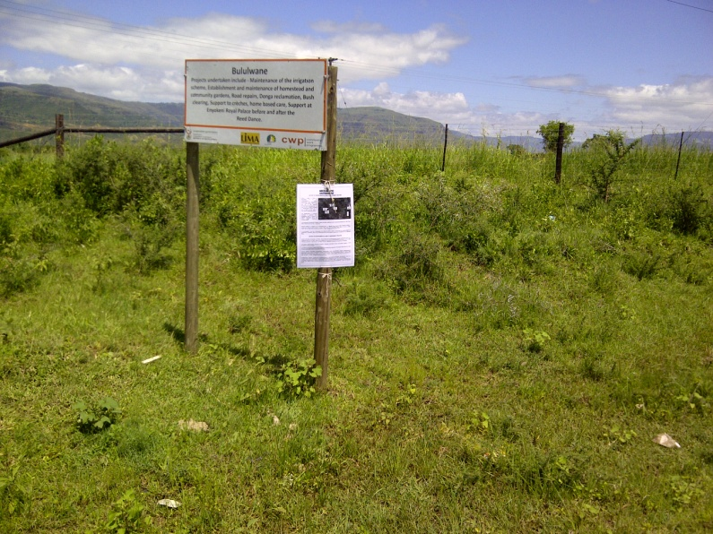
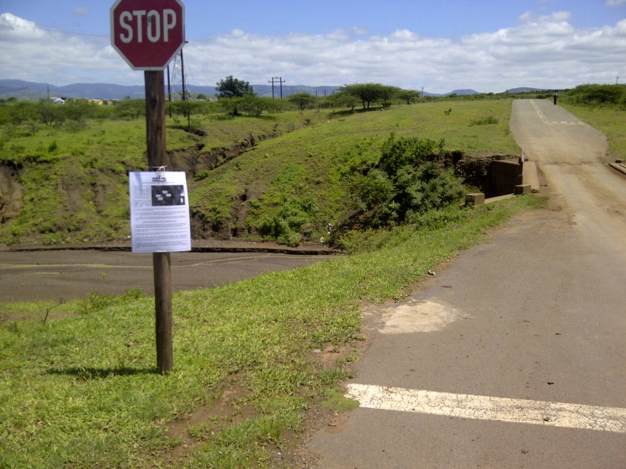

Appendix E4: List of Interested & Affected Parties

Appendix E5: Background Information Document

Appendix F: Draft Environmental Management Programme (EMPr)

Appendix G: Other information

