Appendix A1
Property Boundaries
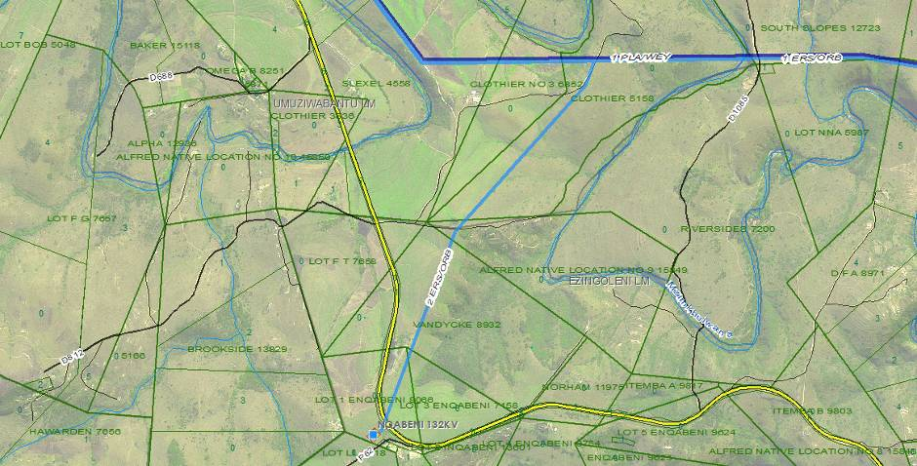
Preferred Corridor 1 coordinates

30⁰3’9.67”E30⁰43’14.12”S
30⁰3’21.34”E30⁰42’47.88”S
30⁰3’30.6”E30⁰42’26.53”S
30⁰3’44.75”E30⁰42’12.11”S
30⁰4’0.19”E30⁰41’57.69”S
30⁰4’7.18”E30⁰41’48.25”S

Alternative corridor 2

30⁰3’20.78”E30⁰43’1.47”S
30⁰3’31.79”E30⁰42’37.9”S
30⁰3’43.37”E30⁰42’21.04”S
30⁰3’57.73”E30⁰42’7.17”S
30⁰4’10.35”E30⁰41’54.04”S

EZINGOLWENI LOCAL
MUNICIPALITY
UMUZIWABANTU LOCAL
MUNICIPALITY
D812
N2
N2
LEGEND

T
N
River
Nqabeni-Eros-Oribi 132kV
Corridor 1
Corridor 2
Eros-Oribi 132kV
Access racks
Substation
Boundaries
Municipality boundary

Appendix A2
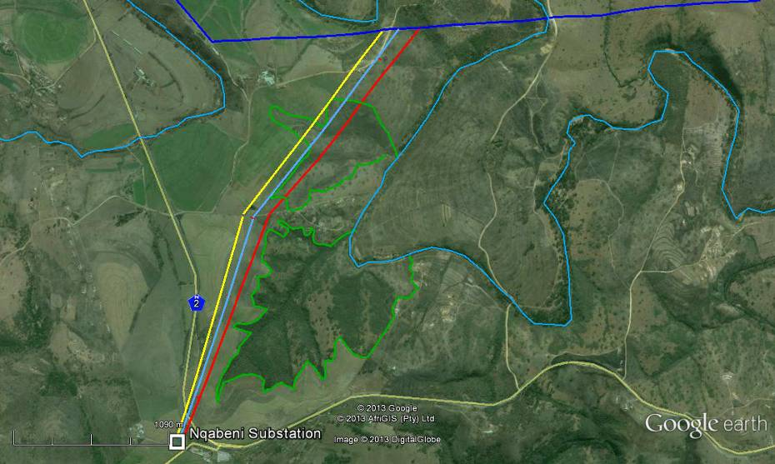
Ortho-Photo showing drainage area
Corridor 1
Corridor 2
Existing powerline
Drainage area
River
T
N

Appendix A3
600m corridor width
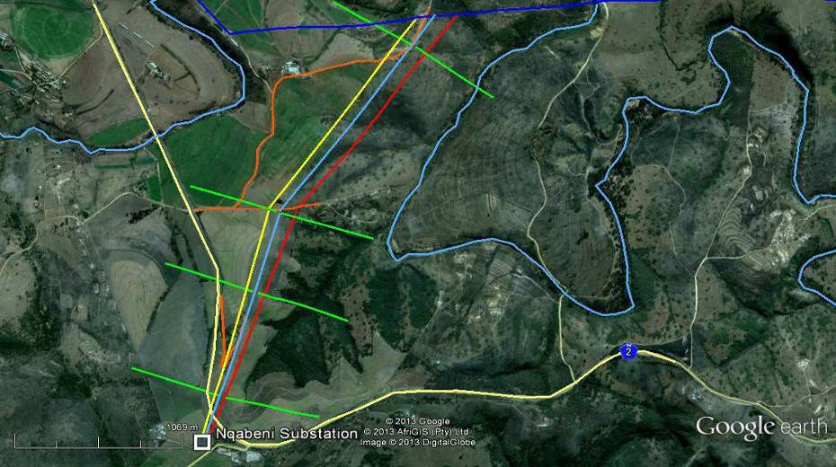
LEGEND
Exact positioning of alternative corridors

`
River
Nqabeni-Eros-Oribi 132kV
Corridor 1
Corridor 2
Eros-Oribi 132kV
600m servitude
Access tracks
T
N
Corridor 2 Centre Coordinates
30° 3'36.65"E30°42'28.14"S
Corridor 1 Centre Coordinates
30° 3'30.88"E 30°42'26.32"S

Appendix A4
250m interval coordinates powerline corridor 1
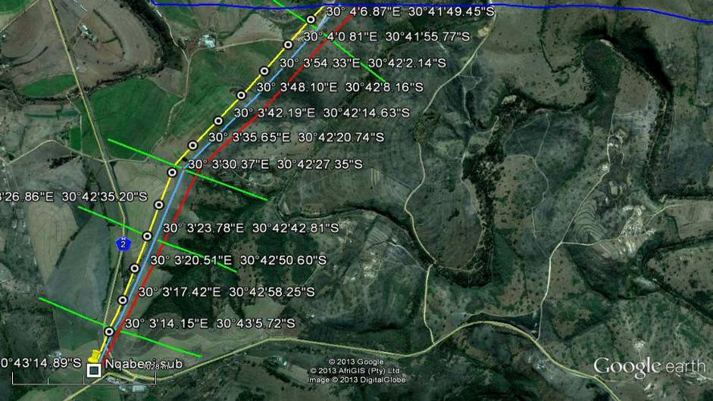
N

Appendix A5
250m interval coordinates powerline corridor 1
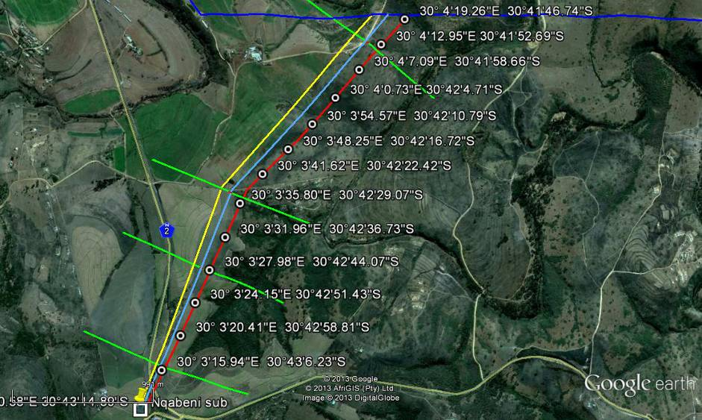
N

N

