|  |  |
| --- | --- |
| https://provincialgovernment.co.za/img/logos/thumb_3_infrastructure_development.png |  |

**ENVIRONMENTAL IMPACT ASSESSMENT**

Background Information Document

**PROPOSED RE-MODELLING AND EXPANSION OF RAMOSUKULA SECONDARY SCHOOL ON ZEEKOEFONTEIN FARM NO 573 PORTION 59 WITHIN EMFULENI SECONDARY SCHOOL**

May 2019

**Prepared by:**   
Exlite Consulting

**Prepared for:**Gauteng Dept of Infrastructure Development (GDID)

**GDARD Ref No:** GAUT 002/19-20/E2390

**Prepared By:**

Exlite Consulting PTY LTD

Grace Magaya

74 Third Street

Northmead

Benoni, 1501

Cellphone No: 081 494 1611

Email: [grace@gkmenvironmental.co.za](mailto:grace@gkmenvironmental.co.za)

**Prepared For:**

Gauteng Dept of Infrastructure Development (GDID)

Mr. Peter Wanjau

17 Keurboom Crescent

Noordwyk

Midrand

Cellphone No: +27 74 965 9021

Email Address: [peter@exilite-consulting.co.za](mailto:peter@exilite-consulting.co.za)

# WHAT DOES THIS DOCUMENT TELL YOU?

The purpose of this document Background Information Document (BID) is to provide you as an interested and affected parties (IAPS) with background information regarding the application for Environmental Authorisation for the proposed re-modelling and expansion of Ramosukula Secondary School on Zeekoefontein Seondary School within the Emfuleni Local Municipality. (*Reference is made to Locality Map Figure 1)*

Any person, company, authority or other entities that might be directly or indirectly affected by the proposed activity can register as an Interested or Affected Party (I&AP). This includes, but is not limited to landowners, tenants, municipal and provincial authorities, interest groups, Non-Government Organisations and conservation groups.

This document further indicates how you can become involved in the project, receive information, or raise issues which may concern and/or interest you. The sharing of information forms the basis of the Public Participation Process and offers you the opportunity to become actively involved in the project from the outset. Input from I&APs ensures that all potential environmental issues are considered within the context of the proposed development.

# STUDY AREA

The proposed project is on Zeekoefontein Farm No 573 portion 59 within the Emfuleni Local Municipality. The property measures 2 hectares and is an area that is mainly farmland.

# PROJECT DESCRIPTION

Exlite Consulting PTY LTD was appointed by Exlite Engineerings on behalf of GDID to undertake Environmental Impact Assessment for the proposed re-modelling and expansion of Ramosukula Secondary School.

The lay-out of the proposed development as well as engineering service requirements including sewage, water, electricity, refuge disposal and stormwater management will be defined and assessed in the EIA Process.

# POTENTIAL IMPACTS ASSOCIATED WITH THE PROPOSED PROJECT

Potential environmental impacts associated with the proposed development have been identified and will be assessed in the Environmental Impact Assessment (EIA) study. Specialist inputs which will form part of the EIA study includes:

|  |  |
| --- | --- |
| **SPECIALISED FIELD** | **ORGANISATION** |
| Flora and Fauna Assessment | Mveledzo Environmental Services |
| Geotechnical Investigation | AM Consulting Engineers |
| Heritage Impact Assessment | Francois Coertzee |
| Bulk Engineering Report | GDID |

# ENVIRONMENTAL STUDIES

An Environmental Impact Assessment (EIA) is an effective planning and decision-making tool, which allows for the identification of potential environmental consequences of a proposed project.

Listed activities to be applied and assessed in the EIA study will include:

|  |  |
| --- | --- |
| **Listing Notice** | **Activities** |
| 1 | 12 |
| 3 | 14 |
| 3 | 23 |

The EIA application and assessments will be submitted to the Gauteng Department of Agriculture and Rural Development (GDARD) for review and approval.

As part of this EIA process all I&APs will be actively involved through a public participation process.

The project will consist of five major steps i.e.

1. Public Participation
2. Application for Environmental Authorisation;
3. Compiling of draft Basic Assessment Report;
4. Final Basic Assessment Report and
5. Environmental Management Programme (EMPr)

These five phases will culminate in the approval or rejection of the project by the competent authority.

# WHAT IS YOUR ROLE?

If you consider yourself an I&AP for the proposed project, we encourage you to make use of the opportunities created by the Public Participation Process to become involved in the process and raise the issues and concerns which affect and/or interest you, and about which you require more information.

By completing and submitting the accompanying registration form, we will ensure that you are registered as an I&AP for the project, and that your concerns or queries regarding the project will be noted and assessed as part of the process. We will also ensure that you are provided with future information pertaining to the project as well as the availability of the draft and final Environmental Reports for comment.

# COMMENTS AND QUERIES

Please direct all comments and queries to:

Grace Magaya

Exlite Consulting PTY LTD

Cell phone No: +27 81 494 1611

Email Address: [grace@gkmenvironmental.co.za](mailto:grace@gkmenvironmental.co.za)

## Figure 1 – Locality Map

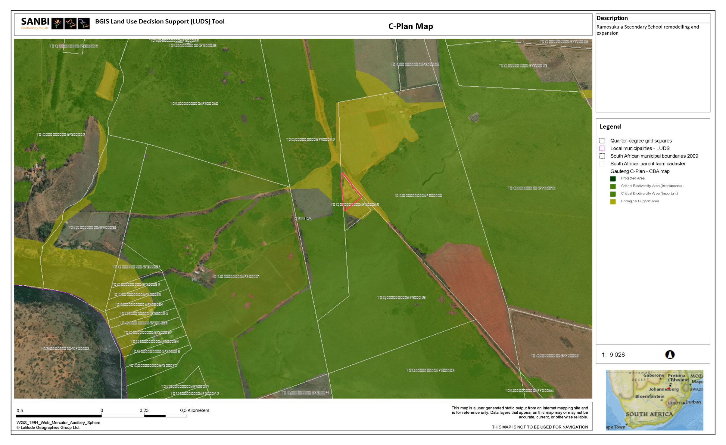

# REGISTRATION FORM

**APPLICATION FOR THE REMODELLING AND EXPANSION OF RAMOSUKULA SECONDARY SCHOOL WITHIN EMFULENI LOCAL MUNICIPALITY IN THE GAUTENG PROVINCE**

To ensure that you are registered as an interested and / or affected party and obtain further information, please submit your name and contact details to the consultant detailed below:

Exlite Consulting PTY LTD

74 3RD Street Northmead

Benoni, 1501

Email: [grace@gkmenvironmental.co.za](mailto:grace@gkmenvironmental.co.za) Tel/Cell No: 081 494 1611

Attention: Grace Magaya

**Personal Details:**

|  |  |
| --- | --- |
| **Name and Surname** |  |
| **Capacity** |  |
| **Physical Address** |  |
| **Cell or Telephone No** |  |
| **Email Address** |  |

1. **What is your main interest in this project?**

**---------------------------------------------------------------------------------------------------------------------------------------------------------------------------------------------------------------------------------------------------------------------------------------------------------------------------------------------------------------------------------------------------------------------------------------------------------**

1. **What potential impacts do you foresee with regards to the proposed project on your property?**

**------------------------------------------------------------------------------------------------------------------------------------------------------------------------------------------------------------------------------------------------------------------------------------------------------------------------------------------------------------------------------------------------------------------------------------------------------------------------------------------------------------------------------------------------------------------------------------------------------------------------------------------------------------------------------------------------------------------------------------------------------------------------------------------------------------------------------------------------------------------------------------------------------------------------**

1. **Is there anyone else you would like us to contact regarding this project? Give us their contacts.**

**------------------------------------------------------------------------------------------------------------------------------------------------------------------------------------------------------------------------------------------------------------------------------------------------------------------------------------------------------------------------------------------------------------------------------------------------------------**

1. **Additional comments**

**--------------------------------------------------------------------------------------------------------------------------------------------------------------------------------------------------------------------------------------------------------------------------------------------------------------------------------------------------------------------------------------------------------------------------------------------------------------------------------------------------------------------------------------------------------------------------------------------------------------------------------------------------------------------------------------------------------------------------------------------------------------------------------------------------------------------------------------------------------------------------------------------------------------------------------------------------------------------------------------------------------------------------------------------------------------------------------------------------------------------------------------------------------------------------------------------------------------------------------**