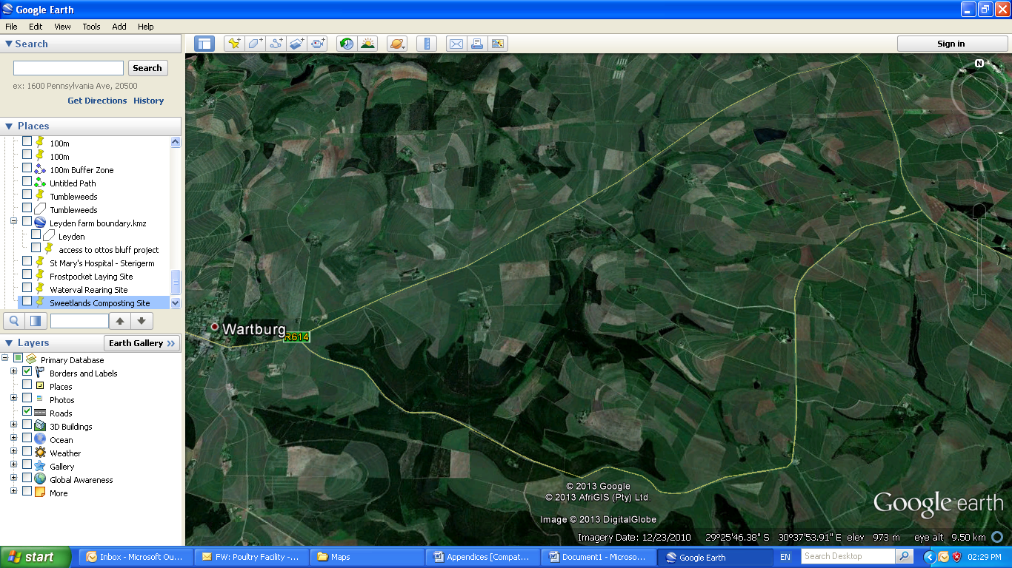

**Sweetlands**

**Composting Site**

29°24’17.01” S 30°38’0.64” E

**Hindenburg Composting Site**

29°25’39.90” S

30°36’31.64” E

**R614**

**Waterval Composting Site**

29°25’49.59” S

30°37’27.81” E

**Waterval**

**Rearing Site**

29°26'2.70"S

30°37'2.15"E

**Waterval East Composting Site**

29°26’29.42” S

30°38’8.00” E

**Wartburg**

**Brockel Composting Site**

**29°26’20.81” S**

**30°35’43.00” E**

**Frostpocket**

**Laying Site**

29°26'53.66"S

30°37'15.05"E.

N

**Scale**

**0m 250m 500m 750m**

**APPENDIX A1:** LOCALITY MAP SHOWING COMPOSTING SITES