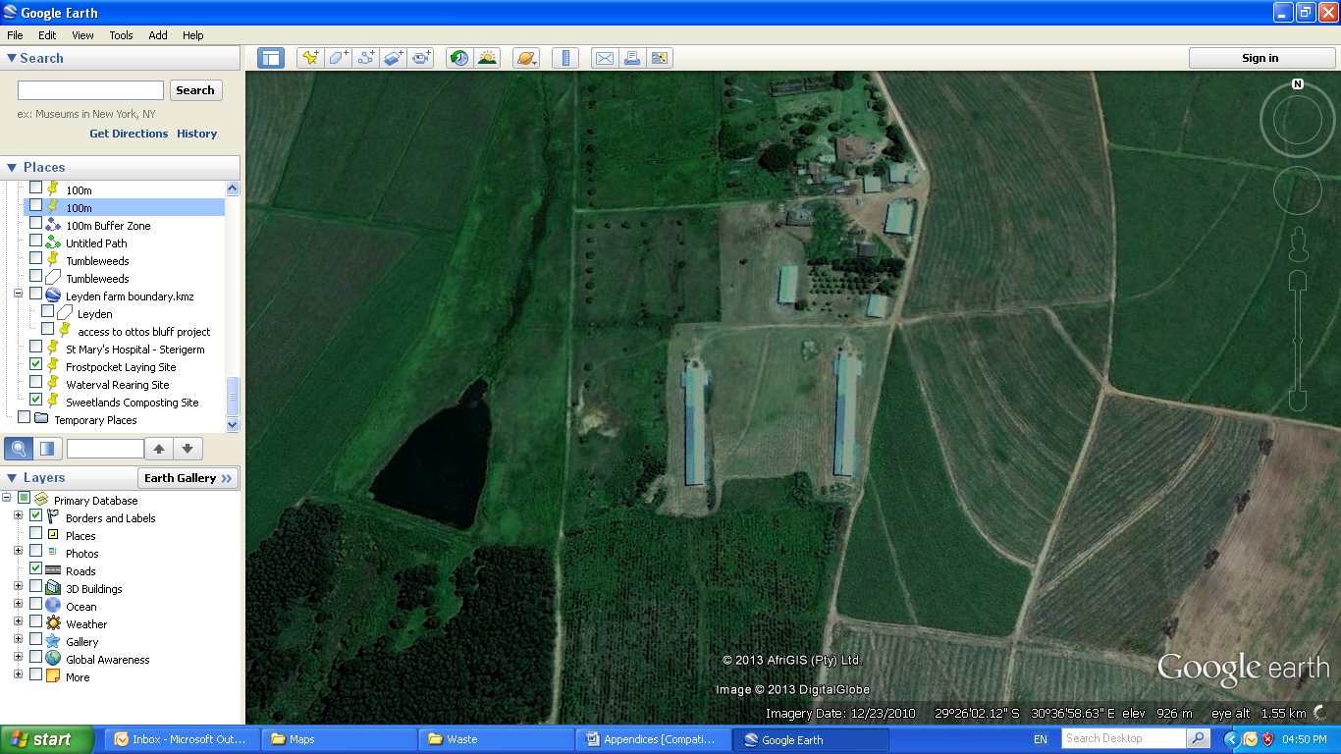

**APPENDIX A1:** WATERVAL – PROPOSED MORTALITY PIT

**Waterval**

**Rearing Site**

29°26'2.70"S

30°37'2.15"E

**Scale**

**0m 25m 50m 75m 100m**

**N**

**Proposed Mortality Pit**

29°26’3.97”S

30°37’10.35”E