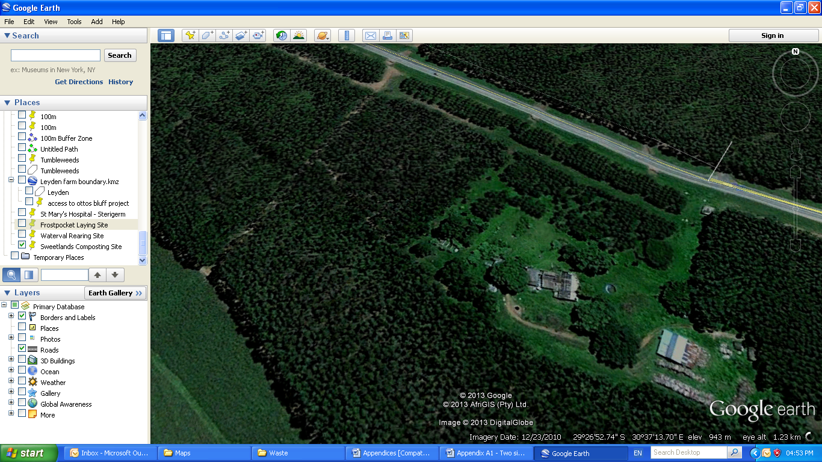

**APPENDIX A2:** FROSTPOCKET – PROPOSED MORTALITY PIT

**Scale**

**0m 25m 50m 75m 100m**

N

**Proposed Mortality Pit**

29°26’51.51”S

30°37’10.35”E

**Frostpocket**

**Laying Site**

29°26'53.66"S

30°37'15.05"E.