Basic Assessment Report in terms of the National Environmental Management Act, 1998 (Act No. 107 of 1998), as amended, and the Environmental Impact Assessment Regulations, 2010 (Version 1)

Gauteng Department of Agriculture and Rural Development (GDARD)

Development

List of all organs of state and State Departments where the draft report has been submitted, their full contact details and contact person

Kindly note that:

- This Basic Assessment Report is the standard report required by GDARD in terms of the EIA Regulations, 2010.

- This application form is current as of 2 August 2010. It is the responsibility of the EAP to ascertain whether subsequent versions of the form have been published or produced by the competent authority.

- A draft Basic Assessment Report must be submitted to all State Departments administering a law relating to a matter likely to be affected by the activity to be undertaken. The draft reports must be submitted to the relevant State Departments and on the same day, two CD’s of draft reports must also be submitted to the Competent Authority (GDARD) with a signed proof of such submission of draft report to the relevant State Departments.

- The report must be typed within the spaces provided in the form. The size of the spaces provided is not necessarily indicative of the amount of information to be provided. The report is in the form of a table that can extend itself as each space is filled with typing.

- Selected boxes must be indicated by a cross and, when the form is completed electronically, must also be highlighted.

- An incomplete report shall be rejected.

- The use of “not applicable” in the report must be done with circumspection because if it is used in respect of material information that is required by the competent authority for assessing the application, it may result in the rejection of the application as provided for in the regulations.

- Five (5) copies (3 hard copies and 2 CDs-PDF) of the final report and attachments must be handed in at offices of the relevant competent authority, as detailed below.

- No faxed or e-mailed reports will be accepted. Only hand delivered or posted applications will be accepted.

- Unless protected by law, and clearly indicated as such, all information filled in on this application will become public information on receipt by the competent authority. The applicant/EAP must provide any interested and affected party with the information contained in this application on request, during any stage of the application process.

DEPARTMENTAL DETAILS

Gauteng Department of Agriculture and Rural Development
Attention: Administrative Unit of the Sustainable Utilisation of the Environment (SUE) Branch
P.O. Box 8769
Johannesburg
2000

Administrative Unit of the Sustainable Utilisation of the Environment (SUE) Branch
18th floor Glen Cairn Building
73 Market Street, Johannesburg

Admin Unit telephone number: (011) 355 1345
Department central telephone number: (011) 355 1900

(For official use only)
File Reference Number:
Application Number:
Date Received:

- submission to State Departments (Number 3 above)

Has a draft report for this application been submitted to all State Departments administering a law relating to a matter likely to be affected as a result of this activity?

Is a list of State Departments referred to above been attached to this report?

if no, state reasons for not attaching the list.

Section A: Activity information

- Activity DESCRIPTION

Project title (must be the same name as per application form):
Project Title
Proposed Development of a Multi-purpose Recreational Facility in Palm Springs for Emfuleni Local Municipality, Gauteng Province

Introduction
The Emfuleni Local Municipality proposes to construct a Multi-purpose Recreational Facility in Palm Springs. The proposed development is intended for recreational purposes and will consist of inter alia a soccer field, sport courts, swimming pool, ablutions, multifunction hall and parking facilities. The proposed development encompasses approximately 6 ha in size. See Appendix A for maps indicating project locality, sensitive areas as well as the project footprint.

In terms of the NEMA EIA Regulations, 2014 promulgated under Chapter 5 of the National Environmental Management Act (Act 107 of 1998) (“NEMA”), activities listed in GN. R 983, 984 and 985 require environmental authorisation before they can proceed and be implemented. The proposed project triggers activities requiring a Basic Assessment in term of NEMA the following listed activities are deemed applicable to the proposed development:

Indicate the number of the relevant Government Notice: | Activity No (s) (relevant notice): e.g. Listing notices 1, 2 or 3 | Describe each listed activity as per the wording in the listing notices:
R. 983, 8 December 2014 (Listing Notice 1) | 12 (iii), (x), (xii)(a) | The development of –  (iii) bridges exceeding 100 square metres in size;  (x) buildings exceeding 100 square metres in size;  (xii) infrastructure or structures with a physical footprint of 100 square metres or more.  Where such development occurs –  - Within a watercourse
 | 19 (i) | The infilling or depositing of any material of more than 5 cubic metres into, or the dredging, excavation, removal or moving of soil, sand, shell grit, pebbles or rock of more than 5 cubic metres from –  - a watercourse.
 | 27 | The clearance of an area of 1 hectares or more, but less than 20 hectares of indigenous vegetation, except where such clearance of indigenous vegetation is required for –  - the undertaking of a linear activity; or  - the maintenance purposes undertaken in accordance with maintenance management plan.
 | 49 (iii), (v)(a) | The expansion of –  (iii) buildings by more than 100 square metres;  (v) infrastructure or structures with a physical footprint of is expanded by 100 square metres or more.  Where such development occurs –  - Within a watercourse
R. 985, 8 December 2014 (Listing Notice 3) | 12 (a) (iv) | The clearance of an area of 300 square metres or more of indigenous vegetation except where such clearance of indigenous vegetation is required for maintenance purposes undertaken in accordance with a maintenance management plan.  - In Gauteng province  (iv) on land, where at the time of the coming into effect of this Notice or thereafter such land was zoned open space, conservation or had an equivalent zoning.
 | 14 (iii), (x), (xii)(a) (b)(x) | The development of –  (iii) bridges exceeding 10 square metres in size;  (x) buildings exceeding 10 square metres in size;  (xii) infrastructure or structures with a physical footprint of 10 square metres or more.  Where such development occurs –  - Within a watercourse  - In Gauteng Province  (x) sites zoned for conservation or public open space or equivalent zoning.
 | 15 (a)(i) | The transformation of land bigger than 1000 square metres in size, to residential, retail, commercial, industrial, or institutional use, where, such land was zoned open space, conservation or had an equivalent zoning, on or after 02 August 2010.  - In Gauteng Province  - All areas
 | 23 (iii), (x), (xii)(a) (d)(x) | The expansion of –  (iii) bridges where the bridge is expanded by 10 square metres or more in size;  (x) buildings exceeding 10 square metres in size;  (xii) infrastructure or structures with a physical footprint of 10 square metres or more.  Where such development occurs –  - Within a watercourse  (d) In Gauteng Province  (x) sites zoned for conservation or public open space or equivalent zoning.

GIBB (Pty) Ltd (GIBB) has been appointed as an Environmental Assessment Practitioner (EAP), to carry out the Basic Assessment, EMPr and associated stakeholder engagement processes for the proposed project in order to obtain an Environmental Authorisation (EA) from the Gauteng Department of Agriculture and Rural Development, (GDARD). The undertaking of the Basic Assessment process is a legislative requirement of the National Environmental Management Act (No 107 of 1998) due to the triggering of activities listed in the Environmental Regulations as amended in 2014. The application has been submitted GDARD under the reference number 002/14-15/0252.

As part of the process the following specialist studies have been undertaken to assess the impacts of the proposed project. All specialist assessment reports have been attached as Appendix G.

Table 1: Specialist studies undertaken during the Basic Assessment process
Name | Organisation | Specialist study conducted
J van Schalkwyk | J van Schalkwyk | Heritage Impact Assessment
Stephen van Staden | Scientific Aquatic Services | Wetland Impact Assessment

Details of the EAP

GIBB (Pty) Ltd. (GIBB) is an integrated group of scientists, project managers, engineers and architects providing cost-effective solutions and specialist services in a wide range of disciplines. The multi-disciplinary consulting, management and design approach allows for the execution of projects in a holistic way, as this is believed to be the best approach to fully meet the needs of our Clients.

The GIBB Environmental Services Division has a formidable track record and comprises highly qualified and experienced technical staff viz, environmental scientists, environmental engineers and geologists that collectively form the national environmental team. The team members have broad experience in terms of working on a range of environmental projects within the public and private sector. Refer to the Table below for the EAP details.
Project EAP: | Umeshree Naicker
Contact Person: | GIBB (Pty) Ltd
Physical Address: | 14 Eglin Road, Sunninghill
Postal Address: | P.O. Box 2700, Rivonia
Postal code: | 2128 | Fax: | 011 807 5670
Telephone: | 011 519 4701 | Cell: | --
Email: | unaicker@gibb.co.za
Expertise to conduct EIA: | Umeshree Naicker is a senior environmental scientist with six years of experience in the environmental management field. Her key experience includes Project management, Scoping & Environmental Impact Reporting, Basic Assessments, and Client Liason. She also has experience as an Environmental Control Officer. She has worked extensively in South Africa within the renewable energy sector.

While GIBB is the acting EAP for the project, in terms of the Environmental Impact Assessment Regulations 2014, section 13 states that the report must be reviewed by an external EAP. The details of the external EAP that reviewed this report is included below:

External EAP | Aurecon
Name: | Rueben Heydenrych
Address: | Aurecon Centre Lynnwood Bridge Office Park 4 Daventry St Lynnwood Manor, 0081, Tshwane South Africa.
Tel: | 012 427 2136
Cell: | --
Email: | Reuben.Heydenrych@aurecongroup.com

Project Location
The proposed project is located in Palm Springs on Erf 4395 Stretford Extension 1 in the Emfuleni Local Municipality and Sedibeng District Municipality within the Gauteng Province. Orange Farm is located to the North of the proposed site with Palm Springs Mall being located east of the site. To the north and west, the site is surrounded by residential areas. A clinic and primary school is located south of the site. A non-perennial watercourse within the development boundary is located along the west and south western side of the site. Access from the N1 highway to the site is gained via the Grasmere interchange and then via the Golden Highway (R553). Figure 1 below represent the locality if the proposed project. For a larger version see Appendix A.1.

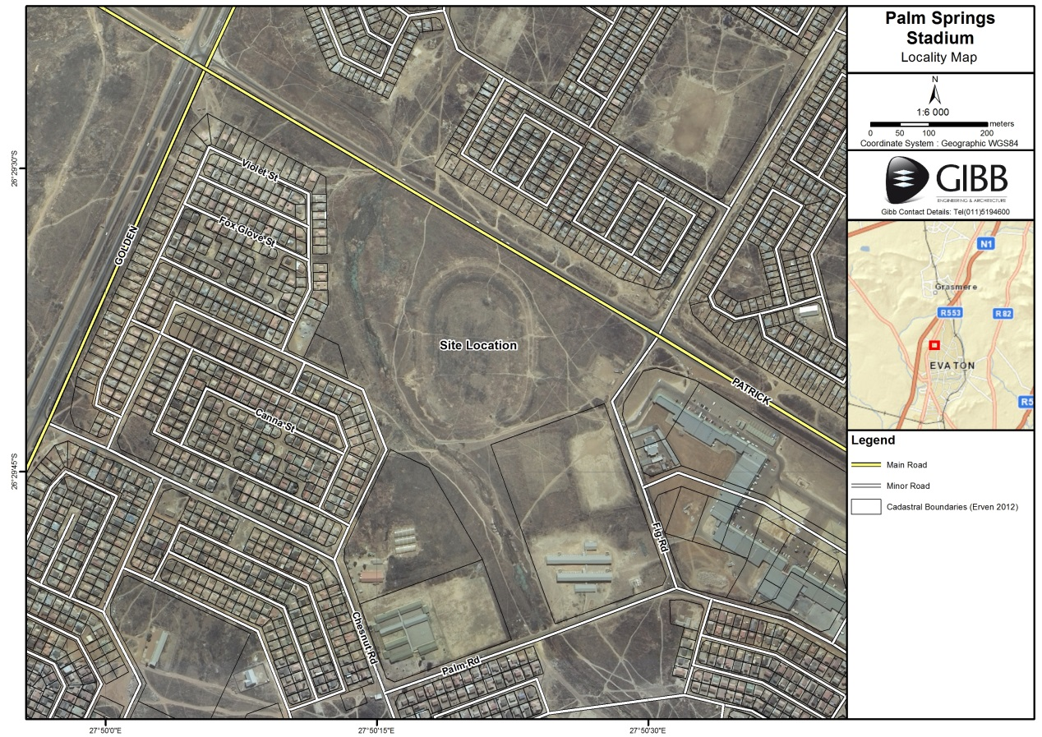
Figure 1: Locality Map

Project Description
Emfuleni Local Municipality proposes to construct a Multi-purpose Recreational Facility in Palm Springs. The proposed development is intended for recreational purposes and will consist of inter alia a soccer field, sport courts, swimming pool, ablutions, multifunction hall and parking facilities. The proposed development encompasses approximately 6 ha in size. The proposed facility illustration for the development can be seen Appendix C.1. The design standards for the proposed project will be as per the Guidelines for Human Settlement Planning and Design, Johannesburg Water Standards and Emfuleni Local Municipality Standards.

- Water Supply
The bulk water supply to the development will be provided by Emfuleni Local Municipality as the water service provider. This supply will be obtained from the Rand Water network. The capacity of the infrastructure will be provided by an external service provider to determine the required upgrade of the bulk water services. However, based on the current existing pipeline information, it is proposed that the water supply for the development be obtained from the existing 200mmØ pipeline running along the eastern boundary of the site in Fig road. The existing water supply network is indicated in blue lines on the layout in Figure 2 below.

Based on the proposed development the estimated daily demand and peak flow for the development is as follows:
 | Daily Demand | Peak Flow
Stadium | 0.22 Kl/day | 1 l/s
Stadium Grounds | 120 Kl/day | 2 l/s

The proposed water design standards for the project are as follows:
- Water consumption:
  - Stadium: 0.22 Kl/1000 people/day
  - Stadium grounds: 40 Kl/ha/day
- Instantaneous Demand Peak Factor: 1.5
- Pipe material: uPVC class 16
- Min residual head during peak flow: 24m

A preliminary layout for the development and proposed standard details are included in Appendix C.2.

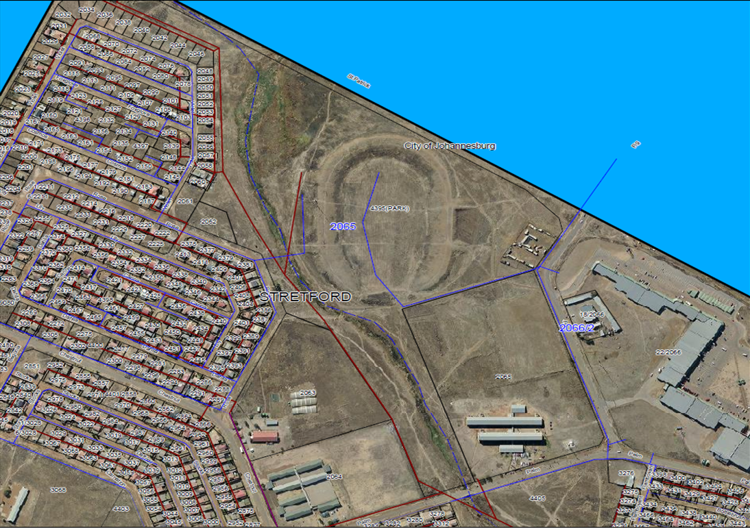
Figure 2: Existing Water Supply (Blue lines) and Sewage Outfall (Red lines). See Appendix C.4 for larger image

- Sewage
The capacity of the existing infrastructure will be investigated by an external service provider to determine if it is necessary to upgrade the bulk sewage infrastructure in order to support the new development. However, based on the current existing pipeline information it is proposed that the internal sewer network connect onto the existing outfall sewer located south of the proposed development next to Palm road. The existing outfall sewer is indicated in red lines on Figure 2 below.

Based on the proposed development the estimated daily demand and peak flow for the development is as follows:
 | Daily Demand | Peak Flow
Stadium | 0.22 Kl/day | 1 l/s

A full water borne sanitation system is proposed, connecting into the existing bulk/link sewer pipes. The design standards will be as per the Guidelines for Human Settlement Planning and Design and the following design standards are proposed:

- Sewage Outflow: 0.22 Kl/1000 people/day
- Daily Peak Factor: 2.5 and Figure C.1
- Infiltration factor: 15%
- Minimum Velocity: 0,7m/s
- Minimum gradients: 1:120 for 100mm dia.
1:200 for 150mm dia.
1:300 for 200mm dia.
- Maximum manhole spacing: 100 metres
- Pipe material: uPVC class 34 solid wall
- Pipe cover: 0,5m minimum at head, 1m generally
- Manholes: Precast concrete rings

A preliminary layout and long section for the development and proposed standard details are included in Appendix C.3.

- Roads
A traffic impact assessment will be conducted to determine the current capacity and required upgrade of the external roads. The only road required to support the development is an access road leading to the parking facilities of the development. The access road will be developed from the existing Fig Road, located to the east of the site. It should be highlighted that the entrance to the facility will therefore be directly from Fig Road. It is proposed that the access road and parking facilities of the development be paved. The following design criteria, has been extracted from the Guidelines for Human Settlement Planning and Design and are proposed for the access road and the parking facilities:

Design Parameters | Road Category
 | Class 5d Access way
Carriage Way width | 4.5 m
Desired Maximum speed | 30 km/hr
Minimum Gradient | 0.50%
Maximum Gradient | 10%
Crossfall | 3%
Minimum Bellmouth Radius | 8 m

- Stormwater
The Rietspruit river, a tributary of the Vaal River, is located approximately 5.5 km south of the site. It flows for approximately 50km in a southerly direction before reaching the Vaal River approximately 15km north west of Sasolburg (Upper Vaal Water Management Area, Quaternary Drainage No. C22H). In addition one wetland feature, representing a single Hydrogeomorphic (HGM) Unit was identified within the study area during the assessment. The wetland is situated within a valley floor landscape unit and is classified as a channelled valley bottom wetland. It is situated in the western portion of the site flowing in a southerly direction and flows into the Rietspruit river.

It is proposed that the runoff generated from the site will be attenuated by means of stormwater detention facilities to be at least equal to the pre-development peak flow rates up to the 1 in 25 year return period storm event. The design criteria for stormwater management is as follows:

Classification | Internal Roads
Recurrence Interval | 1:5 years
Low Points | 1:25 years
Encroachment: Major | 50% of road width free
Encroachment: Minor | 25% encroachment
Roadside Channels | Min. gradient 0.5%
Flow Velocity | Max. velocity 3 m/s
Channel Lining | Channels to be concrete lined. However, grass channels to be used where possible.

- Piping: 450mm diameter minimum. 0.7m/s self cleansing velocity and minimum slope of 0.4%

- Trenches: Widths to SABS 1200, class B bedding, backfilling to 90% mod AASHTO or 93% mod AASHTO in road reserves.

- Pipe Class: 75D alongside roads, 100D underneath roads

- Pipe Cover: Min 450mm alongside roads, Min 600mm underneath roads

- Channel Lining: Concrete lined or grass channels where suitable

- Power/Electricity supply
Power for the project will be supplied by Eskom.

Description of the Receiving Environment

- Climate
The climate of the area can be described as typical of the highveld, with cool to cold, dry winters and moist, warm to hot summers. The study area experiences a dry, sunny climate with temperatures during summer ranging between 20°C and 30°C. Winter temperatures are low with Gauteng experiencing a daily mean temperature of 9.8°C in July. Most of the rainfall (84.4%) falls between October and March, and frost is common, especially in the lower lying parts. The annual average rainfall is 600 mm to 800 mm, which is mostly concentrated between October and March. The prevailing wind direction in the study area is north westerly in winter and south-easterly in summer.

- Topography
The site slopes gently south west towards the existing watercourse located west and south west of the proposed development. The site is affected by floodlines due to the existing defined watercourse. An existing circular embankment of approximately 3m in height is located on site. The area enclosed within the embankment is currently used as a soccer field. The site is covered mainly by grass with some scattered bushes and shrubs.

- Geology
The site is underlain by the Hekpoort Formation of the Pretoria Group (Transvaal Supergroup) consisting mainly of andesite. The general area is underlain by topsoil, alluvium (In a restricted linear area), residual and highly weathered andesite. Rich organic topsoil in a matrix of silty, gravelly sand was encountered to an average depth of 0.4m (Between 0.3 to 0.7m) in a band stretching across the entire site.

The embankment fill material confined in the circular embankment comprises a mixture of most of the materials encountered on site together with scattered boulders of hard Andesite lava. The embankment volume is probably in excess of 300 000 m³ and the quality will generally be of poor construction quality (G10).

The area is classified as having a climatic N-value (after Weinert) of less than 5, which indicates chemical weathering as the main form of weathering.

- Surface and Groundwater
The study area falls within the Highveld Aquatic Ecoregion, which can be considered to contain moderately low aquatic biodiversity and a fairly sensitive aquatic community. The study area falls within the C22H quaternary catchment. The study area falls within the Upper Vaal Water Management Area (WMA). Each Water Management Area is divided into several SubWater Management Areas (subWMA), where catchment or watershed is defined as a topographically represented area, which is drained by a stream, or river network. The subWMA indicated for the study area is the Downstream Vaal Dam. The NFEPA database does not indicate any NFEPA rivers or wetlands within the study area.

One wetland feature comprising a single HGM Unit, was identified during the site assessment. This feature was found to be situated within a valley floor landscape unit and is classified at Level 4 of the Classification System as having a channelled valley-bottom HGM type. The location of the wetland feature in relation to the proposed project site is shown in Figure 3 below. See Appendix G.1 for the Wetland Impact Assessment study.

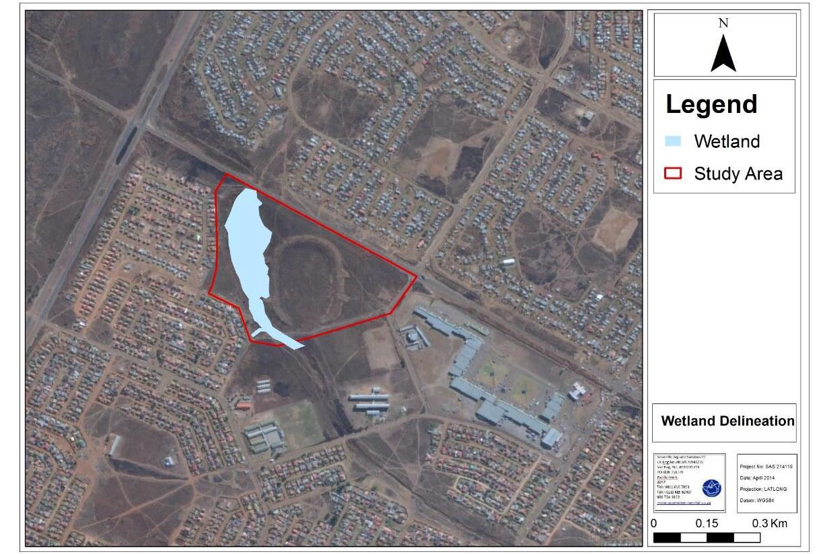

Figure 3: Wetland feature in relation to the proposed project site

- Fauna and Flora
The proposed development falls within the Soweto Highveld Grassland vegetation type which is considered to be a Vulnerable vegetation type. However, during the wetland assessment it noted that the vegetation within the study area is degraded due to impacts from surrounding anthropogenic activities. It should also be highlighted that according to the National Biodiversity Assessment (2011) and Gauteng Conservation Plan the study area is not located within either a formal or an informal protected area and the study area is not considered to be of conservation importance.

Select the appropriate box

The application is for an upgrade of an existing development |  |  | The application is for a new development |  |  | Other, specify

Does the activity also require any authorisation other than NEMA EIA authorisation?

YES | NO

If yes, describe the legislation and the Competent Authority administering such legislation

A Water Use License Application for a Section 21 (c) and (i) in accordance with the National Water Act (Act No 36 of 1998) will be required. The Department of Water and Sanitation will be the competent authority responsible for issuing a water use license.

If yes, have you applied for the authorisation(s)? | YES | NO
If yes, have you received approval(s)? (attach in appropriate appendix) | YES | NO

- Applicable legislation, policies and/or guidelines

List all legislation, policies and/or guidelines of any sphere of government that are applicable to the application as contemplated in the EIA regulations:

Title of legislation, policy or guideline: | Administering authority: | Promulgation Date:
National Environmental Management Act (Act No. 107 of 1998) , as amended 2014 | National & Provincial | 8 December 2014
The Constitution of the Republic of South Africa (1996) | National & Provincial | 18 December 1996
National Water Act (Act 36 of 1998) | National & Provincial | 26 August 1998
Occupational Health and Safety Act (No 85 of 1993) | National & Provincial | 23 June 1993
South African Heritage Resources Act (No 25 of 1999) | National & Provincial | 14 April 1999
The Conservation of Agricultural Resources Act (No 43 of 1983) | National & Provincial | 21 April 1983
National Environmental Management: Biodiversity Act No. 10 of 2004 | National & Provincial | 2004
National Environment Management: Air Quality Act No. 39 of 2004 | National & Provincial | 2004

- ALTERNATIVES

Describe the proposal and alternatives that are considered in this application. Alternatives should include a consideration of all possible means by which the purpose and need of the proposed activity could be accomplished. The determination of whether the site or activity (including different processes etc.) or both is appropriate needs to be informed by the specific circumstances of the activity and its environment.

The no-go option must in all cases be included in the assessment phase as the baseline against which the impacts of the other alternatives are assessed. Do not include the no go option into the alternative table below.

Note: After receipt of this report the competent authority may also request the applicant to assess additional alternatives that could possibly accomplish the purpose and need of the proposed activity if it is clear that realistic alternatives have not been considered to a reasonable extent.
Provide a description of the alternatives considered

No. | Alternative type, either alternative: site on property, properties, activity, design, technology, operational or other(provide details of “other”) | Description
1 | Proposal (preferred alternative) | The preferred alternative is located in the Palm Springs area in Palm Springs on Erf 4395 Stretford Extension 1. This site has been chosen as it has the desired size requirement for the development, which is approximately 6ha, and it is best situated to gain access from Fig Road (located to the east of the proposed site) to the proposed facility. The proposed site also has an existing soccer field that will be upgraded and will form part of the proposed infrastructure for the proposed development. Furthermore this preferred alternative is positioned in such a way as to avoid the wetland/drainage area located on the western side of the proposed site, therefore minimising the impact on the wetland/drainage area.
2
3

In the event that no alternative(s) has/have been provided, a motivation must be included in the table below.

Site Alternatives Considered:
The Emfuleni Local Municipality conducted a site survey for the proposed development. As a result of this survey two site alternatives for the multi-purpose recreational facility were considered (see Figure 4 below). The preferred site is located on Erf 4395, Stretford Extension 1 and is represented by the red line in the figure below and alternative site is represented by the yellow line below.
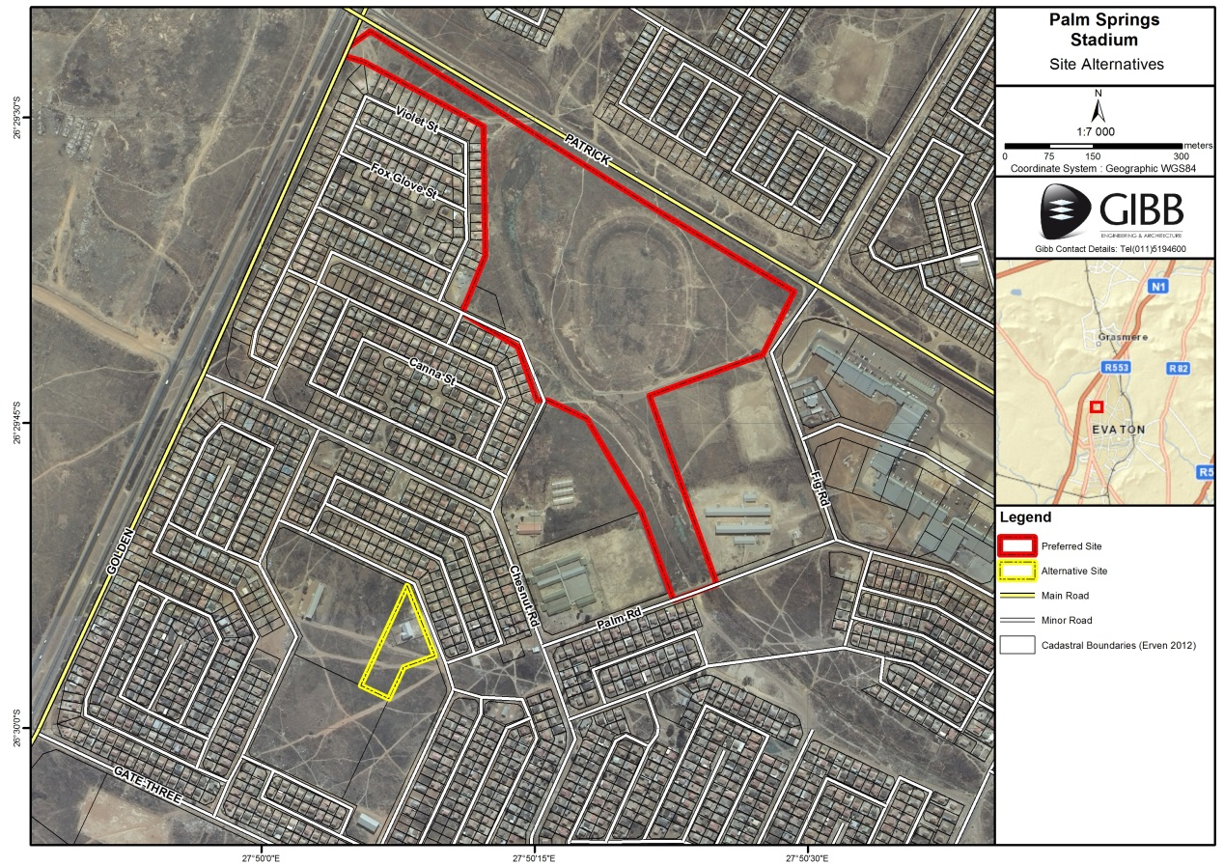
Figure 4: Map indicating site alternative considered

During the process it was discovered that the alternative site did not meet the requirements of the proposed development. The alternative site did not meet the size requirement needed for the proposed development (approximately 6 ha) and furthermore access to the alternative site would be more difficult. Therefore the alternative site was determined not feasible and was not considered further.

Therefore no site alternatives were assessed for the proposed project.

Site Layout Alternatives Considered:

During the planning phase, two (2) site layouts were considered, namely the preferred layout and the alternative layout. The alternative layout included soccer fields with stands as well as infrastructure that encroached on the wetland/drainage area. This presented an environmental and design issue therefore in order to prevent this encroachment and impact on the wetland/drainage area, the layout (as seen in Figure 5) was redesigned. The alternative layout was therefore considered not feasible and was not considered further.
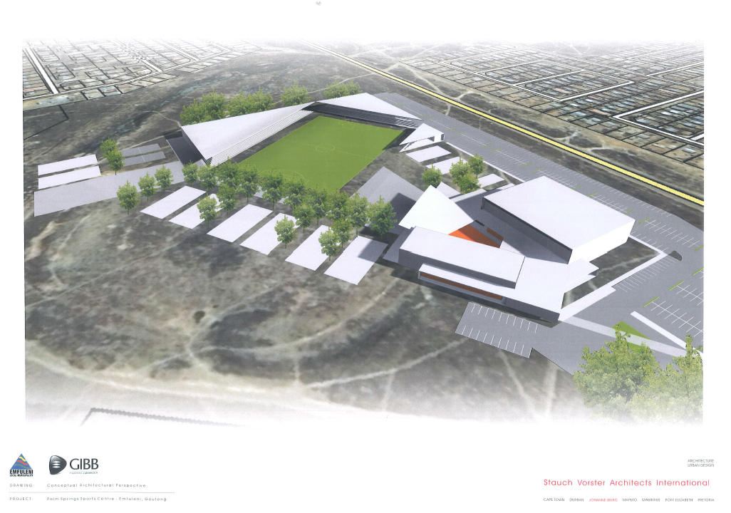
Figure 5: Alternative layout encroaching on wetland/drainage area

The redesigned layout was adjusted to remove the stands surrounding the soccer field and to relocate the infrastructure impacting on the wetland/drainage area (see redesigned layout in Figure 6 below). The preferred alternative is therefore the only layout alternative assessed for the proposed project.

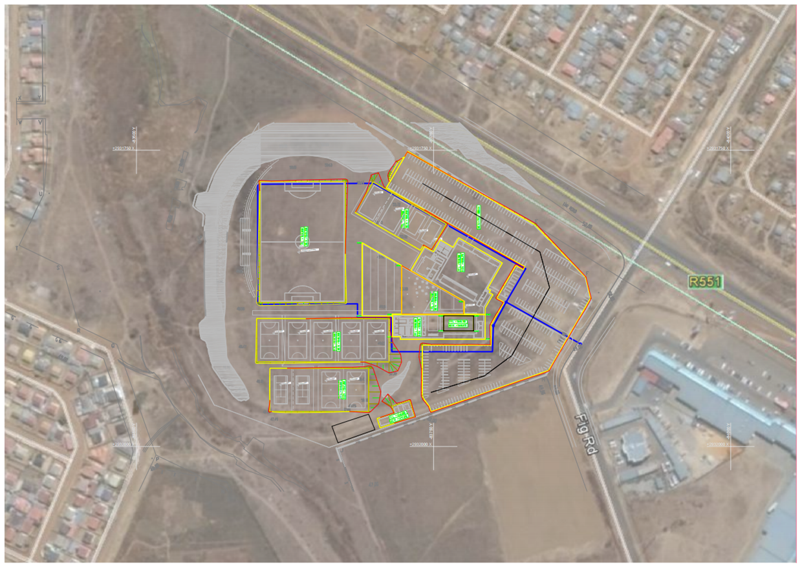
Figure 6: Preferred layout for the proposed recreational facility in Palm Springs. See Appendix A.5 for a larger image.

- Physical size of the activity

Indicate the total physical size (footprint) of the proposal as well as alternatives. Footprints are to include all new infrastructure (roads, services etc), impermeable surfaces and landscaped areas:
 |  | Size of the activity:
Proposed activity |  | +6 ha
Alternatives:
Alternative 1 (if any)
Alternative 2 (if any)
 |  | Ha/ m²

or, for linear activities:
Length of the activity:
Proposed activity
Alternatives:
Alternative 1 (if any)
Alternative 2 (if any)
k/km

Indicate the size of the site(s) or servitudes (within which the above footprints will occur):
 |  | Size of the site/servitude:
Proposed activity |  |  | +16 ha
Alternatives:
Alternative 1 (if any)
Alternative 2 (if any)
 |  | Ha/m²

- Site Access
Proposal
Does ready access to the site exist, or is access directly from an existing road? | YES | NO
If NO, what is the distance over which a new access road will be built | m
Describe the type of access road planned:
The only road required to support the development is an access road leading to the parking facilities of the proposed development. It is proposed that the access road required for the sports recreational facility will be developed off Fig Road. Therefore no new roads will be constructed for the development; Fig Road will most likely undergo upgrades to facilitate the access to the recreational facility. An entrance berth will be developed off Fig Road to access the parking area of the proposed development. Therefore, the internal road network will consist of an entrance from Fig Road leading to the proposed parking facilities.

The following design criteria, has been extracted from the Guidelines for Human Settlement Planning and Design and are proposed for the access road and the parking facilities:

Design Parameters | Road Category
 | Class 5d Access way
Carriage Way width | 4.5 m
Desired Maximum speed | 30 km/hr
Minimum Gradient | 0.50%
Maximum Gradient | 10%
Crossfall | 3%
Minimum Bellmouth Radius | 8 m

Include the position of the access road on the site plan.

Alternative 1
Does ready access to the site exist, or is access directly from an existing road? | YES | NO
If NO, what is the distance over which a new access road will be built | m
Describe the type of access road planned:
Include the position of the access road on the site plan.

Alternative 2
Does ready access to the site exist, or is access directly from an existing road? | YES | NO
If NO, what is the distance over which a new access road will be built | m
Describe the type of access road planned:
Include the position of the access road on the site plan.

PLEASE NOTE: Points 6 to 8 of Section A must be duplicated where relevant for alternatives

Section A 6-8 has been duplicated | 0 | Number of times

(only complete when applicable)

- SITE OR ROUTE PLAN

A detailed site or route (for linear activities) plan(s) must be prepared for each alternative site or alternative activity. It must be attached as Appendix A to this document. The site or route plans must indicate the following:
  - the scale of the plan, which must be at least a scale of 1:2000 ( scale can not be larger than 1:2000 i.e. scale can not be 1:2500 but could where applicable be 1:1500)
  - the property boundaries and numbers of all the properties within 50m of the site;
  - the current land use as well as the land use zoning of each of the properties adjoining the site or sites;
  - the exact position of each element of the application as well as any other structures on the site;
  - the position of services, including electricity supply cables (indicate above or underground), water supply pipelines, boreholes, street lights, sewage pipelines, septic tanks, storm water infrastructure and telecommunication infrastructure;
  - walls and fencing including details of the height and construction material;
  - servitudes indicating the purpose of the servitude;
  - sensitive environmental elements on and within 100m of the site or sites including (but not limited thereto):
  - Rivers and wetlands;
  - the 1:100 and 1:50 year flood line;
  - ridges;
  - cultural and historical features;
  - areas with indigenous vegetation (even if it is degraded or infested with alien species);
    - for gentle slopes the 1m contour intervals must be indicated on the plan and whenever the slope of the site exceeds 1:10, the 500mm contours must be indicated on the plan; and
    - the positions from where photographs of the site were taken.
    - Where a watercourse is located on the site at least one cross section of the water course must be included (to allow the 32m position from the bank to be clearly indicated)

- Site photographs

Colour photographs from the center of the site must be taken in at least the eight major compass directions with a description of each photograph. Photographs must be attached under the appropriate Appendix. It should be supplemented with additional photographs of relevant features on the site, where applicable.

- FACILITY ILLUSTRATION

A detailed illustration of the activity must be provided at a scale of 1:200 for activities that include structures. The illustrations must be to scale and must represent a realistic image of the planned activity. The illustration must give a representative view of the activity. To be attached in the appropriate Appendix.

Section b: description of receiving environment

Note: Complete Section B for the proposal and alternative(s) (if necessary)

Further:

Instructions for completion of Section B for linear activities
- For linear activities (pipelines etc) it may be necessary to complete Section B for each section of the site that has a significantly different environment.
- Indicate on a plan(s) the different environments identified
- Complete Section B for each of the above areas identified
- Attach to this form in a chronological order
- Each copy of Section B must clearly indicate the corresponding sections of the route at the top of the next page.

Section B has been duplicated for sections of the route | 0 | times

Instructions for completion of Section B for location/route alternatives
- For each location/route alternative identified the entire Section B needs to be completed
- Each alterative location/route needs to be clearly indicated at the top of the next page
- Attach the above documents in a chronological order

Section B has been duplicated for location/route alternatives | 0 | times
(complete only when appropriate)

Instructions for completion of Section B when both location/route alternatives and linear activities are applicable for the application

Section B is to be completed and attachments order in the following way
- All significantly different environments identified for Alternative 1 is to be completed and attached in a chronological order; then
- All significantly different environments identified for Alternative 2 is to be completed and attached chronological order, etc.

Section B - Section of Route |  | (complete only when appropriate for above)

Section B – Location/route Alternative No. |  | (complete only when appropriate for above)

- PROPERTY DESCRIPTION

Property description: | The site is located in Palm Springs on Erf 4395 Stretford Extension 1, with Orange Farm located to the north of the proposed site.  The Palm Springs Mall is located east of the site. To the north and west, the site is surrounded by residential areas. A clinic and primary school is located south of the site. A non-perennial watercourse within the development boundary is located along the west and south western side of the site. Access from the N1 highway to the site is gained via the Grasmere interchange and then via the Golden Highway (R553). The site is situated within the Sedibeng District Municipality and Emfuleni Local Municipality.
(Farm name, portion etc.)

- Activity POSITION

Indicate the position of the activity using the latitude and longitude of the centre point of the site for each alternative site. The co-ordinates should be in decimal degrees. The degrees should have at least six decimals to ensure adequate accuracy. The projection that must be used in all cases is the WGS84 spheroid in a national or local projection.

Alternative: | Latitude (S): |  | Longitude (E):
 | 26º29’39.88” |  | 27º50’20.42”
In the case of linear activities:
Alternative: | Latitude (S): | Longitude (E):
- Starting point of the activity | º | º
- Middle point of the activity | º | º
- End point of the activity | º | º

For route alternatives that are longer than 500m, please provide co-ordinates taken every 250 meters along the route and attached in the appropriate Appendix

Addendum of route alternatives attached

- GRADIENT OF THE SITE

Indicate the general gradient of the site.

Flat | 1:50 – 1:20 | 1:20 – 1:15 | 1:15 – 1:10 | 1:10 – 1:7,5 | 1:7,5 – 1:5 | Steeper than 1:5

- location in landscape

Indicate the landform(s) that best describes the site.

Ridgeline | Plateau | Side slope of hill/ridge | Valley | Plain | Undulating plain/low hills | River front

- GroundwateR, Soil and Geological stability of the site

  - Is the site located on any of the following?

Shallow water table (less than 1.5m deep) | YES | NO
Dolomite, sinkhole or doline areas | YES | NO
Seasonally wet soils (often close to water bodies) | YES | NO
Unstable rocky slopes or steep slopes with loose soil | YES | NO
Dispersive soils (soils that dissolve in water) | YES | NO
Soils with high clay content (clay fraction more than 40%) | YES | NO
Any other unstable soil or geological feature | YES | NO
An area sensitive to erosion | YES | NO

Please Note: the following information pertains to the soil and geological stability of the site and was obtained from the design engineer.

Geotechnical Considerations/Recommendations

Four geotechnical constraints have been identified on site, namely:
- Potentially expansive residuum and alluvium;
- Potentially moderately to highly compressible residuum;
- Low bearing capacity (<100 kPa) within the alluvium & upper residuum;
- Possible perched water table below 1.8m.

Soft excavation in terms of SABS 1200 is anticipated to at least a depth of 2 m below existing ground level using light earthmoving equipment. This is due to the dense to soft, to firm silty clay and clayey silt. The degree of weathering is considered to extend below this depth with associated soft excavation, but this will need to be confirmed on site during the construction phase. However, the presence of large, Andesite lava boulders on site cannot be ignored and allowance should be made in the earthworks tender documents to split, excavate and remove off-site these boulders of up to 0.4 m³ volume.

It is anticipated that any cuts carried out on the site will be in residuum or localised embankment fill. The upper soils will need to be battered back at gradients of 1 vertical in 2 horizontal (slope angles of 27 degrees) to promote their long-term stability. If space does not permit, it is recommended that a concrete block retaining wall system be designed and implemented. Although not anticipated on this site (suitably designed terracing should be considered), any slopes greater than 1.5 m in height will need to be analysed in terms of their global stability and should be discussed with GeoZone GeoServices prior to any construction taking place.

It is recommended that the in situ materials be sampled and tested to determine the maximum MADD against which the compaction needs to be assessed. However, preliminary indications are that the majority of the in situ materials may only qualify as low-grade fill due to the moderately high plasticity indices.

The shallow subgrade soils are of poor to fair quality and highly variable and should class as a G8 to G10 rating and saturated below 1.8 m depth. The layerworks design for the access roads and parking area should be cognisant of subgrade CBR values of minimum 5% and maximum 55% and at least 500mm should be over-excavated beneath access roads and parking areas to allow construction of layerworks.

The following recommendations are made:
- The site is underlain by a thick sequence of medium expansive alluvium to the west and moderately to highly compressible residuum with Andesite lava bedrock encountered at an average 1.8 m or more below existing ground level.
- A perched water table was intersected at between 1.8 and 2.2m below surface. If deeper-than-normal strip or pad foundations are selected then temporary de-watering of the foundation trenches and temporary shoring of the excavation side-walls must be allowed for in the tender documents.
- Soft excavation in terms of SABS 1200 is generally anticipated to at least 2 m below existing ground. It is recommended that all earthworks be carried out in accordance with SABS 1200 (current version).
- One of the more important factors in the promotion of a stable site is the control and removal of surface water from the property. It is important that the design of the stormwater management system allows for the drainage of accumulated surface water from the platforms and structures and diverted into the stormwater system or natural drainage lines.
- 500mm should be over-excavated beneath access roads and parking areas to allow construction of layerworks.

(Information in respect of the above will often be available at the planning sections of local authorities. Where it exists, the 1:50 000 scale Regional Geotechnical Maps prepared by Geological Survey may also be used).

b) are any caves located on the site(s) |  | YES | NO
If yes to above provide location details in terms of latitude and longitude and indicate location on site or route map(s)
Latitude (S): | Longitude (E):
º | º

c) are any caves located within a 300m radius of the site(s) |  | YES | NO
If yes to above provide location details in terms of latitude and longitude and indicate location on site or route map(s)
Latitude (S): | Longitude (E):
º | º

d) are any sinkholes located within a 300m radius of the site(s) |  | YES | NO
If yes to above provide location details in terms of latitude and longitude and indicate location on site or route map(s)
Latitude (S): | Longitude (E):
º | º

If any of the answers to the above are “YES” or “unsure”, specialist input may be requested by the Department

- Agriculture

Does the site have high potential agriculture as contemplated in the Gauteng Agricultural Potential Atlas (GAPA 3)? | YES | NO

It should be noted that although the site is not considered to have high agricultural potential, a large portion of the site is considered to have moderate agricultural potential as can be seen in figure 3 below

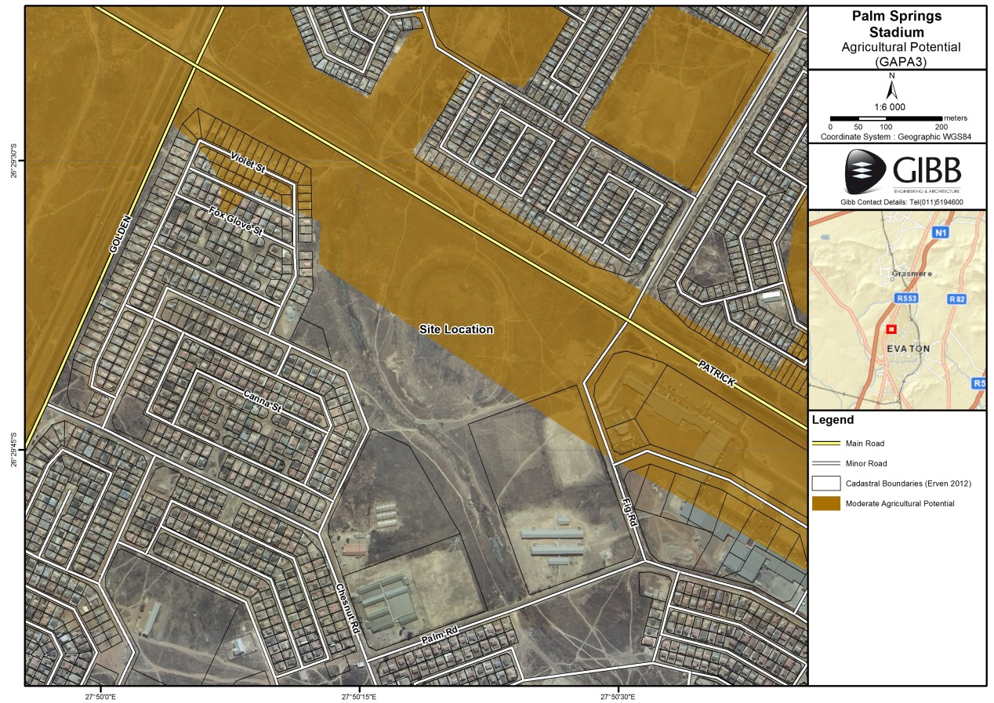
Figure 3: Map indicating the agricultural potential of the proposed site

Please note: The Department may request specialist input/studies in respect of the above.

- Groundcover

To be noted that the location of all identified rare or endangered species or other elements should be accurately indicated on the site plan(s).

Indicate the types of groundcover present on the site and include the estimated percentage found on site

Natural veld - good condition  % = | Natural veld with scattered aliens  % = | Natural veld with heavy alien infestation  % =25 | Veld dominated by alien species  % =30 | Landscaped (vegetation)  % =
Sport field  % =40 | Cultivated land  % = | Paved surface  (hard landscaping)  % = | Building or other structure  % = | Bare soil  % =

Please note: The Department may request specialist input/studies depending on the nature of the groundcover and potential impact(s) of the proposed activity/ies.

Are there any rare or endangered flora or fauna species (including red list species) present on the site |  |  |  |  |  |  |  | YES |  |  | NO
If YES, specify and explain:
Are there any rare or endangered flora or fauna species (including red list species) present within a 200m (if within urban area as defined in the Regulations) or within 600m (if outside the urban area as defined in the Regulations) radius of the site. |  |  |  |  |  |  |  | YES |  |  | NO
If YES, specify and explain:
Are there any special or sensitive habitats or other natural features present on the site? |  |  |  |  |  |  |  | YES |  |  | NO
If YES, specify and explain:
A wetland feature dominates the western portion of the site.
Was a specialist consulted to assist with completing this section |  |  |  |  |  |  |  |  | YES | NO
If yes complete specialist details
Name of the specialist: |  |  | Stephen van Staden
Qualification(s) of the specialist: |  |  | Pr Sci Nat (Ecological Sciences) 400134/05  BSc. Hons (Aquatic Health) (RAU)  M.Sc. Environmental Management (RAU)
Postal address: |  |  | 91 Geldenhuis Road  Malvern East Ext 1
Postal code: |  |  | 2007
Telephone: |  | 011 616 7893 |  | Cell: |  |  | 083 415 2356
E-mail: |  | Stephen@sasenvironmental.co.za |  | Fax: |  |  | 011 615 6240
Are any further specialist studies recommended by the specialist? |  |  |  |  |  |  |  |  | YES | NO
If YES, specify: | N/A
If YES, is such a report(s) attached? |  |  |  |  |  |  |  |  | YES |  | NO
If YES list the specialist reports attached below
Signature of specialist: |  |  |  |  | Date:

Please note; If more than one specialist was consulted to assist with the filling in of this section then this table must be appropriately duplicated

- Land use character of surrounding area

Using the associated number of the relevant current land use or prominent feature from the table below, fill in the position of these land-uses in the vacant blocks below which represent a 500m radius around the site

1. Vacant land | 2. River, stream, wetland | 3. Nature conservation area | 4. Public open space | 5. Koppie or ridge
6. Dam or reservoir | 7. Agriculture | 8. Low density residential | 9. Medium to high density residential | 10. Informal residential
11. Old age home | 12. Retail | 13. Offices | 14. Commercial & warehousing | 15. Light industrial
16. Heavy industrial^{AN} | 17. Hospitality facility | 18. Church | 19. Education facilities | 20. Sport facilities
21. Golf course/polo fields | 22. Airport^{N} | 23. Train station or shunting yard^{N} | 24. Railway line^{N} | 25. Major road (4 lanes or more)^{N}
26. Sewage treatment plant^{A} | 27. Landfill or waste treatment site^{A} | 28. Historical building | 29. Graveyard | 30. Archeological site
31. Open cast mine | 32. Underground mine | 33.Spoil heap or slimes dam^{A} | 34. Small Holdings
Other land uses (describe): | A Clinic is located south of the proposed site

NOTE: Each block represents an area of 250m X250m

NORTH
WEST | Medium to high density residential | Medium to high density residential | Medium to high density residential | Medium to high density residential | Medium to high density residential | EAST
 | Medium to high density residential | Vacant land | Vacant land | Vacant land | Medium to high density residential
 | Medium to high density residential | Vacant land and  Wetland |  | Vacant land | Retail (Shopping centre)
 | Medium to high density residential | clinic | Vacant land and  Wetland | Vacant land | Retail (Shopping centre)
 | Medium to high density residential | primary school | Vacant land and  Wetland | High School | Vacant land
SOUTH
= Site
Note: More than one (1) Land-use may be indicated in a block

Please see site location as well as surrounding land use character in the figure below for orientation purposes.

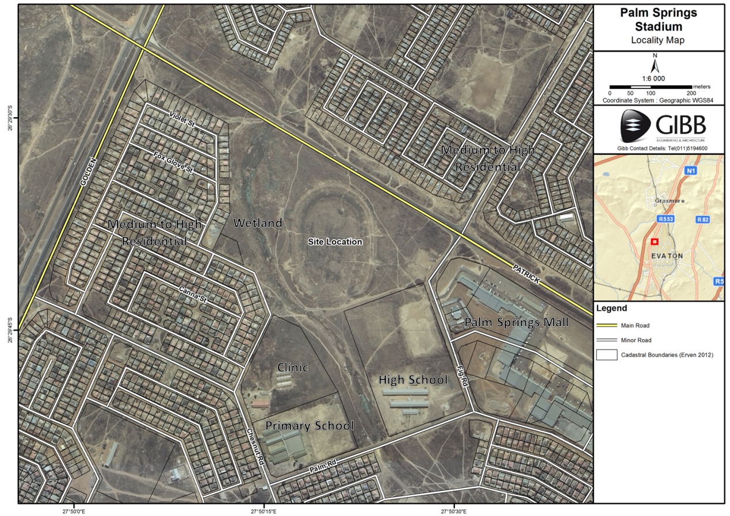

Please note: The Department may request specialist input/studies depending on the nature of the land use character of the area and potential impact(s) of the proposed activity/ies. Specialist reports that look at health & air quality and noise impacts may be required for any feature above and in particular those features marked with an “^{A}“ and with an “^{N”} respectively.

Have specialist reports been attached | YES | NO
If yes indicate the type of reports below
Heritage Specialist Study (Appendix G.2)
Wetland Specialist Study (Appendix G.1)

SOCIO-ECONOMIC CONTEXT

Describe the existing social and economic characteristics of the area and the community condition as baseline information to assess the potential social, economic and community impacts.

The proposed project is located within the Sedibeng District Municipality (SDM) and the Emfuleni Local Municipality (ELM). According to the SDM and the ELM Integrated Development Plan’s (IDP) of 2014/2015 the following social and economic characteristics of the area surrounding the proposed project have reference:

Population Density
According to Statistic SA Community Survey (2011), the total population for Sedibeng was 916 484, indicating a steady increase from the Census community survey of (2007) where the population estimate was 800 819 and Census (2001) where the population was estimated at 796 754. Similarly the ELM also experienced a population increase from the 2001 to 2011 census period. According to the ELM IDP (2014/2015) the population numbers were estimated at 658 422 in 2001 to 721 663 in 2011.

Population Distribution
In terms of population distribution by race within the district and local municipalities SDM shows that of the total population in the SDM (916,483) 82% are Black Africans, followed by 16% White and the Coloured and Indian/Asian populations estimated and 1% each. The ELM follows a similar population distribution pattern with African Males have the highest representation in the municipality followed by African females. The white population is second in terms of representation within the ELM followed by Asians whilst the coloured population is least represented within Emfuleni area.

Education
In terms of education the SDM estimated that 69% of the population do attend school and therefore obtain formal education. However, 4.4% of the population is considered to have no formal education or training therefore implying illiteracy in most cases which in turn makes it difficult for this portion of the population to seek employment and participate in society (SDM IDP, 2014/2015). According to the ELM IDP (2014/2015) education within the municipality has improved steadily from the 2001 to the 2011 period. Statistics show that only 24 079 people in 2011 are considered to have no schooling as opposed to the 60 971 people without schooling in 2001, therefore indicating a significant improvement. Statistics also indicate and increase in bachelor’s degrees as well as maters and doctoral degrees.

Employment
According to the SDM IDP (2014/2015) Emfuleni Local Municipality has the highest employment rate compared to other local municipalities within the SDM. However, with an unemployment rate of 34% job creation is still a priority and a key focus area for the district and local municipalities.

- Cultural/Historical Features

Please be advised that if section 38 of the National Heritage Resources Act 25 of 1999 is applicable to your proposal or alterantives, then you are requested to furnish this Department with written comment from the South African Heritage Resource Agency (SAHRA) – Attach comment in appropriate annexure

38. (1) Subject to the provisions of subsections (7), (8) and (9), any person who intends to undertake a development categorised as-
(a) the construction of a road, wall, powerline, pipeline, canal or other similar form of linear development or barrier exceeding 300m in length;
(b) the construction of a bridge or similar structure exceeding 50m in length;
(c) any development or other activity which will change the character of a site-
(i) exceeding 5 000 m2 in extent; or
(ii) involving three or more existing erven or subdivisions thereof; or
(iii) involving three or more erven or divisions thereof which have been consolidated within the past five years; or
(iv) the costs of which will exceed a sum set in terms of regulations by SAHRA or a provincial heritage resources
authority;
(d) the re-zoning of a site exceeding 10 000 m2 in extent; or
(e) any other category of development provided for in regulations by SAHRA or a provincial heritage resources authority, must at the very earliest stages of initiating such a development, notify the responsible heritage resources authority and furnish it with details regarding the location, nature and extent of the proposed development.

Are there any signs of culturally (aesthetic, social, spiritual, environmental) or historically significant elements, as defined in section 2 of the National Heritage Resources Act, 1999, (Act No. 25 of 1999), including archaeological or palaeontological sites, on or close (within 20m) to the site? | YES |  | NO
If YES, explain:
If uncertain, the Department may request that specialist input be provided to establish whether there is such a feature(s) present on or close to the site.

Briefly explain the findings of the specialist if one was already appointed:
A Heritage Impact Assessment was undertaken by J van Schalkwyk for the proposed development site however, there were no signs of culturally or historically significant elements. The study concluded that no sites, features or objects of cultural heritage significance were identified in the development area and therefore there will be no impact on cultural or heritage resources as a result of the proposed project t. It was however recommended that if archaeological sites or graves are exposed during development activities, it should immediately be reported to a heritage practitioner, so that an investigation and evaluation of the finds can be made. The study therefore concluded that the proposed development would not impact on cultural or historical aspects. Refer to Appendix G.2 for the Heritage Specialist Study report.
Will any building or structure older than 60 years be affected in any way? | YES | NO
Is it necessary to apply for a permit in terms of the National Heritage Resources Act, 1999 (Act 25 of 1999)? | YES | NO
If yes, please attached the comments from SAHRA in the appropriate Appendix

Section C: public participation

- ADVERTISEMENT

The Environmental Assessment Practitioner must follow any relevant guidelines adopted by the competent authority in respect of public participation and must at least –
1(a) Fix a site notice at a conspicuous place, on the boundary of a property where it is intended to undertake the activity which states that an application will be submitted to the competent authority in terms of these regulations and which provides information on the proposed nature and location of the activity, where further information on the proposed activity can be obtained and the manner in which representations on the application may be made;
Site notices have been placed on site and at strategic locations surrounding the proposed development. Please refer to Appendix E.1 for photographic evidence of placement of site notices.

1(b) inform landowners and occupiers of adjacent land of the applicant’s intention to submit an application to the competent authority;
The proposed project site is property of the Emfuleni Local Municipality, who is also the project proponent.
All adjacent landowners will be notified of the proposed project and informed about the review period for the Draft Basic Assessment Report (BAR). It should also be highlighted that all stakeholders will be invited to attend a public meeting. Proof of notifications will be included in the Final Basic Assessment Report.

1(c) inform landowners and occupiers of land within 100 metres of the boundary of the property where it is proposed to undertake the activity and whom may be directly affected by the proposed activity of the applicant’s intention to submit an application to the competent authority;
All stakeholders, including landowners and occupiers of land within 100 metres of the boundary of the property, will be notified of the proposed project and informed about the review period for the Draft BAR. It should also be highlighted that all stakeholders were invited to attend a public meeting.

1(d) inform the ward councillor and any organisation that represents the community in the area of the applicant’s intention to submit an application to the competent authority;
The ward councillor, Louis Ngubane, for the area has been informed of the project and consulted with telephonically on the 15 January 2015 with regards to communicating with the surrounding community. A meeting was held with the councillor on 20 January 2015 to discuss the project

1(e) inform the municipality which has jurisdiction over the area in which the proposed activity will be undertaken of the applicant’s intention to submit an application to the competent authority; and
Local and District Municipalities will be notified of the proposed project and informed about the review period for the Draft BAR. It should also be highlighted that all stakeholders will be invited to attend a public meeting.

1(f) inform any organ of state that may have jurisdiction over any aspect of the activity of the applicant’s intention to submit an application to the competent authority; and
All appropriate organs of state will be notified of the proposed project and informed about the review period for the Draft BAR. It should also be highlighted that all stakeholders will be invited to attend a public meeting.

1(g) place an advertisement in one local newspaper and any Gazette that is published specifically for the purpose of providing notice to the public of applications made in terms of these regulations.
An advertisement regarding the notification of the project, availability of the Draft BAR for public review and notice of the public meeting will be placed in the following newspaper:

- The Sedibeng Ster on Thursday 22 January 2015

- LOCAL AUTHORITY PARTICIPATION

Local authorities are key interested and affected parties in each application and no decision on any application will be made before the relevant local authority is provided with the opportunity to give input. The planning and the environmental sections of the local authority must be informed of the application at least thirty (30) calendar days before the submission of the application to the competent authority (GDARD).

Has any comment been received from the local authority? | YES | NO
If “YES”, briefly describe the comment below (also attach any correspondence to and from the local authority to this application):
N/A
If “NO” briefly explain why no comments have been received
The draft BAR will be distributed to the local authority for comment. Comments received from the distribution of the Draft Basic Assessment report will be included in the Final BAR.

- CONSULTATION WITH OTHER STAKEHOLDERS

Any stakeholder that has a direct interest in the activity, site or property, such as servitude holders and service providers, should be informed of the application at least thirty (30) calendar days before the submission of the application and be provided with the opportunity to comment.

Has any comment been received from stakeholders? | YES | NO
If “YES”, briefly describe the feedback below (also attach copies of any correspondence to and from the stakeholders to this application):
N/A
If “NO” briefly explain why no comments have been received
The draft BAR will be distributed to the relevant stakeholders for comment. Comments received from the distribution of the Draft Basic Assessment report will be included in the Final BAR.

- GENERAL PUBLIC PARTICIPATION REQUIREMENTS

The Environmental Assessment Practitioner must ensure that the public participation is adequate and must determine whether a public meeting or any other additional measure is appropriate or not based on the particular nature of each case. Special attention should be given to the involvement of local community structures such as Ward Committees and ratepayers associations. Please note that public concerns that emerge at a later stage that should have been addressed may cause the competent authority to withdraw any authorisation it may have issued if it becomes apparent that the public participation process was inadequate.

Information documents will be distributed by the councilor to inform the community about the proposed project, public review periods and public meeting date.

The practitioner must record all comments and respond to each comment of the public / interested and affected party before the application is submitted. The comments and responses must be captured in a Comments and Responses Report as prescribed in the regulations and be attached to this application.

- APPENDICES FOR PUBLIC PARTICIPATION

All public participation information is to be attached in the appropriate Appendix. The information in this Appendix is to be ordered as detailed below

Appendix 1 – Proof of site notice
Appendix 2 – Written notices issued to those persons detailed in 1(b) to 1(f) above
Appendix 3 – Proof of newspaper advertisements
Appendix 4 –Communications to and from persons detailed in Point 2 and 3 above
Appendix 5 – Minutes of any public and/or stakeholder meetings
Appendix 6 - Comments and Responses Report
Appendix 7 –Comments from I&APs on Basic Assessment (BA) Report
Appendix 8 –Comments from I&APs on amendments to the BA Report
Appendix 9 – Copy of the register of I&APs
Appendix 10 – Comments from I&APs on the application
Appendix 11 - Other

Section D: resource use and process details

Note: Section D is to be completed for the proposal and alternative(s) (if necessary)

Instructions for completion of Section D for alternatives
- For each alternative under investigation, where such alternatives will have different resource and process details (e.g. technology alternative), the entire Section D needs to be completed
- Each alterative needs to be clearly indicated in the box below
- Attach the above documents in a chronological order

Section D has been duplicated for alternatives | 0 | times
(complete only when appropriate)

Section D Alternative No. | 0 | (complete only when appropriate for above)

- Waste, effluent, and emission management

Solid waste management
Will the activity produce solid construction waste during the construction/initiation phase? | YES | NO
If yes, what estimated quantity will be produced per month? | +1m³
How will the construction solid waste be disposed of (describe)?
Small quantities of solid waste will be generated during the construction phase of the project. This waste will be the responsibility of the contractor and should either be collected and removed to a registered landfill site by an appropriate waste contractor (waste certificates should be kept for document control purposes), or disposed at a licensed waste facility by the contractor.
Where will the construction solid waste be disposed of (describe)?
All waste will be disposed of through the municipal waste stream or at an appropriate licensed waste facility or landfill.
Will the activity produce solid waste during its operational phase? | YES | NO
If yes, what estimated quantity will be produced per month? | m³
How will the solid waste be disposed of (describe)?
It is not anticipated that large amounts of solid waste will be generated during the operational phase of the project. Solid waste produced during the operational phase is expected to be domestic waste generated from the day to day activities taking place within the sports recreational facility and will be collected weekly by the local municipality.
Has the municipality or relevant service provider confirmed that sufficient air space exists for treating/disposing of the solid waste to be generated by this activity? | YES | NO
Where will the solid waste be disposed if it does not feed into a municipal waste stream (describe)?
Solid waste produced during the construction and operational phases will feed into the municipal waste stream or it will be disposed of at a registered waste landfill site.
Note: If the solid waste (construction or operational phases) will not be disposed of in a registered landfill site or be taken up in a municipal waste stream, the applicant should consult with the competent authority to determine whether it is necessary to change to an application for scoping and EIA.
Can any part of the solid waste be classified as hazardous in terms of the relevant legislation? | YES | NO
If yes, inform the competent authority and request a change to an application for scoping and EIA.
Is the activity that is being applied for a solid waste handling or treatment facility? | YES | NO
If yes, the applicant should consult with the competent authority to determine whether it is necessary to change to an application for scoping and EIA.
Describe the measures, if any, that will be taken to ensure the optimal reuse or recycling of materials:
The appointed Contractor will be encouraged to recycle waste generated on site. The residual waste that cannot be recycled will feed into the municipal waste stream and be disposed of at the local municipality landfill site.

Liquid effluent (other than domestic sewage)
Will the activity produce effluent, other than normal sewage, that will be disposed of in a municipal sewage system? |  |  |  | YES | NO
If yes, what estimated quantity will be produced per month? |  |  |  | m³
If yes, has the municipality confirmed that sufficient capacity exist for treating / disposing of the liquid effluent to be generated by this activity(ies)? |  |  |  | YES | NO
Will the activity produce any effluent that will be treated and/or disposed of on site? |  |  |  | Yes | NO
If yes, what estimated quantity will be produced per month? |  |  |  | m³
If yes describe the nature of the effluent and how it will be disposed.
Note that if effluent is to be treated or disposed on site the applicant should consult with the competent authority to determine whether it is necessary to change to an application for scoping and EIA
Will the activity produce effluent that will be treated and/or disposed of at another facility? |  |  |  | YES | NO
If yes, provide the particulars of the facility:
Facility name:
Contact person:
Postal address:
Postal code:
Telephone: |  | Cell:
E-mail: |  | Fax:
Describe the measures that will be taken to ensure the optimal reuse or recycling of waste water, if any:
The contractor will be encouraged to not waste water and to make sure no water is left running unnecessarily on site.

Liquid effluent (domestic sewage)
Will the activity produce domestic effluent that will be disposed of in a municipal sewage system? | YES | NO
If yes, what estimated quantity will be produced per month? | +285m³
If yes, has the municipality confirmed that sufficient capacity exist for treating / disposing of the domestic effluent to be generated by this activity(ies)? | YES | NO
Will the activity produce any effluent that will be treated and/or disposed of on site? | YES | NO
If yes describe how it will be treated and disposed off.
N/A. Temporary ablution facilities will be provided during the construction phase of the project. However, these will be supplied through a contractor and all effluent produced will be the responsibility of the contractor and will be transported off site to an appropriate licensed facility.

Emissions into the atmosphere
Will the activity release emissions into the atmosphere? | YES | NO
If yes, is it controlled by any legislation of any sphere of government? | YES | NO
If yes, the applicant should consult with the competent authority to determine whether it is necessary to change to an application for scoping and EIA.
If no, describe the emissions in terms of type and concentration:
During the construction phase, dust and exhaust emissions will be generated from the movement of vehicles accessing the site. However, these emissions are considered minor and do not pose a significant risk to the immediate and surrounding environment. Management measures to minimise vehicle entrained dust and exhaust emissions will be addressed in the EMPr.

- WATER USE

Indicate the source(s) of water that will be used for the activity
municipal | Directly from water board | groundwater | river, stream, dam or lake | other | the activity will not use water
If water is to be extracted from groundwater, river, stream, dam, lake or any other natural feature, please indicate
the volume that will be extracted per month: |  |  |  |  |  | liters
If Yes, please attach proof of assurance of water supply, e.g. yield of borehole, in the appropriate Appendix
Does the activity require a water use permit from the Department of Water Affairs? |  |  |  |  |  | YES | NO
If yes, list the permits required
The proposed project will required a Water Use License in terms of Section 21 (c) and (i) of the National Water Act (Act No 36 of 1998) for a wetland located to the west and south west of the proposed project. The following is r
Section 21 (c) – Impeding or diverting the flow of water in a watercourse
Section 21 (i) – Altering the bed, banks, course and characteristics of a watercourse
If yes, have you applied for the water use permit(s)? |  |  |  |  |  | YES | NO
If yes, have you received approval(s)? (attached in appropriate appendix) |  |  |  |  |  | YES | NO

- POWER SUPPLY

Please indicate the source of power supply eg. Municipality / Eskom / Renewable energy source
Power will be supplied by the Eskom

If power supply is not available, where will power be sourced from?
N/A. Power will be supplied by the Eskom

- ENERGY EFFICIENCY

Describe the design measures, if any, that have been taken to ensure that the activity is energy efficient:
N/A
Describe how alternative energy sources have been taken into account or been built into the design of the activity, if any:
N/A

Section E: impact assessment

The assessment of impacts must adhere to the minimum requirements in the EIA Regulations, 2006, and should take applicable official guidelines into account. The issues raised by interested and affected parties should also be addressed in the assessment of impacts.

- Issues raised by interested and affected parties

Summarise the issues raised by interested and affected parties.
Issues and responses will be included in the Final Basic Assessment Report.

Summary of response from the practitioner to the issues raised by the interested and affected parties
(A full response must be provided in the Comments and Response Report that must be attached to this report):
Issues and responses will be included in the Final Basic Assessment Report.

- Impacts that may result fRom the CONSTRUCTION and operational PHASE

Briefly describe the methodology utilised in the rating of significance of impacts
The objective of the assessment of impacts is to identify and assess all the significant impacts that may arise as a result of the proposed development.

The assessment of the impacts considered all of the components of the proposed project. The sections which follow provide a summary and anticipated significance of the potential impacts that are likely to occur as a result of the planning and design phase, construction phase, and operational phase, including impacts relating to the choice of technology alternatives as well as the mitigation measures that may eliminate or reduce the potential impacts listed. This impact assessment is applied to all the identified alternatives to the activities identified in Section A (3) of this report.

For each of the main project phases, the existing and potential future impacts and benefits (associated only with the proposed development) will be described using the criteria listed in the Assessment Methodology below. This will be done in accordance with Government Notice R.982, promulgated in terms of Section 24 of the NEMA and the criteria drawn from the IEM Guidelines Series, Guideline 5: Assessment of Alternatives and Impacts, published by the DEAT (April 1998).The assignment of ratings has been undertaken based on past experience of the EIA team as well as through research. Subsequently, mitigation measures have been identified and considered for each impact and the assessment repeated in order to determine the significance of the residual impacts (the impact remaining after the mitigation measure has been implemented).

TABLE 1: ASSESSMENT METHODOLOGY
Criteria | Rating Scales | Notes
Nature | Positive | An evaluation of the effect of the impact related to the proposed development.
 | Negative
Extent | Footprint | The impact only affects the area in which the proposed activity will occur.
 | Site | The impact will affect only the development area.
 | Local | The impact affects the development area and adjacent properties (e.g. construction of a local road).
 | Regional | The effect of the impact extends beyond municipal boundaries (e.g. acid mine drainage)
 | National | The effect of the impact extends beyond more than 2 regional/ provincial boundaries
 | International | The effect of the impact extends beyond country borders .
Duration | Temporary | The duration of the activity associated with the impact will last 0-6 months.
 | Short term | The duration of the activity associated with the impact will last 6-18 months.
 | Medium term | The duration of the activity associated with the impact will last 18 months-5 years.
 | Long term | The duration of the activity associated with the impact will last more than 5 years.
Severity | Low | Where the impact affects the environment in such a way that natural, cultural and social functions and processes are minimally affected
 | Moderate | Where the affected environment is altered but natural, cultural and social functions and processes continue albeit in a modified way; and valued, important, sensitive or vulnerable systems or communities are negatively affected
 | High | Where natural, cultural or social functions and processes are altered to the extent that the natural process will temporarily or permanently cease; and valued, important, sensitive or vulnerable systems or communities are substantially affected.
Potential for impact on irreplaceable resources | No | No irreplaceable resources will be impacted.
 | Yes | Irreplaceable resources will be impacted.
Consequence | Extremely detrimental | A combination of extent, duration, intensity and the potential for impact on irreplaceable resources
 | Highly detrimental
 | Moderately detrimental
 | Slightly detrimental
 | Negligible
 | Slightly beneficial
 | Moderately beneficial
 | Highly beneficial
 | Extremely beneficial
Probability (the likelihood of the impact occurring) | Improbable | It is highly unlikely or less than 50 % likely that an impact will occur.
 | Probable | It is between 50 and 70 % certain that the impact will occur.
 | Definite | It is more than 75 % certain that the impact will occur or it is definite that the impact will occur.
Significance | Very high - negative | A function of Consequence and Probability
 | High - negative
 | Moderate - negative
 | Low - negative
 | Very low
 | Low - positive
 | Moderate - positive
 | High - positive
 | Very high - positive

Duration |  | Extent |  | Irreplaceable Resources |  | Severity |  | Probability |  | Consequence = (Duration+Extent+Irr) x Severity |  | Significance |  | Confidence
1 | Temporary | 1 | Footprint | 1 | Yes | -3 | High - negative | 0 | Improbable | -25 to -33 | Extremely detrimental | -49 to -66 | Very high - negative | Low
2 | Short term | 2 | Site | 0 | No | -2 | Moderate - negative | 1 | Probable | -19 to -24 | Highly detrimental | -37 to -48 | High - negative | Medium
3 | Medium term | 3 | Local |  |  | -1 | Low -negative | 2 | Definite | -13 to -18 | Moderately detrimental | -25 to -36 | Moderate - negative | High
4 | Long term | 4 | Regional |  |  | 0 | Negligible |  |  | -7 to -12 | Slightly detrimental | -13 to -24 | Low - negative
 |  | 5 | National |  |  | 1 | low -positive |  |  | 0 to -6 | Negligible | 0 to -12 | Very low - negative
 |  | 6 | International |  |  | 2 | moderate - positive |  |  | 0 to 6 | Negligible | 0 to 12 | Very Low - positive
 |  |  |  |  |  | 3 | high - positive |  |  | 7 to 12 | Slightly beneficial | 13 to 24 | Low - positive
 |  |  |  |  |  |  |  |  |  | 13 to 18 | Moderately beneficial | 25 to 36 | Moderate - positive
 |  |  |  |  |  |  |  |  |  | 19 to 24 | Highly beneficial | 37 to 48 | High - positive
 |  |  |  |  |  |  |  |  |  | 25 to 33 | Extremely beneficial | 49 to 66 | Very high - positive

Briefly describe and compare the potential impacts (as appropriate), significance rating of impacts, proposed mitigation and significance rating of impacts after mitigation that are likely to occur as a result of the construction phase for the various alternatives of the proposed development. This must include an assessment of the significance of all impacts.

Using the methodology above the following have been identified as significant impacts for the proposed project:

Preconstruction – Negative Impact
Low significance: Removal of vegetation leading to loss of floral habitat and diversity

Construction - Negative Impacts
Low significance: Compaction of soils due to construction activities and erosion.
Low significance: Risk of spillages and dumping of construction waste into surrounding natural areas
Low significance: Removal of vegetation leading to increased runoff, sedimentation and erosion of wetland resources.
Moderate significance: Erosion within natural areas as a result of construction activities
Moderate significance: Alien plant species invading and transforming natural flora habitat

Operational - Negative Impacts
Low significance On-going edge effects such as erosion within natural areas
Low significance Collision of construction vehicles with faunal species

Operational - Positive Impacts
Moderate Significance: Community upliftment
Moderate Significance: Job creation.

A detailed assessment of all impacts follows in the tables below.

PROPOSAL – PREFERRED ALTERNATIVE |  | Pre-mitigation: |  |  |  |  |  |  |  | Post-mitigation:
Aspect | Impact | Duration | Extent | Severity | Impact on irreplaceable resources | Consequence | Probability | Significance | Recommended Mitigation | Duration | Extent | Severity | Impact on irreplaceable resources | Consequence | Probability | Significance | Confidence
 |  | 1,2,3,4 | 1,2,3,4,5,6 | -3,-2,-1,0,1,2,3 | 0,1 | (Dur+Ext+Irr) x Sev | 0,1,2 | -66 to +66 |  | 1,2,3,4 | 1,2,3,4,5,6 | -3,-2,-1,0,1,2,3 | 0,1 | (Dur+Ext+Irr) x Sev | 0,1,2 | -66 to +66
 | PRE-CONSTRUCTION AND CONSTRUCTION
Climate | Contribution to climate change through emission of carbon and other greenhouse gasses into the atmosphere as a result of land clearing and vehicle activities on site. | 3  Medium term | 4  Regional | -2  Moderate Negative | 1  Yes | -16  Moderately Detrimental | 2  Definite | -32  Moderate Negative | - Keep land clearing to a minimum.  - Ensure vehicle exhaust systems function correctly.  - Ensure energy reduction practices are developed & implemented. | 4  Long term | 5  National | -1  Low Negative | 1  Yes | -10  Slightly Detrimental | 1  Probable | -10  Very Low Negative | High
Air Quality | Reduction in ambient air quality from fugitive dust emissions | 2  Short Term | 3  Local | -2  Moderate Negative | 0  No | -10  Slightly Detrimental | 2  Definite | -20  Low Negative | - Dust suppression  - Re-vegetation of areas as soon as possible  - Reduction of drop height as far as is practicable  - Reduction of speed of vehicles to keep within the applicable speed limits and minimise dust emissions | 2  Short Term | 2  Site | -1  Low Negative | 0  No | -4  Negligible | 1  Probable | -4  Very Low Negative | High
Noise | Increased ambient noise levels as a result of construction activities and increased traffic on site during construction. | 2  Short Term | 3  Local | -2  Moderate Negative | 0  No | -10  Slightly Detrimental | 2  Definite | -20  Low Negative | - All machinery used during construction will be maintained in sound mechanical condition.  - The use of appropriate PPE must be encouraged for onsite staff.  - All vehicles will be fitted with appropriate sound suppression devices or silencers.  - All vehicles must keep within the applicable speed limits. | 2  Short Term | 2  Site | -1  Low Negative | 0  No | -4  Negligible | 1  Probable | -4  Very Low Negative | High
Soils | Soil disturbance, loss of nutrients, loss of topsoil cover, loss of in situ structure and physical/chemical properties as a result of clearing of vegetation for the proposed development | 4  Long Term | 2  Site | -2  Moderate Negative | 1  Yes | -14  Moderately Detrimental | 2  Definite | -28  Moderate Negative | - Strip and stockpile top- and subsoils appropriately.  - Commence rehabilitation of affected and completed areas as soon as possible.  - Re-use top- and subsoils during ongoing rehabilitation  - Ensure erosion control and treatment. | 4  Long Term | 2  Site | -1  Low Negative | 1  Yes | -7  Negligible | 1  Probable | -7  Very Low Negative | High
 | Compaction of soils due to construction activities and erosion. | 3  Medium Term | 2  Site | -2  Moderate Negative | 1  Yes | -12  Slightly Detrimental | 2  Definite | -24  Low Negative | - To prevent the erosion of top soils, management measures may include berms, soil traps, hessian curtains and storm water diversion away from areas susceptible to erosion.  - Edge effects of all development activities including erosion and alien control need to be strictly managed throughout the development, particularly in areas of increased ecological sensitivity. | 1  Temporary | 1  Footprint | -1  Low Negative | 0  No | -2  Negligible | 0  Improbable | -2  Very Low Negative | High
 | Soil contamination as a result of spillages and waste (hydrocarbons,  chemicals and waste) | 3  Medium Term | 2  Site | -2  Moderate Negative | 1  Yes | -12  Slightly Detrimental | 2  Definite | -24  Low Negative | - Implementation of good housekeeping practices (vehicle maintenance and waste management).  - In the event of a vehicle breakdown, maintenance of vehicles must be performed with care and drip trays used to contain the oil spillages.  - All areas of increased ecological sensitivity should be marked as such and be off limits to all vehicles and personnel.  - Implement spill clean-up procedures should a spill occur.  - Ensure effective storage and management of waste is undertaken on site. Demarcated areas for waste storage with adequate waste bins must be provided | 3  Medium Term | 2  Site | -1  Low Negative | 1  Yes | -6  Negligible | 1  Probable | -6  Very Low Negative | High
 | Removal of vegetation leading to increased runoff, sedimentation and erosion of wetland resources | 2  Short term | 2  Site | -2  Moderate Negative | 1  Yes | -10  Slightly Detrimental | 2  Definite | -20  Low Negative | - During planning and design, ensure all infrastructure is placed outside of more sensitive habitat area, particularly site camps and other temporary infrastructure.  - The presence of wetland areas should be considered during all phases of planning.  - Develop plans to control alien plant proliferation and erosion within the disturbed areas.  - Ensure stormwater management measures are designed prior to the commencement of construction. | 2  Short Term | 2  Site | -1  Low Negative | 1  Yes | -5  Negligible | 1  Probable | -5  Very Low Negative | High
 | Soil erosion within natural areas as a result of construction activities | 3  Medium Term | 2  Site | -2  Moderate Negative | 1  Yes | -12  Slightly Detrimental | 2  Definite | -28  Moderate Negative | - To prevent the erosion of topsoil, management measures may include berms, soil traps, hessian curtains and storm water diversion away from areas susceptible to erosion.  - Edge effects need to be strictly managed throughout the development.  - All sensitive areas and buffer zones in the vicinity of development should be clearly indicated on site and be off limits for construction vehicles and workers. | 1  Temporary | 1  Footprint | -1  Low Negative | 0  No | -2  Negligible | 1  Probable | -2  Very Low Negative | High
 | Impact of petrochemicals and hydrocarbons on the environment due to refuelling on site. | 2  Short term | 2  Site | -2  Moderate Negative | 1  Yes | -10  Slightly Detrimental | 1  Probable | -10  Very Low Negative | - Surfaces should be protected during refuelling and a supply of absorbent material to treat hydrocarbon spills should be readily available on site.  - Drip trays are to be provided for all stationary vehicles and machinery.  - Extra precautions must be taken to manage fuels and fuel storage when working in the vicinity of water  - Leaking vehicles and machinery should be either immediately taken off site or repaired. | 2  Short term | 2  Site | -1  Low Negative | 1  Yes | -5  Negligible | 1  Probable | -5  Very Low Negative | High
Land use and capability | Construction activities within sensitive habitat areas | 3  Medium Term | 2  Site | -2  Moderate Negative | 1  Yes | -12  Slightly Detrimental | 2  Definite | -24  Low Negative | - All sensitive areas and buffer zones in the vicinity of development should be clearly indicated on site and be off limits for construction vehicles and workers. | 2  Short Term | 1  Footprint | -1  Low Negative | 0  No | -2  Negligible | 0  Improbable | -2  Very Low Negative | High
 | Placement of infrastructure in sensitive habitat areas | 4  Long term | 2  Site | -2  Moderate Negative | 0  No | -12  Slightly Detrimental | 1  Probable | -12  Very Low Negative | - All development footprint areas should remain as small as possible.  - The boundaries of footprint areas are to be clearly defined and it should be ensured that all activities remain within defined footprint areas.  - All wetland areas of increased ecological importance as indicated in the sensitivity map must be considered during all development phases to aid in the conservation of wetland habitat within the study area.  - The planning and design of the proposed activity should take into consideration the sensitive areas and ensure that the proposed development is not situated within these areas. | 4  Long Term | 2  Site | -1  Low Negative | 0  No | -6  Negligible | 0  Improbable | -6  Very Low Negative | High
Hydrologgy/Surface water | Removal of vegetation leading to increased runoff, sedimentation and erosion of wetland resources. | 3  Medium Term | 2  Site | -2  Moderate Negative | 0  No | -10  Slightly Detrimental | 2  Definite | -20  Low Negative | - Limit vegetation removal to the construction the development area. No unnecessary vegetation removal should be permitted. | 2  Short Term | 2  Site | -1  Low Negative | 0  No | -4  Negligible | 1  Probable | -4  Very Low Negative | High
 | Movement of construction vehicles within wetlands leading to loss of wetland habitat, functioning and services provision | 2  Short Term | 2  Site | -2  Moderate Negative | 0  No | -8  Slightly Detrimental | 1  Probable | -8  Very Low Negative | - Operational vehicles should be restricted to travelling only on designated roadways to limit the ecological footprint of the proposed development activities.  - All areas of increased ecological sensitivity beyond the development footprint should be marked as such and be off limits to all vehicles.  - All soils compacted as a result of construction activities falling outside development footprint areas should be ripped and profiled. Special attention should be paid to alien and invasive control within these areas. | 2  Short Term | 1  Footprint | -1  Low Negative | 0  No | -3  Negligible | 1  Probable | -3  Very Low Negative | High
 | Construction activities in wetland depression areas | 3  Medium Term | 2  Site | -2  Moderate Negative | 0  No | -12  Slightly Detrimental | 2  Definite | -24  Low Negative | - All sensitive areas and buffer zones in the vicinity of development should be clearly indicated on site and be off limits for construction vehicles and workers. | 1  Temporary | 1  Footprint | -1  Low Negative | 0  No | -2  Negligible | 2  Definite | -4  Very Low Negative | High
 | Increased runoff volumes due to increased paved and other impervious surfaces impacting on wetland hydrology | 3  Medium Term | 2  Site | -2  Moderate Negative | 0  No | -10  Slightly Detrimental | 2  Definite | -20  Low Negative | - Impermeable surfaces within the proposed development areas should be minimized where possible.  - As much vegetation growth as possible should be promoted within the area of proposed development area in order to protect soils. In this regard rehabilitation works through reseeding and re-vegetating impacted area with indigenous wetland vegetation is emphasized. | 2  Short Term | 2  Site | -1  Low Negative | 0  No | -4  Negligible | 1  Probable | -4  Very Low Negative | High
 | Impacts on seasonal/ perennial streams and storm water channels | 2  Short term | 3  Local | -2  Moderate Negative | 0  No | -10  Slightly Detrimental | 2  Definite | -20  Low Negative | - Precautions should be taken to prevent contaminated water entering any watercourse. i.e divert contaminated water away from watercourses.  - All sensitive areas and buffer zones in the vicinity of development should be clearly indicated on site and be off limits for construction vehicles and workers. | 2  Short Term | 3  Local | -1  Low Negative | 0  No | -5  Negligible | 1  Probable | -5  Very Low Negative | High
Flora | Alien plant species invading and transforming natural flora habitat | 3  Medium Term | 3  Local | -2  Moderate Negative | 1  Yes | -14  Moderately Detrimental | 2  Definite | -28  Moderate Negative | - Proliferation of alien and invasive species is expected within disturbed areas. These species should be eradicated and controlled to prevent their spread beyond the boundary of the development area.  - Alien and invasive vegetation control should take place throughout the all phases of the development. | 1  Temporary | 1  Footprint | -1  Low Negative | 0  No | -2  Negligible | 1  Probable | -2  Very Low Negative | High
 | Removal of vegetation leading to loss of floral habitat and diversity | 3  Medium term | 2  Site | -2  Moderate Negative | 1  Yes | -12  Slightly Detrimental | 2  Definite | -24  Low Negative | - During planning and design, ensure that all infrastructure is placed outside of more sensitive habitat areas, particularly site camps and other temporary infrastructure.  - Areas of increased ecological importance and sensitivity such as wetlands, ridges and buffer areas should be considered during all phases of planning.  - Develop plans to control alien plant proliferation and erosion within the disturbed areas.  - Ensure planned vegetation clearing is kept to a minimum.  - Rehabilitation plan must allow for re-vegetation of disturbed areas upon completion of construction works. | 2  Short Term | 1  Foot Print | -1  Low Negative | 0  No | -2  Negligible | 1  Probable | -3  Very Low Negative | High
Fauna | Site clearing and removal of faunal habitat | 3  Medium Term | 2  Site | -2  Moderate Negative | 1  Yes | -8  Slightly Detrimental | 2  Definite | -16  Low Negative | - Limit the removal of vegetation at the construction site. Vegetation not interfering with the construction activities should not be removed. | 2  Short Term | 1  Footprint | -1  Low Negative | 0  No | -3  Negligible | 1  Probable | -3  Very Low Negative | High
 | Migratory corridors altered due to construction of infrastructure | 2  Short Term | 2  Site | -2  Moderate Negative | 0  No | -10  Slightly Detrimental | 2  Definite | -20  Low Negative | - All sensitive areas and buffer zones in the vicinity of development should be clearly indicated on site and be off limits for construction vehicles and workers. | 2  Short Term | 1  Footprint | -1  Low Negative | 0  No | -3  Negligible | 1  Probable | -3  Very Low Negative | High
 | Fire hazards within the study area; collision of construction vehicles with faunal species | 2  Short Term | 2  Site | -2  Moderate Negative | 0  No | -8  Slightly Detrimental | 1  Probable | -8  Very Low Negative | - Fires should be prohibited on site.  - Operational vehicles should be restricted to travelling only on designated roadways to limit the disturbance of ecological footprint of the proposed development activities.  - Speed limits must be adhered to. | 2  Short Term | 1  Footprint | -1  Low Negative | 0  No | -3  Negligible | 1  Probable | -3  Very Low Negative | High
Heritage | Impact on heritage features | 2  Short Term | 2  Site | -2  Moderate Negative | 0  No | -8  Slightly Detrimental | 0  Improbable | -8  Very Low Negative | - Report any potential heritage features uncovered during the construction activities to the ECO / South African Heritage Resources Agency and follow any instructions they may give.  - Report all confirmed heritage finds to the Gauteng Department of Agriculture and Rural Development | 1  Temporary | 1  Footprint | 0  Negligible | 0  No | -1  Negligible | 1  Probable | -2  Very Low Negative | High
Visual | Change in the Aesthetics / Visual Environment due to Construction vehicles, construction camp, material stockpiles and partially completed structures | 2  Short Term | 3  Local | -2  Moderate Negative | 0  No | -10  Slightly Detrimental | 2  Definite | -20  Low Negative | - Measures to mitigate the visual intrusion of construction activities include the sensitive siting of material storage areas, the appropriate location, profiling, covering and management of stockpiles.  - Ensure good housekeeping and neatness on site.  - Ensure the implementation of an effective waste management programme.  - Ensure the implementation of good traffic management measures.  - Keep cleared areas to a minimum | 2  Short Term | 2  Site | -1  Low Negative | 0  No | -4  Negligible | 1  Probable | -4  Very Low Negative | High
 | Visual disturbance as a result of land clearing and dust emissions due to construction activities | 2  Short Term | 3  Local | -2  Moderate Negative | 0  No | -10  Slightly Detrimental | 2  Definite | -20  Low Negative | - Minimise construction footprint by using existing roads where possible, clearing minimum vegetation and maximising site vegetation retention areas  - Commence rehabilitation of affected and completed areas where appropriate, as soon as practically possible.  - Implement dust suppression activities.  - Ensure the reduction of drop height as far as practicable.  - Speed limits must be adhered to. | 2  Short Term | 2  Site | -1  Low Negative | 0  No | -4  Negligible | 1  Probable | -4  Very Low Negative | High
Waste | Waste generation in the form of construction rubble and general litter | 2  Short Term | 3  Local | -2  Moderate Negative | 0  No | -10  Slightly Detrimental | 2  Definite | -20  Low Negative | - The area of the development should be cleared of litter on a regular basis. Once collected, this litter shall be disposed of at an approved waste disposal site.  - Ensure the provision of bins on site. | 2  Short Term | 2  Site | -1  Low Negative | 0  No | -4  Negligible | 1  Probable | -4  Very Low Negative | High
 | Increased occurrence of fires due to improper waste management activities taking place as well as site staff making fires | 2  Short Term | 2  Site | -2  Moderate Negative | 0  No | -8  Slightly Detrimental | 1  Probable | -8  Very Low Negative | - Prevent accidental fires through proper management and regular removal of construction waste; ensure adequate access control; and ensure proper training and awareness regarding fires are given to site staff | 1  Temporary | 1  Footprint | -1  Low Negative | 0  No | -2  Negligible | 0  Improbable | -2  Very Low Negative | High
Traffic | Change in traffic patterns including traffic congestion, damage to surrounding road surfaces and potential increases in motor vehicle accidents and community members as a result of increased traffic during construction | 2  Short Term | 3  Local | -2  Moderate Negative | 0  No | -10  Slightly Detrimental | 1  Probable | -10  Very Low Negative | - Avoid heavy vehicle movement on public roads during peak traffic hours.  - If required, undertake road repairs in conjunction with the local municipality.  - Ensure adequate training of drivers.  - Speed limits must be adhered to. | 2  Short Term | 3  Local | -1  Low Negative | 0  No | -5  Negligible | 1  Probable | -5  Very Low Negative | High
Social | Impact on social fabric and HIV/ AIDS | 2  Short Term | 3  Local | -1  Low Negative | 0  No | -10  Slightly Detrimental | 1  Probable | -10  Very Low Negative | - Worker education regarding personal conduct should be included in the construction Health and Safety “Tool Box Talks” to create an awareness of the issues. | 2  Short Term | 3  Local | 0  Negligible | 0  No | 0  Negligible | 0  Improbable | 0  Very Low Negative | High
 | Impact on employment/ temporary employment opportunities | 2  Short Term | 3  Local | 1  Low Positive | 0  No | 5  Negligible | 1  Probable | 5  Very Low Positive | - Members of the local community should have preference in the recruitment process of construction labour force.  - Where possible women and disabled members of the community should be given opportunities for employment.  - Labour practices on site should be in accordance with South African law and good ethical practice should be employed on site during all relations with potential or existing employees. | 2  Short Term | 3  Local | 2  Moderate Positive | 0  No | 10  Slightly Beneficial | 1  Probable | 10  Very Low Positive
 | OPERATIONAL PHASE
Climate | Emission of carbon and other greenhouse gasses into the atmosphere through on going vehicle activity | 4  Long Term | 4  Regional | -1  Low Negative | 1  Yes | -18  Moderately Detrimental | 2  Definite | -36  Moderate Negative | - Where necessary, create awareness regarding climate change and greenhouse gases.  - Encourage community to partake in environmentally friendly activities. | 4  Long Term | 4  Regional | -1  Low Negative | 1  Yes | -18  Moderately Detrimental | 1  Probable | -18  Low Negative | Medium
Air quality | Emissions from vehicles resulting in an increase in air pollution. | 4  Long Term | 2  Site | -2  Moderate Negative | 0  No | -12  Slightly Detrimental | 1  Probable | -12  Very Low Negative | - Traffic is not expected to increases substantially in the area therefore there will be little to no impact. | 4  Long Term | 2  Site | -1  Low Negative | 0  No | -6  Negligible | 1  Probable | -6  Very Low Negative | High
Noise | Increased ambient noise from operational activities and increased traffic during operation | 4  Long Term | 3  Local | -1  Low Negative | 0  No | -7  Negligible | 1  Probable | -7  Very Low Negative | - Speed limits must be adhered to.  - No excessive noise should be permitted during the hours of 18h00 to 6h00. | 4  Long Term | 2  Site | -1  Low Negative | 0  No | -6  Negligible | 0  Improbable | -6  Very Low Negative | High
Soils | On-going edge effects such as erosion within natural areas. | 3  Medium Term | 2  Site | -2  Moderate Negative | 1  Yes | -12  Slightly Detrimental | 1  Probable | -12  Very Low Negative | - Ensure water is appropriately diverted to avoid soil erosion.  - In the event that soil erosion should occur implement erosion control and treatment measures.  - Implementation of good housekeeping practices (vehicle maintenance and waste management).  - Edge effects need to be strictly managed during the operational phase of the activities e.g. monitoring of erosion, stabilisation of slope, maintenance of storm water channels. | 3  Medium Term | 2  Site | -1  Low Negative | 1  Yes | -6  Negligible | 0  Improbable | -6  Very Low Negative | Medium
Hydrology/surface water | Impact on surface water quality through increase in impermeable  surface resulting in increased flow causing erosion and through hydrocarbon spillages/leaks as a result of increased traffic | 4  Long Term | 2  Site | -2  Moderate Negative | 0  No | -12  Slightly Detrimental | 2  Definite | -24  Very Low Negative | - Minimise soil erosion.  - Ensure dirty water is adequately diverted away from all surface water entities.  - Continued maintenance of storm water channels to prevent run-off from contaminating surrounding water resources. | 4  Long Term | 2  Site | -2  Moderately Negative | 0  No | -12  Slightly Detrimental | 1  Probable | -12  Very Low Negative | High
 | Sedimentation of surrounding water resources due to run-off from impervious surfaces. | 4  Long Term | 2  Site | -2  Moderate Negative | 0  No | -12  Slightly Detrimental | 2  Definite | -24  Low Negative | - Continued maintenance of storm water channels to prevent run-off from contaminating surrounding water resources. | 4  Long Term | 2  Site | -2  Moderately Negative | 0  No | -12  Slightly Detrimental | 1  Probable | -12  Very Low Negative | High
Flora | Vehicles driving through sensitive areas. | 4  Long Term | 2  Site | -2  Moderate Negative | 0  No | -12  Slightly Detrimental | 1  Probable | -12  Very Low Negative | - Vehicles should be restricted to travelling only on designated roadways to limit the disturbance of ecological footprint of the proposed development | 4  Long Term | 2  Site | -1  Low Negative | 0  No | -6  Negligible | 1  Probable | -6  Very Low Negative | High
 | Loss of habitat for floral species as a result of Increased introduction and proliferation of alien plant species and further transformation of natural habitat. | 3  Medium Term | 2  Local | -2  Moderate Negative | 1  Yes | -10  Slightly Detrimental | 1  Probable | -10  Very Low Negative | - Ensure that operational related activities are kept strictly within the footprint area.  - Alien and invasive vegetation control should take place throughout the operational phase of the development. | 2  Short | 1  Footprint | -1  Low Negative | 0  No | -3  Negligible | 1  Probable | -3  Very Low Negative | High
 | Loss of floral diversity as a result of an increase in alien plant species leading to altered plant community structure and composition. | 3  Medium Term | 2  Local | -2  Moderate Negative | 1  Yes | -10  Slightly Detrimental | 1  Probable | -10  Very Low Negative | - Ensure that operational related activities are kept strictly within the footprint area.  - Alien and invasive vegetation control should take place throughout the operational phase of the development. | 2  Short | 1  Footprint | -1  Low Negative | 0  No | -3  Negligible | 1  Probable | -3  Very Low Negative | High
Fauna | Collision of construction vehicles with faunal species. | 4  Long Term | 2  Site | -2  Moderate Negative | 0  No | -12  Slightly Detrimental | 1  Probable | -12  Very Low Negative | - Vehicles should be restricted to travelling only on designated roadways to limit the faunal fatalities. Speed limits must be adhered to. | 4  Long Term | 2  Site | -1  Low Negative | 0  No | -6  Negligible | 1  Probable | -6  Very Low Negative | High
 | Potential loss of faunal habitat as a result of further decline in faunal diversity due to the associated operational activities within the project footprint and Fire hazard from informal fires. | 3  Medium Term | 3  Local | -2  Moderate Negative | 1  Yes | -14  Moderately Detrimental | 1  Probable | -14  Low Negative | - Ensure that operational related activities are kept strictly within the footprint area.  - Restrict vehicles to travelling only on designated roadways to limit the ecological footprint of the proposed development activities. | 2  Short | 1  Footprint | -1  Low Negative | 0  No | -3  Negligible | 1  Probable | -3  Very Low Negative | High
 | Potential loss of faunal diversity as a result of further decline in faunal diversity due to the associated operational activities within the project footprint, fire hazard from informal fires and bird strikes with power lines and associated avifaunal mortalities | 3  Medium Term | 3  Local | -2  Moderate Negative | 1  Yes | -14  Moderately Detrimental | 1  Probable | -14  Low Negative | - Ensure that operational related activities are kept strictly within the footprint area.  - Restrict vehicles to travelling only on designated roadways to limit the ecological footprint of the proposed development activities.  - Placement of bird diverters/ flaps and anti-roosting spikes on power lines and associated structures to mitigate power line related mortalities to avifauna moving through the study area. | 2  Short | 1  Footprint | -1  Low Negative | 0  No | -3  Negligible | 1  Probable | -3  Very Low Negative | High
Visual | Visual impact on change of “sense of place” | 4  Long Term | 2  Site | -2  Moderate Negative | 0  No | -12  Slightly Detrimental | 2  Definite | -24  Low Negative | - Ensure facility fits in with surrounding community. | 4  Long Term | 2  Site | -1  Low Negative | 0  No | -6  Negative | 2  Definite | -12  Very Low Negative | Medium
Waste | Waste generation from every day running of the activity | 4  Long | 2  Site | -2  Moderate Negative | 0  No | -12  Slightly Detrimental | 2  Definite | -24  Low Negative | - Ensure provisions of bins during the operational phase.  - All waste generated by the recreational facility should be disposed of in appropriate bins provided and collected on a weekly basis through the municipal waste stream. | 4  Long | 2  Site | -1  Low Negative | 0  No | -6  Negligible | 2  Definite | -12  Very Low Negative | High
Traffic | Increased traffic during operational activities | 4  Long | 3  Local | -2  Moderate Negative | 0  No | -14  Moderately Detrimental | 2  Definite | -28  Moderate Negative | - Speed limits must be adhered to. | 4  Long | 3  Local | -1  Low Negative | 0  No | -7  Negligible | 1  Probable | -7  Very Low Negative | High
Social | Community upliftment | 4  Long | 3  Local | 1  Low Positive | 0  No | 7  Slightly Beneficial | 2  Definite | 14  Low Positive | - Ensure that where possible community has access to facility. | 4  Long | 3  Local | 2  Moderately Positive | 0  No | 14  Slightly Beneficial | 2  Definite | 28  Moderate Positive | High
 | Job creation | 4  Long | 3  Local | 1  Low Positive | 0  No | 7  Slightly Beneficial | 2  Definite | 14  Low Positive | - Employment of local community members should be considered to maximise the socio-economic benefits to the local economy. | 4  Long | 3  Local | 2  Moderately Positive | 0  No | 14  Slightly Beneficial | 2  Definite | 28  Moderate Positive | High

List any specialist reports that were used to fill in the above tables. Such reports are to be attached in the appropriate Appendix.
Wetland Impact Assessment Study (Appendix G.1)
Heritage Impact Assessment Study (Appendix G.2)

- Impacts that may result fROm the decomissioning and closure phase

Briefly describe and compare the potential impacts (as appropriate), significance rating of impacts, proposed mitigation and significance rating of impacts after mitigation that are likely to occur as a result of the decommissioning and closure phase for the various alternatives of the proposed development. This must include an assessment of the significance of all impacts.

PROPOSAL – PREFERRED ALTERNATIVE |  | Pre-mitigation: |  |  |  |  |  |  |  | Post-mitigation:
Aspect | Impact | Duration | Extent | Severity | Impact on irreplaceable resources | Consequence | Probability | Significance | Recommended Mitigation | Duration | Extent | Severity | Impact on irreplaceable resources | Consequence | Probability | Significance | Confidence
 |  | 1,2,3,4 | 1,2,3,4,5,6 | -3,-2,-1,0,1,2,3 | 0,1 | (Dur+Ext+Irr) x Sev | 0,1,2 | -66 to +66 |  | 1,2,3,4 | 1,2,3,4,5,6 | -3,-2,-1,0,1,2,3 | 0,1 | (Dur+Ext+Irr) x Sev | 0,1,2 | -66 to +66
 | DECOMISSIONING AND CLOSURE PHASE
Climate | Contribution to climate change through emission of carbon and other greenhouse gasses into the atmosphere as a result of vehicle activities on site. | 3  Medium term | 4  Regional | -2  Moderate Negative | 1  Yes | -16  Moderately Detrimental | 2  Definite | -32  Moderate Negative | - Ensure vehicle exhaust systems function correctly.  - Ensure energy reduction practices are developed & implemented. | 4  Long term | 5  National | -1  Low Negative | 1  Yes | -10  Slightly Detrimental | 1  Probable | -10  Very Low Negative | High
Air Quality | Reduction in ambient air quality from fugitive dust emissions from decommissioning activities | 2  Short Term | 3  Local | -2  Moderate Negative | 0  No | -10  Slightly Detrimental | 2  Definite | -20  Low Negative | - Dust suppression  - Re-vegetation of areas as soon as possible  - Reduction of drop height as far as is practicable  - Reduction of speed of vehicles to keep within the applicable speed limits and minimise dust emissions | 2  Short Term | 2  Site | -1  Low Negative | 0  No | -4  Negligible | 1  Probable | -4  Very Low Negative | High
Noise | Increased ambient noise levels as a result of decommissioning activities and increased traffic on site during decommissioning. | 2  Short Term | 3  Local | -2  Moderate Negative | 0  No | -10  Slightly Detrimental | 2  Definite | -20  Low Negative | - All machinery used during construction will be maintained in sound mechanical condition.  - The use of appropriate PPE must be encouraged for onsite staff.  - All vehicles will be fitted with appropriate sound suppression devices or silencers.  - All vehicles must keep within the applicable speed limits. | 2  Short Term | 2  Site | -1  Low Negative | 0  No | -4  Negligible | 1  Probable | -4  Very Low Negative | High
Soils | Soil disturbance, loss of nutrients, loss of topsoil cover, loss of in situ structure and physical/chemical properties as a result of clearing of vegetation for the demolition dn dismantling activities | 4  Long Term | 2  Site | -2  Moderate Negative | 1  Yes | -14  Moderately Detrimental | 2  Definite | -28  Moderate Negative | - Strip and stockpile top- and subsoils appropriately.  - Commence rehabilitation of affected and completed areas as soon as possible.  - Re-use top- and subsoils during ongoing rehabilitation  - Ensure erosion control and treatment. | 4  Long Term | 2  Site | -1  Low Negative | 1  Yes | -7  Negligible | 1  Probable | -7  Very Low Negative | High
 | Soil contamination as a result of spillages and waste (hydrocarbons,  chemicals and waste) | 3  Medium Term | 2  Site | -2  Moderate Negative | 1  Yes | -12  Slightly Detrimental | 2  Definite | -24  Low Negative | - Implementation of good housekeeping practices (vehicle maintenance and waste management).  - In the event of a vehicle breakdown, maintenance of vehicles must be performed with care and drip trays used to contain the oil spillages.  - All areas of increased ecological sensitivity should be marked as such and be off limits to all vehicles and personnel.  - Implement spill clean-up procedures should a spill occur.  - Ensure effective storage and management of waste is undertaken on site. Demarcated areas for waste storage with adequate waste bins must be provided | 3  Medium Term | 2  Site | -1  Low Negative | 1  Yes | -6  Negligible | 1  Probable | -6  Very Low Negative | High
 | Removal of vegetation leading to increased runoff, sedimentation and erosion of wetland resources | 2  Short term | 2  Site | -2  Moderate Negative | 1  Yes | -10  Slightly Detrimental | 2  Definite | -20  Low Negative | - The presence of wetland areas should be considered during all phases of planning.  - Develop plans to control alien plant proliferation and erosion within the disturbed areas.  - Ensure stormwater management measures are designed prior to the commencement of construction. | 2  Short Term | 2  Site | -1  Low Negative | 1  Yes | -5  Negligible | 1  Probable | -5  Very Low Negative | High
 | Soil erosion within natural areas as a result of decommissioning activities | 3  Medium Term | 2  Site | -2  Moderate Negative | 1  Yes | -12  Slightly Detrimental | 2  Definite | -28  Moderate Negative | - To prevent the erosion of topsoil, management measures may include berms, soil traps, hessian curtains and storm water diversion away from areas susceptible to erosion.  - Edge effects need to be strictly managed throughout the development.  - All sensitive areas and buffer zones in the vicinity of development should be clearly indicated on site and be off limits for vehicles and workers. | 1  Temporary | 1  Footprint | -1  Low Negative | 0  No | -2  Negligible | 1  Probable | -2  Very Low Negative | High
 | Impact of petrochemicals and hydrocarbons on the environment due to refuelling on site. | 2  Short term | 2  Site | -2  Moderate Negative | 1  Yes | -10  Slightly Detrimental | 1  Probable | -10  Very Low Negative | - Surfaces should be protected during refuelling and a supply of absorbent material to treat hydrocarbon spills should be readily available on site.  - Drip trays are to be provided for all stationary vehicles and machinery.  - Extra precautions must be taken to manage fuels and fuel storage when working in the vicinity of water  - Leaking vehicles and machinery should be either immediately taken off site or repaired. | 2  Short term | 2  Site | -1  Low Negative | 1  Yes | -5  Negligible | 1  Probable | -5  Very Low Negative | High
Land use and capability | Decommissioning activities within sensitive habitat areas | 3  Medium Term | 2  Site | -2  Moderate Negative | 1  Yes | -12  Slightly Detrimental | 2  Definite | -24  Low Negative | - All sensitive areas and buffer zones in the vicinity of development should be clearly indicated on site and be off limits for construction vehicles and workers. | 2  Short Term | 1  Footprint | -1  Low Negative | 0  No | -2  Negligible | 0  Improbable | -2  Very Low Negative | High
Hydrologgy/Surface water | Removal of vegetation leading to increased runoff, sedimentation and erosion of wetland resources. | 3  Medium Term | 2  Site | -2  Moderate Negative | 0  No | -10  Slightly Detrimental | 2  Definite | -20  Low Negative | - Limit vegetation removal to the dismantling development area. No unnecessary vegetation removal should be permitted. | 2  Short Term | 2  Site | -1  Low Negative | 0  No | -4  Negligible | 1  Probable | -4  Very Low Negative | High
 | Movement of vehicles within wetlands leading to loss of wetland habitat, functioning and services provision | 2  Short Term | 2  Site | -2  Moderate Negative | 0  No | -8  Slightly Detrimental | 1  Probable | -8  Very Low Negative | - Vehicles should be restricted to travelling only on designated roadways to limit the ecological footprint of the proposed development activities.  - All areas of increased ecological sensitivity beyond the development footprint should be marked as such and be off limits to all vehicles.  - All soils compacted as a result of construction activities falling outside development footprint areas should be ripped and profiled. Special attention should be paid to alien and invasive control within these areas. | 2  Short Term | 1  Footprint | -1  Low Negative | 0  No | -3  Negligible | 1  Probable | -3  Very Low Negative | High
 | Decommissioning activities in wetland depression areas | 3  Medium Term | 2  Site | -2  Moderate Negative | 0  No | -12  Slightly Detrimental | 2  Definite | -24  Low Negative | - All sensitive areas and buffer zones in the vicinity of development should be clearly indicated on site and be off limits for construction vehicles and workers. | 1  Temporary | 1  Footprint | -1  Low Negative | 0  No | -2  Negligible | 2  Definite | -4  Very Low Negative | High
 | Impacts on seasonal/ perennial streams and storm water channels | 2  Short term | 3  Local | -2  Moderate Negative | 0  No | -10  Slightly Detrimental | 2  Definite | -20  Low Negative | - Precautions should be taken to prevent contaminated water entering any watercourse. i.e divert contaminated water away from watercourses.  - All sensitive areas and buffer zones in the vicinity of development should be clearly indicated on site and be off limits for construction vehicles and workers. | 2  Short Term | 3  Local | -1  Low Negative | 0  No | -5  Negligible | 1  Probable | -5  Very Low Negative | High
Flora | Restoration of local ecological (local vegetation) integrity through  rehabilitation activities | 3  Medium Term | 3  Local | 1  Low Positive | 1  Yes | 7  Slightly Beneficial | 2  Definite | 14  Low Positive | - Undertake re-vegetation through the use of indigenous species  - Control and management of weeds and invasive alien plant species | 3  Medium Term | 3  Local | 2  Moderate Positive | 1  Yes | 14  Slightly Beneficial | 2  Definite | 28  Moderate Positive | High
 | Impacts as identified for the construction phase: During the process of demolition and dismantling of the facility, impacts similar to those identified during the construction of the project may occur. Reference is made to the impact assessment section for the construction phase. Management and mitigation measures will similarly apply.
Fauna | Restoration of local ecological (local fauna) integrity through  rehabilitation activities | 3  Medium Term | 3  Local | 1  Low Positive | 1  Yes | 7  Slightly Beneficial | 2  Definite | 14  Low Positive | - Undertake re-vegetation through the use of indigenous species to encourage the return of local indigenous faunal species  - Control and management of weeds and invasive alien plant species | 3  Medium Term | 3  Local | 2  Moderate Positive | 1  Yes | 14  Slightly Beneficial | 2  Definite | 28  Moderate Positive | High
 | Impacts as identified for the construction phase: During the process of demolition and dismantling of the facility, impacts similar to those identified during the construction of the project may occur. Reference is made to the impact assessment section for the construction phase. Management and mitigation measures will similarly apply.
Heritage | Impact on heritage features | 2  Short Term | 2  Site | -2  Moderate Negative | 0  No | -8  Slightly Detrimental | 0  Improbable | -8  Very Low Negative | - Report any potential heritage features uncovered during the construction activities to the ECO / South African Heritage Resources Agency and follow any instructions they may give.  - Report all confirmed heritage finds to the Gauteng Department of Agriculture and Rural Development | 1  Temporary | 1  Footprint | 0  Negligible | 0  No | -1  Negligible | 1  Probable | -2  Very Low Negative | High
Visual | Visual disturbance and  change in landscape character as a result of demolition and dismantling activities | 2  Short Term | 3  Local | -2  Moderate Negative | 0  No | -10  Slightly Detrimental | 2  Definite | -20  Low Negative | - Measures to mitigate the visual intrusion of decommissioning activities include the sensitive siting of material storage areas, the appropriate location, profiling, covering and management of stockpiles.  - Ensure good housekeeping and neatness on site.  - Ensure the implementation of an effective waste management programme.  - Ensure the implementation of good traffic management measures.  - Keep cleared areas to a minimum.  - Commence rehabilitation of affected and completed areas where appropriate, as soon as practically possible. | 2  Short Term | 2  Site | -1  Low Negative | 0  No | -4  Negligible | 1  Probable | -4  Very Low Negative | High
 | Visual disturbance as a result of dust emissions due to decommissioning activities | 2  Short Term | 3  Local | -2  Moderate Negative | 0  No | -10  Slightly Detrimental | 2  Definite | -20  Low Negative | - Commence rehabilitation of affected and completed areas where appropriate, as soon as practically possible.  - Implement dust suppression activities.  - Ensure the reduction of drop height as far as practicable.  - Speed limits must be adhered to. | 2  Short Term | 2  Site | -1  Low Negative | 0  No | -4  Negligible | 1  Probable | -4  Very Low Negative | High
Waste | Waste generation in the form of decommissioning rubble and general litter | 2  Short Term | 3  Local | -2  Moderate Negative | 0  No | -10  Slightly Detrimental | 2  Definite | -20  Low Negative | - The area of the development should be cleared of litter on a regular basis. Once collected, this litter shall be disposed of at an approved waste disposal site.  - Ensure the provision of bins on site.  - Waste generation must be managed accordingly  - Keep waste in vermin proof bins with lids  - All materials that can be recycled must be recycled where possible.  - Rubble must not be stockpiled. It must be transported to an appropriate disposal facility. | 2  Short Term | 2  Site | -1  Low Negative | 0  No | -4  Negligible | 1  Probable | -4  Very Low Negative | High
Traffic | Change in traffic patterns including traffic congestion, damage to surrounding road surfaces and potential increases in motor vehicle accidents and community members as a result of increased traffic during decommissioning | 2  Short Term | 3  Local | -2  Moderate Negative | 0  No | -10  Slightly Detrimental | 1  Probable | -10  Very Low Negative | - Avoid heavy vehicle movement on public roads during peak traffic hours.  - If required, undertake road repairs in conjunction with the local municipality.  - Ensure adequate training of drivers.  - Speed limits must be adhered to. | 2  Short Term | 3  Local | -1  Low Negative | 0  No | -5  Negligible | 1  Probable | -5  Very Low Negative | High
Social | Impact on employment/ temporary employment opportunities | 2  Short Term | 3  Local | 1  Low Positive | 0  No | 5  Negligible | 1  Probable | 5  Very Low Positive | - Members of the local community should have preference in the recruitment process of construction labour force.  - Where possible women and disabled members of the community should be given opportunities for employment.  - Labour practices on site should be in accordance with South African law and good ethical practice should be employed on site during all relations with potential or existing employees. | 2  Short Term | 3  Local | 2  Moderate Positive | 0  No | 10  Slightly Beneficial | 1  Probable | 10  Very Low Positive
 | Loss of jobs from close of recreational facility | 4  Long Term | 3  Local | -2  Moderate Negative | 0  No | -14  Moderately Detrimental | 2  Definite | -28  Moderate Negative | - Assist staff as far as possible with obtaining skills and knowledge in order to seek employment opportunities once the facility is closed. | 4  Long Term | 3  Local | -1  Low Negative | 0  No | -7  Slightly Detrimental | 1  Probable | -7  Very Low Negative | Medium

List any specialist reports that were used to fill in the above tables. Such reports are to be attached in the appropriate Appendix.
Wetland Impact Assessment Study (Appendix G.1)
Heritage Impact Assessment Study (Appendix G.2)

- Cumulative impacts

Describe potential impacts that, on their own may not be significant, but is significant when added to the impact of other activities or existing impacts in the environment. Substantiate response:

PROPOSAL – PREFERRED ALTERNATIVE
Aspect | Impact | Cause | Mitigation | Detailed Description
Climate | Release of greenhouse gas emissions | - Land based vehicle activity  - Clearing of vegetation negatively affects carbon sequestration efficiency and increase emissions resulting from decomposition | - Ensure vehicle exhaust systems function correctly.  - Ensure energy reduction practices are developed implemented. | The release of greenhouse gasses and other contaminants to the atmosphere is expected as a result of land based vehicle activities. The clearing of vegetation negatively affects carbon sequestration efficiency and increase emissions resulting from decomposition. These impacts are regarded as insignificant in terms of contribution. The risks are recognised as a cumulative impact.
Air Quality | No impact expected | N/A | N/A | N/A
Noise | Increased ambient noise from increased traffic | - More vehicles in the immediate area.  - Increased number of people visiting. | - Limit noise after working hours therefore between 18h00 and 6h00. | As a result of increased traffic and movement of people within the recreational facility the ambient noise of the area may be altered. However it is expected that the impact will be insignificant.
Soils | Loss of natural  Resource (topsoil) | - Soil erosion  - Soil contamination by chemicals and hydrocarbons | - Commence rehabilitation of affected and completed areas  - Application of soil emplacement and storage practices  - Fertilisation and amendments  - Erosion control and treatment  - Implementation of good housekeeping practices (vehicle maintenance and waste management)  - Correct storage of dangerous goods, waste and other material which may cause contamination  - Spill clean up | The loss of topsoil as a natural resource may be regarded as cumulative impact
Hydrology/ Surface water | Surface water pollution | - Soil erosion  - Soil contamination by chemicals and hydrocarbons  - Microbial contamination from waste streams generated on site | - Implementation of good housekeeping practices (vehicle maintenance and waste management)  - Correct storage of dangerous goods, waste and other material which may cause contamination  - Spill clean up | Surface water quality impacts will extend beyond the boundary of the site if not managed appropriately.
Biodiversity (Flora and Fauna) | Loss of biodiversity and disruption of existing e functioning | - Land transformed for the recreational facility  - Anthropological activities (poaching, pollution) | - Preservation of vegetation  - Implementation of conservation practices (including the control of weeds and alien invasive species) | The cumulative impacts relate to land transformation resulting in the loss of habitat. The habitat type is not regarded as threatened and not unique the area and the impacts on a regional scale is not expected to be significant.
Heritage | No impact expected | N/A | N/A | N/A
Visual | Visual disturbance and change of landscape character. | - The construction and operation of the recreational facility | - None | Since the area is fairly built up it is not expected that the cumulative impact will be of high significance.
Traffic | Increased traffic | - Increases in construction vehicles as well as private and public vehicles during operation.  - Increased commuter traffic | - Adhere to speed limits and road signage | The increase in traffic flow may have an impact on regional and national roads in the area. The impact is regarded as minor.
Socio-economic | Community upliftment | - Access to the recreational facility | - None | The recreational facility will provide upliftment to the area and surrounding community.

- Environmental impact statement

Taking the assessment of potential impacts into account, please provide an environmental impact statement that sums up the impact that the proposal and its alternatives may have on the environment after the management and mitigation of impacts have been taken into account with specific reference to types of impact, duration of impacts, likelihood of potential impacts actually occurring and the significance of impacts.

Proposal (Preferred Alternative)
The impact tables above depicted the potential impacts that may occur as a result of the proposed project. As indicated in the tables the overall impact of the project can be considered low to very low if all management and mitigation measures are implemented. The proposed multi-purpose recreational facility is not located within any ecologically sensitive areas however according to the wetland assessment undertaken the study area falls within the Soweto Highveld Grassland vegetation type, which is classified as “Vulnerable” (Mucina & Rutherford, 2006). It should however be noted that the vegetation within the study area is degraded due to impacts from existing surrounding anthropogenic activities.

It should also be highlighted that one wetland feature, representing a single Hydrogeomorphic (HGM) Unit was identified within the study area during the assessment. The wetland is situated within a valley floor landscape unit and is classified as a channelled valley bottom wetland. This wetland is located to the west of the proposed development site. The impacts associated with the construction of the proposed multi-purpose recreational facility in Palm Springs are summarised below, for more details please refer to the impact tables above.

Impact | Significance Before Mitigation | Significance After Mitigation
Pre-construction and Construction
Contribution to climate change through emission of carbon and other greenhouse gasses into the atmosphere as a result of land clearing and vehicle activities on site. | -32  Moderate Negative | -10  Very Low Negative
Reduction in ambient air quality from fugitive dust emissions | -20  Low Negative | -4  Very Low Negative
Increased ambient noise levels as a result of construction activities and increased traffic on site during construction. | -20  Low Negative | -4  Very Low Negative
Soil disturbance, loss of nutrients, loss of topsoil cover, loss of in situ structure and physical/chemical properties as a result of clearing of vegetation for the proposed development | -28  Moderate Negative | -7  Very Low Negative
Compaction of soils due to construction activities and erosion. | -24  Low Negative | -2  Very Low Negative
Soil contamination as a result of spillages and waste (hydrocarbons, chemicals and waste) | -24  Low Negative | -6  Very Low Negative
Removal of vegetation leading to increased runoff, sedimentation and erosion of wetland resources | -20  Low Negative | -5  Very Low Negative
Soil erosion within natural areas as a result of construction activities | -28  Moderate Negative | -2  Very Low Negative
Impact of petrochemicals and hydrocarbons on the environment due to refuelling on site. | -10  Very Low Negative | -5  Very Low Negative
Construction activities within sensitive habitat areas | -24  Low Negative | -2  Very Low Negative
Placement of infrastructure in sensitive habitat areas | -12  Very Low Negative | -6  Very Low Negative
Removal of vegetation leading to increased runoff, sedimentation and erosion of wetland resources. | -20  Low Negative | -4  Very Low Negative
Movement of construction vehicles within wetlands leading to loss of wetland habitat, functioning and services provision | -8  Very Low Negative | -3  Very Low Negative
Construction activities in wetland depression areas | -24  Low Negative | -4  Very Low Negative
Increased runoff volumes due to increased paved and other impervious surfaces impacting on wetland hydrology | -20  Low Negative | -4  Very Low Negative
Impacts on seasonal/ perennial streams and storm water channels | -20  Low Negative | -5  Very Low Negative
Alien plant species invading and transforming natural flora habitat | -28  Moderate Negative | -2  Very Low Negative
Removal of vegetation leading to loss of floral habitat and diversity | -24  Low Negative | -3  Very Low Negative
Site clearing and removal of faunal habitat | -16  Low Negative | -3  Very Low Negative
Migratory corridors altered due to construction of infrastructure | -20  Low Negative | -3  Very Low Negative
Fire hazards within the study area; collision of construction vehicles with faunal species | -8  Very Low Negative | -3  Very Low Negative
Impact on heritage features | -8  Very Low Negative | -2  Very Low Negative
Change in the Aesthetics / Visual Environment due to Construction vehicles, construction camp, material stockpiles and partially completed structures | -20  Low Negative | -4  Very Low Negative
Visual disturbance as a result of land clearing and dust emissions due to construction activities | -20  Low Negative | -4  Very Low Negative
Waste generation in the form of construction rubble and general litter | -20  Low Negative | -4  Very Low Negative
Increased occurrence of fires due to improper waste management activities taking place as well as site staff making fires. | -8  Very Low Negative | -2  Very Low Negative
Change in traffic patterns including traffic congestion, damage to surrounding road surfaces and potential increases in motor vehicle accidents and community members as a result of increased traffic during construction | -10  Very Low Negative | -5  Very Low Negative
Impact on social fabric and HIV/ AIDS | -10  Very Low Negative | 0  Very Low Negative
Impact on employment/ temporary employment opportunities | 5  Very Low Positive | 10  Very Low Positive
Operational Phase
Emission of carbon and other greenhouse gasses into the atmosphere through on going vehicle activity | -36  Moderate Negative | -18  Low Negative
Emissions from vehicles resulting in an increase in air pollution. | -12  Very Low Negative | -6  Very Low Negative
Increased ambient noise from operational activities and increased traffic during operation | -7  Very Low Negative | -6  Very Low Negative
On-going edge effects such as erosion within natural areas. | -12  Very Low Negative | -6  Very Low Negative
Impact on surface water quality through increase in impermeable surface resulting in increased flow causing erosion and through hydrocarbon spillages/leaks as a result of increased traffic | -24  Very Low Negative | -12  Very Low Negative
Sedimentation of surrounding water resources due to run-off from impervious surfaces. | -24  Low Negative | -12  Very Low Negative
Vehicles driving through sensitive areas. | -12  Very Low Negative | -6  Very Low Negative
Loss of habitat for floral species as a result of Increased introduction and proliferation of alien plant species and further transformation of natural habitat. | -10  Very Low Negative | -3  Very Low Negative
Loss of floral diversity as a result of an increase in alien plant species leading to altered plant community structure and composition. | -10  Very Low Negative | -3  Very Low Negative
Collision of construction vehicles with faunal species. | -12  Very Low Negative | -6  Very Low Negative
Potential loss of faunal habitat as a result of further decline in faunal diversity due to the associated operational activities within the project footprint and Fire hazard from informal fires. | -14  Low Negative | -3  Very Low Negative
Potential loss of faunal diversity as a result of further decline in faunal diversity due to the associated operational activities within the project footprint, fire hazard from informal fires and bird strikes with power lines and associated avifaunal mortalities | -14  Low Negative | -3  Very Low Negative
Visual impact on change of “sense of place” | -24  Low Negative | -12  Very Low Negative
Waste generation from every day running of the activity | -24  Low Negative | -12  Very Low Negative
Increased traffic during operational activities | -28  Moderate Negative | -7  Very Low Negative
Community upliftment | 14  Low Positive | 28  Moderate Positive
Job creation | 14  Low Positive | 28  Moderate Positive
Decommissioning and Closure Phase
Contribution to climate change through emission of carbon and other greenhouse gasses into the atmosphere as a result of vehicle activities on site. | -32  Moderate Negative | -10  Very Low Negative
Reduction in ambient air quality from fugitive dust emissions from decommissioning activities | -20  Low Negative | -4  Very Low Negative
Increased ambient noise levels as a result of decommissioning activities and increased traffic on site during decommissioning. | -20  Low Negative | -4  Very Low Negative
Soil disturbance, loss of nutrients, loss of topsoil cover, loss of in situ structure and physical/chemical properties as a result of clearing of vegetation for the demolition dn dismantling activities | -28  Moderate Negative | -7  Very Low Negative
Soil contamination as a result of spillages and waste (hydrocarbons,  chemicals and waste) | -24  Low Negative | -6  Very Low Negative
Removal of vegetation leading to increased runoff, sedimentation and erosion of wetland resources | -20  Low Negative | -5  Very Low Negative
Soil erosion within natural areas as a result of decommissioning activities | -28  Moderate Negative | -2  Very Low Negative
Impact of petrochemicals and hydrocarbons on the environment due to refuelling on site. | -10  Very Low Negative | -5  Very Low Negative
Decommissioning activities within sensitive habitat areas | -24  Low Negative | -2  Very Low Negative
Removal of vegetation leading to increased runoff, sedimentation and erosion of wetland resources. | -20  Low Negative | -4  Very Low Negative
Movement of vehicles within wetlands leading to loss of wetland habitat, functioning and services provision | -8  Very Low Negative | -3  Very Low Negative
Decommissioning activities in wetland depression areas | -24  Low Negative | -4  Very Low Negative
Impacts on seasonal/ perennial streams and storm water channels | -20  Low Negative | -5  Very Low Negative
Restoration of local ecological (local vegetation) integrity through  rehabilitation activities | 14  Low Positive | 28  Moderate Positive
Impacts as identified for the construction phase: During the process of demolition and dismantling of the facility, impacts similar to those identified during the construction of the project may occur. Reference is made to the impact assessment section for the construction phase. Management and mitigation measures will similarly apply. | - | -
Restoration of local ecological (local fauna) integrity through  rehabilitation activities | 14  Low Positive | 28  Moderate Positive
Impacts as identified for the construction phase: During the process of demolition and dismantling of the facility, impacts similar to those identified during the construction of the project may occur. Reference is made to the impact assessment section for the construction phase. Management and mitigation measures will similarly apply. | - | -
Impact on heritage features | -8  Very Low Negative | -2  Very Low Negative
Visual disturbance and  change in landscape character as a result of demolition and dismantling activities | -20  Low Negative | -4  Very Low Negative
Visual disturbance as a result of dust emissions due to decommissioning activities | -20  Low Negative | -4  Very Low Negative
Waste generation in the form of decommissioning rubble and general litter | -20  Low Negative | -4  Very Low Negative
Change in traffic patterns including traffic congestion, damage to surrounding road surfaces and potential increases in motor vehicle accidents and community members as a result of increased traffic during decommissioning | -10  Very Low Negative | -5  Very Low Negative
Impact on employment/ temporary employment opportunities | 5  Very Low Positive | 10  Very Low Positive
Loss of jobs from close of recreational facility | -28  Moderate Negative | -7  Very Low Negative

Alternative 1
Alternative 2
No-go (compulsory)
The no development alternative in the context of this project implies that the multi-purpose recreational facility will not be constructed and the area will remain as it is.

The positive impact associated with the project not proceeding would be that all negative impacts associated with the development of recreational facility would be avoided. However, should the development not proceed, the benefits such as social upliftment of the community and job creation will be lost.

The benefits of the no-go alternative are that most of the negative impacts associated with the proposed development option will be prevented. In particular, the following negative impacts will be prevented by the implementation of the no-project alternative:

- Impacts on ecological processes;
- Impacts on the adjacent wetland; and
- Visual impacts.

Prevention of the above impacts will therefore have an ecological, social and economic benefit. However the job creation potential and community upliftment as a result of the proposed project will also be of benefit.

Since the proposed project is considered to have a low impact on the environment provided management measures are implemented, proceeding with the development of the recreational facility while ensuring the protection of the environment is considered a feasible and reasonable option. For this reason, the proposed development, with the recommended mitigation measures, is considered to be the best option.

Therefore is recommended that the no-go option be the largest cost of not proceeding with the project is that the positive impacts of the development option on the local economy would not be realised.

- IMPACT SUMMARY OF THE PROPOSAL OR PREFERRED ALTERNATIVE

For proposal:
In summary there are no highly significant impacts associated with the proposed development. However, impacts experience during the different project phases will need to be mitigated accordingly. There will be a positive impact to the local community and local job creation.

For alternative:

Having assessed the significance of impacts of the proposal and alternative(s), please provide an overall summary and reasons for selecting the proposal or preferred alternative.

The findings of the specialist studies undertaken as part of the Basic Assessment provide an assessment of both potential benefits and potential negative impacts anticipated as the result of the proposed project.

According to the Heritage impact assessment no archeological or cultural artifacts were encountered within the study area and therefore the proposed project will have no impact on heritage resources. Should archaeological sites or graves be exposed during development activities, it should be immediately reported to a heritage practitioner so that an investigation and evaluation of the finds can be made, see heritage assessment in Appendix G.2.

The wetland specialist is of the opinion that the proposed project can be considered favorably provided that all mitigation measures as indicated in the specialist report (Appendix G.1) are adhered to. Among others the boundaries of the development footprint area are to remain as small as possible, be clearly defined and it should be ensured that all activities remain within defined footprint areas.

The findings conclude that there are no environmental fatal flaws that should prevent the proposed from proceeding, provided that the mitigation measures contained within this report and the Environmental Management Programme are implemented throughout the project lifecycle.

- Recommendation of practitioner

Is the information contained in this report and the documentation attached hereto sufficient to make a decision in respect of the activity applied for (in the view of the Environmental Assessment Practitioner). | YES | NO
If “NO”, indicate the aspects that require further assessment before a decision can be made (list the aspects that require further assessment):
If “YES”, please list any recommended conditions, including mitigation measures that should be considered for inclusion in any authorisation that may be granted by the competent authority in respect of the application:

Based on the overall low environmental impact, it is recommended that this activity receives a positive authorisation. Best management and construction practices must be implemented, by the Contractor, from the onset of the project to ensure that disturbances to the neighbouring community and to the surrounding area are kept to a minimum. The environmental management programme and other conditions of environmental authorisation must be adhered to. The following recommendations are also made:

- All mitigation measures proposed in the report form part of the EMPr and adherence to the specifications of the EMPr should form part of the conditions of the environmental authorisation, should this be granted;
- An independent Environmental Control Officer (ECO) must be appointed for the construction of the proposed development to monitor compliance to EMPr.
- The EMPr must be adhered to by the Contractor under the supervision of the Engineer and an ECO.
- The ECO audits must include:
  - Monthly compliance audits - with the first audit being conducted prior to construction activities. Monthly audits will continue until the completion of the construction activities. ; and
  - A post construction (rehabilitation) compliance audit is to be conducted no later than two weeks before the Contractor hands over the completed project.
- A Traffic Impact Assessment must be conducted prior to any development.
- A Stormwater Management Plan should be developed for the proposed project prior to development activities.
- Confirmation from the external service provider regarding the potential need for upgrading of bulk infrastructure for water and sewage must be received considered prior to development activities.
- In addition the wetland specialist is of the opinion that the proposed development can be considered favorably provided that the following essential mitigation measures are adhered to:
  - Development and operational footprint
    - Limit the footprint area of the construction activities to what is absolutely essential in order to minimise environmental damage.
    - Ensure that as far as possible all infrastructure is placed outside of the wetland area and the associated buffer zone.
    - Keep all demarcated sensitive wetland and wetland buffer zones off limits during the construction phase of the development.
    - The boundaries of the development footprint areas are to be clearly defined and it should be ensured that all activities remain within defined footprint areas.
    - Edge effects from the proposed development need to be strictly controlled in both the construction and operational phase of the proposed development.
  - Vehicle access
    - Planning of temporary roads and access routes should take the site sensitivity plan into consideration. If possible, such roads should be constructed a distance from the more sensitive wetland area and not directly adjacent thereto.
    - All wetland areas should be kept off limits to all unauthorised construction and maintenance vehicles.
    - It must be ensured that all hazardous storage containers and storage areas comply with the relevant SABS standards to prevent leakage. All vehicles must be regularly inspected for leaks. Re-fuelling must take place on a sealed surface area to prevent ingress of hydrocarbons into topsoil.
    - All spills should they occur, should be immediately cleaned up and treated accordingly.
  - Alien plant species
    - Proliferation of alien and invasive species is expected within any disturbed areas. These species should be eradicated and controlled to prevent their spread beyond the project footprint. Alien plant seed dispersal within the top layers of the soil within footprint areas, that will have an impact on future rehabilitation, has to be controlled.
  - Wetland habitat
    - The development must ensure the prevention of downstream erosion and upstream ponding by preventing fragmentation of the wetland feature.
    - Appropriate sanitary facilities must be provided for the life of the construction and all waste removed to an appropriate waste facility.
    - No fires should be permitted in or near the construction area.
    - Implement effective waste management in order to prevent construction related waste from entering the wetland environment.
  - Soils
    - To prevent the erosion of top soils, management measures may include berms, soil traps, hessian curtains and stormwater diversion away from areas susceptible to erosion.
    - Monitor all wetland areas for erosion and incision throughout all development phases.
    - As much vegetation growth as possible should be promoted within the proposed development area in order to protect soils.
    - Erosion of top soils needs to be prevented via management measures including berms, soil traps, hessian curtains and stormwater diversion away from areas susceptible to erosion.
  - Rehabilitation
    - All soils compacted as a result of construction activities falling outside of project footprint areas should be ripped and profiled. Special attention should be paid to alien and invasive control within these areas. Alien and invasive vegetation control should take place throughout all construction and rehabilitation phases to prevent loss of floral habitat.
    - Edge effects of activities including erosion and alien/ weed control need to be strictly managed in the wetland areas.
    - All wetland areas affected by construction should be rehabilitated upon completion of the construction phase of the development. Areas should be reseeded with indigenous grasses as required;

In the opinion of the Environmental Practitioner, the proposed activity is not fatally flawed and all potentially negative impacts can be mitigated to an acceptable level. Benefits of to the community will result from the project and as such, it is recommended that the proposed construction of the multi-purpose recreational facility in Palm Springs continue if all recommendations and mitigation measures are followed.

- ENVIRONMENTAL MANAGEMENT PROGRAMME (EMPr)

If the EAP answers yes to Point 7 above then an EMP is to be attached to this report as an Appendix

EMPr attached

Section F: Appendixes

The following appendixes must be attached as appropriate:

It is required that if more than one item is enclosed that a table of contents is included in the appendix

Appendix A: Site plan(s)

Appendix B: Photographs

Appendix C: Facility illustration(s)

Appendix D: Route position information

Appendix E: Public participation information

Appendix F: Water use license(s) authorisation, SAHRA information, service letters from municipalities, water supply information

Appendix G: Specialist reports

Appendix H: EMPr

Appendix I: Other information

CHECKLIST

To ensure that all information that the Department needs to be able to process this application, please check that:

- Where requested, supporting documentation has been attached;
- All relevant sections of the form have been completed; and

