Background Information Document

**APPLICATION FOR ENVIRONMENTAL AUTHORISATION FOR THE PROPOSED MINING ACTIVITIES ALONG THE M35 ROAD TO ONDERSTEPOORT FROM SOSHANGUVE TOWNSHIP ON PORTION OF PORTION 39 OF FARM HAAKDOORNBOOM 267 JR, WITHIN THE JURISDICTION OF THE CITY OF TSHWANE METROPOLITAN MUNICIPALITY IN THE GAUTENG PROVINCE**

Prepared by:

**TPR MIINING RESOURCES**

Box 1097

Lebowakgomo

0737

Mr. Thato Ramoraswi

Prepared for:

**MOMOTIPO PROJECTS (PTY) LTD**

P.O. Box 12570

Onderstepoort

Pretoria

0110

Mr. Julius M. Makwela

**May 2019**

### PURPOSE OF THIS DOCUMENT

The purpose of this Background Information Document (BID) is to provide you with information about the proposed project, and to obtain comments and contributions from you as an Interested and Affected Party (I&AP) with regard to potential issues and associated impacts on the environment. You are invited to register as an I&AP and to assist the EIA Team in identifying possible issues and to make suggestions for the mitigation of associated impacts.

This BID document will help I&APs to:

* Determine if they are interested and/or affected by the proposed project.
* Better understand the project in order to be able to provide comment.
* Understand the environmental authorization process so that they are able to participate effectively.

### INTRODUCTION

TPR Mining Resources (Pty) Ltd was appointed by Momotipo Projects (Pty) Ltd to undertake Basic Environmental Impact Assessment (EIA) process for the proposed Mining activities situated along the M35 route from Soshanguve township to Onderstepoort on a portion of portion 39 (a portion of portion 39) of the farm Haakdoornboom 267 JR, within the jurisdiction of City of Tshwane Metropolitan Municipality in Gauteng Province.

### PROJECT DESCRIPTION

Mining Phases Activities

Phase 1.

* Site establishment
* Mine surveying

Phase 2.

* Excavation of Sand by heavy machinery
* Transportation

### PROJECT LOCALITY

The proposed project is situated approximately 12.6 km on the south eastern side of Soshanguve township en route to Onderstepoort along the M35 road; on a portion of portion 39( a portion of portion 39) of farm Haakdoornboom 267 JR, within the Magisterial district of Tshwane in the jurisdiction of the City of Tshwane Metropolitan Municipality, Gauteng Province.

The GPS coordinates for the proposed area: **S 250 34’12.07’’ E 280 08’58.60”.**

### ENVIRONMENTAL AUTHORISATION REQUIREMENTS

Regulation 326 (14 April 2017) of the National Environmental Management Act (107 of 1998), provides for the control of identified activities that may have an impact on the environment. This act contains a list of activities that require environmental assessment before these activities can be undertaken. The proposed development is listed in this act and an EIA is therefore necessary. Environmental Authorization by the relevant authorities is required before the proposed activity may be undertaken. A relevant activity is:

**R 327 Activity 21 (a,b)**

TPR Mining Resources (Pty) Ltd was appointed by Momotipo Projects (Pty) Ltd to undertake Basic Environmental Impact Assessment (EIA) process for the proposed Mining activities will be situated along the M35 route from Soshanguve township to Onderstepoort on a portion of portion 39 (a portion of portion 39) of the farm Haakdoornboom 267 JR, within the jurisdiction of the City of Tshwane Metropolitan Municipality in the Gauteng Province. This will be done in terms of the legal requirements of the National Environmental Management Act, 1998 (Act No 107 of 1998) and Government Notices R326 of 2017,read together with the Mineral Petroleum Resource development Act 2002 (Act 28 of 2002).The proposed project will undergo the process of Basic Assessment Process.

Authorization in this case has to be granted by Department of Mineral Resources with DMR ref no:

**GP 30/5/1/2/10306 MP**. An application form for the proposed development has been submitted to the competent authority before the consultation phase. Consultative Basic Assessment Report will be submitted to the competent authority, and will be available for comments from interested and affected parties and the state Department for comments for 30 calendar period.

# ENVIRONMENTAL IMPACT ASSESSMENT PROCESS

* The scope of this application will require Specialists in terms of Regulation 12 of R326 of Environmental impact Assessment regulations, 2017.
* The development will trigger **activity 21** “*the any activity including the operation of that activity which requires a mining permit in terms of section 27 of the Mineral and Petroleum Resources Development Act,2002(Act No.28 of 2002),including associated infrastructure, structures and earthworks directly related to the extraction of a mineral resource, including activities for which an exemption has been issued in terms of section 106 of the Mineral and Petroleum Resources Development Act,2002(Act No.28 of 2002)*

# PRELIMINARY LIST OF ENVIRONMENTAL ISSUES

A number of potential environmental issues have already been identified and are listed here to assist I&APs to better understand the investigations to be undertaken as part of the environmental assessment process.

Potential environmental issues are:

* Waste management;
* Impact on water resources
* Impacts on fauna, flora and avi-fauna;
* Loss of current land use capability;
* Benefits of development to the local and regional economy;
* Social and socio-economic impacts;
* Potential employment opportunities for mining operation phase ;

# I&AP REGISTRATION

In terms of the EIA regulations, this proposed project requires assessment and communication of potential environmental impacts of activities based on the procedures, as described in Chapter 6, Regulations 39-44 of the Regulations R326 of 07 April 2017. I&APs are requested to register to ensure that they are sent all relevant correspondence and are notified of important dates for meetings and when project documents will be available for comment.

# INVITATION TO PARTICIPATE

The Assessment Process includes opportunities for you to be involved in the decision-making process. Your comments are important in identifying issues that will help focus the process and enhance decision-making. Your comments will be addressed and included in an Issues and Response Report, which will accompany the Basic Assessment Report. Department of Mineral Resources-Gauteng region as the decision-making authority will review the reports to check the issues that have been adequately addressed in the assessment process. Please make use of the following opportunities for participation:

* Examine and respond to information provided in this Background Information Document, at meetings, and in the Consultative Basic Assessment Reports.
* Register as an Interested and Affected Party in order to receive information and to record your comments.
* Complete the Comments Sheet and return by hand, mail, fax or email.
* Attend meetings to obtain further information, interact with the project team and raise issues and concerns. Details of meetings and workshops will be communicated at the appropriate time.
* Contact the EAP to obtain further project information and raise issues and concerns.

It is important that you take note of the deadlines for the submission of comments during the different phases of the assessment process.



**Basic Assessment Process**

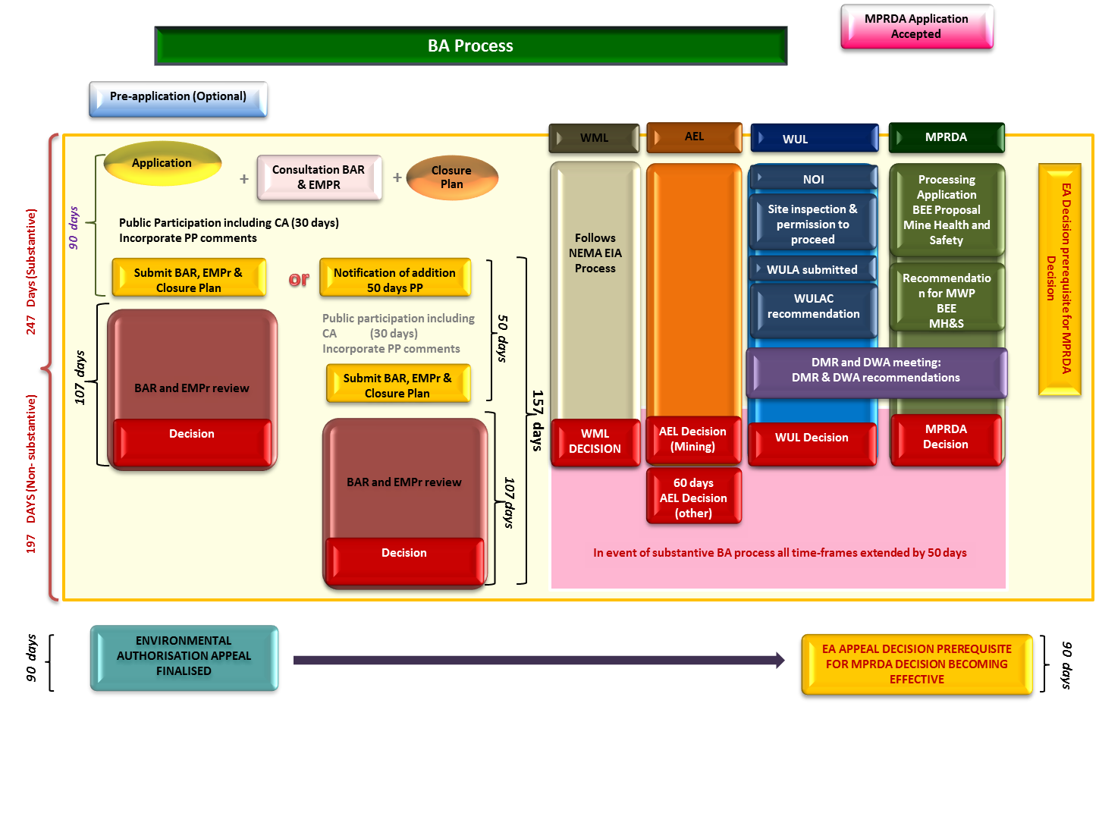

# Public Participation Office Contact Details

## tpr mining resources (Pty) Ltd

Contact Person: Mr. Thato Ramoraswi

Postal Address: P.O Box 1097

Lebowakgomo

0737

Physical Address: No: 137 Watermeyer Street

Klipfontein Ext

Emalahleni, 1034

Cell: 079 244 2470 / 076 115 5939

Fax: 086 599 3318

Email: info@tprmining-resources.co.za

# Details for the proponent

## MOMOTIPO PROJECTS (PTY) LTD

Contact person: Mr.Julius M. Makwela

Postal address: P.O. Box 12570

Onderstepoort

Pretoria

0110

Email: [76julimajuli@gmail.com](mailto:76julimajuli@gmail.com)

# COMMENT AND REGISTRATION SHEET

In order to ensure that you are kept up to date with the project, please ensure that you register as an IAP with TPR Mining Resources. To register as an IAP, kindly forward this page with contact details and any comments to Mr. Thato Ramoraswi at TPR Mining Resources (Pty) Ltd by using the above contact details:

|  |  |
| --- | --- |
| Title |  |
| First Name |  |
| Surname |  |
| Organisation |  |
| Position |  |
| Postal Address |  |
| City |  |
| Tel |  |
| Fax |  |
| Cell |  |
| Email |  |

Please indicate any comments or issues that the basic assessment report should address.

……………………………….............................................................................................................................................................................................................................................................................................................................................................................................................................................................................................................................................................................................................................................................................................................................................................................................................................................................................................................................................................................................................................................................................................................................................................................................................................................................................................................................................................................................................................................................................................................................................................................................................................................................................................................................................................................................................................................................................................................................................................................................................................................................................................................................................................................................................................................................................................................................................

Please provide the names and contact details of any other I&APs who should be added to the list of I&APs

……………………………………………………………..................................................................................................................................................................................................................................................................................................................................................................................................................................................................................................................................................................................................................................................................................................................................................................................................................................................................................................................................................................................................................................................................................................................................................................................................................................................................................................................................................................................................................................................................................................................................................................................................................................................................................................................................................................................................................................................................................................................................................................................................................................................................................................................................