INVITATION TO PARTICIPATE:

Proposed Waterkloof Marina Retirement Village
BACKGROUND INFORMATION DOCUMENT (BID)
Introduction
The purpose of this Background Information Document (BID) is to provide information to Interested and Affected Parties (I&APs) about the Proposed Waterkloof Marina Retirement Village on the Remaining Extent of the Farm Waterkloof 428 J.R, Gauteng Province.

The Environmental Impact Assessment Procedure (EIA) is in process under the December, National Environmental Management Act (NEMA) 2014 legislation and a Notice of Intent was lodged with the Gauteng Department of Agriculture and Rural Development (GDARD). Discussions are being held with GDARD to determine the best approach to the application prior to lodging the application.

This Background Information Document explains the proposed project and the regulatory processes that will have to be complied with, while providing Interested and Affected Parties (I&APs) with the opportunity to:
- Register as stakeholders in the public participation process; and
- Make initial comments on and contributions to the proposed project.

Contact person for representation on the application:
LEAP Contact Person: Jitske van den Heever Public Participation Assistant: Nkhensani Sithole
Tel: 012 344 3852 Tel: (012) 344 3582
Fax: 086 606 6130 E-mail: env@leapenviro.co.za
P.O. Box 13185 Hatfield, 0028
E-mail : jitske@leapenviro.co.za

Affected properties
Location: Remaining Extent of the Farm Waterkloof 428 J.R.
Extent: Approximately 48,8170 Hectares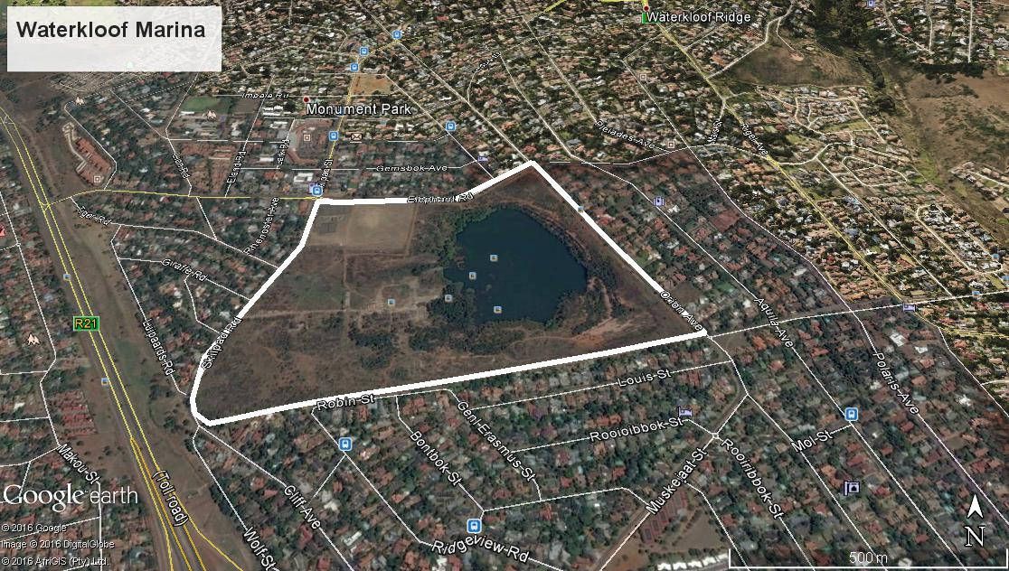
Figure 1: Location map of the remaining extent of the Farm Waterkloof 428 J.R.
Your comment is important
Your comments will ensure that all relevant issues are evaluated in the Environmental Impact Assessment (EIA). You are requested to complete the enclosed registration sheet, write a letter, call or e-mail the public participation office in Pretoria (Jitske van den Heever). Upon request you will then receive further information about the proposed project and the EIA process.

What is an EIA?
The Stone Arch Development Company (Pty) Ltd (The Applicant) to commence with the proposed development, the applicant must conduct an Environmental Impact Assessment (scoping) process and submit an Environmental Impact Assessment Report (EIAR) to the regulatory authorities (GDARD) in support of an application for environmental authorisation to proceed with the project. An Environmental Impact Assessment process is a well-defined and regulated process, in terms of the National Environmental Management Act, involving public participation and technical studies, to identify issues of concern and to evaluate the environmental and socio-economic impacts of a proposed project.

Environmental Impact Assessments are used by planning authorities to obtain an objective view of the potential environmental and social impacts that could arise during the construction and operation of the proposed development. This information must provide a sound basis for decision-making by the authorities. The end product of Environmental Impact Assessments process is an Environmental Impact Assessment Report, which must:
- Identify the potential impacts of the proposed activities;
- Outline the public participation process undertaken; Illustrate the issues, concerns and suggestions raised by Interested and Affected Parties; and
- Outline the environmental management and mitigation measures that must be taken to avoid or reduce negative impacts and enhance positive impacts.

The activities to be applied for:
Indicate the number of the relevant Government Notice: | Activity No (s) (relevant notice): e.g. Listing notices 1, 2 or 3 | Describe each listed activity as per the wording in the listing notices:
GNR 983, 04 December 2014 | Listing notice 1  Activity 9 | The development of infrastructure exceeding 1000 metres in length for the bulk  transportation of water or storm water-  - with an internal diameter of 0,36 metres or more; or  - with a peak throughput of 120 litres per second or more;  excluding where-  - such infrastructure is for bulk transportation of water or storm water or storm water drainage inside a road reserve; or  - where such development will occur within an urban area.
GNR 983, 04 December 2014 | Listing notice 1  Activity 10 | - The development and related operation of infrastructure exceeding 1000 metres in length for the bulk transportation of sewage, effluent, process water, waste water, return water, industrial discharge or slimes  - with an internal diameter of 0,36 metres or more; or  - with a peak throughput of 120 litres per second or more;  excluding where-  - such infrastructure is for bulk transportation of sewage, effluent, process water, waste water, return water, industrial discharge or slimes inside a road reserve; or  - where such development will occur within an urban area.
GNR 983, 04 December 2014 | Listing notice 1  Activity 19 | The infilling or depositing of any material of more than 5 cubic metres into, or the dredging, excavation, removal or moving of soil, sand, shells, shell grit, pebbles or rock of more than 5 cubic metres from-  - a watercourse;  - the seashore; or  - (the littoral active zone, an estuary or a distance of 100 metres inland of the high-water mark of the sea or an estuary, whichever distance is the greater -  But excluding where such infilling, depositing , dredging, excavation, removal or moving-  - will occur behind a development setback;  - is for maintenance purposes undertaken in accordance with a maintenance management plan; or  - falls within the ambit of activity 21 in this Notice, in which case that activity applies.
GNR 983, 04 December 2014 | Listing notice 1  Activity 26 | Residential, retail, recreational, tourism, commercial or institutional developments of 1000 square metres or more, on land previously used for mining or heavy industrial purposes; -  excluding -  - where such land has been remediated in terms of part 8 of the National Environmental Management: Waste Act, 2008 (Act No. 59 of 2008) in which case the National Environmental Management: Waste Act, 2008 applies; or  - where an environmental authorisation has been obtained for the decommissioning of such a mine or industry in terms of this Notice or any previous NEMA notice; or  - where a closure certificate has been issued in terms of section 43 of the Mineral and Petroleum Resources Development Act, 2002 (Act No. 28 of 2002) for such land.
GNR 984, 04 December 2014 | Listing notice 2  Activity 15 | The clearance of an area of 20 hectares or more of indigenous vegetation, excluding where such clearance of indigenous vegetation is required for-  - the undertaking of a linear activity; or  - maintenance purposes undertaken in accordance with a maintenance management plan.
GNR 985, 04 December 2014 | Listing Notice 3  Activity 4 | The development of a road wider than 4 metres with a reserve less than 13,5 metres.  (c) In Gauteng:  - A protected area identified in terms of NEMPAA, excluding conservancies;  - National Protected Area Expansion Strategy Focus Areas;  - Gauteng Protected Area Expansion Priority Areas;  - Sites identified as Critical Biodiversity Areas (CBAs) and Ecological Support Areas (ESAs) in the Gauteng Conservation Plan or in bioregional plans;  - Sites identified within threatened ecosystems listed in terms of the National Environmental Management Act: Biodiversity Act (Act No. 10 of 2004);  - Sensitive areas identified in an environmental management framework adopted by relevant environmental authority;  - Sites identified as high potential agricultural land in terms of Gauteng Agricultural Potential Atlas;  - Important Bird and Biodiversity Area (IBA);  - Sites or areas identified in terms of an International Convention;  - Sites managed as protected areas by provincial authorities, or declared as nature reserves in terms of the Nature Conservation Ordinance (Ordinance 12 of 1983) or the National Environmental Management: Protected Areas Act (Act No. 57 of 2003);  - Sites designated as nature reserves within municipal SDFs; or  - Sites zoned for a conservation or public open space or equivalent zoning.
GNR 985, 04 December 2014 | Listing Notice 3  Activity 12 | The clearance of an area of 300 square metres or more of indigenous vegetation except where such clearance of indigenous vegetation is required for maintenance purposes undertaken in accordance with a maintenance management plan.  - In Eastern Cape, Free State, Gauteng, Limpopo North West and Western Cape provinces:  - Within any critically endangered or endangered ecosystem listed in terms of section 52 of the NEMBA or prior to the publication of such a list, within an area that has been identified as critically endangered in the National Spatial Biodiversity Assessment 2004;  - Within critical biodiversity areas identified in bioregional plans;  - Within the littoral active zone or 100 metres inland from high water mark of the sea or an estuarine functional zone, whichever distance is the greater, excluding where such removal will occur behind the development setback line on erven in urban areas; or  - On land, where, at the time of the coming into effect of this Notice or thereafter such land was zoned open space, conservation or had an equivalent zoning.
GNR 985, 04 December 2014 | Listing Notice 3  Activity 14 | The development of –  - Canals exceeding 10 square metres in size;  - Channels exceeding 10 square metres in size;  - Bridges exceeding square metres in size;  - Dams, where the dam, including infrastructure and water surface area exceeds 10 square metres in size;  - Weirs, where the weir, including infrastructure and water surface area exceeds 10 square metres in size;  - Bulk storm water outlet structures exceeding 10 square metres in size  - Marinas exceeding 10 square metres in size;  - Jetties exceeding 10 square metres in size;  - Slipways exceeding 10 square metres in size;  - Buildings exceeding 10 square metres in size  - Boardwalks exceeding 10 square metres in size; or  - Infrastructure or structures with a physical footprint of 10 square metres or more  Where such development occurs –  - Within a watercourse;  - In front of a development setback; or  - If no development setback has been adopted, within 32 metres of a watercourse measured from the edge of a watercourse  Excluding the development of infrastructure or structures within existing ports or harbours that will not increase the development footprint of the port or harbour  - In Gauteng:  - A protected area identified in terms of NEMPAA, excluding conservancies;  - National Protected Area Expansion Strategy Focus Areas;  - Gauteng Protected Area Expansion Priority Areas;  - Sites identified as Criticial Biodiversity Areas (CBAs) and Ecological Support Areas (ESAs in the Gauteng Conservation Plan or in bioregional plans.  - Sites identified within threatened ecosystems listed in terms of the National Environmental Management Act: Biodiversity Act (Act No 10 of 2004)  - Sensitive areas identfied in an environmental management framework adopted by relevant environmental authority;  - Sites or areas identfied in terms of an International Convention.  - Sites managed as protected areas by provincial authorities, or declared as nature reserves in terms of the Nature Conservation Ordinance (Ordiance 12 of 1983) or the National Environmental Management: Protected Areas Act (Act No. 57 of 2003)  - Sites desiganted as nature reserves within muniicpal SDFs; o  - Sites zoned for conservation or public open space or equivalent zoning.

Public Participation
The public participation process during the Environmental Impact Assessment phase will enable Interested and Affected Parties to influence the course of the technical investigations and to review the findings of the independent studies that are undertaken. The environmental consultants will correspond directly with registered Interested and Affected Parties at various stages during the process to keep them informed of progress in the study and the timing of opportunities to be involved. The steps in the public participation process are outlined below.
- Letters of invitation accompanied by this Background Information Document and comment sheet to be distributed to adjacent landowners within 100m from the area of the proposed development, key individuals and organisations, announcing the project and inviting their comment
- Advertisements in Local newspaper (Citizen) announcing the proposed project and providing opportunity to comment
- Site notices to be erected at strategic places along the property in accordance with the requirements of the Environmental Impact Assessment Regulations, in order to announce the project
- Key stakeholders in the area will be informed by telephone, e-mail or facsimile.
- All issues received from stakeholders will be captured in the comments and response report (C&RR) which will be used to screen and prioritise issues for evaluation

Specialist studies being conducted
The following specialist studies are currently being conducted to provide the necessary detail to GDARD to make informed decisions regarding the application. Furthermore, the specialist studies provide the Interested and Affected Parties the information required to gauge the potential impact and to see if the issues that are important to them are addressed.
- Traffic Impact Assessment
- Services report to include Roads, Water provision, Sewer reticulation and Storm Water
- Electricity
- Architectural Studies
- Town planning Motivational Memorandum
- Ecological Assessment
- Heritage Impact Assessment

A Public Awareness Open Day will be held on the 25th of May 2016 on site by the tennis courts (Corner Elephant and Skilpad Road):

The Open Day will start at 09h00 with a public information session.

A formal presentation will be presented at 18h00.

Due date for registration is 15 April 2016

INVITATION TO PARTICIPATE:  EIA as per NEMA  waterkloof marina  REGISTRATION SHEET  Accompanying Background Information Document  March 2016 | Public Participation Office  LEAP  Jitske van den Heever  P.O. Box 13185, Hatfield, 0028  FAX 086 606 6130  jitske@leapenviro.co.za  Nkhensani Sithole  env@leapenviro.co.za

Please complete and return to the contact details as provided, by 15 April 2016 to register
TITLE |  | FIRST NAME
INITIALS |  | SURNAME
ORGANISATION
POSTAL ADDRESS
 |  | POSTAL CODE
LAND LINE TEL NO |  | CELL NO
FAX NO |  | EMAIL

Please formally register me as an interested and affected party (I&AP) so that I may receive further information and notifications during the EIA (Scoping) process |  |  |  |  | YES | NO
I would like my notifications and documents for comment as follows:
Letter (mail) | E-mail | Fax | On CD | Internet
In terms of this Public Participation process I disclose below any direct business, financial, personal or other interest that I may have in the approval or refusal of the application:
…………………………………………………………………………………………………………………………………………………………

COMMENTS (please use separate sheets if you wish)
I suggest that the following issues of concern be investigated:
………………………………………………………………………………………………………………………………………………...
I suggest the following for the public participation process:
……………………………………………………………………………………………………………………..………………………….
Any other comments:
……………………………………………………………………..…………………………………………………………………………..
……………………………………..…………………………………………………………………………………………………………..

Please also register the following people as I&APs for this process:
…………………………………………………………………………………………………………..…………………………………….
……………………………………………………………………………………………………………..…………………………………

THANK YOU FOR YOUR CONTRIBUTION
Signature
Date

