CONSTRUCTION OF NEW MATAMELA RAMAPHOSA SECONDARY SCHOOL AT SPA PARK BELA-BELA.
PREPARED BY
COMPANY NAME | : RONELL GROUP (PTY) LTD
CONTACT PERSON | : MR. R TSHIBUBUDZE
CONTACT NUMBER | : 081 522 9330
EMAIL ADRESS | : ronellprojects@gmail.com
PREPARED FOR
COMPANY NAME | :Independent Development Trust (IDT:Limpopo Region)

Construction of the New Matamela Ramaphosa Secondary School at Spa Park Bela-Bela
INTRODUCTION AND PROJECT DETAILS
The Independent Development Trust (IDT: Limpopo Region) is Applying for an Environmental Authorisation for the Construction of Matamela Ramaphosa Secondary School. The project is Located on Portion 266 of the Farm Warmbath 1491.The proposed Development (CONSTRUCTION OF NEW MATAMELA RAMAPHOSA SECONDARY SCHOOL AT SPA PARK BELA-BELA) entails the following scope of work:
• 30 Ordinary Classrooms (Single storey buildings no double storey)
• Large Admin Block
• Nutrition Centre
• Multipurpose School Hall
• Science and Life Science Combo (Emphasis on Combo do not separate)
• Computer Lab and Media Centre Combo (Emphasis on Combo do not separate) Media Centre being your traditional library.
• 46 Waterborne Toilets for Learners with 2 being for disabled. 1 for Female and 1 for Male
• 8 additional toilets close to the Admin for teachers. 1 to be for Disabled.
• Multipurpose Classroom
• Perimeter fencing for 4.8 Hectares or for the available land. Fence to be steel palisade at 2.1 meters high (the department advised that there should be a layer of brickwork or concrete at the bottom of the fence to avoid intrusion from below. Preferably concrete)
• Drill and Equip Borehole
• 100Kl water storage on elevated steel tanks. Half of the tanks at 4m high and the other half at 6m high
• 25 Covered Parking Bays and 15 Uncovered paved Parking bays
• Guard House
• Rainwater Harvesting tanks 2 per block
• sports grounds for the kids
The proposed alternative was considered based on the location within land owned by the applicant, avoidance of any high sensitivity on site, no other property alternatives have been proposed for the project as this is the only site available for the applicant. Technology alternatives were not considered, as the applicant will be making use of the Best Practical Environmental Option that is available. The Applicant alternative considered the groundwater availability on the farm and power supply from Eskom.The development triggers listed activities in terms of the Environmental Impact Assessment (EIA) Regulations, Government Notice Regulations (GNR) 983 of 8 December 2014 promulgated under the National Environmental Management Act (NEMA) (Act no 107 of 1998). In terms of the said Regulations, a Basic Assessment (BA) should be undertaken for the proposed project. IDT has appointed Ronell Group (Pty) Ltd as an independent Environmental Assessment Practitioners for the above described project.
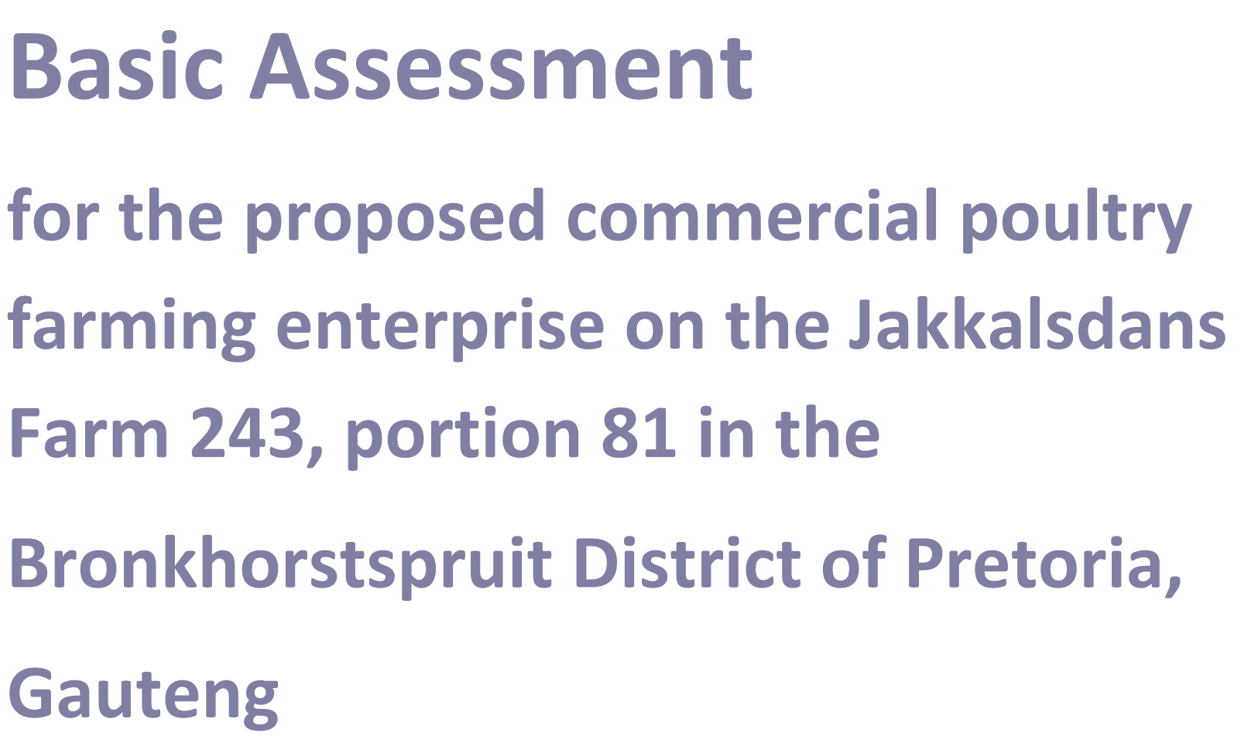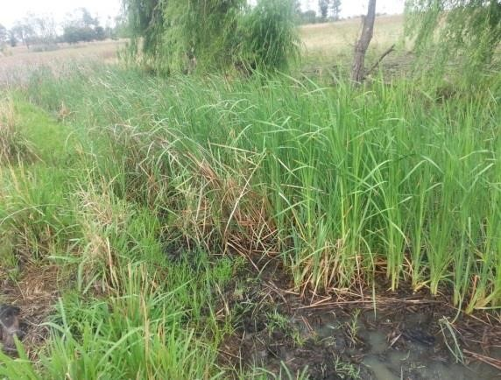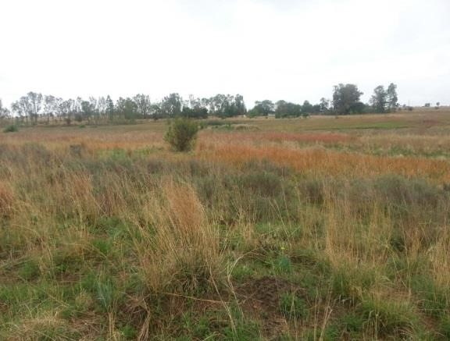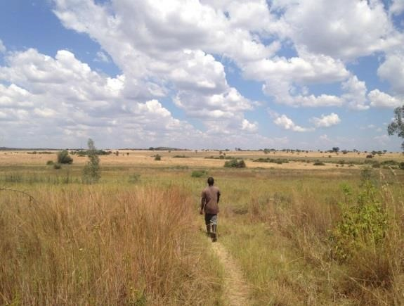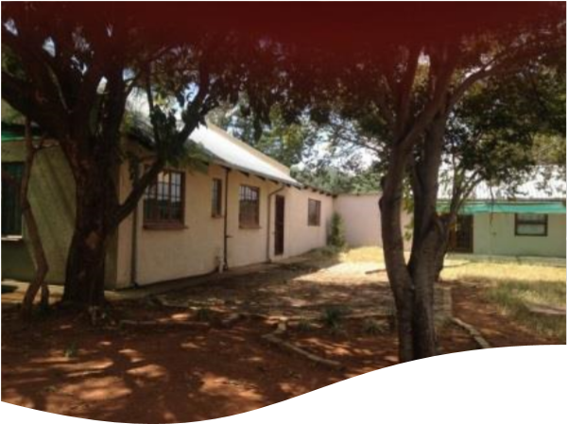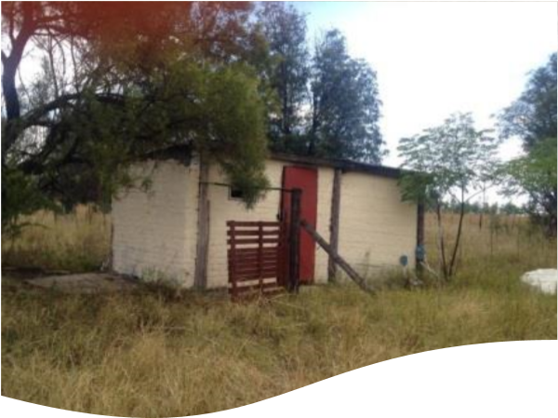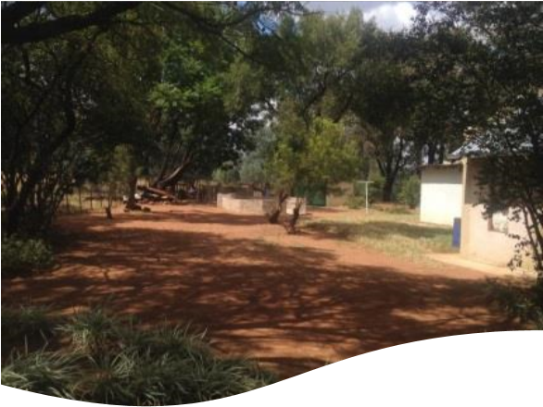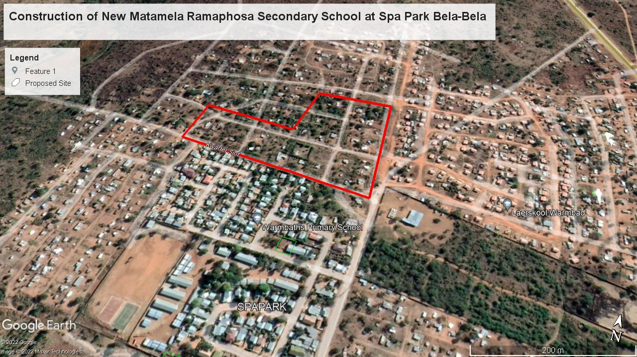

CSIR Reference
Number:

CSIR/CAS/EMS/IR/2015/0001/A

Background Informatn Document

asic Assessment

for

the proposed commercial poultry
farming enterprise on the Jakkalsdans
Farm 243, portion 81 in the

Bronkhorstspruit District of Pretoria,

Gauteng

Dani Property Trust
(
trading as Kganana
Poultry Farm)

Figure 1: Location of the proposed Project

AIM OF THE DOCUMENT
This Background Information Document (BID) provides potential Interested and Affected Parties (I&APs) with:
- Information on the proposed project;
- A description of the Basic Assessment process to be followed; and
- Details on how to register your interest in the project and receive further information.
- Showing the Exact location of the project.
As a registered I&AP, there will be opportunities for you to be involved in this Basic Assessment (BA) process through receiving information, engaging issues and commenting on the Basic Assessment Report (BAR). The input from I&APs, together with the information and assessment provided by the EAP (Ronell Group) and relevant specialists, will be used by the Competent Authority, in this instance the LEDET, for decision-making on the proposed project.
BRIEF PROJECT DESCRIPTION
The proposed Development entails the following scope of work:
• 30 Ordinary Classrooms (Single storey buildings no double storey)
• Large Admin Block
• Nutrition Centre
• Multipurpose School Hall
• Science and Life Science Combo (Emphasis on Combo do not separate)
• Computer Lab and Media Centre Combo (Emphasis on Combo do not separate) Media Centre being your traditional library.
• 46 Waterborne Toilets for Learners with 2 being for disabled. 1 for Female and 1 for Male
• 8 additional toilets close to the Admin for teachers. 1 to be for Disabled.
• Multipurpose Classroom
• Perimeter fencing for 4.8 Hectares or for the available land. Fence to be steel palisade at 2.1 meters high (the department advised that there should be a layer of brickwork or concrete at the bottom of the fence to avoid intrusion from below. Preferably concrete)
• Drill and Equip Borehole
• 100Kl water storage on elevated steel tanks. Half of the tanks at 4m high and the other half at 6m high
• 25 Covered Parking Bays and 15 Uncovered paved Parking bays
• Guard House
• Rainwater Harvesting tanks 2 per block
• sports grounds for the kids
NEED AND JUSTIFICATION FOR THE PROJECT
At a local level, employment opportunities will be created for surrounding land occupiers. The facility will aid in addressing the challenge of Education in South Africa. seeks to eliminate inequalities and poverty amongst households that is made apparent by inadequate and unstable Educational provision and weak institutional support networks and disaster management systems. The proposed project aligns itself with the Municipality Vision outlined in the IDP. The following strategic objectives are sought to be achieved and are aligned with the objectives of the proposed project:
- Promote shared economic growth and job creation;
- Improve financial sustainability;
- Continue institutional development, transformation and innovation.
- Promotes Educational status of the area
ENVIRONMENTAL LEGISLATION –BASIC ASSESSMENT PROCESS
In terms of the NEMA EIA Regulations published in GNR 983, 984 and 985 on the 8 December 2014 Government Gazette Number 38282, a BA process is required as the project triggers the following listed activities (detailed in Table 1 below).
Table 1: Listed activities to be triggered
Indicate the number of the relevant Government Notice: | POTENTIAL APPLICABILITY | Describe each listed activity as per the wording in the listing notices:
GNR327:LN1  Activity 27 | The proposed new school development will lead to the clearance of approximately 4ha of indigenous vegetation. | The clearance of an area of 1 hectare or more but less  than 20 hectares of indigenous vegetation

The Basic Assessment process that will be undertaken for this project is summarised in the steps below:
Step 1: Notify Authorities and potential I&APs (30 days) (current stage)
The first stage in the process entails notifying all potential I&APs of the proposed project, by sending out a Background Information Document (BID), and providing I&APs with an opportunity to register as an I&AP. I&APs are required to register their interest on the project database within 30 days (in order to be included from the outset of the Basic Assessment process) and/or raise issues or concerns.

Step 2: Basic Assessment Report for Public Comment (30 days) (Current stage)
The Basic Assessment process has been undertaken in order to identify and assess potential environmental impacts, both positive and negative, that may be associated with the project. Mitigation and management measures has been identified to reduce potential negative impacts and maximise positive benefits. These mitigation and management measures has been included in the Environmental Management Programme (EMPr) for this project.
The Basic Assessment Report include comments received from all I&APs on this BID and findings of the specialist studies. All registered I&APs on the project database will be notified in writing of the 30-day comment period for the BAR.
The Draft BAR will be submitted to LEDET for review during this period, and after receiving comments and concerns a final BAR will be compiled as per the comments received and all comments and concerns raised will be included on the report to be submitted to the competent authority (LEDET).

Step 3: BAR to be submitted to LEDET for decision-making
The BAR will be drafted and will be submitted to LEDET for decision-making. The comments and issues raised will be included in the BAR submitted to LEDET. All I&APs will be provided with written notification on the decision made by competent authority and about the appeal process.

SPECIALIST SCOPE OF WORK
An Ecological Impact Assessment of the site will be conducted and the Heritage Impact Assessment by the specialists.
HOW TO REGISTER AN INTERESTED AND AFFECTED PARTY OF THE PROPOSED DEVELOPMENT?
- By responding to our invitation for your involvement as advertised in the local newspaper.
- By emailing a comment form to the Environmental Assessment Practitioner indicated below.
- By telephonically contacting the Environmental Assessment Practitioner if you have a query, comment, or require further project information.
- By reviewing the various reports and provide comments within the stipulated comment periods provided (i.e. the BID and Draft BAR).
Environmental Assessment Practitioner Details
To register as an I&AP or to comment on the project, please send your comments on the details below by October 2022:
COMPANY NAME | : RONELL GROUP (PTY) LTD
CONTACT PERSON | : MR. R TSHIBUBUDZE
CONTACT NUMBER | : 081 522 9330
EMAIL ADRESS | : ronellprojects@gmail.com

