Environmental IMPACT ASSESSMENT AND WATER USE LICENSE APPLICATION
for THE Proposed THOKOZA ROAD UPGRADE IN MANDENI CBD

BACKGROUND INFORMATION DOCUMENT and INVITATION TO PARTICIPATE

6 NOVEMBER 2014

1. PURPOSE OF THIS DOCUMENT

The aim of this document is to:
- Provide background information to parties interested in and/or affected by the proposed development;
- Provide information of the Environmental Impact Assessment (EIA) Process to be followed for the proposed upgrade of Thokoza Road with includes a road realignment and installation of culvert; and
- Indicate how you, as an Interested and Affected Party (I&AP), can become involved in the EIA process.

2. PROJECT DESCRIPTION

The Mandeni Local Municipality is planning an upgrade of the Thokoza Road, within the Mandeni Central Business District (CBD). The project includes the realignment of the main arterial road (Thokoza Road) in order to improve the line of sight of the Central Business District (CBD) and an improvement to the section of P.415 between the Ithala Centre and Renken’s Spar, which is aimed at creating a more aesthetically pleasing entrance to Mandeni and developing the road edges as part of a Public Open Space (POS) network. This road upgrade project forms part of the proposed Sundumbili-Mandeni Urban Regeneration Programme, which will include features such as sidewalks, street lighting and new stormwater reticulation.

The road upgrade will require upgrading of the culvert. The box culvert will be 2.5m x 1.8m in extent.

3. PROJECT LOCATION
The site is located on Reserve 21 16882, Mandeni (Refer to Appendix 1, Locality Map). The study area occurs within quarter degree grid cell (QDGC) 2931BA with the geographical coordinates of the site at 29°8'35.80"S and 31°24'10.14"E.
4. INTRODUCTION TO THE PROJECT
The Mandeni Municipality intends to re-align the present Thokoza Road to behind the Ithala Centre over a length of 730m, and provide sidewalks and street lighting to the new road. A new stormwater reticulation relating to the road will also be provided. In addition, the crossing of the Transnet gas pipeline at two locations will require the construction of reinforced concrete in-place box culverts.
Furthermore, the section of P.415 between the Ithala Centre and Renken’s Spar, over a total length of 500m is to be upgraded to tie into the extension of Thokoza Road.
Bulk services supply will be provided by linking up to existing services. Based on the outcome of the traffic impact assessment, required road upgrades will be included.

5. ENVIRONMENTAL IMPACT ASSESSMENT (EIA) AND WATER USE LICENSE APPLICATION PROCESSES - LEGAL FRAMEWORK

In terms of the EIA regulations published in Government Notice No. R544 of 18 June 2010 under Section 24(5), and 44 of the National Environmental Management Act (Act No 107 of 1998), as amended, a Basic Assessment Process (in terms of Listing Notice 1 – GN R544) is required for the listed activity 11 of GNR 544.

Activity 11: The construction of: (i) canals; (ii) channels; (iii) bridges; (iv) dams; (v) weirs; (vi) bulk storm water outlet structures; (vii) marinas; (viii) jetties exceeding 50 square metres in size; (ix) slipways exceeding 50 square metres in size; (x) building exceeding 50 square metres in size; (xi) infrastructure or structures covering 50 square metres or more where such construction occurs within a watercourse, or within 32m of a watercourse, measured from the edge of a watercourse, excluding where such construction will occur behind the development setback line.

In terms of the National Water Act (NWA), (Act 36 of 1998), a Water Use License is required for the listed activities of Section 21 (c) and 21 (i).

Section 21: (c): impeding or diverting the flow of water in a watercourse; (i): altering the bed, banks, course or characteristics of a watercourse.

The Basic Assessment Process and Water Use License Application (WULA) consist of the following two very closely interlinked processes:
- A technical process, which entails the identification and management of possible environmental issues/concerns; and
- A public participation process, which requires public consultation in order to assist in the identification of possible environmental and/or social issues and/or concerns.

6. ANTICIPATED ENVIRONMENTAL ISSUES

It is anticipated that the following environmental aspects will be significant and will hence be addressed by the Project Team during the assessment process:
- Engineering constraints;
- Impacts on vegetation and faunal habitats;
- Impacts on water resources and wetlands;
- Visual impacts; and
- Impacts on the socio-economic dynamics of the area.

Management guidelines will be developed for the abovementioned issues and incorporated in an Environmental Management Plan (EMP).

You are welcome to comment on the above list and provide additional anticipated issues and possible impacts which should be addressed.

7. SPECIALISTS

Due to this proposed road upgrade phase forming part of a larger Sundumbili-Mandeni Urban Regeneration Programme, the specialist studies have been conducted already. The Project Team has thus identified potentially significant issues and will further assess these impacts in terms of their significance in accordance with the guidelines for EIA published by the Department of Environmental Affairs and Tourism (DEAT). The following specialist studies have been conducted:
- Ecological assessment; and
- Wetland delineation;

DEDTEA or other stakeholders may require additional specialists’ studies if necessary.

8. PUBLIC PARTICIPATION PROCESS (PPP)

Public Participation (PP) is any process that involves the public in problem solving or decision-making and forms an integral part of the EIA and WULA processes. The PPP provides people who may be affected by the proposed development, with an opportunity to provide comments and to raise issues of concern, or to make suggestions that may result in enhanced benefits for the project.

Comments and issues raised during the public participation process will be captured, evaluated and included in a Comments and Response Report, which will be incorporated into the draft Basic Assessment Report (BAR). The draft BAR will be made available for public review prior to submission to the environmental authority.

The process to be followed is depicted in Figure 1.

9. APPROVING AUTHORITY

The KwaZulu-Natal Department of Economic Development, Tourism and Environmental Affairs (DEDTEA) is the relevant authority which will review the Basic Assessment Report (BAR) and the Department of Water and Sanitation (DWS) will review the Water Use License Application. DEDTEA has to reach a decision as to whether, and under what conditions, the project may proceed, based on environmental considerations. A Record of Decision (ROD) will be issued based on the information provided in the BAR. DWS has to reach a decision on whether, and under what conditions, a water use license will be issued.

Record of Decision (RoD)
Draft Basic Assessment Report (BAR) & Environmental Management Plan (EMP)

SCOPE ISSUES (FIELDWORK, SPECIAILIST STUDIES ETC.)
Amend and submit Final BAR & EMP to Authority

SCOPE ISSUES (FIELDWORK, SPECIAILIST STUDIES ETC.)
Public Review

Feedback to I&APs

SCOPE ISSUES (FIELDWORK, SPECIAILIST STUDIES ETC.)
Notify I&APs

SCOPE ISSUES (FIELDWORK, SPECIAILIST STUDIES ETC.)
Site Notice

Advert

Letter/BID

Announce Public Participation Process

SCOPE ISSUES (FIELDWORK, SPECIAILIST STUDIES ETC.)
FIGURE 1: BASIC ASSESSMENT PROCESS
Submit Notice of Intent to Authority

SCOPE ISSUES (FIELDWORK, SPECIAILIST STUDIES ETC.)
Receive comments from I&APs

10. INVITATION TO PARTICIPATE

Exigent Engineering Consultants has been appointed by the Mandeni Local Municipality to manage and facilitate the environmental and public participation processes required for the project.

We would like to encourage you to participate in this EIA process. Should you wish to get involved, please complete the enclosed registration sheet and return it on or before 6 December 2014, to:

EXIGENT ENGINEERING CONSULTANTS
Jacolette Adam
P.O. Box 9514, Richards Bay, 3900,
Tel: (035) 788 0398
Fax: (086) 614 7328
E-mail: jacolette@exigent.co.za
Or to :
Themba Mjuza
Senior Town Planner
Mandeni Local Municipality
No. 2 Kingfisher Road, Mandeni, 4499
Tel: (032) 456 8200

APPENDIX 1. Locality Map

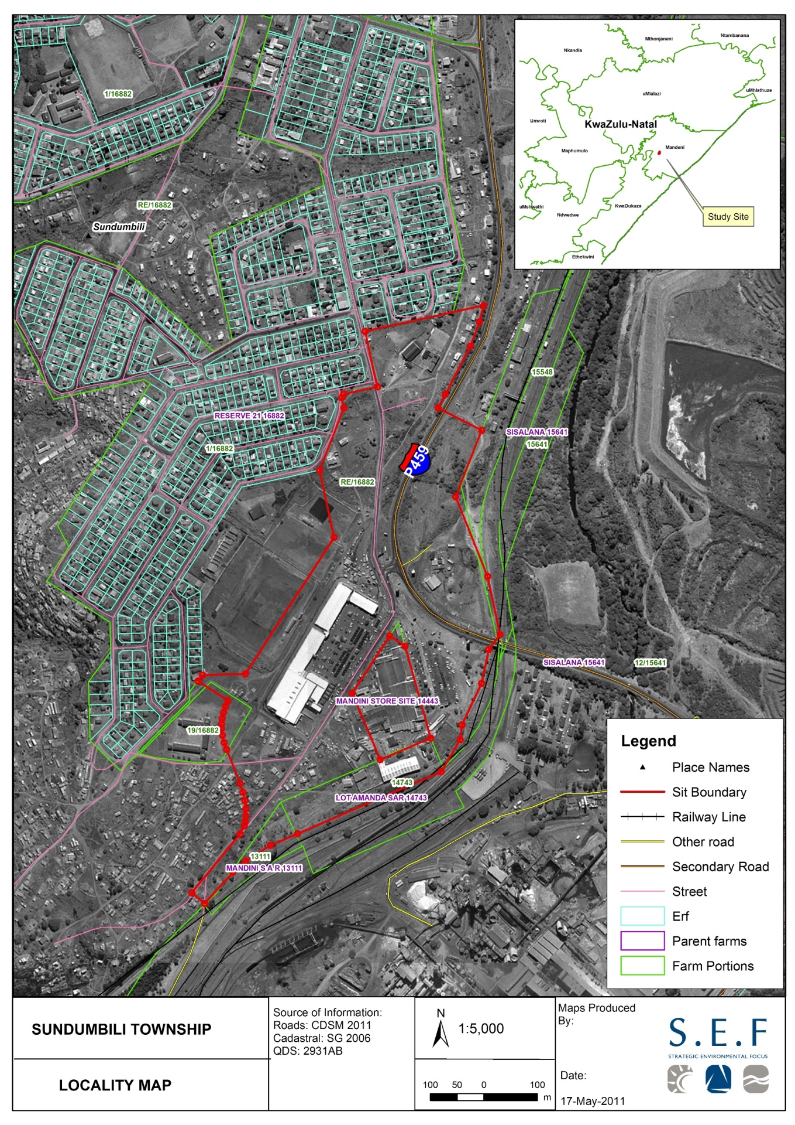
Culvert

