BACKGROUND INFORMATION DOCUMENT (BID)

**Basic Assessment Process:**

**Tilapia aquaponics farm project, Bosplaas West in North of Hammanskraal, in the Moretele Municipality in Bojanala District North West Province**

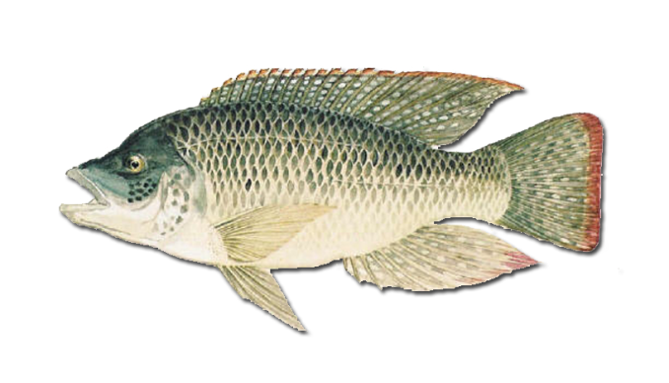

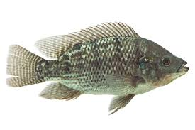

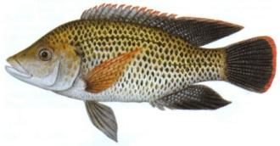

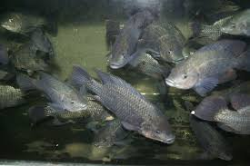



**Mashabela Karabo**

[**kmashabela1@csir.co.za**](mailto:kmashabela1@csir.co.za)

**CSIR Ref No:CSIR/02100/EMS/IR/2017/15674/A**

**INTRODUCTION OF THE PROPOSED PROJECT**

The Blue-Green Aquaculture PTY Ltd is a small scale commercial farming enterprise that was established in 2013 and is proposing to establish an aquaculture production facility. Blue-Green Aquaculture has leased land, i.e Plot 413 in Bosplaas West, from Mr T J Kgomo for the establishment of an aquaculture production farm. The lease agreement includes the utilisation of a borehole. Bosplaas West is north of Hammanskraal, in the Moretele Municipality in Bojanala District North West Province, and the leased area of the farm (Plot 413) is approximately two hectares (figure 1). The BA Process plays an important role in promoting sustainable agriculture.

**TECHNOLOGY CHOICE AND WATER MANAGEMENT**

The enterprise will start as an aquaponics facility and later it will be separated into an aquaculture farm and a hydroponics farm. Water will be sourced from the existing borehole on site and the effluent will be used to irrigate the vegetable garden.The technology that will be employed on the farm is recirculating aquaculture systems (RAS) linked to hydroponic growbeds. Figure 2 is a simplified overview of the technology employed in an aquaponics system. The fish are stocked in the fish rearing tanks (caption 1 in figure 2) and then the fish waste (faeces and uneaten food) flows into the settling tank (caption 2), the process of biofiltration result in the conversion of toxic ammonia into plant friendly nitrates (caption 3) before the nitrate rich water is fed to the plants (caption 4). In the Deep Water Culture (DWC) beds (caption 5); the plants grow and take up the nitrates and other micronutrients thereby cleaning the water (caption 6). The last step (caption 7) is the collection of clean water before being pumped back to the fish tanks.

|  |
| --- |
|  |
| **Figure 2:** Simplistic overview of aquaponics technology. |

**PURPOSE OF THE BACKGROUND INFORMATION**

The purpose of this document is to provide stakeholders with information, opportunity for registration as Interested and Affected Parties in the BA process. It is also to obtain their comments on the proposed Mozambican Tilapia Aquaculture project extending an area of approximately two hectares on Plot 413 Bosplaas West’ north of Hammanskraal, in the Moretele Municipality in the Bojanala District North West Province.

An application for an Environmental Authorisation (EA) will be made by the Council for Scientific & Industrial Research (CSIR) on behalf of Mr Pule Hlahane, (Project Applicant) to the North West Department of Rural Environment and Agricultural Development (READ), in terms of the Environmental Impact Assessment (EIA) Regulations, 2017 published in Government Notice (GN) R324 7 April 2017. The application will be done in terms of activities listed in GN R.327 and 324 which require a Basic Assessment to obtain EA prior to development. The aim of the environmental assessment is to identify potential impacts associated with the development and to recommend methods to avoid or reduce adverse impacts and promote positive impacts.

If you would like to participate in the process, please complete the included registration form to register as an Interested and Affected Party. Please quote the reference number provided and send any concerns or comments to:

**Ms. Karabo Mashabela**

🖳 Email: kmashabela1@csir.co.za

🕿 Tel: 021-888-2482

🖨 Fax: 021-888-2693

📪Address: CSIR, PO Box 320, Stellenbosch, 7599

🖳 Website: <http://www.csir.co.za/ems/specialneeds/>

**Kindly submit comments on or before the 30th of May 2017.**

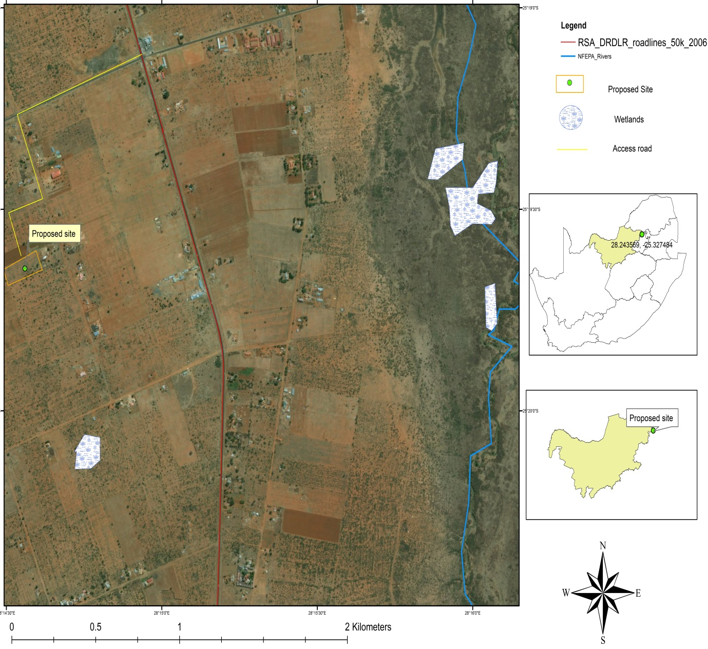

|  |
| --- |
|  |
| Figure 1: Project site for the proposed Blue Green Tilapia aquaponics farm project, Bosplaas West in North of Hammanskraal, in the Moretele Municipality in Bojanala District North West Province |

**SUMMARY OF THE ENVIRONMENTAL ASSESSMENT PROCESS**

Table 1: Listed activities applicable to the project.

|  |  |
| --- | --- |
| **Relevant notice and Activity No(s):** | **Description of each listed activity as per the Government Notice:** |
| GN. R 327, 7 April 2017 Activity 6 | The development and related operation of facilities, infrastructure or structures for aquaculture of—   1. finfish, crustaceans, reptiles or amphibians, where such facility, infrastructure or structures will have a production output exceeding 20 000 kg per annum (wet weight); |
| GN. R 327, 7 April 2017 Activity 8 | The development and related operation of hatcheries or agri-industrial facilities outside industrial complexes where the development footprint covers an area of 2 000 square metres or more. |
| GN. R 324, 7 April 2017 Activity 12 (a) ii. | The clearance of an area of 300 square meters or more of indigenous vegetation except where such clearance is required for maintenance purposes undertaken in accordance with a maintenance management plan.  ii. **C**ritical biodiversity areas as identified in systematic biodiversity plans adopted by the competent authority or in bioregional plans; |
| GN. R 324, 7 April 2017 Activity 13 (a) ii. | The development and related operation of facilities of any size for any form of aquaculture.  ii. A protected area including municipal or provincial nature reserves as contemplated by NEMPAA or other legislation; |

The BA process that will be undertaken for this project is summarised in the following steps:

***Step 1: Notify Authorities and potential Interested and affected parties (I&APs) (30 days) (current stage)***

The first stage in the process entails notifying all potential I&APs of the proposed project, by sending out a Background Information Document (BID), and providing I&APs with an opportunity to register as an I&AP. I&APs are required to register their interest on the project database within 30 days (in order to be included from the outset of the BA process) and/or raise issues or concerns.

***Step 2: Basic Assessment Report for Public Comment (30 days)***

The BA process is undertaken in order to identify and assess potential environmental impacts, both positive and negative, that may be associated with the project. Mitigation and management measures will be identified to reduce potential negative impacts and will be included in the Environmental Management Programme (EMPr) for this project. The Basic Assessment Report will include comments received from all I&APs on this document and findings of the specialist study. All registered I&APs on the project database will be notified in writing of the 30 day comment period for the BAR.

***Step 3: BAR to be submitted to DMR for decision-making***

The BAR will be drafted and will be submitted to the North West Department of Rural Environment and Agricultural Development (READ), for decision-making. The comments and issues raised will be included in the BAR. All I&APs will be provided with written notification on whether the project has been granted or refused EA and about the appeal process.