Batch images for SAHRA Temporary Export permit request 22152
BP/1/8900: Lissodus sp. Single tooth.
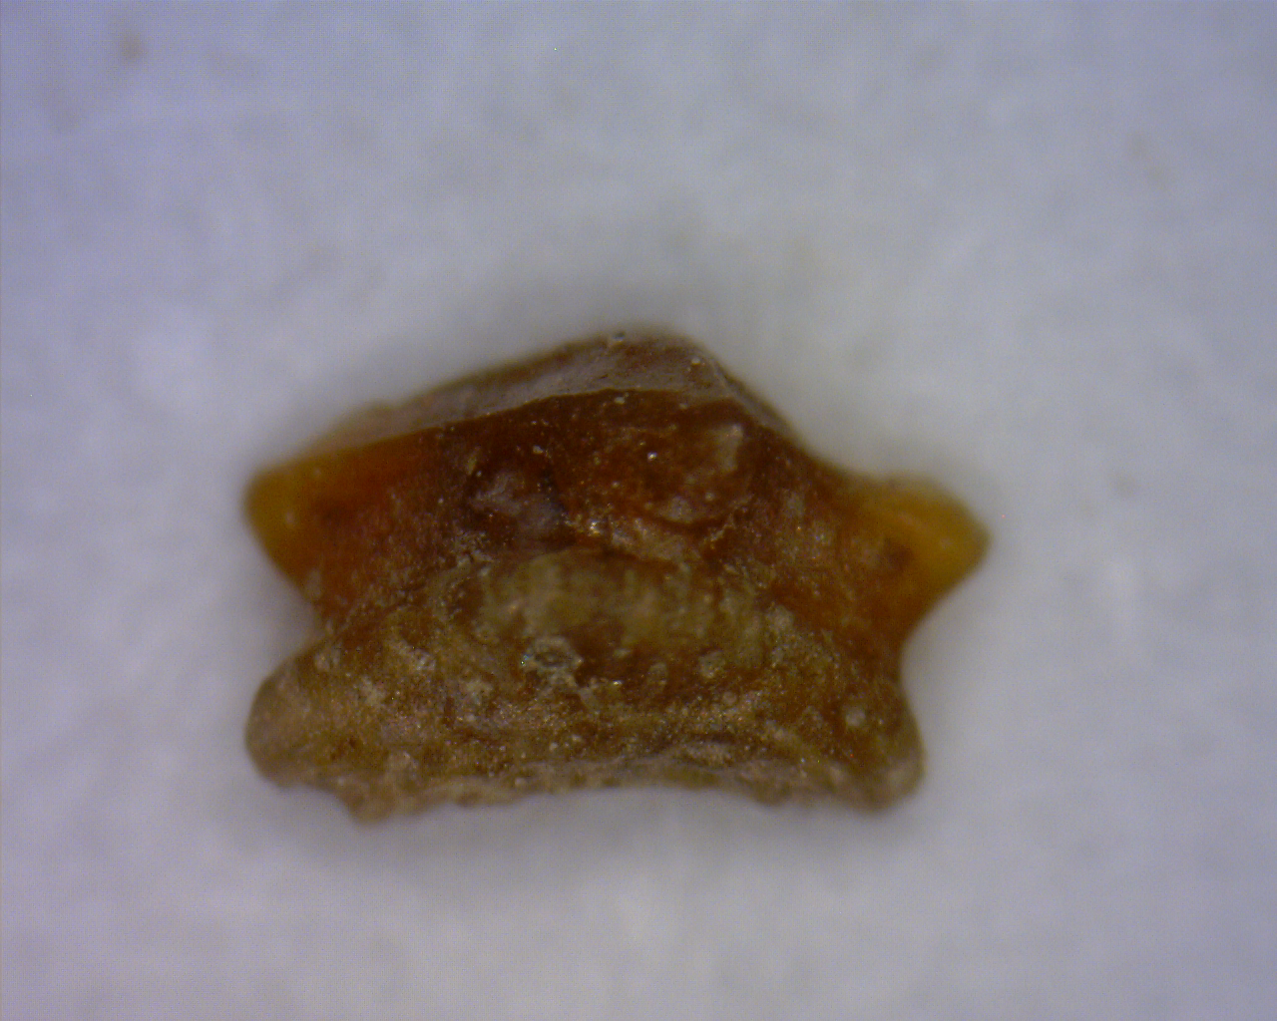
BP/1/8905: Lissodus tumidoclavus. Figured in Duffin et al., 2022, Fig. 4
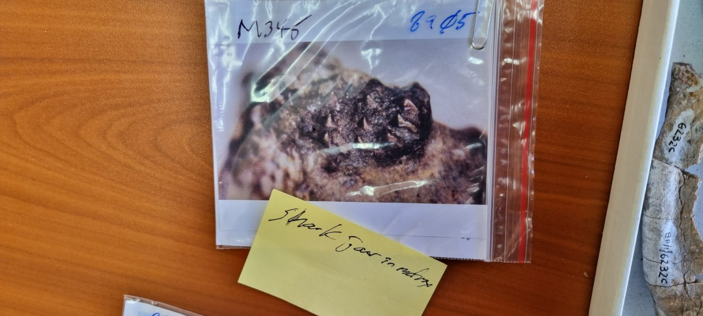

BP/1/8983: Unnamed hybodont. Individual tooth.
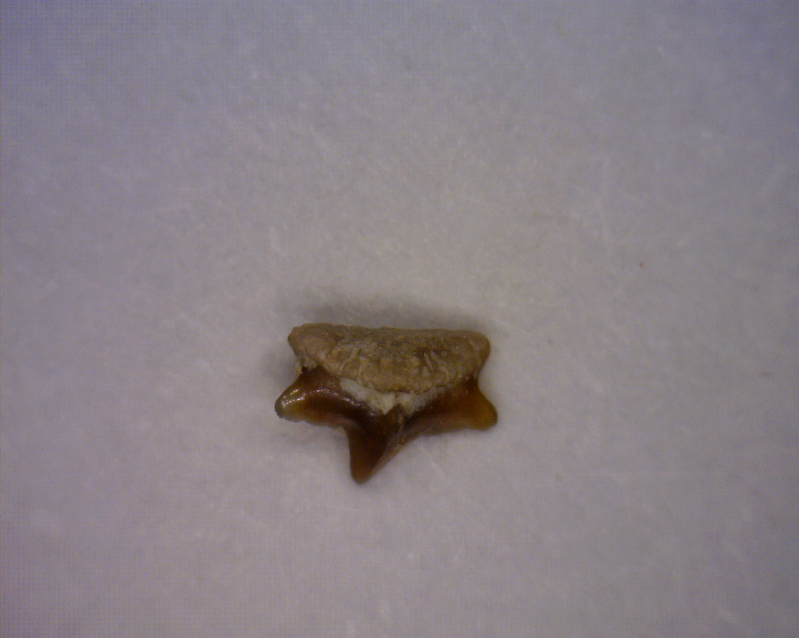

BP/1/8982: Unnamed hybodont. Individual tooth.
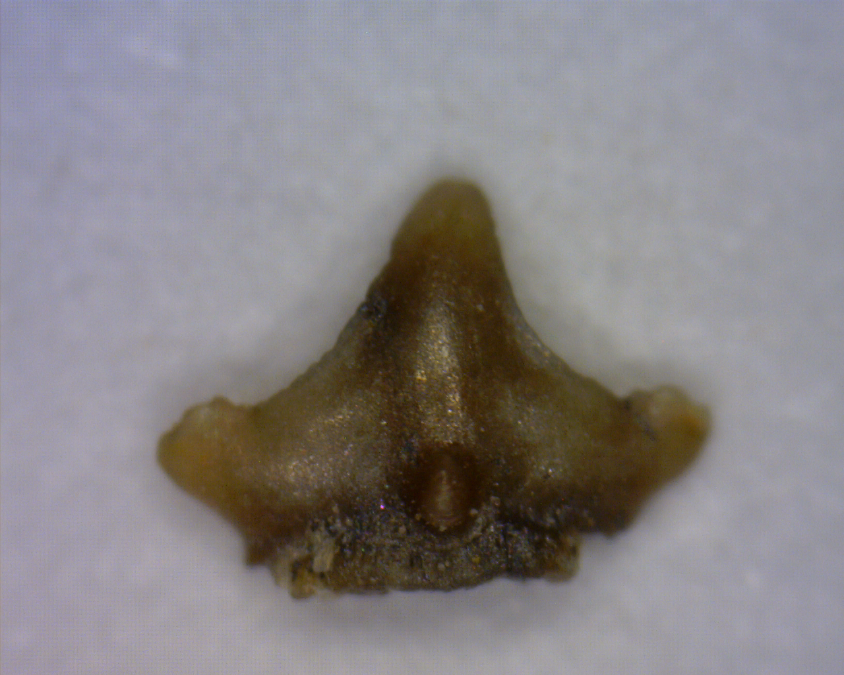
BP/1/8952. Polyacrodus sp.
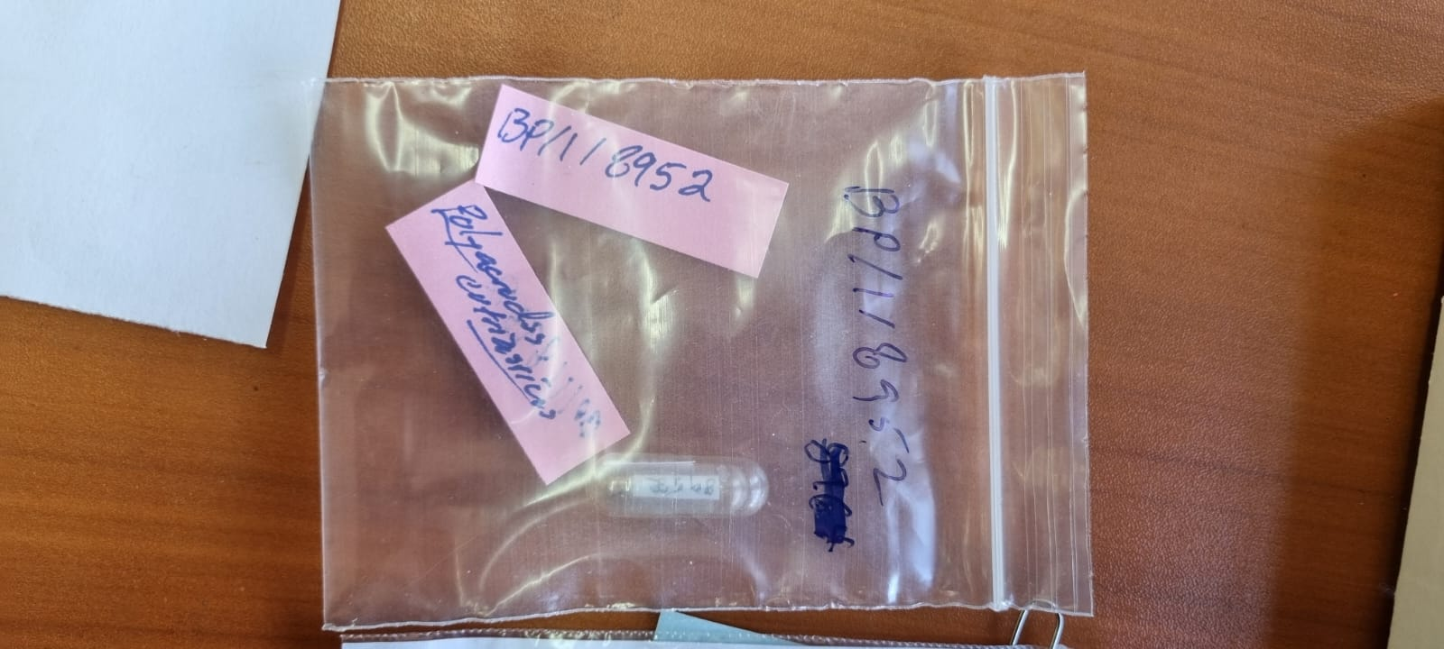

BP/1/9069. Archosauromoph osteoderm?

