CONDITION REPORT 1: ARTEFACTS: Outgoing Loans

Artifact name: IMPLEMENT: SPADE Acc no: RIM.2012.736.TAF
Brief description: Spade with blade worn at the bottom edge; entire spade made of steel
Image: 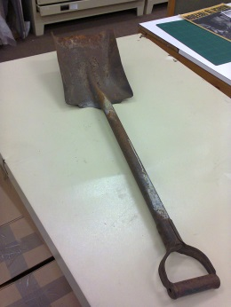
Dimensions: Total length: 910 mm x Total width: 220 mm
Materials: Steel with traces of blue paint: 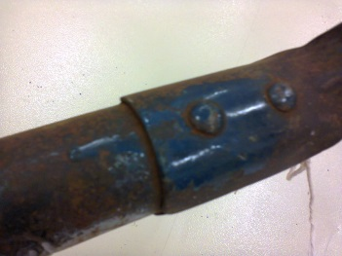
Any markings/Inscriptions: 82 LASHER MC2 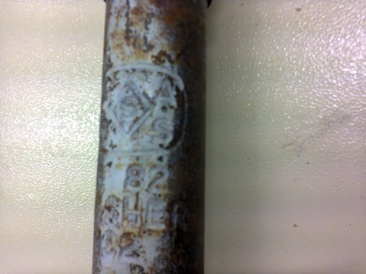
Condition: Overall good;
Signs of corrosion with minor crack center of blade
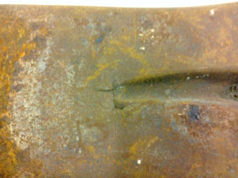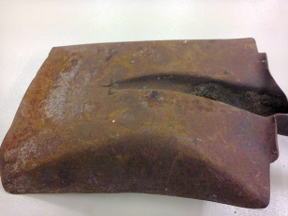

Bottom edge of blade shows signs of wear: 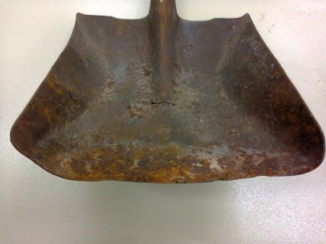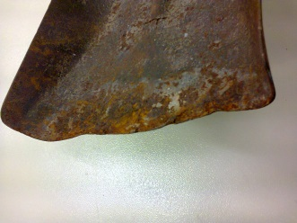
Any treatment done: None Date: n/a
Recommendations for Exhibitions:
- Stable Relative Humidity of 50-55%
- Suitable supports required if displayed vertically
- The spade requires handling with gloves as rust particles can transfer onto surfaces
Loan venue and duration: The Canadian Museum for Human Rights, Winnipeg, Canadä- “Mandela: Struggle for Freedom”; December 2017 to end January 2019.

Examined by: C. Wintein: Art & Artefacts Coordinator Date: October 2017

Condition upon return of loan:

