CONDITION REPORT 2: ARTEFACTS: Outgoing Loans

Artifact name: IMPLEMENT: PICK AXE Acc No: RIM.2012.1740.TAF
Brief description: Pick axe with steel head and wooden handle
Image: General view: 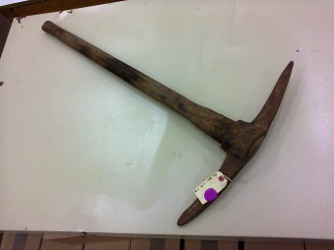
Dimensions: Total length: 900 mm x Total width : 220 mm
Materials: Steel and wood
Any markings/Inscriptions: None
Condition: Overall good;
Signs of corrosion on the head : 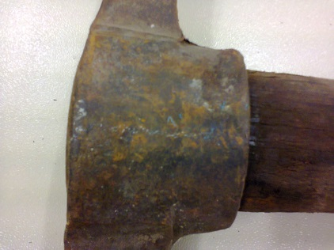

Staining on wood as a result of prolonged use: 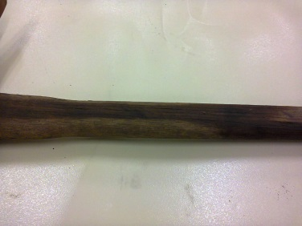
Caution! Head is sitting loose on the handle: 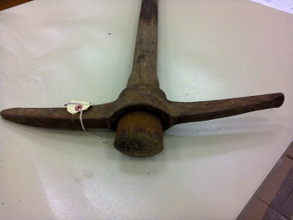

Any treatment done: None Date: n/a
Recommendations for Exhibitions:
- Stable Relative Humidity of 50-55%
- Preferably to be displayed horizontal; suitable support required for head and handle If displayed vertically
Loan venue and duration: The Canadian Museum for Human Rights, Winnipeg, Canada; Title of Exhibition: “Mandela: Struggle for Freedom”; December 2017 to end January 2019.
Examined by: C. Wintein: Art & Artefacts Coordinator Date: October 2017

Condition upon return of loan:

