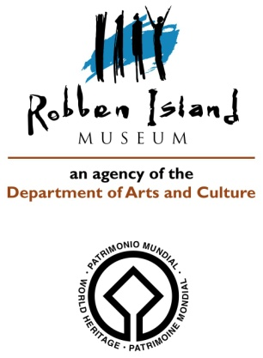

**CONDITION REPORT 4: ARTEFACTS: Outgoing Loans**

Artifact name: ***EQUIPMENT, CLEANING: BRUSH*** Acc. No: ***RIM.2013.101.AF***

Brief description: ***Oval shaped brush consisting of synthetic hairs on a wooden base and elastic band across the center, used as a grip. The brush was used by prisoners to polish the prison floors.***

Image: *General view:*

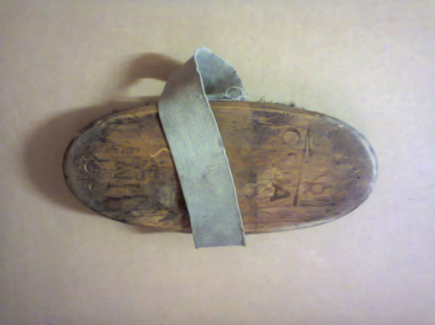  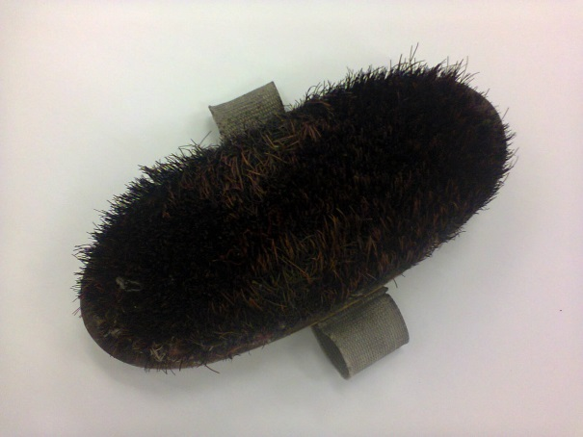

Dimensions: ***Total length: 220 mm x Total width: 90 mm***

Materials: ***Wood, synthetic hair, cotton elastic strap, remnants of polish (red color)***

Any markings/Inscriptions: ***Engraved: SD R and CS SA academy 4407***

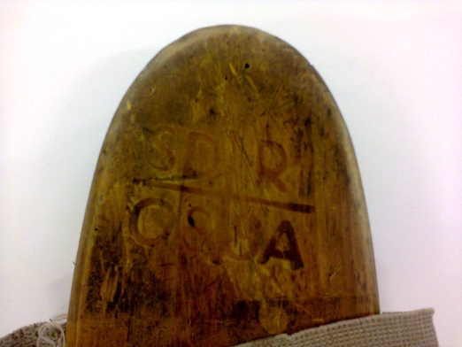 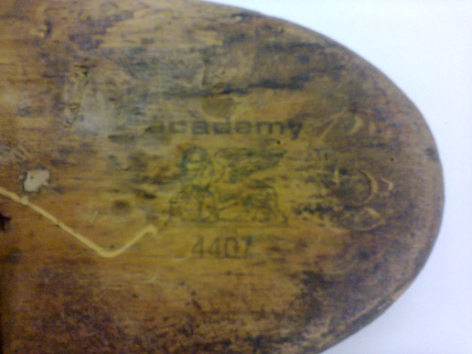

Condition: ***Fair; some hairs missing due to wear and tear and use; generally stable; remnants of color of floor polish used***

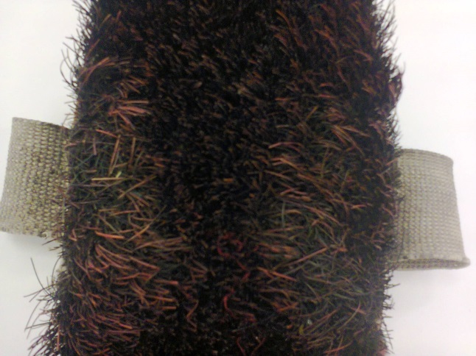

Any treatment done: ***None*** Date: ***n/a***

Recommendations for Exhibitions:

1. ***Stable Relative Humidity of 50-55%***
2. ***Exposure to less than 250 Lux and UV not greater than 75 µW/lm***
3. ***Moderate and constant temperature of 18-20°C***
4. ***Minimal handling as loss of hairs my occur***

Loan venue and duration: ***The Canadian Museum for Human Rights, Winnipeg, Canada; Title of Exhibition: “Mandela: Struggle for Freedom”; December 2017 to end January 2019.***

Examined by: ***C. Wintein: Art & Artefacts Coordinator***Date: ***October 2017***

Condition upon return of loan: