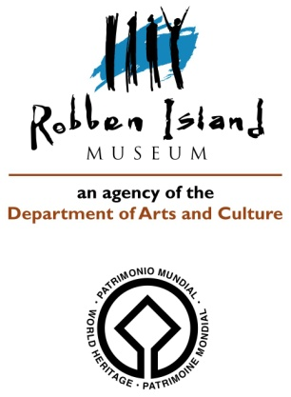
CONDITION REPORT 7: ARTEFACTS: Outgoing Loans

Artifact name: PRISON UNIFORM: PRISONER SHIRT Acc No: RIM/1998/8/AF-ED
Brief description: Khaki green shirt worn by prisoners during the prison services time. It has a V-neck collar and 1 front pocket. The shirt was worn over a pair of matching prison pants.
Image: General view: 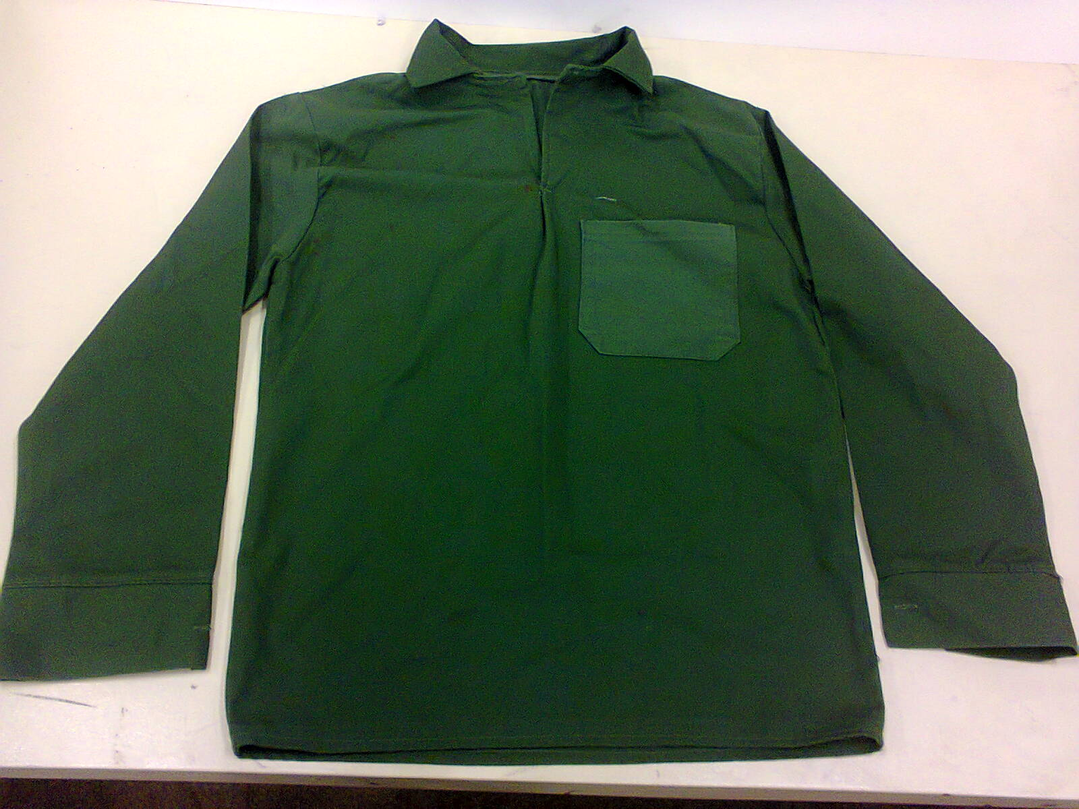
Dimensions: Total length: 720 mm; width: 510 mm
Materials: Heavy cotton cloth
Any markings/Inscriptions: None
Condition: Overall good with few (paint/polish) stains on the sleeves and on the neck line.
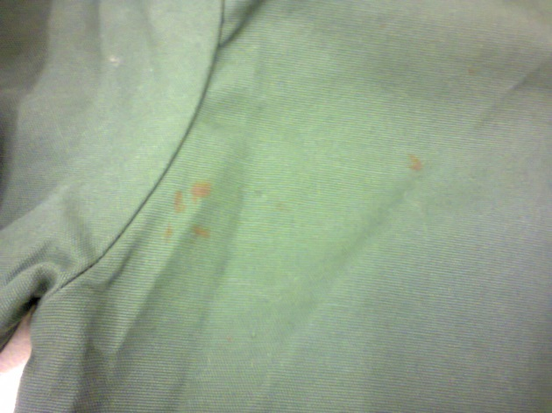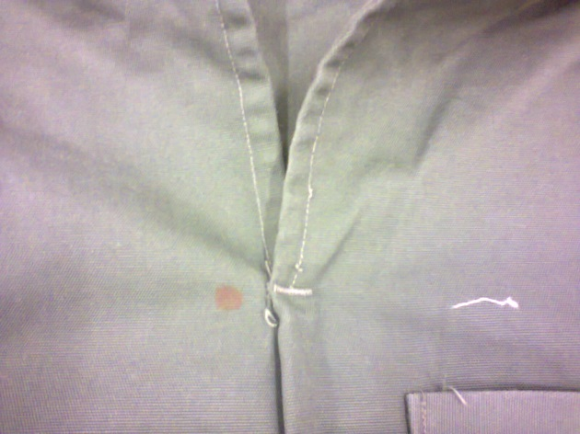

Any treatment done: None Date: n/a
Recommendations for Exhibitions:
- Stable Relative Humidity of 50-55%
- Exposure to less than 50 Lux and UV not greater than 75 µW/lm
Loan venue and duration: The Canadian Museum for Human Rights, Winnipeg, Canada; Title of Exhibition: “Mandela: Struggle for Freedom”; December 2017 to end January 2019.
Examined by: C. Wintein: Art & Artefacts Coordinator Date: October 2017

Condition upon return of loan:

