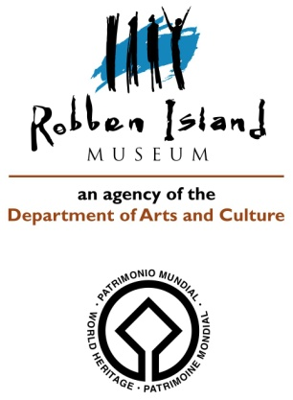
CONDITION REPORT 8: ARTEFACTS: Outgoing Loans

Artifact name: APARTHEID SIGN Acc. No: MCAF.1998.928
Brief description: Rectangular wooden wall sign with gold/yellow writing: “Non-Whites” “Nie-Blankes” and image of a hand indicating to the right. There are 2 holes on either side, used for affixing the sign to a surface/wall.
Image: Front view: 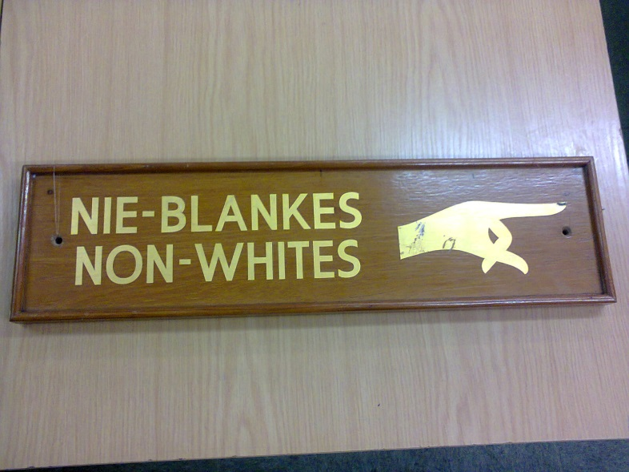
Back view: 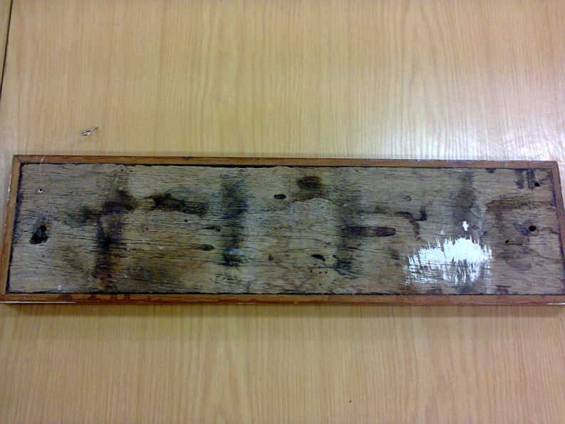
Dimensions: Total length: 600 mm; width: 160 mm
Materials: Wood, varnished in front; paint
Any markings/Inscriptions: See Description
Condition: Overall good with paint showing few scratches on the image of the hand
Any treatment done: None Date: n/a
Recommendations for Exhibitions:
- Stable Relative Humidity of 50-55%
- Exposure to no more than 250 Lux level
- Can be displayed against a wall: hanging device is supplied
Loan venue and duration: The Canadian Museum for Human Rights, Winnipeg, Canada; Title of Exhibition: “Mandela: Struggle for Freedom”; December 2017 to end January 2019.
Examined by: C. Wintein: Art & Artefacts Coordinator Date: October 2017

Condition upon return of loan:

