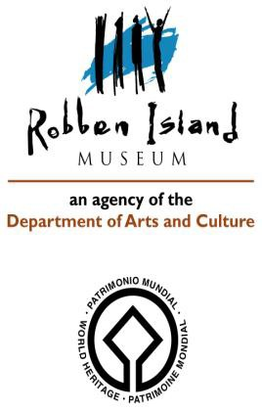INTERNATIONAL OUTGOING LOAN AGREEMENT
between

The Lender:
ROBBEN ISLAND MUSEUM (RIM),
Cape Town, Western Cape, South Africa and
The Borrower:
The CANADIAN MUSEUM FOR HUMAN RIGHTS (CMHR), Winnipeg, Manitoba, Canada

GENERAL INFORMATION:

-Name of Lender: Robben Island Museum
Address and Contact details: Private Bag Robben Island, Cape Town 7400; Tel: +27 (0)21 409 5100
-Name of Borrower: The Canadian Museum for Human Rights (CMHR)
Address & Contact details: 85 Israel Asper Way, Winnipeg, Manitoba, Canada, R3C OL5;
Tel: 204-289-2078; Fax: 204-289-2001; website: https://humanrights.ca
-Persons responsible for the care/handling of artefacts:
Stephanie Chipilski, Conservation Technician
Aston Coles, Exhibition Specialist,
Ian August, Michael Brown, Richard Dyck, Exhibition Technicians,
Lisa Quirion, Registrar

LOAN PERIOD:
-Purpose of loan: To illustrate the narrative and add value to the content of the temporary exhibition, provisionally entitled: “Mandela: Struggle for Freedom”

-Duration of the exhibition: 19th May 2018 to 6th January 2019

-Total duration of the loan: December 2017 to end January 2019 (allowing for (re)packing, transportation and (de)installation of exhibition)

-Location during loan: Level 1 Gallery, Canadian Museum for Human Rights (CMHR)

-Specific conditions:
The Loan applies to the Exhibition at the CMHR only.
The artefacts should be returned as soon as possible after the closing date of the Exhibition.
Any request for extension of the loan period or changes in the exhibition schedule must be submitted in writing to the Lender well in advance of the closing date of the Exhibition.
The loan period will not be extended without prior written approval by the Lender.

The Lender (RIM) reserves the right to recall the item/s from loan if it believes the terms of the Loan Agreement are not being met and will make every effort to give reasonable notice.

DESCRIPTION OF ARTEFACTS ON LOAN (See separate detailed descriptions, images and condition reports attached)

Total Number of items: 8

 | Accession Number | Description | Image
1 | RIM.2012.739.TAF | Metal spade | 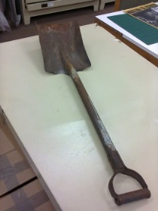
2 | RIM.2012.1740.TAF | Pick axe with steel head and wooden handle | 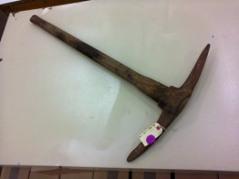
3 | RIM.2013.189.AF | Official Prison Stamp | 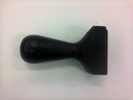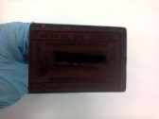
4 | RIM.2013.101.AF | Floor polishing oval brush | 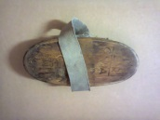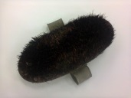
5 | RIM.2013.430.AF | Prison Warder’s Cap | 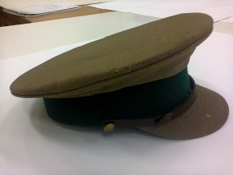
6 | RIM/1998/9/AF-ED | Prisoner khaki green long pants | 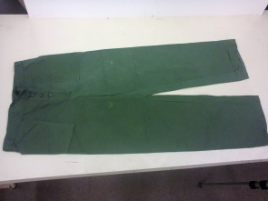
7 | RIM/1998/8/AF-ED | Prisoner khaki green long sleeved shirt | 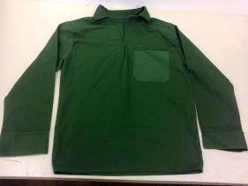
8 | MCAF.1998.928 | Wooden Apartheid Sign:  “Non-Whites/Nie-Blankes” | 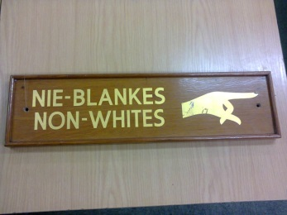

INSURANCE

The Borrower (CMHR) will provide the insurance cover, through AXA Art Insurance Corporation against lost, theft, damage and destruction from any cause:

- From the time and date the artefacts are removed from their primary storage location in South Africa,
- Whilst in transit to and return from the CMHR,
- During the period of the exhibition and duration of the loan agreement.

The Lender (RIM) will specify value estimates to the Borrower (See above).
The Lender (RIM) will be provided with proof of insurance cover and documentation before the artefacts leave the primary storage location.

TRANSPORTATION AND PACKING

The Borrower (CMHR) and the Lender (RIM) will agree on the suitable method of shipment or transportation.
The Lender (RIM) shall be satisfied with the standard of packing of the artefacts before releasing the loan and the artefacts will be returned with the same standard unless otherwise authorized by the Lender.

CARE AND PRESERVATION

The Lender (RIM) will:

- Complete condition reports for each artifact mentioned in the Loan prior to packing, by a suitably qualified professional.
- Provide recommendations/instructions for the suitable display and handling conditions and environment where appropriate.
- Apply for and submit the necessary SAHRA permit approvals and export documentation
- Provide the Borrower (CMHR) with an electronic copy of Loan Agreement, export permit and condition reports prior to shipment/transportation.
- Provide the shipment agent/transportation agent with a copy of Loan Agreement, export permit and condition reports.
- Oversee that the artefacts are packed to museum standard.
- Be satisfied that the storage, preparation and exhibition areas are secure and fire precautions are in place by means of a detailed Facility Report submitted by the Borrower (CMHR) prior to signing the Loan Agreement.

The Borrower (CMHR) will:

- Not alter, clean, restore, re-frame or modify the artefacts in any way without prior written authorization by the Lender (RIM).
- Return the artefacts in the same condition as when leaving the Lender’s (RIM) custody and care. The Borrower conservator/technician will submit a condition report by end of Exhibition and before repacking takes place.
- Exercise the same professional care and handling with respect to the artefacts as it does with artefacts in its own collection.
- Notify the Lender (RIM) immediately of loss, theft or damage while in its the care and custody.
- Only allow qualified conservator/conservator and exhibition technicians to handle the artefacts.
- Submit a detailed Facility Report to the Lender (RIM) outlining the security and environmental conditions in the exhibitions and storage areas.
- Prepare and facilitate the safe return of the loan in relation to their appointed agents and customs and export documentation.

COSTS

The Borrower (CMHR) will bear the costs of insurance, customs formalities, packing and transportation, preparation for exhibition and any conservation costs as a result of damage to artefacts.

REPRODUCTION AND CREDIT

The Lender (RIM) grants the Borrower (CMHR) permission to photograph the artefacts for purposes of promotional material, catalogues, educational resources only. The public may photograph the displayed material in the Exhibition but written permission/authorization must be sought from RIM should a member of the public/researcher wish to photograph/research any RIM artifact on display.

The Borrower (CMHR) will

- Credit the Lender as “On Loan from the Robben Island Museum Collection” in Exhibition labels and catalogues, and where possible in press releases, invitations, flyers and posters.
- Insert the Robben Island Logo as provided by the Lender (RIM) on any promotional material.
- Provide 3 complementary copies of the catalogue to the Lender (RIM).

ANNEXURES:

- Condition reports of the loaned artefacts
- Facility Report submitted by the Borrower (CMHR)

JURISDICTION:

The Lender (RIM) and the Borrower (CMHR) agree that the interpretation and any dispute that should arise from this Loan Agreement will be governed by South African Law.

The Borrower (CMHR) acknowledges that he/she has read the terms and conditions and agrees to abide by the said conditions.

For the Borrower (CMHR): Authorized signatory: Name: Signature: Date:

As Witness: Authorized signatory: Name: Signature: Date:

For the Lender (RIM): Authorized signatory: Name: Signature: Date:

As Witness: Authorized signatory: Name: Signature: Date:

Loan returned (Date) Received by:

