SUBMISSION TO THE SAHRA COUNCIL – 28 October 2016

SUBMITTED BY: Grading and Declaration Unit
DATE: 20 October 2016
FILE REF: 9/2/277/019
ENQUIRIES: Heidi Weldon / Tsholofelo Phago
ITEM: Proposal for National Heritage Site Declaration: Sharpeville Massacre Sites

A1. PURPOSE

A1.1 The purpose of this submission is to request the approval from the Council to declare three sites of the Sharpeville Memorial Precinct; namely the Memorial Garden, the Police Station and the graves of the 69 people killed at the massacre. The precinct is located between Zwane and Seiso Streets, Sharpeville, Vereeniging and the graves are located in the Phelindaba Cemetery, Theunis Kruger Street Vereeniging.

A2. BACKGROUND

A2.1 In 1960, the police at the Sharpeville Police Station opened fire on unarmed peaceful protestors killing 69 black innocent men, women and children and wounding 180. The victims had come to protest peacefully against the tyranny of pass system imposed on all black men and women. The event was organised by the Pan Africanist Congress in the context of increasing, on-going mass action of resistance against Apartheid.

A2.2 The Massacre that took place on the 21st March 1960 became a critical turning point in the history of South Africa, leading to the banning of liberation movements, including the Pan Africanist Congress and the ANC. It also led to the move from passive resistance to armed struggle, which ultimately led to the formation of Poqo and Umkhonto We Sizwe. The 21st March is now commemorated as National Human Rights Day and also the United Nation’s International Day for the Elimination of Racial Discrimination.

A2.3 In 2001/02 SAHRA erected a Garden of Remembrance, a Memorial Boulder and assisted with the tombstones of the 69 graves in commemoration of the 21st March 1960 Massacre. Although SHARA acknowledged the national significance of the site, it was not then graded nor declared.

A2.4 Sharpeville has also been identified as part of the Liberation Heritage Route and is included in the initial nomination for World Heritage Declaration. Therefore, Council graded the Sharpeville Police Station, the Memorial Garden and the graves as Grade 1 sites on 29th April 2016, (please refer to the attached submission that was made to the HRM Sub Committee on 22nd April 2016 for the grading of the sites).

A3. EXECUTIVE SUMMARY

A3.1 Due to the important historical event that took place at the Sharpeville Police Station and where the Garden of Remembrance is situated, the sites have been recognised as having national significance and were graded as Grade 1 sites as well as being identified as part of the Liberation Heritage Route World Heritage Nomination.

A3.2 The Sedibeng District Municipality advised that SAHRA first meet with the Khulumani Support Group and the tenants of the Police Station (Craft Hub businesses) to address their concerns independently before meeting with the broader Sharpeville Community. This meeting took place on 22 July 2016. On the 9th September 2016 two meetings were held, one with strategic stakeholders and the broader Sharpeville Community. There was overall support for the declaration of the three sites; however some concerns were raised ranging from the maintenance and ongoing management of the graves, inclusion of other historical sites in the region and possible benefits of the declaration for the survivors, families, and Sharpeville Community.

A3.3 Formal letters of notification were sent to relevant interested and affected parties. Responses were received from the Khulumani Support Group, the Pan Africanist Congress and the National Department of Arts and Culture.

A3.4 There is currently no Conservation Management Plan for the sites. They are currently managed by the Sedibeng District Municipality’s Department of Sports Art Culture Recreation and Heritage. This and a heritage agreement between SAHRA and the District Municipality have been discussed and it was agreed that this will be developed post declaration. In addition, the National Heritage Council has recently appointed a new service provider to assist with the Liberation Heritage Route World Heritage Nomination, Eco-Africa. Eco-Africa has committed to develop Management Plans for all of the sites listed in the initial nomination and therefore, is in the process of drafting one for Sharpeville.

A3.5 Currently the graves are visited by the families and commemorated annually on Human Rights Day. The Police Station, however, is used as office space for the staff of the District Municipality and Craft Hub. There are plans to further develop the region and the sites as a tourism destination within the District Municipality’s Spatial Development Framework and Development Strategy.
A3.6 As the sites have been identified for the initial Liberation Heritage Route World Heritage Nomination due in February 2017, the site must be nationally protected according to Article 5 of the World Heritage Convention. Therefore, it is recommended that declaration is approved for the sites.

Contents of submission:

1. Landowner’s Details and Attitude towards Declaration
2. Public Participation and Notification
3. Official Description of the Site
4. Description of the Area to be Declared (Site Boundaries)
5. Conservation Management of the Site
6. Condition Assessment and Potential Threats
7. Site Utilization

    - LANDOWNERS’S DETAILS AND ATTITUDES TOWARDS DECLARATION

1.1 The land on which the Police Station and the Memorial Garden occur is owned by the Department of Public Works.

Details: M Dlabantu (Director-General)

Mr M. Dlabantu
Director- General
Department of Public Works
CGO Building
Cnr Bosman and Madiba Street
Pretoria

1.2 The Phelindaba Cemetery where the 69 graves are located is managed by the Emfuleni Local Municipality. The victims’ families are represented by the Khulumani Support Group.

Details: M Mantsho (Chairperson Khulumani Support Group)

Ms Mary Mantsho
Khulumani Support Group
5058 Sobusa Street
Sharpeville
1928

1.3 The Khulumani Support Group have supported the declaration as indicated in their letter to SAHRA received in 27th August 2016.

- PUBLIC PARTICIPATION AND NOTIFICATION

2.1 On the advice from the Sedibeng District Municipality, an initial meeting with the Khulumani Support Group, representing the survivors and families of the victims of the Massacre, and the tenants at the police station was held on the 22nd of July 2016 at the Sharpeville Police Station. The recommendation was based on addressing their concerns independently before presenting to the broader community. Two further meetings were held on 9th September 2016, the first with strategic stakeholders such as the local Tourism Department, the Heritage Education Foundation of South Africa and a second with the broader Sharpeville Community.

2.2 From all three of the meetings there was overall support for the declaration. However, there were some issues or concerns raised mainly about the maintenance and management of the sites, and the benefits the declaration bring to the families, survivors and Sharpeville Community at large.

2.3 There is a large concern about the graves and that SAHRA had assisted with erecting tombstones on them in 2002 and since then they have not been maintained regularly. Superficial work is done annually for the Human Rights Day commemorations. The families and Khulumani Support Group have requested that the SAHRA look at rehabilitating the graves using more durable material such as granite and to demarcate them from the rest of the graves in the cemetery before the site is declared. This request was also mentioned in the Khulumani Support Group’s response letter to SAHRA. This letter has been forwarded to the Burial Grounds and Graves Unit to investigate whether there is a possibility of assisting the families. It was requested that, should SAHRA be able to assist, the families are consulted thoroughly in the process. It was explained that this would be starting point of the project.

2.4 There was also some concern raised that the declaration would limit access to the graves. It was clarified that the declaration would not influence the families’ access to the graves.

2.5 It was also raised that SAHRA’s Sharpeville Massacre background should include information with regard to the forced relocation of the Sharpeville residents from Topville location by the Apartheid regime and the impact that the racial segregation, caused by the relocation, had and the role this played as an important precursor to the 1960 protest. Therefore, it was suggested that this should be captured to reflect the emotional damage and suffering by the then Sharpeville community. There was also a request that families and survivors are given an opportunity to tell their experience of the event.

2.6 Recently it was bought to our attention that Ronald Harrison’s “Black Christ”, which so insightfully captured the struggle, was inspired by the Sharpeville Massacre. The painting challenged the Apartheid system and the notion that Chrsit was white and so was banned in South Africa. The painting was then smuggled out of South Arica and exhibited in the United Kingdom and Europe raising money for the Defence and Aid Movement. While the artist Rondal Harrison experienced intense harassment but the security police which included periods of detention.

2.7 There was also a request that other heritage sites such as the George Thabe Stadium where protestors met the day before and where the Constitution was signed, and sites where other events took place such Boipatong are included. It was explained that these sites must be nominated and will then assess for their significance.

2.8 Formal letters of notification were also sent on 5th August 2016 inviting the relevant interests and affected parties to submit comments. These included:

    - Khulumani Support group
    - Department of Public Works
    - Department of Arts and Culture
    - Sedibeng District Municipality
    - Emfuleni Local Municipality
    - Gauteng PHRA
    - Pan African Congress

2.9 Tenants at the Police Station namely the Craft Hub companies, Bongi Jewellery, Kgabang Glass Beats Corporative, Sethaba Art and Craft, Articulate Kasi Studios, Basadi Kaofela Pty (Ltd), Boiketlo Baka Art Gallery, Humble Africa, Izigqi Zendoda CC, Tshidi and Friends Shoe Making Corporative.

2.10 SAHRA has received comments from the Khulumani Support Group, the Pan Africanist Congress and the Department of Arts and Culture. While all parties support the declaration of the sites, there have been some comments and requests raised. The PAC have requested that signs on all national and provincial and local roads are erected to direct visitors to the sites, that guides are selected from the Sharpeville Community in order to generate employment in the area and enhance the visitor experience and that schools and international tourists must be encouraged to visit the sites. They also believe that the roads to and around the sites must be done in such away as to unlock the economic development potential of the areas and have expressed their desire to be part of the developments.

2.11 The Khulumani Support Group have agreed to the declaration but have requested that the graves are rehabilitated with granite and that they are fenced. They have also requested that photos of the victims and survivors be included in the exhibition centre together with recordings of the survivors’ stories and of the general struggle against Apartheid in Sharpeville.

- OFFICIAL DESCRIPTION OF THE SITE

3.1 Three sites have been considered for declaration, namely:
3.1.1 The Memorial Garden, Erf 9172; Sharpeville; Gauteng (please refer to sheet 5 of General Plan No. 171/1986, Surveyor-General, Pretoria)

3.1.2 The Police Station, Erf 9175; Sharpeville; Gauteng (please refer to sheet 5 of General Plan No. 171/1986, Surveyor-General, Pretoria)

3.1.4 The 69 graves from grave number 1864 through to 1932 in the Phelindaba Cemetery, Theunis Kruger Street Vereeniging.

- DESCRIPTION OF THE AREA TO BE DECLARED (SITE BOUNDARIES)

4.1 The Sharpeville Precinct comprises of three main sites; the Garden of Remebrance Erf 9172, the Police Station Erf 9175 (representing the location where the massacre took place) and the 69 graves of the victims at the Phelindaba Cemetery.

Site name | Erf No/ Farm | Province | Town | Municipalities
 |  |  |  | District Municipality | Local Municipality
Sharpeville Police Station | 9175; Sharpeville | Gauteng | Vereeniging | Sedibeng District Municipality | Emfuleni Local Municipality
Memorial Garden | 9172; Sharpeville | Gauteng | Vereeniging | Sedibeng District Municipality | Emfuleni Local Municipality

Site name | Grave numbers | Cemetery;/ | Province | Town | Municipalities
 |  |  |  |  | District Municipality | Local Municipality
Gravesites of 69 Sharpeville Massacre Victims | 1864 - 1932 | Phelindaba Cemetery | Gauteng | Vereeniging | Sedibeng District Municipality | Emfuleni Local Municipality

4.2 Plan of the Sharpeville Human Rights Precinct [Source: Google Earth Pro. 2015)] indicating the site for declaration:

1 – Phelindaba Cemetery
37 – Sharpeville Memorial Garden
39 – Sharpeville Police Station

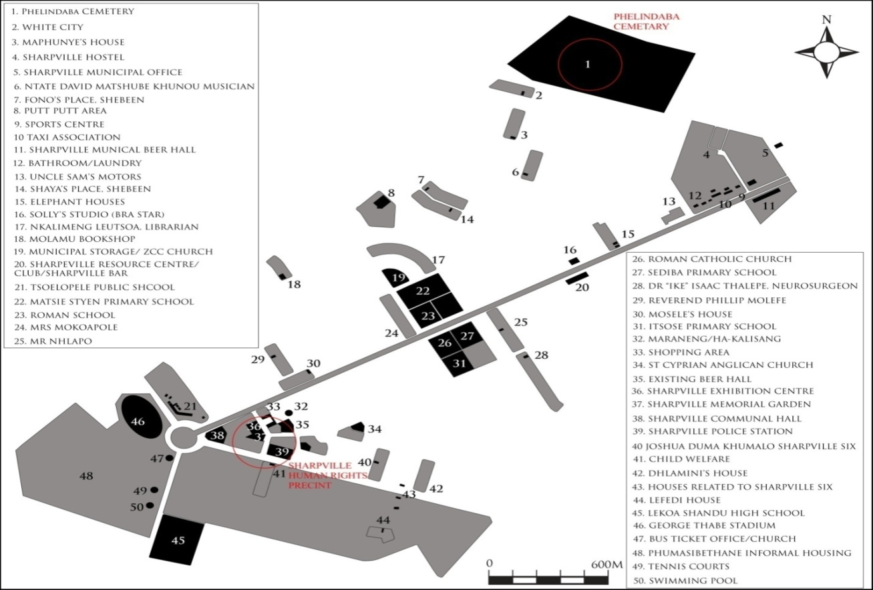

- CONSERVATION MANAGEMENT OF THE SITE

5.1 Currently the Police Station and Garden of Remembrance are managed by Sedibeng District Municipality’s Sports Recreation Arts and Culture directorate. The Phelindaba cemetery is managed by Emfuleni Local Municipality and is therefore responsible for the maintenance and security of the graves within the Phelindaba cemetery including the graves of the 69 victims of the Massacre.

5.2 The management of these sites after declaration will be guided by the Conservation Management Plan (CMPs) that is currently being developed. The National Heritage Council has appointed a dedicated service provider to develop CMPs for the Liberation Heritage Route World Heritage Nominated sites. Sharpeville Massacre Sites are one of these World Heritage Nomination in line with the UNESCO requirements.

5.3 In terms of the Word Heritage Convention Act, no 49 of 1999, the Minister of Department of Environmental Affairs must appoint a Managing Authority for a World Heritage Site. This may be an existing organ of State (Section 8) or an entirely new authority (Section 9). SAHRA has identified the Sedibeng District Municipality as the Managing Authority for sites and have communicated this to the NHC and Eco-Africa. It has also been suggested that representation from the Khulumani Support Group and the Craft Hub at the Police Station are also included in the Managing Authority. However as this is a very recent suggestion, further discussion with relevant parties is still necessary.

5.4 A heritage agreement needs be developed between SAHRA and the Municipality and must clearly define the roles and responsibilities of all entities involved in the sites. This has been discussed with the Sports Recreation Arts and Culture Directorate within the municipality and be developed together with them post declaration.

- CONDITION ASSESSMENT AND POTENTIAL THREATS

6.1 The Khulamani Support Group as well as the Sedibeng District Municipality have raised concern over the condition and lack of ongoing maintenance of the graves. It has been raised that superficial maintenance to the tombstones are only done at the time of the annual commemorations. There has been a request for SAHRA to assist with erecting granite tombstones and to better demarcate the graves from others in the cemetery. This request has been forwarded to the Burial Grounds and Graves Unit as this will fall under their mandate.

6.2 The greatest threats to the sites are lack of maintenance and heritage use. The gardens in the Garden of Remembrance have been well maintained. However the structures require some regular maintenance such as repainting the wall of the water fountain. The water feature and fountain are currently not in use.

6.3 The Police Station has in the main not changed much since the Massacre. However, as the site is currently used by the Khulumani Support Group and the Craft Hub businesses, the opportunity to make use of the site as a heritage site has not materialised.

7. SITE UTILIZATION

7.1 The Police Station is utilized as a multipurpose centre such as Sedibeng District Municipality Heritage Offices and community projects such as the Craft Hub with various craft companies renting space.

7.2 The graves are visited by the families and are also utilized during the annual commemoration event hosted by Sedibeng District Municipality.

7.3 The Memorial Garden is a place of commemoration of the Massacre and the victims.

7.4 Sedibeng District Municipality has identified the Sharpeville Heritage Precinct as a flagship project due to its intrinsic tourism development potential in the District’s Spatial Development Framework for 2014 – 17. The development of the precinct is planned as one of the three proposed Urban Framework Precinct Projects in the Sedibeng Municipality Development Strategy. These developments have also been incorporated in the Emfuleni Local Municipalities Spatial Development Framework.

- RECOMMENDATION

8.1 It is recommended that Council approve the declaration of the three making the Sharpeville Massacre sites as National Heritage Sites.

