Cullinan Mega City Development
Cullinan Extensions 2 and 5 to 12
City of Tshwane Metropolitan Municipality, Gauteng Province
Farm: Portion 86 of the Farm Kafferskraal 475-JR
Fourie, H. Dr heidicindy@yahoo.com
012 322 7632/012 993 3110
Palaeontological Impact Assessment: Desktop Study
Facilitated by: J. Paul van Wyk Urban Economists & Planners cc
P.O. Box 11522, Hatfield, 0028
012 996 0097
2017/07/31
Ref: Gaut 006/17-18/E0003

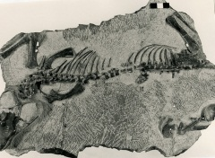

B. Executive summary
Outline of the development project: J. Paul van Wyk Urban Economists & Planners cc facilitated the appointment of Dr H. Fourie, a palaeontologist, to undertake a Paleontological Impact Assessment (PIA), Desktop Study of the suitability of the proposed Cullinan Mega City Development (Cullinan Extensions 2 and 5 to 12) in Cullinan on Portion 86 of the Farm Kafferskraal 475-JR, within the City of Tshwane Metropolitan Municipality in the Gauteng Province.
The applicant, Verge Management Services proposes a dynamic modern mixed-use new-town development with a range of housing typologies aimed at a socio-economically stratified market requiring a diverse product mix and unique settlement form.
The Project includes one Alternative (Figure 3):
Alternative 1: An area blocked in red within Cullinan bordered by the R515 Road (Colin Road) to the west and south-east of Refilwe Township. It is not close to the Elands River. The size of the site is approximately 180 hectares.

Legal requirements:-
The National Heritage Resources Act (Act No. 25 of 1999) (NHRA) requires that all heritage resources, that is, all places or objects of aesthetic, architectural, historical, scientific, social, spiritual, linguistic or technological value or significance are protected. The Republic of South Africa (RSA) has a remarkably rich fossil record that stretches back in time for some 3.5 billion years and must be protected for its scientific value. Fossil heritage of national and international significance is found within all provinces of the RSA. South Africa’s unique and non-renewable palaeontological heritage is protected in terms of the National Heritage Resources Act. According to this act, palaeontological resources may not be excavated, damaged, destroyed or otherwise impacted by any development without prior assessment and without a permit from the relevant heritage resources authority.
The main aim of the assessment process is to document resources in the development area and identify both the negative and positive impacts that the development brings to the receiving environment. The PIA therefore identifies palaeontological resources in the area to be developed and makes recommendations for protection or mitigation of these resources.
For this study, resources such as geological maps, scientific literature, institutional fossil collections, satellite images, aerial maps and topographical maps were used. It provides an assessment of the observed or inferred palaeontological heritage within the study area, with recommendations (if any) for further specialist palaeontological input where this is considered necessary.
A Palaeontological Impact Assessment is generally warranted where rock units of LOW to VERY HIGH palaeontological sensitivity are concerned, levels of bedrock exposure within the study area are adequate; large scale projects with high potential heritage impact are planned; and where the distribution and nature of fossil remains in the proposed area is unknown. The specialist will inform whether further monitoring and mitigation are necessary.

Types and ranges of heritage resources as outlined in Section 3 of the National Heritage Resources Act (Act No.25 of 1999):
(i) (i) objects recovered from the soil or waters of South Africa, including archaeological and palaeontological objects and material, meteorites and rare geological specimens.
This report adheres to the guidelines of Section 38 (1) of the National Heritage Resources Act (Act No. 25 of 1999).
Subject to the provisions of subsections (7), (8) and (9), any person who intends to undertake a development categorised as (a) the construction of a road, wall, power line, pipeline, canal or other similar form of linear development or barrier exceeding 300 m in length; (b) the construction of a bridge or similar structure exceeding 50 m in length; (c) any development or other activity which will change the character of a site (see Section 38); (d) the re-zoning of a site exceeding 10 000 m² in extent; (e) or any other category of development provided for in regulations by SAHRA or a PHRA authority.

This report aims to provide comment and recommendations on the potential impacts that the proposed development could have on the fossil heritage of the area and to state if any mitigation or conservation measures are necessary.

Outline of the geology and the palaeontology:
The geology was obtained from map 1:100 000, Geology of the Republic of South Africa (Visser 1984) and 1:250 000, 2528 Pretoria Geological Map (Walraven 1978).

Figure 3: The geology of the development area.
Legend to map and short explanation.
di – Diabase (green), Vaalian.
Mw – Sandstone, quartzitic in places; conglomerate (brown). Wilgerivier Formation, Waterberg Group. Mokolian.
Vr – Quartzite, shale, subgraywacke (purple). Rayton Formation, Pretoria Group, Transvaal Supergroup. Vaalian.
…… – (black) Lineament (Landsat, aeromagnetic).
------ - Concealed geological boundary.
┴10 – Strike and dip of layer.
□ – Position of proposed Development.

Mining Activities:
Diamonds in the heart of Cullinan.

Summary of findings (1d): The Desktop Study was undertaken towards the middle of July 2017 in the winter in dry and cold conditions. As this is a desktop study the season and conditions has no influence on the outcome and the following is reported:

The development will be situated on the Diabase and Rayton Formation.

The Transvaal Supergroup fills an east-west elongated basin in the south-central part of the old Transvaal (now North – West, Gauteng and Mpumalanga) as far south as Potchefstroom. It is Vaalian in age, approximately 2600 Ma to 2100 Ma. A maximum thickness of the Transvaal Supergroup reaches 2000 m in the north-eastern section. The east-west elongated basin is filled with clastic, volcanic and chemical sedimentary rocks. Three groups based on lithological differences have been established: they are the Rooiberg, Pretoria and Chuniespoort Groups as well as other smaller groups (Kent 1980, Snyman 1996). It is the Bushveld Complex that is responsible for the tilting of the Transvaal sediments and the heat of its intrusion having created andalusite crystals (Norman and Whitfield 2006). This Supergroup is underlain by the Ventersdorp, Witwatersrand and Pongola Supergroups, and the Dominion Group. Three prominent ridges are present from the oldest to the youngest, the Time Ball Hill, Daspoort and Magaliesberg Formations (Norman and Whitfield 2006).

The Pretoria Group consists predominantly of quartzite and shale, together with a prominent volcanic unit, minor conglomerate, chemical and volcanic members. It comprises the Hekpoort Andesite, Dullstroom Basalt, Time Ball Hill, Silverton, and Magaliesberg Quartzite Formations as well as several smaller formations (in total 15) and overlies the Chuniespoort Group (Kent 1980). Both the shale and quartzite of the Pretoria Group are utilised in the building industry (Snyman 1996). The Time Ball Hill shale Formation is known to contain ‘algal microfossils’ diagenetic in origin. Stromatolites as they are known are preserved in the subordinate carbonate rocks (Kent 1980). The Pretoria Group is clastic sedimentary in nature (Eriksson 1999). The pile of sedimentary rocks, mainly mudstones and quartzites with some basalt can collectively reach a thickness of up to 5 km. The Rayton Formation is approximately 1,200 m thick consisting of 4 individual layers of quartzite interlayered with shale and intruded by diabase sills (Visser 1989).

Vaalian to post-Mokolian diabase (di) intrusions occur throughout the area in the form of plates, sills and dykes. These plates are common in the Transvaal Supergroup and when present in the Pretoria Group they are referred to as the Transvaal diabase (Kent 1980, Visser 1989). The diabase sills of Bushveld age (Norman and Whitfield 2006) is typically fine-grained, green-grey with plagioclase and pyroxenes (Visser 1989).

Fossils in South Africa mainly occur in rocks of sedimentary nature and not in rocks from igneous or metamorphic nature. Therefore, if there is the presence of Karoo Supergroup strata the palaeontological sensitivity can generally be LOW to VERY HIGH, and here locally MODERATE for the Rayton Formation and VERY LOW for the diabase (SG 2.2 SAHRA APMHOB, 2012).

Recommendation:
The potential impact of the development on fossil heritage is MODERATE and therefore a Desktop Study was conducted. A Phase 1 PIA and or mitigation are not recommended. Both the Rayton Formation and Diabase are devoid of fossils.

Decision:
- The site has previously been used for farming purposes and is overgrown.
- No further palaeontological studies are required, development can go ahead.
- The poorly defined watercourse within the central part of the site is protected by the EMPr.
- As part of the Environmental Authorisation conditions, an Environmental Control Officer (ECO) will be appointed to oversee the construction activities in line with legally binding Environmental Management Programme (EMPr).
- The EMPr already covers the conservation of heritage and palaeontological artefacts that may be exposed during construction activities. The protocol is to immediately cease all construction activities if a fossil is unearthed and contact SAHRA for further investigation and excavation by a professional palaeontologist.
The Project includes one Alternative (Figure 3):
Alternative 1: An area blocked in red within Cullinan bordered by the R515 Road (Colin Road) to the west and south-east of Refilwe Township. It is not close to the Elands River. The size of the site is approximately 180 hectares.

Concerns/threats (1g,1ni,1nii,1o,1p):
- Threats are earth moving equipment/machinery (for example haul trucks, front end loaders, excavators, graders, dozers) during construction, the sealing-in or destruction of the fossils by development, vehicle traffic and human disturbance (overlying Waterberg nearby).
- No consultation with parties was necessary.
Stakeholders: Developer – Verge Management Services,142 Western Service Road, Woodmead Business Park, Simeka House, Woodmead, 2191.
Environmental – Nali Sustainability Solutions, Stand 1829, Irene Farm Villages, Pierre van Ryneveld, 0045
Landowner – Blue Moonlight Properties 175 (Pty) Ltd 426 Quebec Street, Faerie Glen, Pretoria, 0081.
C. Table of Contents
A. Title page 1
B. Executive Summary 2
C. Table of Contents 5
D. Background Information on the project 5
E. Description of the Property or Affected Environment 7
F. Description of the Geological Setting 8
G. Background to Palaeontology of the area 10
H. Description of the Methodology 11
I. Description of significant fossil occurrences 12
J. Recommendation 13
K. Conclusions 14
L. Bibliography 14
Declaration 15
Appendix 1: Transvaal Supergroup 16
Appendix 2: Table 16

D. Background information on the project
Report
This report is part of the environmental impact assessment process under the National Environmental Management Act, as amended (Act No. 107 of 1998) (NEMA) and includes Appendix 6 (GN R38282 of 4 December 2014) of the Environmental Impact Assessment Regulations (see Appendix 1).

Outline of development
This report discusses and aims to provide the applicant with information regarding the location of palaeontological material that will be impacted by the development. It may be necessary for the applicant to apply for the relevant permit from the South African Heritage Resources Agency (SAHRA / PHRA) if a fossil is found.

The applicant, Verge Management Services proposes a dynamic modern mixed-use new-town development with a range of housing typologies aimed at a socio-economically stratified market requiring a diverse product mix and unique settlement form. The development includes public facilities, open spaces, and commercial business activities. Walkability and public transport usage play an important role in this offering. The aim of the development is to create a liveable destination for all walks of life which promotes community integration.
Figure 1: Approved layout plan (J Paul van Wyk)
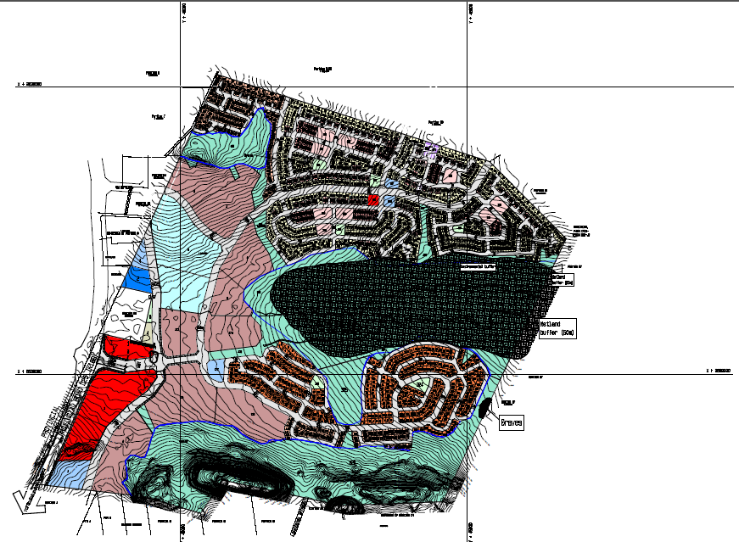
1246 RDP’s and BNG’s units, 239 FLISP/Bonded Houses, 1595 Community Rental, 275 Military Veterans, 1415 Social Housing, 415 Bonded Housing make up the development of 5185 units. Two Créches, 1 Primary School, 1 Secondary School, 1 Clinic, 2 Community Facilities, 1 Church, 1 Shop, 1 Shopping Centre, a Sports Ground, Office Park, Filling Station (PFS), Taxi Rank, 7 Parks, and 3 Public Open Spaces will also be developed.

Infrastructure associated with development:-
- Buildings,
- Roads,
- Electrical pipe lines,
- Sewage and storm water.
Rezoning/ and or subdivision of land: Mixed use comprising of residential and non-residential uses. Sustainable integrated human settlement
Name of developer and consultant: Verge Management Services and J. Paul van Wyk Urban Economists & Planners cc.
Terms of reference: Dr H. Fourie is a palaeontologist commissioned to do a palaeontological impact assessment: field study to ascertain if any palaeontological sensitive material is present in the development area. This study will advise on the impact on fossil heritage mitigation or conservation necessary, if any.
Dr Fourie obtained a Ph.D from the Bernard Price Institute for Palaeontological Research (now ESI), University of the Witwatersrand. Her undergraduate degree is in Geology and Zoology. She specialises in vertebrate morphology and function concentrating on the Therapsid Therocephalia. For the past ten years she carried out field work in the Eastern Cape, Free State, Gauteng, Limpopo and Mpumalanga Provinces. Dr Fourie has been employed at the Ditsong: National Museum of Natural History in Pretoria (formerly Transvaal Museum) for 21 years.
Legislative requirements: South African Heritage Resources Agency (SAHRA) for issue of permits if necessary. National Heritage Resources Act (Act No. 25 of 1999). An electronic copy of this report must be supplied to SAHRA.

E. Description of property or affected environment
Location and depth:
The proposed Cullinan Mega City Development (Cullinan Extensions 2 and 5 to 12) will be situated on Portion 86 of the Farm Kafferskraal 475-JR within the City of Tshwane Metropolitan Municipality in the Gauteng Province. It will be located opposite the Cullinan dam and Refilwe Sewage works to the north of Cullinan on the R515 Road. This development is geared towards the affordable housing market.
The depth is dependant on the thickness of the formation and the depth of the foundations, footings, channels and trenches and can be verified with geological core logs.

The Project includes one Alternative (Figure 3):
Alternative 1: An area blocked in red within Cullinan bordered by the R515 Road (Colin Road) to the west and south-east of Refilwe Township. It is not close to the Elands River. The size of the site is approximately 180 hectares.

Figure 2: Google.earth image showing scheme layout (J Paul van Wyk).
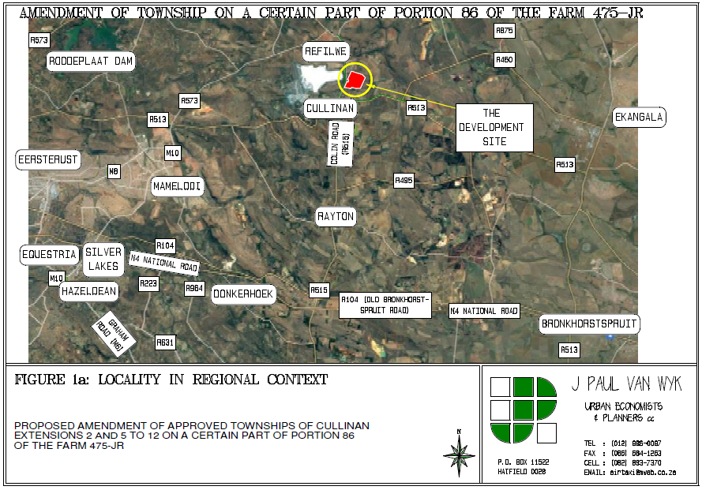

F. Description of the Geological Setting
Description of the rock units:
Figure 3: Excerpt of 1:250 000 Geological Map 2528 Pretoria (Walraven 1978).
Legend to map and short explanation.
di – Diabase, Vaalian.
Mw – Sandstone, quartzitic inplaces; conglomerate (brown). Wilgerivier Formation, Waterberg Group. Mokolian.
Vr – Quartzite, shale, subgraywacke (purple). Rayton Formation, Pretoria Group, Transvaal Supergroup. Vaalian.
…… – (black) Lineament (Landsat, aeromagnetic).
------ - Concealed geological boundary.
┴10 – Strike and dip of layer.
□ – Position of proposed Development.

The Transvaal Supergroup fills an east-west elongated basin in the south-central part of the old Transvaal (now North – West, Gauteng and Mpumalanga) as far south as Potchefstroom. It is Vaalian in age, approximately 2600 Ma to 2100 Ma. A maximum thickness of the Transvaal Supergroup reaches 2000 m in the north-eastern section. The east-west elongated basin is filled with clastic, volcanic and chemical sedimentary rocks. Three groups based on lithological differences have been established: they are the Rooiberg, Pretoria and Chuniespoort Groups as well as other smaller groups (Kent 1980, Snyman 1996). It is the Bushveld Complex that is responsible for the tilting of the Transvaal sediments and the heat of its intrusion having created andalusite crystals (Norman and Whitfield 2006). This Supergroup is underlain by the Ventersdorp, Witwatersrand and Pongola Supergroups, and the Dominion Group. Three prominent ridges are present from the oldest to the youngest, the Time Ball Hill, Daspoort and Magaliesberg Formations (Norman and Whitfield 2006).

The Pretoria Group consists predominantly of quartzite and shale, together with a prominent volcanic unit, minor conglomerate, chemical and volcanic members. It comprises the Hekpoort Andesite, Dullstroom Basalt, Time Ball Hill, Silverton, and Magaliesberg Quartzite Formations as well as several smaller formations (in total 15) and overlies the Chuniespoort Group (Kent 1980). Both the shale and quartzite of the Pretoria Group are utilised in the building industry (Snyman 1996). The Time Ball Hill shale Formation is known to contain ‘algal microfossils’ diagenetic in origin. Stromatolites as they are known are preserved in the subordinate carbonate rocks (Kent 1980). The Pretoria Group is clastic sedimentary in nature (Eriksson 1999). The pile of sedimentary rocks, mainly mudstones and quartzites with some basalt can collectively reach a thickness of up to 5 km. The Rayton Formation is approximately 1,200 m thick consisting of 4 individual layers of quartzite interlayered with shale and intruded by diabase sills (Visser 1989).

The Rayton Formation is present northeast of Pretoria and is approximately 1,200 m thick. It consists of four layers of quartzite alternating with four layers of shale (Visser 1989). In the central part of the basin the quartzite and shale overlying the Magaliesberg Quartzite are combined into the Rayton Formation because intrusion of numerous diabase sills has made it impossible to recognise all the individual formations (Kent 1980). The Magaliesberg Formation is 300 m thick in the Pretoria region and up to 500 m thick in the Lowveld (Visser 1989). The Magaliesberg is a dominant feature of the Gauteng landscape and is north-dipping (Norman and Whitfield 2006). It was shaped by glaciation during the Dwyka times and then slightly modified by post-glacial erosion (McCarthy and Rubidge 2005).

The Waterberg Group of rocks today occurs in several separate regions: in the Limpopo and Mpumalanga Provinces. These separate patches probably originally formed a single sheet of sedimentary rocks that since became fragmented as a result of erosion. A deep red iron oxide is responsible for the colouration. As the rocks are chemically resistant and very hard, they produce spectacular cliffs and mountainous topography (McCarthy and Rubidge 2005).The Waterberg Group (Kent 1980) is known for its reddish sandstone with conglomerates present between Pretoria and Middelburg, older than the coal and younger than the Magaliesberg Quartzite Formation. In the Cullinan-Middelburg base only one formation has been recognised, the unconformable Wilgerivier Formation. Trace fossils are found in the Waterberg Group. Snyman (1996) places the age as 1 800 Ma till 1 700 Ma (Mokolian). A threefold subdivision is recognised, the Nylstroom, Matlabas and Kransberg Subgroups. It overlies the Loskop Formation.

The Wilgerivier Formation overlies the Pretoria Group of the Transvaal Supergroup, the Selonsrivier Formation and the Loskop Formation. It is often covered with Karoo sediments. Sandstone, grit, conglomerate and shale are present. It is 2000 m in thickness. The conglomerate layer is often at the base (Visser 1989).

Vaalian to post-Mokolian diabase (di) intrusions occur throughout the area in the form of plates, sills and dykes. These plates are common in the Transvaal Supergroup and when present in the Pretoria Group they are referred to as the Transvaal diabase (Kent 1980, Visser 1989). The diabase sills of Bushveld age (Norman and Whitfield 2006) is typically fine-grained, green-grey with plagioclase and pyroxenes (Visser 1989).

The Rayton Formation is thick and intruded by numerous diabase sills that form the most prominent, boulder outcrops. Outcrops of the Rayton Formation are generally poor. Cullinan is celebrated in diamond circles as the mine where the worlds’ biggest-ever gem diamond was discovered. The mine was founded by Thomas Cullinan in 1898, the mine was opened in 1902. This kimberlite pipe was at one point the largest in South Africa also making it the oldest kimberlite mined in the world (Norman and Whitfield 2006).

The Project includes one Alternative (Figure 3):
Alternative 1: An area blocked in red within Cullinan bordered by the R515 Road (Colin Road) to the west and south-east of Refilwe Township. It is not close to the Elands River. The size of the site is approximately 180 hectares.

Figure 4: Lithostratigraphic column of the Transvaal Supergroup to show the geological formations present (Walraven 1986).

G. Background to Palaeontology of the area
Summary: When rock units of moderate to very high palaeontological sensitivity are present within the development footprint, a desk top and or field scoping (survey) study by a professional palaeontologist is usually warranted. The main purpose of a field scoping (survey) study would be to identify any areas within the development footprint where specialist palaeontological mitigation during the construction phase may be required (SG 2.2 SAHRA AMPHOB, 2012).

Subgroup / Supergroup | Group | Formation | Fossil Heritage | Comment
- | Waterberg | Wilgerivier | Terrestrial cyanobacterial mats from playa lake deposits | Red beds
Transvaal Supergroup | Pretoria | Rayton Formation | No fossils recorded | -
Table 1: Taken form palaeotechnical report (Groenewald and Groenewald 2014).

Fossils in South Africa mainly occur in rocks of sedimentary nature and not in rocks from igneous or metamorphic nature. Therefore, if there is the presence of Karoo Supergroup strata the palaeontological sensitivity is generally LOW to VERY HIGH, but here locally MODERATE for the Rayton Formation and VERY LOW for the diabase.

Rock Unit | Significance/vulnerability | Recommended Action
Waterberg Group (Mw) | Low | Desktop study is required if surrounded by rocks with a Very High or High sensitivity
Rayton Formation (Vr) | Moderate | Desktop study is required and if surrounded by rocks of Very High and High sensitivity, then a Phase 1
Diabase | Very Low | No studies
Table 2: Criteria used (Fossil Heritage Layer Browser/SAHRA) (Groenewald & Groenewald 2014).

The palaeontological sensitivity of the Waterberg Group is listed here, but the development does not encroach on the Waterberg Group, Wilgerivier Formation.

Databases and collections: Ditsong: National Museum of Natural History. Evolutionary Studies Institute, University of the Witwatersrand (ESI).
Impact: MODERATE for the Rayton Formation and VERY LOW for the diabase. There are zero significant fossil resources that may be impacted by the development.

H. Description of the Methodology (1e)
The palaeontological impact assessment desktop study was undertaken towards the middle of July 2017. A literature survey is included.

Assumptions and Limitations:-
The accuracy and reliability of the report may be limited by the following constraints:
- Most development areas have never been surveyed by a palaeontologist or geophysicist.
- Variable accuracy of geological maps and associated information.
- Poor locality information on sheet explanations for geological maps.
- Lack of published data.
- Lack of rocky outcrops.
- Insufficient data from developer and exact lay-out plan for all structures.
A Phase 1 Palaeontological Impact Assessment: Field Study will include:
- Recommendations for the future of the site.
- Background information on the project.
- Description of the property of affected environment with details of the study area.
- Description of the geological setting and field observations.
- Background to palaeontology of the area.
- Heritage rating.
- Stating of significance (Heritage Value).
A Phase 2 Palaeontological Impact Assessment: Mitigation will include:
- Recommendations for the future of the site.
- Description of work done (including number of people and their responsibilities).
- A written assessment of the work done, fossils excavated, not removed or collected and observed.
- Conclusion reached regarding the fossil material.
- A detailed site plan.
- Possible declaration as a heritage site or Site Management Plan.
The National Heritage Resources Act No. 25 of 1999 further prescribes -
Act No. 25 of 1999. National Heritage Resources Act, 1999.
The National Estate as: 3 (2) (f) archaeological and palaeontological sites, (i)(1) objects recovered from the soil or waters of South Africa, including archaeological and palaeontological objects and material, meteorites and rare geological specimens,
Heritage assessment criteria and grading used: (a) Grade 1: Heritage resources with qualities so exceptional that they are of special national significance;
(b) Grade 11: Heritage resources which, although forming part of the national estate, can be considered to have special qualities which make them significant within the context of a province or a region; and (c) Grade 111: Other heritage resources worthy of conservation.
SAHRA is responsible for the identification and management of Grade 1 heritage resources.
Provincial Heritage Resources Authority (PHRA) identifies and manages Grade 11 heritage resources.
Local authorities identify and manage Grade 111 heritage resources.

No person may damage, deface, excavate, alter, remove from its original position, subdivide or change the planning status of a provincially protected place or object without a permit issued by a heritage resources authority or local authority responsible for the provincial protection.

Archaeology, palaeontology and meteorites: Section 35.
(2) Subject to the provisions of subsection (8) (a), all archaeological objects, palaeontological material and meteorites are the property of the State.
(3) Any person who discovers archaeological or palaeontological objects or material or a meteorite in the course of development or agricultural activity must immediately report the find to the responsible heritage resources authority, or to the nearest local authority offices or museum, which must immediately notify such heritage resources authority.
Mitigation involves planning the protection of significant fossil sites, rock units or other palaeontological resources and/or excavation, recording and sampling of fossil heritage that might be lost during development, together with pertinent geological data. The mitigation may take place before and / or during the construction phase of development. The specialist will require a Phase 2 mitigation permit from the relevant Heritage Resources Authority before a Phase 2 may be implemented.
The Mitigation is done in order to rescue representative fossil material from the study area to allow and record the nature of each locality and establish its age before it is destroyed and to make samples accessible for future research. It also interprets the evidence recovered to allow for education of the public and promotion of palaeontological heritage.
Should further fossil material be discovered during the course of the development (e. g. during bedrock excavations), this must be safeguarded, where feasible in situ, and reported to a palaeontologist or to the Heritage Resources authority. In situations where the area is considered palaeontologically sensitive (e. g. Karoo Supergroup Formations, ancient marine deposits in the interior or along the coast) the palaeontologist might need to monitor all newly excavated bedrock. The developer needs to give the palaeontologist sufficient time to assess and document the finds and, if necessary, to rescue a representative sample.
When a Phase 2 palaeontological impact study is recommended, permission for the development to proceed can be given only once the heritage resources authority has received and approved a Phase 2 report and is satisfied that (a) the palaeontological resources under threat have been adequately recorded and sampled, and (b) adequate development on fossil heritage, including, where necessary, in situ conservation of heritage of high significance. Careful planning, including early consultation with a palaeontologist and heritage management authorities, can minimise the impact of palaeontological surveys on development projects by selecting options that cause the least amount of inconvenience and delay.
Three types of permits are available; Mitigation, Destruction and Interpretation. The specialist will apply for the permit at the beginning of the process (SAHRA 2012).
I. Description of significant fossil occurrences (1f)
Several of the Transvaal Supergroup, Pretoria Group contains stromatolites. Stromatolites are significant indicators of palaeoenvironments and provide evidence of algal growth between 2640 and 2432 million years ago (Groenewald and Groenewald 2014). In the rocks overlying the Black Reef Formation there is evidence for life on an abundant scale as cyanobacteria came to dominate the shallow sea forming stromatolites of varying shapes. Large, elongate stromatolite domes can be seen at Boetsap in the North West Province (McCarthy and Rubidge 2005) and the algal microfossils reported from the Time Ball Hill Formation shales are probably of diagenetic origin (Eriksson 1999).

The Magaliesberg Formation is present to the south of the development area. Nixon et al. (1988) described the black shales south-west of Potchefstroom as consisting of overlapping laminated basal mounds which are stromatolitic as well as spheroidal possible planktonic fossil algae. These can range in size from 3.5 - 17 mm in height and up to 10 mm in diameter and can be present in the development area.

Stromatolites are likely to be present in the Magaliesberg Formation as microbial mat structures. These structures range from a centimetre to several tens of metres in size. They are the result of algal growth in shallow water, indicating a very rich growth that would have caused an enrichment in the amount of oxygen in the atmosphere (Groenewald and Groenewald 2014).

Figure 5: Thin section of a stromatolite (De Zanche and Mietto 1977).
Details of the location and distribution of all significant fossil sites or key fossiliferous rock units are often difficult to be determined due to thick topsoil, subsoil, overburden and alluvium. Depth of the overburden may vary a lot.

The threats are:- earth moving equipment/machinery (for example haul trucks, front end loaders, excavators, graders, dozers) during construction, the sealing-in or destruction of fossils by development, vehicle traffic, and human disturbance. See Description of the Geological Setting (F) above.

J. Recommendation (1j,1l)
a. There is no objection (see Recommendation B) to the development, and it is not necessary to request a Phase 1 Palaeontological Impact Assessment: Field study to determine whether the development will affect fossiliferous outcrops as the palaeontological sensitivity is MODERATE and VERY LOW. A Phase 2 Palaeontological Mitigation is not required. The Rayton Formation is devoid of fossils.
b. This project will benefit the economy, the growth of the community, health and social development of the community.
c. Preferred choice: The impact on the palaeontological heritage is MODERATE and VERY LOW (see Executive Summary).
d. The following should be conserved: if any palaeontological material is exposed during digging, excavating, drilling or blasting SAHRA must be notified. All construction activities must be stopped and a palaeontologist should be called in to determine proper mitigation measures.

Sampling and collecting (1m,1k):
Wherefore a permit is needed from the South African Heritage Resources Agency (SAHRA / PHRA).
- Objections: Cautious. See heritage value and recommendation.
- Conditions of development: See Recommendation.
- Areas that may need a permit: Discussed.
- Permits for mitigation: Not needed.
K. Conclusions
- All the land involved in the development was assessed and none of the property is unsuitable for development (see Recommendation B).
- All information needed for the Palaeontological Impact Assessment was provided by the Consultant. All technical information was provided by J. Paul van Wyk Urban Economists & Planners cc.
- Areas that would involve mitigation (dam Site A) and may need a permit from the South African Heritage Resources Agency are discussed.
- The following should be conserved: if any palaeontological material is exposed during digging, excavating, drilling or blasting, SAHRA must be notified. All development activities must be stopped and a palaeontologist should be called in to determine proper mitigation measures, especially for shallow caves.
- Condition in which development may proceed: It is further suggested that a Section 37(2) agreement of the Occupational, Health and Safety Act 85 of 1993 is signed with the relevant contractors to protect the environment and adjacent areas as well as for safety and security reasons.
L. Bibliography
ALMOND, J., PETHER, J, and GROENEWALD, G. 2013. South African National Fossil Sensitivity Map. SAHRA and Council for Geosciences.
DE ZANCHE, V. and MIETTO, P. 1977. The World of Fossils. Sampson Low Guides, Berkshire, Printed in Italy, Pp 256.
ERIKSSON, P.G. 1999. Pretoria Group, [Transvaal Supergroup]. Catalogue of South African Lithostratigraphic units (Edited Johnson, M.R.), South African Committee for Stratigraphy, Council for Geoscience, 6: 29-32.
GROENEWALD, G. and GROENEWALD, D. 2014. SAHRA Palaeotechnical Report: Palaeontological Heritage of Limpopo Province. South African Heritage Resources Agency, Pp 1-22.
KENT, L. E., 1980. Part 1: Lithostratigraphy of the Republic of South Africa, South West Africa/Namibia and the Republics of Bophuthatswana, Transkei and Venda. SACS, Council for Geosciences, Stratigraphy of South Africa. 1980. South African Committee for Stratigraphy. Handbook 8, Part 1, pp 690.
MCCARTHY, T and RUBIDGE, B. 2005. The Story of Earth Life: A southern African perspective on a 4.6-billion-year journey. Struik. Pp 333.
NIXON, N., ERIKSSON, P.G., JACOBS, R. and SNYMAN, C.P. 1988. Early Proterozoic micro-algal structures in carbonaceous shales of the Pretoria Group, south-west of Potchefstroom. South African Journal of Science, 84: 592-595.
NORMAN, N. 2013. Geology of the Beaten Track: Exploring South Africa’s hidden treasures. De Beers, Struik Nature, Pp 256.
NORMAN, N. and WHITFIELD, G., 2006. Geological Journeys. De Beers, Struik, P 1-320.
PLUMSTEAD, E.P. 1963. The influence of plants and environment on the developing animal life of Karoo times. South African Journal of Science, 59(5): 147-152.
RUBIDGE, B. S. (ed.), 1995. Biostratigraphy of the Beaufort Group (Karoo Supergroup). South African Committee for Biostratigraphy, Biostratigraphic Series No. 1, 46pp. Council for Geoscience, Pretoria.
SG 2.2 SAHRA APMHOB Guidelines, 2012. Minimum standards for palaeontological components of Heritage Impact Assessment Reports, Pp 1-15.
SNYMAN, C. P., 1996. Geologie vir Suid-Afrika. Departement Geologie, Universiteit van Pretoria, Pretoria, Volume 1, Pp. 513.
VAN DER WALT, M., DAY, M., RUBIDGE, B. S., COOPER, A. K. & NETTERBERG, I., 2010. Utilising GIS technology to create a biozone map for the Beaufort Group (Karoo Supergroup) of South Africa. Palaeontologia Africana, 45: 1-5.
VISSER, D.J.L. 1984 (ed). Geological Map of South Africa 1:100 000. South African Committee for Stratigraphy. Council for Geoscience, Pretoria.
VISSER, D.J.L. 1989 (ed). Toeligting: Geologiese kaart (1:100 000). Die Geologie van die Republieke van Suid Afrika, Transkei, Bophuthatswana, Venda, Ciskei en die Koningkryke van Lesotho en Swaziland. South African Committee for Stratigraphy. Council for Geoscience, Pretoria.
VISSER, J.N.J., VON BRUNN, V. and JOHNSON, M.R. 1990. Dwyka Group. Karoo Sequence. Catalogue of South African Lithostratigraphic Units. SACS 2: 15-17.
WALRAVEN, F. 1978. Geological Map of Pretoria 1:250 000 (2528). South African Committee for Stratigraphy. Council for Geoscience, Pretoria.

Declaration (disclaimer) (1b)
I, Heidi Fourie, declare that I am an independent consultant and have no business, financial, personal or other interest in the proposed development project for which I was appointed to do a palaeontological assessment. There are no circumstances that compromise the objectivity of me performing such work.

I accept no liability, and the client, by receiving this document, indemnifies me against all actions, claims, demands, losses, liabilities, costs, damages and expenses arising from or in connection with services rendered, directly or indirectly by the use of the information contained in this document.

It may be possible that the Desktop Study may have missed palaeontological resources in the project area as outcrops are not always present on geological maps while others may lie below the overburden of earth and may only be present once development commences.

This report may not be altered in any way and any parts drawn from this report must make reference to this report.
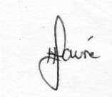
___________
Heidi Fourie
2017/07/31

Appendix 1: Geology of the Transvaal Supergroup (Kent 1980).
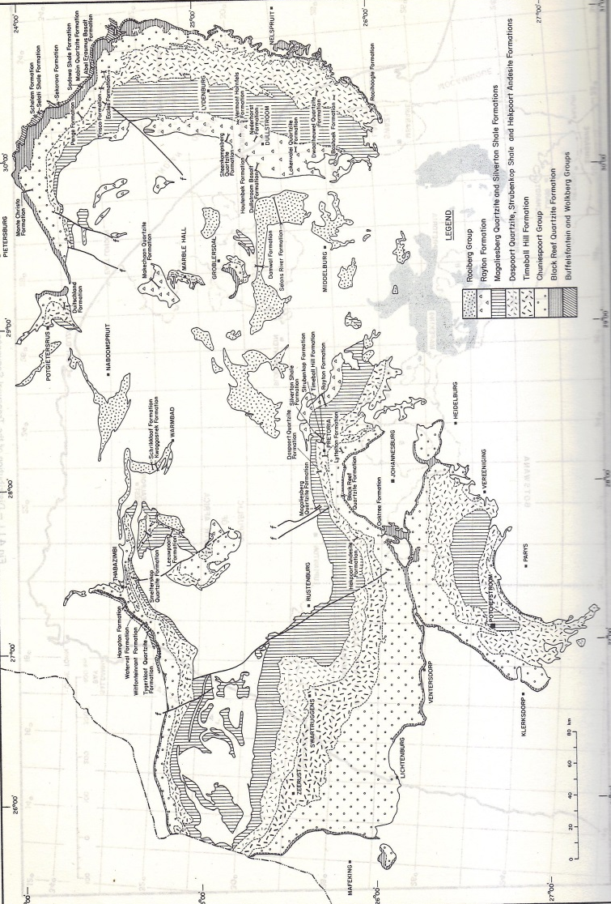

Appendix 2: Listing points in Appendix 6 of the Act and position in Report.
Section | Point in Act | Heading
B | 1(c) | Outline of development project
 | 1(d) | Summary of findings
 | 1(g) | Concerns/threats:
 | 1(n)i | “
 | 1(n)ii | “
 | 1(o) | “
 | 1(p) | “
D | 1(h) | Figures
 | 1(a)i | Terms of reference
H | 1(e) | Description of Methodology
 | 1(i) | Assumptions and Limitations
I | 1(f) | Heritage value
J | 1(j) | Recommendation
 | 1(l) | “
 | 1(m) | Sampling and collecting
 | 1(k) | “
Declaration | 1(b) | Declaration
Appendix 2 | 1(k) | Protocol for finds
 | 1(m) | “
 | 1(q) | “

