**BACKGROUND INFORMATION DOCUMENT**

**ENVIRONMENTAL IMPACT ASSESSMENT (EIA), WATER USE LICENSE APPLICATION AND BORROW PIT APPLICATION FOR THE PROPOSED UPGRADE OF ROAD D1867 WITHIN UPHONGOLA MUNICIPALITY, ZULULAND DISTRICY MUNICIPALITY, KWAZULU NATAL**

**PURPOSE OF THIS DOCUMENT**

Notice of an Environmental Impact Assessment Process is given in terms of The National Environmental Management Act, Act No. 107 of 1998. Activities triggered by this proposed project will require Basic Assessments as per NEMA, 1998 and The Mineral and Petroleum Resources Development Act, Act No.28 of 2002). A Water Use License will also be applied for in terms of the National Water Act, Act no. 36 of 1998.

Issues of concern and potential environmental impacts will be evaluated during the Environmental Impact Assessments and Water Use Licensing Process.

The purpose of this Background Information Document (BID) is to provide a brief description of the project and EIA process to be followed and to obtain initial comments and contributions from Interested and Affected Parties (I&AP’s).

I&AP’s are hereby invited to comment on the environmental and social issues relating to the proposed upgrade of D1867 including the proposed new road alignment and bridge crossing the Mozana River and two Borrow Pits along the alignment to be used. Your comments will ensure that relevant issues are evaluated and will form part of the Assessment.

Should you wish to register as an I&AP and/or receive additional information regarding the project, you are requested to complete the form, on page 4 and email, post or hand deliver it to Afzelia Environmental Consultants by 21 October 2019, at the following address: Solomon Fataki and or Joleen Wilson at Afzelia Environmental Consultants (Pty) Ltd, P.O BOX 37069, Overport, 4067 | First Floor, 236 9th Avenue, Morningside, Durban, 4001. 031 303 2835 | [solomon@afzelia.co.za](mailto:solomon@afzelia.co.za) or [joleen@afzelia.co.za](mailto:joleen@afzelia.co.za)

**DESCRIPTION OF THE DEVELOPMENT**

The existing Road D1867 is approximately 7.5m wide and 10.5 km long with a road reserve of 30m and the project entails the upgrading and widening from 7.5m to 8.5m wide surfaced Type 4 Low Standard Secondary Road with a carriageway width consisting of 2 x 3.5m lanes and a 1.5m concrete paved footway. The proposed upgrade will start from KM 6 of the existing D1867 road at approximately GPS coordinates: 27°16’51.34”S and 31°14’20.94”E to the KM10.5 of the existing D1867 road at approximately at GPS coordinates: 27°20’38.26” and 31°11’3.99”E. The project includes the construction of a new bridge over the Mozana River and small section of the road before and after the bridge requires re-alignment.

Three existing Borrow Pits are found along the D1867 alignment, however two will be assessed and authorisation applied for to allow use of the natural resources during the construction D1867.

**REGIONAL SETTING AND LOCATION**

The proposed Road D1867 starts in the Belgrade area within the Pongola area and ends at Oranjedal also in the Pongola area. The road runs through the Inkosi S.Q Mtungwa Ndlangamandla, Inkosi T.K Sibiya and Msibi Traditional Authority areas. The new road alignment to allow for the new bridge is located within the province of Mpumalanga whereas the remaining area of the road is located within KwaZulu Natal province. The proposed road is located approximately 40km west of the town of Pongola and approximately 52km south-east of Piet Retief. Access to the road is from the N2 at the north and from an unnamed road at Oranjedal at the south-west. The south-west end of the road is located at the border between KwaZulu Natal and Mpumalanga, however, is still within the KZN boundary.

**LEGAL REQUIREMENTS**

The EIA process for this assessment will be conducted accordance with the EIA Regulations, 2014 in terms of the National Environmental Management Act, 1998 (Act No. 107 of 1998) as amended; in accordance with The Mineral and Petroleum Resources Development, 2002 (Act No. 28 of 2002) and Section 21 in terms of The National Water Act, 1998 (Act No. 36 of 1998).

The National Environmental Management Act, 1998, EIA Regulations as amended lists activities that may have a significant impact on the environment which consequently require authorisation from the relevant authorities. The regulations further specify the assessment process and the information that is required to enable the Department of Economic Development, Tourism and Environmental Affairs, the Department of Mineral Resources and the Department of Water and Sanitation to make a decision regarding the proposed activities.

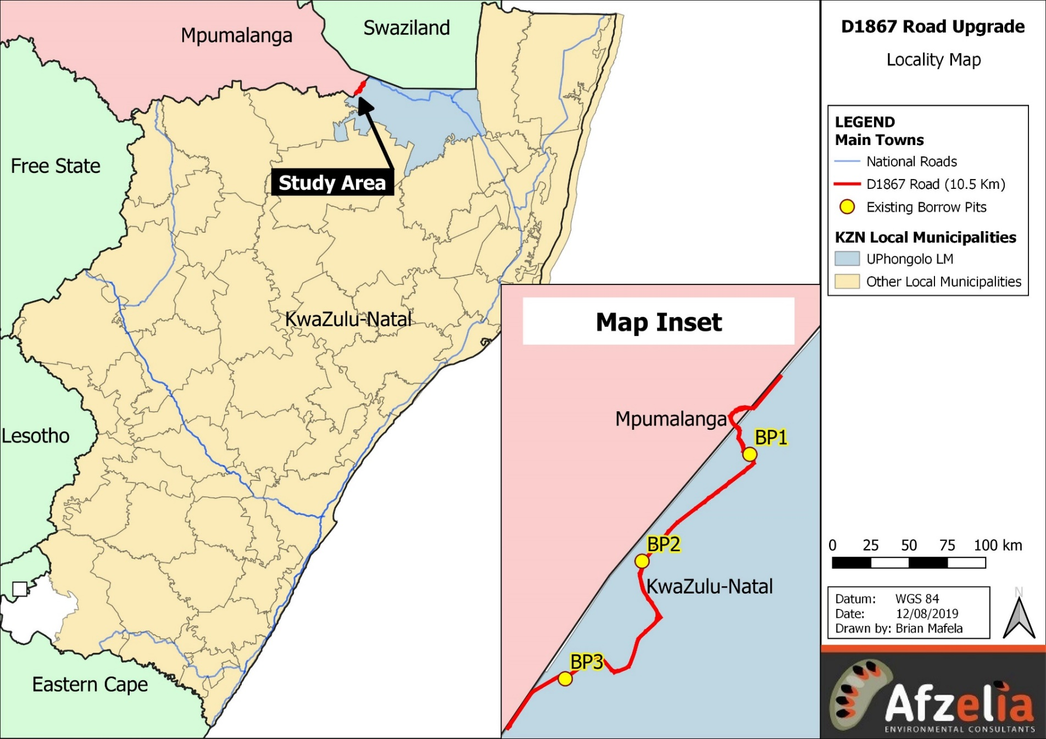

**Figure 1: Locality map**

**APPENDIX 1: I&AP REGISTRATION FORM**

**ENVIRONMENTAL IMPACT ASSESSMENT, BORROW PIT APPLICATION AND WATER USE LICENSE APPLICATION FOR THE PROPOSED UPGRADE OF ROAD D1867 IN UPHONGOLA MUNICIPALITY, ZULULAND DISTRICT MUNICIPALITY, KWAZULU NATAL**

|  |  |  |  |  |  |  |  |  |  |  |  |  |  |
| --- | --- | --- | --- | --- | --- | --- | --- | --- | --- | --- | --- | --- | --- |
| Title |  | | Name |  | | Surname | | | |  | | | |
| Company |  | | | | | | | | | | | | |
| Designation |  | | | | | | | | | | | | |
| Address |  | | | | | | | | | | | | |
|  | | | | | | | | | | Postal code | |  |
| Tel No. |  | | | | Fax No. | |  | | | | | | |
| Email |  | | | | Cell No. | |  | | | | | | |
| I would like to receive my notifications by (mark with X): | | | | | Post | | | Email | | | | Fax | |
| **Please indicate why you have interest in the abovementioned project?** | | | | | | | | | | | | | |
|  | | | | | | | | | | | | | |
|  | | | | | | | | | | | | | |
| **Please write your comments and questions here:** | | | | | | | | | | | | | |
|  | | | | | | | | | | | | | |
|  | | | | | | | | | | | | | |
|  | | | | | | | | | | | | | |
|  | | | | | | | | | | | | | |
|  | | | | | | | | | | | | | |
|  | | | | | | | | | | | | | |
| *Please feel free to attach a separate document* | | | | | | | | | | | | | |
| **Please add any person you think may be an interested and affected party:** | | | | | | | | | | | | | |
| Full Name | |  | | | Company | |  | | | | | | |
| Address | |  | | | | | | | | | | | |
| Email | |  | | | Tel/ Cell No. | | | |  | | | | |
| **PLEASE SEND YOUR REGISTRATION FORM AND COMMENTS TO:** | | | | | | | | | | | | | |
| Company | Afzelia Environmental Consultants (Pty) Ltd | | | | Contact person | | | | Mr Solomon Fataki / Ms Joleen Wilson | | | | |
| Address | PO Box 37069, Overport, 4067 | | | | | | | | | | | | |
| Tel No. | 031 303 2835 | | | | | | | | | | | | |
| Email | [solomon@afzelia.co.za](mailto:solomon@afzelia.co.za) / [joleen@afzelia.co.za](mailto:joleen@afzelia.co.za) | | | | Website | | [www.afzelia.co.za](http://www.afzelia.co.za) | | | | | | |