TEL: 072 455 5168
EMAIL: sheldon@satenviro.co.za
WEBSITE: www.satenviro.co.za
ADDRESS: 97 Hyacinth Road
Redhill
Durban
4051

DRAFT BACKGROUND INFORMATION DOCUMENT (BID) - IBISI SEWER RETICULATION SYSTEM
HARRY GWALA DISTRICT MUNICIPALITY
EDTEA REF NO:

PREPARED ON BEHALF OF:
MAKHAOSE, NARASIMULU AND ASSOCIATES (PTY) LTD
84 CLELAND ROAD,
HAYFIELDS,
PIETERMARITZBURG
3200
TEL: 033 346 2835
WEBSITE: WWW.MNA-SA.CO.ZA
DETAILS OF THE ENVIRONMENTAL ASSESSMENT PRACTITIONER, APPLICANT AND SPECIALISTS
DETAILS OF ENVIRONMENTAL ASSESSMENT PRACTITIONER
EAP | Environmental Experience | Contact Details
Mr. S. Singh, Pr.Sci.Nat (119038)  Sen. Environmental Specialist | 17 Years | 072 4555 168  sheldon@satenviro.co.za
Sarian Pillay  (BSc Hydrology Eng.)  (BSc Soil Physics & Chemistry) | 1 Year | 074 522 7761  info4@satenviro.co.za
DETAILS OF THE SPECIALISTS
Specialist Discipline | NAME | COMPANY | QUALIFICATION | REPORT
Wetland Specialist | Miss. Rowena Harrison | Malachite Specialists | Wetland & Aquatic Ecologist (Pr Sci Nat) | Wetland & Riparian Impact Assessment
Heritage Specialist | Mr. Frans Prins | Active Heritage cc. | MA (Archaeology) | Heritage Impact Assessment
Biodiversity  Specialist | Dr Craig Widdows | Malachite Specialists | PHD  (Ecological Sciences) | Biodiversity Assessment

*Information outlined in this report has been obtained from various sources and acknowledged in the report*.

Table of Contents
1. PURPOSE OF DOCUMENT 2
2. PROJECT BACKGROUND INFORMATION 3
3. PROJECT LOCATION 3
4. NEED AND DESIRABILITY OF THE PROJECT 4
4.1 EXISTING SANITATION INFRASTRUCTURE 4
5. ENVIRONMENTAL APPLICATIONS 4
5.1 BASIC ASSESSMENT APPLICATION PROCESS 4
5.2 WATER USE LICENCE APPLICATION PROCESS 4
6. PUBLIC PARTICIPATION PROCESS 5
7. SPECIALIST STUDIES 7
7.1 POTENTIAL ENVIRONMENTAL IMPACTS 8
8. ROLE AS AN I & AP 9

1. PURPOSE OF DOCUMENT
SAT Environmental Consultants was appointed by Makhaotse, Narasimulu and Associates (Pty) Ltd as an independent Environmental Consultant to conduct an Environmental and a Water Use License Application for Ibisi Sewer Reticulation System.
The purpose of the Background Information Document (BID) is to:
- Provide project description and application processes for the proposed development activities.
- Allow registered Interested and/or Affected Parties (I&AP’s) an opportunity to lodge any concerns and provide comments in relation to the proposed development. Interested and Affected Parties (I&AP’s) are invited to complete and submit the attached “Comments and Registration Sheet’’ attached to this document.
- Consult stakeholders to form part of the interested and Affected Parties (I&AP) register.
Input from the Interested and Affected Parties forms a crucial component of the Public Participation Process (PPP) and ensures that all potential environmental issues are considered during the submission of the application processes.
This document contains the following information:
- Project Background information
- Project Location
- Need and Desirability of the project
- Summary of Specialist Assessments
- Potential Environmental Impacts
- Associated Environmental Processes
- Roles of an I&AP
- Comments & Registration Sheet

2. PROJECT BACKGROUND INFORMATION
Harry Gwala District Municipality proposes to construct an Ibisi Sewer Reticulation System. Ibisi town is located in the uMzimkhulu local municipality within the jurisdiction of Harry Gwala District Municipality. The aim of the proposed project is to provide water borne sewerage reticulation system to the community of Ibisi. Furthermore, the proposed implementation of the Ibisi sewer reticulation, will provide a medium to high level waterborne sanitation and waste water removal service to the Ibisi community. The scope of works for the proposed development activities entail the following activities:
- The laying of approximately 15.3km of 160mm diameter sewer gravity mains,
- The laying of approximately 10km of 110mm diameter ERF Connections,
- The construction of approximately 258 no. manholes,
- Construction of pump station including the supply and installation of duty and standby pumps,
- The laying of approximately 0.37km of 110mmØ sewer rising main,
- The supply and installation of approximately 334 no. toilet top structures and plumbing connections,
- The connection of approximately 39 no. erven which currently have septic tanks into the sewer reticulation, and
- ISD and training of the community.

3. PROJECT LOCATION
The site for the proposed sewer reticulation system is the Ibisi town, located in ward 11 of the uMzimkhulu local municipality (Refer to figure 1). The proposed site area is approximately 20km South West of uMzimkhulu CBD.
TABLE 1: PROJECT LOCATION
CENTRAL COORDINATES
NAME | LATITUDE | LONGITUDE
Ibisi Town | 30°24’50’’ S | 29°53’19’’ E

4. NEED AND DESIRABILITY OF THE PROJECT
It will be necessary to design and construct the Ibisi Sewer Reticulation System in order to enhance development potential for approximately 1336 people and improve service delivery offered by the municipalities.

4.1 EXISTING SANITATION INFRASTRUCTURE
Currently the area of Ibisi does not have any existing Waterborne Sanitation Infrastructure. The existing infrastructure consists of traditional pits, VIP’s and septic tanks.
The Harry Gwala District Municipality has constructed an existing outfall sewer and Wastewater Treatment Works (WWTW) to cater for the sewage generated from Ibisi. The existing outfall sewer is a 250mm diameter pipeline which runs along the eastern boundary of Ibisi to the existing WWTW.
The existing WWTW was designed to cater for an adjacent low-cost housing project as well as Ibisi town. The capacity of the treatment works is 800Kl/day. The estimated discharge from the low-cost housing project is 250 Kl/day. The treated effluent currently discharges into the Ibisi River.

5. ENVIRONMENTAL APPLICATIONS

5.1 BASIC ASSESSMENT APPLICATION PROCESS
The Basic Assessment (BA) process for the proposed development will be undertaken in accordance with the National Environmental Management Act,1998 (Act No.107 of 1998) in terms of the EIA Regulations, 2014 as amended. As part of the BA process the project will require the approval from the Department of Economic Development, Tourism and Environmental Affairs (EDTEA) prior to commencement of the project for activities triggering any Listing Notices contained in the EIA Regulations, 2014 as amended.

5.2 WATER USE LICENCE APPLICATION PROCESS
A Water Use Licence Application under the provision of the Nation Water Act,1998 (Act No. 36 of 1998) is also required for the proposed project. Water Use License Application (WUL) must be lodged with the Department of Water and Sanitation (DWS) for approval.

6. PUBLIC PARTICIPATION PROCESS
The Public Participation Guideline in terms of National Environmental Management Act,1998 (Act No.107 of 1998) and the Environmental Impact Assessment Regulations, 2014 as amended, describes public participation process as “a process by which potential interested and affected parties are given opportunity to comment on, or raise issues”. Therefore, the public participation process will provide for the opportunity for interested and affected parties, stakeholders and competent authorities to obtain clear, accurate and understandable information about the environmental impacts associated with the proposed project.
Public Participation Process can be summarized as follows:
- Distribution of the Background Information Document (BID) to all identified stakeholders, providing an opportunity to register as an I&AP.
- Erecting site notices in close proximity to the site area.
- Placing an advertisement in the local newspaper.
- The draft Basic Assessment & Water Use Technical reports will be circulated to registered I&APs for comments. (Should no comments be received within the stipulated timeframes; the Environmental Consultant will take it as No Comments received in accordance with the relevant sections of the legislation).

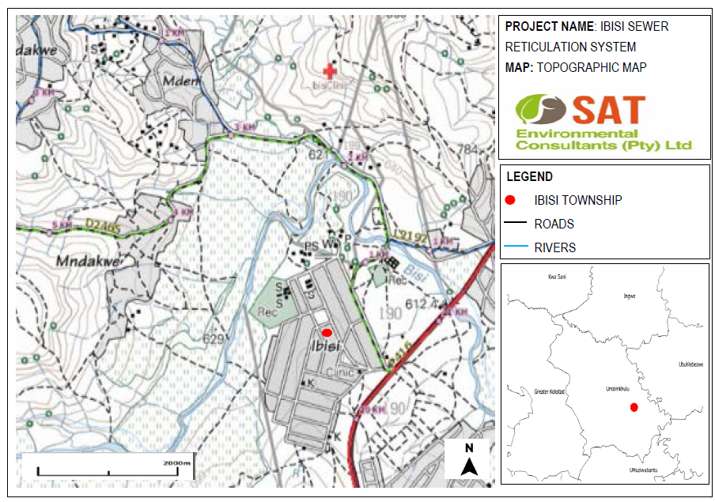
FIGURE 1: LOCALITY MAP OF IBISI TOWN

7. SPECIALIST STUDIES
The proposed development requires the following specialist studies to be undertaken:
- Wetland Assessment
- Heritage Impact Assessment
- Hydrological and Geotechnical Assessment
- Biodiversity Assessment

7.1 POTENTIAL ENVIRONMENTAL IMPACTS
Potential environmental impacts associated with the proposed development have been identified and will be assessed during the Basic Assessment process.
POTENTIAL IMPACTS | RESPONSIBLE FOR MITIGATION RECOMMENDATIONS
Soil erosion, sedimentation & degradation of wetland areas | Addressed in the Wetland Impact assessment undertaken by Malachite Specialist Services.
Pollution of Water Resources & Soil | Addressed in the Wetland Impact assessment undertaken by Malachite Specialist Services.
Alien invasive species encroachment | Addressed in the Wetland Impact assessment undertaken by Malachite Specialist Services.
Water Quality Degradation during the effluent discharge to the Ibisi river. | Addressed in the Wetland Impact assessment undertaken by Malachite Specialist Services.
Waste Generation | Addressed by the Environmental Assessment Practitioner in the Basic Assessment Report.

8. ROLE AS AN I & AP
Should you wish to register as an Interested/Affected Party (I&AP) or if you have any comments, concerns or objections regarding the project, kindly follow the procedure outlined below:

1. Complete the comments and registration sheet attached to this document and email or post the completed sheet to SAT Environmental Consultants (PTY) LTD as per details below.
2. Contact the environmental consultant directly via email or telephonically, if you have any queries or require further information on the project.

Please register by completing the attached comments and registration sheet.
For all inquiries, comments and concerns, kindly contact:
Name: Sarian Pillay
Cell: 074 522 7761
Email: info4@satenviro.co.za
Address: 97 Hyacinth Road, Redhill, Durban, 4051

APPENDIX 1
COMMENTS & REGISTRATION SHEET
ATTENTION: SARIAN PILLAY
PROJECT: IBISI SEWER RETICULATION SYSTEM

TITLE: |  | TEL/CELL:
NAME & SURNAME: |  | EMAIL:
ORGANISATION:
ADDRESS:

Please tick the appropriate box:
- I would like to register as an Interested and Affected Party.

- Please remove me from the distribution sheet for the proposed project. I would prefer not to receive any further correspondence regarding this process.
Yes | No
- Do you have any direct business, financial, personal or other interest in the approval or refusal or this application?

If yes please explain:
______________________________________________________________________________________________________________________________________________________________________________________________________________________________
______________________________________________________________________________________________________________________________________________________________________________________________________________________________

Comments:

______________________________________________________________________________________________________________________________________________________________________________________________________________________________
______________________________________________________________________________________________________________________________________________________________________________________________________________________________

All comments are to be submitted within 14 days of receipt of the BID to: info4@satenviro.co.za alternatively contact Sarian Pillay, Tel: 074 522 7761

