ENVIRONMENTAL IMPACT ASSESSMENT FOR

**THE PROPOSED TOWNSHIP DEVELOPMENT OF MALAMULELE EXTENSION E, WITHIN THE COLLINS CHABANE LOCAL MUNICIPALITY, LIMPOPO PROVINCE.**

**PREPARED BY:**

Global Geo Enviro Specialists

Contact Person: Danielle Potgieter

Email: [potgieter.danielle@gmail.com](mailto:potgieter.danielle@gmail.com)

Cell: 0825639024

**PREPARED FOR:**

Collins Chabane Local Municipality

DCO Offices, Hospital Road, Malamulele, 0982

Contact Person: Tiko Shimange

Email: tikoshimange@gmail.com

Contact number: 0833620539

|  |  |  |
| --- | --- | --- |
| DOCUMENT DETAILS | | |
| DOCUMENT TITLE | THE PROPOSED TOWNSHIP DEVELOPMENT OF MALAMULELE EXTENSION E, WITHIN THE COLLINS CHABANE LOCAL MUNICIPALITY, LIMPOPO PROVINCE. |  |
| GLOBAL GEO ENVIRO SPECIALISTS REFERENCE | 1006E |  |
| CLIENT | Collins Chabane Local Municipality |  |
|  |  |  |
| DOCUMENT CONTROL | | |
|  | Name | Signature |
| COMPILED | Daniëlle Potgieter |  |
| COMPILED | Davrotiah Lekala |  |
| CHECKED | Kabelo Phakwago |  |
|  |  |  |
| REVISION AND AMENDMENTS | | |
| REVISION DATE | DESCRIPTION | REV # |
|  |  |  |
|  |  |  |
|  |  |  |
|  |  |  |

Table of Contents

**LIST OF TABLES** iii

**LIST OF FIGURES** iv

**LIST OF APPENDICES** iv

**ACRONYMS AND ABBREVIATIONS** vi

**EAP’S CURRICULUM VITAE AND CONTACT DETAILS** vii

**PROJECT INFORMATION** vii

**EXECUTIVE SUMMARY** viii

**ENVIRONMENTAL IMPACT ASSESSMENT (EIA) PROCESS** viii

**DECLARATION OF INTEREST**

1. INTRODUCTION 1

2. PROJECT NEED AND DESIRABILITY 2

3. SITE LOCALITY 2

4. PROPERTY DESCRIPTION 4

4.1. Topography 4

4.2. Geology and Soils 5

4.3. Climate 7

4.4. Vegetation 7

4.5. Environmental Sensitivity 8

5. PROJECT ALTERNATIVES 10

5.1. LOCATION ALTERNATIVE 11

5.2. SITE LAYOUT ALTERNATIVE 11

5.3. ACTIVITY ALTERNATIVE 11

5.4. THE NO-GO ALTERNATIVE 11

6. LEGISLATIVE GUIDELINES 12

7. OTHER GUIDELINES AND DOCUMENTATION CONSIDERED IN THE DRAFTING OF THE SCOPING REPORT INCLUDE: 14

7.1. CONSTITUTION OF THE REPUBLIC OF SOUTH AFRICA 14

7.2. NOISE CONTROL REGULATIONS, 1992 (GN R.154) 14

7.3. NATIONAL ENVIRONMENTAL MANAGEMENT: BIODIVERSITY ACT, 2004 (ACT NO. 10 OF 2004) 15

7.4. INTEGRATED ENVIRONMENTAL MANAGEMENT (IEM) 15

7.5. NATIONAL HERITAGE RESOURCES ACT, 1999 (ACT NO. 25 OF 1999) 16

7.6. AUTHORITY CONSULTATION 16

8. SPECIALIST STUDIES 17

9. ENVIRONMENTAL AUTHORISATION PROCESS 18

10. SUMMARY OF SPECIALIST STUDIES 19

10.1. PHASE 1 HERITAGE IMPACT ASSESSMENT 19

10.2. BIODIVERSITY (FAUNA AND FLORA) STUDY 20

10.3. ENGINEERING SERVICES REPORT 22

10.4. GEOTECHNICAL INVESTIGATION 23

11. ENVIRONMENTAL IMPACT ASSESSMENT 24

11.1. PROCEDURE 24

11.2. Description of Potential Impacts to be further investigated. 24

11.2.1. Geology and Soil 24

**11.2.2.** **Topography** 25

**11.2.3.** **Topsoil and Land use** 25

**11.2.4.** **Fauna** 25

**11.2.5.** **Flora** 25

**11.2.6.** **Air Quality** 25

**11.2.7.** **Archaeology and Palaeontology** 25

**11.2.8.** **Visual Impacts** 25

**11.2.9.** **Socio-Economic** 25

**a)** **Positive Socio-Economic Impacts:** 25

**b)** **Negative Socio-Economic Impacts:** 25

**11.2.10.** **Cumulative Impacts** 25

12. PROPOSED METHODOLOGY FOR ASSESSING ENVIRONMENTAL IMPACTS 26

13. PUBLIC PARTICIPATION 44

13.1. NOTICE TO THE PUBLIC / I&AP REGISTRATION PERIOD 45

13.2. AVAILABILITY OF CONSULTATIVE ENVIRONMENTAL IMPACT ASSESSMENT REPORT FOR REVIEW AND COMMENT 45

14. PLAN OF STUDY FOR ENVIRONMENTAL IMPACT ASSESSMENT 45

15. CONCLUSION AND RECOMMENDATIONS 46

15.1. RECOMMENDATIONS AND CONDITIONS 47

16. APPENDICES 48

### **LIST OF TABLES**

Table 1 - Summary of Area Sensitivities - generated by the National Screening Tool from the Department of Forestry, Fisheries and the Environment 9

Table 2 -Site selection criteria 10

Table 3: Listed activities triggered by the proposed township development in terms of the NEMA EIA regulations (2014) as amended. 14

Table 4 - Summary of results for Phase 1 Heritage Impact Assessment 19

Table 5- Summary of results for the Biodiversity Impact Assessment 20

Table 6 - Summary of Engineering services and proposed design criteria 22

Table 7 – Proposed Site key geotechnical findings 23

Table 8 - Description of the nature of the possible environmental Impacts. 26

Table 9 Point Allocation for the rating of Impacts. 27

Table 10 The significance of the ratings on proposed impacts. 27

Table 11-Air Quality: Environmental Impact Significance and Possible mitigation measures 29

Table 12 - Noise: Environmental Impact Significance and Possible mitigation measures 30

Table 13 - Geology and Soil: Environmental Impact Significance and Possible mitigation measures 34

Table 14 - Ecology (Fauna and Flora): Environmental Impact Significance and Possible mitigation measures 38

Table 15 - Socio-economic and Heritage: Environmental Impact Significance and Possible mitigation measures 39

Table 16 - Visual: Environmental Impact Significance and Possible mitigation measures 40

Table 17- Water quality and quantity: Environmental Impact Significance and Possible mitigation measures 43

### **LIST OF FIGURES**

Figure 1 - Locality map of the proposed Township development area in Malamulele 2

Figure 2- Proposed Layout Plan for the proposed Township development of sites in Malamulele 3

Figure 5 - Description of Geological formation surrounding the proposed township development site in mabandla Village 5

Figure 6 - Description of Lithostratigraphy at the proposed township development site in Mabandla Village 6

Figure 8 - Broad Terrestrial Vegetation for Malamulele proposed township development of sites 8

Figure 9 - EIA process flow diagram 18

Figure 10 - Public Participation Process 44

### **LIST OF APPENDICES**

No table of figures entries found.

### **ACRONYMS AND ABBREVIATIONS**

CA Competent Authority

DEFF Department of Environment, Forestry, and FisheriesdSR Draft Scoping Report

EA Environmental Authorization

EAP Environmental Assessment Practitioner

EIA Environmental Impact Assessment

EIR Environmental Impact Report

EMC Environmental Management Committee

EMP Environmental Management Plan

EMPr Environmental Management Programme

ESR Environmental Scoping Report

I&AP Interested and Affected Party

IAR Impact Assessment Report

IDP Integrated Development Plan

LEDET Limpopo Department of Economic Development, Environment, and Tourism

NCRs National Noise Control Regulations

NEMA National Environmental Management Act of 1998 as amended

NHRA National Heritage Resources Act of 1999

NWA National Water Act of 1998

PPP Public Participation Process

ROD Record of Decision

SANRAL South African National Roads Agency Limited

SDF Spatial Development Framework

SR Scoping Report

TBA To Be Announced

### **EAP’S CURRICULUM VITAE AND CONTACT DETAILS**

EAP’s Qualifications (Ms Daniëlle Potgieter):

* BSc (Hons) Environmental Monitoring and Modelling), University of South Africa
* BSc Geology, University of Pretoria
* Course completed in Geotechnical Core Logging, Soil Profiling and Chip Logging from SAIEG -South African Institute for Engineering and Environmental Geologists

Contact details of the EAP

Name DL (Daniëlle) Potgieter

Company Name Global Geo Enviro Specialists

Postal/ Physical Address 270 Malherbe Street, Capital Park, Pretoria, 0084

Email potgieter.danielle@gmail.com

Telephone +27 825639024

### **PROJECT INFORMATION**

|  |  |
| --- | --- |
| **District** | Greater Vhembe District |
| **Local Municipality** | Collins Chabane Local Municipality |
| **Property description** | The remainder of the farm Malamulele No. 234-LT |
| **Surveyor-General code** | T0LT00000000023400000 |
| **Nearest town** | Malamulele |
| **Coordinates (Centre point)** | 22° 58’ 39.31” S; 30° 43’ 26.28” E |
| **Current land use** | Agricultural |
| **Surrounding land use** | Agricultural and residential |

### **EXECUTIVE SUMMARY**

Global Geo Enviro Specialists was appointed as the Environmental Assessment Practitioner (EAP) by Mahlori Development Consultants on behalf of Collins Chabane Local Municipality (the applicant) to assist with undertaking the required Environmental Authorization (EA) application processes (including the statutory public participation) for the proposed township development of Malamulele Extension E of 2038 sites on the remainder of the farm Malamulele No. 234-LT in Limpopo Province.

The applicant is proposing the township development of Malamulele Extension E 2038 sites covering an area of approximately 289.33 hectares in Malamulele within the Greater Vhembe District of the Limpopo Province. The geographical coordinates of the center of the site are 22° 58’ 39.31” S; 30° 43’ 26.28” E

The proposed township development will include the following under the jurisdiction of Makhado Local Municipality: REFER TO THE LAYOUT PLAN (APPENDIX A)

• Residential 1 (1555 Dwelling units)

• Residential 2 (422 Group Housing (Eco-Estate))

• Residential 3 (5 Dwelling units)

• 1 Business (14 businesses)

• Educational (1 Primary School and 1 High School)

• Institutional (1 Medical Centre; 1 Clinic; 5 Churches; 3 Crèche; 3 Hall)

• Government (2 Government Purposes)

• Public Open Space (3 Park, 6 Agricultural, 3 Powerline)

• Private Open Space (10 Play Park & Conservation,1 Sports and Recreation Facility)

• Transport (1 Taxi Rank)

• Special (1 Access Control and 1 Future development)

• Streets

**ENVIRONMENTAL IMPACT ASSESSMENT (EIA) PROCESS**

The environmental studies can be summarized in two phases:

• Phase 1: Environmental Scoping Study (ESS)

• Phase 2: Environmental Impact Assessment (EIA) and Environmental Management Programme (EMPr) **(APPENDIX G)**

The scope of the entire EIA process is to provide an assessment of all impacts related to the proposed

project in compliance with the EIA Regulations of 2010.

The Environmental Impact Assessment (EIA) is a comprehensive evaluation and study phase that addresses all environmental consequences raised in the Scoping Phase. The EIA phase is significant and consists of six key objectives:

1. Description of the biophysical and socio-economic environment that is likely to be affected by the proposed township development of sites through the use of specialist studies.
2. Continue with the public participation process.
3. Assess the significance of impacts that may occur from the proposed development of sites.
4. Assess the alternatives proposed during the Scoping Phase.
5. Provide details of mitigation measures and management recommendations to reduce the significance of impacts.
6. Provide a framework for the development of the Environmental Management Programme (EMPr).

**Specialist studies**

Specialist studies are undertaken to thoroughly examine key issues and environmental impacts. Appointed specialists gather relevant data to identify and assess environmental impacts that might occur on the specific component of the environment that they are studying (for instance waste management, air quality, noise, vegetation, water quality, pollution, and waste management). Once completed, these studies are combined and presented in full as appendices to the Environmental Impact Assessment (EIA).

**The Public Participation Process**

The public participation process (PPP) initiated at the beginning of the Scoping Phase continues into the EIA Phase aiding I&APs to voice their concerns and raise issues regarding the project. All comments and issues raised by the I&APs and stakeholders on the Final Scoping Report will be considered and addressed in the final EIA.

**Assessment of the Significance of Impacts**

It is necessary to determine the significance rating of impacts on the natural or social environment. A significance rating scale that determines the spatial and temporal extent, and the significance and probability of any impact occurring, including impacts relating to any project alternatives if available. This allows the overall significance of a positive or negative impact to be determined. The overall intent of undertaking a significance assessment is to provide the competent authority with information on the potential environmental impacts allowing them to make an informed, balanced and fair decision.

**Mitigation Measures and Recommendations**

Critical to any EIA is the recommendation of practical and reasonable mitigation measures and recommendations. These recommendations relate to the actions that are needed to avoid, minimise or offset any negative impacts from the development of sites.

**Planning input**

An effective EIA process should actively engage and contribute to the project planning process to mitigate environmental impacts through improved design and layout.

**Environmental Impact Report**

The above-mentioned tasks are combined in the EIR. This will allow the assessment of the relationship of environmental impacts to project actions, and assess the overall significance of these impacts. The EIR will also provide sufficient information to allow the competent authority to make an informed decision concerning the environmental authorisation.

The Environmental Impact Assessment (EIA) Regulations, 2010 (Regulation 543) determine that an environmental authorisation is required for certain listed activities, which might have detrimental effects on the environment. The following activities have been identified with special reference to the proposed development and are listed in the EIA Regulations: **Activity 15 of the Listed Notice 2 GNR 325 7 April 2017 stating**: The clearance of an area of 20 hectares or more of indigenous vegetation, excluding where such clearance of indigenous vegetation is required for (i) the undertaking of linear activity; or (ii) maintenance purposes undertaken in accordance with a maintenance management plan.

|  |  |
| --- | --- |
|  | **Requirements for the contents of an Environmental Impact Assessment Report as specified in the NEMA Regulations 982 (2014) as amended** |
| a | * + - Details of the EAP who prepared the document     - The expertise of the EAP, including a curriculum vitae; |
| b | The location of the activity, including:   1. the 21-digit Surveyor General code of each cadastral land parcel 2. where available, the physical address and farm name 3. where the required information in items (i) and (ii) is not available, the coordinates of the boundary of the property or properties on which the activity is to be undertaken; |
| c | A plan which locates the proposed activity or activities applied for as well as the associated structures and infrastructure at an appropriate scale, or, if it is -   1. a linear activity, a description and coordinates of the corridor in which the proposed activity or activities are to be undertaken 2. on land where the property has not been defined, the coordinates within which the activity is to be undertaken; |
| d | A description of the scope of the proposed activity, including   1. all listed and specified activities triggered and being applied for; and 2. a description of the associated structures and infrastructure related to the proposed development; |
| e | Motivation for the need and desirability for the proposed project, including the need and desirability of the activity in the context of the preferred location |
| f | Motivation for the preferred development footprint within the recommended site; |
| g | A full description of the process followed to reach the proposed development footprint within the proposed site, including:   1. details of the proposed project footprint alternatives that were considered 2. details of the public participation process undertaken in terms of regulation 41 of the Regulations, including copies of the supporting documents and inputs 3. a summary of the issues raised by interested and affected parties, and an indication of how the issues were incorporated, or the reasons for not including them 4. the environmental attributes associated with the development footprint alternatives focusing on the geographical, physical, biological, social, economic, heritage and cultural aspects 5. the impacts and risks identified including the nature, significance, consequence, extent, duration and probability of the impacts, including the degree to which these impacts Any other matters required in terms of section 24(4)(a) and (b) of the Act can be reversed **bb.** may cause irreplaceable loss of resources; and **cc.** can be avoided, managed or mitigated 6. the methodology used in determining and ranking the nature, significance, consequences, extent, duration and probability of potential environmental impacts and risks 7. positive and negative impacts that the proposed activity and alternatives will have on the environment and on the community that may be affected focusing on the geographical, physical, biological, social, economic, heritage and cultural aspects 8. the possible mitigation measures that could be applied and the level of residual risk 9. if no alternative development locations for the activity were investigated, the motivation for not considering such; and 10. a concluding statement indicating the preferred alternative development located within the approved site; |
| h | A full description of the process undertaken to identify, assess and rank the impacts the activity and associated structures and infrastructure will impose on the preferred location through the life of the activity, including   1. a description of all environmental issues and risks that were identified during the environmental impact assessment process; and 2. an assessment of the significance of each issue and risk and an indication of the extent to which the issue and risk could be avoided or addressed by the adoption of mitigation measures; |
|  | An assessment of each identified potentially significant impact and risk, including   1. cumulative impacts; 2. the nature, significance and consequences of the impact and risk; 3. the extent and duration of the impact and risk; 4. the probability of the impact and risk occurring; 5. the degree to which the impact and risk can be reversed; 6. the degree to which the impact and risk may cause irreplaceable loss of resources; and 7. the degree to which the impact and risk can be mitigated; |
|  | Where applicable, a summary of the findings and recommendations of any specialist report complying with Appendix 6 to these Regulations and an indication as to how these findings and recommendations have been included in the final assessment report; |
|  | An environmental impact statement which contains   1. a summary of the key findings of the environmental impact assessment: 2. a map at an appropriate scale which superimposes the proposed activity and its associated structures and infrastructure on the environmental sensitivities of the preferred site indicating any areas that should be avoided, including buffers; and 3. a summary of the positive and negative impacts and risks of the proposed activity and identified alternatives; |
|  | Based on the assessment, and where applicable, recommendations from specialist reports, the recording of proposed impact management objectives, and the impact management outcomes for the development for inclusion in the EMPr as well as for inclusion as conditions of authorisation; |
| i | The final proposed alternatives respond to the impact management measures, avoidance, and mitigation measures identified through the assessment; |
| j | Any aspects which were conditional to the findings of the assessment either by the EAP or specialist which are to be included as conditions of authorisation; |
| k | Description of any assumptions, uncertainties and gaps in knowledge which relate to the assessment and mitigation measures proposed; |
| l | A reasoned opinion as to whether the proposed activity should or should not be authorised, and if the opinion is that it should be authorised, any conditions that should be made in respect of that authorisation; |
| m | Where the proposed activity does not include operational aspects, the period for which the environmental authorisation is required and the date on which the activity will be concluded and the post-construction monitoring requirements finalised; |
|  | An indication of any deviation from the approved scoping report, including the plan of study, including i. any deviation from the methodology used in determining the significance of potential environmental impacts and risks; and ii. a motivation for the deviation; |
| n | Any specific information that may be required by the competent authority; and |
|  | Any other matters required in terms of sections 24(4)(a) and (b) of the Act |

### **DECLARATION OF INTEREST**

I, Daniëlle Lianri Potgieter, as an authorized representative of Global Geo Enviro Specialists hereby confirm my independence as an Environmental Assessment Practitioner and declare that neither I nor Global Geo Enviro Services has any interest, be it business, financial, personal or other, in any proposed activity, application or appeal in respect of which Global Geo Enviro Specialists was appointed as Environmental Assessment Practitioner in terms of the National Environmental Management Act, 1998 (Act No. 107 of 1998), other than fair remuneration for work performed, specifically in connection with the Environmental Authorisation process for the proposed development of sites.

1. INTRODUCTION

Global Geo Enviro Specialists was appointed by Mahlori Development Consultants on behalf of Collins Chabane Local Municipality to conduct an Environmental Impact Assessment for the proposed township development of Malamulele E Extension, of 2038 sites on an area of approximately 289.33 hectares in Malamulele on the remainder of the farm Malamulele No. 234-LT in the Greater Vhembe District of the Limpopo Province. The geographical coordinates of the centre of the proposed site are 22° 58’ 39.31” S; 30° 43’ 26.28” E and the proposed development site is approximately 289.33 h hectares

The proposed Township development will include the following under the jurisdiction of Makhado Local Municipality: **REFER TO THE LAYOUT PLAN (APPENDIX A)**

• Residential 1 (1555 Dwelling units)

• Residential 2 (422 Group Housing (Eco-Estate))

• Residential 3 (5 Dwelling units)

• 1 Business (14 businesses)

• Educational (1 Primary School and 1 High School)

• Institutional (1 Medical Centre; 1 Clinic; 5 Churches; 3 Crèche; 3 Hall)

• Government (2 Government Purposes)

• Public Open Space (3 Park, 6 Agricultural, 3 Powerline)

• Private Open Space (10 Play Park & Conservation,1 Sports and Recreation Facility)

• Transport (1 Taxi Rank)

• Special (1 Access Control and 1 Future development)

• Streets

This Environmental Scoping Report (ESR) was compiled following the scoping-phase investigations and Public Participation Process (PPP), and is currently available for public review and comment, from 28 January 2022 to 28 February 2022, resulting in 30 days consultation period.

Following the lapsing of the commenting period, all comments received from the registered Interested and Affected Parties (I&APs) will be incorporated into the final ESR, which will then be submitted to the Limpopo Department of Economic Development and Environmental Tourism (LEDET).

1. PROJECT NEED AND DESIRABILITY

To assess the “need and desirability” of the proposed project, the following relevant documents were consulted (1): Collins Chabane Local Municipality: Integrated Development Plan (IDP), (2) Collins Chabane Local Economic Development Strategy (2013), and (3) A draft guideline on the information requirements to describe need and desirability in the EIA process (DEAT, 2008).

* The existing community of Mabandla Village identified the need to expand their existing village. The need for housing is especially evident in lower-income groups.
* There will be a new crèche, a church site as well as possible business opportunities, for the residents in the surrounding area.

In the following sections, this EAP attempts to make an objective assessment of the “need and desirability” of the project and makes a recommendation based on the available documents and information.

1. SITE LOCALITY

The proposed township development site is located in Malamulele, in the Greater Vhembe District of the Limpopo Province. The geographical coordinates of the Centre of the proposed site are 22° 58’ 39.31” S; 30° 43’ 26.28” E, and the proposed development site is approximately 37.6 hectares.

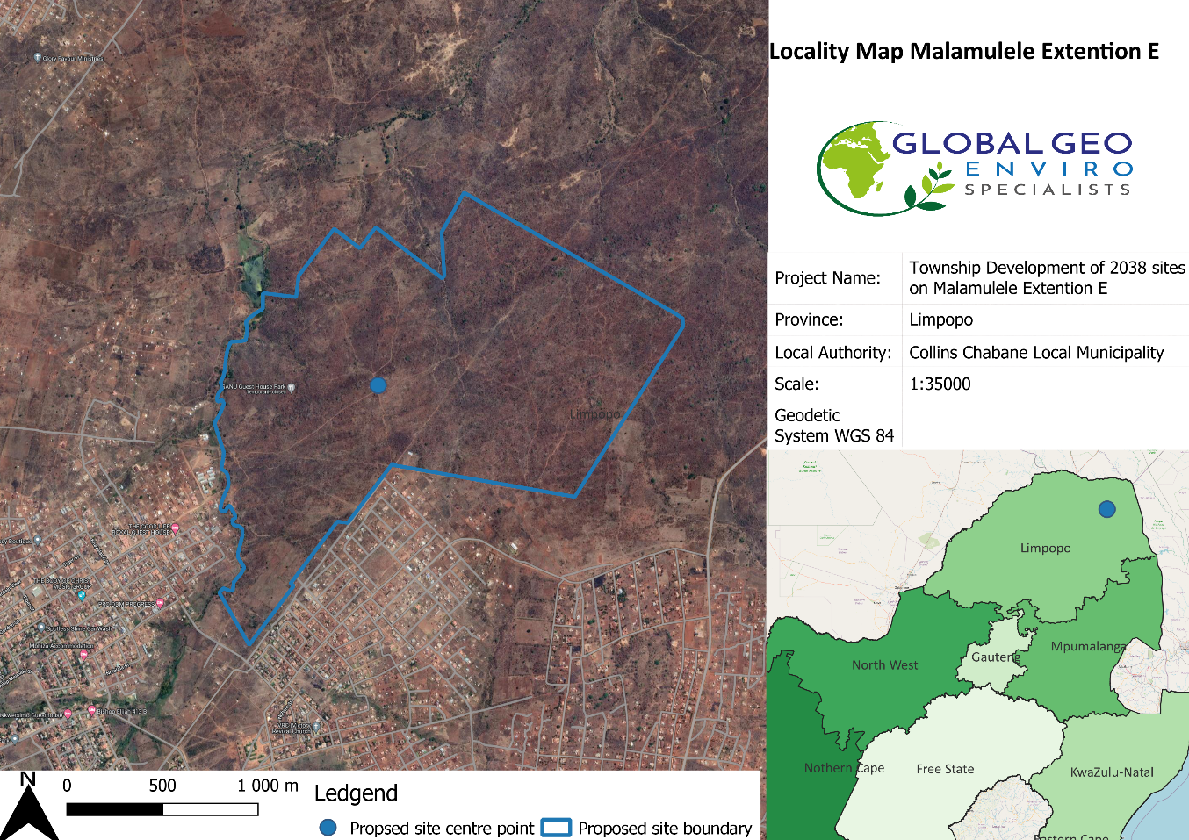

Figure 1 - Locality map of the proposed Township development area in Malamulele

.

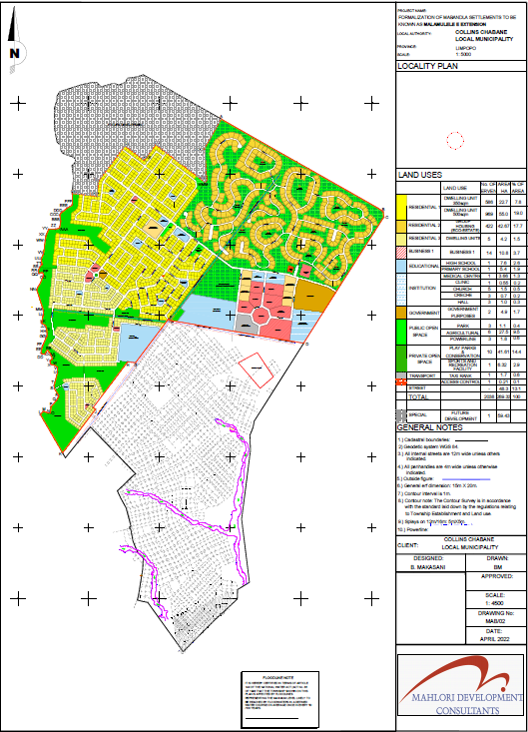

Figure 2- Proposed Layout Plan for the proposed Township development of sites in Malamulele

1. PROPERTY DESCRIPTION
   1. Topography

The area is characterised by an undulating landscape with associated flat moderate slopes with an approximate gradient of 5.2% on average.

The approximate altitudes above the mean sea level of the site are as follows Maximum: 565 m, Minimum: 528m, and Average: 544m.

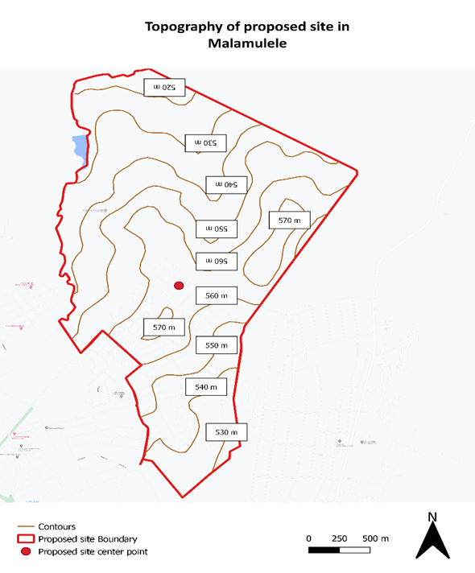

* 1. Geology and Soils

The Geology of the proposed site falls within the Meinhardskraal Granite and Sand River Gneiss groups. The principal rock types can be seen in figure 5 under the Giyani, Goudplaats-Hout River Gneiss and the Jerome Granites. The soil types and soil properties underlying the transported horizon is a ferruginous material is underlain by slightly to moderately weathered granite, granite gneiss, amphibolite and dolerite dyke.

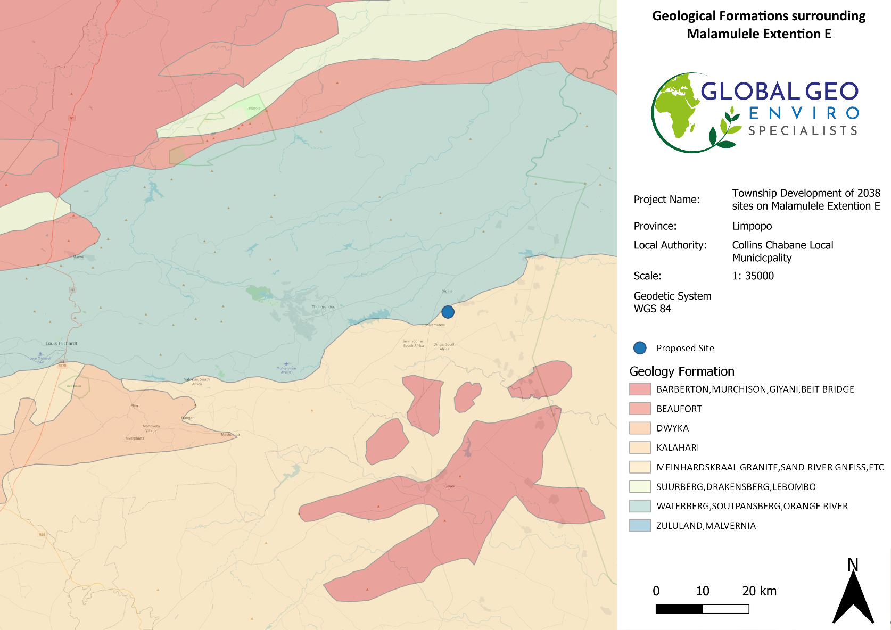

Figure 5 - Description of Geological formation surrounding the proposed township development site in mabandla Village

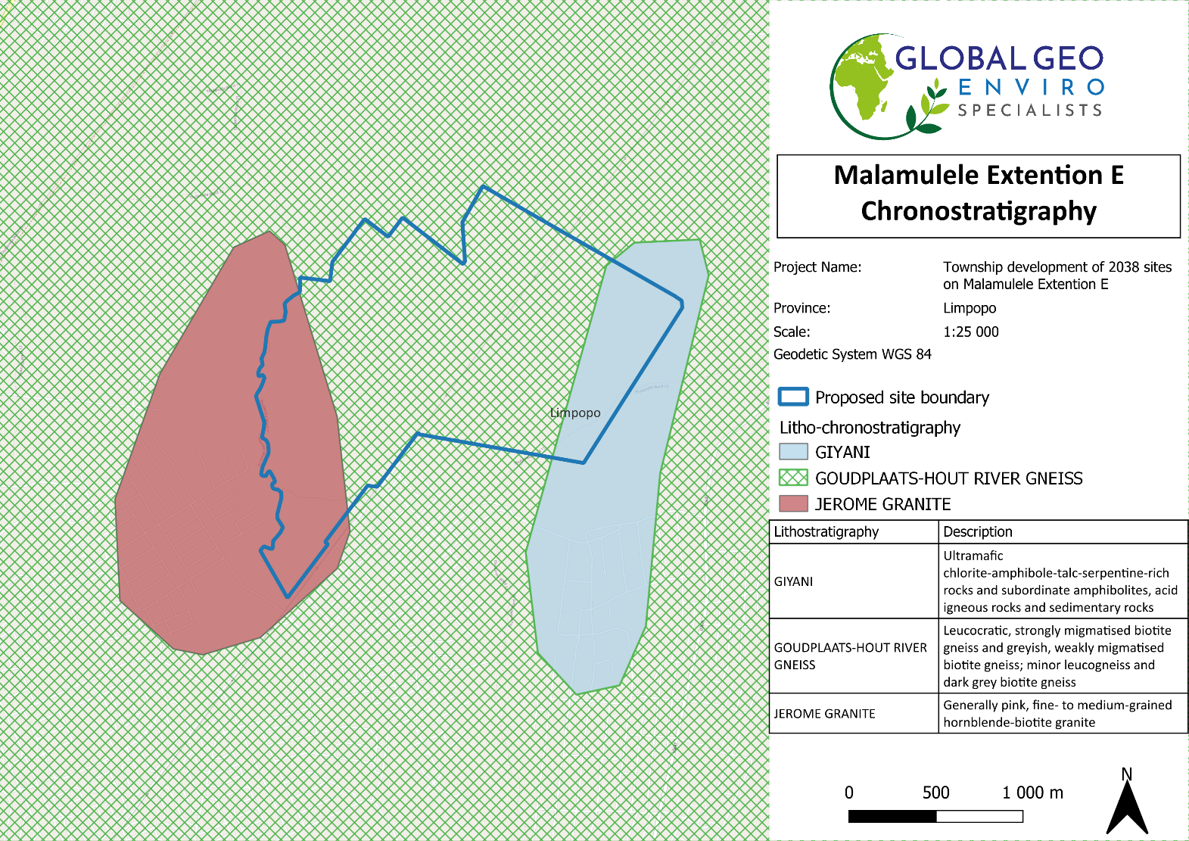

Figure 6 - Description of Lithostratigraphy at the proposed township development site in Mabandla Village

* 1. Climate

Collins Chabane Local Municipality is located in an arid region, and it has a very dry subtropical climate, specifically a humid subtropical climate with long hot and rainy summers coupled with short cool and dry winters. The climate can be considered as generally warm to temperate. Malamulele is considered a summer rainfall region.

According to (Geotsy, 2022) area’s maximum temperatures of Malamulele occurs in January with a maximum temperature of 34°c during the day and 18°c at night. The minimum annual temperatures occur in July with a maximum temperature of 23°c and a minimum temperature of 11°c.

Malamulele is a low-lying area and at risk of flooding.

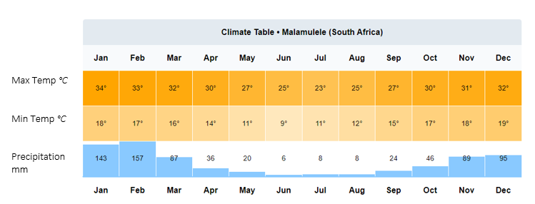

* 1. Vegetation

Upon conducting a desktop study of the area using the 2018 National Vegetation map as seen on the Biodiversity Advisor of the South African National Biodiversity Institute (SANBI) the area surrounding the proposed site consists of predominately Granite Lowveld within the Savanna Biome and the Lowveld Bioregion as shown in figure 7 below. It should be noted that some Sclerocarya birrea, commonly known as the marula trees also found on the site and should be considered during all phases of the proposed township development of sites. The proposed site is densely vegetated with predominantly grasslands and Sweet Thorn trees. A biodiversity study was conducted to further investigate the vegetation of the proposed site and the Biodiversity study report is attached

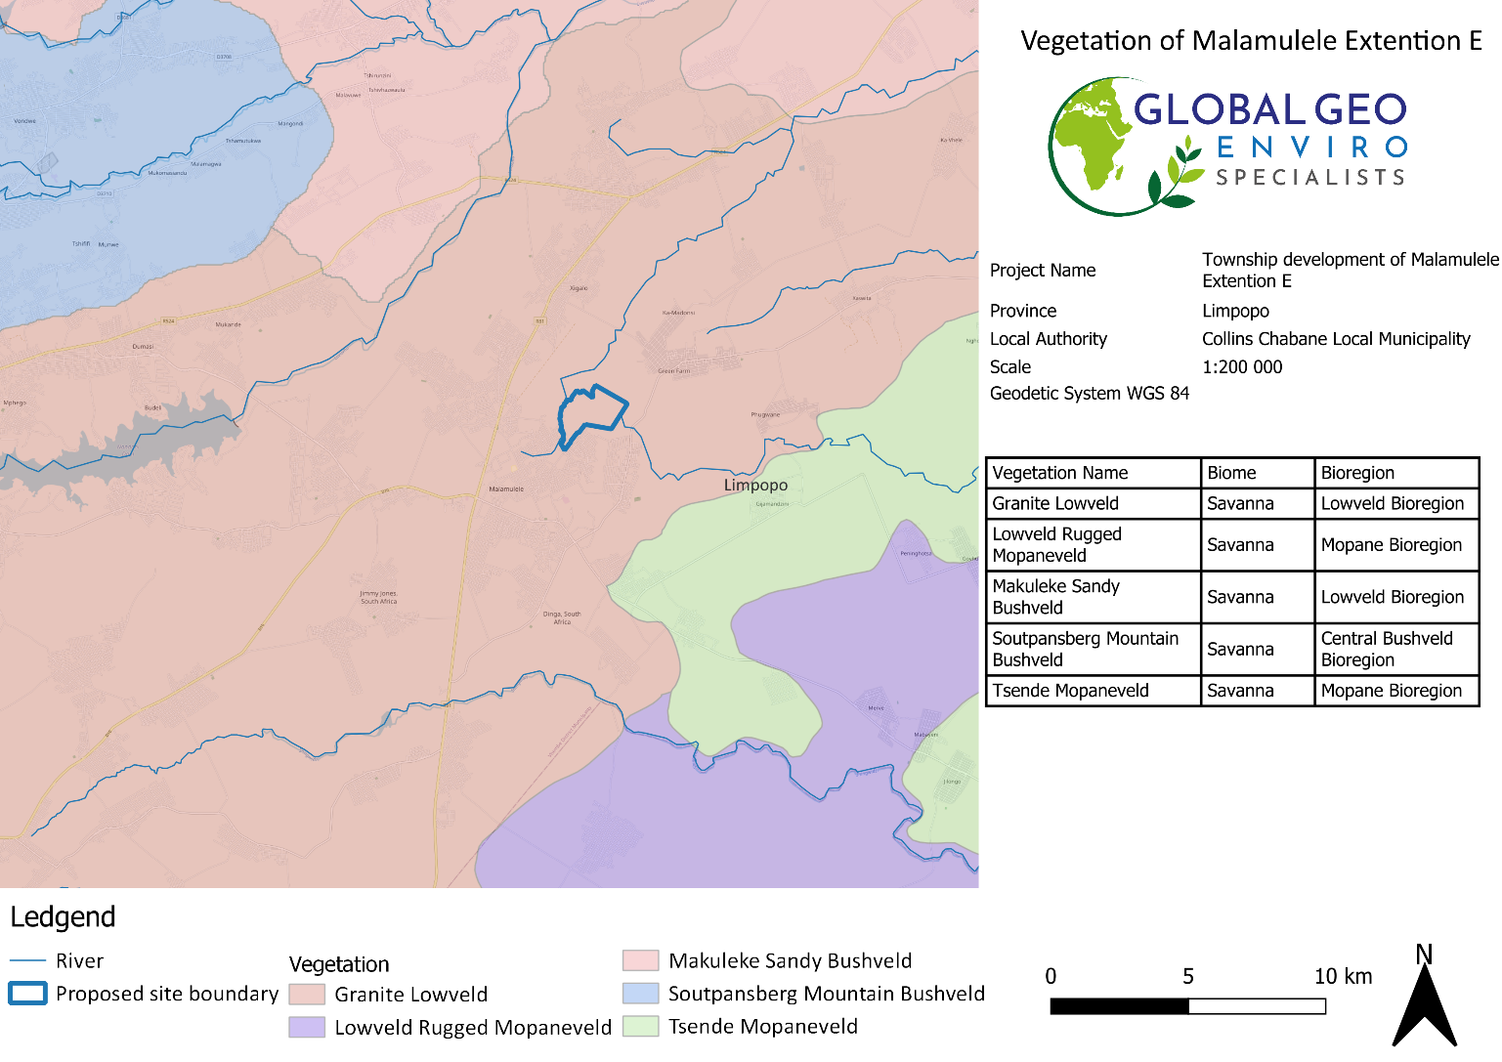

Figure 8 - Broad Terrestrial Vegetation for Malamulele proposed township development of sites

* 1. Environmental Sensitivity

The Sensitivity of the area is discussed in full in the Screening Report for an Environmental Authorisation as required by the 2014 EIA regulations and can be found in **APPENDIX E**. The screening report is generated by the National Screening Tool from the Department of Forestry, Fisheries, and the Environment.

Table 1 below indicated the relative sensitivities as generated by the National Screening Tool, only the highest sensitivity in each theme is indicated. These sensitivities are indicative and should be verified on-site by a suitably qualified person.

|  |  |  |  |  |
| --- | --- | --- | --- | --- |
| Theme | Very High sensitivity | High sensitivity | Medium sensitivity | Low sensitivity |
| Agriculture |  | X |  |  |
| Animal Species |  | X |  |  |
| Aquatic Biodiversity |  |  |  | X |
| Archaeological and Cultural Heritage |  |  |  | X |
| Civil Aviation |  | X |  |  |
| Defence |  |  |  | X |
| Palaeontology |  |  | X |  |
| Plant Species |  |  | X |  |
| Terrestrial Biodiversity | X |  |  |  |

Table 1 - Summary of Area Sensitivities - generated by the National Screening Tool from the Department of Forestry, Fisheries and the Environment

1. PROJECT ALTERNATIVES

In terms of Environmental Impact Assessment (EIA) regulation, the Environmental Assessment Practitioner (EAP) should investigate feasible and reasonable alternatives for the proposed project. In other words, different means of meeting the requirements for the activity.

According to the requirements listed within Appendix 2 (2) (g) (ix) of the 2014 amended EIA Regulations, a site selection matrix should be provided indicating how the preferred site was determined through a site selection process. On a site-specific level, the site was deemed suitable due to all the site selection factors being favourable. The site selection criteria considered by the Applicant are discussed in the table below.

|  |  |
| --- | --- |
| FACTOR | SUITABILITY OF THE PREFERRED SITE |
| Land Availability | The remainder of Farm Malamulele No. 234-LT is a suitable size for the proposed project. The land is state-owned and available for development. |
| Site Accessibility | The proposed project site can be accessed via an existing gravel road. The existing gravel road can be accessed from the R81 National Road. |
| Topography | The area is characterised by an undulating landscape with associated flat moderate slopes with an approximate gradient of 5.2% on average.  The approximate altitudes above the mean sea level of the site are as follows Maximum: 565 m, Minimum: 528m, and Average: 544m. |
| Current Zone of Area | Agriculture |
| Landowner Willingness | The land is owned by the state and signed consent for the use of the land for the proposed project. This is considered an important aspect of the proposed project in terms of its viability (i.e. this will limit potential appeals during the decision-making process, as the landowner is willing and supportive of the proposed projects being undertaken on the remainder of the farm). |

Table 2 -Site selection criteria

In the EIA process, the consideration of alternatives is always important, should the proposed site not fit

into the parameters of the EIA framework. The alternatives can be categorised as follows.

* Location alternatives
* Site Layout Alternatives
* Activity alternatives
* No-Go alternative
  1. LOCATION ALTERNATIVE

The specific location has been chosen because it is adjacent to the existing Mabandla Village.

* The community of Mabandla identified a need for formalization and therefore, residential and other new developments in the area, currently developing at a fast rate, are a suitable option.
* The site is currently zoned as Agricultural.

**There is no location alternative – the layout plan can only be moved around on the remainder of the farm Malamulele No. 234-LT**

A Biodiversity study, Geotechnical study and Heritage assessment will be undertaken before the proposed activity will take place to thoroughly assess the plausibility of the proposed location.

* 1. SITE LAYOUT ALTERNATIVE
* A geotechnical study will be conducted before development, and the positioning of certain parts of the layout of the development can be altered based on the ideal or most suitable soil conditions.
* By carrying out a Heritage assessment before development, the re-positioning of certain parts of the development can be based on the occurrence of heritage aspects. Areas can also be avoided if necessary due to the presence of heritage characteristics.

**There is currently no layout alternative for the proposed development, however, there is a possibility of a layout alternative that will still meet the objective of the project scope.**

.

* 1. ACTIVITY ALTERNATIVE

The purpose of the proposed activity is the township development of stands and formalisation of Mabandla villages on State-owned land, the township development includes public open spaces, private open spaces, residential, educational, business, institutional sites, and Government buildings. The proposed site is surrounded by residential developments, schooling as well as local businesses making the proposed activity preferably situated.

Based on the above, at this stage, there is no reason to suggest that any activity alternatives are investigated as these would not meet the general purpose and need of the proposed activity.

**Therefore, no activity alternatives were investigated for this Scoping Report.**

* 1. THE NO-GO ALTERNATIVE

The no-go alternative is the option not to go ahead with the proposed project. The no-go alternative will only be considered as an alternative if it is concluded that the preferred alternative will have significant negative impacts on the environment which cannot be reduced or managed to an acceptable level. As there have already been indicated that there is a need and desirability for the proposed development it is anticipated that this development will relieve the demand for housing and basic services in the region. It is anticipated that the no-go alternative will constrain the development planning of the Local Municipality.

1. LEGISLATIVE GUIDELINES

National Environmental Management Act, 1998 (Act No. 107 of 1998), as amended The National Environmental Management Act (NEMA) provides the legislative framework for Integrated Environmental Management (IEM) in South Africa. Section 24 provides that all activities that may significantly affect the environment and require authorization by law must be assessed before approval. NEMA also provides for cooperative environmental governance by establishing principles for decision-making on matters affecting the environment, institutions that will promote cooperative governance and procedures for coordinating environmental functions exercised by organs of the State and to provide for matters connected therewith. Section 2 of NEMA establishes a set of principles that apply to the activities of all organs of state that may significantly affect the environment. These include the following:

• Development must be sustainable,

• Pollution must be avoided or minimized and remedied,

• Waste must be avoided or minimized, reused or recycled,

• Negative impacts must be minimized, and

• Responsibility for the environmental health and safety consequences of a policy, project, product or service exists throughout its life cycle.

These principles are taken into consideration when a government department exercises its powers, for example during the granting of permits and the enforcement of existing legislation or conditions of approval. Section 28(1) of NEMA states that “every person who causes, has caused or may cause significant pollution or degradation of the environment must take reasonable measures to prevent such pollution or degradation from occurring, continuing or recurring”. If such pollution cannot be prevented, then appropriate measures must be taken to minimize or rectify such pollution.

These measures may include:

• Assessing the impact on the environment,

• Informing and educating employees about the environmental risks of their work and ways of minimising these risks,

• Ceasing, modifying or controlling actions that cause pollution/degradation,

• Containing pollutants or preventing movement of pollutants,

• Eliminating the source of pollution, and

• Remedying the impacts of the pollution,

• The authorities may direct industry to rectify or remedy a potential or actual pollution problem,

• If such a directive is not complied with, the authorities may undertake the work and recover the costs from the responsible industry.

|  |  |  |
| --- | --- | --- |
| **LISTED ACTIVITY** | **Activity Description** | **Applicability of the Activity** |
| Listing Notice 1 (GNR 984, 07 April 2017)  *Activity 9* | The development of infrastructure exceeding 1 000 metres in length for the bulk transportation of water or stormwater—   1. with an internal diameter of 0,36 metres or more; or 2. with a peak throughput of 120 litres per second or more;   excluding where—   1. such infrastructure is for bulk transportation of water or stormwater or stormwater drainage inside a road reserve or railway line reserve; or 2. where such development will occur within an urban area. | Facilities for bulk transportation of storm water may be required as part of the construction and/or operational activities for this project. The dimensions of the stormwater infrastructure are unknown at present but will be clarified during the EIA phase. |
| Listing Notice 1 (GNR 984, 07 April 2017)  *Activity 10* | The development and related operation of infrastructure exceeding 1 000 metres in length for the bulk transportation of sewage, effluent, process water, wastewater, return water, industrial discharge or slimes –   1. with an internal diameter of 0,36 metres or more; or 2. with a peak throughput of 120 litres per second or more;   excluding where—   1. such infrastructure is for the bulk transportation of sewage, effluent, process water, wastewater, return water, industrial discharge or slimes inside a road reserve or railway line reserve; or 2. where such development will occur within an urban area. | Facilities for bulk transportation of sewage will be required as part of the construction and/or operational activities for the proposed project. The dimensions of the sewage infrastructure are unknown at present but will be clarified during the EIA phase |
| Listing Notice 1 (GNR 984, 07 April 2017)  *Activity 30* | Any process or activity identified in terms of section 53(1) of the National Environmental Management: Biodiversity Act, 2004 (Act No. 10 of 2004). | Will be applicable during the proposed project for the removal of protected trees which will require a DAFF Permit |
| Listing Notice 2 (GNR 325 of 7 April 2017)  *Activity 15* | The clearance of an area of 20 hectares or more of indigenous vegetation, excluding where such clearance of indigenous vegetation is required for   1. the undertaking of linear activity; or 2. maintenance purposes are undertaken in accordance with a maintenance management plan. | The proposed project involves the clearance of 289,33 hectares of indigenous vegetation for the proposed township development. This clearance of indigenous vegetation is greater than the 20-hectare threshold of this listed activity and therefore an application for Environmental Authorisation (EA) through a Scoping and EIA process is required. |

Table 3: Listed activities triggered by the proposed township development in terms of the NEMA EIA regulations (2014) as amended.

1. OTHER GUIDELINES AND DOCUMENTATION CONSIDERED IN THE DRAFTING OF THE SCOPING REPORT INCLUDE:
   1. CONSTITUTION OF THE REPUBLIC OF SOUTH AFRICA

The Constitution of the Republic of South Africa has major implications for environmental management. The main effects are the protection of environmental and property rights, the change brought about by the sections dealing with administrative law, such as access to information, just administrative action and broadening of the locus standi of litigants. These 15 aspects provide general and overarching support and are of major assistance in the effective implementation of the environmental management principles and structures of the NEMA. Section 24 in the Bill of Rights of the Constitution specifically states that: Everyone has the right –

To an environment that is not harmful to their health or well-being, and,

To have the environment protected, for the benefit of present and future generations, through reasonable legislative and other measures that –

• Prevent pollution and ecological degradation,

• Promote conservation, and

• Secure ecologically sustainable development and use of natural resources while promoting,

• Justifiable economic and social development.

* 1. NOISE CONTROL REGULATIONS, 1992 (GN R.154)

In terms of section 25 of the ECA, the National Noise Control Regulations (GN R. 154 – NCRs) published in Government Gazette No. 13717 dated 10 January 1992, were promulgated. The NCRs were revised under GN R. 55 of 14 January 1994 to make it obligatory for all authorities to apply the regulations. The NCRs will need to be considered concerning the potential noise that may be generated mainly during the construction and decommissioning phases of the proposed project. The two key aspects of the NCRs relate to disturbing noise and noise nuisance. Section 4 of the Regulations prohibits a person from making, producing or causing a disturbing noise, or allowing it to be made produced or caused by any person, machine, device or apparatus or any combination thereof. Disturbing noises are defined in the Regulations as “a noise level which exceeds the zone sound level or if no zone sound level has been designated, a noise level which exceeds the ambient sound level at the same measuring point by 7 dBA or more.” Section 5 of the NCRs in essence prohibits the creation of a noise nuisance. A noise nuisance is defined as “any sound which disturbs or impairs or may disturb or impair the convenience or peace of any person.” Noise nuisance is not anticipated as part of the proposed farming activities as there are no nearby noise receptors.

* 1. NATIONAL ENVIRONMENTAL MANAGEMENT: BIODIVERSITY ACT, 2004 (ACT NO. 10 OF 2004)

The purpose of the Biodiversity Act is to provide for the management and conservation of South Africa’s biodiversity within the framework of the NEMA and the protection of species and ecosystems that warrant national protection. As part of its implementation strategy, the National Spatial Biodiversity Assessment was developed. This Act applies to this application for environmental authorisation, in the sense that it requires the project applicant to consider the protection and management of local biodiversity.

* 1. INTEGRATED ENVIRONMENTAL MANAGEMENT (IEM)

IEM is a philosophy for ensuring that environmental considerations are fully integrated into all stages of the development process. This philosophy aims to achieve a desirable balance between conservation and development (DEAT, 1992). The IEM guidelines intend to encourage a proactive approach to sourcing, collating and presenting information in a manner that can be interpreted at all levels. The DEA Integrated Environmental Management Information Series guidelines are also considered during this S&EIR application process. 17 EIA Regulations promulgated under the National Environmental Management Act, Act 107 of 1998, as amended (NEMA EIA Regulations, 2014) New EIA Regulations were promulgated under Section 24 of NEMA and came into effect on 04 December 2014. These EIA Regulations prescribe two different authorisation processes as follows:

• The Basic Assessment Process; and

• The Scoping and EIA process.

Irrespective of which process applies, the Regulations make provision for the following:

• Public Participation was undertaken at various stages during the assessment process.

• Assessments must be conducted by an Independent Environmental Assessment Practitioner (EAP).

• The authority delegated with deciding on environmental applications responds to applications and submissions within stipulated timeframes.

• Decisions taken by the authorities can be appealed by the proponent or any other interested and affected party (IAP).

* 1. NATIONAL HERITAGE RESOURCES ACT, 1999 (ACT NO. 25 OF 1999)

The National Heritage Resources Act (NHRA) (Act 25 of 1999) stipulates that cultural heritage resources may not be disturbed without authorization from the relevant heritage authority. Section 34(1) of the NHRA states that “No person may alter or demolish any structure or part of a structure which is older than 60 years without a permit issued by the relevant provincial heritage resources authority…”. The last few years have seen a significant change toward the inclusion of heritage assessments as a major component of the Environmental Impacts Processes required by NEMA. This change requires us to evaluate the Section of these Acts relevant to heritage. The NEMA 23(2)(b) states that an integrated environmental management plan should, “…identify, predict and evaluate the actual and potential impact on the environment, socio-economic conditions and cultural heritage”. A study of subsections (23)(2)(d), (29)(1)(d), (32)(2)(d) and (34)(b) and their requirements reveals the compulsory inclusion of the identification of cultural resources, the evaluation of the impacts of the proposed activity on these resources, the identification of alternatives and the management procedures for such cultural resources for each of the documents noted in the Environmental Regulations.

* 1. AUTHORITY CONSULTATION

The competent authority to approve the proposed township development Limpopo Department of Economic Development, Environment and Tourism. The site does not have implications for international environmental commitments or relations; and will not take place within an area protected by employing an international environmental instrument, or the site is not a conservancy; a protected natural environment; a proclaimed private nature reserve; a natural heritage site; the buffer zone or transitional area of a biosphere reserve; or the buffer zone or transitional area of a world heritage site. Therefore, the competent authority has been correctly identified, based on the above reasons.

1. SPECIALIST STUDIES

In terms of section 24(5)(h) of the NEMA, 1998 (Act No 107 of 1998) and regulation 16(1)(b)(v) of the EIA regulations, 2014, as amended, the required DEFF Screening Report is provided as part of Appendix E. After running the DEFF screening tool, specialist studies that were deemed necessary after preforming a desktop study as well as a site visit included:

* Archaeological / Heritage Assessment
* Ecological/ Biodiversity Study
* Geotechnical study
* Engineering Services Report
* Flood line Report

Relevant Specialists were appointed to conduct the above-mentioned studies. These studies are used to identify possible impacts during a scoping study phase and the mitigation of impacts during the EIA phase of the project.

1. ENVIRONMENTAL AUTHORISATION PROCESS

Global Geo Enviro Specialists, as independent environmental consultants, facilitate the implementation of the Integrated Environmental Management (IEM) process as per the approved EIA Guideline as seen in Figure 4 below:

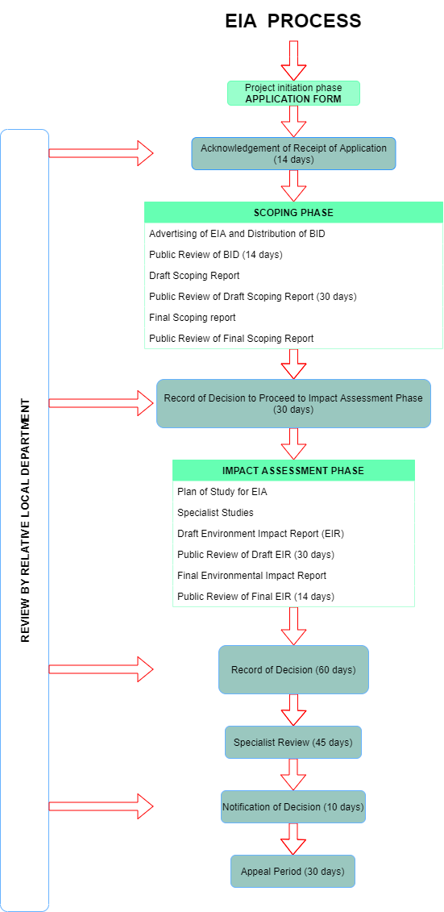

Figure 9 - EIA process flow diagram

1. SUMMARY OF SPECIALIST STUDIES
   1. PHASE 1 HERITAGE IMPACT ASSESSMENT

*The following information has been extracted from the Phase 1 Heritage Impact report undertaken by A.J. Pelser & Ms AM Matabane of APelser Archaeological Consulting (APAC) in July 2022.*

|  |  |
| --- | --- |
| SUMMARY OF RESULTS FOR HERITAGE IMPACT ASSESSMENT | |
| **Built Environment Findings** | During the field-based survey, no sites, features or materials of cultural heritage (archaeological and/or historical) origin or significance were recorded in the study and development footprint area |
| **Burial Grounds & Graves Findings** | No Burial Grounds & Graves were recorded |
| **Artefacts and Other Cultural Material** | During previous Heritage Impact Assessments by the author of this report in the Malamulele area (for different township developments) few individual pieces of undecorated Iron Age pottery were identified in places across the area (Pelser 2022: 13). However, over and above these artefacts, no other archaeological and/or recent historical sites, features or material were recorded in the study area. |

Table 4 - Summary of results for Phase 1 Heritage Impact Assessment

**RECOMMENDATIONS:**

Cultural Heritage recommended that the proposed township development be permitted to proceed while taking into account the mitigation measures to be put in place before the development of the proposed site. The following recommendations were made in relation to the Heritage impact assessment:

1. That a "Chance finds Protocol" to be implemented and adhered to should any cultural heritage structures, objects, materials, features or graves of significance be uncovered during earth-moving activities in the initial clearing and construction phase of the project.
2. Construction teams are to be inducted to identify cultural heritage sites, features or material before engaging any earth-moving equipment on-site during initial project construction.
   1. BIODIVERSITY (FAUNA AND FLORA) STUDY

*The following information has been extracted from the draft Biodiversity study report undertaken by Mr Munzhelele ED of Africa Ecological and Development Services.*

The Biodiversity study was undertaken on 13 February 2022, which falls within a month of the growing season to maximise the identification of vegetation.

|  |  |
| --- | --- |
| SUMMARY OF RESULTS FOR BIODIVERSITY IMPACT ASSESSMENT | |
| **Fauna Findings** | **Reptiles and Amphibians:** During the field trip, no reptiles were identified, although the following are expected to be present: Moles, Chameleons, and Lizards various snakes. Area is also a favourable snake such as green mambas and pythons especially on hilly areas as goes down the slopes. Amphibians are highly likely to be found in the area since the area do have some seasonal and non-perennial rivers. Although snakes were not physically sighted, they exist in this suitable habitat.  **Mammals:** Some cattle were spotted during the site survey. The vegetation types make it highly likely for some larger mammals to be present |
| **Flora Findings** | **Trees:** According to the Biodiversity study the proposed site is located on the foot of the mountain. The site at the time of the investigation was covered with mature trees of which according to the Red data plant species status Table in the biodiversity study most fall under the category of Least concern with only the Zebra wood,Xilutsi being a Near threatened species, the site also includes trees from the protected species list such as the Marula Tree, Lead wood tree and Apple leaf trees.  To disturb or cut indigenous trees and protected trees a license must be applied for from the Department of Agriculture, forestry, and fisheries as per National Forest Act, 1998 (Act No. 84 of 1998).  **Grass:** Grass was also identified during field survey by means of walking through a line transect which was demarcated at an interval of 10m apart and 30m long.  **Alien plants:** Exotic plants on the site are of least concern as the vegetation of the area is in a good condition with few exotic plant species. |

Table 5- Summary of results for the Biodiversity Impact Assessment

**RECOMMENDATIONS AND MITIGATION:**

1. To address any environmental issues listed on the impact assessment, a specialist (environmental officer) must be appointed. This will make it easier to implement an environmentally friendly development.
2. A license to disturb or cut indigenous trees and protected trees must be applied for from the Department of Agriculture, forestry, and fisheries as per National Forest Act, 1998 (Act No. 84 of 1998)
3. National Environmental management biodiversity 2004 (Act No 10 of 2004) (NEMBA) must also be considered when dealing with invasive alien plants so that all measure can be based on this legislation and its regulations.
4. Environmental management plan must be developed to cater for detailed mitigations during all development phases and for a catchment possible indirect impact. (seeps and march sites must be taken care of).
5. Minimize cutting down of big indigenous trees where possible but also ensure that protected tree is not removed since they are few unless the lay out plan doesn’t allow or can’t be altered.
6. Transportation of material must be done with care to minimize the transportation of alien plants seeds from one point to another.
7. People must be encouraged to include big trees within their plans to promote conservation of vegetation. This will help to promote insitu conservation of most of species.
8. Municipality must promote an eco-rural development in the area to safeguard existing vegetation especially big trees that includes marula.
9. A buffer zone of 100m and 50m must be complied to without any compromise to protect seeps and streams.
10. Control measures must be developed and implemented to minimize impact on possible expansion of dongas due to type of soil which is sandy.
11. Areas of slopes to the range of 5 to 10 percent must be considered for restrictions for stands or where no alternatives special measures for slope control and erosion must be detailed and signed off for people to follow.
    1. ENGINEERING SERVICES REPORT

*The following information has been extracted from the Engineering services report undertaken by Werner Fourie and Leon Wentzel of CIVILCONSULT Systems (Pty) Ltd.*

The purpose of the engineering services report is to address the requirements of Collins Chabane Local Municipality regarding the provision of municipal services. The report is attached in (**APPENDIX F).** summarized the level and extent of services to be provided, as well as the estimated cost. All known existing services are evaluated to determine the preliminary extent and possible connection opportunities.

|  |  |
| --- | --- |
| SUMMARY OF EXISTING ENGINEERING SERVICES | DESIGN CRITERIA |
| **Water** | A formal request was sent to CCLM to confirm if existing stormwater infrastructure are available for the Proposed township development and if any  external stormwater infrastructure upgrades will be required for the Proposed Development.  We are still waiting for feedback in this regard |
| **Sewage** | The estimated sewage flow for the Proposed Development is add up to the total of 2 694.85 and is shown in Table 9.1.1 on the Engineering Service Report. |
| **Roads** | The site is accessed from the existing internal roads of U5(b) in Mabandla village.   * The proposed pavement design will be based on calculated traffic volumes and ground conditions. REFER TO TABLE 11.4 in the Engineering report |
| **Electricity** | The Proposed Development will be supplied with electricity from the Collins Chabane Local  Municipality (CCLM) Network. |
| **Stormwater** | See Table 10.5 lists the standards to be used in the design of the stormwater drainage system on the Engineering Service Report. |

Table 6 - Summary of Engineering services and proposed design criteria

* 1. GEOTECHNICAL INVESTIGATION

*The following information has been extracted from the draft Geotechnical Investigation report undertaken by Nduna Mabasa of Ntamu Engineers.*

The aim of the geotechnical investigation was aimed at defining founding materials and the establishment of broader geotechnical conditions and their suitability for the proposed township development.

The site investigation took place on 10th till the 13th of May 2022. Using a TLB, a total of one hundred (100) experimental pits were progressed to depths ranging from 0.3 and 1.6 meters beneath the surface (mbgl).

The geotechnical investigation yielded two main Zones in the proposed area i.e. Zone 1: 2/R/H1/C1/S1 and Zone 2: 2//H1/C1/S1.. The following table indicates a summary of the key findings for Zones 1 and 2.

|  |  |
| --- | --- |
| **Top soil** | Colluvium sands found on site are slightly moist, reddish brown, loose, intact, clayey silty sand.  This was encountered in ninety-six (96) trial pits as seen in the geotechnical report **on page or in table**  This material was found at depths between 0 to 1.1 mbgl. |
| **Water seepage** | Water seepage was only found at TP4 during site investigation. |
| **Dolomite** | According to the council of Geoscience the proposed site is not underlain by dolomitic rocks and hence the site is not classified as a dolomitic land. |
| **Foundation recommendations** | According to the NHBRC Standards and Guidelines of 1999 two main zones were classified on site.  **ZONE 1 -** The central portion of the proposed development classifies as a NHBRC Site Class “2/R/H1/C1/S1**”** and given the moderate horizon of potentially stable soils and expansive soils which blanket this soil zone that cover this soil zone (aside from areas that may be affected by a flood line), one of the following foundation systems may be considered for single-storey, rigid, residential masonry structures: Strip Footing Construction and Soil Raft. Refer to page 26 for detailed explanation  **ZONE 2 -** The major portion of the proposed development classifies as a NHBRC Site Class 2/H1/C1/S1 given the moderate horizon of potentially stable soils and expansive soils which blanket this soil zone that cover this soil zone (aside from areas that may be affected by a flood line), one of the following foundation systems may be considered for single-storey, rigid, residential masonry structures: Soil Raft. Refer to page 27 for detailed explanation |

Table 7 – Proposed Site key geotechnical findings

1. ENVIRONMENTAL IMPACT ASSESSMENT

During the Scoping Process, a range of potential impacts that may have a significant impact on the environment have been identified and will be subject to further investigation as part of the Impact Assessment Phase. A summary of the potential environmental impacts that were identified is provided below; further details of the impacts that require further investigation are described in the section below:

* 1. PROCEDURE

The impact significance rating methodology is presented herein in tables 3, 4 and 5, which is guided by the requirements of the NEMA EIA Regulations 2014 (as amended). The methodology addresses possible impacts that can be predicted in the planning, construction and operational phases of the proposed activity. A broad approach to the significance rating methodology is used to determine the environmental risk (ER) by considering the consequence of each impact in terms of Extent, Duration, Intensity, Probability and Significance of the impact occurring. The ER is determined for the pre-and post-mitigation scenarios. In addition, cumulative impacts are taken into account when determining the environmental impact assessment. The impact assessment will be applied to all identified alternatives.

* 1. Description of Potential Impacts to be further investigated.

The following Potential Impacts must be further investigated using the Methodology described below in Tables 3, 4 and 5.

* + 1. Geology and Soil

During the demarcation of sites, the clearing of vegetation may lead to some soil erosion depending on the soil properties, ground slope, vegetation, and rainfall amount and intensity. During construction, a disturbance in surface geology may occur as a result of laying foundations. The potential impacts relating to geology and soil will be evaluated by a specialist geotechnical report that will elaborate on the underlying geology and the soil composition and texture of the site.

### **Topography**

Erosion during the clearing and construction phases of the project may lead to an impact on the topography. Building material may also alter the topography of the area.

### **Topsoil and Land use**

During the clearing and construction phase of the project, soil recourses including essential topsoil may be impacted. Erosion of topsoil may occur as well as the compaction of the soil.

### **Fauna**

Impact on Fauna may occur as a result of the disruption of habitats during the construction phase and clearing phase of the project.

### **Flora**

A loss in vegetation may occur during the demarcation phase when clearing the area as well as the removal of vegetation before construction activities take place. The site is located within an area marked with a high potential for terrestrial impact.

### **Air Quality**

CO² Emissions from construction vehicles and machinery, as well as dust during the construction phase, will have an impact on air quality.

### **Archaeology and Palaeontology**

The possibility occurs that the construction activity may lead to an impact on Archaeology and Palaeontology aspects.

### **Visual Impacts**

The visual perspective of the property will be changed.

### **Socio-Economic**

Socio-Economic can be divided into the following two categories:

### **Positive Socio-Economic Impacts:**

The proposed development will result in job creation during the construction phase of the project and community improvement during the operational phase with the services to be provided.

### **Negative Socio-Economic Impacts:**

An increase in criminal activities in the local regions of the proposed activity. Safety impacts may occur as a result of improper safety management on site.

### **Cumulative Impacts**

Cumulative Impacts include a potential change in surface and groundwater source quality. This impact will be investigated further in the Impact Assessment Report.

|  |  |
| --- | --- |
| **Nature** | **Classification of whether the impact is positive or negative, direct or indirect.** |
| **Extent** | **Spatial scale of impact and classified as:** **Site:** The impacted area is the whole site or a significant portion of the site. **Local:** Within a radius of 2 km of the construction site. **Regional:** The impacted area extends to the immediate, surrounding and neighbouring properties.  **National:** The impact can be considered to be of national significance. |
| **Duration:** | **Indicates the lifetime of the impact and is classified as:** **Short term:** The impact will either disappear with mitigation or will be mitigated through natural processes in a span shorter than the relevant project phase.  **Medium-term:** The impact will last for the period of the relevant project phase in which it takes place, whereafter it will be entirely negated.  **Long-term:** The impact will continue or last for the entire operational life of the development but will be mitigated by direct human action or by natural processes thereafter. The only class of impact will be non-transitory.  **Permanent:** Mitigation either by man or natural process will not occur in such a way or in such a time that the impact can be considered transient. |
| **Intensity:** | **Describes whether an impact is destructive or benign;  Low:** Impact affects the environment in such a way that natural, cultural and social functions and processes are not affected.  **Moderate:** The affected environment is altered, but natural, cultural and social functions and processes continue albeit in a modified way. **High:** Natural, cultural and social functions and processes are altered to extent that they temporarily cease. **Very High:** Natural, cultural and social functions and processes are altered to extent that they permanently cease. |
| **Probability**: | **Describes the likelihood of an impact occurring: Improbable:** The likelihood of the impact materializing is very low.  **Possible:** The impact may occur.  **Highly Probable:** Most likely that the impact will occur.  **Definite:** Impact will occur. |
| **Significance**: | **Based on the above criteria the significance of issues was determined. The total number of points scored for each impact indicates the level of significance of the impact and is rated as follows:  Low:** The impacts are less important. **Medium:** The impacts are important and require attention; mitigation is required to reduce the negative impacts**.   High:** The impacts are of great importance. Mitigation is therefore crucial. |
| **Cumulative**: | **In relation to an activity, means the impact of an activity that in itself may not be significant but may become significant when added to the existing and potential impacts eventuating from similar or diverse activities or undertakings in the area.** |
| **Mitigation**: | **Where negative impacts are identified, mitigation measures (ways of reducing impacts) have been identified. An indication of the degree of success of the potential mitigation measures is given per impact.** |

1. PROPOSED METHODOLOGY FOR ASSESSING ENVIRONMENTAL IMPACTS

Table 8 - Description of the nature of the possible environmental Impacts.

|  |  |  |  |  |
| --- | --- | --- | --- | --- |
| **Criteria for the rating of impacts** | | | | |
| **Criteria** | **Description** | | | |
| **Extent** | National | Regional | Local | Site |
| **Duration** | Permanent | Long-term | Medium-term | Short-term |
| **Intensity** | Very high | High | Moderate | Low |
| **Probability** | Definite | Highly probable | Possible | Improbable |
| **Points allocation** | **4** | **3** | **2** | **1** |

Table 9 Point Allocation for the rating of Impacts.

|  |  |  |
| --- | --- | --- |
| **Significance of Rating classified impacts** | | |
| **Impact** | **Points** | **Description** |
| **Low** | **4-6** | A low impact has no permanent impact of significance. Mitigation measures are feasible and are readily instituted as part of a standing design, construction or operating procedure. |
| **Medium** | **7-9** | Mitigation is possible with additional design and construction inputs. |
| **High** | **10 -12** | The design of the site may be affected. Mitigation and possible remediation are needed during the construction and/or operational phases. The effects of the impact may affect the broader environment. |
| **Very high** | **13-16** | The design of the site may be affected. Mitigation and possible remediation are needed during the construction and/or operational phases. The effects of the impact may affect the broader environment. |
| **Status** | Perceived effect of the impact | |
| **Positive (+)** | Beneficial impact | |
| **Negative (-)** | Adverse impact | |
| Negative impacts are shown with a (-) while positive ones are indicated as (+) | | |

Table 10 The significance of the ratings on proposed impacts.

|  |  |  |  |  |  |  |  |  |  |
| --- | --- | --- | --- | --- | --- | --- | --- | --- | --- |
| Project Phase | **Environmental aspect: Air quality** | | | | | | | |  |
| Activity that causes impact | Specific impact | Intensity | Duration | Extent | Probability | Significance | |  |
| Before mitigation | After mitigation | Possible mitigation |
| Construction | Earthworks and vegetation clearance | Air Pollution by excessive dust formation | Before mitigation | | | | High | Low | • Construction sites should be wet to limit dust formation. The internal gravel roads must be maintained regularly through grading or watering.  • As the construction advances, areas should be cleared in stages. The cleaned topsoil should be stacked so that wind and rain can't transport it. This can be accomplished by limiting stockpile height to 1.2 m, covering it, and/or sandbagging it. |
| 3 | 3 | 2 | 4 |
| After mitigation | | | |
| 1 | 1 | 1 | 2 |
| Movement of construction vehicles | Air Pollution by excessive fumes/CO₂ emissions (smoke and dust) | Before mitigation | | | | Medium | Low | • Construction staff must adhere to a speed restriction of 30-40 km/h within the site borders as well as on the access road.  •To avoid producing excessive smoke, construction vehicles and machinery must be serviced sufficiently  •Construction should be limited to the hours between sunrise and sunset on weekdays. |
| 1 | 2 | 2 | 3 |
| After mitigation | | | |
| 1 | 2 | 1 | 2 |
| Burning of cleared vegetation | Air pollution by excessive smoke | Before mitigation | | | | Medium | Low | •The construction teams' solid waste or any cleared vegetation may not be burned on-site or in the nearby areas, but rather disposed of at designated waste removal sites. |
| 2 | 1 | 2 | 2 |
| After mitigation | | | |
| 1 | 1 | 1 | 1 |
| Accidental fires | Air pollution by excessive smoke | Before mitigation | | | | Low | Low | •According to the National Veld and Forest Fire Act, veld fires should be avoided whenever feasible by using fire breaks. Vegetation removal should be limited to construction sites. |
| 2 | 1 | 2 | 1 |
| After mitigation | | | |
| 1 | 1 | 1 | 1 |
| The use of fires for cooking | Air pollution by excessive smoke | Before mitigation | | | | Low | Low | •No open fires for cooking or other possible uses are permitted on the construction site to prevent unnecessary veld fires to take place. |
| 1 | 2 | 1 | 2 |
| After mitigation | | | |
| 1 | 1 | 1 | 1 |
| Operation | Burning of fossil fuels and waste | Air pollution by excessive smoke | Before mitigation | | | | Medium | Low | •Individuals are not permitted to burn solid waste or vegetation on their property and should rather be disposed of at approved municipal disposal sites. |
| 2 | 2 | 2 | 3 |
| After mitigation | | | |
| 1 | 1 | 1 | 1 |
| Veld fires | Air pollution caused by smoke | Before mitigation | | | | Medium | Low | •Make sure your firebreaks are in place and that they are wide and long enough to stop a fire.  •Provide adequate emergency vehicle access and water supply. |
| 3 | 1 | 3 | 2 |
| After mitigation | | | |
| 1 | 1 | 1 | 1 |
| Increased movement of private and public vehicles | Air pollution due to an increase in fumes from vehicles and dust from the roads | Before mitigation | | | | High | Medium | •The developer does not influence over this period, but each household is responsible for ensuring that the environment is not harmed. |
| 2 | 3 | 2 | 4 |
| After mitigation | | | |
| 2 | 2 | 1 | 2 |

Table 11-Air Quality: Environmental Impact Significance and Possible mitigation measures

|  |  |  |  |  |  |  |  |  |  |
| --- | --- | --- | --- | --- | --- | --- | --- | --- | --- |
| Project Phase | **Environmental aspect: Noise** | | | | | | | |  |
| Activity that causes impact | Specific impact | Intensity | Duration | Extent | Probability | Significance | |  |
| Before mitigation | After mitigation | Possible mitigation |
| Construction | Presence of the construction camp as well as the construction workers | Increased noise level, nuisance & disturbance to the surrounding public | Before mitigation | | | | Medium | Low | • Building/construction should only be done during daylight hours. No construction on Sundays and public holidays.  • Contractors are required to follow provincial noise rules. |
| 1 | 2 | 1 | 3 |
| After mitigation | | | |
| 1 | 1 | 1 | 1 |
| Operation of construction vehicles and equipment | Disturbance & nuisance to surrounding landowners or residents. | Before mitigation | | | | Medium | Low | • Construction vehicles, machinery, and equipment must be properly maintained to avoid excessive noise.  • To prevent noise generation, construction staff must adhere to speed limits of 30-40 km/h within the site borders and on the access road.  • Construction equipment must be furnished with noise mufflers; the equipment and its exhaust systems must be properly maintained. |
| 1 | 2 | 2 | 3 |
| After mitigation | | | |
| 1 | 1 | 1 | 2 |
| Operation | Increased vehicle movement Increased noise levels due to increase in people on developed sites | Disturbance and nuisance to the surrounding landowners or residents | Before mitigation | | | | Medium | Low | • The developer does not influence over this period, but each home is responsible for ensuring that the environment is not harmed.  • Municipal by-laws regulate the amount of noise in a township.  • Speed limits are strictly enforced by law. |
| 2 | 2 | 2 | 3 |
| After mitigation | | | |
| 1 | 1 | 1 | 1 |

Table 12 - Noise: Environmental Impact Significance and Possible mitigation measures

|  |  |  |  |  |  |  |  |  |  |
| --- | --- | --- | --- | --- | --- | --- | --- | --- | --- |
| Project Phase | **Environmental aspect: Geology and Soil** | | | | | | | |  |
| Activity that causes impact | Specific impact | Intensity | Duration | Extent | Probability | Significance | |  |
| Before mitigation | After mitigation | Possible mitigation |
| Construction | Construction vehicle leaks or spills and spills from temporary fuel/oil/chemical storage areas | Contamination/pollution of soil. | Before mitigation | | | | Medium | Low | • To prevent leaks and spills, construction vehicles must be well-maintained and serviced. Spill sorbs should be used if spills occur.  • When refuelling and servicing construction vehicles or equipment, drip pans should be used as well as pacing them under stationary construction vehicles and equipment.  • Vehicle and equipment refuelling and servicing should ideally take place at the building contractor's workshop rather than on-site.  • Used or spilt oil must be recycled at a nearby oil refinery or recycling plant.  • The temporary vehicle maintenance yard and storage area should be gated and at least 100 meters away from wetlands, sponges, and surface streams. |
| 2 | 3 | 1 | 2 |
| After mitigation | | | |
| 1 | 1 | 1 | 1 |
| Spillage Caused by a temporary sanitation system | Contamination/pollution of soil. | Before mitigation | | | | Medium | Low | •Temporary sanitation facilities must be serviced regularly to avoid spillage or leaks from the toilets to the surface- and groundwater.  • Temporary toilets should be kept at least 100 meters away from surface streams.  • There should be one restroom available for every 15 personnel on-site. |
| 2 | 1 | 1 | 3 |
| After mitigation | | | |
| 1 | 1 | 1 | 1 |
| On-site storage and disposal of construction debris, household waste, and litter are unsatisfactory | Soil pollution + nuisance to the public. | Before mitigation | | | | Medium | Low | • Used parts, such as filters, should be kept and disposed of at a facility that is licensed to handle such waste.  • Solid waste should be stored in animal-proof waste bins and building rubble and domestic waste should be taken to the nearest disposal site regularly.  • To reduce the effects of littering generated by construction activities, regular clean-up programs should be implemented across the grounds. |
| 2 | 2 | 1 | 3 |
| After mitigation | | | |
| 1 | 1 | 1 | 1 |
| Stormwater runoff is excessive on-site, particularly along slopes, roads, and cleared areas | Soil degradation/erosion and dongas forming along roads and steep slopes. | Before mitigation | | | | High | Medium | • Vegetation removal must be limited to the proposed location; excessive vegetation clearing must be avoided to minimize soil erosion.  • To prevent erosion, cleared areas should be re-vegetated preferably with indigenous vegetation or paved as quickly as possible. Erosion will be limited by berms that restrict the passage of water across cleared areas.  • Stormwater diversion channels must be built into the gravel roads utilized during construction to decrease the flow of water over the road surface. This will help to decrease erosion on steep slopes and water catchment |
| 3 | 2 | 2 | 3 |
| After mitigation | | | |
| 2 | 1 | 1 | 2 |
| Structural changes to the geology and soil during the excavation of service trenches and foundations | Soil degradation / Erosion | Before mitigation | | | | Medium | Low | • Trenches must be restored as soon as possible after construction to prevent further topsoil loss due to wind or runoff floods.  • Wherever possible, trenches should be dug alongside roads to minimize their impact. Trenches from engineering services should be filled, compacted, and slightly raised above the nearby grounds.  • A site-specific Geotechnical investigation should be conducted before construction starts to determine and evaluate the structure and characteristics of the underlying soils and geology in terms of foundation design and access roads, as well as the suitability of the underlying soil material as construction materials  • Temporary erosion control: silt fencing, temporary silt trap basins, short-term seeding or mulching of exposed soil areas, restrictions on heavy machinery access and material storage to prevent soil compaction  •Permanent erosion control: Minimize the amount of bare soil by staggered earthworks and leaving as much ground cover as achievable throughout construction. Protect erosion-prone regions and ensure that activities within and next to the construction camp and work zones do not result in excessive soil erosion. For adequate rehabilitation growth, repair all erosion damage promptly, no later than six months before the maintenance period ends. Limit the concentration of surface or stormwater and the flow down of water through or fill slopes or along pipeline routes. |
| 2 | 2 | 1 | 4 |
| After mitigation | | | |
| 1 | 1 | 1 | 2 |
| Improper removal and stockpile of topsoil | Loss and Damage to fertile topsoil | Before mitigation | | | | Medium | Low | Topsoil preservation during construction:  •Topsoil should only be handled twice: first for stripping and stockpiling, and again for replacing, levelling, shaping, and scarifying.  Separate topsoil from subsoil while stockpiling  Protect stockpile areas from stormwater runoff and wind.  •Topsoil heaps should not exceed 2.0 meters in height and should ideally be covered with mulch and remain weed-free.  •Topsoil should not be compacted, and no objects should be placed or heaped on top of it. Stockpile topsoil for the shortest possible time, i.e., strip directly before the required activity begins and refill as soon as it is finished. |
| 3 | 2 | 1 | 3 |
| After mitigation | | | |
| 1 | 1 | 1 | 1 |
| Operation | Improper disposal, storage and littering of solid waste | Soil pollution + irritant | Before mitigation | | | | High | Low | • Metals, bottles, and plastics should actively be separated and sent to a credible recycling program.  Solid waste should be kept in garbage bins and disposed of at a permitted dumping site. This has the dual impact of minimizing soil contamination while also promoting the preservation of important resources through recycling and/or reusing materials. |
| 2 | 3 | 2 | 3 |
| After mitigation | | | |
| 1 | 1 | 1 | 1 |
| Leaks from the  sanitation system | Contamination / pollution of soil | Before mitigation | | | | Medium | Low | • Any leaks or malfunctions in the sanitation system should be reported and corrected as soon as possible. |
| 3 | 3 | 1 | 2 |
| After mitigation | | | |
| 1 | 1 | 1 | 1 |
| Enhanced run-off during severe precipitation events as a result of cleared areas | Topsoil erosion and structural deterioration, particularly on steeper slopes | Before mitigation | | | | Medium | Low | • After the construction phase, cleared areas should be re-vegetated with native flora to minimize erosion.  • All building structures' gutters can be built to channel rainwater to water storage tanks/containers, where they can be reused in gardens (if possible). This will reduce stormwater runoff and put less strain on the water system. |
|  |  |  |  |
| 3 | 3 | 1 | 2 |
| After mitigation | | | |

Table 13 - Geology and Soil: Environmental Impact Significance and Possible mitigation measures

|  |  |  |  |  |  |  |  |  |  |
| --- | --- | --- | --- | --- | --- | --- | --- | --- | --- |
| Project Phase | **Environmental aspect: Ecology – Fauna and Flora** | | | | | | | |  |
| Activity that causes impact | Specific impact | Intensity | Duration | Extent | Probability | Significance | |  |
| Before mitigation | After mitigation | Possible mitigation |
| Construction | Negligent clearing of vegetation and earthworks | Plant and animal species native to the area are lost.  Disturbance of a sensitive ecosystem | Before mitigation | | | | Medium | Low | • Areas with a high sensitivity must be avoided  • Vegetation removal should be limited to building zones.  • It's important to avoid clearing vegetation that isn't necessary. Wherever possible, natural vegetation should be preserved; huge trees should not be removed but rather incorporated into the design plan.  • Wherever possible cleared vegetation should be composted to preserve the soil fertility.  •Cleared vegetation, especially of alien species, should be heaped up and transported to the nearest landfill site. |
| 3 | 3 | 1 | 2 |
| After mitigation | | | |
| 1 | 1 | 1 | 1 |
| On-site of veld fires | Destruction of ecosystems and the destruction of indigenous flora and fauna. | Before mitigation | | | | Medium | Low | • Vegetation that has been cleared should not be burned on site.  • Fires should only be permitted in defined areas within the construction site, and additional caution should be exercised to avoid veld fires.  • The National Veld and Forest Fire Act of 1998 should be followed while building firebreaks. |
| 3 | 1 | 2 | 2 |
| After mitigation | | | |
| 1 | 1 | 1 | 1 |
| Spillage caused by a temporary sanitation system | Contamination of the water and ground can lead to the destruction of fauna and flora as well as being a public nuisance | Before mitigation | | | | Medium | Low | •  Temporary sanitation facilities must be serviced regularly to ensure that no spills or leaks from toilets reach the surface- and groundwater.  • Temporary toilets should be kept at least 100 meters away from surface streams.  • It should be ensured that one restroom is available for every 15 personnel on-site. |
| 3 | 1 | 1 | 2 |
| After mitigation | | | |
| 1 | 1 | 1 | 1 |
| Littering on the side of the road and construction sites | A public annoyance as well as loss of native fauna and flora | Before mitigation | | | | Medium | Low | • At the construction camp and sites, there should be an appropriate amount of animal-proof waste bins to avoid littering.  • To reduce the impact of littering generated by construction operations, regular clean-up programs will be implemented along the access road and throughout the grounds.  • Construction debris and household rubbish should be hauled to the nearest landfill regularly. |
| 2 | 3 | 2 | 2 |
| After mitigation | | | |
| 1 | 1 | 1 | 1 |
| Construction of Fencing around the site | Disturbance of accessible habitats small mammals, reptiles, and amphibians may be restricted from moving | Before mitigation | | | | High | Medium | • Where possible use natural barriers or fencings such as plants or trees.  • Use fencing rather than walls where possible to ensure that some movement of small animals and amphibians is still possible. |
| 2 | 3 | 2 | 3 |
| After mitigation | | | |
| 1 | 2 | 2 | 2 |
| The killing of animals for food or through the use of poisonous pesticides or herbicides | Direct and indirect loss of species as a result of killing animals for food or a disturbance in the cycle of life | Before mitigation | | | | Medium | Low | • Construction employees are not allowed to kill, capture, or hunt animals on site.  • Poisonous pesticides and herbicides should never be used to control animals without consulting an ecologist or zoologist beforehand, non-toxic and environmentally friendly alternatives should be considered. |
| 3 | 1 | 1 | 2 |
| After mitigation | | | |
| 1 | 1 | 1 | 1 |
| Operation | Planting indigenous vegetation in gardens | Improve native bio-diversity | Before mitigation | | | | Medium Positive Impact | N/A |  |
| 2 | 3 | 1 | 3 |
| After mitigation | | | |
| 1 | 1 | 1 | 1 |
| Cleared areas are being restored using indigenous vegetation. | Improve the native biodiversity and provide habitat for indigenous species. | Before mitigation | | | | High Positive Impact | N/A |  |
| 3 | 4 | 2 | 3 |
| After mitigation | | | |
| 2 | 2 | 1 | 1 |
| Cleared regions are being restored not using indigenous flora | Exotic invasive plant species will spread causing a loss in habitat and indigenous plants. | Before mitigation | | | | Medium | Low | • Residents should be encouraged to plant indigenous vegetation around their homes and in their yards. |
| 2 | 3 | 1 | 2 |
| After mitigation | | | |
| 1 | 2 | 1 | 1 |
| Leaks from the Sanitation System | Destruction and pollution to ecosystems as well as being a public annoyance. | Before mitigation | | | | Medium | Low | • The sewage treatment system should be inspected regularly to ensure that no spills or leaks from the sanitation system reach groundwater or surface water. |
| 3 | 3 | 1 | 2 |
| After mitigation | | | |
| 1 | 1 | 1 | 1 |
| Veld fires are caused by open fires or the burning of vegetation | The loss of indigenous fauna & flora | Before mitigation | | | | Medium | Low | • Fires should only be permitted in approved areas, using caution to avoid veld fires.  • The National Veld and Forest Fire Act of 1998 should be followed while building firebreaks. |
| 3 | 1 | 2 | 2 |
| After mitigation | | | |
| 1 | 1 | 1 | 1 |
| Controlling pests and vermin in an unsafe way. Such as using poisonous herbicides or pesticides | Poisoning and killing of wildlife that feeds on poisoned insects or pests | Before mitigation | | | | Medium | Medium - Low | • Poisonous pesticides and herbicides should never be used to control animals without consulting an ecologist or zoologist beforehand, non-toxic and environmentally friendly alternatives should be considered. |
| 2 | 3 | 2 | 2 |
| After mitigation | | | |
| 1 | 2 | 1 | 1 |
| The construction of barriers such as walls or fences. | Disturbance of accessible habitats small mammals, reptiles, and amphibians may be restricted from moving | Before mitigation | | | | High | Medium | •Where possible use natural barriers or fencings such as plants or trees.  • Use fencing rather than walls where possible to ensure that some movement of small animals and amphibians is still possible |
| 3 | 3 | 2 | 3 |
| After mitigation | | | |
| 2 | 2 | 1 | 2 |
| The killing of animals for food | Direct and indirect loss of species as a result of killing animals for food or a disturbance in the cycle of life | Before mitigation | | | | Medium | Low | • Construction employees are not allowed to kill, capture, or hunt animals on site.  • Poisonous pesticides and herbicides should never be used to control animals without consulting an ecologist or zoologist beforehand, non-toxic and environmentally friendly alternatives should be considered. |
| 3 | 1 | 1 | 2 |
| After mitigation | | | |
|  |  |  |  |
| Littering and improper disposal of solid waste | A public annoyance as well as loss of native fauna and flora as a result of pollution caused by littering | Before mitigation | | | | Medium | Low | • Solid waste should be kept in waste bins & disposed of at a licensed dumping site. |
| 2 | 3 | 2 | 2 |
| After mitigation | | | |
| 1 | 2 | 1 | 1 |

Table 14 - Ecology (Fauna and Flora): Environmental Impact Significance and Possible mitigation measures

|  |  |  |  |  |  |  |  |  |  |
| --- | --- | --- | --- | --- | --- | --- | --- | --- | --- |
| Project Phase | **Environmental aspect: Socio-economic and Heritage** | | | | | | | |  |
| Activity that causes impact | Specific impact | Intensity | Duration | Extent | Probability | Significance | |  |
| Before mitigation | After mitigation | Possible mitigation |
| Construction | Negligent earth-moving and soil-clearing practices | Archaeological and heritage sites are being desecrated. | Before mitigation | | | | Medium | Low | • During the construction process, anything of historical significance that is uncovered must be noted and reported to the Heritage Specialist or SAHRA, construction at the area where the feature was uncovered must cease until the heritage specialist gave the go-ahead. |
| 3 | 2 | 1 | 2 |
| After mitigation | | | |
| 1 | 1 | 1 | 1 |
| Job creation temporarily | Job creation causes an improvement in Socioeconomic aspects of the community | Before mitigation | | | | High Positive Impact | N/A |  |
| 3 | 2 | 3 | 3 |
| After mitigation | | | |
|  |  |  |  |
| Operation | Improper or incorrect running of activities | Archaeological and heritage sites are being desecrated. | Before mitigation | | | | Medium | Low | • During the operational phase, anything of historical significance that is uncovered must be noted and reported to the and the Heritage Specialist or SAHRA, construction at the area where the feature was uncovered must cease until the heritage specialist gave the go-ahead. |
| 3 | 3 | 1 | 1 |
| After mitigation | | | |
| 1 | 1 | 1 | 1 |
| Job creation permanently | Job creation causes an improvement in Socioeconomic aspects of the community | Before mitigation | | | | High Positive Impact | N/A |  |
| 3 | 3 | 3 | 3 |
| After mitigation | | | |
|  |  |  |  |

Table 15 - Socio-economic and Heritage: Environmental Impact Significance and Possible mitigation measures

|  |  |  |  |  |  |  |  |  |  |
| --- | --- | --- | --- | --- | --- | --- | --- | --- | --- |
| Project Phase | **Environmental aspect: Visual** | | | | | | | |  |
| Activity that causes impact | Specific impact | Intensity | Duration | Extent | Probability | Significance | |  |
| Before mitigation | After mitigation | Possible mitigation |
| Construction | Construction errors, temporary camp, and vegetation removal | Visual Disturbances | Before mitigation | | | | Medium | Low | • To minimize the visual impact, cleared areas should be re-vegetated with indigenous vegetation as soon as possible following construction. |
| 2 | 2 | 1 | 3 |
| After mitigation | | | |
| 1 | 1 | 1 | 1 |
| The installation of security lights | Visual disturbance and annoyance | Before mitigation | | | | Medium | Low | • During the construction phase, security lights (if needed) should shine directly down and away from the nearby landowners and households. External floodlights and spotlights should not be permitted. To control the area of brightness, all external illumination should be covered. |
| 1 | 2 | 2 | 2 |
| After mitigation | | | |
| 1 | 1 | 1 | 1 |
| Littering by the construction crew | Visual disturbance and annoyance | Before mitigation | | | | Medium | Low | • Construction phase waste management plan with regular collection and disposal at appropriate sites.  • The contractor should have waste (construction and domestic) disposed of properly and not allowed to be strewn on-site and in surrounding areas. |
| 1 | 2 | 2 | 3 |
| After mitigation | | | |
| 1 | 1 | 1 | 1 |
| Operation | The addition of buildings and infrastructure as a result of the projected development is present. | Visual disturbance | Before mitigation | | | | High | Medium | • As much as possible, electricity should be distributed via subterranean cables from existing power lines to various development zones.  • As little as possible bright colours should be used in the buildings and infrastructure (excluding boards) to blend in with neighbouring residential areas and to minimize the visual effect. |
| 2 | 4 | 2 | 4 |
| After mitigation | | | |
| 1 | 3 | 1 | 2 |
| Brightness as a result of lights in the infrastructure | Residents are bothered by the increased brightness | Before mitigation | | | | High | Low -Medium | • No naked lighting should be used.  • Caution should be taken to avoid the use of highly reflective materials. |
| 1 | 3 | 3 | 3 |
| After mitigation | | | |
| 1 | 2 | 1 | 1 |

Table 16 - Visual: Environmental Impact Significance and Possible mitigation measures

|  |  |  |  |  |  |  |  |  |  |
| --- | --- | --- | --- | --- | --- | --- | --- | --- | --- |
| Project Phase | **Environmental aspect: Water quality and quantity** | | | | | | | |  |
| Activity that causes impact | Specific impact | Intensity | Duration | Extent | Probability | Significance | |  |
| Before mitigation | After mitigation | Possible mitigation |
| Construction | Fuel and grease spillage from construction vehicles and temporary fuel, oil, and chemical storage | Pollution of water resources by chemicals, human health and biodiversity are both affected | Before mitigation | | | | Medium | Low | • All vehicles on the site should be serviced regularly at a place preferably away from the site to avoid or reduce the danger of water contamination from spills or leaks.  • Drip pans should be used during the refuelling of vehicles on-site and during necessary servicing that can’t take place off-site. The drip pans should also be placed underneath stationary site vehicles and equipment.  •Used parts (such as filters) should be contained and disposed of at a place licensed for dumping waste products.  • Oil that has been used or spilt should be transferred to a nearby oil refinery or recycling plant to be recycled. |
| 2 | 2 | 1 | 3 |
| After mitigation | | | |
| 1 | 1 | 1 | 1 |
| On-site storage and disposal of construction debris, solid waste, and litter | Pollution of water resources,  human health and biodiversity are both affected | Before mitigation | | | | Medium | Low | • The construction teams' solid waste may not be burned on-site or in the nearby areas.  • Solid waste, as well as construction waste, should be kept in animal-proof bins or appropriate areas at the construction camp and removed regularly to municipal waste disposal sites or licensed dumping sites. |
| 2 | 2 | 2 | 3 |
| After mitigation | | | |
| 1 | 1 | 1 | 1 |
| Over-use of water during Construction activities and dust abatement along internal roads and at construction sites | Depletion of water resources used for construction purposes | Before mitigation | | | | Medium | Low | • Water should be used sparingly and no water should be wasted, for example, by inspecting pipes regularly for leakage.  • Water tanks, if relevant, should be inspected regularly to ensure that no leaks occur. |
| 1 | 2 | 2 | 2 |
| After mitigation | | | |
| 1 | 1 | 1 | 1 |
| Leaks and spills from temporary sanitation stations | Pollution of water resources,  human health and biodiversity are both affected | Before mitigation | | | | Medium | Low | • Temporary sanitary facilities should not be located on steep slopes or within 100 meters of surface water, and a ratio of one toilet for every 15 workers on site should be maintained.  • A licensed operator must maintain and service temporary sanitation systems. |
| 2 | 2 | 1 | 2 |
| After mitigation | | | |
| 1 | 1 | 1 | 1 |
| Runoff from stormwater over cleared areas, roads, and trenches | The turbidity of the water increases causing the quality of the water to deteriorate | Before mitigation | | | | Medium | Low | • Cleared areas should be restored as quickly as possible by reinstalling indigenous plants or paving to avoid erosion and water quality degradation.  • Only necessary vegetation removal should take place at the building zones to avoid soil barren land. |
| 1 | 2 | 2 | 2 |
| After mitigation | | | |
| 1 | 1 | 1 | 1 |
| Stockpiles from Construction and clearing materials, wind and rain are used to transport accumulated material | The turbidity of the water increases causing the quality of the water to deteriorate as well as pollution of water resources | Before mitigation | | | | Medium | Low | •Stockpile heaps should not exceed 2.0 meters in height and should ideally be covered with mulch and remain weed-free.  •Stockpiles should not be compacted, and no objects should be placed or heaped on top of it. Stockpile topsoil for the shortest possible time, i.e., strip immediately before the required activity begins and refill as soon as it is finished. |
| 2 | 1 | 2 | 2 |
| After mitigation | | | |
| 1 | 1 | 1 | 1 |
| Spillages and leaks caused by construction work (e.g. bitumen, mixing of concrete, cement, paints etc.) | Pollution of water resources | Before mitigation | | | | Medium | Low | • Cement, concrete, paints, and other similar materials must be mixed in authorized locations within concrete aprons or on protective plastic linings to prevent spillages into surface or groundwater resources. |
| 2 | 2 | 1 | 2 |
| After mitigation | | | |
| 1 | 1 | 1 | 1 |
| Operation | Pollution of water resources due to the discharge and storage of household waste | The pollution will impact both human health and biodiversity | Before mitigation | | | | Medium | Low - Medium | • No solid waste or garden waste may be burned on the premises.  • Solid garbage should be disposed of in waste bins at a permitted disposal location. |
| 2 | 3 | 1 | 3 |
| After mitigation | | | |
| 1 | 1 | 1 | 1 |
| Excessive Water use by exotic invasive plant species | Depletion of surface and groundwater water resources | Before mitigation | | | | Medium | Low | •Promote the use of indigenous plants to be planted in gardens to minimize the use of water.  •If applicable, any exotic weed/plant species should be eradicated. They increase water absorption of the surface and groundwater resources. |
| 1 | 3 | 2 | 3 |
| After mitigation | | | |
| 1 | 2 | 1 | 1 |
| Water use for domestic purposes | Overuse and possible depletion of available water sources | Before mitigation | | | | High | Medium | • Water consumption for building and home use is unavoidable, but wastewater must be avoided. |
| 2 | 2 | 3 | 4 |
| After mitigation | | | |
| 1 | 1 | 1 | 2 |
| Leaks from sanitation systems | Biological pollution impacts human health and the biodiversity | Before mitigation | | | | Medium | Low | • Any leaks or malfunctions in the sanitation system must be recorded and fixed as soon as possible. |
| 2 | 3 | 2 | 2 |
| After mitigation | | | |
| 1 | 1 | 1 | 1 |
| Contaminated surface run-off | Water pollution and destruction of aquatic ecosystems | Before mitigation | | | | Medium | Low | • Stormwater capacity should be well-designed to minimize surface pollution through contaminated surface runoff. |
| 2 | 3 | 2 | 2 |
| After mitigation | | | |
| 1 | 1 | 1 | 1 |

Table 17- Water quality and quantity: Environmental Impact Significance and Possible mitigation measures

1. PUBLIC PARTICIPATION

The public participation process was undertaken following regulations as set in Regulation 54 of the EIA regulations. The process followed to conduct public participation is presented in figure 2 below.

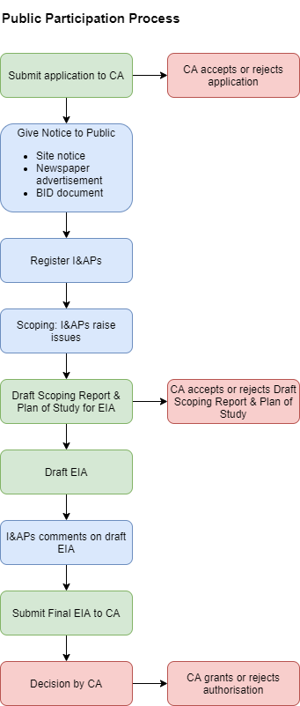

Figure 10 - Public Participation Process

* 1. NOTICE TO THE PUBLIC / I&AP REGISTRATION PERIOD

The commencement of the EIA process / I&AP registration period is be advertised for 30 days through the use of a newspaper advertisement in the **Limpopo Mirror** on **25/02/2022**, site notices and the list of stakeholders who will be directly notified:

* Publication of a notice in English will be posted in the local newspaper (The Limpopo Mirror).
* Site notices in English and Venda describing the proposed development and location, as well as contact details for where more information is needed will be placed near the site as well as in communal areas close to the proposed site; see
* Direct notification of identified Interested and/or Affected Parties (I&APs).
* The public will be informed following a meeting with the Chief of the area. Background Information Documents (BID) presented in English and Venda will be handed out in the areas surrounding the proposed site as well as explaining the proposed project to the public. The sole purpose thereof is to allow members of the public and stakeholders to communicate with the project team to obtain information about the proposed project and to have their comments, queries and/or concerns addressed.
  1. AVAILABILITY OF CONSULTATIVE ENVIRONMENTAL IMPACT ASSESSMENT REPORT FOR REVIEW AND COMMENT

This consultative Environmental Impact Assessment Report is currently available for public review and comment for a period from 27 JULY 2022 to 29 AUGUST 2022. All registered Interested and Affected Parties are welcomed to request electronic copies through an email, and such will be provided accordingly.

1. PLAN OF STUDY FOR ENVIRONMENTAL IMPACT ASSESSMENT

The following Plan of Study for EIA sets out the proposed approach to the Environmental Impact Assessment phase of the application. Description of the tasks to be undertaken during the Scoping and Environmental Impact Assessment Process as well as the tasks that have been undertaken are summarized below, with details of the tasks to be undertaken provided in more detail. Please see the full Plan of Study attached in **Appendix D.**

1. CONCLUSION AND RECOMMENDATIONS

The purpose of this report is to provide the relevant authority (LEDET) with sufficient information regarding the potential impacts of the proposed township development to make an informed decision regarding the approval of the Environmental Impact Assessment report. Potential impacts were identified in consultation with I&APs and technical specialists (where applicable) and were assessed using a matrix and by applying professional knowledge.

An EIA was undertaken to identify all the potential risks and impacts associated with each phase of the proposed demarcation of sites activities as well as potentially feasible alternatives. The identification of probable consequences was guided by background information on the surrounding areas, biodiversity, cultural heritage, geotechnical and bulk engineering specialist assessment reports, as well as the National Web-based Environmental Screening Tool Report. During the various project phases, all of the identified risks and implications were evaluated. The extent, duration, intensity, probability, significance, and cumulative impact of the potential impacts were among the assessment criteria.

The potentially significant negative and positive impacts that have been identified should be mitigated through the implementation of the mitigation measures contained in Section 12 of this report.

Impacts with a rating of High are impacts that are regarded as potentially significant, rated without any mitigation measures. In this impact assessment, the following impacts were regarded as potentially significant impacts:

1. Increased movement of private and public vehicles
2. Stormwater runoff is excessive on-site, particularly along slopes, roads, and cleared areas.
3. Improper disposal, storage and littering of solid waste
4. Construction of Fencing around the site
5. The construction of barriers such as walls or fences.
6. The addition of buildings and infrastructure as a result of the projected development is present.
7. Brightness as a result of lights in the infrastructure
8. Water use for domestic purposes
9. Job creation temporarily (POSITIVE)
10. Job creation permanently (POSITIVE)
11. Cleared areas are being restored using indigenous vegetation (POSITIVE).

It is submitted that the proposed mitigation measures, will effectively diminish the impacts to acceptable levels. Given the socio-economic requirements of the development, the residual impacts are not of sufficient importance to prevent the development.

It is the professional opinion of GLOBAL GEO ENVIRO SPECIALISTS that the proposed development does not present any fatal flaws in terms of negative impacts on the environment and therefore will not have any significant detrimental impacts to render the project unfeasible.

The Department is therefore respectfully requested to evaluate this Impact Assessment Report, as part of an application that has been lodged in terms of Chapter 5 of the National Environment Management Act, 1998(Act no 107 of 1998), in respect of the activities identified in Government Notices R545.

* 1. RECOMMENDATIONS AND CONDITIONS

It is proposed that the following conditions must be included in the Environmental Authorisation if the project is authorised:

* Throughout the entire project, the EMPr should be followed.
* An independent environmental control officer (ECO) has been recommended for this project and will be in charge of ensuring adherence to the EA and EMPr. Should non-compliance occur, this representative will be held accountable.
* Before saving, relocating, or destroying any protected species, permission under the National Forest Act or a permit for threatened or protected species must be obtained. Moreover, clearance must be restricted to the proposed layout that is proposed in the EIA report.
* Surface water features nearby cannot be impacted without the Department of Water and Sanitation's consent (DWS).
* Invasive and alien species need to be properly managed and eliminated (where relevant).

1. APPENDICES