

**DRAFT SCOPING REPORT FOR THE PROPOSED TOWNSHIP ESTABLISHMENT OF EMZINONI EXTENSION 13 & 14 ON THE REMAINDER OF PORTION 6 OF THE FARM BLESBOKSPRUIT 150-IS IN MPUMALANGA PROVINCE.**

**PREPARED BY:**

Mang Geo-Enviro Services

687 Silverlakes Road, Unit 11 King Fisher Building

Hazeldean Office Park

0081

**PREPARED FOR:**

Govan Mbeki Local Municipality

Horwood Street, Secunda

2302

**MAY 2021**

Table of Contents

LIST OF FIGURES 4

LIST OF TABLES 4

ACRONYMS AND ABBREVIATIONS 5

**EXECUTIVE SUMMARY** 6

**DECLARATION OF INTEREST** 8

**1.** **INTRODUCTION** 9

2. PROJECT NEED AND DESIRABILITY 10

3. SITE LOCALITY 10

4. PROPERTY DESCRIPTION 11

4.1. Topography 11

4.2. Geology and Soils 11

4.4. Hydrology 12

4.5. Sensitive Area 12

5. PROJECT ALTERNATIVES 12

6. LEGISLATIVE GUIDELINES 13

6.1. National Environmental Management Act, 1998 (Act No. 107 of 1998), as amended 13

6.2. Other guidelines and documentation considered in the drafting of the Scoping Report includes: 15

6.2.1. Constitution of the Republic of South Africa 15

6.2.2. National Environmental Management: Biodiversity Act, 2004 (Act No. 10 of 2004) 15

6.2.3. Integrated Environmental Management (IEM) 15

6.2.4. National Heritage Resources Act, 1999 (Act No. 25 of 1999) 16

6.2.5. Authority Consultation 16

7. CONTACT DETAILS OF THE EAP 16

8. SPECIALIST STUDIES 17

**9.** **ENVIRONMENTAL AUTHORISATION PROCESS** 17

10. THE RECEIVING ENVIRONMENT 18

10.1. Description of Potential Impacts to be investigated further 18

**Geology** 18

**Topography** 19

**Topsoil and Land use** 19

**Surface Water and Groundwater** 19

**Fauna** 19

**Flora** 19

**Noise** 19

**Air Quality** 19

**Archaeology and Paleontology** 19

**Visual Impacts** 19

**Socio Economic** 20

**Positive Socio-Economic Impacts:** 20

**Negative Socio-Economic Impacts:** 20

**Cumulative Impacts** 20

11. PLAN OF STUDY FOR ENVIRONMENTAL IMPACT ASSESSEMENT 23

Scoping Phase 23

Environmental Impact Assessment 23

Particulars of the Public Participation Process that must be followed: 23

Identification and Notification of Interested & Affected Parties 24

Issues & Concerns 24

**12.** **Consultation with DARDLEA** 25

13. CONCLUSION AND RECOMMENDATIONS 25

### 

### **LIST OF FIGURES**

Figure 1: Locality map of the proposed development site 10

Figure 2: Township layout of the proposed activity 11

Figure 3: Sensitivity map of the proposed site 12

Figure 4: EIA process diagram 17

### **LIST OF TABLES**

Table 1: Activities triggered by the proposed development 14

### **ACRONYMS AND ABBREVIATIONS**

EMC Environmental Management Committee

EIA Environmental Impact Assessment

EMP Environmental Management Plan

I&AP Interested and Affected Party

DARDLEA Mpumalanga Department of Agriculture, Rural Development, Land and Environmental Affairs

IAR Impact Assessment Report

IDP Integrated Development Plan

NEMA National Environmental Management Act of 1998 as amended

NHRA National Heritage Resources Act of 1999

NWA National Water Act of 1998

PPP Public Participation Process

SANRAL South African National Roads Agency Limited

SDF Spatial Development Framework

CA Competent Authority

EA Environmental Authorization

ROD Record of Decision

SR Scoping Report

### **EXECUTIVE SUMMARY**

Mang Geoenviro Services was appointed by Real Development Planning Company on behalf of Govan Mbeki Local Municipality to conduct an Environmental Impact Assessment for the proposed township establishment of Emzinoni extension 13 & 14 on the remainder of portion 6 of the farm Blesbokspruit 150-IS in Mpumalanga province.

.

The applicant is proposing the establishment of a township with 5 731 sites covering an area of approximately 582 hectares in Emzinoni township, Mpumalanga Province. The proposed development is located in Emzinoni township under the jurisdiction of the Gert Sibande District Municipality, and the site can be accessed from the road R35 toward Amsterdam. The geographical coordinates of the site are: 26°30'1.11" S, 29°28'45.90" E.

The development establishment is divided into two phases (phase 1 and phase 2) entailing the provision of services to enable the proposed township establishment of Emzinoni township extension 13 & 14 which will consist of the following infrastructure-**REFER TO THE LAYOUT PLAN**

**Phase 1 –** Covers 2970 sites on a 245 hectares’ area

* 2 High density residential
* 1897 Medium density residential
* 409 Low-medium density residential
* 637 Low density residential
* 2 General mixed use
* 9 Institutional
* 14 Public open spaces
* Street

**Phase 2 –** covers 2761 stands on a 337 hectares’ area

* 1 High density residential
* 1592 Medium density residential
* 1145 Low-medium density residential
* 1 General mixed use
* 6 Institutional
* 15 Public open spaces
* Street

The Scoping and EIA Process is being undertaken in terms of the National Environmental Management Act (Act no.107 of 1998) (NEMA) read with the Environmental Impact Assessment Regulations, 2017 (GNR 326 of 7 April 2017).

**REPORT TITLE:** DRAFT SCOPING REPORT FOR THE PROPOSED TOWNSHIP ESTABLISHMENT OF EMZINONI EXTENSION 13 & 14 ON THE REMAINDER OF PORTION 6 OF THE FARM BLESBOKSPRUIT 150-IS IN MPUMALANGA PROVINCE.

**CLIENT:**  GOVAN MBEKI LOCAL MUNICIPALITY

**PROJECT NAME:** DRAFT SCOPING REPORT FOR THE PROPOSED TOWNSHIP ESTABLISHMENT OF EMZINONI EXTENSION 13 & 14 ON THE REMAINDER OF PORTION 6 OF THE FARM BLESBOKSPRUIT 150-IS IN MPUMALANGA PROVINCE.

**DATE:** MAY 2021

### **DECLARATION OF INTEREST**

I, Phakwago M. Kabelo, as authorised representative of Mang Geoenviro Services hereby confirm my independence as an Environmental Assessment Practitioner and declare that neither I nor Mang Geoenviro Services have any interest, be it business, financial, personal or other, in any proposed activity, application or appeal in respect of which Mang Geoenviro Services was appointed as Environmental Assessment Practitioner in terms of the National Environmental Management Act, 1998 (Act No. 107 of 1998), other than fair remuneration for worked performed, specifically in connection with the Environmental Authorisation process for the proposed township establishment.

### **INTRODUCTION**

Mang Geoenviro Services was appointed by Real Development Planning Company, on behalf of the Govan Mbeki Local Municipality to conduct an Environmental Impact Assessment for the proposed establishment of the Emzinoni township extension 13 & 14 on the remainder of the portion 6 of the farm Blesbokspruit 150-IS, Mpumalanga Province. The geographical coordinates of the proposed site are: 26°30'1.11" S, 29°28'45.90" E and the proposed development site is 582 hectares.

The proposed development is divided into two phases (phase 1 and phase 2) entailing the provision of services to enable the proposed township establishment of Emzinoni extension 13 & 14, which will consist of the following infrastructure-**REFER TO THE LAYOUT PLAN**

**Phase 1 –** Covers 2970 sites on a 245 hectares’ area

* 2 High density residential – Social housing
* 1897 Medium density residential – 1 Dwelling
* 409 Low-medium density residential – 1 Dwelling
* 637 Low density residential – 1 Dwelling
* 2 General mixed use – Business
* 9 Institutional – Primary School, Community facility, Crèche, Health facility, Cemetery, Church and Reservoir
* 14 Public open spaces
* Street

**Phase 2 –** covers 2761 stands on a 337 hectares’ area

* 1 High density residential – Social Housing
* 1592 Medium density residential -1 Dwelling
* 1145 Low-medium density residential - 1 Dwelling
* 1 General mixed use - Business
* 6 Institutional - Community facility, Creche and Church
* 15 Public open spaces
* Street

The proposed development with provide 5 731 sites covering an area of 582 hectares with Phase 1 and Phase 2 of the Emzinoni township extension 13 & 14. However, a portion of the proposed development site is occupied by residential infrastructures (shacks), which were identified during a site visit.

### **PROJECT NEED AND DESIRABILITY**

In order to assess the “need and desirability” alternatives of the proposed project, the following documents relevant to these two aspects that were consulted (1): Govan Mbeki Local Municipality: Spatial Development Framework (SDF); (2) Draft guideline on the information requirements to describe need and desirability in the EIA process (DEAT, 2008). In the following sections this EAP attempts to make an objective assessment of the “need and desirability” of the project and makes a recommendation based on the available documents and information.

### **SITE LOCALITY**

The proposed development site is located in Emzinoni township, Mpumalanga Province. The geographical coordinates of the proposed site are: 26°30'1.11" S, 29°28'45.90" E and the proposed development site is 582 hectares.

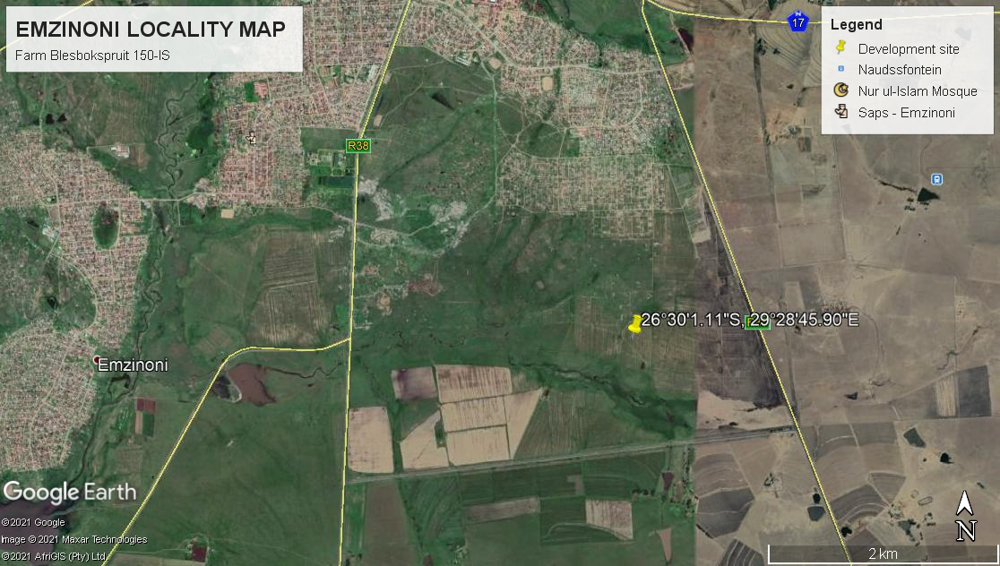

Figure 1: Locality map of the proposed development area

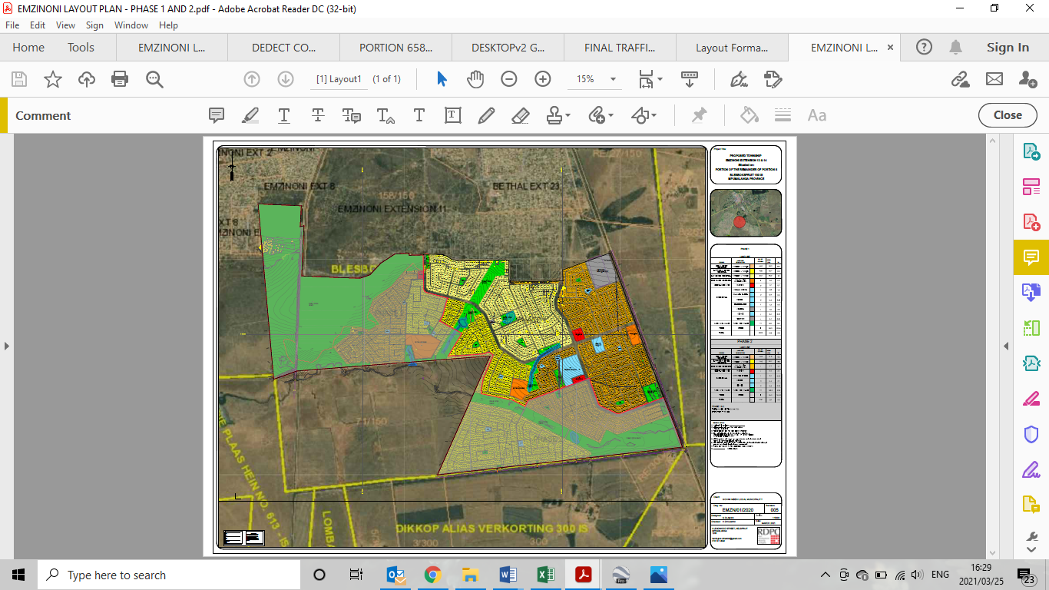

Figure 2: Proposed township layout

### **PROPERTY DESCRIPTION**

### **Topography**

Regarding physical geography, Govan Mbeki falls within the greater Savanna Biome, commonly known as the Bushveld with some small pockets of grassland and forest Biomes.

### **Geology and Soils**

The soil structure within the region is described as strongly structured cracking soils, mainly dark colored, dominated by swelling clay (vertic soils). They may occur associated with one or more of melanic and red structured soils

* 1. **Climate**

Emzinoni near Bethal is situated within the sub-tropical zone. Emzinoni has a moderate climate. There is a lot of rainfall in the summer, and in the winter it is quite dry again. The average annual temperature for Emzinoni is 25°C. Winters are mild during the day and cold during the nights. Rainfall season is between September and March, while the winter season is from April to August.

### **Hydrology**

The study area falls within the B11D quaternary catchment and within the Olifants water management area. There is a water source that originate from the Trichardspruit and flows past the study town, and drains to the Trichardtsfontein.

### **Sensitive Area**

According to the national screening tool, the project area has zones of high terrestrial biodiversity sensitivities. The ecological/ biodiversity study has to be done rating of the sensitives of the area.

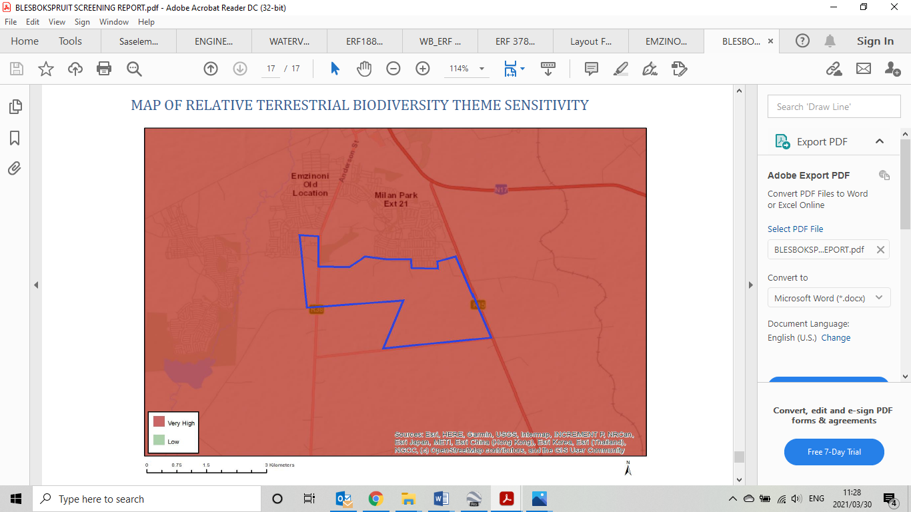

Figure 3: Sensitivity map of the proposed site

### **PROJECT ALTERNATIVES**

In terms of Environmental Impact Assessment (EIA) regulation, the Environmental Assessment Practitioner (EAP) should investigate feasible and reasonable alternatives for the proposed project. In other words, different means of meeting the requirements for the activity.

No site alternatives were identified so far, however there is a possibility of a layout alternative that will still meet the objective of the project scope.

**The No-Go Alternative**

The no-go alternative is the option not to go ahead with the development. The no-go alternative will only be considered as an alternative if it is concluded that the preferred alternative will have significant negative impacts on the environment which cannot be reduced or managed to an acceptable level. As there it has already been indicated that there is a need and desirability for the proposed development it is anticipated that this development will relieve the demand for housing and basic services in the region. It is anticipated that the no-go alternative will constrain the development planning of the Local Municipality.

### **LEGISLATIVE GUIDELINES**

### National Environmental Management Act, 1998 (Act No. 107 of 1998), as amended

The National Environmental Management Act (NEMA) provides the legislative framework for Integrated Environmental Management (IEM) in South Africa. Section 24 provides that all activities that may significantly affect the environment and require authorization by law must be assessed prior to approval. NEMA also provides for co-operative environmental governance by establishing principles for decision making on matters affecting the environment, institutions that will promote co-operative governance and procedures for coordinating environmental functions exercised by organs of the State and to provide for matters connected therewith. Section 2 of NEMA establishes a set of principles that apply to the activities of all organs of state that may significantly affect the environment. These include the following:

• Development must be sustainable;

• Pollution must be avoided or minimised and remedied;

• Waste must be avoided or minimised, reused or recycled;

• Negative impacts must be minimised; and

• Responsibility for the environmental health and safety consequences of a policy, project, product or service exists throughout its life cycle.

These principles are taken into consideration when a government department exercises its powers, for example during the granting of permits and the enforcement of existing legislation or conditions of approval. Section 28(1) of NEMA states that “every person who causes, has caused or may cause significant pollution or degradation of the environment must take reasonable measures to prevent such pollution or degradation from occurring, continuing or recurring”. If such pollution cannot be prevented, then appropriate measures must be taken to minimize or rectify such pollution.

These measures may include:

• Assessing the impact on the environment;

• Informing and educating employees about the environmental risks of their work and ways of minimising these risks; • Ceasing, modifying or controlling actions which cause pollution/degradation;

• Containing pollutants or preventing movement of pollutants;

• Eliminating the source of pollution; and

• Remedying the impacts of the pollution.

• The authorities may direct an industry to rectify or remedy a potential or actual pollution problem.

• If such a directive is not complied with, the authorities may undertake the work and recover the costs from the responsible industry.

|  |  |  |
| --- | --- | --- |
| **LISTED ACTIVITY** | **ACTIVITY Number** | **DESCRIPTION** |
| GNR 325 of 7 April 2017 | Activity 15 | The clearance of an area of 20 hectares or more of indigenous vegetation, excluding where such clearance of indigenous vegetation is required for (i) the undertaking of a linear activity; or (ii) maintenance purposes undertaken in accordance with a maintenance management plan. |
| GNR 327 of 7 April 2017 | Activity 23 | The development of cemeteries of 2 500 square metres or more in size. |
| GNR 327 of 7 April 2017 | Activity 28 | Residential, mixed, retail, commercial, industrial or institutional developments where such land was used for agriculture, game farming, equestrian purposes or afforestation on or after 01 April 1998 and where such development:   1. Will occur inside an urban area, where the total land to be developed is bigger than 5 hectares; or 2. Will occur outside an urban area, where the total land to be developed is bigger than 1 hectare;   excluding where such land has already been developed for residential, mixed, retail, commercial, industrial or institutional purposes. |

Table 1: Activities triggered by the proposed development.

### Other guidelines and documentation considered in the drafting of the Scoping Report includes:

### **Constitution of the Republic of South Africa**

The Constitution of the Republic of South Africa has major implications for environmental management. The main effects are the protection of environmental and property rights, the change brought about by the sections dealing with administrative law, such as access to information, just administrative action and broadening of the locus standi of litigants. These 15 aspects provide general and overarching support and are of major assistance in the effective implementation of the environmental management principles and structures of the NEMA. Section 24 in the Bill of Rights of the Constitution specifically states that: Everyone has the right –

To an environment that is not harmful to their health or well-being, and;

To have the environment protected, for the benefit of present and future generations, through reasonable legislative and other measures that –

• Prevent pollution and ecological degradation;

• Promote conservation; and

• Secure ecologically sustainable development and use of natural resources while promoting

• Justifiable economic and social development.

### **National Environmental Management: Biodiversity Act, 2004 (Act No. 10 of 2004)**

The purpose of the Biodiversity Act is to provide for the management and conservation of South Africa’s biodiversity within the framework of the NEMA and the protection of species and ecosystems that warrant national protection. As part of its implementation strategy, the National Spatial Biodiversity Assessment was developed. This Act is applicable to this application for environmental authorisation, in the sense that it requires the project applicant to consider the protection and management of local biodiversity.

### **Integrated Environmental Management (IEM)**

IEM is a philosophy for ensuring that environmental considerations are fully integrated into all stages of the development process. This philosophy aims to achieve a desirable balance between conservation and development (DEAT, 1992). The IEM guidelines intend encouraging a pro-active approach to sourcing, collating and presenting information in a manner that can be interpreted at all levels. The DEA Integrated Environmental Management Information Series guidelines are also considered during this S&EIR application process. 17 EIA Regulations promulgated under the National Environmental Management Act, Act 107 of 1998, as amended (NEMA EIA Regulations, 2014) New EIA Regulations were promulgated under Section 24 of NEMA and came into effect on 04 December 2014. These EIA Regulations prescribe two different authorisation processes as follows:

• The Basic Assessment Process; and

• The Scoping and EIA process.

Irrespective of which process applies, the Regulations make provision for the following:

• Public Participation must be undertaken at various stages during the assessment process.

• Assessments must be conducted by an Independent Environmental Assessment Practitioner (EAP).

• The authority delegated with deciding on environmental applications respond to applications and submissions within stipulated timeframes.

• Decisions taken by the authorities can be appealed by the proponent or any other interested and affected party (IAP).

### **National Heritage Resources Act, 1999 (Act No. 25 of 1999)**

This Act legislates the necessity for cultural and heritage impact assessment in areas earmarked for development, which exceed 0.5 hectares (ha) and where linear developments 19 (including roads) exceed 300 metres in length. The Act makes provision for the potential destruction to existing sites, pending the archaeologist’s recommendations through permitting procedures. Permits are administered by the South African Heritage Resources Agency (SAHRA).

### **Authority Consultation**

The competent authority to approve the construction of the road upgrade is the Mpumalanga Department of Agriculture, Rural Development, Land and Environmental Affairs. The site does not have implications for international environmental commitments or relations; and will not take place within an area protected by means of an international environmental instrument, or the site is not a conservancy; a protected natural environment; a proclaimed private nature reserve; a natural heritage site; the buffer zone or transitional area of a biosphere reserve; or the buffer zone or transitional area of a world heritage site. Therefore, the competent authority has been correctly identified, based on the above reasons.

### **CONTACT DETAILS OF THE EAP**

Name Phakwago M. Kabelo

Company Name Mang Geoenviro Services

Postal/ Physical Address 687 Silverlakes Road, Unit 11 King Fisher Building, Hazeldean Office Park, 0081

Email [kabelo@manggeoenviro.co.za](mailto:kabelo@manggeoenviro.co.za)

Telephone 012 770 4022/ 079 054 7652

### **SPECIALIST STUDIES**

Specialist studies which have been identified in terms of Section 28 (1) of the NEMA EIA Regulations, of which some are the following:

* Heritage Study
* Ecological/ Biodiversity Study
* Geotechnical study
* Engineering Services Report
* Traffic Impact Assessment Report
* Floodline Report

These studies will be used to identify issues at a scoping study phase and impacts will be mitigated during the EIA phase of the project.

### **ENVIRONMENTAL AUTHORISATION PROCESS**

Mang Geoenviro Services, as independent environmental consultants, will facilitate the implementation of the Integrated Environmental Management (IEM) process as per the approved EIA Guideline as follows:

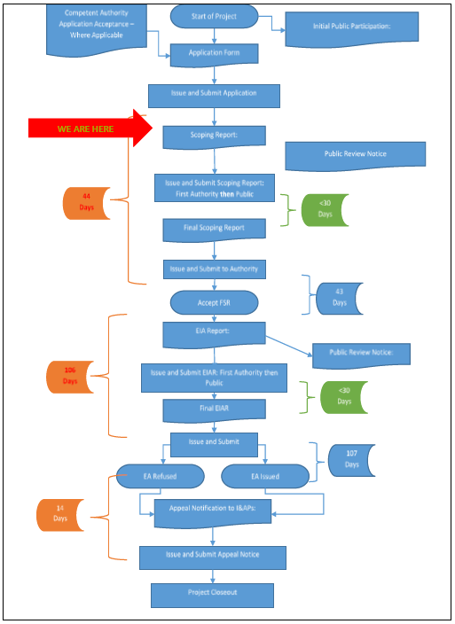

Figure 4: EIA process diagram.

### **THE RECEIVING ENVIRONMENT**

A broad range of potential environmental impacts that may have a significant impact on the environment have been identified during the Scoping Process, and will be subject to further investigation as part of the Impact Assessment Phase. A summary of the potential environmental impacts that were identified is provided below, with further details of those impacts that require further investigation described in Section below:

### Description of Potential Impacts to be investigated further

The following Potential Impacts must be further investigated by means of the Methodology described in section below.

### **Geology**

Due to construction, disturbance in surface geology may occur as result of foundations. The potential impacts relating to geology and soil will be evaluated by a specialist geotechnical report that will elaborate on the underlying geology and the soil composition and texture of the site.

### **Topography**

Erosion during the clearing and construction phases of the project may lead to an impact on the topography. Building material may also alter the topography of the area.

### **Topsoil and Land use**

During the construction phase of the project, soil recourses including essential top soil may be impacted on. Erosion of topsoil may occur as well as the compaction of soil.

### **Surface Water and Groundwater**

Contamination of surface water may occur as a result of improper management of contaminants. Improper management of sanitation may result in the contamination of groundwater. The project is adjacent to wetland on the western boundary of the property. A wetland impact assessment and or ecological assessment will detail the impacts of the development to such resources.

### **Fauna**

Impact on Fauna may occur as a result of the distraction of habitats during the construction phase and clearing phase of the project.

### **Flora**

A loss in vegetation may occur during vegetation removal prior to construction activities taking place. The site is within an area marked with high potential of terrestrial impact.

### **Noise**

During the construction phase of the project, noise will be generated by construction vehicles, construction machinery and contractors.

### **Air Quality**

CO² Emissions from construction vehicles and machinery, as well as dust during the construction phase will have an impact on air quality.

### **Archaeology and Paleontology**

The possibility occurs that the construction activity my lead to an impact on Archaeology and Paleontology aspects.

### **Visual Impacts**

The visual perspective of the property will be changed.

### **Socio Economic**

Socio Economic can be divide into the following two categories:

### **Positive Socio-Economic Impacts:**

The proposed development will result in job creation during the construction phase of the project and community improvement during operational phase with the services to be provided.

### **Negative Socio-Economic Impacts:**

• An increase in criminal activities in the local regions of the proposed activity.

• Safety impacts may occur as a result of improper safety management on site.

### **Cumulative Impacts**

Cumulative Impacts include a potential change in surface and ground water source quality. This impact will be investigated further in the Impact Assessment Report.

Methodology adopted in the assessment of potential impacts

The impacts must be evaluated by applying the methodology as described below. The impact is defined and the significance is rated from Low to High as indicated in the table below with an explanation of the impact magnitude and a guide that reflects the extent of the proposed mitigation measures deemed necessary.

The Nature of impact is a broad indication of what is being affected and how.

Severity relates to the nature of the event, aspect or impact to the environment and describes how severe the aspects impact on the biophysical and socio-economic environment



**Extent:** refer to the spatial influence of an impact be local (extending only as far as the activity, or will be limited to the site and its immediate surroundings), regional (will have an impact on the region), national (will have an impact on a national scale) or international (impact across international borders);



**Frequency** refers to how often the specific activity, related to the event, aspect or impact, is undertaken.



**Probability** considers the likelihood of an impact/incident occurring over time



**Duration**: Duration refers to the amount of time that the environment will be affected by the event, risk or impact, if no intervention e.g. remedial action takes place.



After following the above criteria, the impact significance will be evaluated using the following formula:

**SP (significance points) = (magnitude + duration + extent + irreplaceable + reversibility) x probability**

### **PLAN OF STUDY FOR ENVIRONMENTAL IMPACT ASSESSEMENT**

The following Plan of Study for EIA sets out the proposed approach to the Environmental Impact Assessment phase of the application. Description of the tasks to be undertaken during the Scoping and Environmental Impact Assessment Process as well as the tasks that have been undertaken are summarized below, with details of the tasks to be undertaken provided in more detail.

### Scoping Phase

* A desktop review of available literature and site visits must be undertaken for the proposed project.
* Specialists must be appointed to investigate potential significant environmental impacts.
* Authorities and I&AP’s must be informed about the project to identify potential significant environmental impacts associated with the proposed project.

The Draft Scoping Report must be made available for comments to I&AP’s /stakeholders and relevant Departments. The comments received on the Draft Scoping Report will be incorporated into the Final Scoping Report and Impact Assessment Report.

No environmental fatal flaws have been identified during the environmental scoping study, although a number of potentially significant environmental impacts have been identified that must be further investigated in the Impact Assessment Report.

### **Environmental Impact Assessment**

An EIA will be undertaken to provide a comprehensive assessment of the identified potential significant environmental impacts and where impacts cannot be avoided altogether, appropriate mitigation measures will be proposed. The EIA will also be used to evaluate the proposed alternatives and to assist in identifying the alternative that will have the least impact on the environment. The EIA must adequately investigate and address all the significant environmental issues in order to provide the Competent Authority (DARDLEA) with sufficient information to make an informed decision regarding the proposed project.

### **Particulars of the Public Participation Process that must be followed:**

### 

The following must be undertaken as part of the public participation process explained in section 3 above as follows. The following activities will be done in compliance to chapter 6 of GNR 326 of 2017 section 41 which describes the public participation process.

• Placement of site notices as required by section 41 (2)(a) of the act

• Notices sent to adjacent land owners required by section 41 (2)(b)(i-vi)

• Placement of advert in local newspaper required by section 41 (2) (c)

All the public participation records must be included on the final scoping report upon submission to the competent authority and the process is summarized in the following section.

### Identification and Notification of Interested & Affected Parties

After submission, the competent authority must acknowledge the application with a reference number for the public participation process as followed as stipulated by the present EIA regulations as published in 2017.

An EIA notice will be hand delivered/ emailed to the interested and affected parties and copies placed at strategic places on site and published in the local newspaper so as to ensure maximum exposure to all the potential interested and affected parties.

All possible Interested & Affected parties will be identified and will be afforded an opportunity to participate and comment on the proposed development. Contact will also be made with adjacent property owners and key interested & affected parties. After the I&AP’s and relevant authorities are identified they will be informed of the EIA process and invited to participate. This will be done through electronic mail and hand deliveries. Consultations and discussions will be held with I&AP’s and stakeholders during visits. Records of notifications and the I&AP and stakeholder register will be included on the final scoping report.

The Draft Scoping Report was completed according to the EIA regulations and will also be distributed to the I&AP’s as well as the CA. Written comments and feedback received from the I&AP’s will be included in the final scoping report.

### Issues & Concerns

Issues and concerns will be identified through a process of consultation with the proponent and then with relevant authorities and interested & affected parties and stakeholders. A comments and response report will also be included in the final SR.

### **Consultation with DARDLEA**

According to the requirements of the Act, a Plan of Study for Environmental Impact Assessment must be developed and submitted to the relevant CA to be discussed and agreed upon with the consultant.

The following consultation must be done with DARDLEA:

* Consultation through a letter in line with the application for the proposed project and other requirements specific toe the provincial department.

DARDLEA must be provided with a copy of the Draft Scoping Report as well as the Plan of Study for Impact Assessment Report for their perusal. Comments on the Draft Scoping Report as well as any additional information that may be required will be incorporated into the Final Scoping Report, and will be investigated in the Impact Assessment Report.

An Environmental Management Plan (EMP) for the Planning-, Construction-, Operational- and Decommissioning phases of the project will be submitted to DARDLEA, for approval.

### **CONCLUSION AND RECOMMENDATIONS**

The above draft report provides a broad introduction into the issues that are applicable to the proposed development, and highlights important issues to be investigated during the EIA Phase of the project. The EIA Phase will draw on the above information and make use of the recommended specialist studies to reach an objective decision on the overall impact of the proposed development. The EIA Phase must culminate in the compilation of mitigation measures to reduce impacts, and the identification of sensitive areas within the study area which may require more specific management measures. The EIA Phase will also aim to optimize and improve potential positive impacts that may result from the proposed development. Specialist studies conducted during the scoping phase for the proposed development will identify any fatal flaws for the project site. However, a number of potentially significant (positive and negative) environmental impacts will be identified and will need to be evaluated during the detailed EIR phase of the project. In addition, the EIR Phase will provide a more detailed comparative analysis of these potential impacts against the “no-go” alternative. Detailed mitigation and management measures will be developed during the Environmental Management Programme (EMPr) phase of the project, in response to the detailed assessment, and will be run towards the end of EIR phase of the project. Please note that this is not an environmental authorisation, therefore the proposed activity must not commence until the Environmental Authorisation is obtained from the Competent Authority (DARDLEA).

**APPENDICES**

Appendix A: Locality Map

Appendix B: Layout Map

Appendix C: Site Photographs

Appendix D: Specialist Reports

Appendix E: Environmental Management Programme

Appendix F: Public Participation Process

Appendix G: Curriculum Vitae of EAP

Appendix H: Additional Information

Appendix H1: Declarations

Appendix H2: Title Deeds

### **APPENDICES**

### **Appendix A: Locality Map**

### **Appendix B: Layout Map**

### **Appendix C: Site Photographs**

### **Appendix D: Specialist Reports**

### **Appendix E: Environmental Management Programme**

### **Appendix F: Public Participation Process**

### **Appendix G: Curriculum Vitae of EAP**

### **Appendix H: Additional Information**

### **Appendix H1: Declarations**

### **Appendix H2: Title Deeds**