

**DRAFT SCOPING REPORT FOR THE PROPOSED TOWNSHIP ESTABLISHMENT IN AERORAND SOUTH ON PORTION 364 (THE REMAINDER OF PORTION 27) OF THE FARM MIDDELBURG TOWN AND TOWNLANDS 287-JS, STEVE TSHWETE LOCAL MUNICIPALITY, MPUMALANGA PROVINCE IN SOUTH AFRICA.**

**PREPARED BY:**

Mang Geo-Enviro Services

687 Silverlakes Road, Unit 11 King Fisher Building

Hazeldean Office Park

0081

**PREPARED FOR:**

Steve Tshwete Local Municipality

Corner Walter Sisulu Street and Wanderers Avenue

Middelburg

1050

**JULY 2021**

Table of Contents

**LIST OF FIGURES** 4

**LIST OF TABLES** 4

**ACRONYMS AND ABBREVIATIONS** 5

**EXECUTIVE SUMMARY** 6

**DECLARATION OF INTEREST** 8

**1.** **INTRODUCTION** 9

**2.** **PROJECT NEED AND DESIRABILITY** 9

**3.** **SITE LOCALITY** 9

**4.** **PROPERTY DESCRIPTION** 11

**4.1.** **Topography** 11

**4.3.** **Geology and Soils** 11

**4.5.** **Wetland** 11

**4.6.** **Sensitive Area** 11

**5.** **PROJECT ALTERNATIVES** 12

**6.** **LEGISLATIVE GUIDELINES** 13

6.1. National Environmental Management Act, 1998 (Act No. 107 of 1998), as amended 13

6.2. Other guidelines and documentation considered in the drafting of the Scoping Report includes: 14

6.2.1. Constitution of the Republic of South Africa 14

**6.2.2.** **National Environmental Management: Biodiversity Act, 2004 (Act No. 10 of 2004)** 15

**6.2.3.** **Integrated Environmental Management (IEM)** 15

**6.2.4.** **National Heritage Resources Act, 1999 (Act No. 25 of 1999)** 16

**6.2.5.** **Authority Consultation** 16

**7.** **CONTACT DETAILS OF THE EAP** 16

**8.** **SPECIALIST STUDIES** 16

**9.** **ENVIRONMENTAL AUTHORISATION PROCESS** 17

**10.** **THE RECEIVING ENVIRONMENT** 17

10.1. Description of Potential Impacts to be investigated further 17

**Geology** 18

**Topography** 18

**Topsoil and Land use** 18

**Surface Water and Groundwater** 18

**Fauna** 18

**Flora** 18

**Noise** 18

**Air Quality** 18

**Archaeology and Paleontology** 19

**Visual Impacts** 19

**Socio Economic** 19

**Positive Socio-Economic Impacts:** 19

**Negative Socio-Economic Impacts:** 19

**Cumulative Impacts** 19

**11.** **CONCLUSION AND RECOMMENDATIONS** 22

### **LIST OF FIGURES**

Figure 1: Locality map of the proposed development site 10

Figure 2: Township layout of the proposed activity 11

Figure 3: Sensitivity map of the proposed site 12

Figure 4: EIA process diagram 17

### **LIST OF TABLES**

Table 1: Activities triggered by the proposed development 14

### **ACRONYMS AND ABBREVIATIONS**

EMC Environmental Management Committee

EIA Environmental Impact Assessment

EMP Environmental Management Plan

I&AP Interested and Affected Party

DARDLEA Mpumalanga Department of Agriculture, Rural Development, Land and Environmental Affairs

IAR Impact Assessment Report

IDP Integrated Development Plan

NEMA National Environmental Management Act of 1998 as amended

NHRA National Heritage Resources Act of 1999

NWA National Water Act of 1998

PPP Public Participation Process

SANRAL South African National Roads Agency Limited

SDF Spatial Development Framework

CA Competent Authority

EA Environmental Authorisation

ROD Record of Decision

SR Scoping Report

### **EXECUTIVE SUMMARY**

Mang Geoenviro Services was appointed by Steve Tshwete Local Municipality to conduct an Environmental Impact Assessment for the proposed township establishment on portion 364 (the remainder of portion 27) of the farm Middelburg town and Townlands 287 JS, Mpumalanga Province.

The applicant is proposing to establish a township for business purposes in Aerorand South covering an area of approximately of 43.5 hectares out of 74.49 hectares on portion 364 (the remainder of portion 27) of the farm Middelburg town and Townlands 287 JS, Mpumalanga Province. The proposed development is located in Aerorand South, and the site can be accessed from the R35 road and Sondagrivier street. The geographical coordinates of the site are: 25°48'48.68S 29°27'25.04 E.

The development will entail the provision of services to enable the proposed establish of business area in Aerorand South, which will consist of the following infrastructure-**REFER TO THE LAYOUT PLAN**

* Business
* Motor Sales Market
* Public Open Space

The Scoping and EIA Process is being undertaken in terms of the National Environmental Management Act (Act no.107 of 1998) (NEMA) read with the Environmental Impact Assessment Regulations, 2017 (GNR 326 of 7 April 2017).

**REPORT TITLE:** DRAFT SCOPING REPORT FOR THE PROPOSED TOWNSHIP ESTABLISHMENT IN AERORAND SOUTH ON PORTION 364 (THE REMAINDER OF PORTION 27) OF THE FARM MIDDELBURG TOWN AND TOWNLANDS 287-JS, STEVE TSHWETE LOCAL MUNICIPALITY, MPUMALANGA PROVINCE IN SOUTH AFRICA.

**CLIENT:**  STEVE TSHWETE LOCAL MUNICIPALITY

**PROJECT NAME:** DRAFT SCOPING REPORT FOR THE PROPOSED TOWNSHIP ESTABLISHMENT IN AERORAND SOUTH ON PORTION 364 (THE REMAINDER OF PORTION 27) OF THE FARM MIDDELBURG TOWN AND TOWNLANDS 287-JS, STEVE TSHWETE LOCAL MUNICIPALITY, MPUMALANGA PROVINCE IN SOUTH AFRICA.

**DATE:** JULY 2021

### **DECLARATION OF INTEREST**

I, Phakwago M. Kabelo., as authorised representative of Mang Geoenviro Services hereby confirm my independence as an Environmental Assessment Practitioner and declare that neither I nor Mang Geoenviro Services have any interest, be it business, financial, personal or other, in any proposed activity, application or appeal in respect of which Mang Geoenviro Services was appointed as Environmental Assessment Practitioner in terms of the National Environmental Management Act, 1998 (Act No. 107 of 1998), other than fair remuneration for worked performed, specifically in connection with the Environmental Authorisation process for the proposed township establishment.

### **INTRODUCTION**

Mang Geoenviro Services was appointed by Steve Tshwete Local Municipality to conduct an Environmental Impact Assessment for the proposed establishment of township on portion 364 (the remainder of portion 27) of the farm Middelburg Town and townlands 287-JS in Aerorand South, Mpumalanga Province. The geographical coordinates of the proposed site are: 25°48'48.68S 29°27'25.04E and the proposed development site is 74.49 hectares.

The development will entail the provision of services to enable the proposed establishment of business area in Aerorand South, which will consist of the following infrastructure-**REFER TO THE LAYOUT PLAN**

* Business
* Motor Sales Market
* Public Open Space

An area of approximately 43.5 hectares of the proposed development site will be utilized for business purposes, which is indicated by the red colour and the Motor sales market (indicated by the blue colour). The remaining 30.99 hectares will be used as public open space (indicated by the green colour).

### **PROJECT NEED AND DESIRABILITY**

In order to assess the “need and desirability” alternatives of the proposed project, the following documents relevant to these two aspects that were consulted (1): Steve Tshwete Local Municipality: Spatial Development Framework (SDF); (2) Draft guideline on the information requirements to describe need and desirability in the EIA process (DEAT, 2008). In the following sections this EAP attempts to make an objective assessment of the “need and desirability” of the project and makes a recommendation based on the available documents and information.

### **SITE LOCALITY**

The proposed development site is located in Aerorand South, Mpulamanga Province. The geographical coordinates of the proposed site are: 25°48'48.68S 29°27'25.04E and the proposed development site is 74.49 hectares.

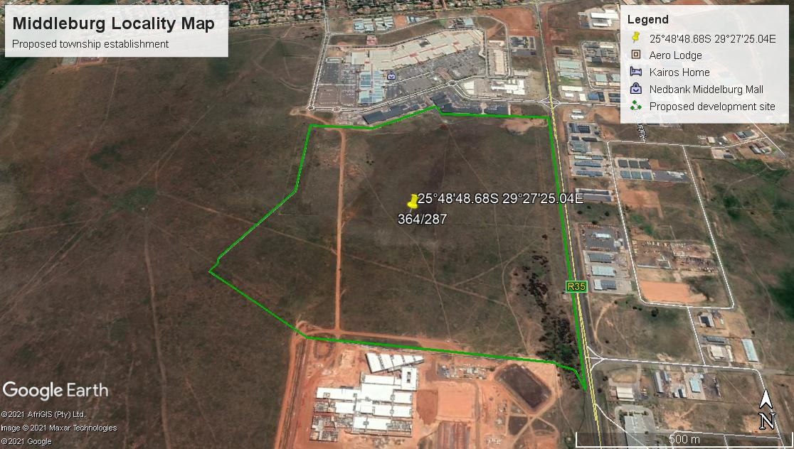

Figure 1: Locality map of the proposed development area

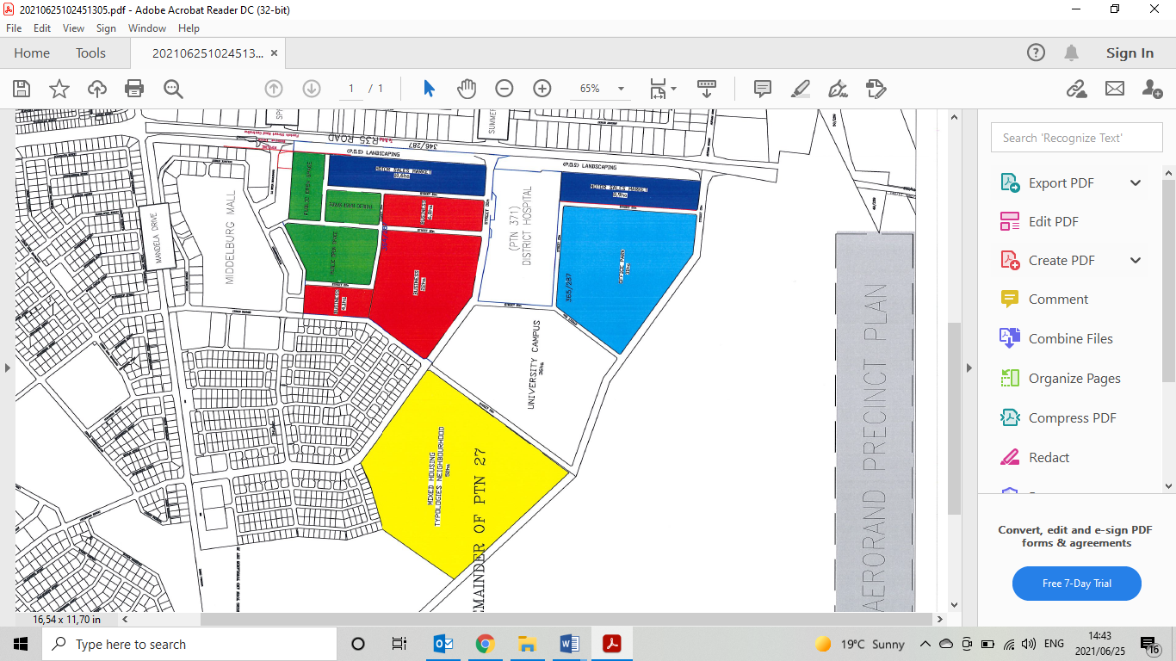

Figure 2: Proposed township layout

### **PROPERTY DESCRIPTION**

### **Topography**

Middelburg is 1478m above sea level. In Middelburg, the climate is warm and temperate. In winter, there is much less rainfall in Middelburg than in summer. The climate here is classified as Cwb by the Köppen-Geiger system. In Middelburg, the average annual temperature is 16.5 °C | 61.7 °F. The rainfall here is around 714 mm | 28.1 inch per year.

* 1. **Biodiversity**

The study area is situated nationally within the Grassland Biome, and is classified by Acocks (1953) as Bankenveld (A61) and as Moist Sandy Highveld Grassland (LR38) by Low & Rebelo (1998). Classified on a regional scale and according to a more detailed system the site is classified as Rand Highveld Grassland (Gm11), according to Mucina & Rutherford (2006). This veld type is rated as Endangered due to the low percentage of conservation areas (1%) and the high percentage of transformation due to agriculture, mining, urban sprawl and roads infrastructure (Mucina & Rutherford, 2006).

### **Geology and Soils**

The soil structure in Middelburg is underlined by rocks of the Karoo Supergroup and Ecca formation. The area is characterized Ecca lithology which consist of maroon shale, shale sandstone, grift, sandstone, conglomerate, coal (in place near base and top).

* 1. **Climate**

Average temperatures are more moderate in the area than in certain other parts of the country, the global phenomenon of climate change and related temperature increases can still be expected to have significant implications for the region.

### **Wetland**

The wetland around the area is classified as a flat wetland and it occurs seasonally. Wetlands constitute an important and restricted habitat type for a variety of plants and animals. The wetland vegetation throughout the Mpumalanga Highveld region is under great threat from factors such as alien invasive plant species (Henderson and Musil, 1987), altered hydrological patterns, reduced water quality, ploughing and overgrazing. Any remaining area of untransformed wetland must therefore be regarded as of elevated conservation importance.

### **Sensitive Area**

The project area according to the national screening tool has areas of high agricultural sensitivities. The ecological/ biodiversity study has to be done rating of the sensitives of the area.

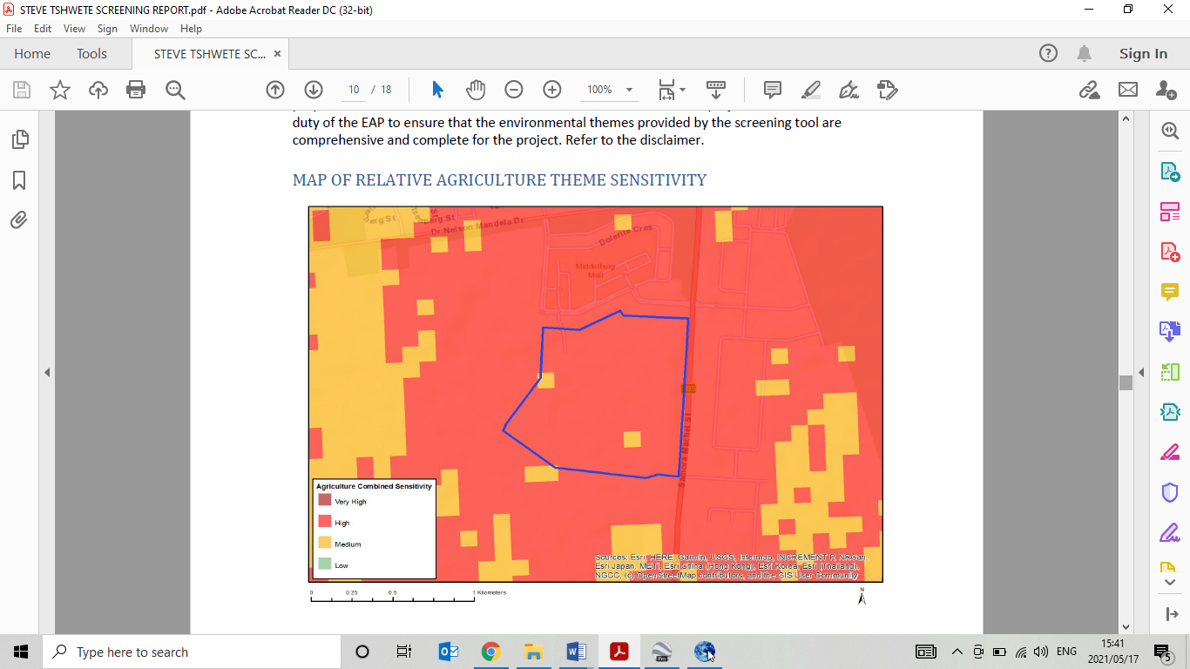

Figure 3: Sensitivity map of the proposed site

### **PROJECT ALTERNATIVES**

In terms of Environmental Impact Assessment (EIA) regulation, the Environmental Assessment Practitioner (EAP) should investigate feasible and reasonable alternatives for the proposed project. In other words, different means of meeting the requirements for the activity.

No site alternatives were identified so far, however there is a possibility of a layout alternative that will still meet the objective of the project scope.

**The No-Go Alternative**

The no-go alternative is the option not to go ahead with the development. The no-go alternative will only be considered as an alternative if it is concluded that the preferred alternative will have significant negative impacts on the environment which cannot be reduced or managed to an acceptable level. As there it has already been indicated that there is a need and desirability for the proposed development it is anticipated that this development will relieve the demand for housing and basic services in the region. It is anticipated that the no-go alternative will constrain the development planning of the Local Municipality.

### **LEGISLATIVE GUIDELINES**

### National Environmental Management Act, 1998 (Act No. 107 of 1998), as amended

The National Environmental Management Act (NEMA) provides the legislative framework for Integrated Environmental Management (IEM) in South Africa. Section 24 provides that all activities that may significantly affect the environment and require authorization by law must be assessed prior to approval. NEMA also provides for co-operative environmental governance by establishing principles for decision making on matters affecting the environment, institutions that will promote co-operative governance and procedures for coordinating environmental functions exercised by organs of the State and to provide for matters connected therewith. Section 2 of NEMA establishes a set of principles that apply to the activities of all organs of state that may significantly affect the environment. These include the following:

• Development must be sustainable;

• Pollution must be avoided or minimised and remedied;

• Waste must be avoided or minimised, reused or recycled;

• Negative impacts must be minimised; and

• Responsibility for the environmental health and safety consequences of a policy, project, product or service exists throughout its life cycle.

These principles are taken into consideration when a government department exercises its powers, for example during the granting of permits and the enforcement of existing legislation or conditions of approval. Section 28(1) of NEMA states that “every person who causes, has caused or may cause significant pollution or degradation of the environment must take reasonable measures to prevent such pollution or degradation from occurring, continuing or recurring”. If such pollution cannot be prevented, then appropriate measures must be taken to minimize or rectify such pollution. These measures may include:

• Assessing the impact on the environment;

• Informing and educating employees about the environmental risks of their work and ways of minimising these risks; • Ceasing, modifying or controlling actions which cause pollution/degradation;

• Containing pollutants or preventing movement of pollutants;

• Eliminating the source of pollution; and

• Remedying the impacts of the pollution.

• The authorities may direct an industry to rectify or remedy a potential or actual pollution problem.

• If such a directive is not complied with, the authorities may undertake the work and recover the costs from the responsible industry.

|  |  |  |
| --- | --- | --- |
| **LISTED NOTICES** | **ACTIVITY NUMBER** | **DESCRIPTION** |
| GNR 325 of 7 April 2017 | Activity 15 | The clearance of an area of 20 hectares or more of indigenous vegetation, excluding where such clearance of indigenous vegetation is required for (i) the undertaking of a linear activity; or (ii) maintenance purposes undertaken in accordance with a maintenance management plan. |
| GNR 327 of 7 April 2017 | Activity 28 | Residential, mixed, retail, commercial, industrial or institutional developments where such land was used for agriculture, game farming, equestrian  purposes or afforestation on or after 01 April 1998 and where such development:  (i) will occur inside an urban area, where the total land to be developed is bigger than 5 hectares; or  (ii) will occur outside an urban area, where the total land to be developed is bigger than 1 hectare;  excluding where such land has already been developed for residential, mixed, retail, commercial, industrial or institutional purposes. |

Table 1: Activities triggered by the proposed development.

### Other guidelines and documentation considered in the drafting of the Scoping Report includes:

### Constitution of the Republic of South Africa

The Constitution of the Republic of South Africa has major implications for environmental management. The main effects are the protection of environmental and property rights, the change brought about by the sections dealing with administrative law, such as access to information, just administrative action and broadening of the locus standi of litigants. These 15 aspects provide general and overarching support and are of major assistance in the effective implementation of the environmental management principles and structures of the NEMA. Section 24 in the Bill of Rights of the Constitution specifically states that: Everyone has the right –

To an environment that is not harmful to their health or well-being, and;

To have the environment protected, for the benefit of present and future generations, through reasonable legislative and other measures that –

• Prevent pollution and ecological degradation;

• Promote conservation; and

• Secure ecologically sustainable development and use of natural resources while promoting

• Justifiable economic and social development.

### **National Environmental Management: Biodiversity Act, 2004 (Act No. 10 of 2004)**

The purpose of the Biodiversity Act is to provide for the management and conservation of South Africa’s biodiversity within the framework of the NEMA and the protection of species and ecosystems that warrant national protection. As part of its implementation strategy, the National Spatial Biodiversity Assessment was developed. This Act is applicable to this application for environmental authorisation, in the sense that it requires the project applicant to consider the protection and management of local biodiversity.

### **Integrated Environmental Management (IEM)**

IEM is a philosophy for ensuring that environmental considerations are fully integrated into all stages of the development process. This philosophy aims to achieve a desirable balance between conservation and development (DEAT, 1992). The IEM guidelines intend encouraging a pro-active approach to sourcing, collating and presenting information in a manner that can be interpreted at all levels. The DEA Integrated Environmental Management Information Series guidelines are also considered during this S&EIR application process. 17 EIA Regulations promulgated under the National Environmental Management Act, Act 107 of 1998, as amended (NEMA EIA Regulations, 2014) New EIA Regulations were promulgated under Section 24 of NEMA and came into effect on 04 December 2014. These EIA Regulations prescribe two different authorisation processes as follows:

• The Basic Assessment Process; and

• The Scoping and EIA process.

Irrespective of which process applies, the Regulations make provision for the following:

• Public Participation must be undertaken at various stages during the assessment process.

• Assessments must be conducted by an Independent Environmental Assessment Practitioner (EAP).

• The authority delegated with deciding on environmental applications respond to applications and submissions within stipulated timeframes.

• Decisions taken by the authorities can be appealed by the proponent or any other interested and affected party (IAP).

### **National Heritage Resources Act, 1999 (Act No. 25 of 1999)**

This Act legislates the necessity for cultural and heritage impact assessment in areas earmarked for development, which exceed 0.5 hectares (ha) and where linear developments 19 (including roads) exceed 300 metres in length. The Act makes provision for the potential destruction to existing sites, pending the archaeologist’s recommendations through permitting procedures. Permits are administered by the South African Heritage Resources Agency (SAHRA).

### **Authority Consultation**

The competent authority to approve the construction of the road upgrade is the Mpumalanga Department of Agriculture, Rural Development, Land and Environmental Affairs. The site does not have implications for international environmental commitments or relations; and will not take place within an area protected by means of an international environmental instrument, or the site is not a conservancy; a protected natural environment; a proclaimed private nature reserve; a natural heritage site; the buffer zone or transitional area of a biosphere reserve; or the buffer zone or transitional area of a world heritage site. Therefore, the competent authority has been correctly identified, based on the above reasons.

### **CONTACT DETAILS OF THE EAP**

Name Phakwago M. Kabelo

Company Name Mang Geoenviro Services

Postal/ Physical Address 687 Silverlakes Road, Unit 11 King Fisher Building, Hazeldean Office Park, 0081

Email [kabelo@mangegeoenviro.co.za](mailto:kabelo@mangegeoenviro.co.za)

Telephone 012 770 4022

### **SPECIALIST STUDIES**

Specialist studies which have been identified in terms of Section 28 (1) of the NEMA EIA Regulations, of which some are the following:

* Heritage Study
* Ecological/ Biodiversity Study
* Geotechnical study
* Paleontological Impact Assessment
* Wetland Delineation Report
* Traffic Impact Assessment

These studies will be used to identify issues at a scoping study phase and impacts will be mitigated during the EIA phase of the project.

### **ENVIRONMENTAL AUTHORISATION PROCESS**

Mang Geoenviro Services, as independent environmental consultants, will facilitate the implementation of the Integrated Environmental Management (IEM) process as per the approved EIA Guideline as follows:

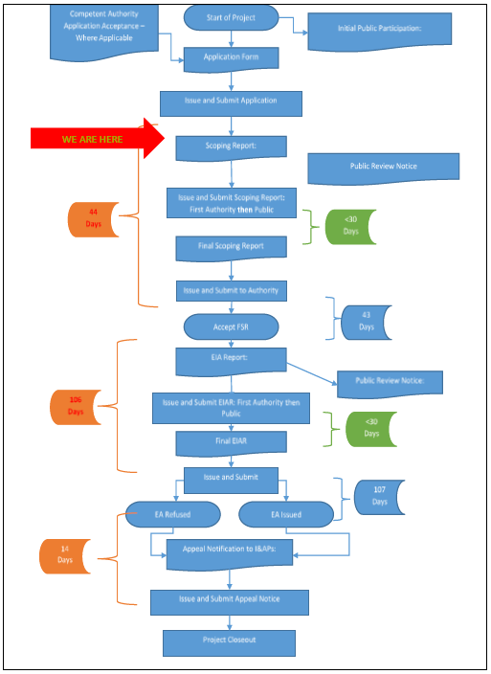

Figure 4: EIA process diagram.

### **THE RECEIVING ENVIRONMENT**

A broad range of potential environmental impacts that may have a significant impact on the environment have been identified during the Scoping Process, and will be subject to further investigation as part of the Impact Assessment Phase. A summary of the potential environmental impacts that were identified is provided below, with further details of those impacts that require further investigation described in Section below:

### 

### Description of Potential Impacts to be investigated further

The following Potential Impacts must be further investigated by means of the Methodology described in section below.

### **Geology**

Due to construction, disturbance in surface geology may occur as result of foundations. The potential impacts relating to geology and soil will be evaluated by a specialist geotechnical report that will elaborate on the underlying geology and the soil composition and texture of the site.

### **Topography**

Erosion during the clearing and construction phases of the project may lead to an impact on the topography. Building material may also alter the topography of the area.

### **Topsoil and Land use**

During the construction phase of the project, soil recourses including essential top soil may be impacted on. Erosion of topsoil may occur as well as the compaction of soil.

### **Surface Water and Groundwater**

Contamination of surface water may occur as a result of improper management of contaminants. Improper management of sanitation may result in the contamination of groundwater. The project is adjacent to wetland on the western boundary of the property. A wetland impact assessment and or ecological assessment will detail the impacts of the development to such resources.

### **Fauna**

Impact on Fauna may occur as a result of the distraction of habitats during the construction phase and clearing phase of the project.

### **Flora**

A loss in vegetation may occur during vegetation removal prior to construction activities taking place.

### **Noise**

During the construction phase of the project, noise will be generated by construction vehicles, construction machinery and contractors.

### **Air Quality**

CO² Emissions from construction vehicles and machinery, as well as dust during the construction phase will have an impact on air quality.

### **Archaeology and Paleontology**

The possibility occurs that the construction activity my lead to an impact on Archaeology and Paleontology aspects. The site is within an area marked with high potential of archaeological discoveries thou none were identified during the site assessment

### **Visual Impacts**

The visual perspective of the property will be changed.

### **Socio Economic**

Socio Economic can be divide into the following two categories:

### **Positive Socio-Economic Impacts:**

The proposed development will result in job creation during the construction phase of the project.

### **Negative Socio-Economic Impacts:**

• An increase in criminal activities in the local regions of the proposed activity.

• Safety impacts may occur as a result of improper safety management on site.

### **Cumulative Impacts**

Cumulative Impacts include a potential change in surface and ground water source quality. This impact will be investigated further in the Impact Assessment Report.

Methodology adopted in the assessment of potential impacts

The impacts must be evaluated by applying the methodology as described below. The impact is defined and the significance is rated from Low to High as indicated in the table below with an explanation of the impact magnitude and a guide that reflects the extent of the proposed mitigation measures deemed necessary.

The Nature of impact is a broad indication of what is being affected and how.

Severity relates to the nature of the event, aspect or impact to the environment and describes how severe the aspects impact on the biophysical and socio-economic environment



**Extent:** refer to the spatial influence of an impact be local (extending only as far as the activity, or will be limited to the site and its immediate surroundings), regional (will have an impact on the region), national (will have an impact on a national scale) or international (impact across international borders);



**Frequency** refers to how often the specific activity, related to the event, aspect or impact, is undertaken.



**Probability** considers the likelihood of an impact/incident occurring over time



**Duration**: Duration refers to the amount of time that the environment will be affected by the event, risk or impact, if no intervention e.g. remedial action takes place.



After following the above criteria, the impact significance will be evaluated using the following formula:

**SP (significance points) = (magnitude + duration + extent + irreplaceable + reversibility) x probability**

### **CONCLUSION AND RECOMMENDATIONS**

The above draft report provides a broad introduction into the issues that are applicable to the proposed development, and highlights important issues to be investigated during the EIA Phase of the project. The EIA Phase will draw on the above information and make use of the recommended specialist studies to reach an objective decision on the overall impact of the proposed development. The EIA Phase must culminate in the compilation of mitigation measures to reduce impacts, and the identification of sensitive areas within the study area which may require more specific management measures. The EIA Phase will also aim to optimize and improve potential positive impacts that may result from the proposed development. Specialist studies conducted during the scoping phase for the proposed development will identify any fatal flaws for the project site. However, a number of potentially significant (positive and negative) environmental impacts will be identified and will need to be evaluated during the detailed EIR phase of the project. In addition, the EIR Phase will provide a more detailed comparative analysis of these potential impacts against the “no-go” alternative. Detailed mitigation and management measures will be developed during the Environmental Management Programme (EMPr) phase of the project, in response to the detailed assessment, and will be run towards the end of EIR phase of the project. Please note that this is not an environmental authorisation, therefore the proposed activity must not commence until the Environmental Authorisation is obtained from the Competent Authority (DARDLEA).