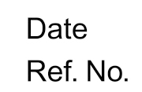
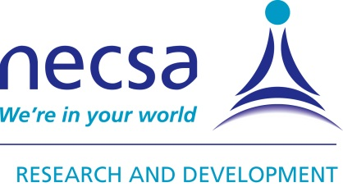
Research & Development – a division of Necsa

PO Box 582
Pretoria 0001
South Africa
012 305 5258
012 305 58581
0828556685
Frikkie.debeer@necsa.co.za
www.necsa.co.za
RS-INTNAT-LET-13002

18 April 2013

REQUEST TO PERFORM NEUTRON TOMOGRAPHY SCANS ON SOUTH AFRICAN FOSSIL MATERIAL IN GERMANY

To whom it may be concerned.

The South African Nuclear Energy Corporation (Necsa), West of Pretoria, who owns the SAFARI-1 Nuclear Research Reactor, has been in collaboration with the Cultural Heritage community for many years in terms of neutron tomography (NR) investigations on artifacts and fossil materials from the DITSONG museum group. This NR facility is the only one in South Africa and provides a complementary result to X-ray tomography which makes it an attractive Non-destructive method of investigation for unique fossil material.

The following recent peer reviewed papers, as an example, were generated on Cultural Heritage samples being NR-scanned at Necsa’s NR-facility:
- Koleini, F., De Beer, F.C., et.al. “Efficiency of neutron tomography in visualizing the internal structure of metal artefacts from Mapungubwe museum collection with the aim of conservation”, Journal of Cultural Heritage, (2012), Vol 13, 3, p246.
- Jacobson, L., De Beer, F.C., et.al. “Tomography imaging of South African archaeological and heritage stone and pottery objects. “, NIM-A, (2012), 651, p240.
- Smith, P., De Beer, F.C., et.al. “Canteen Kopje: A new look at an old skull”:, South African Journal of Science 2012, 108(1/2)

The local NR-facility at Necsa is currently out of commission until Q3 2014 for an upgrade initiative that is being funded by the DST-NRF worth MR13.18 : Contract: FUNNRF75433.

A need arises to continue with the collaboration with the DITSONG museum group once the NR-facility is in the upgrade phase to determine the success of Fast-, Thermal- and Cold neutron radiography/tomography on fossil samples. The aim is to obtain the necessary information and knowledge/skill for the samples to be scanned at the upgraded NR- South African facility in future.

Samples are earmarked for the NR-tomography scanning in Europe from the following DITSONG museum researcher:
- Curator: Me. Stephany Potze (Plio-Pleistocene Palaeontology Section)

Samples: Sts 5 ii; Sts 1039 and MB 10.19

Me. Potze has been invited as keynote speaker during the Neutron Imaging and Neutron Methods in Museums and Cultural Heritage Research (NINMACH 2013) Conference held from 9 – 12 Sept 2013 in Garching, Germany on the outcome of this scanning and research. See : www.frm2.tum.de/indico/event/ninmach2013

The following scientists at the European analytical laboratories are earmarked to perform Neutron tomography scanning:

- Dr Nikolay Kardjilov
Chief Scientist: Neutron Radiography
Helmholtz-Zentrum Berlin für Materialien und Energie GmbH
SF3 Werkstoffe
Glienicker Str. 100
14109 Berlin
GERMANY
Phone:++49 (0)30 8062 2298
email: kardjilov@helmholtz-berlin.de
URL: http://www.helmholtz-berlin.de

- Dr. Burkhard Schillinger
Chief Scientist: Neutron Radiography
Neutronentomographie ANTARES
Forschungsreaktor FRM-II
Technische Universität München
D-85747 Garching bei München
Germany
Tel. +49 89 2891-2185 Fax -4997

We trust that the request will be positively dealt with for the application to be successful and the samples to be transported by 22nd June 2013 by the author of this letter.

Yours sincerely,

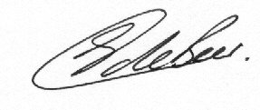
Frikkie de Beer
Section Head: Radiography/Tomography
Chief Scientist: Neutron Radiography
Necsa

