**MODDERFONTEIN BIRD AND SCULPTURE PARK**

**SOCCER FIELDS**

**MODDERFONTEIN EXT 2**

**ENVIRONMENTAL MANAGEMENT PROGRAMME**

June 2019

Prepared by:

Yonanda Martin (*Pri. Sci. Nat*)

Environmental Assessment Practitioner

# **GENERAL INFORMATION**

|  |  |
| --- | --- |
| **Report name:** | Draft Environmental Management Programme for the Soccer Fields at the Modderfonetin Bird and Sculpture Park. |
| **Environmental Auditor:** | Green Tree Environmental Consulting  7 Dublin Street  Rangeview Ext 2  Krugersdorp  Gauteng  082 409 0405  [yonanda@gtec.net.za](mailto:yonanda@gtec.net.za) |
| **Client:** | Nevada Group Lakeside (Pty) Ltd |
| **Report Compiled by:** | Yonanda Martin  CV attached as Annexure A |
| **Date of Report:** | 5 June 2019 |
| **Ref No:** | GAUT 002/18-19/E0245 |

# **DECLARATION OF INDEPENDENCE**

I, Yonanda Martin, appointed environmental assessment practitioner responsible for compiling the Draft Environmental Management Programme declare that I: -

* act as an independent environmental consultant, my conclusions are formed independently and without influence from external parties;
* I will perform the work relating to this audit in an objective manner, even if the results and findings are not favourable to the applicant.
* have no financial interest in Nevada Group Lakeside (Pty) Ltd or any of its subsidiaries;
* do not have any financial interest in the undertaking of the activity, other than remuneration for the work performed;
* undertake to disclose, to the competent authority, any material information that has or may have the potential to influence the decision of the competent authority or the objectivity of any report, plan or document. and
* based on information provided to me by the project proponent, and in addition to information obtained during the course of this study and the site visit, will present the results and conclusion within the associated document to the best of my professional judgment.

Signed:

Date: 2019/06/05

# **ENVIRONMENTAL MANAGEMENT PROGRAMME REQUIREMENTS**

|  |  |
| --- | --- |
|  |  |
| 1. An EMPr must comply with section 24N of the Act and include: |  |
| 1. details of– 2. the EAP who prepared the EMPr; and 3. the expertise of that EAP to prepare an EMPr, including a curriculum vitae; | Annexure A |
| 1. a detailed description of the aspects of the activity that are covered by the EMPr as identified by the project description; | Page 1 |
| 1. a map at an appropriate scale which superimposes the proposed activity, its associated structures, and infrastructure on the environmental sensitivities of the preferred site, indicating any areas that should be avoided, including buffers; | Page 2, 3 and 5 |
| 1. a description of the impact management outcomes, including management statements, identifying the impacts and risks that need to be avoided, managed and mitigated as identified through the environmental impact assessment process for all phases of the development including─ 2. planning and design; 3. pre-construction activities; 4. construction activities; 5. rehabilitation of the environment after construction and where applicable post 6. closure; and 7. where relevant, operation activities; | Page 12 - 39 |
| 1. a description of proposed impact management actions, identifying the manner in which the impact management outcomes contemplated in paragraph (d) will be achieved, and must, where applicable, include actions to — 2. avoid, modify, remedy, control or stop any action, activity or process which causes pollution or environmental degradation; 3. comply with any prescribed environmental management standards or practices; 4. comply with any applicable provisions of the Act regarding closure, where applicable; and 5. comply with any provisions of the Act regarding financial provision for rehabilitation, where applicable; | Page 12 - 39 |
| 1. the method of monitoring the implementation of the impact management actions contemplated in paragraph (f); | Page 40 |
| 1. the frequency of monitoring the implementation of the impact management actions contemplated in paragraph (f); | Page 12 - 39 |
| 1. an indication of the persons who will be responsible for the implementation of the impact management actions; | Page 6 - 9  Page 12 - 39 |
| 1. the time periods within which the impact management actions contemplated in paragraph (f) must be implemented; | Page 12 - 39 |
| 1. the mechanism for monitoring compliance with the impact management actions contemplated in paragraph (f); | Page 12 - 39 |
| 1. a program for reporting on compliance, taking into account the requirements as prescribed by the Regulations; | Page 40 |
| m) an environmental awareness plan describing the manner in which—   * + 1. the applicant intends to inform his or her employees of any environmental risk which may result from their work; and  1. risks must be dealt with in order to avoid pollution or the degradation of the environment; and | Page 12 |
| 1. any specific information that may be required by the competent authority. | N/A |
|  |  |
| GNR326, National Environmental Management Act 107 of 1998, Environmental Impact Assessment Regulations – as amended 7 April 2017 (Appendix 4) | |

# **ABBREVIATIONS AND ACCORNYMS**

|  |  |
| --- | --- |
|  |  |
| BAR | Basic Assessment Report |
| CBA | Critical Biodiversity Area |
| CoJ | City of Johannesburg Metropolitan Municipality |
| DWS | Department of Water and Sanitation |
| EA | Environmental Authorisation |
| EAP | Environmental Assessment Practitioner |
| ECO | Environmental Control Officer |
| EIA | Environmental Impact Assessment |
| EMI | Environmental Management Inspectorate |
| EMPr | Environmental Management Programme |
| ESA | Ecological Support Area |
| GA | General Authorisation |
| GDARD | Gauteng Department of Agriculture and Rural Development |
| GDARD C- Plan | Gauteng Department of Agriculture and Rural Development Conservation Plan (Version 3.3) |
| GIS | Geographical Information System |
| GPEMF | Gauteng Province Environmental Management Framework |
| GSDF | Gauteng Spatial Development Framework |
| NEMA | National Environmental Management Act, Act No. 107 of 1998 |
| NFEPA | National Freshwater Ecosystem Priority Areas |
| OH&S | Occupational Health & Safety |
| SANBI | South African National Biodiversity Institute |
| SAHRA | South African Heritage Resources Agency |
| SDF | Spatial Development Framework |
| WULA | Water Use License Application |

|  |  |
| --- | --- |
| Lakeside Park | Modderfontein Bird and Sculpture Park was previously called the Lakeside Park and therefore the Wetland Delineation and Assessment Report refers to the Lakeside Park. |

**TABLE OF CONTENT**

**GENERAL INFORMATION** ii

**DECLARATION OF INDEPENDENCE** iii

**ENVIRONMENTAL MANAGEMENT PROGRAMME REQUIREMENTS** iv

**ABBREVIATIONS AND ACCORNYMS** vi

**INTRODUCTION** 1

**Location** 1

**Project Description** 1

**Sensitive Environments** 4

**PURPOSE OF THE EMPr** 7

**ROLES AND RESPONSIBILITIES** 8

**SITE DOCUMENTATION** 12

**ASSESSMENT CRITERIA** 13

**IMPACT MANAGEMENT OUTCOMES AND ACTIONS** 14

**REPORTING PROCEDURE** 46

**Declarations by the Developer/Project Manager, Engineer and Contractor** 46

**Method Statements** 46

**Record Keeping** 46

**Post-Construction Audit / Closure Report** 47

**REFERENCES** 48

**ANNEXURE A – CV OF EAP** 49

**ANNEXURE B – MASTERPLAN** 52

**ANNEXURE C – DECLARATION BY THE DEVELOPER/PROJECT MANAGER, ENGINEER AND CONTRACTOR** 53

**ANNEXURE D – METHOD STATEMENT EXAMPLE** 56

**ANNEXURE E – ENVIRONMENTAL INCIDENT LOG EXAMPLE** 57

**LIST OF TABLES**

Table 1 Roles and Responsibilities

Table 2 Assessment Criteria

Table 3 Impact Management Outcomes

**LIST OF FIGURES**

Figure 1 Locality Map

Figure 2 Locality Map: Aerial Photograph

Figure 3 Biodiversity Map

Figure 4 Wetland Delineation

# **INTRODUCTION**

Green Tree Environmental Consulting was appointed by Nevada Group Lakeside (Pty) Ltd to conduct the Environmental Impact Assessment (EIA) Process for the proposed upgrade / refurbishment of the Modderfontein Bird and Sculpture Park, Modderfontein Extension 2. As per the National Environmental Management Act 107 of 1998 (NEMA), an Environmental Management Programme (EMPr) must be submitted as part of the EIA Process. The EMPr together with the Environmental Authorisation (EA) and any other licenses or conditions issued will be used to manage and monitor the environmental impacts of the project.

## **Location**

Modderfontein Bird and Sculpture Park is located on the Remainder of Erf 185, Modderfontein Extension 2. The park is located along the Modderfontein Dam No 1, which flows into the Modderfonteinspruit. The project site forms part of the Acacia Mine properties. Refer to Figures 1 and 2: Locality Maps for the exact location of the proposed project.

## **Project Description**

The proposed development includes the upgrade and improvement of the park and surrounding facilities for optimum use by the residential community while improving the habitat and indigenous biodiversity of the area.

The upgrade of the Modderfontein Bird and Sculpture Park took place in two phases; Phase 1 of the park upgrade included activities such as the replacement of the old kids play area, implementation of outdoor art, implementation of benches, planting of indigenous vegetation, removal of alien invasive plant species, removal of damaged trees (*Salix babelonica*), the dog park, maintenance of the storm water outlets and safety signs were erected. Phase 2 of the park include the construction of two soccer fields, a parking area, access road and the boardwalk, these are all activities that triggered Listing Notice 1 and Listing Notice 2 of the National Environmental Management Act (Act 107 of 1998), Environmental Impact Assessment Regulations, as amended on 7 April 2017. Refer to Annexure B for the Master Plan of the Modderfontein Bird and Sculpture Park.

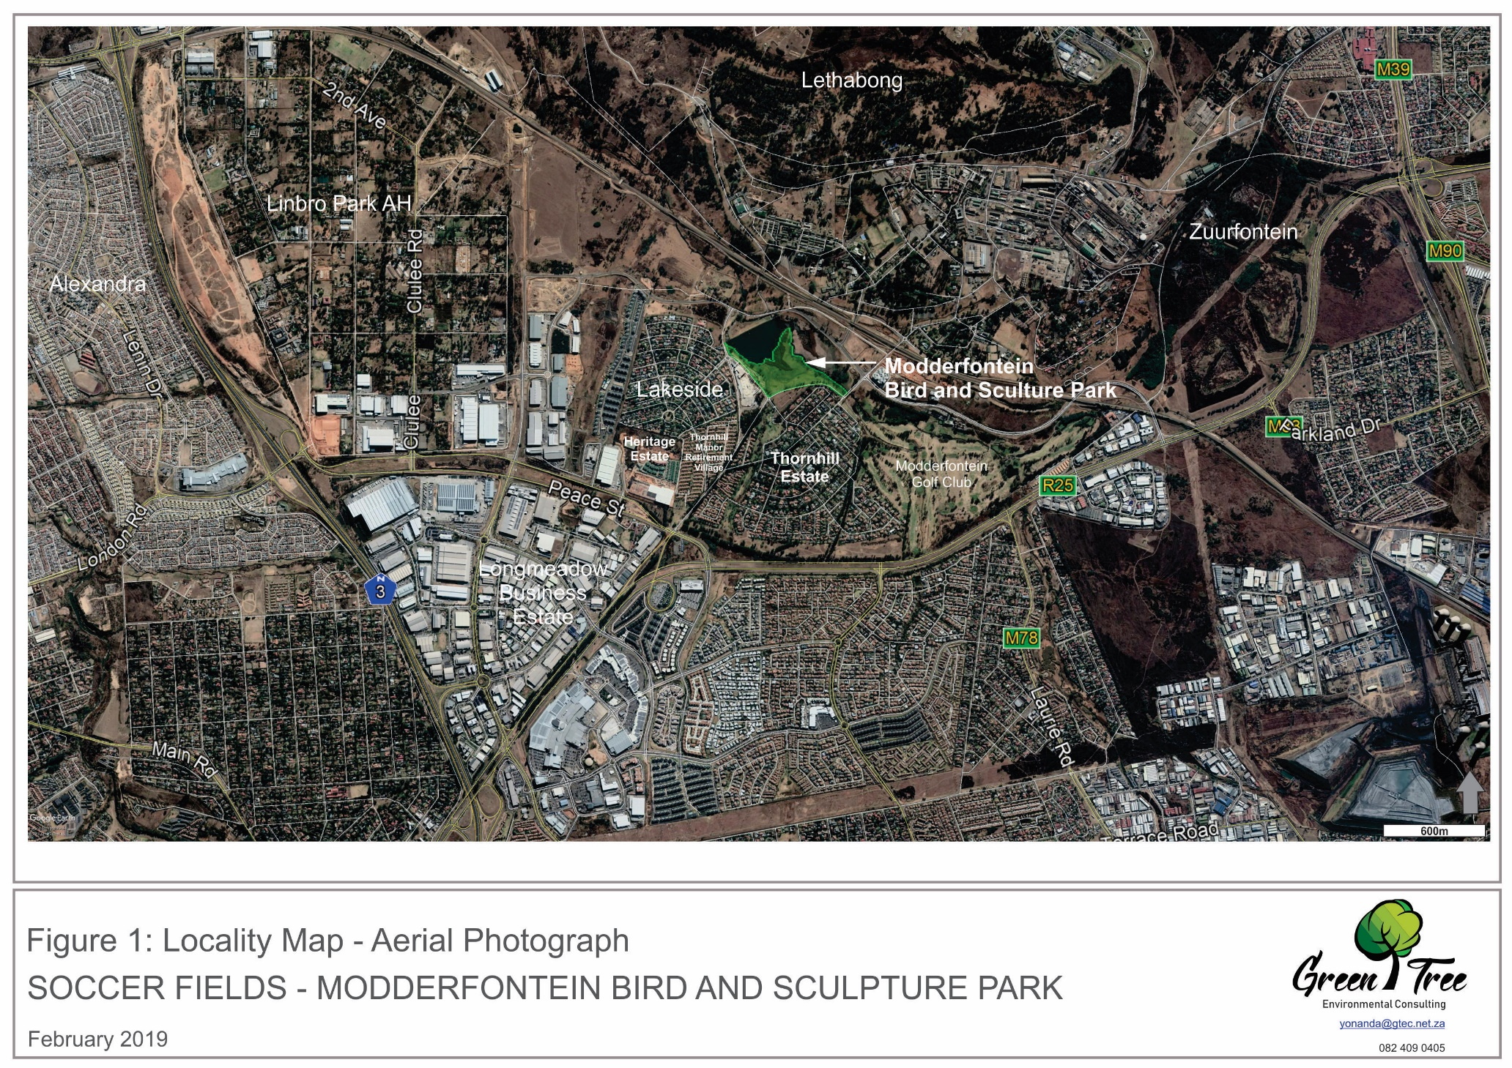  
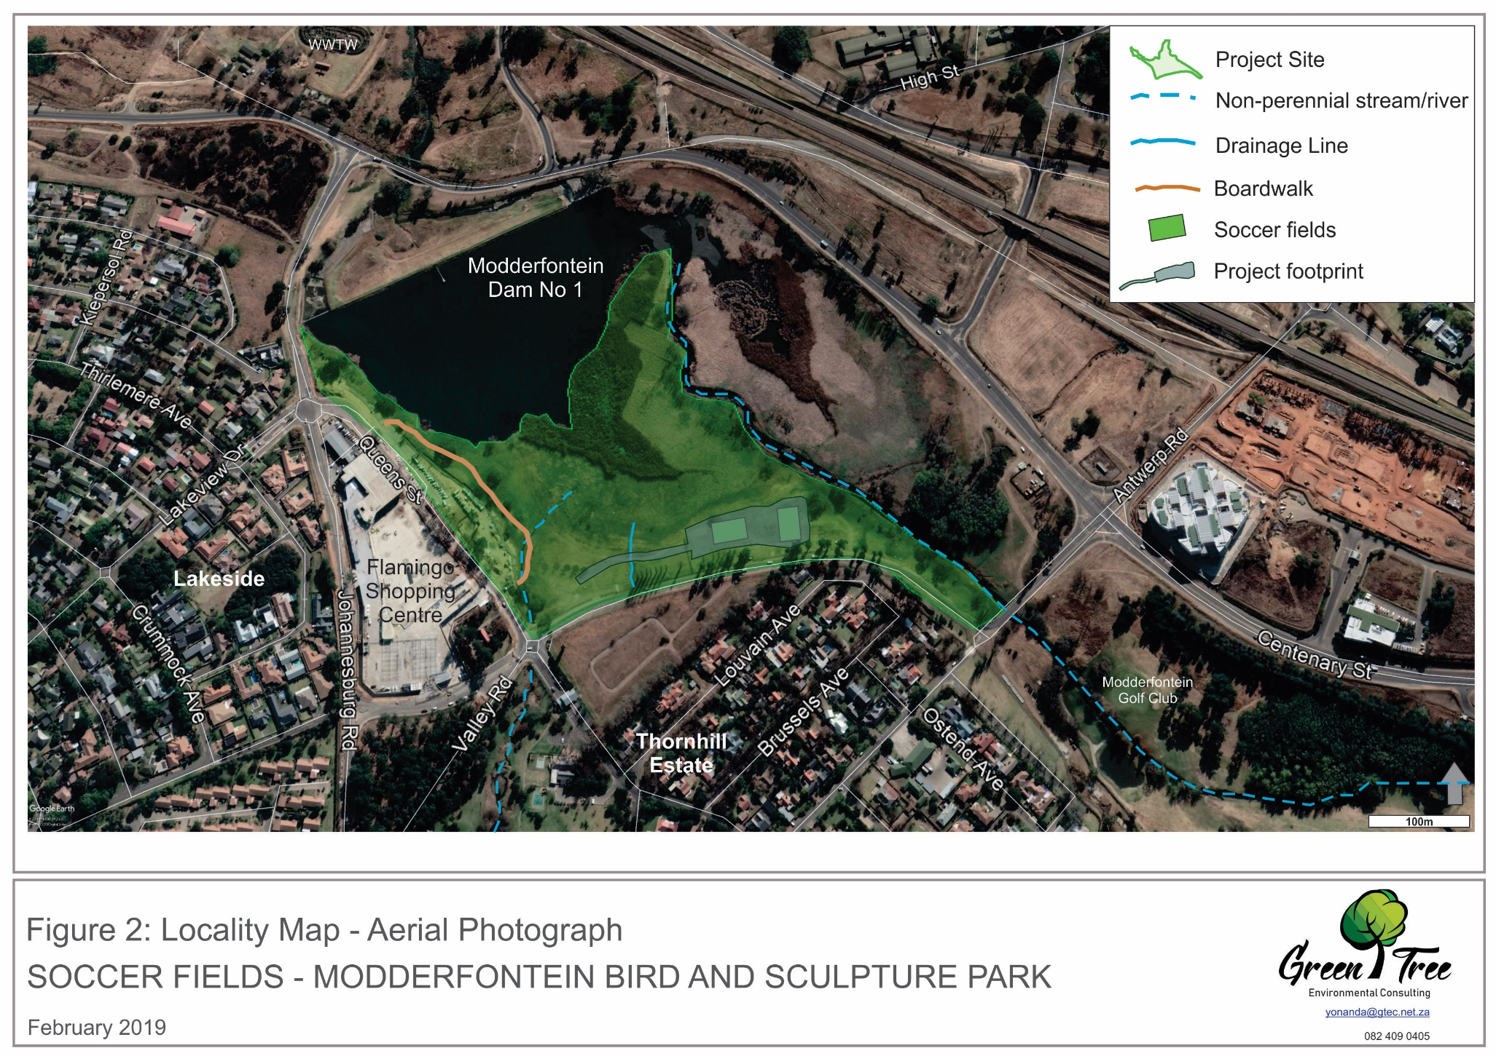

## **Sensitive Environments**

According to the Gauteng Department of Agriculture and Rural Development’s (GDARD) Conservation Plan (C-Plan ver 3), sections of Modderfontein Bird and Sculpture Park falls within Critical Biodiversity and Ecological Support Areas.

The park falls within the riparian habitat of the Modderfontein Dam 1 and according to the Wetland Assessment Report that was compiled by Flori Scientific Services (Appendix A) most of the riparian habitat is classified as a wetland.

Refer to Figure 3 and Figure 4 for the demarcation of the Environmental Sensitive Areas.

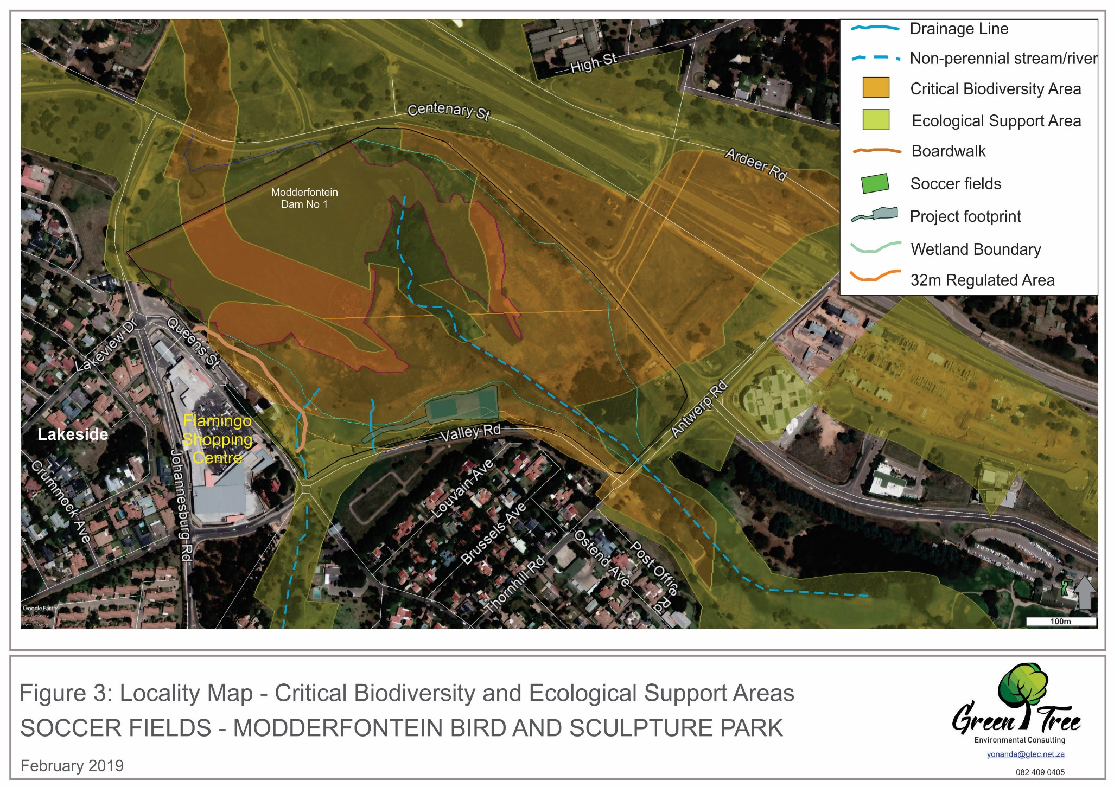

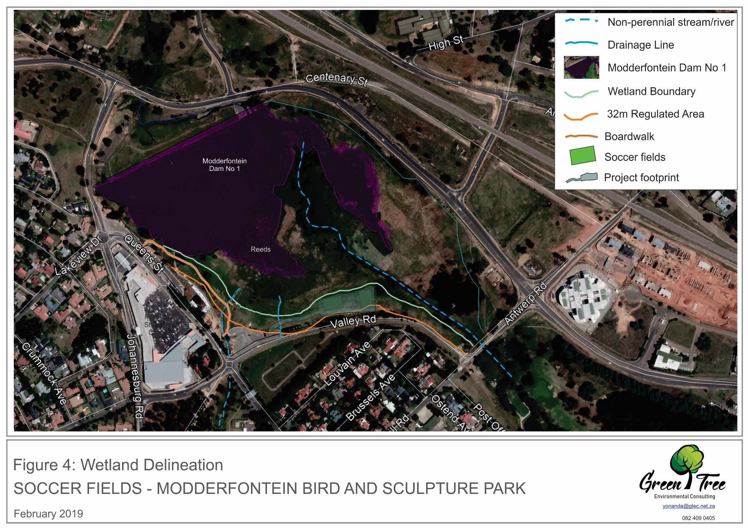

# **PURPOSE OF THE EMPr**

The purpose of the EMPr is to ensure that the impacts of the proposed project is kept to a minimum by implementing best practise mitigation / management measures. The EMPr is based on the NEMA Principles and therefore includes:

* avoid, minimise, or correct pollution and degradation of the environment;
* avoid or minimise waste, re-use or re-cycle waste where possible;
* apply a cautious approach;
* anticipate and prevent a negative impact on the environment, if the impacts can’t be prevented it must be minimized or remedied;
* negative impacts on the environment and on people’s environmental rights must be anticipated and prevented, if the impacts can’t be prevented it must be minimized or remedied;
* environmental management must be an integrated approach, taking into consideration the effects of decisions on all aspects of the environment and all people in the environment by using best practice environmental options;
* the social, economic and environmental impacts of activities, including disadvantages and benefits must be considered, assessed and evaluated. Decisions must be based on these considerations and assessments.

Taking all of the above into consideration the EMPr therefore:

* ensures compliance with guidelines and stipulations as provided by the Authority / Government;
* provides an action plan for the implementation of management measures during construction and operation;
* provides a clear picture of the roles and responsibilities of the various role players on site;
* provides monitoring guidelines for the activities and assessment thereof;
* provides mitigation measures that can be used to prevent or reduce potential impacts on the environment;
* provides a structure that can be used to communicate or address the concerns of Interested and Affected Parties (I&APs);
* provides a feedback loop for communication to the authorities, developer, contractor and the public;
* complies with the requirements as per Annexure 4 of the NEMA EIA Regulations.

# **ROLES AND RESPONSIBILITIES**

The effective implementation of an EMPr is dependent on a clear understanding of the role, responsibility and feedback/reporting of each role player involved in the implementation of the proposed project. The various roles and feedback/reporting lines, as discussed below, are based on the definitions as provided in the Department of Environmental Affairs’ (DEA) Generic EMPr Series.

**Table 1: Roles and responsibilities for the implementation of the EMPr**

|  |  |
| --- | --- |
| **Function** | **Role & Responsibilities** |
| Developer’s Project Manager | Role:  Accountable for ensuring compliance with the EMPr and any other licenses or conditions issued by the Authority. The Project Developer must appoint an independent Environmental Control Officer (ECO) to monitor the implementation of the EMPr and any other conditions as provided by the Authority. The Project Developer is responsible for providing and giving mandate to enable the ECO to perform responsibilities, and he must ensure that the ECO is part of the Project Team.  Responsibilities:   * Be fully conversant with the conditions of the EA; * Ensure that all stipulations within the EMPr are communicated and adhered to by the Developer and its Contractor(s); * Monitor the implementation of the EMPr throughout the project by means of site inspections and meetings; * Ensure that periodic environmental performance audits are undertaken on the project implementation. |
| Site Supervisor | Role:  The Site Supervisor reports directly to the Project Manager, oversees site works, liaise with the contractor(s) and the ECO. The Site Supervisor is responsible for the day to day implementation of the EMPr and for ensuring the compliance of all contractors with the conditions and requirements stipulated in the EMPr.  Responsibilities:   * Must be fully conversant with the conditions of the EA. Oversees site works, liaison with the Contractor and ECO. * Must ensure that all landowners have the relevant contact details of the site staff, ECO and Occupational Health & Safety; * Will issue all non-compliance to the contractor; * Ratify the monthly Environmental Report. |
| Environmental Control Officer (ECO) | The ECO should be employed by the developer for the duration of the project. The ECO should have appropriate training and experience in the implementation of environmental management specifications. The primary role of the ECO is to act as an independent quality controller and monitoring agent regarding all environmental concerns and associated environmental impacts. In this respect, the ECO is to conduct periodic site inspections, attend regular site meetings, pre-empt problems and suggest mitigation and be available to advise on incidental issues that arise. The ECO provides feedback to the Site Supervisor and Project Manager regarding all environmental matters. The Contractor is answerable to the ECO for non- compliance with the Performance Specifications as set out in the environmental authorisation and EMPr.  The ECO provides feedback to the Site Supervisor and Project Manager, who in turn reports back to the Implementing Agent and potential and Registered Interested & Affected Party's (I&AP’s), as required. Issues of non-compliance raised by the ECO must be taken up by the Project Manager, and resolved with the Contractor as per the conditions of his contract. Decisions regarding environmental procedures, specifications and requirements which have a cost implication (i.e. those that are deemed to be a variation, not allowed for in the Performance Specification) must be endorsed by the Project Manager.  The ECO must also, as specified by the EA, report to the relevant competent authority as and when required.  **Responsibilities:**   * Be aware of the findings and conclusions of all environmental authorisations related to the development; * Be familiar with the recommendations and mitigation measures of the EMPr; * Be conversant with relevant environmental legislation, policies and procedures, and ensure compliance with them; * Undertake regular and comprehensive site inspections / audits of the construction site according to the EMPr and applicable licenses in order to monitor compliance as required; * Educate the construction team about the management measures contained in the EMPr and environmental licenses; * Compilation and administration of an environmental monitoring plan to ensure that the environmental management measures are implemented and are effective; * Monitoring the performance of the Contractors and ensuring compliance with the EMPr and associated Method Statements; * In consultation with the Site Supervisor order the removal of person(s) and/or equipment which are in contravention of the specifications of the EMPr and/or environmental licenses; * Liaison between the Developer Project Manager, Contractors, authorities and other lead stakeholders on all environmental concerns; * Issuing of site instructions to the Contractor for corrective actions required; * Compile a regular environmental audit report highlighting any non-compliance issues as well as satisfactory or exceptional compliance with the EMPr; * Assisting in the resolution of conflicts; * Facilitate training for all personnel on the site – this may range from carrying out the training, to reviewing the training programmes of the Contractor and/or sub-contractors; * In case of non-compliances, the ECO must first communicate this to the Senior Site Supervisor, who has the power to ensure this matter is addressed. Should no action or insufficient action be taken, the ECO may report this matter to the authorities as non-compliance; * Maintenance, update and review of the EMPr; * Communication of all modifications to the EMPr to the relevant stakeholders. |
| Contractor | Role:  The Contractor has overall responsibility for ensuring that all work, activities, and actions linked to the delivery of the contract are in line with the EMPr and that Method Statements are implemented as described. External contractors must ensure compliance with this EMPr while performing the onsite activities as per their contract with the Project Developer. The contractors are required, where specified, to provide Method Statements setting out in detail how the management actions contained in the EMPr will be implemented during the development of overhead transmission and distribution electricity infrastructure activities.  **Responsibilities:**   * project delivery and quality control for the construction services as per appointment; * employ a suitably qualified person to monitor and report to the Project Developer’s appointed person on the daily activities on-site during the construction period; * ensure that safe, environmentally acceptable working methods and practices are implemented and that equipment is properly operated and maintained, to facilitate proper access and enable any operation to be carried out safely; * attend on site meeting(s) prior to the commencement of construction activities to confirm the construction procedure and designated activity zones; * ensure that contractors’ staff (or sub-contractors) repair, at their own cost, any environmental damage as a result of a contravention of the specifications. |
|  |  |

# **SITE DOCUMENTATION**

The following documentation must be kept on site / in the site office and must be made available to the ECO or to the GDARD Environmental Management Inspectorate (EMI) Officials:

* The Environmental Authorisation (EA;)
* The approved EMPr;
* Declarations by the Developer/Project Manager, Engineer and Contractor;
* Method Statements;
* Environmental Incident Log;
* All environmental training related documents;
* The monitoring reports submitted by the ECO;
* Master Plan or Layout Plan;
* Construction Programme.

# **ASSESSMENT CRITERIA**

During the site visits the activities on site will be compared to the EMPr, EA and any other licenses or conditions issued for the project. The activities will be assessed as either being compliant, partially compliant or non-compliant as defined in Table 2 below:

**Table 2: Assessment Criteria**

|  |  |
| --- | --- |
| **Compliant:** | Fully compliant. Meets the requirements of the license condition. Documented or audited proof of compliance is available. No further actions required |
| **Partially Compliant:** | Actions are being taken to meet the requirements of the license condition but are falling short of the requirements. Evidence of attempts being made are available. |
| **Non-compliant** | Compliance not achieved or no action is being undertaken to meet the requirements of the license condition. The information regarding this aspect is unavailable at the time of the audit or not available at all. |
| **Unknown** | The compliance could not be confirmed due to limitations. |
| **Not Applicable** | This condition is not currently applicable to the operation. |

Recommendations must be provided where specific requirements haven’t been met and therefore resulted in non-compliance or partial compliance.

# **IMPACT MANAGEMENT OUTCOMES AND ACTIONS**

1. **Environmental Awareness Training**

|  |  |  |  |  |  |  |  |  |
| --- | --- | --- | --- | --- | --- | --- | --- | --- |
| **Management Outcome:** All onsite staff are aware and understands the individual responsibilities in terms of this EMPr. | | | | | | | | |
| **Impact Management Actions** | **Implementation** | | | | **Monitoring** | | |
| **Responsible person** | **Method of Implementation** | **Timeframe for Implementation** | **Responsible person** | | **Frequency** | **Evidence of Compliance** |
| * + All staff must receive environmental awareness training;   + The Contractor must allow for sufficient sessions to train all personnel;   + All new staff coming onto site must receive environmental awareness training;   + All staff are aware of the conditions and controls linked to the Environmental Authorisation and within the EMPr;   + The responsible operator of equipment must have the required training to make use of the spill kit in emergency situations;   + All staff are made aware of their individual roles and responsibilities in achieving compliance with the environmental authorisation and EMPr;   + The Contractor must erect and maintain information posters at key locations on site;   + Environmental awareness training should include the following:   1. Description of significant environmental impacts, actual or potential, related to their work activities;   2. Mitigation measures to be implemented when carrying out specific activities;   3. Emergency preparedness and response procedures;   4. Emergency procedures;   5. Procedures to be followed when working near or within sensitive areas;   6. Water usage and conservation;   7. Solid waste management procedures;   8. Sanitation procedures.   + A record of all environmental awareness training courses undertaken as part of the EMPr must be available;   + Educate workers on the dangers of open and/or unattended fires;   + An attendance register of all staff that received environmental awareness training must be kept;   + Course material must be available and presented in all appropriate languages. | Contractor | Presentations should be as visual as possible it can include posters, power point, videos or any other material that will assist in the training. | Environmental awareness training must be done before construction starts and as soon as new staff members start on site.  Environmental posters must be on site at all times and must be visible / readable. | ECO | | As and when required | Photos  Attendance Register  Training material |

1. **Site Establishment**

|  |  |  |  |  |  |  |  |  |
| --- | --- | --- | --- | --- | --- | --- | --- | --- |
| **Management Outcome:** Impacts on the environment are minimised when constructing new infrastructure and the development footprint are kept to demarcated construction area. | | | | | | | | |
| **Impact Management Actions** | **Implementation** | | | | **Monitoring** | | |
| **Responsible person** | **Method of Implementation** | **Timeframe for Implementation** | **Responsible person** | | **Frequency** | **Evidence of Compliance** |
| * A Method Statement must be provided by the contractor prior to any onsite activity that includes the layout of the construction camp in the form of a plan showing the location of key infrastructure and services, including but not limited to:   + overnight vehicle parking areas;   + stockpile and lay down areas,   + the batching area/ plant;   + equipment cleaning areas;   + cooking and ablution facilities;   + waste management;   + access route * Location of the site camp must be within an approved area to ensure that the site does not impact on sensitive areas identified in the environmental assessment or site walk through; * Sites should be located where possible on previously disturbed areas; * No temporary facilities or portable toilets to be setup within 50m of any watercourse, including streams, dams and drainage lines (even if dry). * The site camp must be fenced; * No staff to be accommodated on the property; * Construction signs must be erected on the fence and entrance to the construction site. | Contractor |  | Before construction starts | ECO | | During all site visits | Photos |

1. **No-Go Areas**

|  |  |  |  |  |  |  |  |  |
| --- | --- | --- | --- | --- | --- | --- | --- | --- |
| **Management Outcome:** Access to no-go areas prevented | | | | | | | | |
| **Impact Management Actions** | **Implementation** | | | | **Monitoring** | | |
| **Responsible person** | **Method of Implementation** | **Timeframe for Implementation** | **Responsible person** | | **Frequency** | **Evidence of Compliance** |
| * Identification of No-Go areas is to be informed by the environmental assessment, site walk through and any additional areas identified during development; * Erect, demarcate and maintain a temporary fence around the perimeter of the construction area; * Unauthorised access and development related activity inside No-Go areas is prohibited. * In this case the No-Go area will also include the 32m regulated zone that needs to be setup and implemented, as per the delineated maps. | Contractor |  | Before construction starts | ECO | | During all site visits | Photos |

1. **Access Roads**

|  |  |  |  |  |  |  |  |  |
| --- | --- | --- | --- | --- | --- | --- | --- | --- |
| **Management Outcome:** Minimise impact to the environment through the planned and restricted movement of vehicles on site. | | | | | | | | |
| **Impact Management Actions** | **Implementation** | | | | **Monitoring** | | |
| **Responsible person** | **Method of Implementation** | **Timeframe for Implementation** | **Responsible person** | | **Frequency** | **Evidence of Compliance** |
| * Access to the site must fall within the assessed and authorised area; * Maximum use of existing roads must be made; * Access is to be established by vehicles passing over the same track on natural ground, multiple tracks are not permitted. | Contractor |  | During construction | ECO | | During all site visits | Photos |

1. **Fencing**

|  |  |  |  |  |  |  |  |  |
| --- | --- | --- | --- | --- | --- | --- | --- | --- |
| **Management Outcome:** To minimise impact to the environment and ensure safe and controlled access to the site through the erection of a fence and gates where required. | | | | | | | | |
| **Impact Management Actions** | **Implementation** | | | | **Monitoring** | | |
| **Responsible person** | **Method of Implementation** | **Timeframe for Implementation** | **Responsible person** | | **Frequency** | **Evidence of Compliance** |
| * Use existing gates to gain access to all parts of the study site; * All gates must be fitted with locks and be kept locked after working hours; * All demarcation fencing and barriers must be maintained in good working order for the duration of the construction period; * Fencing must be erected around the camp, batching plants, hazardous storage areas, and all designated no-go areas, where applicable; * All fencing must be developed of high-quality material bearing the SABS mark; * The use of razor wire as fencing must be avoided; * On completion of the project all temporary fences are to be removed and where possible re-used by the contractor at new projects; * The contractor will ensure that all fence uprights are appropriately removed, ensuring that no uprights are cut at ground level but rather removed completely. | Contractor |  | Before construction starts | ECO | | During all site visits | Photos |

1. **Water Management**

|  |  |  |  |  |  |  |  |  |
| --- | --- | --- | --- | --- | --- | --- | --- | --- |
| **Management Outcome:** Undertake responsible water usage | | | | | | | | |
| **Impact Management Actions** | **Implementation** | | | | **Monitoring** | | |
| **Responsible person** | **Method of Implementation** | **Timeframe for Implementation** | **Responsible person** | | **Frequency** | **Evidence of Compliance** |
| * All reasonable measures to limit pollution or sedimentation of the downstream watercourse must be implemented. * Ensure water conservation is being practiced by:   + Minimising water use during cleaning of equipment;   + Undertaking regular audits of water systems; * Discuss water usage and conservation during environmental awareness training and toolbox talks. | Contractor |  | During construction | ECO | | During all site visits | Photos |

1. **Storm and Waste Water Management**

|  |  |  |  |  |  |  |  |  |
| --- | --- | --- | --- | --- | --- | --- | --- | --- |
| **Management Outcome:** An effective system of storm water run-off control is implemented, where required and impacts to the environment caused by storm water and wastewater discharges during construction are avoided. | | | | | | | | |
| **Impact Management Actions** | **Implementation** | | | | **Monitoring** | | |
| **Responsible person** | **Method of Implementation** | **Timeframe for Implementation** | **Responsible person** | | **Frequency** | **Evidence of Compliance** |
| * Appropriate pollution control necessary to prevent discharge of water containing polluting matter or visible suspended; * Materials into watercourses or water bodies must be designed and implemented; * Runoff from the cement/ concrete batching areas must be strictly controlled, and contaminated water must be collected, stored and either treated or disposed of off-site, at a location approved by the Project Manager; * All spillage of oil onto surfaces must be controlled by the use of an approved absorbent material and the used absorbent material disposed of at an appropriate waste disposal facility; * Natural storm water runoff not contaminated by development operations and clean water can be discharged directly to watercourses and water bodies, subject to the Project Manager’s approval and support by the ECO. | Contractor |  | Measures implemented before construction starts and checked during construction. | ECO | | During all site visits | Photos |

1. **Solid Waste Management**

|  |  |  |  |  |  |  |  |  |
| --- | --- | --- | --- | --- | --- | --- | --- | --- |
| **Management Outcome:** Wastes are appropriately stored, handled and safely disposed of at a licensed waste facility**.** | | | | | | | | |
| **Impact Management Actions** | **Implementation** | | | | **Monitoring** | | |
| **Responsible person** | **Method of Implementation** | **Timeframe for Implementation** | **Responsible person** | | **Frequency** | **Evidence of Compliance** |
| * All measures regarding waste management must be undertaken using an integrated waste management approach; * Sufficient, covered waste collection bins (scavenger and weatherproof) must be provided; * A suitably positioned and clearly demarcated waste collection site must be identified and provided; * The waste collection site must be maintained in a clean and orderly fashion; * Waste must be segregated into separate bins and clearly marked for each waste type; * Staff must be trained in waste segregation; * Bins must be emptied regularly; * General waste produced onsite must be disposed of at recognised and licenced waste disposal sites/ recycling company; * Hazardous waste must be disposed of at a registered waste disposal site; * Certificates of safe disposal for general, hazardous and recycled waste must be maintained. | Contractor |  | Measures must be implemented before construction starts and must be controlled during construction. | ECO | | During all site visits | Photos |

1. **Protection of Watercourses**

|  |  |  |  |  |  |  |  |  |
| --- | --- | --- | --- | --- | --- | --- | --- | --- |
| **Management Outcome:** Pollution and contamination of the watercourse environment as well as potential erosion are prevented. | | | | | | | | |
| **Impact Management Actions** | **Implementation** | | | | **Monitoring** | | |
| **Responsible person** | **Method of Implementation** | **Timeframe for Implementation** | **Responsible person** | | **Frequency** | **Evidence of Compliance** |
| * All watercourses and water bodies must be protected from direct or indirect spills of pollutants such as solid waste, sewage, cement, oils, fuels, chemicals, aggregate tailings, wash and contaminated water or organic material resulting from the Contractor’s activities; * In the event of a spill, prompt action must be taken to clear the polluted or affected areas; * Where possible, no development equipment must traverse any seasonal or permanent wetland; * Erosion potential to be monitored at all times during the construction phase. Any erosion to be corrected immediately. * Site to be inspected after the first heavy rain falls after completion of the construction phase to assess erosion. Thereafter it can form part of the regular maintenance plan. * The delineated 32m regulated area must be maintained. No temporary lay-down areas of site office in this area. Only very limited development should be allowed in the 32m regulated zone. * When working in or near any watercourse or wetland, the following environmental controls and consideration must be taken: * When working in flowing water, such as the small stream crossings, downstream sedimentation must be controlled by installing and maintaining the necessary temporary sedimentation barriers, e.g. geotextile silt curtains or sedimentation weirs developed out of suitably secured straw bales. Sedimentation barriers must be a maximum of 25 m downstream of the construction activities;   + During the execution of the project, appropriate measures to prevent pollution and contamination of the watercourse must be implemented e.g. including ensuring that construction equipment is well maintained;   + Where earthwork is being undertaken in close proximity to any watercourse, slopes must be stabilised using suitable materials, i.e. sandbags or geotextile fabric, to prevent sand and rock from entering the watercourse; and * Appropriate rehabilitation and re-vegetation measures for the watercourse (wetland area and streams) must be implemented timeously. | Contractor |  | Measures must be implemented before construction starts and must be controlled during construction. | ECO | | During all site visits | Photos |

1. **Vegetation Clearing**

|  |  |  |  |  |  |  |  |  |
| --- | --- | --- | --- | --- | --- | --- | --- | --- |
| **Management Outcome:** Vegetation clearing is restricted to the authorised development footprint of the proposed infrastructure. | | | | | | | | |
| **Impact Management Actions** | **Implementation** | | | | **Monitoring** | | |
| **Responsible person** | **Method of Implementation** | **Timeframe for Implementation** | **Responsible person** | | **Frequency** | **Evidence of Compliance** |
| * Removal of any vegetation along the water’s edge to be limited to alien species. * Removal of invasive grey poplar trees (weed) will be a positive impact on the water environment. * Old, large weeping willow trees to be protected and not removed (even though they are exotic species) unless it is a threat to the safety of people visiting the park. * Only vegetation located within the footprint of the development must be removed; * Trees felled due to construction must be monitored and listed in the Audit Environmental Report; * Rivers, watercourses and other water bodies must be kept clear of felled trees, vegetation cuttings and debris; * All vegetation removed during the construction period must be disposed off at a registered “green” landfill site or in an appropriate manner as agreed by the ECO and Landscape Architect; * Only a registered pest control operator may apply herbicides on a commercial basis and commercial application must be carried out under the supervision of a registered pest control operator, supervision of a registered pest control operator or is appropriately trained; * A daily register must be kept of all relevant details of herbicide usage as stipulated in Act 36 of 1947; * Trees, shrubs, grass, natural features and topsoil which are not removed during vegetation clearance shall be protected from damage during operation of the park; * Removal of alien invasive plant species must be done in an appropriate manner and by a professional; * Disposal of the alien invasive plant species must be done in an appropriate manner and according to the Alien Invasive Species Regulations 2014 (NEMBA Act 10 of 2004). * A site-specific rehabilitation plan is required. * Part of the rehabilitation plan must include the rehabilitation of the stream banks and the re-seeding of the bare soils. * Locally indigenous trees to be planted along the water’s edges. * Disturbed dug up areas to be reshaped and re-contoured to original contours and to blend in with surrounding topography. * Re-seeding of bare areas with grasses to be part of the rehabilitation plan. Existing, exotic species may be used for rehabilitation. * A plan should be to plant numerous indigenous trees along the water edges. | Contractor |  | During construction | ECO | | During all site visits | Photos |

1. **Protection of fauna**

|  |  |  |  |  |  |  |  |  |
| --- | --- | --- | --- | --- | --- | --- | --- | --- |
| **Management Outcome:** minimise the disturbance to fauna. | | | | | | | | |
| **Impact Management Actions** | **Implementation** | | | | **Monitoring** | | |
| **Responsible person** | **Method of Implementation** | **Timeframe for Implementation** | **Responsible person** | | **Frequency** | **Evidence of Compliance** |
| * The breeding sites of wild birds species must be taken into consideration during the planning of the development programme; * Breeding sites must be kept intact and disturbance to breeding birds must be avoided. Special care must be taken where nestlings or fledglings are present; * No poaching must be tolerated under any circumstances; * No fishing will be allowed during the construction and operational phase. * Aquatic monitoring of the construction activities should be implemented. | Contractor |  | During construction | ECO | | During all site visits | Photos |

1. **Protection of heritage resources**

|  |  |  |  |  |  |  |  |  |
| --- | --- | --- | --- | --- | --- | --- | --- | --- |
| **Management Outcome:** minimise the disturbance to heritage resources. | | | | | | | | |
| **Impact Management Actions** | **Implementation** | | | | **Monitoring** | | |
| **Responsible person** | **Method of Implementation** | **Timeframe for Implementation** | **Responsible person** | | **Frequency** | **Evidence of Compliance** |
| * Identify, demarcate and prevent impact to all known sensitive heritage features on site in accordance with the no-go procedure; * Carry out general monitoring of excavations for potential fossils, artefacts and material of heritage importance; * All work must cease immediately, if any human remains and/or other archaeological, palaeontological and historical material are uncovered. Such material, if exposed, must be reported to the nearest museum, archaeologist/ palaeontologist (or the South African Police Services), so that a systematic and professional investigation can be undertaken. Sufficient time should be allowed to remove/collect such material before development recommences. | Contractor |  | During construction | ECO | | During all site visits | Photos |

1. **Safety of the public**

|  |  |  |  |  |  |  |  |  |
| --- | --- | --- | --- | --- | --- | --- | --- | --- |
| **Management Outcome:** all precautions are taken where possible to minimise the risk of injury, harm or complaints. | | | | | | | | |
| **Impact Management Actions** | **Implementation** | | | | **Monitoring** | | |
| **Responsible person** | **Method of Implementation** | **Timeframe for Implementation** | **Responsible person** | | **Frequency** | **Evidence of Compliance** |
| * Demarcate and restrict public access to the construction area; * Ensure that there is signage all over the site that warns the public of construction activities; * Ensure that there are sufficient road signs so that the public are aware of construction vehicles moving around; * If necessary points men/women must be appointed to direct traffic or warn motorist of any danger on the roads; * All unattended open excavations must be adequately fenced or demarcated; * Adequate protective measures must be implemented to prevent unauthorised access to and climbing of construction material; * Maintain an incidents and complaints register in which all incidents or complaints involving the public are logged. | Contractor |  | Proper planning must be done before construction and implemented during construction | ECO | | During all site visits | Photos |

1. **Sanitation**

|  |  |  |  |  |  |  |  |  |
| --- | --- | --- | --- | --- | --- | --- | --- | --- |
| **Management Outcome:** clean and well-maintained toilet facilities are available to all staff in an effort to minimise the risk of disease and impact to the environment. | | | | | | | | |
| **Impact Management Actions** | **Implementation** | | | | **Monitoring** | | |
| **Responsible person** | **Method of Implementation** | **Timeframe for Implementation** | **Responsible person** | | **Frequency** | **Evidence of Compliance** |
| * Mobile chemical toilets are installed onsite if no other ablution facilities are available; * The use of ablution facilities and or mobile toilets must be used at all times and no indiscriminate use of the veld for the purposes of ablutions must be permitted under any circumstances; * Proper hand washing facilities, including soap, must be provided if it is not included as part of the chemical toilets; * Where mobile chemical toilets are required, the following must be ensured: * Toilets are located no closer than 100m to any watercourse or water body; * Toilets are secured to the ground to prevent them from toppling due to wind or any other cause; * No spillage occurs when the toilets are cleaned or emptied and the contents are managed in accordance with the EMPr; * Toilets have an external closing mechanism and are closed and secured from the outside when not in use to prevent toilet paper from being blown out; * Toilets are emptied before long weekends and workers holidays, and must be locked after working hours; * Toilets are serviced regularly and the ECO must inspect toilets to ensure compliance to health standards; * A copy of the waste disposal certificates must be maintained. | Contractor |  | Toilets must be provided before construction starts. | ECO | | During all site visits | Photos |

1. **Emergency Procedures**

|  |  |  |  |  |  |  |  |  |
| --- | --- | --- | --- | --- | --- | --- | --- | --- |
| **Management Outcome:** emergency procedures are in place to enable a rapid and effective response to all types of environmental emergencies. | | | | | | | | |
| **Impact Management Actions** | **Implementation** | | | | **Monitoring** | | |
| **Responsible person** | **Method of Implementation** | **Timeframe for Implementation** | **Responsible person** | | **Frequency** | **Evidence of Compliance** |
| * Compile an Emergency Response Action Plan (ERAP) prior to the commencement of the proposed project; * The Emergency Plan must deal with accidents, potential spillages and fires in line with relevant legislation; * All staff must be made aware of emergency procedures as part of environmental awareness training; * The relevant local authority must be made aware of a fire as soon as it starts; * In the event of emergency necessary mitigation measures to contain the spill or leak must be implemented refer to the section below - Hazardous Substances. | Contractor |  | Must be done before construction starts and implemented during construction. | ECO | | During all site visits | Photos |

1. **Hazardous Substances**

|  |  |  |  |  |  |  |  |  |
| --- | --- | --- | --- | --- | --- | --- | --- | --- |
| **Management Outcome:** safe storage, handling, use and disposal of hazardous substances. | | | | | | | | |
| **Impact Management Actions** | **Implementation** | | | | **Monitoring** | | |
| **Responsible person** | **Method of Implementation** | **Timeframe for Implementation** | **Responsible person** | | **Frequency** | **Evidence of Compliance** |
| * The use and storage of hazardous substances to be minimised and non-hazardous and non-toxic alternatives substituted where possible; * All hazardous substances will be stored in suitable containers as defined in the Method Statement provided by the contractor; * Containers will be clearly marked to indicate contents, quantities and safety requirements; * All storage areas will be bunded. The bunded area will be of sufficient capacity to contain a spill / leak from the stored containers; * An Alphabetical Hazardous Chemical Substance (HCS) control sheet will be drawn up and kept up to date on a continuous basis; * All hazardous chemicals that will be used on site will have Material Safety Data Sheets (MSDS); * All employees working with HCS will be trained in the safe use of the substance and according to the safety data sheet; * Employees handling hazardous substances / materials must be aware of the potential impacts and follow appropriate safety measures. Appropriate personal protective equipment must be made available; * The Contractor must ensure that diesel and other liquid fuel, oil and hydraulic fluid is stored in appropriate storage tanks or in bowsers; * The tanks/ bowsers must be situated on a smooth impermeable surface (concrete) with a permanent bund. The impermeable lining must extend to the crest of the bund and the volume inside the bund must be 130% of the total capacity of all the storage tanks/ bowsers (110% statutory requirement plus an allowance for rainfall); * The floor of the bund must be sloped, draining to an oil separator; * Provision must be made for re-fuelling at the storage area by protecting the soil with an impermeable groundcover. Where dispensing equipment is used, a drip tray must be used to ensure small spills are contained; * All empty externally dirty drums must be stored on a drip tray or within a bunded area; * No unauthorised access into the hazardous substances’ storage areas shall be permitted; * No smoking must be allowed within the vicinity of the hazardous storage areas; * Adequate fire-fighting equipment must be made available at all hazardous storage areas; * An appropriately sized spill kit kept onsite relevant to the scale of the activity/s involving the use of hazardous substance must be available at all times; * The responsible operator must have the required training to make use of the spill kit in emergency situations; * In the event of a spill, contaminated soil must be collected in containers and stored in a central location and disposed of according to the National Environmental Management: Waste Act 59 of 2008. | Contractor |  | Planning done prior to construction and implemented during construction. | ECO | | During all site visits | Photos |

1. **Workshop, equipment maintenance and storage**

|  |  |  |  |  |  |  |  |  |
| --- | --- | --- | --- | --- | --- | --- | --- | --- |
| **Management Outcome:** Soil, surface water and groundwater contamination is minimized. | | | | | | | | |
| **Impact Management Actions** | **Implementation** | | | | **Monitoring** | | |
| **Responsible person** | **Method of Implementation** | **Timeframe for Implementation** | **Responsible person** | | **Frequency** | **Evidence of Compliance** |
| * Where possible and practical all maintenance of vehicles and equipment must take place in a workshop area; * During servicing of vehicles or equipment, especially where emergency repairs are done outside the workshop area, a suitable drip tray must be used to prevent spills onto the soil. * Leaking equipment must be repaired immediately or be removed from site to facilitate repair; * Should a workshop area be located on site it must be monitored for oil and fuel spills; * Appropriately sized spill kit kept onsite relevant to the scale of the activity taking place must be available; * The workshop area must have a bunded concrete slab that is sloped to facilitate runoff into a collection sump or suitable oil / water separator where maintenance work on vehicles and equipment can be performed; * Water drainage from the workshop must be contained and managed in accordance to the section on waste water management. | Contractor |  | During construction. | ECO | | During all site visits | Photos |

1. **Batching Area**

|  |  |  |  |  |  |  |  |  |
| --- | --- | --- | --- | --- | --- | --- | --- | --- |
| **Management Outcome:** To control concrete and cement batching activities in order to minimise spillages and contamination of soil, surface water and groundwater. | | | | | | | | |
| **Impact Management Actions** | **Implementation** | | | | **Monitoring** | | |
| **Responsible person** | **Method of Implementation** | **Timeframe for Implementation** | **Responsible person** | | **Frequency** | **Evidence of Compliance** |
| * Concrete mixing must be carried out on an impermeable surface (such as on boards and/or within a bunded area with an impermeable surface) or make a hard surface and remove when done; * Concrete mixing areas must be fitted with a containment facility for the collection of cement laden water. This facility must be impervious to prevent soil and groundwater contamination; * Bagged cement must be stored in an appropriate facility and at least 10 m away from any water courses, gullies and drains; * A washout facility must be provided for washing of concrete associated equipment. Water used for washing must be restricted; * Hardened concrete from the washout facility or concrete mixer can either be reused or disposed of at an appropriate licenced disposal facility; * Empty cement bags must be secured with adequate binding material if these will be temporarily stored on site; * Sand and aggregates containing cement must be kept damp to prevent the generation of dust; * Any excess sand, stone and cement must be removed or reused from site on completion of construction period and disposed at a registered disposal facility. | Contractor |  | During construction. | ECO | | During all site visits | Photos |

1. **Dust Emission**

|  |  |  |  |  |  |  |  |  |
| --- | --- | --- | --- | --- | --- | --- | --- | --- |
| **Management Outcome:** dust prevention measures are applied to minimise the generation of dust. | | | | | | | | |
| **Impact Management Actions** | **Implementation** | | | | **Monitoring** | | |
| **Responsible person** | **Method of Implementation** | **Timeframe for Implementation** | **Responsible person** | | **Frequency** | **Evidence of Compliance** |
| * Take all reasonable measures to minimise the generation of dust as a result of project development activities to the satisfaction of the ECO; * Removal of vegetation must be avoided until such time as soil stripping is required and similarly exposed surfaces must be re- vegetated or stabilised as soon as is practically possible; * Excavation, handling and transport of erodible materials must be avoided under high wind conditions or when a visible dust plume is present; * During high wind conditions, the ECO will evaluate the situation and make recommendations as to whether dust-damping measures are adequate, or whether working will cease altogether until the wind speed drops to an acceptable level; * Where possible, soil stockpiles must be located in sheltered areas where they are not exposed to the erosive effects of the wind; * Where erosion of stockpiles becomes a problem, erosion control measures must be implemented at the discretion of the ECO; * Appropriate dust suppression measures must be used when dust generation is unavoidable, e.g. dampening with water; particularly during prolonged periods of dry weather in summer. Such measures must also include the use of temporary stabilising measures (e.g. chemical soil binders, straw, brush packs, chipping); * Straw stabilisation must be applied at a rate of one bale/10m² and harrowed into the top 100 mm of top material, for all completed earthworks; * For significant areas of excavation or exposed ground, spray water or wet areas using trucks to minimise the spread of dust. | Contractor |  | During construction. | ECO | | During all site visits | Photos |

1. **Noise**

|  |  |  |  |  |  |  |  |  |
| --- | --- | --- | --- | --- | --- | --- | --- | --- |
| **Management Outcome:** To prevent unnecessary noise to the environment by ensuring that noise from construction activity is mitigated. | | | | | | | | |
| **Impact Management Actions** | **Implementation** | | | | **Monitoring** | | |
| **Responsible person** | **Method of Implementation** | **Timeframe for Implementation** | **Responsible person** | | **Frequency** | **Evidence of Compliance** |
| * Operating hours as determined by the environmental authorisation are adhered to during the development phase. Where not defined, development must be limited to daylight hours; * If possible construction must be limited to the week and should construction take place over a weekend the I&APs must be notified. | Contractor |  | During construction. | ECO | | During all site visits | Photos |

1. **Fire prevention**

|  |  |  |  |  |  |  |  |  |
| --- | --- | --- | --- | --- | --- | --- | --- | --- |
| **Management Outcome:** Prevention of uncontrollable fires. | | | | | | | | |
| **Impact Management Actions** | **Implementation** | | | | **Monitoring** | | |
| **Responsible person** | **Method of Implementation** | **Timeframe for Implementation** | **Responsible person** | | **Frequency** | **Evidence of Compliance** |
| * Designate smoking areas where the fire hazard could be regarded as insignificant; * Firefighting equipment must be available on all vehicles located on site; * The local Fire Protection Agency (FPA) must be informed of construction activities; * Contact numbers for the FPA and emergency services must be communicated in environmental awareness training, toolbox talks and displayed at a central location on site. | Contractor |  | During construction. | ECO | | During all site visits | Photos |

1. **Stockpile and Stockpiling Areas**

|  |  |  |  |  |  |  |  |  |
| --- | --- | --- | --- | --- | --- | --- | --- | --- |
| **Management Outcome:** To reduce erosion and sedimentation as a result of stockpiling. | | | | | | | | |
| **Impact Management Actions** | **Implementation** | | | | **Monitoring** | | |
| **Responsible person** | **Method of Implementation** | **Timeframe for Implementation** | **Responsible person** | | **Frequency** | **Evidence of Compliance** |
| * All material that is excavated during the project development phase (either during piling (if required) or earthworks) must be stored appropriately on site in order to minimise impacts to watercourses, wetlands and water bodies; * All stockpiled material must be maintained and kept clear of weeds and alien vegetation growth by undertaking regular weeding and control methods; * Stockpiles must not exceed 2 m in height; * During periods of strong winds and heavy rain, the stockpiles should be covered with appropriate material (e.g. cloth, tarpaulin etc.); * Where possible, sandbags (or similar) should be placed at the bases of the stockpiled material in order to prevent erosion of the material. | Contractor |  | During construction. | ECO | | During all site visits | Photos |

1. **Temporary Closure of Site**

|  |  |  |  |  |  |  |  |  |
| --- | --- | --- | --- | --- | --- | --- | --- | --- |
| **Management Outcome:** Minimise the risk of environmental impact during periods of site closure greater than five days. | | | | | | | | |
| **Impact Management Actions** | **Implementation** | | | | **Monitoring** | | |
| **Responsible person** | **Method of Implementation** | **Timeframe for Implementation** | **Responsible person** | | **Frequency** | **Evidence of Compliance** |
| * Bunds must be emptied (where applicable); * Hazardous storage areas must be well ventilated; * Fire extinguishers must be serviced and accessible. Service records to be filed and audited at last service; * Emergency and contact details displayed must be displayed; * Security personnel must be briefed and have the facilities to contact or be contacted by relevant management and emergency personnel; * Night hazards such as reflectors, lighting, traffic signage etc. must have been checked; * Wind and dust mitigation must be implemented; * Cement and materials stores must have been secured; * Toilets must have been emptied and secured; * Refuse bins must have been emptied and secured; * Drip trays must have been emptied and secured. | Contractor |  | During construction. | ECO | | During all site visits | Photos |

1. **Landscaping and Rehabilitation**

|  |  |  |  |  |  |  |  |  |
| --- | --- | --- | --- | --- | --- | --- | --- | --- |
| **Management Outcome:** No environmental degradation occurs as a result of the project. | | | | | | | | |
| **Impact Management Actions** | **Implementation** | | | | **Monitoring** | | |
| **Responsible person** | **Method of Implementation** | **Timeframe for Implementation** | **Responsible person** | | **Frequency** | **Evidence of Compliance** |
| * All areas disturbed by construction activities must be subject to landscaping and rehabilitation; * All spoil and waste will be disposed to a registered waste site and certificates of disposal provided; * All slopes in excess of 2% (1:50) must be contoured in accordance with the Conservation of Agricultural Resources Act, No 43 of 1983; * All slopes in excess of 12% (1:8.3) must be terraced in accordance with the Conservation of Agricultural Resources Act, No 43 of 1983; * Berms that have been created should have a slope of 1:4 and be replanted with indigenous species and grasses; * Indigenous species will be used for replanting; * Stockpiled topsoil must be used for rehabilitation; * Stockpiled topsoil will be evenly spread so as to facilitate seeding and minimise loss of soil due to erosion; * Before placing topsoil, all visible weeds from the placement area and from the topsoil must be removed; * Subsoil must be ripped before topsoil is placed; * The project must be timed so that rehabilitation can take place at the optimal time for vegetation establishment; * Where impacted through construction related activity, all sloped areas must be stabilised to ensure proper rehabilitation is effected and erosion is controlled as per the instruction from the ECO; * Sloped areas stabilised using design structures or vegetation as specified in the design to prevent erosion of embankments. The contract design specifications must be adhered to and implemented strictly; * Where required, re-vegetation can be enhanced using a vegetation seed mixture as described below. A mixture of seed can be used provided the mixture is carefully selected to ensure the following: * Annual and perennial plants are chosen; * Pioneer species are included; * Species chosen must grow in the area feasible to grow; * Root systems must have a binding effect on the soil; * The final product should not cause an ecological imbalance in the area. | Contractor |  | After construction. | ECO | | During all site visits | Photos |

1. **Project Maintenance**

|  |  |  |  |  |  |  |  |  |
| --- | --- | --- | --- | --- | --- | --- | --- | --- |
| **Management Outcome:** Maintenance of the project interventions so that there is no environmental degradation as a result of the project. | | | | | | | | |
| **Impact Management Actions** | **Implementation** | | | | **Monitoring** | | |
| **Responsible person** | **Method of Implementation** | **Timeframe for Implementation** | **Responsible person** | | **Frequency** | **Evidence of Compliance** |
| * All areas disturbed by construction activities must be checked during the operational phase to ensure that rehabilitation is successful; * Weed controlled programme to be compiled and implemented as part of the maintenance phase. * Rehabilitation (which should be part of the construction phase) to be assessed and corrected where necessary. * Erosion (which is potentially low) to be monitored and corrected if occurs (especially in areas where the pipeline goes down steep gradients). * Two small streams / drainage lines to be properly and fully rehabilitated. * Erosion and siltation of these two small streams to be checked after heavy downpours and corrected where necessary. | Contractor |  | During operation. | Applicant, ECO or Landscape Architect | | Every second week for at least 8 months after constructions | Photos |

1. **Project Operation**

|  |  |  |  |  |  |  |  |  |
| --- | --- | --- | --- | --- | --- | --- | --- | --- |
| **Management Outcome:** Operational management measures to prevent degradation of the environment while the project is in operation. | | | | | | | | |
| **Impact Management Actions** | **Implementation** | | | | **Monitoring** | | |
| **Responsible person** | **Method of Implementation** | **Timeframe for Implementation** | **Responsible person** | | **Frequency** | **Evidence of Compliance** |
| * Proper and professional site management must be undertaken by the owner and/or landlord and/or the lessee/s (these conditions and mitigating measures to be included in the lease agreement). * Proper and professional site management includes the following: * The area must be kept clear of litter, especially during sport and community events. * Noise should be restricted to during sport and community events only. * Lights should be minimized or even turned off at night when the Park is no longer in use. * Traffic congestion must be managed during sport and community events. * Balustrades must be erected to prevent encroachment into the water course by the public. * Access to environmental sensitive areas must be restricted. * Invasion of alien vegetation and weeds must be managed. * Old, large weeping willow trees to be protected and not removed. * Stormwater must be managed to prevent silt and erosion. * The clearing of reeds must be minimized to protect breeding and resting habitats for birds and minimize visual intrusion of the Park activities. * Breeding sites must be kept intact and disturbance to breeding birds must be avoided. Special care must be taken where nestlings or fledglings are present.   + Indigenous vegetation must be planted.   + No fishing must be allowed - signs must be erected to educate the public.   + No poaching must be tolerated under any circumstances - signs must be erected to educate the public.   + No water activities must be permitted e.g. rowing, boating, swimming - signs must be erected to educate the public.   + Signs must be erected to educate the public on the various bird species that can be found in the area.   + Noise must be limited to the normal working hours and kept to a minimum, especially after dark.   + Waste from the soccer field must be recycled. | Applicant/ Lessee |  | During operation. | Applicant, ECO or Landscape Architect | | As and when required | Photos and/ or documentation |

# **REPORTING PROCEDURE**

## **Declarations by the Developer/Project Manager, Engineer and Contractor**

The Developer/ Project Manager, Engineer and the Contractor must sign a declaration in which they declare that they understand the contents of the EMPr and will implement the mitigation/management measures during the construction and operational phases of the project. Refer to Annexure C for an example of the Declaration.

## **Method Statements**

The Contractor must provide the Project Manager, Engineer and/or the ECO with a written method statement prior to the commencement of the construction phase, refer to Annexure D for an example of a method statement. The Method Statement must address the following:

* What activity will take place?
* Where the activity will take place on the project site?
* What management measures will be implemented?

Should there be any changes to the methods that will be used by the contractor a new Method Statement must be submitted and approved by the Project Manager, Engineer and/or the ECO.

## **Record Keeping**

The Contractor must keep a record of all environmental incidents on site, refer to Annexure E for an example of an Environmental Incident Log. The Contractor must keep a photographic record of the incident and must include before and after photos. The contractor must notify the Project Manager and the ECO of the environmental incidents. The Environmental Incident Log must be kept on site and must be checked by the ECO during each visit to the project site.

The appointed ECO will continuously monitor the Contractor’s adherence to the Environmental Authorisation and approved EMPr. The ECO must issue the Contractor a notice of non-compliance whenever transgressions are observed, fines should be agreed upon before construction starts. The ECO should document the following when there is non-compliance on site:

* nature and magnitude of the non-compliance
* action taken to discontinue the non-compliance
* action taken to mitigate the non-compliance
* results of the actions taken.

The non-compliance will be documented as part of the ECO’s monthly reports and will be circulated to the Developer/Project Manager, Engineer, Contractor and to GDARD Environmental Management Inspectorate (EMI).

A copy of the Environmental Report issued by the ECO must be kept on site / in the site office.

## **Post-Construction Audit / Closure Report**

A post-construction audit must be carried out for submission to the Developer / Project Manager. The objectives of the report should be to audit compliances with the key components of the EA and the EMPr, to identify the main areas requiring attention and recommend priority actions that must take place before the site can be closed or signed off to the Applicant.

Once all concerns, non-compliance and outstanding activities, as listed in the post-construction report, have been addressed by the Contractor, a closure report can be compiled by the ECO and submitted to GDARD EMI.

# **REFERENCES**

Department of Environmental Affairs. 2017. Generic Environmental Management Programme (EMPr) for the development and expansion of infrastructure for the overhead transmission and distribution of electricity. Pretoria.

Gauteng Department of Agriculture and Rural Development, Conservation Plan, version 3.3. 2011. (GDARD C-Plan)

Flori Scientific Services. 2018. Lakeside Park Wetland Delineation and Impact Assessment.

# **ANNEXURE A –** **CV OF EAP**

**Yonanda martin**

**green tree Environmental consulting**

7 Dublin Street, Rangeview, Krugersdorp

082 409 0405

Yonanda@gtec.net.za

**EXPERIENCE:**

2006 – 2012

Environmental Assessment practitioner, Newtown landscape architects

Responsible for writing up of environmental projects, which includes:

* Basic Assessments,
* Environmental Impact Assessments (Scoping & EIA),
* Environmental Management Programmes (EMPr),
* Environmental Monitoring,
* Water Use Licenses,
* Visual Impact Assessments.

2012 – 2017

Associate and Senior Environmental Assessment Practitioner, Newtown landscape architects

* Manager of the Environmental Division at NLA
* Management of junior staff
* Management of specialist
* Management of the proposals and invoices of the Environmental Division
* Responsible for writing up of environmental projects, which includes:
* Basic Assessments,
  + Environmental Impact Assessments (Scoping & EIA),
  + Environmental Management Programmes (EMPr),
  + Environmental Monitoring,
  + Water Use Licenses,
  + Visual Impact Assessments.

**EDUCATION:**

2003

BSc. Environmental Sciences, north west university – potechefstroom campus

2007

MSc. Ecological Remediation and Sustainable Utilization, north west university – potchefstroom campus

Thesis: Tree vitality along the urbanization gradient in Potchefstroom, South Africa

2016 Environmental Law Training, Business Success Solutions

2016 Invasive Species Training: Module 1 – Introduction to Legislation, South African

Green Industries Council (SAGIC)

2016 Invasive Species Training: Module 2 – Developing and Implementing Control Plans,

South African Green Industries Council (SAGIC)

2015 Invasive Species Identification Training Workshop, South African Green Industries

Council (SAGIC)

2014 Sharpening the Tool: New techniques and methods in Environmental Impact

Assessment, SE Solutions

2014 First Aid Level 1, Action Training Academy

2011 Supervisory Management, ISIMBI

2009 Public Participation Course, International Association for Public Participation, Golder

Midrand

2008 Wetland Training Course on Delineation, Legislation and Rehabilitation, University of

Pretoria

2008 Environmental Impact Assessment: NEMA Regulations – A practical approach,

Centre for Environmental Management: University of North West

2008 Effective Business Writing Skills, ISIMBI

2007 Short course in Geographic Information Systems (GIS), Planet GIS

**EXPERIENCE:**

**Environmental Projects**

Diepsloot East Residential Development, Diepsloot. Environmental Impact Assessment, Environmental Management Programme, Water Use License and management of specialist.

Lindley Waste Water Treatment Works, Mogale City Local Municipality project located in Lindley / Lanseria. Environmental Screening, Environmental Impact Assessment, Environmental Management Programme and Water Use License Application and management of specialist.

African Leadership Academy, Laser Park, Johannesburg. This project entails the rectification of activities undertaken by ALA as well as the compilation of an overall Environmental Management Programme (EMPr) that addresses current environmental concerns on campus but also future projects such as recycling, rain water harvesting, vegetable gardens and events.

Orchards Extension 50-53, Orchards. The project includes the construction of a residential development. The project includes monitoring of the environmental conditions as well as the appointment of sub-consultants for rehabilitation purposes.

Kareekloof Oxidation Ponds, Suikerbosrand. This project entails the environmental monitoring during construction and rehabilitation of the project

**Visual Impact Assessments**

Holfontein Integrated Waste Management Facility Project (SLR Consulting (Pty) Ltd), Holfontein, Gauteng Province

Eskom Arnot Ash Dump Project (Environmental Impact Management Services), Rietkuil, Mpumalanga Province

Kalkheuwel Housing Development (ECO Assessments), Kalkheuvel, NorthWest Province

Kyasand Light Industrial Project (Terre Pacis Environmental), Kyasand, Gauteng Province

**AFFILIATIONS:**

Registered Professional Natural Scientist – 400204/09 (September 2009)

Member of IAIAsa

IAIAsa Gauteng Branch Chair 2016/17, 2017/18 & 2018/19

# **ANNEXURE B – MASTERPLAN**

# **ANNEXURE C – DECLARATION BY THE DEVELOPER/PROJECT MANAGER, ENGINEER AND CONTRACTOR**

**DECLARATION OF UNDERSTANDING: DEVELOPER/PROJECT MANAGER**

I, _________________________________________________________________________

representing _______________________________________________________________

declare that I have read and understood the contents of the Environmental Management Programme (EMPr) and the conditions as per the Environmental Authorisation for the Modderfontein Bird and Sculpture Park Project.

I also declare that I understand my responsibilities in terms of implementing and enforcing the management/ mitigation measures as per the EMPr.

Signed: _____________________________________

Place: _____________________________________

Date: ______________________________________

**DECLARATION OF UNDERSTANDING: ENGINEER**

I, _________________________________________________________________________

representing _______________________________________________________________

declare that I have read and understood the contents of the Environmental Management Programme (EMPr) and the conditions as per the Environmental Authorisation for the Modderfontein Bird and Sculpture Park Project.

I also declare that I understand my responsibilities in terms of implementing and enforcing the management/ mitigation measures as per the EMPr.

Signed: _____________________________________

Place: _____________________________________

Date: ______________________________________

**DECLARATION OF UNDERSTANDING: CONTRACTOR**

I, _________________________________________________________________________

representing _______________________________________________________________

declare that I have read and understood the contents of the Environmental Management Programme (EMPr) and the conditions as per the Environmental Authorisation for the Modderfontein Bird and Sculpture Park Project.

I also declare that I understand my responsibilities in terms of implementing the management/ mitigation measures as per the EMPr.

Signed: _____________________________________

Place: _____________________________________

Date: ______________________________________

# **ANNEXURE D – METHOD STATEMENT EXAMPLE**

|  |  |  |  |
| --- | --- | --- | --- |
| **METHOD STATEMENT:** | Activity (Example: Solid Waste) | | |
| **Start Date:** |  | | |
| **End Date:** |  | | |
|  |  | | |
| **What works will be undertaken?** | Explain what works will be undertaken on site  Example: What works on site will generate waste and what type of waste will be generated (solid, hazardous or non-hazardous) | | |
| **Where will works be undertaken?** | If possible provide a site map/plan indicating where activities will take place.  Example: Indicate on the site plan which activities will generate waste, where will the waste bins be located. | | |
| **How will the activity be managed?** | Give as much detail as possible regarding the management of the activity. Additional information such as plans, images or descriptions can also be included | | |
|  |  | | |
| **Engineer** | Signature: | Name: | Date: |
| **ECO** | Signature: | Name: | Date: |
| **Contractor** | Signature: | Name: | Date: |
| *Once the Engineer, ECO and the Contractor is satisfied with the Method Statement the Method Statement can be signed by all three parties. | | | |

# **ANNEXURE E – ENVIRONMENTAL INCIDENT LOG EXAMPLE**

|  |  |  |  |  |
| --- | --- | --- | --- | --- |
| **DATE** | **ENVIRONMENTAL INCIDENT OR CONDITION** | **COMMENTS**  (Give explanation of the current condition and possible responsible party. Include records, photos or any other supporting documents) | **CORRECTIVE ACTION TAKEN**  (Give details on action taken and attach relevant documents and photos) | **SIGNATURE** |
|  |  |  |  |  |
|  |  |  |  |  |
|  |  |  |  |  |
|  |  |  |  |  |
|  |  |  |  |  |
|  |  |  |  |  |
|  |  |  |  |  |