NDG AFRICA | ACACIAVILLE HOUSING PROJECT  ENVIRONMENTAL IMPACT ASSESSMENT PROCESS  DRAFT ENVIRONMENTAL SCOPING REPORT

[MARCH, 2018]
i

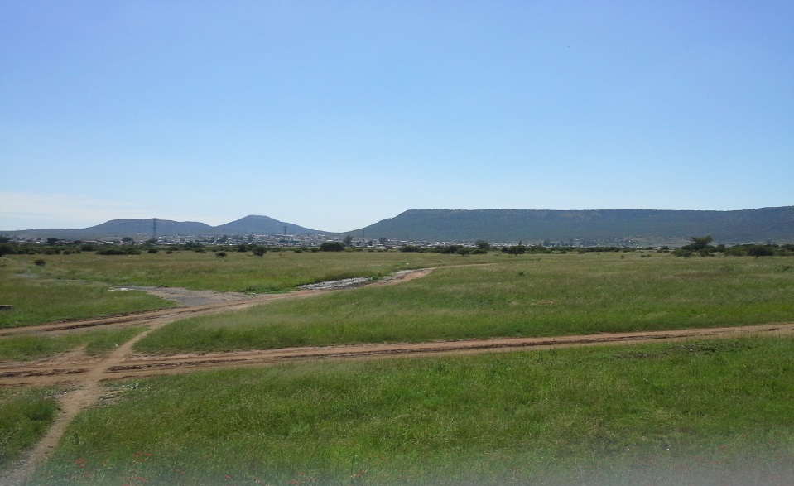
Prepared by: Patrick Addo
Prepared for:

Nature and Development Group of Africa

All correspondence to be directed to: Patrick Addo Tel: 033 3431468, Fax email 082 7219597
Email: ndgafrica@telkomsa.net P O Box 1978, Pietermaritzburg, 3200

DETAILS OF ENVIROMENTAL ASSESSMENT PRACTITIONER

Nature and Development Group of Africa was appointed by the Alfred Duma Municipality to conduct an EIA and obtain the necessary environmental authorization for the proposed the Alfred Duma Municipality Housing Project. The Environmental Assessment Practitioner (EAP) responsible for overseeing the conduct of this scoping study and the compilation of the scoping report is Mr. Patrick Addo. He holds a Master of Science (MSc.) Degree in the field of Environment and Development. Mr. Addo is assisted by Mr. Kofi Quartey - a Master’s Degree in Environmental Politics and undergraduate Degree in Geography and Environmental Sciences. GIS support is provided by Mr. Dornee Addo also a graduate in the field of GIS and simulation modeling.

Mr. Addo has 18 years practical experience in Environmental Consulting, mostly in conducting Environmental Impact Assessment, Environmental Auditing and Monitoring (Environmental Control Officer), and the preparation of Strategic Environmental Assessment and Environmental Management Framework Plans. He also has an additional 4 years previous experience of activities related to environmental management in various other institutions. Mr. Patrick Addo is knowledgeable of the EIA process and the regulations governing its implementation.

This scoping report provides information based on the professional expertise of the team and the vast experience and knowledge of the EIA processes. The team has no vested interest whatsoever in the proposed development or the outcome of the decision regarding the development.

Signed……………………………
EAP (Patrick Addo)

Table of Contents
List of Figures iv
SECTION 1 INTRODUCTION AND BACKGROUND 5
1.1 Project Development 5
1.2 Location of the Project area 5
1.3 Goal and objectives 6
1.4 Objectives of this Scoping Phase of the EIA Process Error! Bookmark not defined.
1.5 Brief description of the housing development process 8
1.6 Working Principles Adopted for this Environmental Assessment Process 9
SECTION 2: LEGAL AND REGULATORY REQUIREMENTS 12
2.1 National Environmental Management Act 107 of 1998 12
2.2 Occupational Health and Safety Act 85 of 1993 15
2.3 Conservation of Agricultural Resources Act 43 of 1983 15
2.4 Subdivision of Agricultural Land Act, Act 70 of 1970 15
2.5 National Water Act 36 of 1998 17
2.6 National Forests Act 84 of 1998 17
2.7 Kwazulu-Natal Heritage Act 10 of 1997 17
SECTION 3 APPROACH FOLLOWED IN THE EIA PROCESS 19
3.1 Public Participation Process 19
3.1.1 Project discloser and announcing the opportunity to contribute 19
3.2 Approach 20
3.2.1 Method of Assessing Significance Alternatives 21
3.3 Housing typology Error! Bookmark not defined.
3.4 Sanitation Error! Bookmark not defined.
3.5 Field Visits and Investigations Error! Bookmark not defined.
3.6 The Scoping Process Error! Bookmark not defined.
SECTION 4 CONSIDERATION OF ALTERNATIVES 24
4.1 Site Alternative 24
4.1.1 On-site (In-situ) development Error! Bookmark not defined.
4.1.2 Off-site (green field) development Error! Bookmark not defined.
4.2 Alternative Designs and Layout 25
4.3 Alternative Technologies 25
4.3.1 VIP toilets 25
4.3.2 Waterborne sanitation 26
4.3.3 Alternative Landuses 26
4.4 Assessment of Landuse Alternative 30
4.4.1 Significance of negative landuse impacts 30
4.4.1 Significance of positive landuse impacts 33
4.5 No-Go Alternative 35
SECTION 5 DESCRIPTION OF THE ENVIRONMENT THAT MAY BE AFFECTED BY THE PROPOSED DEVELOPMENT 36
5.1 Physical and Landscape Characteristics 36
5.1.1 Soils 36
5.1.2 Topography and Major Land Features 36
5.1.3 Climate Error! Bookmark not defined.
5.2 Ecological Characteristics 37
5.3 Hydrology and Drainage 39
5.5 Wetlands 39
5.6 Current and Competing Landuses 40
5.7 Current Zoning 41
5.8 Existing Infrastructure and Services 41
5.8.4 Hazardous Installations 42
Figure 15 Infrastructure and servitudes on site Error! Bookmark not defined.
5.9 The Socio-Economic Environment 42
5.10 Heritage (Archaeological and Cultural) Characteristics 43
SECTION 6 DESCRIPTION OF ENVIRONMENTAL ISSUES AND POTENTIAL IMPACTS 45
6.1 POTENTIAL ENVIRONMENTAL ISSUES RELATING TO THE BIOPHYSICAL ENVIRONMENT 45
6.1.1 Landscape issues 45
6.1.2 Issues Relating to Alternative Land use 46
6.1.3 Issues Associated with Ecological Characteristics 49
6.1.5 Issues Relating to Hydrological 50
6.1.6 Evaluation of Sanitation and Waste Management Issues 51
6.1.7 Water supply issues 52
6.1.8 Stormwater issues 53
6.1.9 Litter and Solid Waste Management Issues 54
6.1.10 Access roads and traffic issues 54
6.2 POTENTIAL ENVIRONMENTAL ISSUES RELATING TO THE SOCIO-ECONOMIC ENVIRONMENT 56
6.2.1 Education and health issues 56
6.2.2 Heritage Issues 57
SECTION 7 CONCLUSIONS AND RECOMMENDATIONS 59
7.1 CONCLUSIONS 59
7.1.1 Conclusions relating biophysical issues 59
7.1.2 Conclusions relating to the provision of services and facilities 59
7.1.3 Conclusions relating socio-cultural issues 60
7.1.4 Concluding Remarks 60
7.2 RECOMMENDATIONS 60
SECTION 8 PLAN OF STUDY FOR ENVIRONMENTAL IMPACT ASSESSMENT 62

List of Tables
List of Figures
List of Appendices

SECTION 1 INTRODUCTION AND BACKGROUND

1.1 Project Development

Alfred Duma Municipality intends to undertake a middle income housing project on currently vacant land located at the south eastern outskirts of Ladysmith. Nature and Development Group of Africa is conducting an Environmental Impact Assessment as part of the overall planning process for the development. This development is in response to the need for the Alfred Duma Municipality to address its housing delivery responsibilities as part of its social responsibility and commitment to facilitating social development in the municipality. This report is part of the overall feasibility and planning processes that have been instituted to ensure project sustainability and compliance with relevant statutory requirements.

1.2 Location of the Project area

This project is located in the Alfred Duma Municipality on a eastern outskirts of Ladysmith.
Figure 1: Location of Khetshe Mixed Use Proje3ct Area
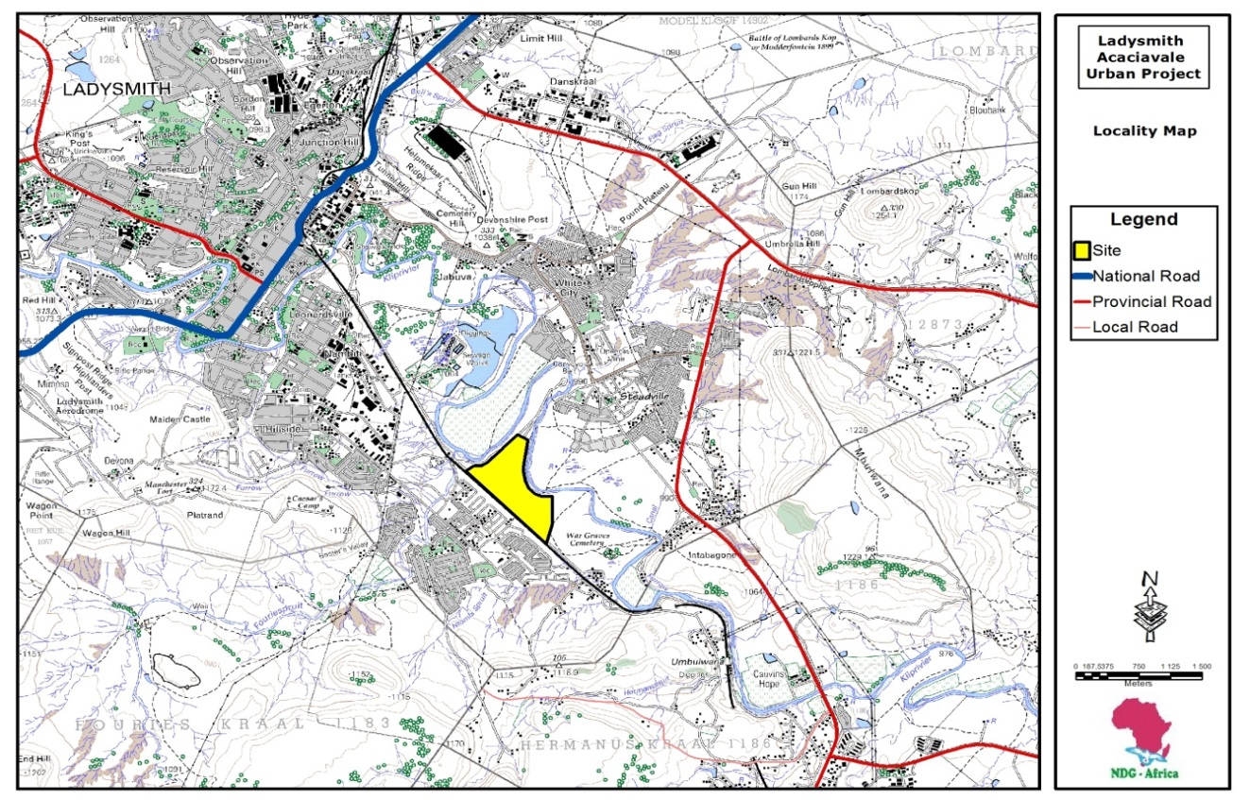
Figure 1: Location of the project area

The development area is approximately XXXXXX hectares on the Portion of the Remainder of Ladysmith. The project site is located within the yellow paintings and enclosed byb the black boundary lines. The western sections of the project site, from the southern to the norther ends of the site is enclosed by railway tracks and northern borders is made up of Alluvial wetlands and also the Klip River. The same Klip river meanders some meters away from the estern boundaries of the project site.
Key neighbouring characteristics of the project area that are important for the environmental investigation are:
- Ladysmith and its infrastructure
- Proposed and ongoing developments within the project area
- Neighbouring open spaces
- Natural characteristics on the site and its surroundings

These environmental characteristics are likely to influence the planning processes and the direction of the EIA process.
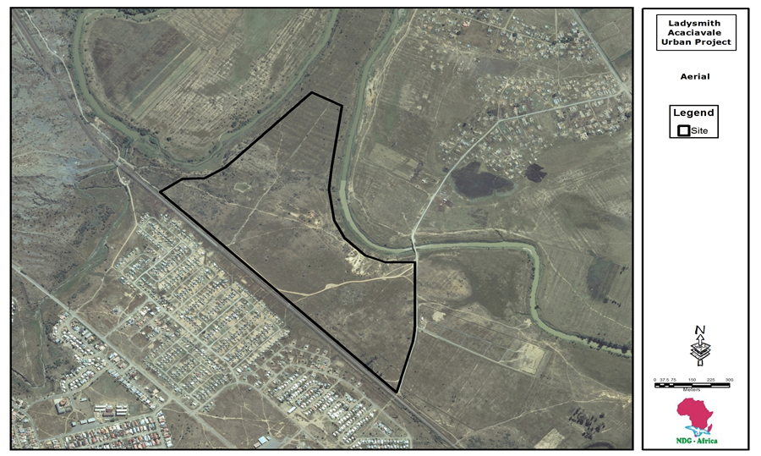
Figure 2: Google image of the project area.

1.3 Goal and objectives of Environmental Scoping

The assessment is currently at the scoping phase of the environmental assessment process. Environmental scoping can be defined as an exercise involving the preliminary identification of environmental issues related to a project or programme. Environmenral scoping is expected to identify, evaluate, categorise, and prioritise issues that are of concern or complementary of the project or programme. Often, the scoping stage will also identify suitable mitigation and recommend only those issues for which knowledge gap is wide and therefore require detailed studies or those issues for which futher mitigation assessment is required. Public participation is an integral component of the scoping phase because it assists the Environmental Assessment Practitioner (EAP) to identify, categorize, and recommend issues that are significant for further consideration at the EIA phase.

The goal of this scoping study is therefore to investigate, evaluate, and make recommendations to the Department of Economic Development Tourism and Environmental Affairs regarding the environmental implications of the proposed development and the scope of further studies that may be required. This assessment is based on the principles of integrated environmental management, sustainable development, and duty of care.

The specific objectives for the study are the following:
- Identify the biophysical, agricultural, socio-economic, cultural, institutional, infrastructural, and archaeological characteristics of the environment within which the proposed activities is located;
- Identifiy the issues and concerns relating to the proposed development and the receiving environment;
- Identify any alternative development processes, if any, that would meet the objectives of the proposed development without compromising the needs of the project or the integrity of the environment;
- Evaluate the significance of the identified issues of the proposed development and alternatives on these environmental characteristics and vice versa;
- Undertake a public participation process in the identified study area as part of the issue identification and evaluation process;
- Synthesize findings from the environmental investigations and compile an Environmental Scoping Report and a Plan of Study for EIA; and
- To submit an Environmental Scoping Report together with Plan of Study for EIA to EDTEA for review decision making.

1.4 Brief Description of the Proposed Development

1.4.1 Planning and Preliminary Infrastructure Designs
Figure : preliminary layout plan
AT THE MOMENT THE PLAN IS STILL BEING DESIGNED

From the layout plan, the following have been identified to be included in the development;
- Xxxx
- Xxxx
- Xxxx
- Xxxx

1.4.2 Implementation Process

The proposed development may be implemented in two phases, which may occur one after the other or may overlap. The initial phase of the process would involve the establishment of bulk infrastructure namely: the provision water stormwater management systems; provision of electricity and the construction of internal roads; establishment of water reticulation; and development of sewer mains. This phase would end with the establishment for site platforms where houses would be built. The second phase, which may begin at a suitable period within the bulk infrastructure development phase, would involve the establishment of top structure, rehabilitation of the construction area, and landscaping.

1.5 Working Principles Adopted for this Environmental Assessment Process

The principles of Integrated Environmental Management (IEM) and the general IEM procedure for an environmental impact assessment were followed during this initial environmental impact assessment process. The working principles upon which the study was based are detailed below:
- A broad meaning given to the term environment (i.e. one that includes social, economic, cultural, historical, and biological components);
- Informed decision making;
- Open and participatory approach to the study;
- Consultation with interested and affected parties;
- Due consideration to alternative options;
- Suggestion of measures to mitigate negative impacts and to enhance positive aspects of the development;
- Suggestions of measures to ensure that the ‘social costs’ of this development does not outweigh the benefits;
- Democratic regard for individual rights and obligations.

1.6 Need and Desirability of the Project

1.6.1 Strategic Location of Ladysmith and its Administrative Growth

Ladysmith is one of the growing economic hubs that is servicing the surrounding towns as a key economic development strategic route in KZN. Ongoing and anticipated stimulation of future economic growth in Ladysmith and surrounding has resulted in a steady increase in population and a consequent demand for housing in the area. This growth has certainly outrun the rate of provision of middle income housing in particular to the working class.

The need for the proposed middle class housing development is premised on the following social imperatives:
- Increase investment in Public Space and Infrastructure that will support individual and community activities, support and encourage higher levels of private investment.
- Reduce unemployment and increase income for families through greater connectivity to opportunities in the wider municipal area and through the provision of space and infrastructure that promotes local economic development.
- Improve quality of life through improved delivery of and operation of services and facilities and through restructuring of the rural environment.
- Reduction in crime and an improvement in safety and security through improved design of infrastructure, housing, facilities and the public environment.
- Protect biodiversity as the key generator of ecosystem goods and services for local and regional users. A long term view should be adopted in protecting biodiversity and ecosystem, goods and services supply in the face of increasing challenges and risks posed by climate change.

1.6.2 A Means of Bridging the Housing Disparity Between Local Socio-economic Classes

Current government policy regarding the provision of subsidisd housing favours largely the poor unemployed, and low income earners who are citizens of South Africa. However, a large proportion of the purportedly employed persons are only marginally above the threshold income bracket and as a result are equally poor low income earners. These income group are unfortunately left out of any means of securing housing since they fall just outside of the criteria for qualification for government housing subsidies.

Local Councilors and municipalities have been overwhelmed with demands and request for housing they cannot meet because current housing policy directives do not provide for assistance of this category of the working class. There is an apparent feeling of disappointment, denial, and depravation of what is perceived a constitutional right by those who cannot afford any form of housing and yet do not qualify for government subsidized housing.

1.6.3 Conformity to Municipal Development Programmes

The proposed development is in conformity to the S.D.F. and H.S.P of the Umvoti Municipality. Generally the provision of housing opportunities is seen as a priority in IDP municipal documentation. The Alfred Duma Municipality IDP ranks the provision of housing highly. However, drawn-out housing delivery is compounded by the fact that there are generally backlogs in municipal areas in the provision of:
- Bulk services to include water, electricity, roads and sanitation.
- Social facilities.
  - Provision of educational facilities.
  - The lack of employment opportunities.
  - Other infrastructure development.
Taking the above into consideration, it is recommended that alternative best practices are considered in some instances. For example, alternative technologies, appropriate sanitation practices, etc.

SECTION 2: LEGAL AND REGULATORY REQUIREMENTS

Developments of all kinds are governed by guidelines regulations and laws. These regulatory instruments are particularly important where it involves entire communities and vulnerable groups such children and women. For the proposed Acaciaville Housing Project where the project is located within a high density settlement area and within a greenfield environment, appropriate guidelines and regulation governing the planning, safety, and sustainability of the community need to be integrated accordingly in the development process. The following Acts are therefore pertinent to this development:

2.1 National Environmental Management Act 107 of 1998

The National Environmental Management Act 107 of 1998 has in terms of section 24 and 24D of the Act established regulations regarding the conduct of EIA processes made under section 24 (5) of the Act and published in Government Notice 38282 of December 2014. These regulations published lists of activities (Listing Notice 1, 2 and 3 of GNR 38282 of December 2014) that require various levels of applications of EIA process.

This project is governed by Listing Notice 2 which requires that scoping and EIA be the regulatory guidelines followed in seeking authorisation for the project. According to the regulations the content of a scoping report should have the following:

Box (1)
A scoping report must contain all the information that is necessary for a proper understanding of the nature of issues identified during scoping, and must include-
(a) details of-
(i) the EAP who prepared the report; and
(ii) the expertise of the EAP to carry out scoping procedures;
(b) a description of the proposed activity;
(c) a description of any foreseeable and reasonable alternatives that have been identified;
(d) a description of the property on which the activity is to be undertaken and the location of the activity on the property,
(e) a description of the environment that may be affected by the activity and manner in which the activity may be affected by the environment;
(f) an identification of all legislation and guidelines that have been considered in the preparation of the scoping report;
(g) a description of environmental issues and potential impacts, including cumulative impacts, that have been identified;
(h) details of public participation process conducted in terms of regulation 41(a), including-
(i) the steps that were taken to notify potentially interested and affected parties of the application;
(ii) poof that notice boards, advertisements and notices notifying potentially interested and affected parties of the application have been displayed, placed or given;
(iii) a list of all persons or organisations that were identified and registered in terms of regulation 42 and 43 as interested and affected parties in relation to the application; and
(iv) a summary of the issues raised by interested and affected parties, the date of receipt of and the response of the EAP to those issues;
(i) a description of the need and desirability of the proposed activity;
(j) a description of identified potential alternatives to the proposed activity, including advantages and disadvantages that the proposed activity, or alternatives may have on the environment and the community that may be affected by the activity;
(k) copies of any representations, and comments received in connection with the application or the scoping report from the interested and affected parties;
(l) Copies of minutes of any meetings held by the EAP with interested and affected parties and other role players which record the views of the participants; and
(m) any responses by the EAP to those representations and comments and views;
(n) any plan of study for environmental impact assessment which sets out the proposed approach to the environmental impact assessment of the application, which must include-
(i) a description of the tasks that will be undertaken as part of the environmental assessment process, including any specialist reports, or specialised processes, and the manner in which such processes will be undertaken;
(ii) an indication of the stages at which the competent authority will be consulted;
(iii) a description of the proposed method of assessing the environmental issues and alternatives, including the portion of not proceeding with the activity; and
(iv) particulars of the public participation process that will be conducted during the environmental impact assessment process;
(o) any specific information required by the competent authority; and
In addition, a scoping report must take into account any guidelines applicable to the kind of activity which is the subject of the application.
2 The EAP managing the application must provide the competent authority with detailed, written proof of an investigation and motivation if no reasonable or feasible alternatives, as contemplated in sub-regulation (1)(c), exist.

The potential triggers and list of activities under this development in terms of the GRN 38282 under the National Environmental Management Act (Act 107 of 1998) are listed in Table 2:

Table 2: List of activities applied for under the proposed development
Relevant Notice | Activity No. | Activity Description and Relevance to Project
GNR 983 Listing Notice 1  December 2014 | 9 | The development of infrastructure exceeding 1000 meters in length for the bulk transportation of water or stormwater-  - With an internal diameter of 0.36m or more  - With a peak throughput of 120 litres per second  - This development proposes to install 1200 meters of stormwater pipes with internal diameter of between 0.45 meters to 0.65 meters. The peak throughput flow is expected to 180 litres per second
GNR 983 Listing Notice 1  December 2014 | 10 | The development of infrastructure exceeding 1000 meters in length for the bulk transportation of sewage or stormwater-  - With an internal diameter of 0.36m or more  - With a peak throughput of 120 litres per second  - This development proposes to install 1200 meters of sewer pipes with internal diameter of between 0.4 meters and 0.45 meters. The peak throughput flow is expected to 126 litres per second
GNR 983 Listing Notice 1  December 2014 | 12 | The construction of:  - (vi) bulk stormwater outlet structures  - (x) buildings exceeding 100m² in size  - (xi) construction of infrastructure or structures covering 100m² or more  Within 32m of a water course  - This development involve the construction of stormwater outlets and sewage pipes in close proximity to a wetland in the area. The total coverage of this infrastructure is approximately 450 m²
GNR 983 Listing Notice 1 December 2014 | 19 | The infilling, or deposition
GNR984 Listing Notice 2 December 2014 | 15 | The clearance of an area of 20 hectares or more of indigenous vegetation.  - The development will clear a mixture of alien plants and indigenous vegetation covering an area of 1300 ha.
GNR985 Listing Notice 3 December 2014 | 12 | The clearance of an area of 300 m² or more of indigenous vegetation except where such clearance of indigenous vegetation is required for maintenance purposes undertaken in accordance with a maintenance plan.  - This development involve the clearance of indigenous vegetation of approximately 100 ha

It should be noted that, the entire lists of activities triggered by this development can only be fully registered at detailed planning stage of the project planning process. Thus this list may be revised as detail designs are made.

2.2 Occupational Health and Safety Act 85 of 1993

The specific requirements under this Act that are relevant to the proposed project are the regulations on Major Hazardous Installations (MHI) and their potential health and safety impacts. Section 9 of the MHI regulation, which came into force in 1999, requires that where practicable the developer shall prevent the establishment of a MHI adjacent to sites or areas that the MHI would potentially pose a hazard.

This Act also bears relevance to the National Environmental Management Act, which requires proponents of development to ensure a ‘risk averse’ approach where there is adequate information that a given development is associated with potential for health and safety risks to beneficiary and neighbouring communities. Where a given development affects settlements, the requirement of this Act needs to be carefully and adequately integrated in the planning process. In the case of the Ladysmith Housing Project, the proximity of the proposed settlement area should be considered in relation to the Spatial Development Plan of the uPhongola Municipality to ensure that planned industrial development activities classified as hazardous are considered and appropriately mitigated if possible.

2.3 Conservation of Agricultural Resources Act 43 of 1983

The objective of this Act is to provide for the conservation of natural resources by maintaining the production potential of land, combating and preventing erosion, preventing the weakening or destruction of water resources, protecting natural vegetation, and preventing and/or combating invader plants and weeds. The planning and implementation processes of the proposed project therefore will take cognizance of relevant provisions of this Act.

2.4 Subdivision of Agricultural Land Act, Act 70 of 1970

In the past 15 years, land transformation for property development as an alternative landuse to agriculture has dominated the economic scene of the country. There was an unprecedented growth of property development activities and an equally rapid transformation of virgin and particularly active and productive agricultural land to the detriment of agriculture as a whole and food security in particular. The future of agriculture in the country was on a declining trajectory as productive agricultural land was irreversibly lost to the so called ‘Property Boom’. This phenomenon aroused authorities to evoke the hitherto not stickly enforced Act relating to the fragmentation and decimation of agricultural land, in a bid to save future agricultural needs and assure national food security.
The aim of this Act was to prevent the subdivision of agricultural land to extent where the new portions created are so small that farming will no longer be economically viable. Subsequent legislation has made this complex matter, as explained below (includes extracts in italics from GhostDigest© on the internet).

In the Act, exceptions included subdivisions for servitudes, e.g. for electricity and water, and “… land situated in the area of jurisdiction of a municipal council, city council, town council, village council, village management board, village management council, local board, health board or health committee…”.

However, the situation changed significantly because of the Local Government Transition Act 209 of 1993, in which the area of jurisdiction of local authorities was extended. This resulted in agricultural land, which prior to commencement of 1993 Act fell outside the jurisdiction of a local authority, as referred to in this section 1 of the Act, now falling within the area of jurisdiction of the “extended” local authorities.

The following commentary provides details of changes and processes leading to the implementation of the Act:

The 1993 Act made the identification of agricultural land almost impossible for purposes of determining when the consent of the Minister will be necessary for the registration of certain transactions of agricultural land.

Proclamation No R100 of 1995 promulgated in the Government Gazette No 16785 of 31 October 1985 also amended the definition of agricultural land in section 1 of the Act by the addition of a provision to the definition of “agricultural land” to declare land situated in the extended area of jurisdiction, as provided for in 1993 Act, or the said local authorities as agricultural land. The said proclamation still did not shed much light on the question as to which land must be regarded as “agricultural land” for the purposes of applying the provisions of section 3 (no subdivision and no housing developments permitted on Agricultural Land) and 6A (permission for servitudes)

This resulted in certain transactions being registered in the deeds registries as without the necessary consent or on the basis of consent granted by local authorities, who did not have the authority to provide the necessary consent. The Department of Agriculture also raised its concerns that the transaction registered without consents or with consent by local authorities have serious economic implications, especially when prime agricultural land is involved.

In respect of farm land, (i.e. land in which the property description refers to a farm) being subdivided, transferred in undivided shares, or certain real rights being registered over such land (with the exception of those referred to in section 6A of the Act, (the registration of servitudes), the following must be lodged with the registrar of deeds concerned:

- A consent by the Minister of Agriculture; or
- A letter from the Department of Agriculture to the effect that farm land in question is not agricultural land as defined in section 1 of the Act (CRC 6 of 2002)
Where land is being subdivided as in this case of the proposed Ladysmith Housing Project the National Department of Agriculture may have to consent to the such subdivisions prior to implementation of the project.

2.5 National Water Act 36 of 1998

Current regulations regarding discharge of surface water requires that surface water is handled with care both in terms of quality and quantity before being discharged into any natural water course, so that the quality and flow rate of natural systems are not significantly disrupted.

Although the Klip River does not occur within 100 m of the proposed development area, there apparent wetlands within the project t is noted that in terms of sections 21 (c) of the National Water Act, a water use license need to be obtained from the National Department of Water and Sanitation in cases where a given activity or development has the potential to affect water courses and or occurs within 500 m of a given wetland. The proposed development is not likely to impact directly on a stream or river but is likely to impact on wetlands located within 500 m of the site. The location of a wetland on the site most probably triggers the requirement of Water Use license prior to implementation of the project.

Furthermore, the development under investigation is expected to generate large quantities of stormwater especially at the substation and consequently an accelerated run off at the discharge points. This Act requires that stormwater control measures are satisfactorily addressed, and a maintenance programme developed to ensure that stormwater discharge points and downstream impacts are effectively mitigated.

2.6 National Forests Act 84 of 1998

The National Forest Act dictates the procedures and processes required for the protection of natural forests and forest trees. The relevance of this Act to the development under investigation is that the impact of the development on trees in the riparian vegetation on the site should be minimized as much as possible. Any removal of indigenous trees has to be authorized by the Department of Forestry and Fisheries.

2.7 Kwazulu-Natal Heritage Act 10 of 1997

The objective of the KwaZulu-Natal Heritage Act in summary is to introduce an integrated and interactive system for the management of the provincial heritage resources to promote good government at all levels, and empower civil society to nurture and conserve their heritage resources so that they may be bequeathed to future generations. Since the proposed development cuts across various land uses and socio-cultural environments it would be important to take into consideration the provisions of the KwaZulu-Natal Heritage Act.

SECTION 3 APPROACH FOLLOWED IN SCOPING PROCESS

The project is currently at the scoping phase of the environmental assessment process. Scoping can be defined as an exercise involving the identification of environmental issues surrounding a project that require assessment. It identifies the potential impacts that are to be addressed at the EIA stage. Public participation is essential at the scoping phase because it assists the Environmental Assessment Practitioner (EAP) to identify, categorize, and recommend issues that are significant for further consideration at the EIA phase.

Procedure for this scoping process involves undertaking activities in accordance with the guidelines for scoping and EIA contained in Regulation 38282 of December 2014 under the National Environmental Management Act 107 of 1998. The scoping process involved consultations, meetings, and field investigations. These processes are described below:

3.1 Public Participation Process

Objectives for the public participation process is designed to provide sufficient and accessible information to interested and affected parties (I&APs) in an objective manner to assist them to:
- During the scoping phase:
  - raise issues of concern and suggestions for enhanced benefits
  - verify that their issues have been captured
- During the impact assessment phase:
  - verify that their issues have been considered by the technical investigations
  - comment on the findings of the EIA

Details of the public participation activities conducted thus far is contained in Appendix 2.

3.1.1 Project discloser and announcing the opportunity to contribute

The opportunity for the stakeholders to participate in the EIA was announced as follows:

- Copies of Background Information Document (BID) were provided to the municipality for comments ad also distributed to interested and affected parties (I&APs) and stakeholders in the area
- Site notices will be put up on all the proposed sites on A2 size posters.
- The public will be informed about this project through a local newspaper advertisement.
- The Ward Councilor was briefed about the project
- A public meeting will be held to inform and discuss the project with interested and affected parties

3.1.2 Stakeholders consultation

Stakeholders who have decision making authority in specific disciplines that affect this project will be consulted through the BID. The stakeholders to whom the BID will be sent are: Alfred Duma Municipality, XXXXX District, Department of Water and Sanitation, Ezemvelo KZN Wildlife, Amafa aKwaZulu Natali, and Wildlife and Environment Society of South Africa (WESSA).

3.2 Approach

The general approach and specific activities undertaken at the scoping phase and those to be undertaken during the EIA Phase are tabulated in Table 3.

Table 3: Phases of the EIA Process and General Activities

Phase | Main Activities | Activity Description
Scoping | Project Assessment | Establish objectives
 |  | Establish legal requirement/procedure
 |  | Consider alternatives
 | Pre-scoping consultations | Consult authorities
 |  | Prepare and submit application documents
 | Environmental Scoping | Identify alternatives sites, processes, technologies
 |  | Identify and contact key stakeholders
 |  | Undertake sites analysis and scoping of the environment/collect background information
 |  | Evaluate alternatives
 |  | Conduct public participation process
 |  | Identify gabs and problem areas with technical team and Interested & affected party involvement
 | Reporting | Prepare draft Environmental scoping report (ESR)
 | Plan of study for EIA | Prepare plan of study for EIA
 | I&AP Review | Place draft ESR and plan of study for EIA in library for review
 | Final ESR | Evaluate comments and prepare final scoping report
 | Authority Review | Submit Final scoping report and plan of study to edtea
EIA | Specialist studies and assessment | Conduct specialist studies recommended at scoping
 |  | Evaluate alternatives if any
 |  | Evaluate impacts including cumulative impacts
 |  | Identify and evaluate mitigation
 | Draft EIR | Collate information and prepare draft EIR
 | Environmental Management Programme (EMPr) | Prepare EMPr
 | Review | Place draft EIR and EMP in library for review
 | Decision | Submit final EIR to EDTEA for decision making

3.2.1 Method of Evaluating Issues and Alternatives

The method of evaluating the environmental issues raised and alternatives considered were based on both professional reasoning and objective analysis from both imperical data and verifiable secondary information. The approach to this methodology include rationales such as:
- Policy directive relating to aspects of the alternative(s)
- Site specific conditions of the affected alternative(s)
- Condideration of the issues raised by interested and affected parties

The methodology and criteria used in evaluating the environmental issues and priotising the environmental attributes of alternatives involve the following:

Extent of the impact:

The extent of the impact was assessed accordingly:
- Limited to the site and its immediate surroundings.
- Local/Municipal extending only as far as the local community or urban area.
- Provincial/Regional.
- National i.e. South Africa.
- Across International borders.

Duration of the impact:
The lifespan of the impact was assessed to be:
- Immediate (less than 1 year).
- Short term (1-5 years).
- Medium term (6-15 years).
- Long term (the impact will cease after the operational life span of the project).
- Permanent (no mitigation measures or natural process will reduce impact after construction)

Magnitude of the impact:
The magnitude or severity of the impacts is indicated as either:
- None (where the aspect will have no impact on the environment)
- Minor (where the impact affects the environment in such a way that natural, cultural and social functions and processes are not affected).
- Low (where the impact affects the environment in such a way that natural, cultural and social functions and processes are slightly affected).
- Moderate (where the affected environment is altered but natural, cultural and social functions and processes continue albeit in a modified way).
- High (where natural, cultural or social functions or processes are altered to the extent that it will temporarily cease).
- Very high/don’t know (where natural, cultural or social functions or processes are altered to the extent that it will permanently cease).

Probability of occurrence:
The likelihood of the impact actually occurring was indicated as either:
(0) None (impact will not occur)
(1) Improbable (the possibility of the impact materializing is very low as a result of design, historic experience or implementation of adequate mitigation measures).
(2) Low probability (there is a possibility that the impact will occur).
(3) Medium probability (the impact may occur).
(4) High probability (it is most likely that the impact will occur).
(5) Definite/do not know (the impact will occur regardless of the implementation of any prevention or corrective actions or it the specialist does not know what the probability will be based on too little published information).
Status of the impact:
The impacts are assessed as either having a:
- Negative effect (i.e. at a cost to the environment).
- Positive effect (i.e. at a benefit to the environment).
- Neutral effect on the environment.

Reversibility of Impact
The degree to which the impact can be reversed

Irreplaceable loss of resources
The degree to which the impact may cause irreplaceable loss of resources

Cumulative impact:
The impact of the development is considered together with additional developments of the same or similar nature and magnitude. The combined impacts may be:
- Negative – i.e. the net effect is the same as the single development
- Marginal – i.e. the impact of two developments of a similar nature is less than twice the impact of a single development. This implies it is better to place two developments in the same environment rather than in separate environments.
- Compounding – i.e. the impact of two developments is more than twice the impact of two single – developments. This implies that it is better to split the two developments into separate developments.

Significance of the impact:
Based on the synthesis of the information contained in the points above, the potential impacts were assigned a significance weighting (S). The weighting is formulated by adding the sum of numbers assigned to extent (E), duration (D) and magnitude (M) and multiplying this sum by probability (P) of the impact hence S=(E+D+M)P.
- Negligible: 0
- Low: 1 – 9
- Low – Medium: 10 – 19
- Medium: 20 – 29
- Medium- High: 30– 39
- High: >40
Table 4 provides the definition of impact categories to be used.

Table 4: Impact categories scaling and scores
0 | Negligible | There is no impact
1 | Low | Impact is of a low order, mitigation measures are easy and simple or not required
2 | Low-Medium | Impact is higher but with limited effect, mitigation measures are feasible and easily achieved
3 | Medium | Impact is real but not sustainable and mitigation is both feasible and fairly possible
4 | Medium-high | Impact is substantial and mitigation measures are difficult, expensive and time consuming
5 | High | Impact is of the highest order and there are few, if any, mitigation measures to offset impact

SECTION 4 CONSIDERATION OF ALTERNATIVES

Consideration of viable alternatives is cardinal in the EIA process the aim of which is to ensure that options regarding development processes, development footprint, and development technologies have been adequately evaluated and the best options that are environmentally friendly, socially acceptable and economically feasible have been adopted for implementation.

4.1 Site Alternatives

Land for settlement is one of the greatest challenges facing the Umvoti Municipality in its slums clearance and middle income housing projects. In terms of the settlement policy of the Department of Human Settlement (refer to Box 2), communities must be resettled to site close to their sources of livelihood if in-situ upgrades cannot meet the service provision needs of the communities.

The proposed project is aimed primarily at providing suitable housing to the middle income earners within Umvoti and surrounding areas. It should be noted that the suitability of land for government subsidized housing (especially for township establishment) is influenced by several factors. These factors include among others:
- Environmental suitability
- Size of the land
- Proximity of the land to services, economic and commercial centers, and opportunities for employment.

Box 2: The policy of the Department of Housing in its integrated Housing Development Strategy is to settle communities where they are and to avoid unnecessary relocation of households or communities. Further it is the department’s policy to locate communities in areas where sufficient social services are readily available to them and close to centers of economic development or where they could readily access employment and other economic opportunities.

It is recorded that the Developer had pre-identified the land under investigation prior to commencement of the environmental investigations. As a result no other sites were presented to the EIA team as atlternatives to the proposed site.

In terms of the EIA regulations 38282 of December 2014 reasons must be given in cases where no alternatives exists for a proposed development. In the case of the Ladysmith Housing Project, the reasons provided by the developer for the lack of alternative sites is that there are no land parcels available that meet the land selection criteria for settlement purposes as indicated in section 4.1.1 and box 2 above. The only available land of sufficient size to meet the settlement needs of the municipality is the site under investigation.

The land identified for this development described as Portion of the Remainder of Townlands of Ladysmith No. 5695 and meets the requirements for the proposed development because it has the following advantages:

- It is a large enough land to accommodate the anticipated number of families,
Alien infested grassland
- There will be no excess land that would be burdensome to the municipality in terms of open space maintenance
- To a large extent the agricultural potential of the site is low and as such other alternative land uses such as agriculture is potentially low. Settlement is therefore a candidate land use for the area.
- Biodiversity conservation significance of portions of the site is low since several man-made and natural factors such as grazing, illegal dumping, have resulted in significant degradation of the site.

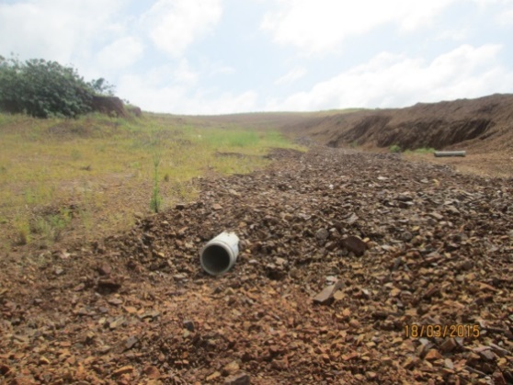
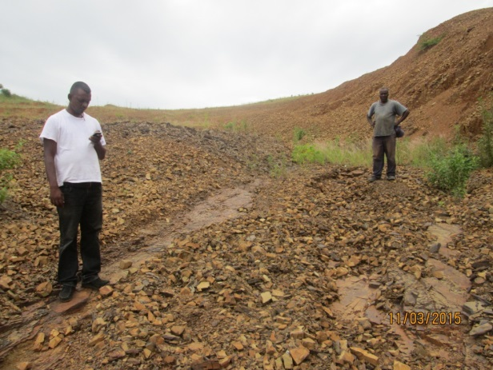
The disadvantage of the selected site is that the development will result in:
- A total and irreversible transformation of vegetation on the site land and
- Preclusion of the site from any other land use such as agriculture

4.2 Alternative Designs and Layout

The footprint of a government subsidy based house is predetermined as 40m². The footprint of these houses cannot be altered much as the available finance could only generate an optimized building plan which is the plan generally used in most middle income housing projects. On a developmental scale therefore, the housing typology does not have much lee-way in terms of designs alternative. However, options such as stand-alone houses as opposed to blocks of flats is an issue that is might be discussed with the relevant stakeholders including the beneficiary community

4.3 Alternative Technologies

Technologies such as electricity and water will be provided from the municipal supply systems. However, owing to the potential environmental impacts from sanitation systems, alternative sanitation technologies were considered. The options considered were:

4.3.1 VIP toilets

VIP is a cheap sanitation system. The provision of VIP will result in significant financial surpluses that could be used to develop a better top structure houses or other infrastructure such as roads. However, VIP sanitation for this project was rejected for the following disadvantages:
- The area has several wetlands and VIP could contaminate the wetlands and possibly underground water
- In dense settlements such as this project, VIP toilets are unsuitable as they cannot be relocated when they are full due to limited space. The photographs below (Figures 3a and 3b) show VIPs in some communities that have been identified as posing significant environmental and health problems.

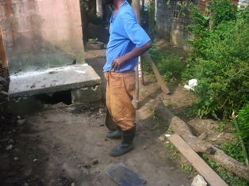
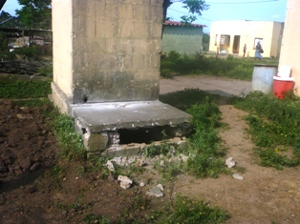

Figure 3a: The above photographs show broken bases of full VIP toilets in a community The bases were broken from behind in order to reach the waste
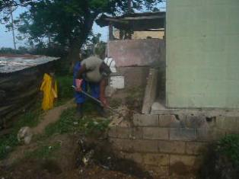
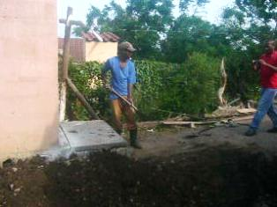

Figure 3b: Photograph showing waste from VIP toilets being manually emptied by scooping the waste from the pit by hand.

Given these social and environmental issues with VIP toilets, there is compelling reasons against VIP sanitation technologies especially in dense settlement as proposed for the Umvoti middle income Housing Project.

4.3.2 Waterborne sanitation

Water borne sanitation for the project was considered as an alternative to VIP toilets because it has the advantage of being environmentally less hazardous. However, this option may not be feasible in view of the absence of sanitation infrastructure close to the development site.

4.3.3 Alternative Landuses

The most contentious of the potential issues relating the site under consideration is the potential for other competing landuses. The competing landuses in the case of this site are:
- Settlement
- Agriculture
- Conservation

The rationale for assessing the significance of these alternatives are premised on the following considerations:

Settlement as an Alternative Landuse

The growing incidence of urbanization exerts tremendous pressure on the many urban municipalities and including Ladysmith. This is partly as a result of young people seeking jobs in urban centres and the desire of individuals and households to draw closer to areas of social services. These individuals and households aggregate often in informal settlements with limited settlement infrastructure. Owing to the current huge backlog of housing needs in the Alfred Duma Municipality, there is compelling reasons why settlement should be prioritized by the municipality.

The argument for settlement becomes even more compelling when considered in the context of the deplorable socio-economic and high risk environmental conditions that the informal communities are exposed to. Furthermore, the availability of suitable land for settlement purposes is one of Alfred Duma Municipality’s major challenges as indicated under section 4.1. Thus settlement as a landuse option is justifiable in terms of land suitability that meets the technical requirements and relevant policy directives of the Department of Human Settlement.

The advantages and disadvantages of the settlement on the site as a landuse alternative that are stipulated in sections 4.1 apply to settlement as a landuse option for the site.

Agriculture as an Alternative Landuse

Agriculture is the backbone of many rural households where land is available in abundance especially areas where land is under traditional authority ownership. In cases of peri-urban communities, as is in the case of Ladysmith however, land tends to be scarce and often under private ownership. It is estimated that in townships, plot sizes range from as little as 130m² to 420m² often housing a few structures of the family and for some livestock.
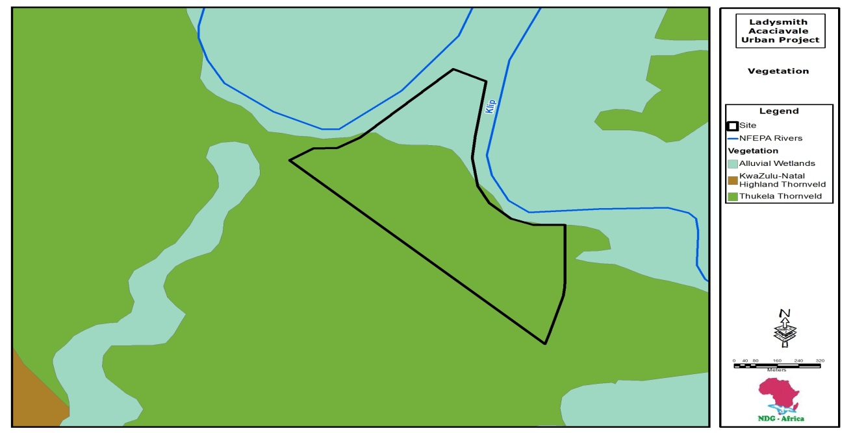
Agricultural practice on the land under investigation is limited and restricted to extensive grazing practices. Petty trade and informal jobs were of significant interest to households. Given the choice of suggested landuse options for the site, community members indicated that settlement would be a preferred alternative to agriculture.

However, it should be noted that, theoretically, the agricultural potential of the site is considered to be moderate at the northern half of te site and low on te southern half (Figure 4). The poor potential of the site may be due to limitations such as poor soils, low water retension capacity, and inadequate water supply. This implies that, the land could only be put under semi intensive agriculture on the northern half and extensive agricultural production on the southern half. It would appear therefore that agriculture suitability and desirability as an alternative landuse for the site are moderate on the northern side and relatively low at the southern half.

It should be noted however that at the time of this assessment, active grazing of livestock was being undertaken on the site. As indicated under section 6.1.2 the social attribute of the use of the land is significant since livestock in the African culture is a form of social security and status in society. Even if not for direct economic gain, the land is currently providing an indirect agricultural purposes in the form of grazing. The social cost of loss of grazing land and the consequent socio-cultural impacts may be significant.

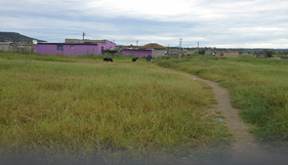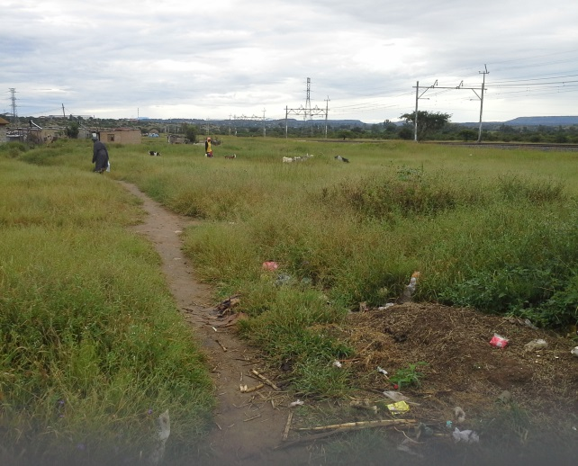

The above photographs show livestock grazing o the project site
Figure 5: Transformed areas on the project area
Conservation as an Alternative Landuse

The vegetation of the area is largely disturbed at the northern half of the site with only small patches of the south and north eastern boundaries not having undergone modification (Figure 5). It is noted that, the site borders properties where the current land use is mainly forestry and and provincial roads P6 on the wester section and P16 on the southern portios.

It is further noted that, the ecological status of the site is low in the sense that there are no critical biodiversity significance sites that have been identified by conservation agencies such as KZN Wildlife. It thus appears that conservation is a not a contending landuse for the proposed development. The google image illustrates a visual reality of the associated landuse map.

Figure 5: Modified areas of the site

4.4 Evaluation of Landuse Alternative

The negative and positive significance of the landuse alternatives for this site in the Tables 5a to 5e below are assessed on the basis of the methodology and rationale discussed in sections 3.2.1 and 4.3.3 above.

4.4.1 Significance of negative landuse impacts

Table 5a Significance of Landuse Alternatives: Settlement
Landuse | Nature of the Issue | Significance Levels |  |  |  |  | Cumulative | Significance Level
 |  | Extent of Issue | Duration of Issue | Magnitude of Issue | Probability of Occurrence | Reversibility of Issue
Settlement | Implementation of the project is likely to permanently transform the area and preclude it from any other landuses. This is likely to result in a permant loss of vegetation on the site | The loss of vegetation and opportunity cost to other forms of land use is limited to the site | The loss of vegetation and exclusion of other land uses will be long term | The ecological significance of permanent loss of vegetation on the site is low and exclusion of other land uses is moderate. The magnitude of the issue is thus low to medium | The total and irreversible loss of vegetation and exclusion to other land uses is certain | The issues are irreversible | Several other developments with similar conditions could result in a higher impact | Moderate
Significance Rating |  | Medium (3) | Medium (3) | Medium (3) | Medium (3) | Medium (3) | Medium (3) | Medium (18)
The overall significance of the settlement as opposed other land uses is considered to be high (if not implemented) for the following reasons:
  - High health and safety risks that the informal communities will persist
  - Several other households in similar situation are also likely to persist in similar high environmental and health and safety risk conditions.
  - Implementation of the project is likely to resolve both the environmental and social hazards to which the communities are exposed.

Landuse | Nature of Issue | Significance Levels |  |  |  |  | Cumulative | Significance Level
 |  | Extent of Issue | Duration of Issue | Magnitude of Issue | Probability of Occurrence | Reversibility of Issue
Agriculture | Suitable agricultural land is scarce in the area  Specific site characteristics are not likely to be supportive of intensive agriculture  The proposed development is likely to result in the total loss of the site to settlement and as a result preclude the site from other forms of agriculture as future land development option | Restricted to the local unproductive land | Long term | The agricultural potential of the land is low | Likely to occur | The issue is irreversible | Pressure on agricultural land is increasing.  Continuous loss of agricultural land is likely to impact negatively on food security and the agricultural economy. Howver, the agricultural potential of the lan is low. | Moderate
Significance Rating |  | Low (2) | Mdium (3) | Low (2) | Medium (3) | Medium (3) | Low (2) | Low to medium (15)
The overall significance of the impact on agriculture is considered to be moderate for the following reasons”
- Agricultural potential of the land is low due to
  - Poor soils
  - Low water retension capacity
  - Large scale land degradation as a result of settlement, crop cultivaand grazing
Table 5b Significance of Landuse Alternatives: Agriculture

Landuse | Status of Issue | Significance Levels |  |  |  |  | Cumulative | Significance Level
 |  | Extent of Issue | Duration of Issue | Magnitude of Issue | Probability of Occurrence | Reversibility of Issue
Conservation | There is significant vegetation trandformation in the area.  No rare animal or plant species was identified on the site  The conservation plan of KZN Wildlife denotes the site as low significance | Local | The loss of the site to settlement precludes it from being considered for future conservation planning | The site does not present characteristics suitable for conservation purposes | The exclusion of the site from conservation is very likely to occur | Irreversible | The site does not present characteristics suitable for conservation purposes | Moderate
Significance Rating |  | Low (2) | Medium (2) | Low (2) | Medium (3) | Medium to high (3) | Low (2) | Low to medium (14)
The overall significance of the issue on conservation as an alternative landuse is low for the following reasons”
- Biodiversity value of the vegetation is medium to high due to
  - Largely transformed and degraded portions of the land
  - No Critical Biodiversity area on the site
  - Conservation status is low
Table 5c Significance of Landuse Alternatives: Conservation

4.4.1 Significance of positive landuse Issue

Table 5d Significance of Landuse Alternatives: Settlement
Landuse | Status of Impact | Significance Levels |  |  |  |  | Cumulative | Significance Level
 |  | Extent of Impact | Duration of Impact | Magnitude of Impact | Probability of Occurrence | Reversibility of Impact
Settlement | Communities are settled under environmentally unsafe conditions with high health and safety risks  Continuous impact on sensitive environments is detrimental to both households and environmental sustainability | Majority of the site will be lost to the settlement and its infrastructure except for the ecological support areas | The loss of vegetation will be permanent | Severe as health and safety of individuals was at stake | Very likely | The impact is reversible | Several other individuals, households and communities are in similar conditions and if supported will result in better quality of life and general well-being of individuals | High
Significance Rating |  | High (5) | High (5) | High (5) | High (5) | High (5) | High (5) | Medium to High (30)
The overall significance of the impact on settlement is considered to be high (if not implemented) for the following reasons:
  - High health and safety risks that the informal communities will persist
  - Several other households in similar situation are also likely to persist in similar high environmental and health and safety risk conditions.
  - Implementation of the project is likely to resolve both the environmental and social hazards to which the communities are exposed.

Landuse | Status of Impact | Significance Levels |  |  |  |  | Cumulative | Significance Level
 |  | Extent of Impact | Duration of Impact | Magnitude of Impact | Probability of Occurrence | Reversibility of Impact
Agriculture | Specific site characteristics are not likely be supportive of intensive agriculture  Agriculture is not a major landuse of the community currently and is not likely to be a desired future land development option | Restricted to the local area | Long term loss of agricultural land | Low since land is relatively unproductive | Likely to occur | The impact is irreversible | Pressure on agricultural land is increasing.  Continuous loss of agricultural land is likely to impact negatively on food production and the agricultural economy other | Moderate
Significance Rating |  | Low (1) | Medium (3) | Low (1) | Medium (3) | Medium (3) | Low to Medium (3) | Low to Medium (14)
The overall significance of the impact on agriculture is considered to be moderate for the following reasons”
- Agricultural potential of the land is low due to
  - Unsuitable and steep slopes in some areas
  - Poor soils
  - Lack of water resources
Table 5e Significance of Landuse Alternatives: Agriculture

4.5 No-Go Alternative

The ‘no-go’ alternative is expected to shed light on what the potential issues are likely to be should the development be refused. The need and desirability statement presented in section 1.6 explains the needs and disireability of housing and infrastructure for the target community. Currently, a close by (Ladysmith Slums) community is potentially at high health and safety risk since the social infrastructure of the community is poor. These issues suggest that the negative social impacts of a no-go alternative are significant. Thus a no-go alternative is not recommended.

Furthermore, discussion relating to landuse alternatives suggest that there are no compelling ecological and agricultural reasons why these alternative landuse options should be considered as options to the proposed settlement.

It is noted however that the full significance of the cumulative impacts of the project will only be quantified at the EIA stage when all specialist studies and conclusions and recommendations including mitigation assessment have been undertaken.

SECTION 5 DESCRIPTION OF THE ENVIRONMENT THAT MAY BE AFFECTED BY THE PROPOSED DEVELOPMENT

5.1 Physical and Landscape Characteristics

5.1.1 Geology and Soils

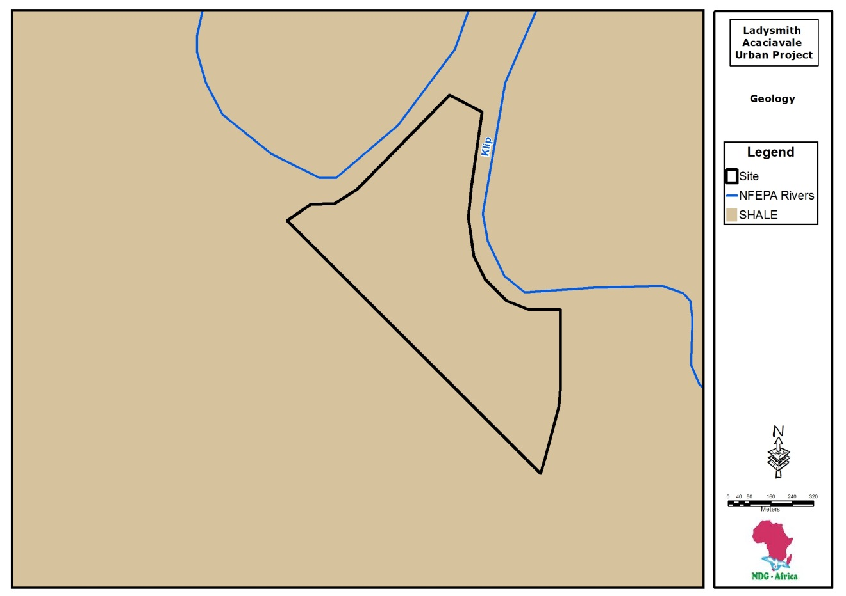 According to the geological map above, the general area within which the site is located is underlain predominantly by shale. A detailed geotechnical investigation is yet to be undertaken.
Figure 7: General Geology of the Site

5.1.2 Land Cover and Land Features

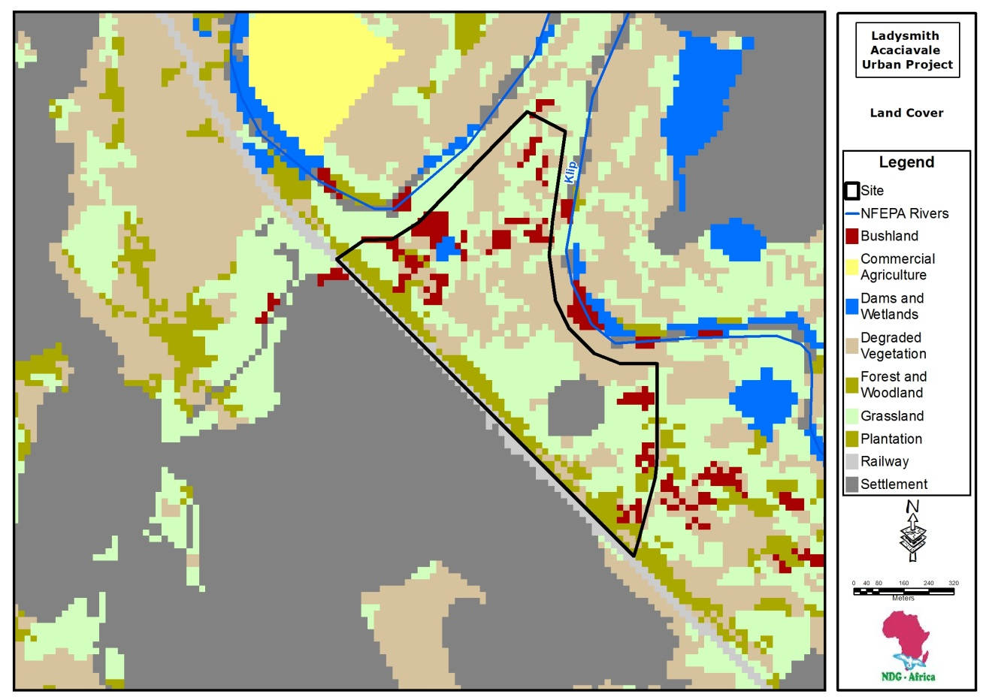
Figure 8: Land Cover the Site
As depicted in Figure 8, the land cover shows that predominantly, the land is a grassland that is sparingly interspaced with Bushland. It has some forest and woodland that stretches along the wester boundaries of the project site otherwise, most of the land on the site is degraded

5.2 Ecological Characteristics

5.2.1 Vegetation Characteristics

It should be noted that at this point of time, there has been no conduction vegetation assessement of the proposed project site. However, a preliminary study in yielded Figure 9 below. From figure 9, it can be reslised that general vegetation type of

Figure 9: Vegetation
Figure 9: Vegetation types of the site

The proposed site is largely transformed in this vegetation type indicated above. As seen in Figure 10 below, a substancial amount of vegetation on the site has been transformed of its original vegetation of the grassland. See transformed grey colour sections in figure 10

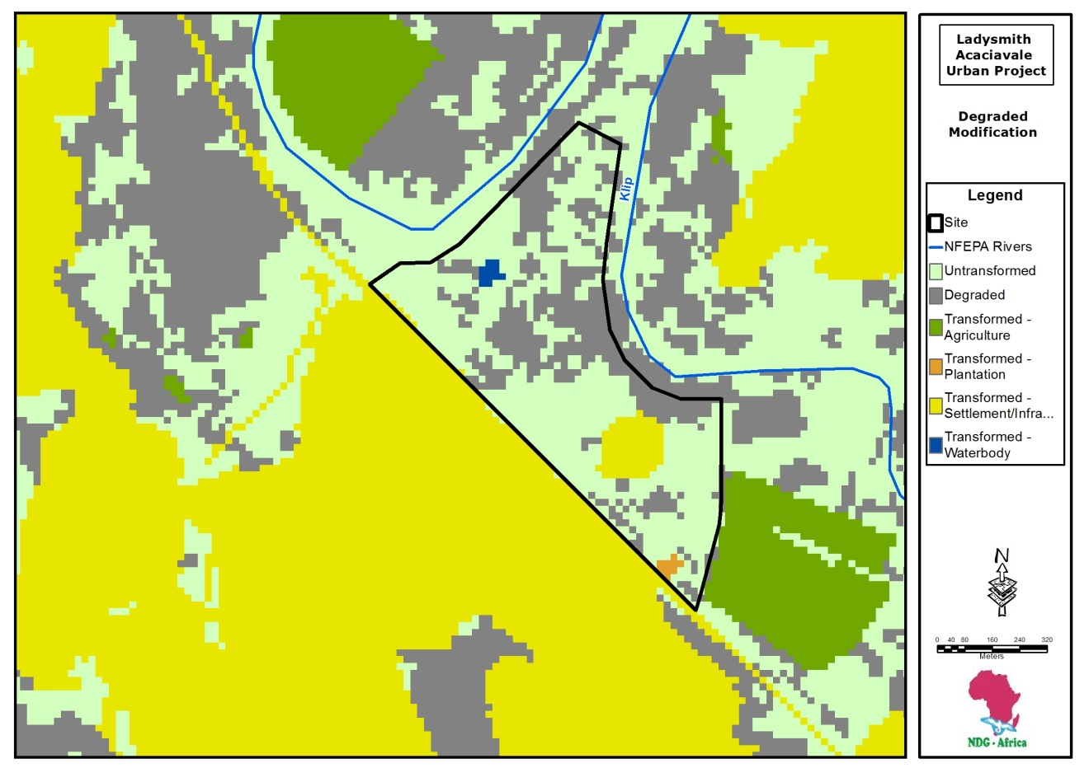
Figure 10: Transformation

5.2.2 Fauna

Wildlife was not observed on the site during site assessment although a few common birds of no ecological significance were identified. Attempts to verify the presence of wildlife through droppings and footmarks, and nests indicated that wildlife in the area is possibly nonexistent. Although attempts to identify animal species in the area and especially those recorded in the Red Data Book proved negative, the presence of biodiversity priority sites may well be habitats for fauna. This would be confirmed at the EIA stage when detailed ecological assessment is undertaken.
The entire site is void of Critical Biodiversity Areas(CBA) except the northeastern protrusion which also happens to be within the wetland
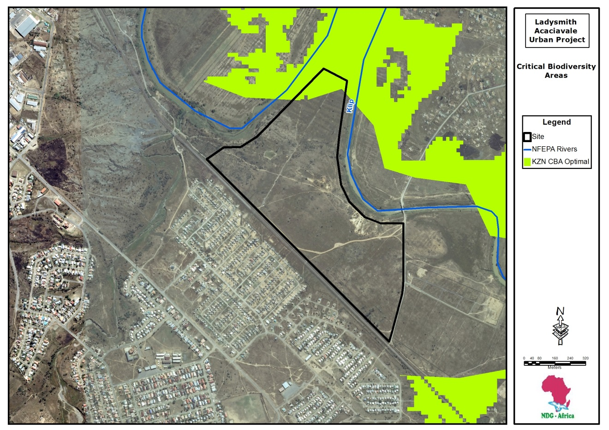

5.3 Hydrology and Drainage

5.3.1 Streams

There is virtually no stream on the site. The only concer there is with hydrology is that the north eastern section of the site is within the wetland and with the Klip River being the biggest water body on the outskirts of the project site, it is a recommended that s wetland specialist is consulted to delineat the wetland areas out of the project are.
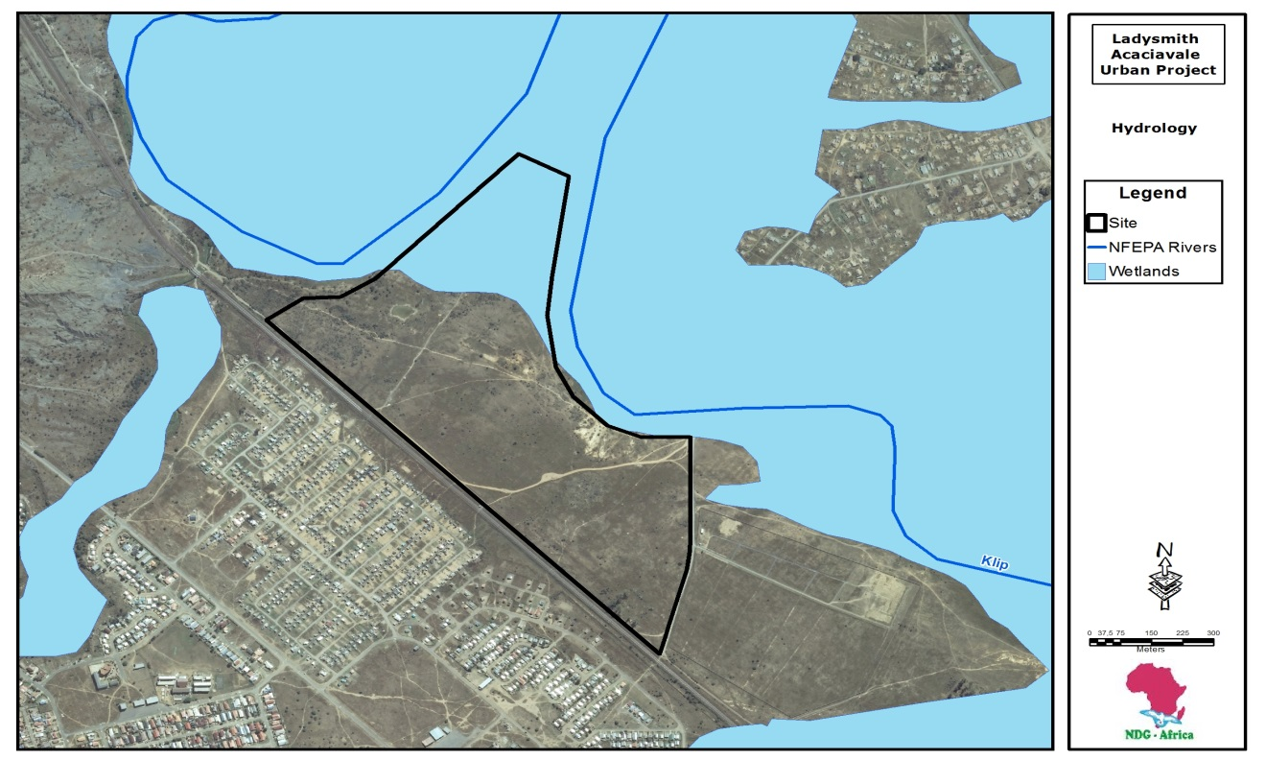
Figure11: Hydrology

5.3.2 Wetlands

Although no standing or pools of water was found at the time of this preliminary site wetland observation, most wetlands are mostly associated with drainage lines and usually disperse or spread in open areas on more flatter grounds.

The geotechnical investigation further which is an essential study to undertake will indicate whether or not groundwater flow at the flat interface are likely to become more prolific in the rainy months. Platforms intercepting this interface are likely to encounter groundwater seepage during these times. A specialist wetland study will throw more lioght on the findings of the geotechnical report.

5.5 Current and Competing Landuses
The land proposed for this development borders with commercial timber plantations and is largely unsettled. There is currently no defined use on the land but appears to be used informally for grazing purposes.

5.6 Current Zoning

The land under investigation is a land (belong the government of the Republic of South Africa). According to the SDF prepared for Alfred Duma Municipality, the area is outside any town planning scheme and is therefore zoned agricultural land.

5.7 Existing Infrastructure

The site is crisscrossed by many motorable tracks and footpaths. Across the gravel road within walking distance is evidence ofwithin the western section of the site and may be the result of domestic animals which have extensively grazed or overgrazed the grassland.
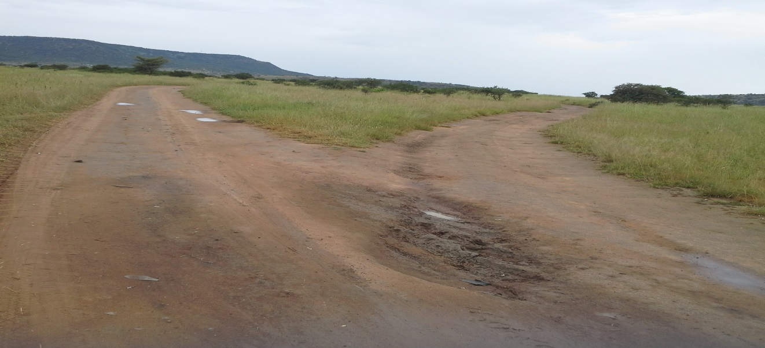
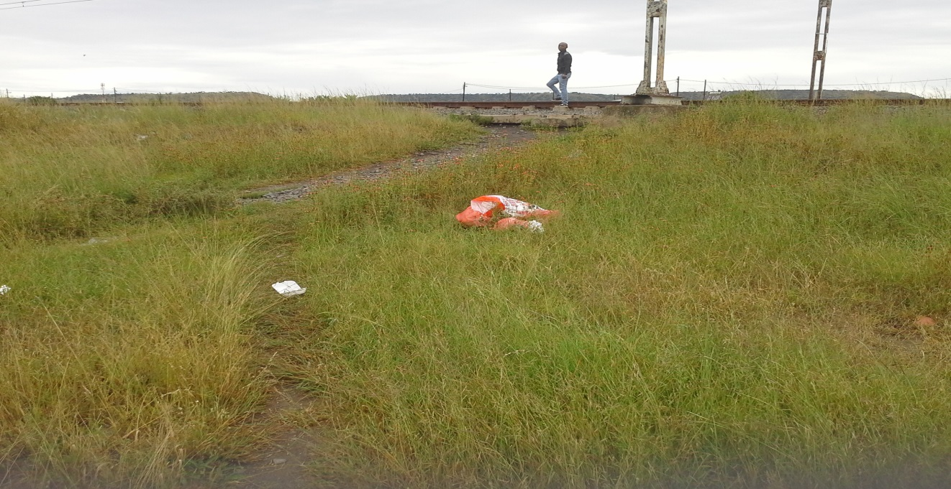
The site does not have any services or settlement infrastructure at this stage. However, there are services and infrastructure in the vicinity of the development site from which the proposed development could benefit.

5.7.1 Access roads

Access to the site is itself is available through the Acaciaville community. Internally on the site, Local gravel roads occur throughout the existing site offering access to various sections of the area. The undeveloped site does not have infrastructure.

5.7.2 Stormwater Infrastructure

Stormwater infrastructure should be poorly developed in the area.
ts of V-drains intercepted by kerbs at 100 m intervals into 300 mm ø concrete pipes. These in turn discharge into existing nearby open spaces in the area.

5.7.2 Existing Sewer infrastructure

Sanitation infrastructure is reportly of septic tanks in the formal communities that surround the project site. The developing settlements on the site have VIP toilets. No conventional waste water treatement plants or related infrastructure occurs within 25 km of the site.

However, it is highly recommended that VIP toilets are not used for the elimination of the possible hazards it may pose to the environment refere to section 4.3.1 above.

5.7.2 Water supply

Water supply infrastructure is not available on the site. However, bulk infrastructure occurs within the vicinity of the project site from which the new areas of the development will be served.

5.7.3 Electricity

The picture above is an indication of the existence of electric power lines traversing the project area. The proposed development will include electrification of all newly constructed houses from the national grid and this electricity infrastructure will be provided by the Alfred Duma munich

5.7.4 Existing Services

Apart from the presence of electric power lines withing the project area, the site does not have any other services at the moment. However, there are services in the vicinity of the site that could be of benefit to the new development.

5.8 The Socio-Economic and Cultural Environment

The Ladysmith population is characterised by significantly more women than men. 47% households are headed by women in the absence of partners seeking employment in other urban centres. Close to half of the population are children, placing pressure on the need for educational and social facilities. Many of these children will be orphaned as a result of HIV/AIDS. At least 11.7% of the population is already infected with HIV. This has a severe impact on the need for health, social and welfare services.

Income levels are low with 66% of households receiving no income or less than R2 400 per month. The traditional and rural areas are the most poverty stricken. Unemployment levels are relatively high and with only 13.43% of the population being formally employed. Dependency levels are also high with every employed person having to support 6.5 persons of which 3 are over 15 years of age. The farming sector employs a significant number of people, indicating the importance of the agricultural sector in the economy of the area. The majority of the population relies on public transport facilities.

Most of the urban communities have access to clean water with severe shortcomings in this respect as far as rural communities are concerned and have access to less than 5 litres of water per day

The larger urban areas have sanitation systems and household electricity, but the rural areas rely on septic tanks, pit latrines or no sanitation or electrification system at all. The need for electricity provision at schools and health facilities is especially critical.

5.9 Heritage (Archaeological and Cultural) Characteristics

Site walk-over revealed a couple of suspected cultural and historical issues namely:

SECTION 6 DESCRIPTION OF ENVIRONMENTAL ISSUES AND POTENTIAL IMPACTS

6.1 POTENTIAL ENVIRONMENTAL ISSUES RELATING TO THE BIOPHYSICAL ENVIRONMENT

6.1.1 Landscape issues

Detailed geotechnical assessment should be conducted for the proposed development to indicate that the site is generally stable and suitable for the development. However, the steeper areas at the southern half of the site must be developed with due care for erosion protection and slope stabilization due to highly erodible soils.

6.1.1.2 Cumulative impacts

The development is not likely to result in significant local changes to the landscape of the area. However, the cumulative impact of the development on the terrain and land stability will only be determined at the EIA phase when detailed geotechnical assessment has been conducted.

6.1.1.3 Further work recommendations

Geotechnical investigation should be conducted at a detailed level with relevant recommendations. No further investigations are required.

6.1.2 Issues Relating to Alternative Landuse

Alternatives relating to landuse and alternative land have adequately been considered during the scoping phase of this EIA process. It is observed that grazing of livestock is currently a key land use of the proposed site. It should be noted that although the need for housing takes a high priority in the Alfred Duma Municipality, the social needs of community members who graze their livestock on the site should be taken into account during the planning process.

6.1.2.1 Evaluation of Issues

The land being considered for this development is ideal for settlement purposes because its meets the development criteria outlines in section 4.1.1 of the report
Table 6: Landuse issues
Agriculture | The agricultural potential for the site is thoeritically considered to be moderate. At the moment only small scale crop production occurs on site being presumable largely fed by rainfall. Manual irrigation is practiced indicating that rainfall alone does not meet the water requirements of agriculture in the area. There is indicated that agriculture may not be significant contributor to socio-economic upliftment or sustenance in the area and as a result may not be a priority landuse contender for the site. Thus although the land is currently agricultural, the overall suitability of this zoning classification must be considered in relation to other landuse options for optimum decision making
Settlement | Settlement appears to be the fastest growing landuse on the site. The site is significantly disturbed through previous and ongoing anthropogenic activities. Some infrastructure related to settlement such as electricity facilities already exists on the and may have contributed to the general degradation on the site.
Conservation and Environmental Sustainability | Conservation of biodiversity on the site appears to be only ideal for the southern half of the site. As can be seen from the insert photo 1 and 2, the southern boundary has a major river that may be negatively affected should the development extend to the south. This areaFurther, photo insert 2 shows a rather rugged terrain at the southern half with landuse, ecological, and topographical conditions suited to conservation  Photo 1 | Photo 2

In view of the discussions of relating to landuse options above the following landuse options appears to be most suited to the development area:

Figure 19: Summary of landuse options for the project site

6.1.2.2 Further work recommendations

For the socio-economic landuse reasons given above, a social impact assessment should be undertaken in order to establish an appropriate baseline information and data for decision making purposes.

6.1.3 Issues Associated with Ecological Characteristics

The proposed site effectively corresponds with the transformation situation of this vegetation type indicated above. As seen in map 2 above, the low lying, flatter and more readily accessible northern half of the site has been stripped of its original vegetation of tree population and the expected tall grass species and has been redeuced to short grass species through overgrazing, settlement, regular burning and other anthropogenic activities such as agriculture.

No red data species were identified on the site visit, and it is unlikely that any red data species exist on the site. A lack of suitable habitats and constant disturbance of the site by humans and livestock generally precludes the possibility of red data species existing in the area. This is because red data species tend to be more sensitive to disturbance. For reasons mentioned above, it is highly improbable that any red data species will be damaged by this development.

5.2.2 Fauna

Wildlife was not observed on the site during site assessment although a few common birds of no ecological significance were identified. Attempts to verify the presence of wildlife through droppings and footmarks, and nests indicated that wildlife in the area is possibly nonexistent. Although attempts to identify animal species in the area and especially those recorded in the Red Data Book were proved negative, this would be confirmed at the EIA stage when detailed ecological assessment is conducted.

It should be noted that, site assessment And ground truthing’’ did not reveal any red data species on the site and that the identification of a portion of the site as a critical biodiversity area is only indicative of a potential threat to biodiversity. Proposals must therefore be planned taking the conservation needs of the site into account. It is therefore likely that biodiversity conservation managers such as Ezemvelo KZN Wildlife would advocate for land use proposals that aim at conserving the site rather than activities that are likely to result in a total and irreversible modification of the site.

6.1.3.1 Evaluation of vegetation issues

The fact that the settlement footprint would be totally and irreversibly deprived of vegetation makes the impact in this area high. Furthermore, the likelihood of further vegetation losses both in quality and quantity due to post development degradation by the inhabitants, casts a higher concern on the intensity of this impact.

According to KZN Wildlife biodiversity data base, vegetation in the area is totally irreplaceable and all development proposals must be preceded by an environmental impact assessment, the aim of which will be to plan mitigation for any rare and endangered or vulnerable biological species in the area.

6.1.3.2 Cumulative impacts

The possibility of the area within the development footprint reverting to natural vegetation is irreversible and thus impact after mitigation is till high. However, impacts on the surrounding especially the wetland areas could be kept under control if mitigation measures are implemented effectively. The cumulative impact will be determined when vegetation assessment is undertaken for the area.

6.1.3.3 Further work recommendations

The ecological significance of the vegetation at this stage is uncertain. However, given that portions of the area have biodiversity issues of concern, there is the need to further investigate the ecological status of the area with the aim of determining an appropriate land use and or planning mitigation to conserve any threatened plant species. Thus a vegetation assessment is recommended during the EIA phase of the planning process.

6.1.4 Issues relating to Wildlife

Local disturbances of settlements grazing and agriculture appear to have created unsuitable environment for wildlife. This is evidenced by the lack of any wildlife species in the area during site walk-over. The absence of animal droppings, footprints, nests, and tracks further suggests the unlikelihood of wildlife in the area.

      - Cumulative impacts

The development of the area is not likely not change the ecological status of wildlife in the area. Thus the potential cumulative impact on wildlife is likely to be unaffected.

6.1.4.2 Further work Recommendations

Further work regarding impact on wildlife is not recommended. However, specialist opinion will be solicited for the management of any possible wildlife that may occur in the area.

Issues Relating to Hydrological

The site has a few watercourses and what appears to be wetlands. The development may thus pose some threats to water resources in the area.

      - Evaluation of potential issues

There appears to be visible water logging especially after heavy rainfall. Although geotechnical investigation conducted on the site reports that no groundwater seepage was encountered in any of the inspection pits excavated. The investigation indicated however also indicates that during periods of prolonged rainfall, particularly during the summer season, a marked increase in the occurrence and magnitude of groundwater seepage flow can be anticipated.

The geotechnical investigation further indicates that perched groundwater flows at the soil/rock interface are likely to become more prolific in the rainy months. Platforms intercepting this interface are likely to encounter groundwater seepage during these times.

6.1.5.2 Cumulative impacts

This development will irreversibly remove vegetation and increase hardened surfaces (roads, pavements, roofs, parking lots etc.), and thus increase surface runoff and thereby, change the surface drainage of the area. These changes are likely to impact on the hydrology of the area particularly the wetlands on site. To some extent, these expected changes may enhance the quality of the streams and wetlands. On the other hand, the removal of vegetation is likely to result in an increased volume and speed of runoff especially from the steeper northwestern and south western parts of the site which has the potential to induce erosion and land degradation in the area.
It is therefore necessary to conserve and enhance the quality and functionality of the wetlands on the site so as to enable them to serve as attenuation, purification and flood control system in the project area.

6.1.5.3 Further work recommendations

A wetland functionality assessment and delineation is recommended in order to provide suitable protection and buffers to the wetlands. This assessment should be conducted in accordance with requirements of the Department of Water and Sanitation

6.1.6 Evaluation of Sanitation and Waste Management Issues

VIP sanitation systems are cheap but are known to pose significant environmental problems unless there is sufficient space to relocate VIP toilets when their life cycle is complete. VIP toilets are often difficult sanitation systems to maintain in a proposed development such as Umvoti middle Income housing project where the settlement density is expected to be high and space is limited. VIP toilets are unsuitable options. Septic tanks are also high maintenance sanitation options for this development as they have size requirements that cannot be met by this development.

Of the sanitation systems available, water-borne sanitation is the most environmentally suitable. However waterborne sewage infrastructure is not available in the area as expressed by the authorities of the municipality. Thus a more detailed assessment may need to be undertaken in the form of a sanitation technical feasibility study in order to the most appropriate sanitation and sewage management system that meets the need of the proposed development without compromising the general environmental health of the area.

6.1.6.1 Cumulative impacts

The nature of the sanitation system to be adopted is uncertain at this stage. However, it can be said that VIP toilets will invariably negatively impact on the environment given the extent of this development. In the same vain, water borne sanitation if implemented will exert additional pressure on treatment works and other infrastructure. It appears that the cumulative impact resulting from this development would be high environmentally for VIP toilets, and economically for water born systems. It should be noted that the degree of severity of the cumulative impact relating to sanitation can only be ascertain after the specialist sanitation technical feasibility study has been undertaken.

6.1.6.2 Further work recommendations

A sanitation technical feasibility assessment is needed during the EIA phase of the project. This assessment should include an investigation of the capacity of existing sewage treatment works to accommodate and treat sewage from the proposed project area. The assessment should also consider water supply requirements and the ability of beneficiaries to pay for and maintain such level of service. An investigation of water supply systems to the area is recommended.

6.1.7 Water supply issues

As discussed earlier, there are water services and infrastructure within the adjacent formal community of Gretown. This presupposes that there is bulk water supply infrastructure within the vicinity of the project area. Although water infrastructure is available, the sufficiency of this infrastructure to support the water requirements of the incoming project needs to be assessed if water borne sanitation is to be inculcated into the development.

6.1.7.1 Cumulative impacts

Water supply to the community already exist however it is unknown if there is sufficient pressure to meet the water demand of the proposed project. Therefore the positive or negative impact of water on the project is unknown at this stage.

6.1.7.2 Further work recommendations

Engineering investigation into the water supply potential of the area needs to be investigated

6.1.8 Stormwater management issues

This development will irreversibly remove vegetation and increase hardened surfaces (roads, pavements, roofs, parking lots etc.), and thus increase surface runoff and thereby, change the surface drainage of the area. These changes are likely to impact on the hydrology of the area particularly the streams and wetlands on site. It is therefore necessary to conserve and enhance the quality and functionality of the wetlands on the site so as to enable them to serve as attenuation, purification and flood control system in the project area. Stormwater runoff is likely to increase given the size of the development envisaged. Since there is limited natural drainage lines in the area to accommodate surface runoff, appropriate stormwater infrastructure needs to be installed.

6.1.8.1 Evaluation of storm water issues

The removal of vegetation coupled with hardened surface in the settlement area would cause accelerated stormwater runoff and possible erosion. The net result of improper stormwater management would be land degradation and possible siltation of the wetlands in the drainage lines. The increase in the volume and surface flow of stormwater from the settlement area is likely to be permanent. Development of gullies is possible and could be extended to the riparian areas with severe impacts on the water courses in the area.

Increased stormwater volumes and accelerated flow of surface water have the potential to result in severe erosion and land degradation. The resultant water pollution and loss of soil have high environmental consequences in the area.

      - Cumulative impacts

Post development runoff is likely to be significantly higher than is currently experienced. Given that increase in stormwater flows, all associated management infrastructure and potential impacts are likely to increase, the cumulative impact resulting from this development is likely to be high.

6.1.8.3 Further work recommendations

Engineering investigation into the storm water infrastructure is required at the EIA phase of the planning process. This investigation should include storm water attenuation investigations and discharge modalities. The feasibility of storm water harvesting and use at household level should form part of the investigation.

6.1.9 Litter and Solid Waste Management Issues

Domestic waste management in the Forderville community is poor since there is indiscriminate dumping of refuse on the site. It is likely that the proposed development will generate higher quantities of household waste and possibly some amount of commercial wastes from the expected 700 households to be established in the area. The common issues related to solid waste, are offensive stench from uncollected stockpiles, possible disease outbreaks, increase in pests and parasites, and the loss of aesthetic value of the environment.

6.1.9.1 Evaluation of Potential issues

Currently, Umvoti Municipality does not collect refuse from the area. The lack of a technological approach to waste management could result in unconventional management methods such as burning. Burning of waste is one of the causes of fires in high density communities.

With improved road network and ready access to designated areas, waste management is likely to improve significantly in the area including the current settlement area. It is noted that, waste in the area will significantly increase during the construction period. However, this increase is likely to be temporal and would appear to be manageable by means of an EMPr.

      - Cumulative impacts

If waste collection and management is not undertaken effectively, there is the likelihood of accumulation of litter in the area from domestic and commercial activities. The associated pollution and health risks are likely to be high. The extent of the cumulative impact of waste in the area can only be determined with certainty at the EIA stage of the planning process.

6.1.9.3 Further work

Engineering investigation into waste management for the area needs to be undertaken and planned

6.1.10 Access roads and traffic issues

The development proposed involves formally planned settlement which would include the construction of new houses and new roads. These new streets would be connected to the existing road at Forderville. Due to the low economic status of the incoming population, it is unlikely that there will be higher volume of private transport to and from the development area. However, public transport volumes (taxis) may increase due to the higher population, it is unlikely that the increase will be significant.

6.1.10.1 Evaluation of potential issues

Possible increase in the number of households as a result of the proposed development is unlikely to result in higher than current traffic volume on the main roads in the vicinity of the project area. Thus traffic congestion and its potential impact on roads is unlikely to be a significant issue that needs to be investigated.

However, the construction of houses and other settlement structures is likely to attract a large number of construction vehicles. The movement of these vehicles in the area is also likely to impact on traffic flow on the main road leading to the site. Furthermore, the safety of residents of the community may be an issue as heavy duty construction vehicles move within the community during construction.

At this stage the actual socio-economic standing of the incoming community is unknown. It is expected that the beneficiaries are impoverished households whose total household income is does not exceed R3500.00. Given this economic standing, it would be expected that households would not be in the position to own moto vehicles. However, experience from other supposedly low income communities indicate that either household members own vehicles are extended family members who board with beneficiary relatives own moto vehicles.

In the event that several households own vehicles, the volume of traffic flow in the roads in the area and especially at the intersection leading to area may significantly increase. This possibility coupled with a potential increase in taxi volumes when the settlement is established may result in a net increase in traffic volumes in the area. However, the relevance and significance of this issue would only be confirmed through a socio-economic impact assessment at the EIA stage.

        - Cumulative impacts

This development is likely to result in the net increase in household population in the area and may also consequently result in an increase in the volume of traffic flows in the area. The cumulative impact of traffic flows and its impact on traffic infrastructure would be ascertained during the EIA stage.

6.1.10.3 Further work recommendations

A traffic impact assessment is recommended.

6.2 POTENTIAL ENVIRONMENTAL ISSUES RELATING TO THE SOCIO-ECONOMIC ENVIRONMENT

6.2.1 Education and health issues

Currently, there are limited educational facilities in the area. With the introduction of 700 households with an estimated population of 4200 individuals, there will be the need for both educational and health facilities.

6.2.1.1 Evaluation of potential issues

The project layout has not yet been developed. It is noted that current government subsify schemes for human settlement does not make provision for educational and health facilities although such facilities and services are integral to all settlement planning requirements. It follows therefore that these services are not likely to be immediately available to the inhabitants who must consequently rely on available services and facilities in the neighbouring communities.

The key issues to be addressed are:
- Whether there is sufficient capacity to provide the needed services to the incoming population
- Whether the available services is of sufficient quality to meet the needs of the incoming population

Should the current service levels be inadequate, the development is likely to put a greater strain the existing resources to the detriment of the de facto and de jour populations.

6.2.1.2 Employment and job creation

The project area has limited employment and job creation opportunities. Currently, the skills and the educational levels of the community is unknown and therefore future planning to meet the socio-economic needs of the community cannot be ascertained.

It is noted however that the proposed development may result in some direct employment opportunities during construction and some secondary economic opportunities for residents of the area. The development is therefore likely to provide some economic benefits and income generation opportunities. Long term entrepreneurial opportunities such as the establishment of spaza shops and petty trading activities as well as a boost for trading potential of existing businesses due to the increased population are additional socio-economic benefits that are likely to emanate from the proposed development.

6.2.1.3 Health and safety issues

Issues relating to infrastructure risks

Potential increase in crime

There is a school of thought that an increase in population at any given point and location has the potential to result in increased crime and related social vices. This issue becomes more relevant in view of the fact that neighbouring land uses such as game farms and tourism activities are economic based and thus any event of criminal activities could potentially impact negatively on such land uses.

      - Cumulative impacts

The introduction of households in an area that is devoid of adequate social and economic structure is likely to pose significant social problems. The social situation of the area may deteriorate as potential social vices increase. Therefore the cumulative impact of the project on the social conditions of the area is likely to be high.

Unemployment in the area could result in crime and inability of households to meet their civil obligations. Increased poverty could result in severe social vices to the detriment particularly to surround economic activities such as tourism and game farming, and the general economic environment within Ladysmith.

6.2.1.3 Further work recommendations

A socioeconomic impact assessment is recommended. The assessment should investigate among other things, adequacy of existing services and recommendations, the skills level and employability of the community the cultural demands of the community (example, cemetery).

6.2.2 Heritage Issues

The site does not have structures that are likely to be over 60 years or older. The prevailing legislation of the National Heritage Act and the Kwa Zulu Natal Heritage Resources Act stipulate that a permit is required for the tempering, alternation or demolishing of any buildings and related structures that are 60 years and older. This legislation may well be investigated given that vestigaes of old structures were observed on the site.

It is further noted that in terms of the said acts, linear development above or underground that are 300 m in length require consent from the heritage agency of KwaZulu Natal. Given that there are some linear activities (roads, pipe lines) associated with the proposed development, it is imperative that the heritage agency of KwaZulu Natal need to be involved in determining the significance of heritage impacts in the area and planning mitigation for the impacts.

Site assessment revealed suspected cluster of graves on the site. These may well be materials of cultural or archaeological significance in the area. The location and planning of mitigation for the graves may have to be undertaken by a suitable heritage.

Given that uncertainties of the heritage resources on the site, the potential cumulative impact of developing the area on heritage resources cannot be pre-empted at this stage. Amafa KwaZulu Natal will be engaged on this issue and the necessary studies and mitigation planning undertaken.

6.2.2.1 Further work recommendations

A heritage impact assessment is required.

SECTION 7 CONCLUSIONS AND RECOMMENDATIONS

7.1 CONCLUSIONS

7.1.1 Conclusions relating biophysical issues

- This assessment indicate that the site is geotechnically stable and suitable for the proposed development. However, geotechnical assessment recommendations and mitigation measures must be adhered to.

- Slope is more gentle at the northern half thereby providing for development with minimal landscape impacts. The northern half of the site is more suitable for the proposed development.

- The rugged nature of the southern half presents a lahdform for the occurrence of more probounced drainage lines.

- The southern half of the site appears to be ecologically sensitive and with some areas designated as critical biodiversity management importance areas. The site has drainage characteristics that are likely to play a significant role in stormwater infrastructure planning and management. Integration of these wetlands in the layout is therefore necessary to complement stormwater infrastructure in the area.

- Vegetation is largely modified at the northern half wheras the southern half has relatively untransformed vegetation.

7.1.2 Conclusions relating to the provision of services and facilities

- The project does not have conventional sanitation infrastructure. The existing settlements rely on either VIP toilets or septic tanks.

- Social services are critical for the incoming population. The availability, sufficiency and quality of services in the area is an important consideration for the proposed development. At the moment a detailed socio-economic assessment has not been undertaken and thus the significance of the potential impact of the development on infrastructure is unknown.

- Although settlement population will increase, it is appears that the proposed project is unlikely to impact on the traffic situation in the area due to the low economic status of the incoming population.

- The grazing of livestock on the site is a social issue that should not be ignored in this assessment since the development has the potential to totally exclude grazing as a land us option. The extent to which grazing could be impacted by the development need to be considered during this planning process.

7.1.3 Conclusions relating socio-cultural issues

- Farming areas are usually areas having materials of potentially significant heritage value. There are visible vetiges of old informal building and stuctures and suspected graves on the site. There is therefore the need to conduct a heritage impact assessment to verify whether or not any materials of heritage significance are located on the proposed development site.

7.1.4 Concluding Remarks

Although there appears to be issues of concern with regards to both the biophysical and socio-economic environments of the area, there are no fatal flaws in the environment that would necessitate a ‘no development’ option.

7.2 RECOMMENDATIONS

The need to house poor impoverished communities is a necessity in order to reduce the environmental risks and social hardship the Ladysmith development is currently exposed to. It is therefore recommended that planning processes continue in the bid to solve the pending problems in the area. However further assessment is recommended in the following areas:

Wetland assessment
- Wetland assessment and delineation need to be undertaken to protect the wetland in the area

Assessment of Sanitation Stormwater Impacts
- Engineering investigation is needed to verify the sufficiency of services such as water and electricity in the area in order that the development does not disrupt the supply of such services in the receiving environment.
- More critically, a sanitation impact assessment is recommended to determine the most feasible means of managing sewage and solid waste in the area.
- The development is also expected to generate large volumes if runoff. He impacts of expected stormwater and means of managing this also need to be investigated.

Heritage impact assessment
- A heritage impact assessment is required to determine whether there are any heritage resources in the area.

Socioeconomic impact assessment
- The ability of existing services to meet the social needs of the incoming community is unknown. A social impact assessment needs to be undertaken to assist in a holistic long term planning for the area.

Vegetation impact assessment
- There are areas with vegetation of conservation significance. An ecological assessment is recommended

SECTION 8 PLAN OF STUDY FOR ENVIRONMENTAL IMPACT ASSESSMENT

8.1 INTRODUCTION

According to the EIA regulations No. 38282 of December 2014 under the National Environmental Management Act 107 of 1998, a plan of study for the conduct of the EIA as part of the scoping stage is required. This plan of study is to fulfill the requirements of section 2(i) of Appendix 2 of the regulations 38282 of December 2014, and has been prepared in accordance to the specific information requirements of this regulation.

8.2 Description of the tasks to be undertaken during the EIA process

The key area of environmental concern and issues for this project that require further assessment are discussed in section 6 and summarized in section 7.2 of this report. These issues have been recommended for impact assessment during the EIA phase. The tasks to be performed at the EIA phase are described below.

8.2.1 Specialist studies

Issues that have been identified at the scoping stage as significant issues have been recommended for further assessment will be targeted for specialist studies during the EIA stage. Specialists will thus be appointed to conduct the following environmental impact assessments. The broad objective of the specialists studies are provided below and the related terms of reference.

8.2.1.1 Vegetation assessment

Vegetation characteristics in the area have been identified as important since the area has remained undeveloped and some areas have been identified as open space systems. The grassland vegetation in the area is particularly rich in species diversity and composition. This development is likely to result in the removal of significant portions of vegetation during construction and operation have the potential to impact on the sustainability species in the area.

Specific Tasks
- Identify species composition and diversity at the selected substation sites and the corridors
- Identify the rare plant species and recommend whether relocation of plant species, or relocation and re-routing of infrastructure is needed
- Provide a detailed impact report according to the methods in this plan of study
- Prepare a detailed biodiversity management plan during construction and operation of the project.

8.2.1.2 Potential impact on Heritage Resources

Heritage materials of significance were not identified during the scoping process. However, it is noteworthy that, rural settlements especially along the rivers and river basins are areas that may contain hidden heritage treasures that may be of local, regional or national significance. It is also noted that the area has landscape that presents aesthetically pleasing environments which may have cultural benefits and therefore require a thorough cultural investigation.

Specific Tasks
- Investigate the history of the land use and other historical anthropogenic activities in the area
- Investigate the possibility of any cultural or historical events in the area and the possible material residues of those events that may be of any archaeological significance in the area and its implication for this development
- Provide a detailed impact heritage report according to the methods detailed in this plan of study
- Prepare a detailed heritage resources management plan during construction and operation of the project.

8.2.1.3 Potential Impact on Socio-Economic Environment

There is pertinent concerns regarding services and service infrastructure such as schools, health facilities and employment. The skill base of the individuals in the area is unknown. The project is also likely to create some temporal job opportunities during construction which should benefit the communities in the area. However, the capacity of the services in the area to meet the need of the existing and incoming population need to be investigated.

Specific Tasks

- Describe the social and socio-economic environment within the areas highlighting those socio-economic attributes and components which may influence or by the proposed project during construction and operation
- Assess the land use character of the area with particular emphasis on grazing as a land use by community members
- Identify potential impacts of the project on the socio-economic environment. Particular attention should be given to prepare impacts on existing infrastructure, nuisance impacts, and health and safety impacts
- Identify mitigation measures for enhancing benefits and avoiding or mitigating negative impacts and risks
- Formulate a simple system to monitor impacts, and their management based on key indicators.

8.1.2.4 Assessment of impact of sanitation and solid waste

The issue of sewage management is one of the most significant issues identified during the scoping process. This issue involves a multi sectorial decision making process. The impact of sanitation therefore requires a detailed assessment that considered s collective representation and decisions from all relevant departments in the UPhongolaMunicipality.

Specific Tasks
- Identify the waste and sewage management options available for this development
- Assess the feasibility of each option in relation to broader planning schemes and specific to the project requirements
- Recommend the most feasible option sanitation and waste management options that suite the needs of the project

8.2.2 Involving the Public

Public participation will form an important part of the EIA process. The public participation will involve the following:
- Update the list of interested and affected parties
- Inform the general public through site notices, direct notification, information centers etc. of the EIA process
- Stakeholders meeting will be held to discuss specialist reports and findings
- Public meetings will be held to discuss findings with interested and affected parties

Appendix 1 contain detailed of the public participation process.

8.3 Manner in which the above Tasks would be undertaken

The key functions of any specialist study will be to investigate impacts relevant to the specific areas of their specialization. The manner of these activities will be considered are as follows:

8.3.1 Consultation with Relevant Stakeholders

At the inception of the EIA process of the EIA (in terms of activities stipulated under item 4 above) will be discussed with relevant stakeholders.

Table 7: Relevant Stakeholders for Various Fields of Specialist Studies
Field of Specialist Study | Relevant Stakeholders
Overall EIA process | KZN Department of Economic Development Tourism and Environmental Affairs, Umvoti Department of Environmental Protection, Department of Water Affairs, KZN Wildlife, Amafa aKwaZulu Natali,
Geotechnical  Assessment | Relevant engineering Department of UMVOTI Municipality
Ecological Assessment  Heritage Impact  Assessment | Alfred DumaMunicipality Environmental department, KZN Wildlife,  Amafa aKwaZulu Natali
Agricultural Assessment | The land use planning section of Alfred Duma Municipality, KZN Department of Agriculture
Socio-economic Impact Assessment | Alfred Duma Municipality
Sanitation and Waste Impact Assessment | District, Department of Water and Sanitation

8.3.2 Integration of specialist reports

A workshop will be held where the results of each specialist will be discussed. The specialist reports will be integrated with the results of the public participation process in a draft EIA report.

8.3.3 Involvement of the competent authority

The KZN Department of Economic Development Tourism and Environmental Affairs (EDTEA) will be consulted at the following stages:

- A site visit will be arranged with EDTEA at the inception stage of the EIA to show the department where the target substation areas foe EIA are;
- A meeting will be arranged EDTEA to discuss findings of specialist investigation. A site to key areas of concern may be arranged with EDTEA and specialists if necessary.

8.3.4 Assessment of Impacts

The assessment of all impacts of all specialists will follow the criteria contained in this section. Each specialist will be required to comply with the requirements of GNR 38282 of December 2014 as stipulated in the EIA regulations .

8.3.4.1 Method of Assessing the Environmental Impacts and Alternatives

The methodology and criteria assessing the environmental impact of environmental attributes will involve the following:

Extent of the impact:

The extent of the impact was assessed accordingly:
- Limited to the site and its immediate surroundings.
- Local/Municipal extending only as far as the local community or urban area.
- Provincial/Regional.
- National i.e. South Africa.
- Across International borders.

Duration of the impact:
The lifespan of the impact was assessed to be:
- Immediate (less than 1 year).
- Short term (1-5 years).
- Medium term (6-15 years).
- Long term (the impact will cease after the operational life span of the project).
- Permanent (no mitigation measures or natural process will reduce impact after construction)

Magnitude of the impact:
The magnitude or severity of the impacts is indicated as either:
- None (where the aspect will have no impact on the environment)
- Minor (where the impact affects the environment in such a way that natural, cultural and social functions and processes are not affected).
- Low (where the impact affects the environment in such a way that natural, cultural and social functions and processes are slightly affected).
- Moderate (where the affected environment is altered but natural, cultural and social functions and processes continue albeit in a modified way).
- High (where natural, cultural or social functions or processes are altered to the extent that it will temporarily cease).
- Very high/don’t know (where natural, cultural or social functions or processes are altered to the extent that it will permanently cease).

Probability of occurrence:
The likelihood of the impact actually occurring was indicated as either:
- (0) None (impact will not occur)
- (1) Improbable (the possibility of the impact materializing is very low as a result of design, historic experience or implementation of adequate mitigation measures).
- (2) Low probability (there is a possibility that the impact will occur).
- (3) Medium probability (the impact may occur).
- (4) High probability (it is most likely that the impact will occur).
- (5) Definite/do not know (the impact will occur regardless of the implementation of any prevention or corrective actions or it the specialist does not know what the probability will be based on too little published information).
Status of the impact:
The impacts are assessed as either having a:
- Negative effect (i.e. at a cost to the environment).
- Positive effect (i.e. at a benefit to the environment).
- Neutral effect on the environment.

Reversibility of Impact
The degree to which the impact can be reversed

Irreplaceable loss of resources
The degree to which the impact may cause irreplaceable loss of resources

Cumulative impact:
The impact of the development is considered together with additional developments of the same or similar nature and magnitude. The combined impacts may be:
- Negative – i.e. the net effect is the same as the single development
- Marginal – i.e. the impact of two developments of a similar nature is less than twice the impact of a single development. This implies it is better to place two developments in the same environment rather than in separate environments.
- Compounding – i.e. the impact of two developments is more than twice the impact of two single – developments. This implies that it is better to split the two developments into separate developments.

Significance of the impact:
Based on the synthesis of the information contained in the points above, the potential impacts were assigned a significance weighting (S). The weighting is formulated by adding the sum of numbers assigned to extent (E), duration (D) and magnitude (M) and multiplying this sum by probability (P) of the impact hence S=(E+D+M)P.
- Negligible: 0
- Low: 1 – 15
- Low – Medium: 16 – 30
- Medium: 31 – 45
- Medium- High: 46 – 60
- High: >60

Table 5 provides the definition of impact categories to be used. Table 8 defines the themes

Table 8: Impact categories scaling and scores
0 | Negligible | There is no impact
1 | Low | Impact is of a low order, mitigation measures are easy and simple or not required
2 | Low-Medium | Impact is higher but with limited effect, mitigation measures are feasible and easily achieved
3 | Medium | Impact is real but not sustainable and mitigation is both feasible and fairly possible
4 | Medium-high | Impact is substantial and mitigation measures are difficult, expensive and time consuming
5 | High | Impact is of the highest order and there are few, if any, mitigation measures to offset impact

Table 9: Themes that describe the rationale for the assessment of impacts
Theme | {description of environmental theme}
Nature of issue | {describe nature of impact}
Legal requirements | {list any legal compliance requirements}
Stage | {these are assumed to have similar impacts} | Operation:
Extent of impact | {Site, local, regional, national, international} | { All operational issues to be evaluated in the same manner}
Duration of impact | {Immediate (< 1 yr), short-term (1-5yrs), medium-term (6-15 yrs), long-term (> 15yrs), or permanent}
Intensity | {negligible, minor, low, moderate, high, very high}
Probability of occurrence | {none, unlikely, low, probable, high, definite}
Status of the impact | Environment – positive/negative/neutral
Reversibility | Describe possibility of reversibility
Irreplaceable loss of resources | Describe the potential loss of resources
Cumulative impact | {negligible, marginal, compounding}
Level of significance | {negligible, low, low-medium, medium, medium-high, high}
Mitigation measures | {describe possible mitigation measures}
Level of significance after mitigation | {negligible, low, low-medium, medium, medium-high, very high}
EMP requirements | {describe any specific mitigation and management aspects that need to be included in the EMPr}

8.4 Preparation of Environmental Management Programme (EMPr)

Based on the results of specialist studies and recommendations and input from I&APs and stakeholders, an EMPr will be prepared to management potential impacts during construction. It is understandable that some parts of the EMP will be site specific to address pertinent site specific issues and other parts will address generally anticipated impacts.

8.5 Proposed Time Frame for Consulting the Competent Authority

A tentative activity schedule and the proposed time frames during the Environmental Impact Assessment process for consultation of the EDTEA is scheduled in Table 10. This programme will be finalized with EDTEA prior to commencement of the EIA phase.

Table 10: Proposed Time Frames for Consulting EDTEA
DATES | ACTIVITIES
March 4th 2018 | - Submit Draft EIA Report to EDTEA,
May 30th 2018 | - Site visit with EDTEA
June 30th 2018 | - Obtain authorisation from EDTEA

APPENDIX 2

PUBLIC PARTICIPATION

As part of the EIA process, public participation which aims to inform the stakeholders, interested and affected parties, especially the community members who are in close proximity to the proposed project area were informed through various means one of which if the pasting of Site Notices on the project site and also the placement of site notices at vantage points notice boards or places where community members usually frequent. See below, photographs of site notices placed at various vantage points.

APPENDIX: 2a
Background Information Document

APPENDIX: 2b
Background Information Document List

