ENVIRONMENTAL SCOPING REPORT FOR
The proposed township development of Malamulele Extension E, within THE Collins Chabane Local Municipality, Limpopo Province.

PREPARED BY:
Global Geo Enviro Specialists
Contact Person: Danielle Potgieter
Email: potgieter.danielle@gmail.com
Contact Number: 0825639024

PREPARED FOR:
Collins Chabane Local Municipality
DCO Offices, Hospital Road, Malamulele, 0982
Contact Person: Tiko Shimange
Email: tikoshimange@gmail.com
Contact number: 0833620539

DOCUMENT DETAILS
DOCUMENT TITLE | THE PROPOSED TOWNSHIP DEVELOPMENT OF MALAMULELE EXTENSION E, WITHIN THE COLLINS CHABANE LOCAL MUNICIPALITY, LIMPOPO PROVINCE.
GLOBAL GEO ENVIRO SPECIALISTS REFERENCE | 1006E
CLIENT | Collins Chabane Local Municipality
DOCUMENT CONTROL
 | Name | Signature
COMPILED | Daniëlle Potgieter
COMPILED | Davrotiah Lekala
CHECKED | Kabelo Phakwago
REVISION AND AMENDMENTS
REVISION DATE | DESCRIPTION | REV #

Table of Contents
LIST OF TABLES iv
LIST OF FIGURES iv
ACRONYMS AND ABBREVIATIONS vi
EAP’S CURRICULUM VITAE AND CONTACT DETAILS vii
PROJECT INFORMATION vii
EXECUTIVE SUMMARY viii
PURPOSE OF THE SCOPING REPORT viii
DECLARATION OF INTEREST xiii
1. INTRODUCTION 1
2. PROJECT NEED AND DESIRABILITY 2
3. SITE LOCALITY 2
4. PROPERTY DESCRIPTION 4
4.1. Topography 4
4.2. Geology and Soils 5
4.3. Climate 7
4.4. Vegetation 8
4.5. Environmental Sensitivity 8
4.6. Socio-Economic Aspects 9
1. PROJECT ALTERNATIVES 12
2. LEGISLATIVE GUIDELINES 14
3. OTHER GUIDELINES AND DOCUMENTATION CONSIDERED IN THE DRAFTING OF THE SCOPING REPORT INCLUDE: 16
3.1. CONSTITUTION OF THE REPUBLIC OF SOUTH AFRICA 16
3.2. NOISE CONTROL REGULATIONS, 1992 (GN R.154) 16
3.3. NATIONAL ENVIRONMENTAL MANAGEMENT: BIODIVERSITY ACT, 2004 (ACT NO. 10 OF 2004) 17
3.4. INTEGRATED ENVIRONMENTAL MANAGEMENT (IEM) 17
3.5. NATIONAL HERITAGE RESOURCES ACT, 1999 (ACT NO. 25 OF 1999) 18
AUTHORITY CONSULTATION 18
4. SPECIALIST STUDIES 18
5. ENVIRONMENTAL AUTHORISATION PROCESS 20
6. ENVIRONMENTAL IMPACT ASSESSMENT 21
6.1. PROCEDURE 21
6.2. Description of Potential Impacts to be further investigated. 21
6.2.1. Geology and Soil 21
6.2.2. Topography 21
6.2.3. Topsoil and Land use 21
6.2.4. Fauna 21
6.2.5. Flora 21
6.2.6. Air Quality 21
6.2.7. Archaeology and Palaeontology 21
6.2.8. Visual Impacts 22
6.2.9. Socio-Economic 22
a) Positive Socio-Economic Impacts: 22
b) Negative Socio-Economic Impacts: 22
6.2.10. Cumulative Impacts 22
PROPOSED METHODOLOGY FOR ASSESSING ENVIRONMENTAL IMPACTS 24
7. PUBLIC PARTICIPATION 25
7.1. NOTICE TO THE PUBLIC / I&AP REGISTRATION PERIOD 26
7.2. AVAILABILITY OF CONSULTATIVE DRAFT SCOPING REPORT FOR REVIEW AND COMMENT 26
8. PLAN OF STUDY FOR ENVIRONMENTAL IMPACT ASSESSMENT 26
9. CONCLUSION AND RECOMMENDATIONS 27
APPENDICES 28

LIST OF TABLES
Table 1 - Summary of Area Sensitivities - generated by the National Screening Tool from the Department of Forestry, Fisheries and the Environment 9
Table 2 - Summary of the socio-economic aspects 11
Table 3 - Site selection criteria 12
Table 4 - Listed activities triggered by the proposed demarcation in terms of the NEMA EIA regulations (2014) as amended. 16
Table 5 - Description of Impacts 23
Table 6 - Point Allocation for the rating of Impacts. 24
Table 7 - The significance of the ratings on proposed impacts. 24

LIST OF FIGURES
Figure 1- Locality map of the proposed township development area in Malamulele 3
Figure 2- Proposed Layout of the proposed township development area in Malamulele 3
Figure 3 -Site Contour Lines 4
Figure 4 - Area Geology and rock types at the Proposed Township development site on Malamulele Extension E 5
Figure 5 -Lithostratigraphy and principal rock types at the proposed Township development site on Malamulele Extension E 6
Figure 6 - Broad Terrestrial Vegetation for Malamulele Extension E proposed township development 8

LIST OF APPENDICES

APPENDICES
APPENDIX A - LOCALITY MAP
APPENDIX B - LAYOUT MAP
APPENDIX C - PLAN OF STUDY
APPENDIX D - SCREENING REPORT
APPENDIX E - ENVIRONMENTAL MANAGEMENT PROGRAMME (EMPR)
APPENDIX F - PUBLIC PARTICIPATION PROCESS
APPENDIX G - SPECIALIST AND EAP DECLARATIONS
APPENDIX H - CURRICULUM VITAE OF EAP
APPENDIX I - INFORMATION
APPENDIX J - DECLARATIONS
APPENDIX K - TITLE DEEDS

ACRONYMS AND ABBREVIATIONS
CA Competent Authority
DEFF Department of Environment, Forestry, and Fisheries
dSR Draft Scoping Report
EA Environmental Authorization
EAP Environmental Assessment Practitioner
EIA Environmental Impact Assessment
EIR Environmental Impact Report
EMC Environmental Management Committee
EMP Environmental Management Plan
EMPr Environmental Management Programme
ESR Environmental Scoping Report
I&AP Interested and Affected Party
IAR Impact Assessment Report
IDP Integrated Development Plan
LEDET Limpopo Department of Economic Development, Environment, and Tourism
NCRs National Noise Control Regulations
NEMA National Environmental Management Act of 1998 as amended
NHRA National Heritage Resources Act of 1999
NWA National Water Act of 1998
PPP Public Participation Process
ROD Record of Decision
SANRAL South African National Roads Agency Limited
SDF Spatial Development Framework
SR Scoping Report
TBA To Be Announced

EAP’S CURRICULUM VITAE AND CONTACT DETAILS
EAP’s Qualifications (Ms Daniëlle Potgieter):

- BSc (Hons) Environmental Monitoring and Modelling), University of South Africa
- BSc Geology, University of Pretoria
- Course completed in Geotechnical Core Logging, Soil Profiling and Chip Logging from SAIEG -South African Institute for Engineering and Environmental Geologists

Contact details of the EAP
Name DL (Daniëlle) Potgieter
Company Name Global Geo Enviro Specialists
Postal/ Physical Address 270 Malherbe Street, Capital Park, Pretoria, 0084
Email potgieter.danielle@gmail.com
Telephone +27 825639024

PROJECT INFORMATION
District | Greater Vhembe District
Local Municipality | Collins Chabane Local Municipality
Property description | The remainder of the farm Malamulele No. 234-LT
Surveyor-General code | T0LT00000000023400000
Nearest town | Malamulele
Coordinates (Centre point) | 22° 58’ 39.31” S; 30° 43’ 26.28” E
Current land use | Agricultural
Surrounding land use | Agricultural and residential

EXECUTIVE SUMMARY

Global Geo Enviro Specialists was appointed as the Environmental Assessment Practitioner (EAP) by Mahlori Development Consultants on behalf of Collins Chabane Local Municipality (the applicant) to assist with undertaking the required Environmental Authorization (EA) application processes (including the statutory public participation) for the proposed township development of Malamulele Extension E of 2038 sites on the remainder of the farm Malamulele No. 234-LT in Limpopo Province.

The applicant is proposing the township development of Malamulele Extension E 2038 sites covering an area of approximately 289.33 hectares in Malamulele within the Greater Vhembe District of the Limpopo Province. The geographical coordinates of the centre of the site are 22° 58’ 39.31” S; 30° 43’ 26.28” E

The proposed Township developmentwill include the following under the jurisdiction of Makhado Local Municipality: REFER TO THE LAYOUT PLAN (APPENDIX A)

- Residential 1 (1555 Dwelling units)
- Residential 2 (422 Group Housing (Eco-Estate))
- Residential 3 (5 Dwelling units)
- 1 Business (14 businesses)
- Educational (1 Primary School and 1 High School)
- Institutional (1 Medical Centre; 1 Clinic; 5 Churches; 3 Crèche; 3 Hall)
- Government (2 Government Purposes)
- Public Open Space (3 Park, 6 Agricultural, 3 Powerline)
- Private Open Space (10 Play Park & Conservation,1 Sports and Recreation Facility)
- Transport (1 Taxi Rank)
- Special (1 Access Control and 1 Future development)
- Streets

PURPOSE OF THE SCOPING REPORT

The purpose of the scoping process is to:
- Identify the policies and legislation that are relevant to the activity,
- Motivate the need and desirability of the proposed activity, including the need and desirability of
- the activity in the context of the preferred location,
- Identify the possible impacts and risk assessment process including cumulative impacts and a ranking
- process focusing on the physical, biological, social, economic, and cultural aspects of the environment,
- Identify the key issues to be addressed in the assessment phase,
- Agree on the level of assessment to be undertaken, including the methodology applied,
- expertise required, as well as the extent of further consultation to be undertaken to determine the
- impacts and risks the activity will impose on the preferred site through the life of the activity, including the nature, significance, consequence, extent, duration, and probability of the impacts to inform the
- location of the development footprint within the preferred site, and
- The identification of suitable measures to avoid, manage, or mitigate identified impacts and to determine the extent of the residual risks that need to be managed and monitored.

The Scoping and EIA Process is being undertaken in terms of the National Environmental Management Act (Act no.107 of 1998) (NEMA) read with the Environmental Impact Assessment Regulations, 2017 (GNR 326 of 7 April 2017).

The Environmental Impact Assessment (EIA) Regulations, 2010 (Regulation 543) determine that an environmental authorisation is required for certain listed activities, which might have detrimental effects on the environment.

The following activities have been identified with special reference to the proposed development and are listed in the EIA Regulations:
LISTED ACTIVITY | Activity Description | Applicability of the Activity
Listing Notice 1 (GNR 984, 07 April 2017)  Activity 9 | The development of infrastructure exceeding 1 000 metres in length for the bulk transportation of water or stormwater—  - with an internal diameter of 0,36 metres or more; or  - with a peak throughput of 120 litres per second or more;  excluding where—  - such infrastructure is for bulk transportation of water or stormwater or stormwater drainage inside a road reserve or railway line reserve; or  - where such development will occur within an urban area. | The proposed Township development will require a internal water reticulation for bulk water transportation exceeding a length of 1000m with an internal diameter of 110mm to 500mm exceeding the threshold of 0.36m.
Listing Notice 1 (GNR 984, 07 April 2017)  Activity 10 | The development and related operation of infrastructure exceeding 1 000 metres in length for the bulk transportation of sewage, effluent, process water, wastewater, return water, industrial discharge or slimes –  - with an internal diameter of 0,36 metres or more; or  - with a peak throughput of 120 litres per second or more  excluding where—  - such infrastructure is for the bulk transportation of sewage, effluent, process water, wastewater, return water, industrial discharge or slimes inside a road reserve or railway line reserve; or  - where such development will occur within an urban area. | Facilities for bulk transportation of sewage will be required as part of the proposed project's construction and/or operational activities. The water network will exceed a length of 1000m with an internal diameter of 110mm to 500mm exceeding the threshold of 0.36m.
Listing Notice 1 (GNR 984, 07 April 2017)  Activity 30 | Any process or activity identified in terms of section 53(1) of the National Environmental Management: Biodiversity Act, 2004 (Act No. 10 of 2004). | Will be applicable during the proposed project for the removal of protected trees which will require a DAFF Permit
Listing Notice 1 (GNR 325 of 7 April 2017)  Activity 15 | The clearance of an area of 20 hectares or more of indigenous vegetation, excluding where such clearance of indigenous vegetation is required for  - the undertaking of linear activity; or  - maintenance purposes are undertaken in accordance with a maintenance management plan. | The proposed project involves the clearance of 289,33 hectares of indigenous vegetation for the proposed township development. This clearance of indigenous vegetation is greater than the 20-hectare threshold of this listed activity and therefore an application for Environmental Authorisation (EA) through a Scoping and EIA process is required.

 | Requirements for the contents of a scoping report as specified in the Regulations
 | 29(1) A scoping report must contain all the information that is necessary for a proper understanding of the nature of issues identified during scoping and must include
a | Details of the EAP who prepared the document
b | A description of the proposed activity
c | A description of any feasible and reasonable alternatives that have been identified
d | A description of the property on which the activity is to be undertaken and the location of the activity on the property
e | A description of the environment that may be affected by the activity and how the activity may be affected by the environment.
f | An identification of all legislation and guidelines that have been considered in the preparation of the scoping report
g | A description of environmental issues and potential impacts, including cumulative impacts, that have been identified
h | Details of the public participation process conducted in terms of regulation 27(a), including
 | (i) The steps that were taken to notify potentially interested and affected parties of the application
(ii) Proof that notice boards, advertisements, and notices notifying
potentially interested and affected parties of the application have been
displayed, placed, or given
(iii) A list of all persons or organizations that were identified and
registered in terms of regulation 55 as interested and affected parties
concerning the application
 | (iv) a summary of the issues raised by interested and affected parties, the date of receipt of and the response of the EAP to those issues
i | Copies of any representations and comments received in connection with the application or the scoping report from interested and affected parties
j | Copies of minutes of any meetings held by the EAP with interested and affected parties and other role-players which record the view of the participants
k | Any response by the EAP to those representations and comments and views
l | A description of the need and desirability of the proposed activity
m | A description of the identified potential alternatives to the proposed activity, including advantages and disadvantages that the proposed activity or alternatives may have on the environment and the community that may be affected by the activity
n | A plan of study for environmental impact assessment which sets out the proposed approach to the environmental impact assessment of the application, which must include
 | (i) A description of the tasks that will be undertaken as part of the environmental impact assessment process, including any specialist reports or specialized processes, and how such tasks will be undertaken
 | (ii) An indication of the stages at which the competent authority will be consulted
 | (iii) A description of the proposed method of assessing the environmental issues and alternatives, including the option of not proceeding with the activity; and
 | (iv) Particulars of the public participation process that will be conducted during the environmental impact assessment process
o | Any specific information required by the competent authority
p | Any other matters required in terms of sections 24(4) (a) and (b) of the  Act
In addition, a scoping report must take into account any guidelines
applicable to the kind of activity which is the subject of the application.
The EAP managing the application must provide the competent
authority with detailed, written proof of an investigation as required by
section 24(4)(b)(i) of the Act.

DECLARATION OF INTEREST

I, Daniëlle Lianri Potgieter, as an authorized representative of Global Geo Enviro Specialists hereby confirm my independence as an Environmental Assessment Practitioner and declare that neither I nor Global Geo Enviro Services has any interest, be it business, financial, personal or other, in any proposed activity, application or appeal in respect of which Global Geo Enviro Specialists was appointed as Environmental Assessment Practitioner in terms of the National Environmental Management Act, 1998 (Act No. 107 of 1998), other than fair remuneration for work performed, specifically in connection with the Environmental Authorisation process for the proposed demarcation of sites.

INTRODUCTION

Global Geo Enviro Specialists was appointed by Mahlori Development Consultants on behalf of Collins Chabane Local Municipality to conduct an Environmental Impact Assessment for the proposed township development of Malamulele E Extension, of 2038 sites on an area of approximately 289.33 hectares in Malamulele on the remainder of the farm Malalmulele No. 234-LT in the Greater Vhembe District of the Limpopo Province. The geographical coordinates of the centre of the proposed site are 22° 58’ 39.31” S; 30° 43’ 26.28” E and the proposed development site is approximately 289.33 h hectares.

The proposed Township developmentwill include the following under the jurisdiction of Collins Chabane Local Municipality: REFER TO THE LAYOUT PLAN

- Residential 1 (1555 Dwelling units)
- Residential 2 (422 Group Housing (Eco-Estate))
- Residential 3 (5 Dwelling units)
- 1 Business (14 businesses)
- Educational (1 Primary School and 1 High School)
- Institutional (1 Medical Centre; 1 Clinic; 5 Churches; 3 Crèche; 3 Hall)
- Government (2 Government Purposes)
- Public Open Space (3 Park, 6 Agricultural, 3 Powerline)
- Private Open Space (10 Play Park & Conservation,1 Sports and Recreation Facility)
- Transport (1 Taxi Rank)
- Special (1 Access Control and 1 Future development)
- Streets

This Environmental Scoping Report (ESR) was compiled following the scoping-phase investigations and Public Participation Process (PPP), and was available for public review and comment, from 20 May 2022 to 14 June 2022, resulting in 30 days consultation period.
Following the lapsing of the commenting period, all comments received from the registered Interested and Affected Parties (I&APs) will be incorporated into the final ESR, which will then be submitted to the Limpopo Department of Economic Development and Environmental Tourism (LEDET).

PROJECT NEED AND DESIRABILITY

To assess the “need and desirability” of the proposed project, the following relevant documents were consulted (1): Collins Chabane Local Municipality: Integrated Development Plan (IDP), (2) Collins Chabane Local Economic Development Strategy (2019), and (3) A draft guideline on the information requirements to describe need and desirability in the EIA process (DEAT, 2008).
- The existing community of Malamulele Village identified the need to expand their existing village. The need for housing is especially evident in lower-income groups.
- The proposed township development includes but is not limited to the following new developments: Educational institutions, a church site as well as possible business opportunities, for the residents in the surrounding area.
In the following sections, this EAP attempts to assess the “need and desirability” of the project and make a recommendation based on the available documents and information.

SITE LOCALITY

The proposed demarcation site is located in Malamulele, in the Greater Vhembe District of the Limpopo Province. The geographical coordinates of the centre-point of the proposed site are 22° 58’ 39.31” S; 30° 43’ 26.28” E and the proposed township development site is approximately 289.33 h hectares.
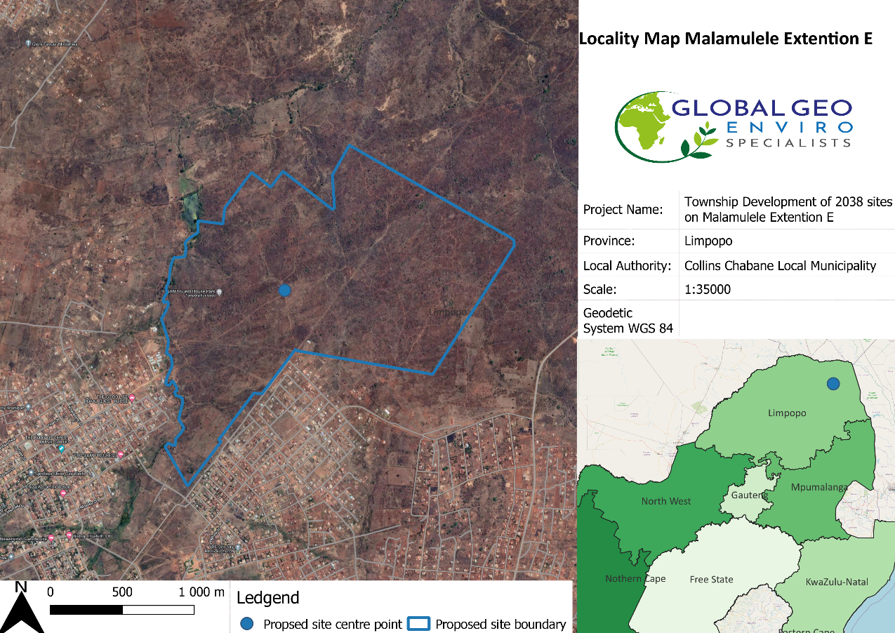
Figure 1 - Locality map of the proposed township development area in Malamulele
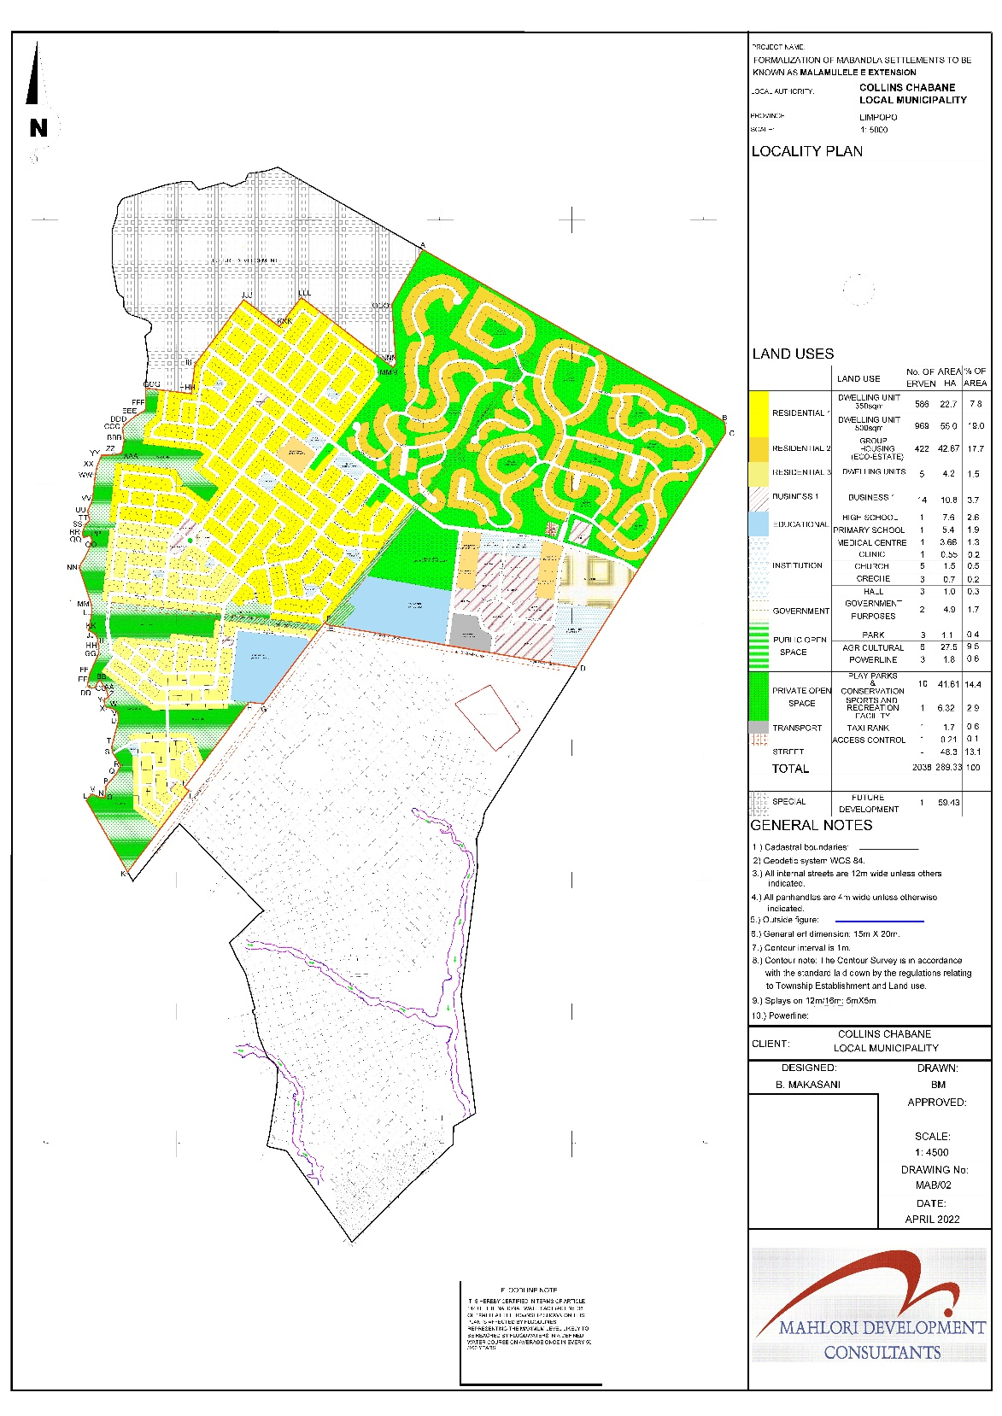
Figure 2- Proposed Layout of the proposed township development area in Malamulele
Figure SEQ Figure \* ARABIC 2 - Proposed Layout Plan for the proposed township development in Malamulele

PROPERTY DESCRIPTION

Topography
The area is characterised by an undulating landscape with associated flat moderate slopes with an approximate gradient of 5.2% on average.
The approximate altitudes above the mean sea level of the site are as follows Maximum: 565 m, Minimum: 528m, and Average: 544m.

Figure SEQ Figure \* ARABIC 3 - Topography of proposed Site
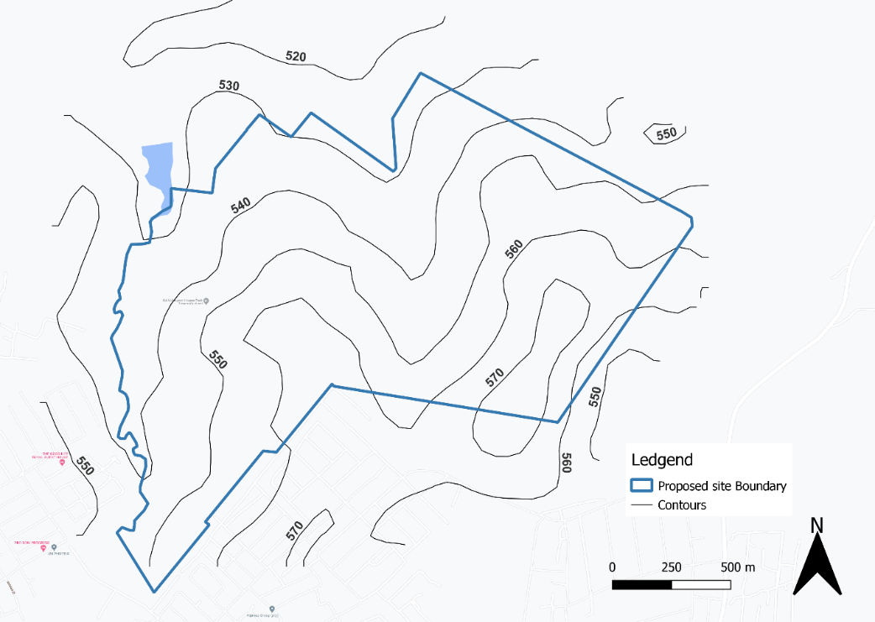
Figure 3 - Topography of the proposed development site in Malamulele

Geology and Soils
The Geology of the proposed site falls within the Meinhardskraal Granite and Sand River Gneiss groups. The principal rock types can be seen in figure 5 under the Giyani, Goudplaats-Hout River Gneiss and the Jerome Granites. The soil types and soil properties underlying the transported horizon is a ferruginous material that is underlain by slightly to moderately weathered granite, granite gneiss, amphibolite and dolerite dyke.

The Phase 1 Geotechnical Investigation will be described in the EIA Report in full as well as gives recommendations on the foundations that should be considered in during the construction phase of the proposed development.
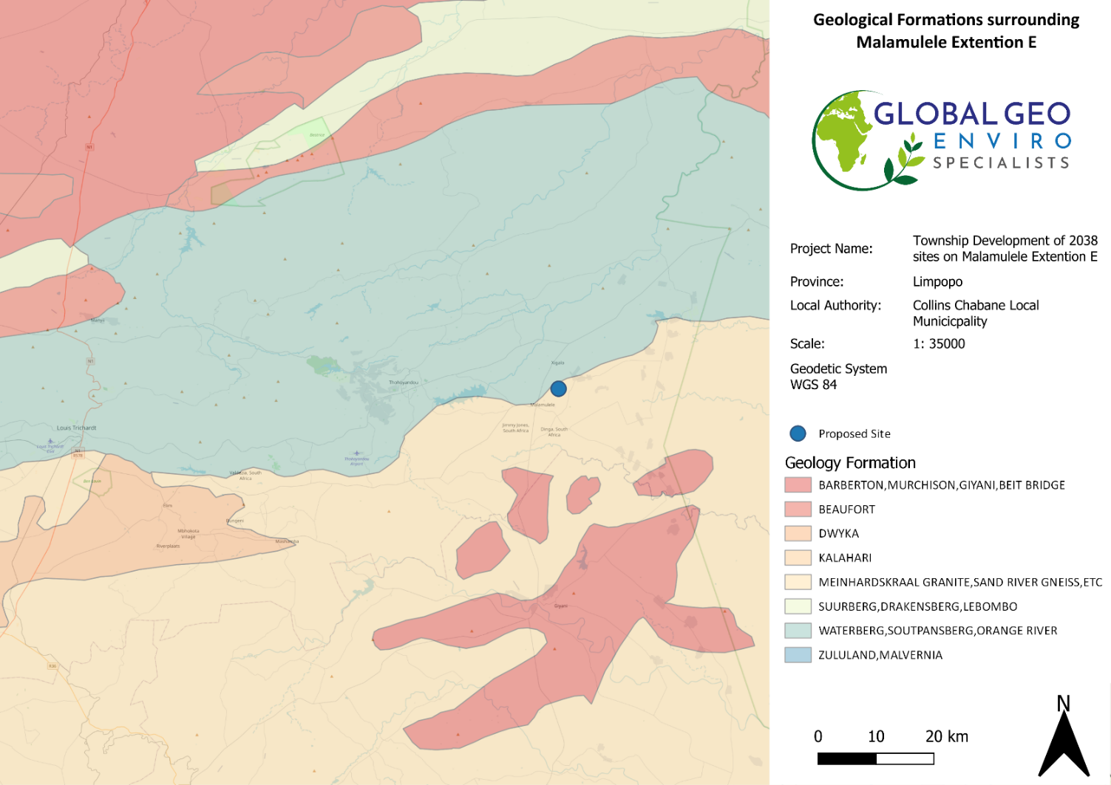
Figure 4 - Area Geology and rock types at the Proposed Township development site on Malamulele Extension E
Figure SEQ Figure \* ARABIC 4 - Description of Geology at the proposed Township development site on Malamulele Extension E
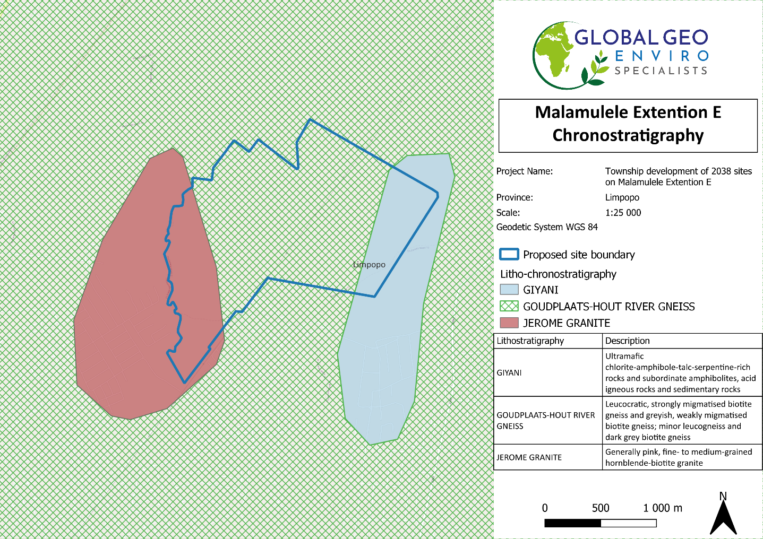
Figure 5 - Lithostratigraphy and principal rock types at the proposed Township development site on Malamulele Extension E

Climate
Collins Chabane Local Municipality is located in an arid region, and it has a very dry subtropical climate, specifically a humid subtropical climate with long hot and rainy summers coupled with short cool and dry winters. The climate can be considered as generally warm to temperate. Malamulele is considered a summer rainfall region.
According to (Geotsy, 2022) area’s maximum temperatures of Malamulele occurs in January with a maximum temperature of 34°c during the day and 18°c at night. The minimum annual temperatures occur in July with a maximum temperature of 23°c and a minimum temperature of 11°c.
Malamulele is a low-lying area and at risk of flooding.
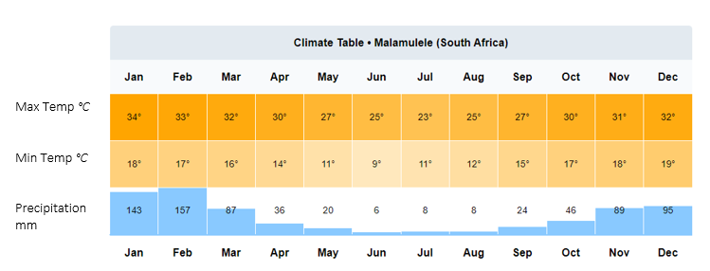
Figure SEQ Figure \* ARABIC 6 - Annual Climate table for Malamulele

Vegetation
Upon conducting a desktop study of the area using the 2018 National Vegetation map as seen on the Biodiversity Advisor of the South African National Biodiversity Institute (SANBI) the area surrounding the proposed site consists of predominately Granite Lowveld within the Savanna Biome and the Lowveld Bioregion as shown in figure 7 below.
It should be noted that some protected species were identified on the proposed site these include the Sclerocarya birrea, commonly known as the marula tree as well as the Combretum imberbe, commonly known as the Lead Wood tree. The protected species should be identified and considered during all phases of the proposed township development of sites. The proposed site is densely vegetated with predominantly grasslands and Sweet Thorn trees. A biodiversity study was conducted to further investigate the vegetation of the proposed site and the biodiversity study report will be described in the EIA Report.
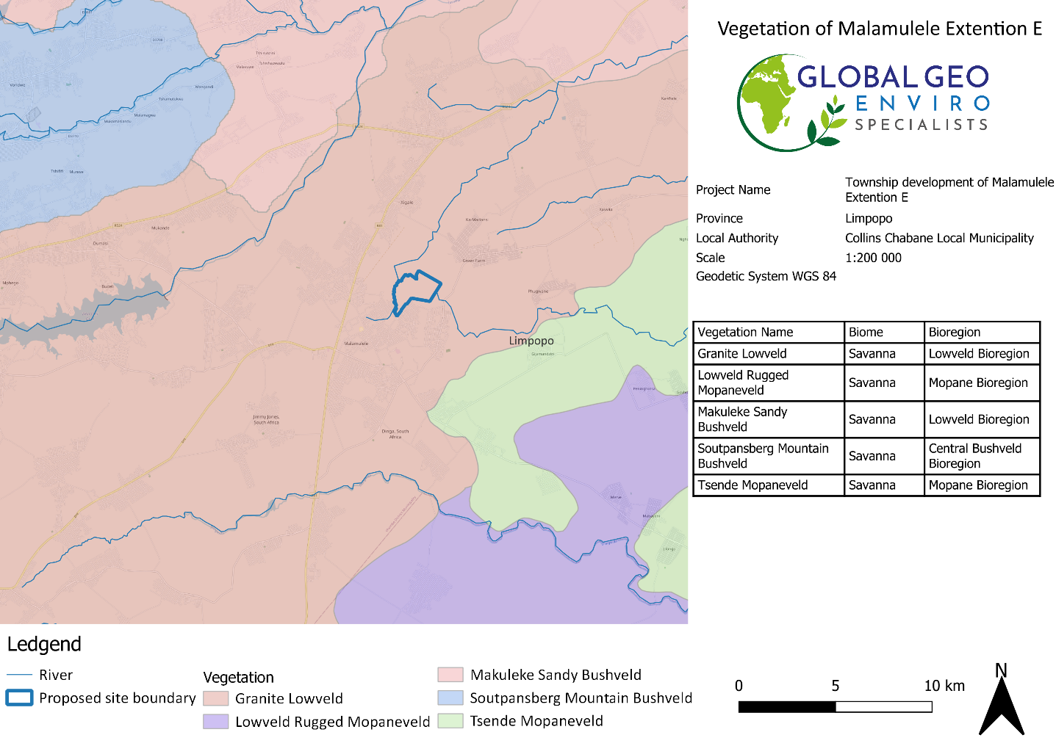
Figure 6 - Broad Terrestrial Vegetation for Malamulele proposed township development of sites

Environmental Sensitivity
The Sensitivity of the area is discussed in full in the Screening Report for an Environmental Authorisation as required by the 2014 EIA regulations and can be found in APPENDIX D. The screening report is generated by the National Screening Tool from the Department of Forestry, Fisheries, and the Environment.

Table 1 below indicated the relative sensitivities as generated by the National Screening Tool, only the highest sensitivity in each theme is indicated. These sensitivities are indicative and should be verified on-site by a suitably qualified person.

The verification and discussion of the environmental sensitivities will be discussed in full in the EIR.

Theme | Very High sensitivity | High sensitivity | Medium sensitivity | Low sensitivity
Agriculture |  | X
Animal Species |  | X
Aquatic Biodiversity |  |  |  | X
Archaeological and Cultural Heritage |  |  |  | X
Civil Aviation |  | X
Defence |  |  |  | X
Palaeontology |  |  | X
Plant Species |  |  | X
Terrestrial Biodiversity | X
Table 1 - Summary of Area Sensitivities - generated by the National Screening Tool from the Department of Forestry, Fisheries and the Environment

Socio-Economic Aspects
The following section provides a summary of the social and economic environment that may be influenced by the proposed project. Information in this section was sourced from the (Collins Chabane Local Municipality, 2021/22) Integrated Development Plans (IDPs).
Aspect | Collins Chabane Local Municipality
District Municipality | Vhembe District Municipality
Province | Limpopo Province
Municipal Area Size | 5 467.216km²
Number of Wards | 36
Population Size | 347 974 inhabitants
Number of households | According to (Collins Chabane Local Municipality, 2021/22)IDP, the number of households in the municipal area is 91936.
Estimated growth/change in population size from 2007 to 2017 | 1.6% increase
Population composition | The average growth rate is 0.9% according to (Collins Chabane Local Municipality, 2021/22)IDP. Approximately 347 975 people are residing in the municipal area. Black Africans (347109) had the highest number of people staying in Collins Chabane Local Municipal area, followed by Asian (301), Coloured (294) and White ( 271).
Languages | 99% of the people in Malamulele are the Vatsonga People and speak Xitsonga as their language.
Age | The distribution of the Collins Chabane population has a majority of 129019 Youths between the ages of 15-34, followed by 126835 Children between the ages of 1-14, 66017 Adults between the ages of 35-64 and 26104 Elderly people aged 65+,
Gender | The male and female population distribution of Collins Chabane Local Municipality is approximately 155051 males to 192924 females. There is therefore an unequal distribution with women being slightly in the majority.
Education | 20.7% of the population have no schooling, 21.3% have completed matric, and 6.8% have some form of higher education.
Land use | The dominant land use is commercial agriculture and farming activities and mixed residential land use.
Housing | The majority of households within the Collins Chabane Local Municipality live in Formal dwellings or brick/concrete block structures, the remainder of households being comprised of informal dwellings and other forms of housing (e.g., flats/rooms, Cluster houses in complex and townhouses).
Access to water | Only 4373 households in the municipality have access to piped water in their dwellings, with 35745 of the households having access to piped water in their yards, 24900 have access to piped water on community stands, with 2784 having access to Boreholes in their yards, and 96 have access to Rain-water tanks in their yards
Nearby towns | The municipality shares borders with Musina in the North, Thulamela in the North-east, the Mopani District in the South, and Makhado in the West
Percentage employment | One of the main challenges that the Municipality faces is the absence of data regarding the economic activities, employment, unemployment and income status.
Percentage unemployment
Large economic contribution | The main economic drivers in the municipality  are Agriculture, Mining, Infrastructure Development, and Manufacturing
Tourism | Malamulele does not have any predominant tourist attractions but is located approximately 50km from the Punda Maria entrance of the Kruger National Park on the R524 which causes some tourists to pass through Malamulele.
Table 2 - Summary of the socio-economic aspects

PROJECT ALTERNATIVES

In terms of Environmental Impact Assessment (EIA) regulation, the Environmental Assessment Practitioner (EAP) should investigate feasible and reasonable alternatives for the proposed project. In other words, different means of meeting the requirements for the activity.

According to the requirements listed within Appendix 2 (2) (g) (ix) of the 2014 amended EIA Regulations, a site selection matrix should be provided indicating how the preferred site was determined through a site selection process. On a site-specific level, the site was deemed suitable due to all the site selection factors being favourable. The site selection criteria considered by the Applicant are discussed in the table below.

FACTOR | SUITABILITY OF THE PREFERRED SITE
Land Availability | The remainder of Farm Malamulele No. 234-LT is a suitable size for the proposed project. The land is state-owned and available for development.
Site Accessibility | The proposed project site can be accessed via an existing gravel road. The existing gravel road can be accessed from the R81 National Road.
Topography | The area is characterised by an undulating landscape with associated flat moderate slopes with an approximate gradient of 5.2% on average.  The approximate altitudes above the mean sea level of the site are as follows Maximum: 565 m, Minimum: 528m, and Average: 544m.
Current Zone of Area | Agriculture
Landowner Willingness | The land is owned by the state and signed consent for the use of the land for the proposed project. This is considered an important aspect of the proposed project in terms of its viability (i.e. this will limit potential appeals during the decision-making process, as the landowner is willing and supportive of the proposed projects being undertaken on the remainder of the farm).
Table 3 - Site selection criteria
In the EIA process, the consideration of alternatives is always important, should the proposed site not fit
into the parameters of the EIA framework. The alternatives can be categorised as follows.
- Location alternatives
- Site Layout Alternatives
- Activity alternatives
- No-Go alternative
  - LOCATION ALTERNATIVE

The specific location has been chosen because it is adjacent to the existing Malamulele Village and owned by the state.
- The community of Malamulele identified a need for expansion, therefore, residential and other new developments in the area, currently developing at a fast rate, are a suitable option.
- The site is currently zoned as Agricultural.

There is no location alternative – the layout plan can only be moved around on the remainder of the farm Malamulele No. 234-LT.

A Biodiversity study, Geotechnical study and Heritage assessment will be undertaken before the proposed activity will take place to thoroughly assess the plausibility of the proposed location of the layout on the proposed site.

  - SITE LAYOUT ALTERNATIVE
- A geotechnical study will be conducted before development, and the positioning of certain parts of the layout of the development can be altered based on the ideal or most suitable soil conditions.
- By carrying out a Heritage assessment before development, the re-positioning of certain parts of the development can be based on the occurrence of heritage aspects. Areas can also be avoided if necessary due to the presence of heritage characteristics.

There is currently no layout alternative for the proposed development, however, there is a possibility of a layout alternative that will still meet the objective of the project scope.

.
  - ACTIVITY ALTERNATIVE

The purpose of the proposed activity is the township development of stands and formalisation of Mabandla villages on State-owned land, the township development includes public open spaces, private open spaces, residential, educational, business, institutional sites, and Government buildings. The proposed site is surrounded by residential developments, schooling as well as local businesses making the proposed activity preferably situated.
Based on the above, at this stage, there is no reason to suggest that any activity alternatives are investigated as these would not meet the general purpose and need of the proposed activity.
Therefore, no activity alternatives were investigated for this Scoping Report.

  - THE NO-GO ALTERNATIVE

The no-go alternative is the option not to go ahead with the proposed project. The no-go alternative will only be considered as an alternative if it is concluded that the preferred alternative will have significant negative impacts on the environment which cannot be reduced or managed to an acceptable level. As there have already been indicated that there is a need and desirability for the proposed demarcation it is anticipated that this demarcation will relieve the demand for housing and basic services in the region. It is anticipated that the no-go alternative will constrain the development planning of the Local Municipality.

LEGISLATIVE GUIDELINES

National Environmental Management Act, 1998 (Act No. 107 of 1998), as amended The National Environmental Management Act (NEMA) provides the legislative framework for Integrated Environmental Management (IEM) in South Africa. Section 24 provides that all activities that may significantly affect the environment and require authorization by law must be assessed before approval. NEMA also provides for cooperative environmental governance by establishing principles for decision-making on matters affecting the environment, institutions that will promote cooperative governance and procedures for coordinating environmental functions exercised by organs of the State and to provide for matters connected therewith. Section 2 of NEMA establishes a set of principles that apply to the activities of all organs of state that may significantly affect the environment. These include the following:
  - Development must be sustainable,
  - Pollution must be avoided or minimized and remedied,
  - Waste must be avoided or minimized, reused or recycled,
  - Negative impacts must be minimized, and
  - Responsibility for the environmental health and safety consequences of a policy, project, product or service exists throughout its life cycle.

These principles are taken into consideration when a government department exercises its powers, for example during the granting of permits and the enforcement of existing legislation or conditions of approval. Section 28(1) of NEMA states that “every person who causes, has caused or may cause significant pollution or degradation of the environment must take reasonable measures to prevent such pollution or degradation from occurring, continuing or recurring”. If such pollution cannot be prevented, then appropriate measures must be taken to minimize or rectify such pollution.

These measures may include:
  - Assessing the impact on the environment,
  - Informing and educating employees about the environmental risks of their work and ways of minimising these risks,
  - Ceasing, modifying or controlling actions that cause pollution/degradation,
  - Containing pollutants or preventing the movement of pollutants,
  - Eliminating the source of pollution, and
  - Remedying the impacts of the pollution,
  - The authorities may direct industry to rectify or remedy a potential or actual pollution problem,
  - If such a directive is not complied with, the authorities may undertake the work and recover the costs from the responsible industry.

LISTED ACTIVITY | Activity Description | Applicability of the Activity
Listing Notice 1 (GNR 984, 07 April 2017)  Activity 9 | The development of infrastructure exceeding 1 000 metres in length for the bulk transportation of water or stormwater—  - with an internal diameter of 0,36 metres or more; or  - with a peak throughput of 120 litres per second or more;  excluding where—  - such infrastructure is for bulk transportation of water or stormwater or stormwater drainage inside a road reserve or railway line reserve; or  - where such development will occur within an urban area. | The internal water reticulation network will have an internal diameter of 110mm to 500mm.  This, therefore, exceeds the 0.36m threshold.
Listing Notice 1 (GNR 984, 07 April 2017)  Activity 10 | The development and related operation of infrastructure exceeding 1 000 metres in length for the bulk transportation of sewage, effluent, process water, wastewater, return water, industrial discharge or slimes –  - with an internal diameter of 0,36 metres or more; or  - with a peak throughput of 120 litres per second or more;  excluding where—  - such infrastructure is for the bulk transportation of sewage, effluent, process water, wastewater, return water, industrial discharge or slimes inside a road reserve or railway line reserve; or  - where such development will occur within an urban area. | The internal sewage reticulation network will have a minimum internal diameter of 45mm  This, therefore, exceeds the 0.36m threshold.
Listing Notice 1 (GNR 984, 07 April 2017)  Activity 30 | Any process or activity identified in terms of section 53(1) of the National Environmental Management: Biodiversity Act, 2004 (Act No. 10 of 2004). | The removal of protected trees will require a DAFF Permit.  On the proposed development two protected tree species are found on site and the removal of these trees will require a DAFF permit.  The common names for these trees include the Marula and Lead Wood trees.
Listing Notice 2 (GNR 325 of 7 April 2017)  Activity 15 | The clearance of an area of 20 hectares or more of indigenous vegetation, excluding where such clearance of indigenous vegetation is required for  - the undertaking of linear activity; or  - maintenance purposes are undertaken in accordance with a maintenance management plan. | The proposed project involves the clearance of 289,33 hectares of indigenous vegetation for the proposed township development. This clearance of indigenous vegetation is greater than the 20-hectare threshold of this listed activity and therefore an application for Environmental Authorisation (EA) through a Scoping and EIA process is required.
Table 4 - Listed activities triggered by the proposed demarcation in terms of the NEMA EIA regulations (2014) as amended.

OTHER GUIDELINES AND DOCUMENTATION CONSIDERED IN THE DRAFTING OF THE SCOPING REPORT INCLUDE:

CONSTITUTION OF THE REPUBLIC OF SOUTH AFRICA

The Constitution of the Republic of South Africa has major implications for environmental management. The main effects are the protection of environmental and property rights, the change brought about by the sections dealing with administrative law, such as access to information, just administrative action and broadening of the locus standi of litigants. These 15 aspects provide general and overarching support and are of major assistance in the effective implementation of the environmental management principles and structures of the NEMA. Section 24 in the Bill of Rights of the Constitution specifically states that: Everyone has the right –
To an environment that is not harmful to their health or well-being, and,

To have the environment protected, for the benefit of present and future generations, through reasonable legislative and other measures that –
  - Prevent pollution and ecological degradation,
  - Promote conservation, and
  - Secure ecologically sustainable development and use of natural resources while promoting,
  - Justifiable economic and social development.

NOISE CONTROL REGULATIONS, 1992 (GN R.154)

In terms of section 25 of the ECA, the National Noise Control Regulations (GN R. 154 – NCRs) published in Government Gazette No. 13717 dated 10 January 1992, were promulgated. The NCRs were revised under GN R. 55 of 14 January 1994 to make it obligatory for all authorities to apply the regulations. The NCRs will need to be considered concerning the potential noise that may be generated mainly during the construction and decommissioning phases of the proposed project. The two key aspects of the NCRs relate to disturbing noise and noise nuisance. Section 4 of the Regulations prohibits a person from making, producing or causing a disturbing noise, or allowing it to be made produced or caused by any person, machine, device or apparatus or any combination thereof. Disturbing noises are defined in the Regulations as “a noise level which exceeds the zone sound level or if no zone sound level has been designated, a noise level which exceeds the ambient sound level at the same measuring point by 7 dBA or more.” Section 5 of the NCRs in essence prohibits the creation of a noise nuisance. A noise nuisance is defined as “any sound which disturbs or impairs or may disturb or impair the convenience or peace of any person.” Noise nuisance is not anticipated as part of the proposed farming activities as there are no nearby noise receptors.

NATIONAL ENVIRONMENTAL MANAGEMENT: BIODIVERSITY ACT, 2004 (ACT NO. 10 OF 2004)

The purpose of the Biodiversity Act is to provide for the management and conservation of South Africa’s biodiversity within the framework of the NEMA and the protection of species and ecosystems that warrant national protection. As part of its implementation strategy, the National Spatial Biodiversity Assessment was developed. This Act applies to this application for environmental authorisation, in the sense that it requires the project applicant to consider the protection and management of local biodiversity.

INTEGRATED ENVIRONMENTAL MANAGEMENT (IEM)

IEM is a philosophy for ensuring that environmental considerations are fully integrated into all stages of the development process. This philosophy aims to achieve a desirable balance between conservation and development (DEAT, 1992). The IEM guidelines intend to encourage a proactive approach to sourcing, collating and presenting information in a manner that can be interpreted at all levels. The DEA Integrated Environmental Management Information Series guidelines are also considered during this S&EIR application process. 17 EIA Regulations promulgated under the National Environmental Management Act, Act 107 of 1998, as amended (NEMA EIA Regulations, 2014) New EIA Regulations were promulgated under Section 24 of NEMA and came into effect on 04 December 2014. These EIA Regulations prescribe two different authorisation processes as follows:
  - The Basic Assessment Process; and
  - The Scoping and EIA process.
Irrespective of which process applies, the Regulations make provision for the following:
  - Public Participation must be undertaken at various stages during the assessment process.
  - Assessments must be conducted by an Independent Environmental Assessment Practitioner (EAP).
  - The authority delegated with deciding on environmental applications responds to applications and submissions within stipulated timeframes.
  - Decisions taken by the authorities can be appealed by the proponent or any other interested and affected party (IAP).

NATIONAL HERITAGE RESOURCES ACT, 1999 (ACT NO. 25 OF 1999)

The National Heritage Resources Act (NHRA) (Act 25 of 1999) stipulates that cultural heritage resources may not be disturbed without authorization from the relevant heritage authority. Section 34(1) of the NHRA states that “No person may alter or demolish any structure or part of a structure which is older than 60 years without a permit issued by the relevant provincial heritage resources authority…”. The last few years have seen a significant change toward the inclusion of heritage assessments as a major component of the Environmental Impacts Processes required by NEMA. This change requires us to evaluate the Section of these Acts relevant to heritage. The NEMA 23(2)(b) states that an integrated environmental management plan should, “…identify, predict and evaluate the actual and potential impact on the environment, socio-economic conditions and cultural heritage”. A study of subsections (23) (2)(d), (29)(1)(d), (32)(2)(d) and (34)(b) and their requirements reveals the compulsory inclusion of the identification of cultural resources, the evaluation of the impacts of the proposed activity on these resources, the identification of alternatives and the management procedures for such cultural resources for each of the documents noted in the Environmental Regulations.

AUTHORITY CONSULTATION

The competent authority to approve the proposed Township developmentLimpopo Department of Economic Development, Environment and Tourism. The site does not have implications for international environmental commitments or relations; and will not take place within an area protected by employing an international environmental instrument, or the site is not a conservancy; a protected natural environment; a proclaimed private nature reserve; a natural heritage site; the buffer zone or transitional area of a biosphere reserve; or the buffer zone or transitional area of a world heritage site. Therefore, the competent authority has been correctly identified, based on the above reasons.

SPECIALIST STUDIES

In terms of section 24(5)(h) of the NEMA, 1998 (Act No 107 of 1998) and regulation 16(1)(b)(v) of the EIA regulations, 2014, as amended, the required DEFF Screening Report is provided as part of Appendix E. After running the DEFF screening tool, specialist studies that were deemed necessary after preforming a desktop study as well as a site visit included:
- Archaeological / Heritage Assessment
- Ecological/ Biodiversity Study
- Geotechnical study
- Engineering Services Report
- Flood line Report

Relevant Specialists will be appointed to conduct the above-mentioned studies. These studies will be used to identify possible impacts during a scoping study phase and the mitigation of impacts during the EIA phase of the project.

ENVIRONMENTAL AUTHORISATION PROCESS
Global Geo Enviro Specialists, as independent environmental consultants, will facilitate the implementation of the Integrated Environmental Management (IEM) process as per the approved EIA Guideline as seen in Figure 4 below:
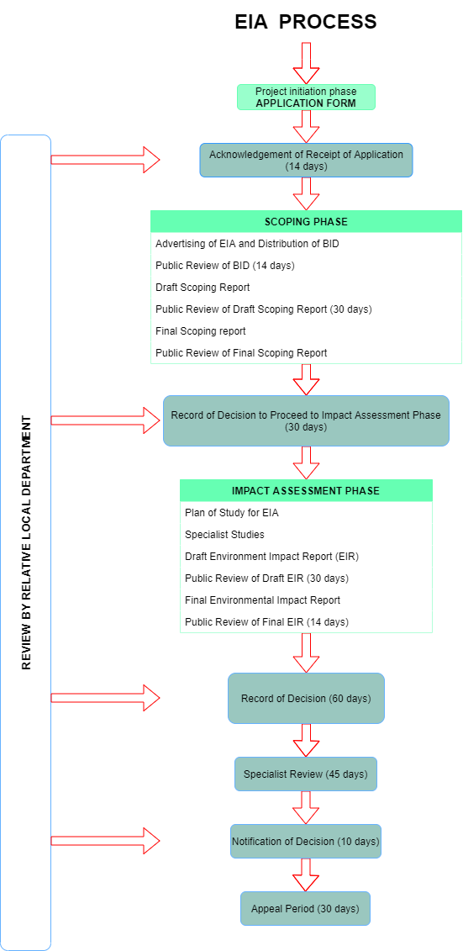
Figure SEQ Figure \* ARABIC 8 - EIA process flow diagram

ENVIRONMENTAL IMPACT ASSESSMENT
During the Scoping Process, a range of potential impacts that may have a significant impact on the environment have been identified and will be subject to further investigation as part of the Impact Assessment Phase. A summary of the potential environmental impacts that were identified is provided below; further details of the impacts that require further investigation are described in the section below:

PROCEDURE
The impact significance rating methodology is presented herein in tables 3, 4 and 5, which is guided by the requirements of the NEMA EIA Regulations 2014 (as amended). The methodology addresses possible impacts that can be predicted in the planning, construction and operational phases of the proposed activity. A broad approach to the significance rating methodology is used to determine the environmental risk (ER) by considering the consequence of each impact in terms of Extent, Duration, Intensity, Probability and Significance of the impact occurring. The ER is determined for the pre-and post-mitigation scenarios. In addition, cumulative impacts are taken into account when determining the environmental impact assessment. The impact assessment will be applied to all identified alternatives.

Description of Potential Impacts to be further investigated.
The following Potential Impacts must be further investigated using the Methodology described below in Tables 3, 4 and 5.

Geology and Soil
During the demarcation of sites, the clearing of vegetation may lead to some soil erosion depending on the soil properties, ground slope, vegetation, and rainfall amount and intensity. During construction, a disturbance in surface geology may occur as a result of laying foundations. The potential impacts relating to geology and soil will be evaluated by a specialist geotechnical report that will elaborate on the underlying geology and the soil composition and texture of the site.

Topography
Erosion during the clearing and construction phases of the project may lead to an impact on the topography. Building material may also alter the topography of the area.

Topsoil and Land use
During the clearing and construction phase of the project, soil recourses including essential topsoil may be impacted. Erosion of topsoil may occur as well as the compaction of the soil.

Fauna
Impact on Fauna may occur as a result of the disruption of habitats during the construction phase and clearing phase of the project.

Flora
A loss in vegetation may occur during the demarcation phase when clearing the area as well as the removal of vegetation before construction activities take place. The site is located within an area marked with a high potential for terrestrial impact.

Air Quality
CO² Emissions from construction vehicles and machinery, as well as dust during the construction phase, will have an impact on air quality.

Archaeology and Palaeontology
The possibility occurs that the construction activity may lead to an impact on Archaeology and Palaeontology aspects.

Visual Impacts
The visual perspective of the property will be changed.

Socio-Economic
Socio-Economic can be divided into the following two categories:

Positive Socio-Economic Impacts:
The proposed development will result in job creation during the construction phase of the project and community improvement during the operational phase with the services to be provided.

Negative Socio-Economic Impacts:
An increase in criminal activities in the local regions of the proposed activity. Safety impacts may occur as a result of improper safety management on site.

Cumulative Impacts
Cumulative Impacts include a potential change in surface and groundwater source quality. This impact will be investigated further in the Impact Assessment Report.

Nature | Classification of whether the impact is positive or negative, direct or indirect.
Extent | Spatial scale of impact and classified as:  Site: The impacted area is the whole site or a significant portion of the site.  Local: Within a radius of 2 km of the construction site.  Regional: The impacted area extends to the immediate, surrounding and neighbouring properties.  National: The impact can be considered to be of national significance.
Duration: | Indicates the lifetime of the impact and is classified as:  Short term: The impact will either disappear with mitigation or will be mitigated through natural processes in a span shorter than the relevant project phase.  Medium-term: The impact will last for the period of the relevant project phase in which it takes place, whereafter it will be entirely negated.  Long-term: The impact will continue or last for the entire operational life of the development but will be mitigated by direct human action or by natural processes thereafter. The only class of impact that will be non-transitory.  Permanent: Mitigation either by man or natural process will not occur in such a way or in such a time that the impact can be considered transient.
Intensity: | Describes whether an impact is destructive or benign;  Low: Impact affects the environment in such a way that natural, cultural and social functions and processes are not affected.  Moderate: The affected environment is altered, but natural, cultural and social functions and processes continue albeit in a modified way.  High: Natural, cultural and social functions and processes are altered to extent that they temporarily cease.  Very High: Natural, cultural and social functions and processes are altered to extent that they permanently cease.
Probability: | Describes the likelihood of an impact occurring:  Improbable: The likelihood of the impact materializing is very low.  Possible: The impact may occur.  Highly Probable: Most likely that the impact will occur.  Definite: Impact will occur.
Significance: | Based on the above criteria the significance of issues was determined. The total number of points scored for each impact indicates the level of significance of the impact and is rated as follows:  Low: The impacts are less important.  Medium: The impacts are important and require attention; mitigation is required to reduce the negative impacts.  High: The impacts are of great importance. Mitigation is therefore crucial.
Cumulative: | About an activity, means the impact of an activity that in itself may not be significant but may become significant when added to the existing and potential impacts eventuating from similar or diverse activities or undertakings in the area.
Mitigation: | Where negative impacts are identified, mitigation measures (ways of reducing impacts) have been identified. An indication of the degree of success of the potential mitigation measures is given per impact.
Table 5 - Description of Impacts

PROPOSED METHODOLOGY FOR ASSESSING ENVIRONMENTAL IMPACTS

Criteria for the rating of impacts
Criteria | Description
Extent | National | Regional | Local | Site
Duration | Permanent | Long-term | Medium-term | Short-term
Intensity | Very high | High | Moderate | Low
Probability | Definite | Highly probable | Possible | Improbable
Points allocation | 4 | 3 | 2 | 1
Table 6 - Point Allocation for the rating of Impacts.

Significance of Rating classified impacts
Impact | Points | Description
Low | 4-6 | A low impact has no permanent impact of significance. Mitigation measures are feasible and are readily instituted as part of a standing design, construction or operating procedure.
Medium | 7-9 | Mitigation is possible with additional design and construction inputs.
High | 10 -12 | The design of the site may be affected. Mitigation and possible remediation are needed during the construction and/or operational phases. The effects of the impact may affect the broader environment.
Very high | 13-16 | The design of the site may be affected. Mitigation and possible remediation are needed during the construction and/or operational phases. The effects of the impact may affect the broader environment.
Status | Perceived effect of the impact
Positive (+) | Beneficial impact
Negative (-) | Adverse impact
Negative impacts are shown with a (-) while positive ones are indicated as (+)
Table 7 - The significance of the ratings on proposed impacts.

PUBLIC PARTICIPATION
The public participation process was undertaken following regulations as set in Regulation 54 of the EIA regulations. The process followed to conduct public participation is presented in figure 2 below.
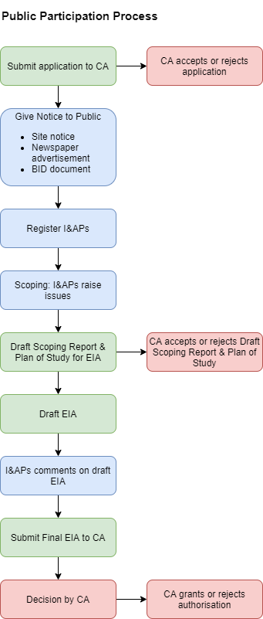

NOTICE TO THE PUBLIC / I&AP REGISTRATION PERIOD

The commencement of the EIA process / I&AP registration period is being advertised for 30 days through the use of a newspaper advertisement in the Giyani View on the 19/05/2022, site notices and the list of stakeholders who will be directly notified:

- Publication of a notice in English will be posted in the local newspaper (The Giyani View).
- Site notices in English and Xitsonga describing the proposed development and location, as well as contact details for where more information is needed will be placed near the site as well as in communal areas close to the proposed site; see
- Direct notification of identified Interested and/or Affected Parties (I&APs).
- The public will be informed following a meeting with the Chief of the area. Background Information Documents (BID) presented in English and Xitsonga will be handed out in the areas surrounding the proposed site as well as explaining the proposed project to the public. The sole purpose thereof is to allow members of the public and stakeholders to communicate with the project team to obtain information about the proposed project and to have their comments, queries and/or concerns addressed.

AVAILABILITY OF CONSULTATIVE DRAFT SCOPING REPORT FOR REVIEW AND COMMENT
This consultative Draft Scoping Report is currently available for public review and comment for a period from May 2022 to June 2022. All registered Interested and Affected Parties are welcomed to request electronic copies through an email, and such will be provided accordingly.

PLAN OF STUDY FOR ENVIRONMENTAL IMPACT ASSESSMENT
The following Plan of Study for EIA sets out the proposed approach to the Environmental Impact Assessment phase of the application. Description of the tasks to be undertaken during the Scoping and Environmental Impact Assessment Process as well as the tasks that have been undertaken are summarized below, with details of the tasks to be undertaken provided in more detail. Please see the full Plan of Study attached in Appendix D.

CONCLUSION AND RECOMMENDATIONS
The above draft report provides an extensive introduction to the issues that apply to the proposed Township development and highlights important issues to be investigated during the EIA Phase of the project. The EIA Phase will draw on the above information and make use of the recommended specialist studies to reach an objective decision on the overall impact of the proposed township development.

The EIA Phase must culminate in the compilation of mitigation measures to reduce impacts and the identification of sensitive areas within the study area which may require more specific management measures. The EIA Phase will also aim to optimize and improve potential positive impacts that may result from the proposed development. Specialist studies conducted during the scoping phase for the proposed development will identify any fatal flaws in the project site. However, several potentially significant (positive and negative) environmental impacts will be identified and will need to be evaluated during the detailed EIR phase of the project.

In addition, the EIR Phase will provide a more detailed comparative analysis of these potential impacts against the “no-go” alternative. Detailed mitigation and management measures will be developed during the Environmental Management Program (EMPr) phase of the project, in response to the detailed assessment, and will be run towards the end of the EIR phase of the project. Please note that this is not an environmental authorization, therefore the proposed activity must not commence until the Environmental Authorization is obtained from the Competent Authority (LEDET).

APPENDICES

