
FINAL BASIC ASSESSMENT REPORT
and
ENVIRONMENTAL MANAGEMENT PROGRAMME REPORT
SUBMITTED FOR ENVIRONMENTAL AUTHORISATIONS IN TERMS OF THE NATIONAL ENVIRONMENTAL MANAGEMENT ACT, 1998 AND THE NATIONAL ENVIRONMENTAL MANAGEMENT WASTE ACT, 2008 IN RESPECT OF LISTED ACTIVITIES THAT HAVE BEEN TRIGGERED BY APPLICATIONS IN TERMS OF THE MINERAL AND PETROLEUM RESOURCES DEVELOPMENT ACT, 2002 (MPRDA) (AS AMENDED).
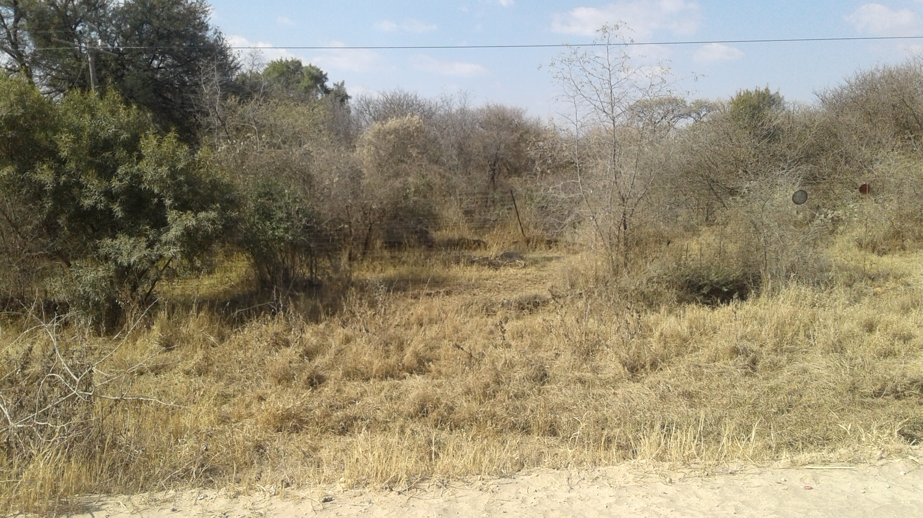
ESTABLISHMENT OF BORROW PIT FOR EXCAVATION OF GRAVEL MATERIAL FOR CONSTRUCTION OF 10 KM EXISTING GRAVEL ROAD P124-1 FROM THE DWARSBERG INTERSECTION (ROAD D506 WITH ROAD P124-1) TO MOLATEDI VILLAGE WITHIN THE MOSES KOTANE LOCAL MUNICIPALITY

NAME OF APPLICANT : Department of Public Works and Roads
TEL NO : 018 388 1679
POSTAL ADDRESS : Private Bag X2037, Mmabatho, 2735
PHYSICAL ADDRESS : Modiri Molema Street, Old Parliament Complex
FILE REFERENCE NUMBER SAMRAD : NW30/5/1/1/3/2/1/00048EM

IMPORTANT NOTICE
In terms of the Mineral and Petroleum Resources Development Act (Act 28 of 2002 as amended), (“MPRDA”) the Minister must grant a prospecting or mining right if among others the mining “will not result in unacceptable pollution, ecological degradation or damage to the environment”.

Unless an Environmental Authorisation can be granted following the evaluation of an Environmental Impact Assessment and an Environmental Management Programme report in terms of the National Environmental Management Act (Act 107 of 1998) (NEMA), it cannot be concluded that the said activities will not result in unacceptable pollution, ecological degradation or damage to the environment.

In terms of section 16(3) (b) of the EIA Regulations, 2014, any report submitted as part of an application must be prepared in a format that may be determined by the competent authority and in terms of section 17 (1) (c) the competent authority must check whether the application has taken into account any minimum requirements applicable or instructions or guidance provided by the competent authority to the submission of applications.

It is therefore an instruction that the prescribed reports required in respect of applications for an environmental authorisation for listed activities triggered by an application for a right or a permit are submitted in the exact format of, and provide all the information required in terms of, this template. Furthermore please be advised that failure to submit the information required in the format provided in this template will be regarded as a failure to meet the requirements of the Regulation and will lead to the Environmental Authorisation being refused.

It is furthermore an instruction that the Environmental Assessment Practitioner must process and interpret his/her research and analysis and use the findings thereof to compile the information required herein. (Unprocessed supporting information may be attached as appendices). The EAP must ensure that the information required is placed correctly in the relevant sections of the Report, in the order, and under the provided headings as set out below, and ensure that the report is not cluttered with un-interpreted information and that it unambiguously represents the interpretation of the applicant.

Objective of the basic assessment process

The objective of the basic assessment process is to, through a consultative process─
(a) Determine the policy and legislative context within which the proposed activity is located and how the activity complies with and responds to the policy and legislative context;
(b) identify the alternatives considered, including the activity, location, and technology alternatives;
(c) describe the need and desirability of the proposed alternatives,
(d) through the undertaking of an impact and risk assessment process inclusive of cumulative impacts which focused on determining the geographical, physical, biological, social, economic, heritage, and cultural sensitivity of the sites and locations within sites and the risk of impact of the proposed activity and technology alternatives on the these aspects to determine:
(i) the nature, significance, consequence, extent, duration, and probability of the impacts occurring to; and
(ii) the degree to which these impacts—
(aa) can be reversed;
(bb) may cause irreplaceable loss of resources; and
(cc) can be managed, avoided or mitigated;
(e) through a ranking of the site sensitivities and possible impacts the activity and technology alternatives will impose on the sites and location identified through the life of the activity to—
(i) identify and motivate a preferred site, activity and technology alternative;
(ii) identify suitable measures to manage, avoid or mitigate identified impacts; and
(iii) identify residual risks that need to be managed and monitored.

PART A SCOPE OF ASSESSMENT AND BASIC ASSESSMENT REPORT

CONTACT PERSON AND CORRESPONDENCE ADDRESS
Contact Person | Lesego Senna
Address | 25 Caroline Close  Rowlands Estate  Mafikeng,  2745
Tel No | 018 011 0002/083 763 7854
Fax No | 086 541 6369
E-mail address | lesego@lesekha.co.za

:

Details of

Details of the EAP
Lesego Senna
ii) Expertise of EAP.
- The qualifications of EAP
Lesego Senna is a qualified Environmental Practitioner who managed and coordinated the EIA study of the project in discussion. Lesego holds the Bachelor Degree: in Natural Science majoring in Microbiology and Biochemistry. She also holds an Honours Degree: Environmental Sciences, Majoring in Environmental Impact Assessment and Earth Sciences – North West University (Potchefstroom Campus).
Lesego holds a certificate in Environmental Law (NQF level 7) with the following courses: Waste Management, Biodiversity Management, Waste Management, Heritage Assessment, Environmental law & Environmental Impact Assessment obtained from the Centre of Environmental Management at Potchefstroom University). She also holds a certificate in GIS and GPS course (NQF level 5) from the Free State University, with the following Modules: Spatial data Structures; Spatial data symbolisation and analysis and interpretation Map design. Lesego is a registered Environmental Scientist registered with the South African Council of Natural Scientific Profession SACNASP (Reg.No.300029/14). The acquired qualifications and experience demonstrated that we are uniquely qualified to undertake this Environmental Impact Assessment Study.
- Summary of EAP’s past experience
(In carrying out the Environmental Impact Assessment Procedure)
Lesego compiled the EMPr for obtaining the mining permit for all the roads projects for application of the mining permit as contemplated in Section 27 of the Mineral and Petroleum Resources Development Act, 2002 MPRDA (Act 28 of 2002).
Please refer to the attached details of a Practitioner attached as Appendix 1

3) Location of the overall Activity

Farm Name: | Molatedi Village
Application area (Ha) | The mining footprint is 3.2 ha
Magisterial district | Moses Kotane Local Municipality within the Bojanala District Municipality
Distance and direction from nearest town | The nearest Town is 80km from Swartruggens and Rustenburg is 120.5 km
21 digit Surveyor General Code for each farm portion | The area to be mined is not surveyed it’s in a communal land administrated by Kgosi

Table 1: Coordinates of the Borrowpit No 4

REFERENCE POINT | LONGTUDE | LATITUDE
A | 24°52'5.21"S | 26°36'2.31"E
B | 24°52'4.46"S | 26°35'54.19"E
C | 24°52'10.82"S | 26°35'55.56"E
D | 24°52'12.98"S | 26°36'1.04"E

c) Locality map
(Show nearest town, scale not smaller than 1:250000)

Figure 1: locality map for Dwarsberg

d) Description of the scope of the proposed overall activity.
Provide a plan drawn to a scale acceptable to the competent authority but not less than 1: 10 000 that shows the location, and area (hectares) of all the aforesaid main and listed activities, and infrastructure to be placed on site.

The Department of Public Works and Roads intends to commence with mining of the gravel material from the borrow pit on piece of land under the Molatedi Tribal Authority in the Dwarsberg area. The gravel material will be used as surface material for the upgrade of the P124-1 gravel road to tar. The total mining area identified for the borrow pit is 3.2ha however clearance of vegetation will only confine to 0.6ha footprint to mine the gravel material. The estimated Volume of the gravelled material to be mined on borrow pit 4 is about 14 000m³. No infrastructure will be placed on site; once the gravel material has been mined it will be hauled to the road construction site. The borrow pit is on the communal land administered by Molatedi Traditional authority. The purpose of the proposed establishment of the suitable identified borrow-pit No.4 is to provide gravel material to be used to upgrade the existing road, P-124-1 road. The borrow-pit will therefore be strategic borrow-pit, operating when the need for reserve material exists. The mineral used for a specific contract, will be extracted to obtain optimal usage of the phase. The area disturbed the contractor will, after completion of the contract, rehabilitate the area.
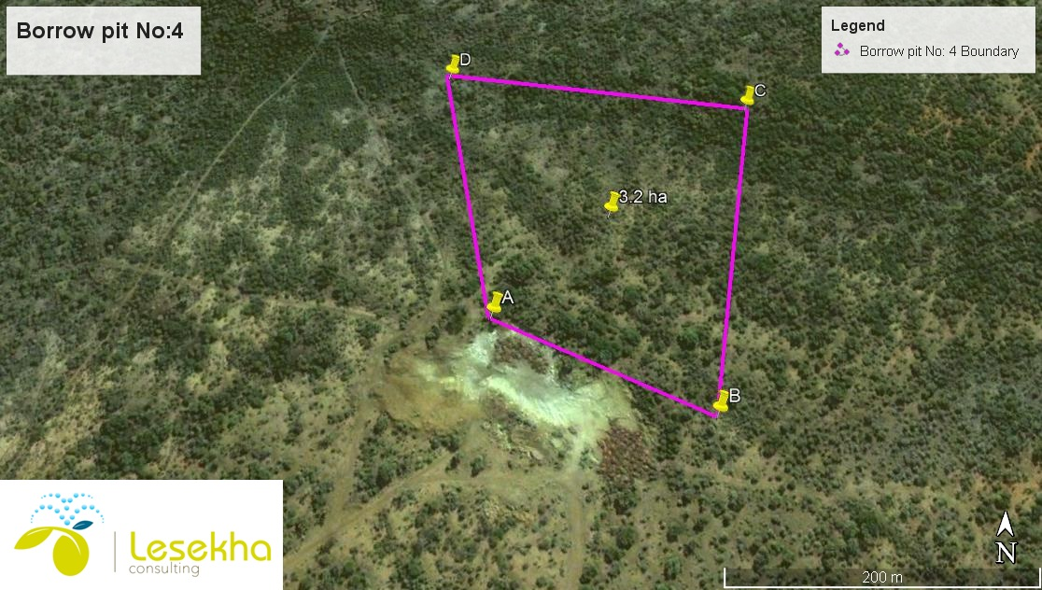

Figure 2 locality map for borrow pit No.4

(I) listed and specified activities
NAME OF ACTIVITY  (E.g. For prospecting - drill site, site camp, ablution facility, accommodation, equipment storage, sample storage, site office, access route etc…etc…etc.  E.g. for mining,- excavations, blasting, stockpiles, discard dumps or dams, Loading, hauling and transport, Water supply dams and boreholes, accommodation, offices, ablution, stores, workshops, processing plant, storm water control, berms, roads, pipelines, power lines, conveyors, etc…etc…etc.) | AERIAL EXTENT  OF THE ACTIVITY  Ha or m² | LISTED  ACTIVITY  Mark with an X where  applicable or Affected. | APPLICABLE  LISTING  NOTICE  (GNR 327 ,  GNR 326 or  GNR 325)
Any activity including the operation of that activity which requires a mining permit in terms of section 27 of the Mineral and Petroleum Resources Development Act, 2002 (Act No. 28 of 2002), including —  - associated infrastructure, structures and earthworks, directly related to the extraction of a mineral resource[,] ; or [including activities for which an exemption has been issued in terms of section 106 of the Mineral and Petroleum Resources Development Act, 2002 (Act No. 28 of 2002)]  This project will include the open cast/trenching (earthworks) method of extraction. | 3.2 ha | X | Listing Notice 1.GN R. 327, 07 April 2017. Activity 21
The clearance of an area of 1 hectare or more, but less than 20 hectares, of Indigenous vegetation, except where such clearance of indigenous vegetation is required for-(i) The undertaking of a linear activity.  (ii) Maintenance purposes undertaken in accordance with a maintenance management plan. | 3.2 ha | X | Listing Notice 1. GN R. 327, 07 April 2017 Activity 27

(ii) Description of the activities to be undertaken
(Describe Methodology or technology to be employed, including the type of commodity to be prospected/mined and for a linear activity, a description of the route of the activity).

The Department of Public Works and Roads is proposing a small scale mining of borrow pits for gravel material. The borrow pit contains the gravel material that is required as surface material for the upgrading of the gravel road P124-1. The estimated quantity of material to be mined is approximately 14 000m³ of gravel material. The project will entail an open cast/surface method of excavation; mined gravel material will be hauled using trucks to the construction site. The proposed project will include the application for a mining permit which triggers a listed activity in terms of the Environmental Impact Assessment (EIA) Regulations, Government Notice Regulations GN R. 327, 07 April 2017 promulgated under the National Environmental Management Act (NEMA) (Act no 107 of 1998).
The surface area will be rehabilitated by establishing the general topography of the surrounding area, ensuring that there are no remnants of the gravel material. Closure and rehabilitation of pits will be undertaken when the activities are completed in those pits. Post-closure monitoring will assist in determining the success of the rehabilitation and also identify whether any additional measures need to be taken to ensure the area is restored to a reasonable and acceptable condition.
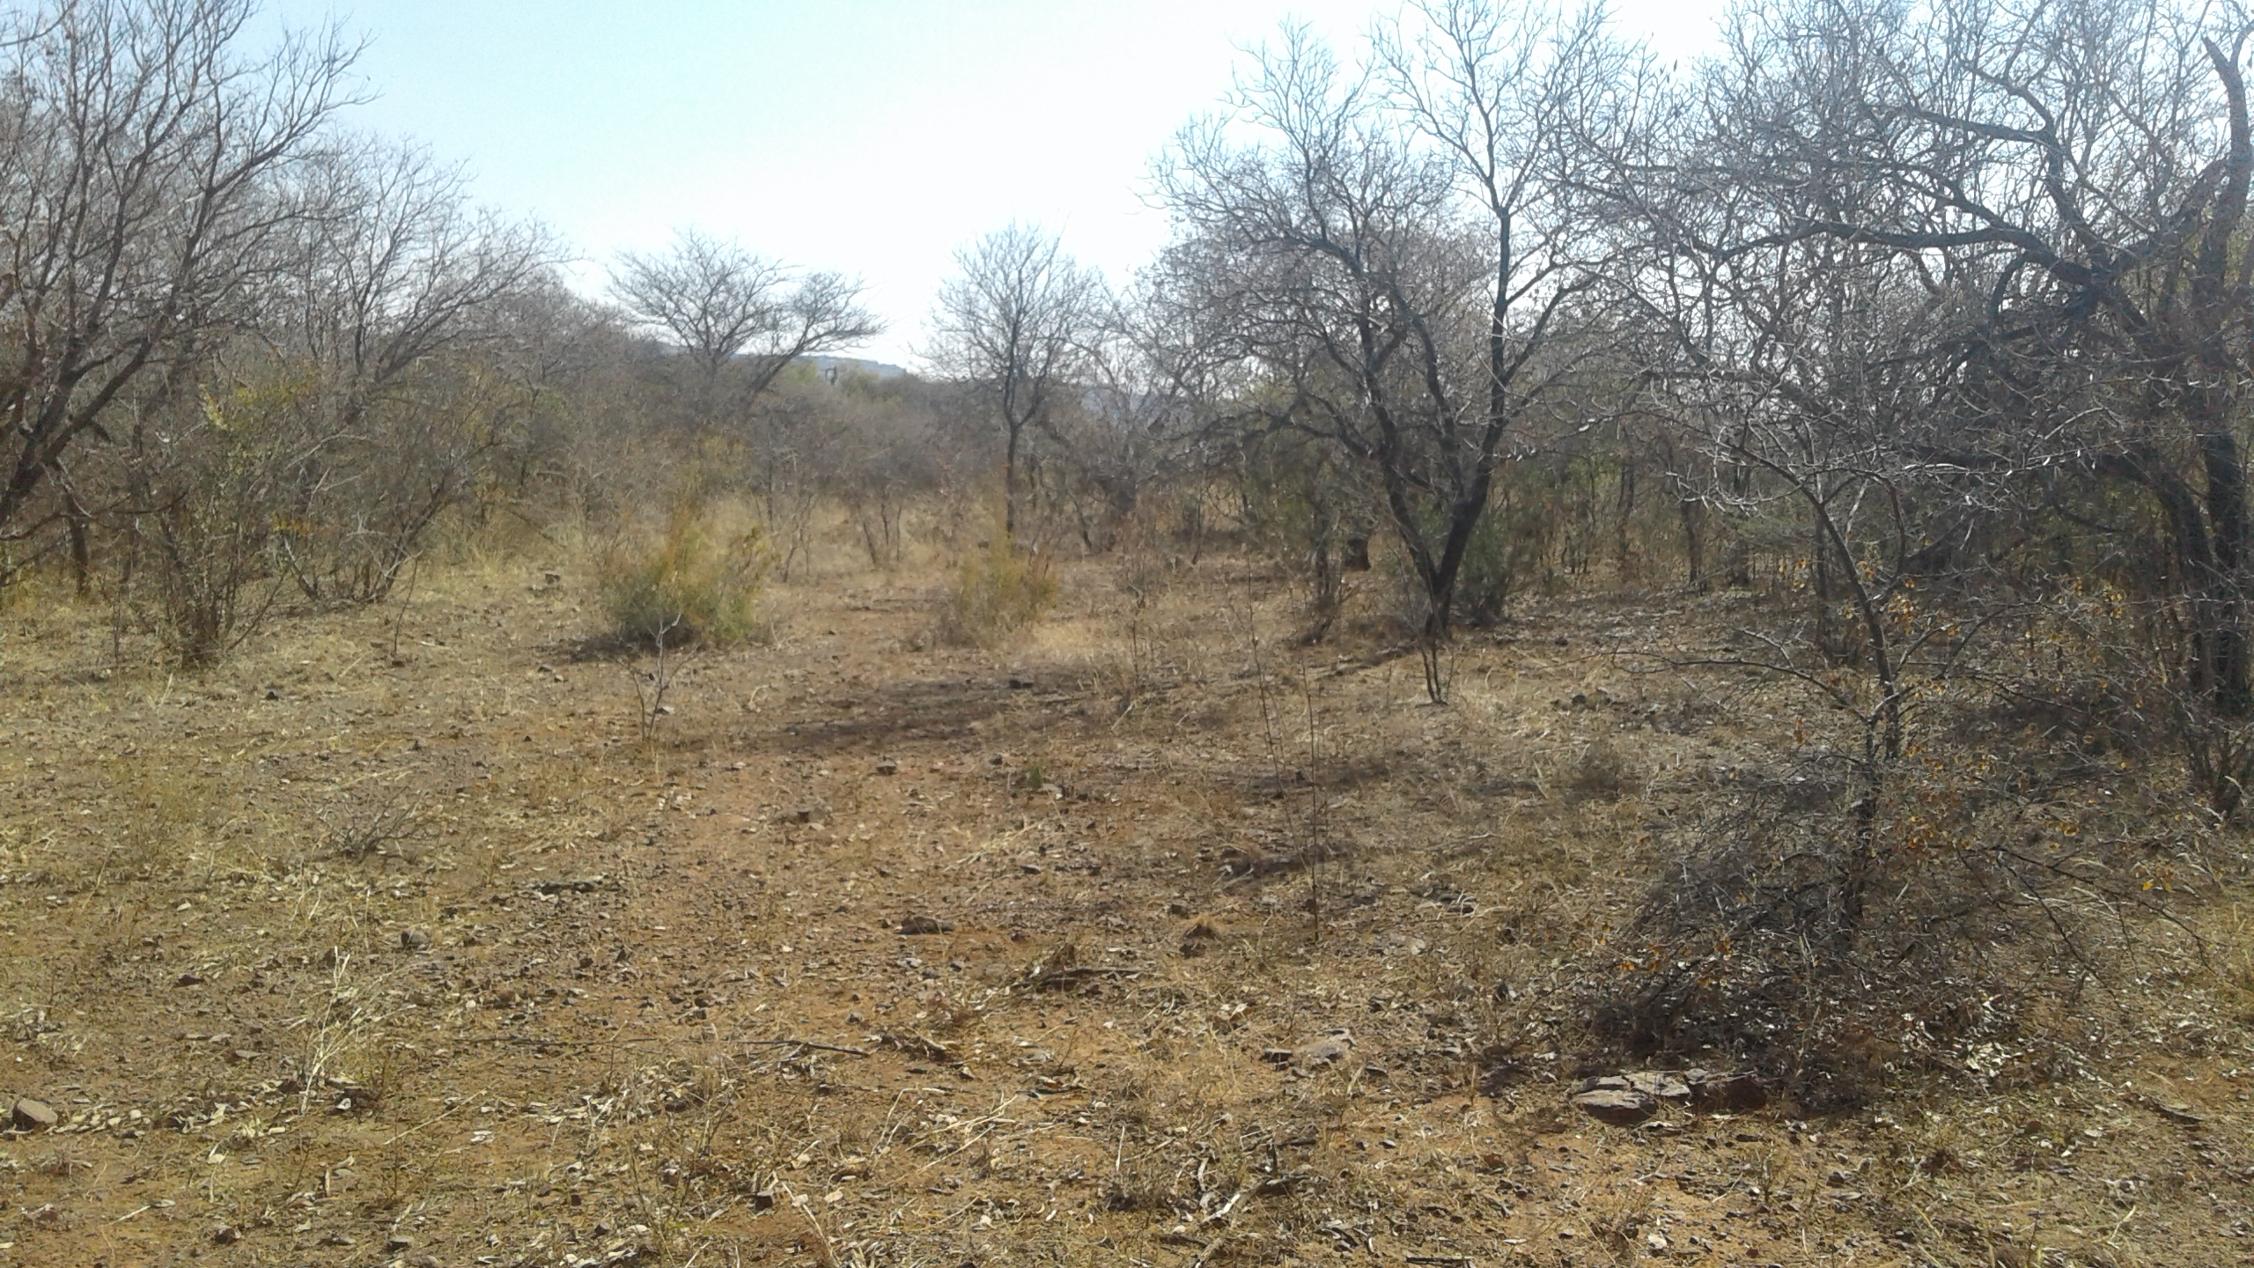
Picture 1: The current state of the Borrow pit site

e) Policy and Legislative Context
APPLICABLE LEGISLATION AND GUIDELINES USED TO COMPILE THE REPORT  (A description of the policy and legislative context within which the development is proposed including an identification of all legislation, policies, plans, guidelines, spatial tools, municipal development planning frameworks and instruments that are applicable to this activity and are to be considered in the assessment process. | REFERENCE WHERE APPLIED | HOW DOES THIS DEVELOPMENT COMPLY WITH AND RESPOND TO THE LEGISLATION AND POLICY CONTEXT.  (E.g. In terms of the National Water Act. Water Use License has not been applied for)
The Constitution of South Africa (No108 of 1996) | Section 24 of CSA | The Constitution, which is the cornerstone of the democracy in South Africa, lays the foundation of a more just and equitable society. It guarantees everyone the right to an environment that is not harmful to their health or wellbeing and guarantees the right to have the environment protected, for the benefit of present and future generations, through reasonable legislative and other measures.
National Environmental Management Act (Act 107 of 1998), as amended | S24(1) of NEMA  S28(1) of NEMA | This Basic Assessment is being undertaken in terms of the National Environmental Management Act (No. 107 of 1998). This is in order to determine any possible impacts on the environment and to propose sufficient mitigation in order to not harm the environment.
National Mineral and Petroleum Resources Development Act (Act No 28 of 2002) | Section 102 | A mining permit application has been applied for.
National Environmental Management: Biodiversity Act (Act No. 10 of 2004) | Mining Activities | The potential impact on Conservation Important Floral and faunal species in the Study Area, and the management thereof is addressed in this BAR.
National Environmental Management Air Quality Act (Act No. 39 of 2004, Government Gazette No. 27318) (NEMAQA) | Mining Activities | Standards for particulates and dust are used to regulate the concentration of a substance that can be tolerated without any environmental deterioration.
The National Heritage Resources Act (No. 25 of 1999) | Management/monitoring measures | The National Heritage Resources Act legislates the necessity for cultural and heritage impact assessment in areas earmarked for development, which exceed 0.5 hectares (ha). The proposed borrow pit mining operations will not have any impact on Heritage resources, as no resources of significance were identified within the footprint of the proposed development.
National Forests Act (Act 84 of 1998) (NFA) | Section 3 of NFA | The principles of the National Forests Act (Act 84 of 1998) (NFA) pertain to;  - The protection of natural forests (except under exceptional circumstances when the Minister determines that the proposed development is preferable in terms of its economic, social or environmental benefits)  - The conservation of a minimum area of each woodland type; and  - The management of forests to ensure sustainability of resources (wood, soil, biological diversity, etc)  No person may cut, disturb, damage or destroy any indigenous living tree in, or destroy any indigenous living tree in, or remove or receive any such tree from, a natural forest except in terms of-  - A license issued under subsection (1) or section 23; or  - An exemption from the provisions of this subsection published by the Minister in the Gazette on the advice of the Council.
The Occupational Health and Safety Act, 1993 (No 85 of 1993) | Section 8 of OHSA | The Occupational Health and Safety Act, 1993 (No 85 of 1993) provides for the health and safety of persons at work; for the health and safety of persons in connection with the use of plant and machinery at the borrow pits , and the protection of plant and machinery; and the protection of persons other than persons at work against hazards to health and safety arising out of or in connection with the activities of persons at work. A number of regulations are published under this Act including:  - Environmental Regulations for Workplaces (GN R2281 of 1987-10-16)  - Regulations for Hazardous Chemical Substances (GN R179 of 1995-08-25)  - Asbestos Regulations (GN R109 of 2003-01-17)
The Mine Health and Safety Act, 1996 (No 26 of 1996) | Mining Activities | The Mine Health and Safety Act, 1996 (No 26 of 1996) provides for the protection of health and safety of employees and other persons at mines and serves-  - To promote a culture of health and safety;  - To provide for the enforcement of health and safety measurements;  - To provide for appropriate systems for employee, employer and state participating in health and safety matters;  - To provide effective monitoring systems and inspections, investigations and inquiries to improve health and safety;  - To promote training and human resource of development;  - To regulate employers’ and employees’ duties to identify hazards and eliminate, control and minimise the risk to health and safety;  To entrench the right to refuse to work in dangerous conditions.
North West Provincial Development Plan | Needs and desirability of the proposed activities | Municipal plans were used to identify relevant socio-economic information and spatial development information with regards to the area relevant to the project site.

f) Need and desirability of the proposed activities.
(Motivate the need and desirability of the proposed development including the need and desirability of the activity in the context of the preferred location).

Table 2: Need and Desirably of the Dwarsberg Road Project
Need and desirability of the proposed project
Questions |  | Answer
Part 1: Need
1 | Is the land use associated with the activity being applied for considered within the timeframe intended by the existing approved SDF agreed to be the relevant environmental authority? | Yes. The proposed development is in line with the projects and programs identified as priorities within the Moses Kotane Local municipality SDF to enhance environmentally sound and safe roads that is compatible with the present land use.
2 | Should the development, or if applicable, expansion of the town/area concerned in terms of this land use occurs here at this point in time? | Yes, according to the Regional Developmental Overview for Moses Kotane the proposed project falls within an area which is demarcated as “rural”, and the intention of development in this area is to create vibrant, equitable and sustainable rural development which provides food and work opportunities.
3 | Does the community/area need the activity and the associated land use concerned? This refers to the strategic as well as local level. | Yes it does. According to the LED strategy of 2016, this is a predominantly rural region. Farming activities focus on cattle ranching, and maize, wheat, fruit and vegetable cultivation. Several kinds of minerals, including gold, diamonds platinum also mined. Agriculture and mining form the economic backbone of the district.
4 | Are the necessary services with adequate capacity currently available (at the time of application) or must additional capacity is created to cater for the development? | Yes. The proposed project will be using water directly from Marico river and will not rely on municipal water services.
5 | Is this development provided for in the infrastructure planning of the municipality, and if not what will the implication is on the infrastructure planning of the municipality (priority and placement of the services and opportunity cost)? | The development is not provided for in the infrastructure planning of the municipality as it is a small development of local importance. Thus, the proposed project will not have any implications for the infrastructure planning, as no services and/or infrastructure needs to be upgraded or created to cater for this development.
6 | The project part of a national programme to address an issue of national concern or importance? | This project is part of national program to address the roads and bridge infrastructures issues. The needs for proper and safe roads have become priority in South Africa. This is because of increasing in population and urbanization that places pressure on the roads and the environment.  In addition, The National Development Plan  (NDP) Vision for 2030 offers a long-term perspective. It defines a desired destination and identifies the role different sectors of society need to play in reaching that goal. The main goals highlighted in the NDP which pertain to the proposed project are employment. Chapter 6 of the National Development Plan highlights an “inclusive rural economy” and the objectives of this plan are to create jobs.
Part II: Desirability
1 | Is the development the best practicable environmental option for this land/site? | Yes. This site does not have a high agricultural potential due to over grazing. The current land use map attached highlights the current state of the site. The area is characterized by high levels of poverty and the project will create employment thus offers a solution fitting with the surrounding environment.
2 | Would the approval of this application compromise the integrity of the existing approved and credible IDP and SDF as agreed to by the relevant authorities? | No. The proposed project aligns itself with the Moses Kotane Local Municipalities IDP for 2015/2016. The following strategic objectives are sought to be achieved and are aligned with the objectives of the proposed project:  - Promote shared economic growth and  - job creation  - Improve financial sustainability  - Continue institutional development, transformation and innovation.
3 | Would the approval of this application compromise the integrity of the existing environmental management priorities for the area (e.g. as defined in EMFs), and if so, can it be justified in terms of sustainability considerations? | No, the integrity of the existing environmental management priorities for the area will not be compromised by this development.
4 | Do location factors favour this land use at this place? (this relates to the contextualization of the proposed land use on this site within its broader context). | Yes, this area is characterised by has low agricultural potential and high levels of poverty so the project will help to alleviate these problems.
5 | How will the activity of the land use associated with the activity being applied for, impact on sensitive natural and cultural areas (built and rural/natural environment)? | The development of the proposed development associated with temporary infrastructure measuring around 3.2 ha in size will exert an impact on the environment; but based on the impact assessment findings and the locality of the site, the impacts associated with this proposed development can be mitigated to an acceptable level (Low, Low-Medium).
6 | How will the development impact on people’s health and well-being? (E.g. In terms of noise, odours, visual character and sense of place, etc.)? | Please refer to (v) of this Report with regards to the Impact Assessment. In summary, due to the fact that this area has an extremely low density of residents and dwellings the impacts on well-being, following mitigation, will be as follows:  - Visual: Low  - Dust: Low  - Noise: Low  - Sense of place: Low
7 | Will the proposed land use result in unacceptable cumulative impacts? | No. The proposed project has only been identified to have minimal cumulative impacts that can be mitigated to an acceptable level. The measures outlined in the EMP attached will serve as a method to keep the proposed project from having any serious long term cumulative impacts on the receiving environment.

g) Motivation for the overall preferred site, activities and technology alternative.
The proposed borrow pit site is located at Molatedi Village in the Moses Kotane Local Municipality according to the municipality IDP 2015/2016; the road should be delivered to the community. The proposed method of open pit mining allows easy access of machinery to the site and does not require extensive machinery as other methods, making it feasible for gravel mining. It reduces the overall costs associated with the mining process.

No alternative sites are selected as the preferred site has adequate and good quality material needed for the road construction. This is the relevant site close to the construction site. Mining of the gravel material will boost the economic development through this proposed project which is surrounded by the Dwarsberg and Molatedi villages. This project will provide employment opportunities, thus stimulating development of the communities. The preferred site has the material to construct durable roads.

The parameters taken into account therefore motivating the site selection is the following.
- Several test pits have been studied and borrow pit has proved to have the most suitable material for the road upgrade purposes.
- No significant endemic vegetation needs to be cleared during the mining activities.
- No critical biodiversity areas or threatened ecosystems will be negatively impacted.
- The proposed site has adequate space to excavate and protect the topsoil for rehabilitation purposes.
- Noise and dust impacts are not deemed to be significant, seeing that the proposed Borrow Pit is not in close proximity to any residential areas.
The open cast mining of the area (using an excavator and front end loader) was identified as the most effective method to obtain the desired material. Due to the small size of the activity and the remote location of the mining area the potential impacts on the surrounding environment, associated with open cast mining, is deemed to be of low significance.

h) Full description of the process followed to reach the proposed preferred alternatives within the site.
NB!! – This section is about the determination of the specific site layout and the location of infrastructure and activities on site, having taken into consideration the issues raised by interested and affected parties, and the consideration of alternatives to the initially proposed site layout.

A soil sample was taken from this borrow pit to investigate the quality and adequacy of the gravel material. This borrow pit has the needed material therefore there was no need to assess another alternatives. The preferred borrow pit did not have any fatal flaws or limited resources based on the surrounding land use, material present, volume of available material, vegetation sensitivity and surrounding erosions. The chosen borrow pit is therefore preferred site for having the good quality material need for upgrading the road.

i) Details of the development footprint alternatives considered.

With reference to the site plan provided and the location of the individual activities on site, provide details of the alternatives considered with respect to:

(a) the property on which or location where it is proposed to undertake the activity;
(b) the type of activity to be undertaken;
(c) the design or layout of the activity;
(d) the technology to be used in the activity;
(e) the operational aspects of the activity; and
(f) the option of not implementing the activity.

(a) The property on which or location where it is proposed to undertake the activity;

The site is situated at Molatedi village approximately 80 km directly north of Swartruggens and approximately 50 km north-west of the Pilanesberg Nature Reserve in the Northwest Province. The proposed borrow pit will be at the communal land administered by Molatedi Traditional Authority, located East of Molatedi residential vicinity and is administered by Molatedi tribal authority. The borrow pit is approximately 3.2ha.
Fig figure 3: Locality map of the borrow pit 4

- The type of activity to be undertaken;
No project alternatives were considered for this assessment. The mining permit is required for the sole purpose of excavating gravel material to be used as surface material for the upgrade of the P124- 1 gravel road.

(c) The design or layout of the activity;
The gravel material mining does not require any infrastructure such as offices, storage areas. Constructing infrastructure would not be feasible and an unnecessary intrusion and not preferred. TLB, trucks, shovels and excavators will be used to mine the gravel material and the material will further be hauled by trucks to the construction site. No other alternative technologies can be used because of the nature of the mineral.

(d) The technology to be used in the activity;

The preferred mining method (using an excavator, front end loaders and haul trucks) is a proven mining method for this type of mineral and for the small scale of mining. This mining method is also considered to have a low environmental impact if managed correctly. No other mining method will be assessed.
These mining methods are standard practise for opencast mining operations. The reasons for the abovementioned method being implemented are driven by the dimension and size of the proposed gravel material mining, and the required amount of gravel material that has to be produced in order to comply with targets. Technology does not have a bearing on the proposed mine.

(e) The operational aspects of the activity; and

Gravel material from the borrow-pit will be transported by trucks to and stockpiled at the road construction areas. The transport by road is therefore the only alternative considered due to the existing haul roads in the area.

(f) The option of not implementing the activity.

The no-go activity has been considered, and assumes that should the proposed activity not proceed then the status quo would remain. This project is in an area of mineral potential and that the proposed road/mining would lead to job creation, contribution to the GDP of the municipality and the province, and be an opportunity to improve the local socio-economic situation. Thus, the no-go option will not be taken forward into the assessment phase.

Department of Public Works and Roads as the custodian of all provincial and national roads will not reach its mandate of providing proper road. Locally the Integrated Development Plan of Moses Kotane Local Municipality states the aim as being that of providing basic services such as roads and developing the local economy. The upgrade of these roads will contribute towards the achievement of both of these goals by providing continued jobs for the road staff, by providing proper and safe roads in the area, boosting South Africa’s economy.

Should the proposed gravel material mining operation therefore not be authorised to proceed, it is anticipated that status quo of the road will not improve and the roads will continue to be muddy and pose danger to road users. No-Go alternative is therefore not a feasible option in this case as it suggests that the road not be upgraded. Accidents will still continue to happen and dust emitted from the road will still persist and pose health hazards to the community.

ii) Details of the Public Participation Process Followed

Describe the process undertaken to consult interested and affected parties including public meetings and one on one consultation. NB. The affected parties must be specifically consulted regardless of whether or not they attended public meetings. Information to be provided to affected parties must include sufficient detail of the intended operation to enable them to assess what impact the activities will have on them or on the use of their land.
The following steps were undertaken as part of the public participation process in order to notify interested and affected parties:
1. Potential I&APs were identified through the use of an existing I&AP databases. The existing databases include landowners, neighbouring landowners, community members and non-governmental organisations (NGOs) who have participated in previous EIA processes in the area.
2. I&APs were notified about the project by means of:
- Letters to surrounding landowners;
- Media advertisements and site notices; and
- Written notifications to the Local Municipalities.
3. Newspaper advertisements were placed in the Rustenburg Herald a local newspaper.
4. A Background Information Document (BID) was circulated to all surrounding Dwarsberg community. The BID highlighted the proposed project and invited participants to participate in the BA process. A reply form was attached to the BID on which I&APs can provide written comments on the proposed development.
5. I&APs will have the opportunity to review and comment on the Final Basic Assessment Report.
6. I&APs will be notified of the environmental authorisation, once received and the appeal process to be followed.

iii) Summary of issues raised by I&APs
(Complete the table summarising comments and issues raised, and reaction to those responses) Comments have been received from Interested and Affected Parties (I&AP’s) at the time of the meeting that was held at Obakeng hall (Please refer to the minutes attached as Appendix 4)

Interested and Affected Parties  List the names of persons consulted in this  column, and mark with an X where those who  must be consulted were in fact consulted. | Date of  comments  received | Issues raised | EAP’s response to issues as mandated by the applicant | Section and paragraph  reference in this report  where the issues and or  response were  Incorporated.
AFFECTED PARTIES
Batlokwa Traditional Authority (Molatedi Village)  Mr Dirang 082 939 02505 | 27 July 2017 | He is very grateful for the construction of the road although they were promised a 17 km road | Consent from the land owner is important aspect of EIA. | N/A
Emily Badimela | 26 August 2017 | We are looking forward to the construction of the road. | The construction of the road in the Dwarsberg is will improve the standards of living of the local community. | N/A
Arafat Hosan | 26 August 2017 | He want the road as it will make it easy for him to travel to Molatedi and Botswana | The construction of the road will result in the improved in service delivery and the road will become safer to use. | N/A
Welemina Kujane | 26 August 2017 | There construction of the road is a need to the community. | The construction of the road will reduce impacts such as dust, flooding of the bridge and it will make the road safer. | N/A
Gloria Sephati  Cell: 082 5136278 | 27 July 2017 | We had experience about contractors who promise to rehabilitate and fail to do so. | In terms of Regulation all mining activity encompassed closure plan/rehabilitation plan. After excavating borrow pit must be rehabilitated to mitigate risk to animals and human being. | N/A
Betty Mokgongwane  Cell: 078 388928 | 27 July 2017 | After the excavating gravel material, where are you going to obtain soil to refill excavated site | Before commencement of excavating gravel material, topsoil is the soil that will be used for rehabilitation. | N/A
Mamogale Legari [mamogale.legari@sanparks.org] | 10 October 2017 | Requested for the map for borrow pits. | A copy of the map was provided. | N/A
Dorcas Mokgogwa  Cell: 083 925 800 | 27 July 2017 | What are the community will be able to benefits about the excavating gravel material | Community will benefits in various ways such as creation of jobs, after clearance of vegetation community will be able to be donated or offered to collect firewood from damaged or destroyed trees/vegetation and tar road. | N/A
Mr Ntuane (landowner ) | 23 August 2017 | No comment | N/A | N/A
Interested Parties
Department of Agriculture, Forestry and Fisheries  Mr L. Nevhufumba  Email:NevhufumbaL@daff.gov.za. | No comment received yet | No issues | Site inspection was done, awaiting for comments | N/A
Department of Water and Sanitation Ms Lethabo Ramashala 012 253 1026 | No comment received yet | No comment | Report was submitted, still waiting for comments. | N/A
Municipal Councillor (ward 1)  Mr.Tunzi | No comment received yet | No comment | N/A | N/A
Moses Kotane Local Municipality  Mr Chiloane 060 966 4869 | No comment received yet | No comment | N/A | N/A

iv). The Environmental attributes associated with the alternatives.

(The environmental attributes described must include socio-economic, social, heritage, cultural, geographical, physical and biological aspects).
(1) Baseline Environment

- Type of environment affected by the proposed activity.
(Its current geographical, physical, biological, socio- economic and cultural character).

Introduction

This section provides a general description of the environment in which the proposed borrow pit mining operation is proposed. The purpose of this section is to provide a perspective of the local environment within which the proposed mining operation will be located, with a view to identify sensitive issues/areas, such as wetlands or other ecological aspects, which need to be considered when conducting the impact assessment and designing the various components of the project.

  - Topography of the site.

The MKLM lies on a fairly flat but undulating landscape intercepted by mountain ranges, hills and rocky outcrops (koppies). The Pilanesberg and Dwarsberg Mountains serve as the two prominent topographical features in MKLM. The two main drainage systems in the area are the Thulane and Kolobeng Rivers. Thulane River drains in a northerly direction from Madikwe Dam in the south-west of MKLM, to Molatedi Dam in the north-west of MKLM. Kolobeng River drains in a north-easterly direction. The secondary and tertiary drainage system consists of a number of other small rivers such as the Sehubyane, Pitsedisulejang, Sedutlane, Metselodi, Motlhabe, Lesobeng, Sandspruit, Mogoditshane, Mankwe, and Phulane.

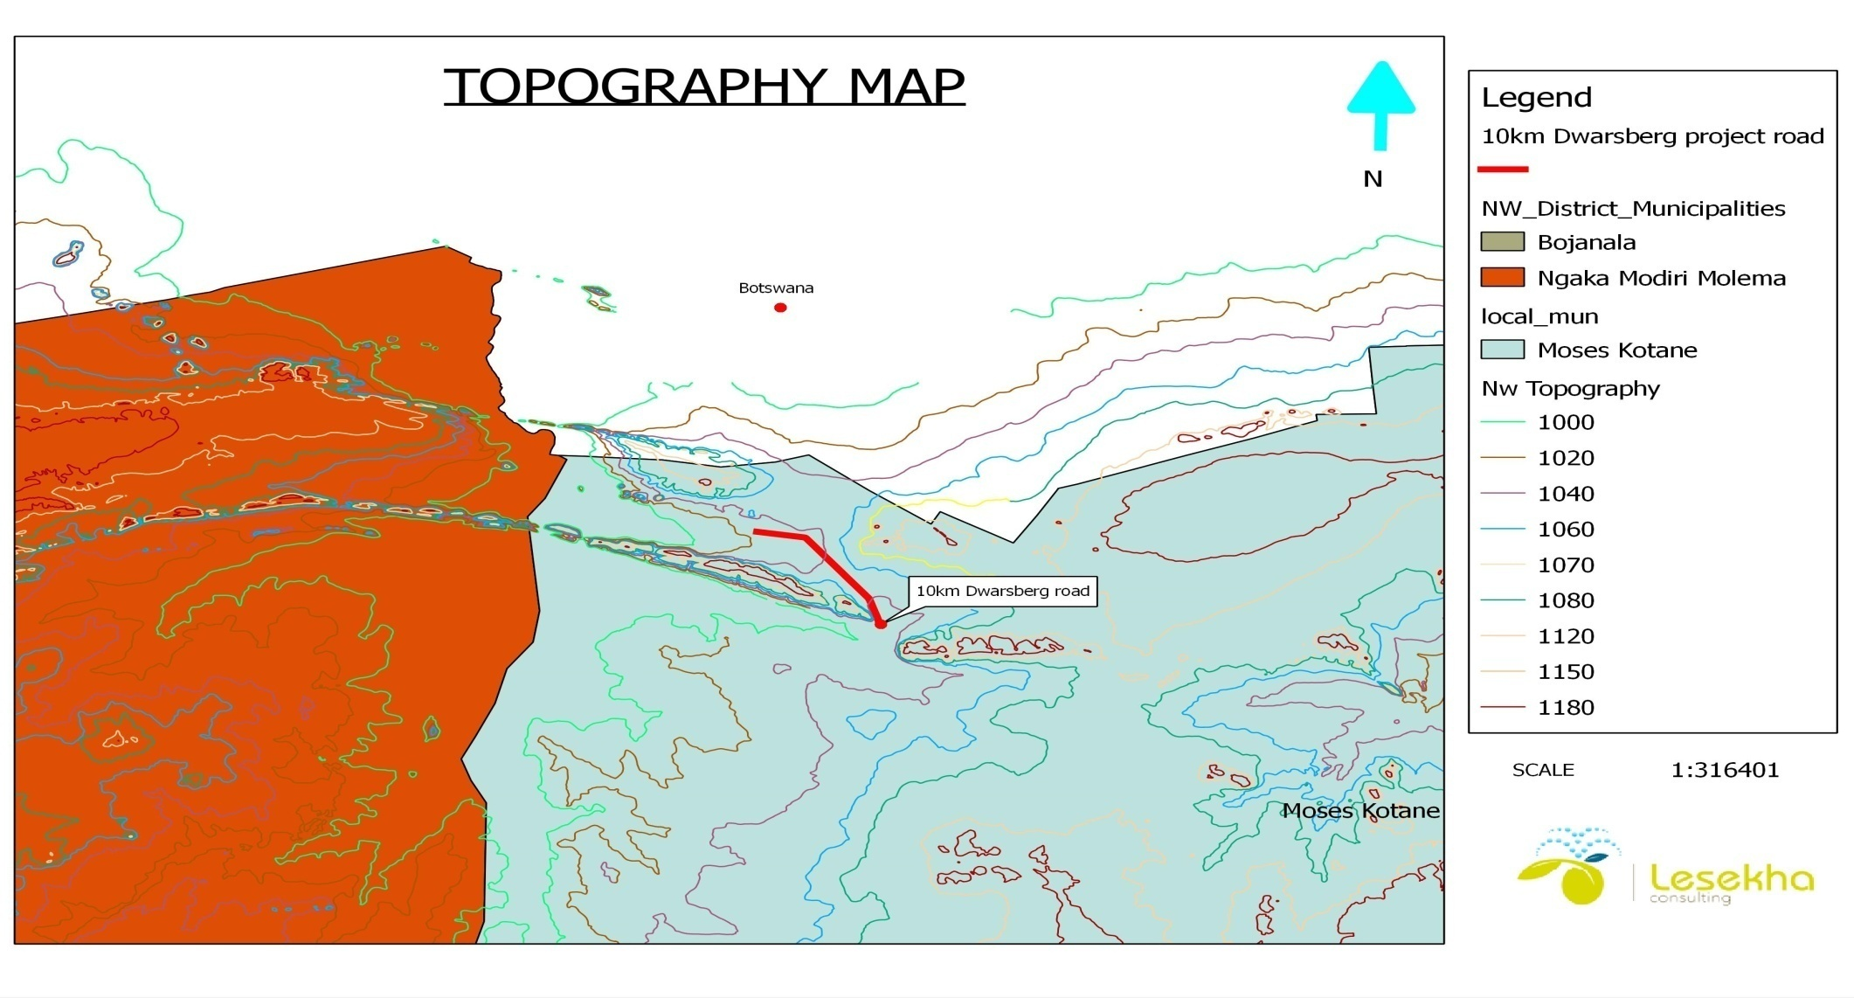
Middle Figure 4: Topographic map for Dwarsberg
1.2 Soil of the site.

The Eastern extents of the MKLM are dominated by the Pilanesberg complex which consists of gabbro, alkali-feldspar syenite, and lava. The western extents are dominated by sedimentary formations and clinopyroxenite. Mineral deposits include platinum group metals, chrome, gold, diamond, limestone, nickel and manganese. The majority of the study area consist of red massive or weak structures soils with a high base status (accounting for 48.4% of the total area), and black and red strongly structured clay soils with a high base status (accounting for 27.8%) of land area. Both these soil types cover the vast majority of the central and western parts of the study area. The eastern parts mainly consist of soils of minimal development, usually shallow on hard or weathering rock with or without intermittent diverse soils.

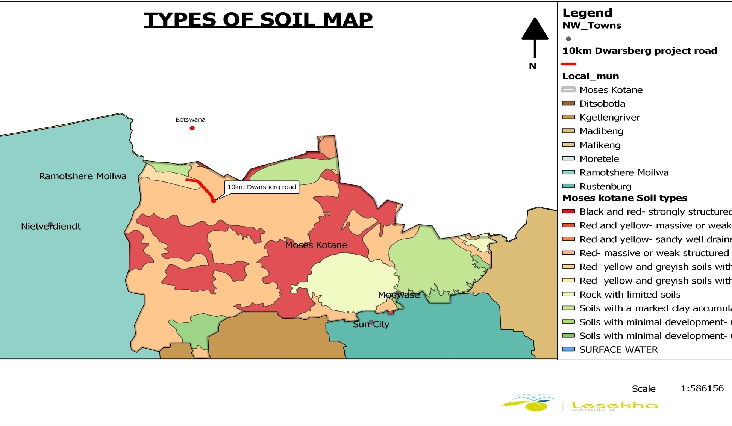
Figure 5: Soil Type Map for Dwarsberg
1.3 Vegetation

The dominant vegetation types that characterise MKLM Western Transvaal Thornveld covers most of the central and western parts of the study area, accounting for 36% of the total land area of Moses Kotane. Zeerust Clay Thornveld is mainly concentrated in the extreme western parts of Moses Kotane, and represents approximately 12.7% of the total land area. Central broadleaved sandy bushveld mainly occurs in the eastern parts (east of the Pilanesberg National Park), and covers just over 12% of the land area of Moses Kotane.

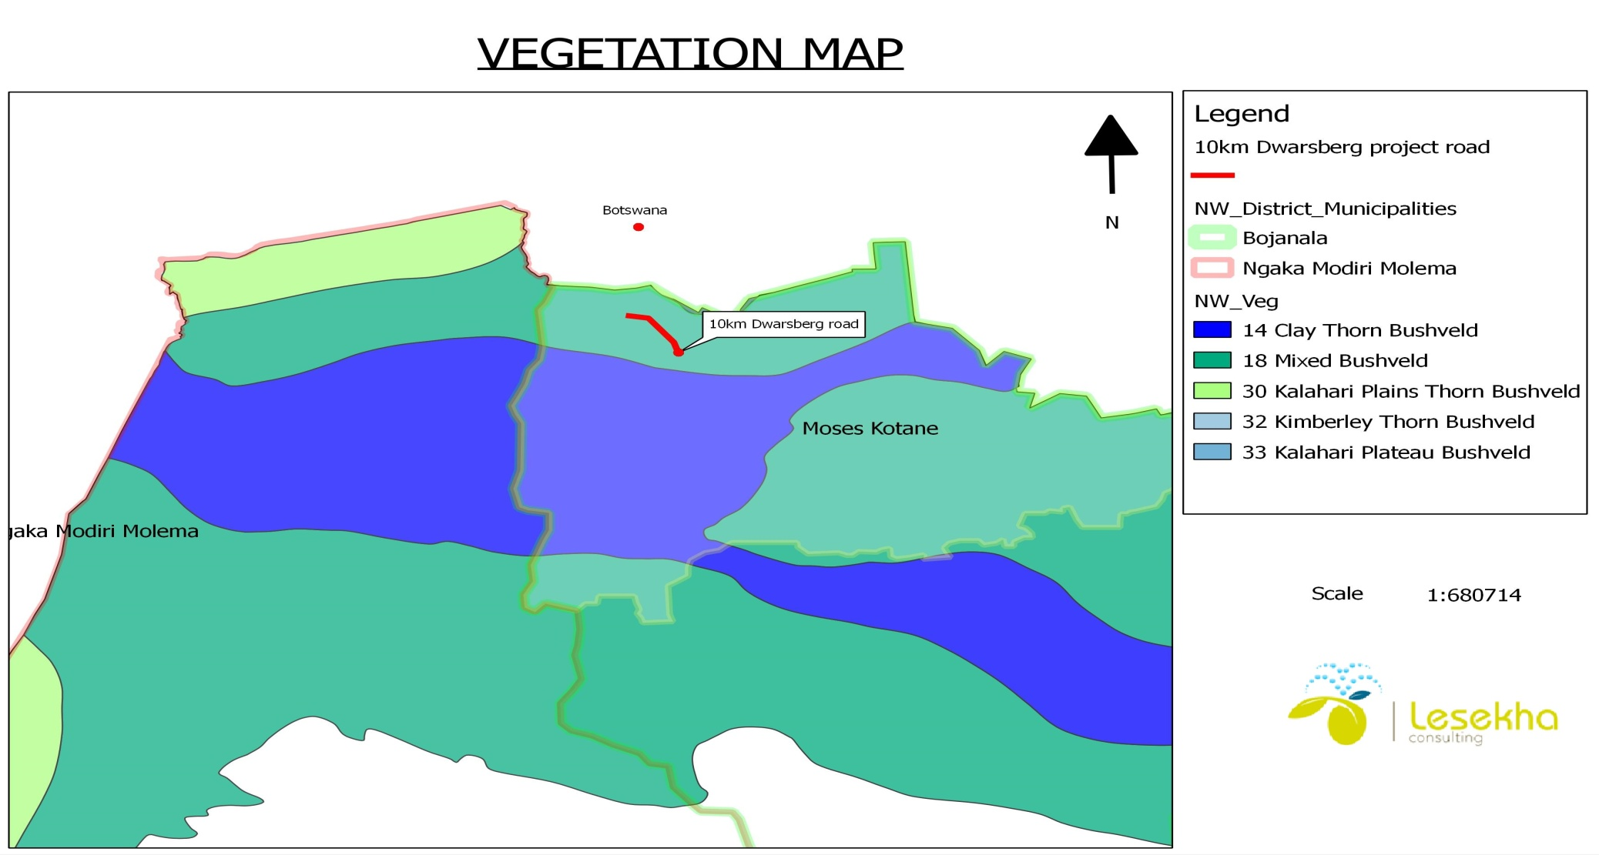
Figure 6: Vegetation map for Dwarsberg
1.4 Biodiversity and Environmental Sensitivity

According to the Environmental Policy Report for Moses Kotane LM (conducted by Africon in 2004), the Mabeskraal Ridge Bushveld and Swartruggens Mountain Bushveld are two of the five unique, important, and sensitive habitats for conservation purposes. The former is especially prevalent within the Moses Kotane LM. When the floral and mammal biodiversity of Moses Kotane LM are combined it becomes evident that the Pilanesberg Complex, as well as the numerous ridges scattered throughout the LM features very high levels of sensitivity.
Due to the fact that numerous settlements throughout the LM are already located within very sensitive areas, the expansion of these should be well planned so as to avoid severe environmental damage. Furthermore, the entire central portions of the LM features medium to high levels of environmental sensitivity. Hence, from an environmental conservation perspective the need exists to consolidate the dispersed settlement structure of the LM. The southern portions (except the areas surrounding the Tholwane River) generally feature low levels of environmental sensitivity.

1.5. Climate

The MKLM can be described as a semi-arid area, with average annual precipitation in the region ranging between 300mm and 500mm. The annual evaporation rate ranges between 1800mm to 1900mm. The wettest month of the year is January, with an average monthly total rainfall of 132 mm. The driest month is July, with an average monthly total rainfall of 2 mm (Weather Bureau, 1997).Mean annual air temperatures range from 11,8°C in June/July to 23,8°C in January. Average daily maxima range from 20,4°C to 30,3°C, and minima from 2,8°C to 17,2°C (Weather Bureau, 1997). The Lightening Ground Flash Density in the study area is between 5 to 7 strikes/km2/year on a scale of 0 to 19 (2001 Eskom’s LPATS system; Clara, 2001).
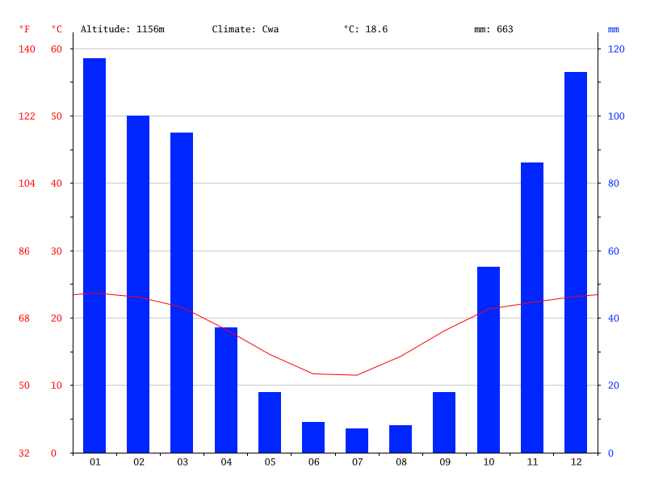
Figure 7: shows the Climatic Conditions of Dwarsberg

1.6. Water Supply
According to the Moses Kotane Water Services Development Plan (2006 / 2007), the MKLM currently receives water from boreholes, a number of local supply schemes (Madikwe, Pella and Molatedi), and the Vaalkop Supply Scheme . Although the greater part of the MKLM is serviced through boreholes, the underground water supply is often unreliable mainly due to insufficient underground supply. The local supply schemes of Madikwe, Pella and Molatedi receive their water from the Madikwe, Pella and Molatedi Dams respectively. There is a heavy reliance on ground water resources to meet domestic, agricultural, mining, and industrial needs. Unfortunately, these users are also responsible for the contamination of groundwater resources.

1.7. Surface Water Sources
There are four driving forces affecting surface water resources in the MKLM area. These include climatic conditions, increased population growth, increases in mining and industrial demand for water, policy and legislation issues. For the purposes of formulating the SDF, pressures impacting on surface water resources should also be identified.
An increase in population exerts pressure on the environmental quality and quantity of water resources. It results in greater demand for water as well as an increase in the discharge of used water through sewerage systems and other effluents. The pressures exerted on the water resources include changed hydrology patterns in the major river. The amount of available surface water decreases from east to west in the MKLM area. The eastern portions have higher surface water flows than the western portions. The primary and secondary catchments of MKLM partly fall within the boundaries of the study area. There are 8 large impoundments (dams) within the study area. These impoundments provide water for domestic supply, mining industry, agriculture and recreation. Although the majority of consumers in MKLM are reliant on groundwater sources, there are however also a number of significant surface water sources that are being utilised.

1.8. Groundwater Sources

Ground and surface water are integrated and interdependent as dolomitic eyes or springs are the sources of several of the major river systems. Groundwater is of vital importance in the study area as it is in many instances the only source of water for the rural population particularly in the more arid and western region. More than 82% of the rural communities in the MKLM depend on groundwater supply for domestic purposes.

1.9. Air Quality

Air quality in settlements and houses that using wood as a source of fuel for heating and cooking is a cause of concern. Dust from the MKLM’s extensive network of gravel roads impacts on air quality. Smoke from veld fires which are common in the dry winter months also impact on local air quality.

1.10 The social economic environment

Moses Kotane Local Municipality is a category B4 municipality located within the Bojanala District Municipality in the North West Province. channel has a total population of 243 643, a population density of 42/km² The Municipality covers an area of approximately 5220km² and is mostly rural in nature comprising 107 villages and two formal towns of Mogwase and Madikwe. Moses Kotane Local Municipality population was estimated at 242 553 by 2011 and has population growth of 0.10 % per annum.
1.11 Demographic Profile

Moses Kotane Local Municipality population was estimated at 242 553 by 2011 Census compared to 237 175 by Census 2001. It should be noted that the recognized legal statistics to be used in developing IDP’s is from Census 2011. Geographic information of households by 2011 was estimated at 75 195 compared to 61 759 by Census 2001 with the same total number of demarcated wards.

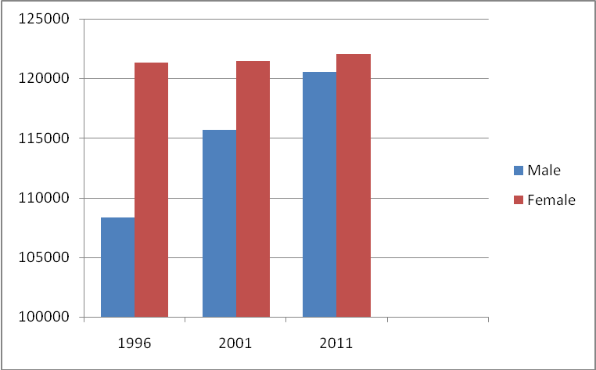
Graph 1: Demographic Indicators

Moses Kotane features a widely dispersed settlement structure that is characterised by poor accessibility, low density, and large distances between settlements. The Municipality has a predominantly African population with fewer Indian, Coloured and White groups who are mostly residing in Sun City residence and Mogwase Unit 2.
Population group | Percentage
Black African | 97%
Coloured | 0,20%
Indian / Asian | 0,60%
White | 1,10%
Table 2: shows the population by ethnic group

1.12 Age and gender profile

The table below utilized to reflect the Age profiles of Moses Kotane Local Municipality area. About 102987 people of the total population fall within the age category of 15 – 34 years. This implies a very young population for the Moses Kotane Local Municipality. The gender profile for the Municipal area indicates a slightly higher proportion of females than males in the area (51% females to 49% males) in terms of gender break down of the total population.
Age and Gender Distribution
Age | Male | Male (%) | Female | Female (%) | Total
0 – 4 | 16173 | 51 | 15798 | 49 | 31971
5 – 14 | 34624 | 52 | 32351 | 48 | 66975
15 – 34 | 47075 | 46 | 55913 | 54 | 102987
35 – 64 | 42400 | 46 | 36829 | 54 | 79229
65 – 105 | 4611 | 38 | 7378 | 62 | 11989
Table 2: Age and Gender Distribution

  - Employment
An overview and analysis of the current workforce is provided in employment profile of the municipality. Information on the profile indicates that the total number of employees in Moses Kotane Local Municipality in 2016 is 811, this number include both permanent and non-permanent employees. A total of 621 males, 190 females are employed. The number of personnel at top management is 1 and senior management level is 54. The total number of professionally qualified and experienced specialists and mid-management is 58. The proportion of the workforce in the management or professionally qualified component is thus only 58.

 | South Africa | North West Province | Bojanala District Municipality | Moses Kotane local Municipality
Employment status as percentage of economically active population.
Economically active population | 18 412 541 | 389 843 | 226 559 | 33 897
Employed | 67% | 64% | 68% | 45%
Unemployed | 33% | 36% | 38% | 55%
Total | 100% | 100% | 100% | 100%
Table 3: Employment
1.13 Household Income
The municipality is a predominantly rural municipality and its rural economy is unable to provide individuals with remunerative jobs or self-employment opportunities. An estimated 55% of the people in the municipality had no income in 2007. In general terms, the majority of households in the municipality earns less than the poverty line (about R1, 600 per household per month) and can be considered poor. Those classified as economically active are employed in the services sector. This sector is dominated by the services in terms of the various departments that render services such as health, justice, local government, education, SAPS.
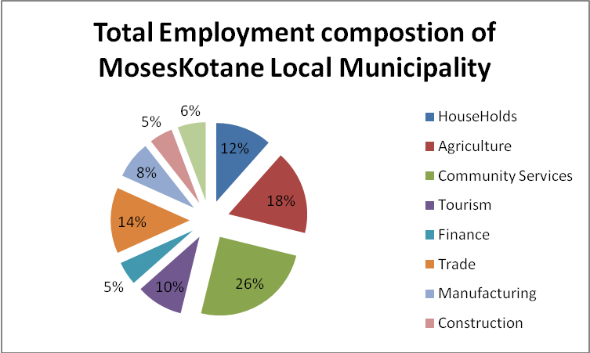

1.14 Health care facilities
The municipality is served by forty five clinics as well as four heath care centres, mobile clinic services at rural wards, in addition to these clinics; the other associated health services in the area include offices of the North West Department of Health as well as the Moses Kotane Hospital. The challenges facing the community within the boundaries of the municipal are that; people have to travel long distance to access health care facilities; mobile clinics that service the rural areas are not consistent in their visits to these areas, some clinics do not operate 24 hours.
1.15 Community safety and security
The whole municipality area is affected by high crime rates which can be addressed by increased visible policing. There are reportedly uncontrollable noises by allegedly unlicensed shebbeens and drinking places in the villages. The Community Policing Forums are identified as one platform that could facilitate the reporting of illegal sale of liquor and criminal activities in our areas. Installation of high mast lighting in rural areas could also reduce darkness during the night.
1.16 Education
Unavailability and inadequate educational facilities in some areas of the municipality leads to relocation or migration of learners to assumably better schools, possible closing of some schools and under-utilization of existing ones. Walking long distances to schools in rural areas contributes to school drop-out rate. There is no university in the Moses Kotane Municipality. There is a need to approach other tertiary institutions to have satellites campuses within the municipal area. The table below shows the levels of education within the municipality in 2016 for people aged above the age of 20. An estimated 7.5 % of the population had no schooling in 2007 with 30.9% of the population having completed matric.
EDUCATION LEVELS | TOTAL | PERSONS %
No Schooling | 18 256 | 7.5%
Matric | 12 6 624 | 30.9%
Higher Learning | 13 808 | 4%
TOTAL | 144 072 | 45.4%
Table 4: educational levels in Moses Kotane Local Municipality
- Description of the current land uses.
The land use comprises of disturbed areas with the majority having been disturbed by economic. The borrow pit is located in the Molatedi Village on a land that is currently used for grazing animals. There are also residential areas in the Molatedi village. The mining activities on the site of the gravel material will occur close to the road where the landscape, soils and the capability of the land has been significantly altered, the natural grasslands and biodiversity have all been altered by these activities.

(c) Description of specific environmental features and infrastructure on the site.

There is no area of any importance near/around the proposed sites that needs any special attention, protection, management or avoidance. The proposed area to be mined is surrounded by thorn bushes which are not protected, there are no any natural feature e.g. stream, river or wetland, no archaeological aspect like graves, artefacts that will be tempered with. The new borrow pit is close to the old used pit. The area where the borrow pit will be excavated is not a pristine environment.

(d) Environmental and current land use map.

Refer to the Map on figure 2 showing the location of the borrow pit
v) Impacts and risks identified including the nature, significance, consequence, extent, duration and probability of the impacts, including the degree to which these impacts. Including the degree to which these impacts:

(Provide a list of the potential impacts identified of the activities described in the initial site layout that will be undertaken, as informed by both the typical known impacts of such activities, and as informed by the consultations with affected parties together with the significance, probability, and duration of the impacts. Please indicate the extent to which they can be reversed, the extent to which they may cause irreplaceable loss of resources, and can be avoided, managed or mitigated).
Table 5: shows environmental impacts associated with the proposed facility
 | Impact pathway | Nature of  potential  impact/risk | Status¹ | Extent ² | Duration ³ | Consequence | Probability | Significance of  impact/risk  = consequence  x probability | Reversibility of  impact | Irreplaceability of  receiving  environment/  resource | Can  impact be  avoided? | Can impact  be  managed  or  mitigated? | Potential mitigation  measures | Significance  of residual  risk/impact  (after  mitigation) | Ranking of  impact/  risk
Fauna and  Flora | Clearing of vegetation | Habitat and  loss of species. | - | site | Long-term | Substantial | Very likely | Moderate | No | Moderate | No | Yes | Rehabilitation Programme and ensuring workers are aware on the site boundary. | low | 4
Fauna and  Flora | Clearing of vegetation | Exposed soils susceptible to  Erosion. | - | site | Medium term | Moderate | Likely | Low | Yes | Low | No | Yes | Erosion Management Plan (EMPr) | Very low | 5
Fauna and  Flora | Disturbance of  soils | Alien plant  invasions in  disturbed  areas. | - | site | Long-term | Severe | Very likely | Moderate | Yes (rehab after Decommissioning) | Low | No | Yes | Removal of alien plant to reduce encroachment. | Low | 4
Geohydrology | Spills, pollution | Contamination of groundwater | - | site | Long-term | Substantial | Likely | Moderate | No | Low | Yes | Yes | Minimal spillage will be from machines leakages no filing of fuel to be done onsite. | Very low | 5
Geohydrology | Water runoff | Altered  hydrological  regimes and  water quality | - | local | Long-term | Substantial | unlikely | Moderate | Yes (rehab after  decommissioning  ) | Moderate | No | Yes | Implementation of storm water management measures | Low | 4
Geohydrology | Increase in use of water | Impact on available groundwater resources and water levels in the area. | - | Local | Short term | Medium term | Unlikely | low | No | Moderate | Yes | Yes | The gravel material mining requires no water, minimal water will only be used for drinking purpose | Very low | 5
Social | Labour required  for project  development | Employment  opportunities | + | Local | Long-term | Moderate | Likely | Moderate | No | Low | No | Yes | Locals first’ employment policy  considering the skills are adequate | Medium  (positive | 3  (positive)
Social | Traffic operations | Increase in traffic and pressure on the road network | - | Local/regional | Long-term | low | Likely | Moderate | No | Low | No | No | Transportation of gravel material kept to normal operational hours. | low | 4
Social | Health and safety of workers | High risk work environment causing injury and/or death | - | site | Long-term | Moderate | Unlikely | Moderate | No | High | Yes | Yes | Proper training, Health and Safety precautions in place and routing maintenance of equipment as per the EMPr | low | 4
Air Quality | Air Quality disturbance due to emissions from operations and trucks | Decrease in the quality of the air | - | local | Long-term | Substantial | likely | Low | No | Low | No | Yes | Keep within regulated acceptable emissions standards& consider cumulative impacts | Very low | 4
Air Quality | Dust generation | Increase in road traffic on dirt roads causing dust generation | - | site | Short-term | Moderate | Very likely | Moderate | No | low | No | Yes | Use of grey water for dust spraying and wetting, proper grading of roads and keeping traffic to a reasonable level | low | 4
economic | Project Expenditure (incl. direct capital investment, | Investment and growth in local economy | + | Regional | Long term | Medium (positive) | Very likely | Moderate (positive ) | Yes | Moderate | No | Yes | None | Moderate  (positive) | 3  (positive)
economic | Development of the proposed project | Decreased property values | - | Local | Long-term | Slight | Unlikely | Low | Yes | High | Yes | Yes | The nearest community is approximately 5km away from the mining site. No property value will be encountered. | Very low | 5
Noise | Noise disturbance during operation | Disruption to surroundings  due to noise levels | - | local | Long-term | Moderate | unlikely | Moderate | No | High | Yes | Yes | The trees around the site will serve as a breaker for the transmission of noise. The noise expected from the machinery to be utilised onsite will not be a nuisance to the labourers and will be within the required noise ambient. Conversely ear plugs will be provided to the labourers to mitigate the noise impact. The silencer will also be installed on the machines to be used. | Low | 4
Heritage | Clearing the  site | Destruction  of  archaeology | - | site | Permanent | Slight | Unlikely | Low | No | low | No | Yes | There were graves identified far away from the mining area. The mining activity will not disturb the indentified graves.  Should any unmarked graves unearthed during the mining process they must be reported to the heritage authorities and may require inspection by an archaeologist as appropriate. | Very Low | 5

vi) Methodology used in determining and ranking the nature, significance, consequences, extent, duration and probability of potential environmental impacts and risks;

(Describe how the significance, probability, and duration of the aforesaid identified impacts that were identified through the consultation process were determined in order to decide the extent to which the initial site layout needs revision).

The assessment methodology that will be utilised in determining the significance of the potential Construction impacts of the existing and planned activities, on the biophysical and socio-economic environment is explained in the following sections. The methodology is broadly consistent to that described in Integrated Environmental Management Series. In order to assess the significance as objectively as possible, the criteria as per the 1998 Department of Environmental affairs and Tourism (DEAT) guidelines and the 2002 DEAT Information Series document will be used as the basis for the assessment methodology adopted by Lesekha Environmental Consulting.
Assessment of Potential Impacts
The assessment of impact significance is based on the following conventions:
Nature of Impact - this reviews the type of effect that a proposed activity will have on the environment and should include “what will be affected and how?”
Spatial Extent - this should indicate whether the impact will be:
- Site specific;
- Local (<2 km from site);
- Regional (within 30 km of site); or
- National.
Duration - The timeframe during which (lifetime of) the impact will be experienced:
- Temporary (less than 1 year);
- Short term (1 to 6 years);
- Medium term (6 to 15 years);
- Long term (the impact will cease after the operational life of the activity); or

Permanent (mitigation will not occur in such a way or in such a time span that the impact can be considered transient).
Intensity - it should be established whether the impact is destructive or innocuous and should be
Described as either:
- High (severe alteration of natural systems, patterns or processes such that they temporarily or permanently cease);
- Medium (notable alteration of natural systems, patterns or processes; where the environment continues to function but in a modified manner); or
- Low (negligible or no alteration of natural systems, patterns or processes); can be easily avoided by implementing appropriate mitigation measures, and will not have an influence on decision making.
Probability - this considers the likelihood of the impact occurring and should be described as:
- Improbable (little or no chance of occurring);
- Probable (<50% chance of occurring);
- Highly probable (50 – 90% chance of occurring); or
- Definite (>90% chance of occurring).
Reversibility - this considers the degree to which the adverse environmental impacts are reversible or irreversible. For example, an impact will be described as low should the impact have little chance of being rectified to correct environmental impacts. On the other hand, an impact such as the nuisance factor caused by noise impacts from wind turbines can be considered to be highly reversible at the end of the project lifespan. The assessment of the reversibility of potential impacts is based on the following terms:
- High - impacts on the environment at the end of the operational life cycle are highly reversible;
- Moderate - impacts on the environment at the end of the operational life cycle are reasonably reversible;
- Low - impacts on the environment at the end of the operational life cycle are slightly reversible; or
- Non-reversible - impacts on the environment at the end of the operational life cycle are not reversible and are consequently permanent.
Irreplaceability - this reviews the extent to which an environmental resource is replaceable or irreplaceable. For example, if the proposed project will be undertaken on land that is already transformed and degraded, this will yield a low irreplaceability score; however, should a proposed development destroy unique wetland systems for example, these may be considered irreplaceable and thus be described as high. The assessment of the degree to which the impact causes irreplaceable loss of resources is based on the following terms:
- High irreplaceability of resources (this is the least favourable assessment for the environment);
- Moderate irreplaceability of resources;
- Low irreplaceability of resources; or
- Resources are replaceable (this is the most favourable assessment for the environment.

 | RISK/IMPACT = CONSEQUNCE X PROBABILITY
PROBABILITY | Very likely |  |  |  |  |  | Very high risk/impact (1)
PROBABILITY | Likely |  |  |  |  | High risk/impact (2)
PROBABILITY | Unlikely |  |  |  | Moderate risk/impact (3)
PROBABILITY | Very unlikely |  | Low risk/impact (4)
PROBABILITY | Extremely unlikely | Very Low Risk/impact (5)
PROBABILITY |  | Slight | Moderate |  | Substantial | Severe | Extreme
PROBABILITY | CONSEQUENCE
Figure 8: Guide to assessing risk/impact significance as a result of consequence and Probability.
The status of the impacts and degree of confidence with respect to the assessment of the
Significance is stated as follows:
Status of the impact: A description as to whether the impact will be:
- Positive (environment overall benefits from impact);
- Negative (environment overall adversely affected); or
- Neutral (environment overall not affected).
Degree of confidence in predictions: The degree of confidence in the predictions, based on the availability of information and specialist knowledge. This should be assessed as:
- High;
- Medium; or
- Low.
Based on the above considerations, the specialist provides an overall evaluation of the significance of the potential impact, which should be described as follows:
- Low to very low: the impact may result in minor alterations of the environment and can be reduced or avoided by implementing the appropriate mitigation measures, and will only have an influence on the decision-making if not mitigated;
- Medium: the impact will result in moderate alteration of the environment and can be reduced or avoided by implementing the appropriate mitigation measures, and will only have an influence on the decision-making if not mitigated; or
- High: Where it could have a “no-go” implication for the project unless mitigation or re-design is practically achievable. Furthermore, the following must be considered:
- Impacts should be described both before and after the proposed mitigation and management measures have been implemented.
- All impacts should be evaluated for the construction, operation and decommissioning phases of the project, where relevant.
- The impact evaluation should take into consideration the cumulative effects associated with this and other facilities which are either developed or in the process of being developed in the region, if relevant.
Management Actions:
- Where negative impacts are identified, mitigatory measures will be identified to avoid or reduce negative impacts. Where no mitigatory measures are possible this will be stated.
- Where positive impacts are identified, augmentation measures will be identified to potentially enhance these. Quantifiable standards for measuring and monitoring mitigatory measures and enhancements will be set. This will include a programme for monitoring and reviewing the recommendations to ensure their ongoing effectiveness.
Monitoring:
Specialists should recommend monitoring requirements to assess the effectiveness of mitigation actions, indicating what actions are required, by whom, and the timing and frequency thereof.
Cumulative Impact:
Consideration is given to the extent of any accumulative impact that may occur due to the proposed development. Such impacts are evaluated with an assessment of similar developments already in the environment. Such impacts will be either positive or negative, and will be graded as being of negligible, low, medium or high impact.
Mitigation:
The objective of mitigation is to firstly avoid and minimise impacts where possible and where these cannot be completely avoided, to compensate for the negative impacts of the development on the receiving environment and to maximise re-vegetation and rehabilitation of disturbed areas. For each impact identified, appropriate mitigation measures to reduce or otherwise avoid the potentially negative impacts are suggested. All impacts are assessed without mitigation and with the mitigation measures as suggested

vii) The positive and negative impacts that the proposed activity (in terms of the initial site layout) and alternatives will have on the environment and the community that may be affected.
(Provide a discussion in terms of advantages and disadvantages of the initial site layout compared to alternative layout options to accommodate concerns raised by affected parties)
Advantages
- Several test pits have been studied and the borrow pit has proved to have the most suitable material for road upgrade purposes.
- The proposed site can easily be rehabilitated for agricultural purposes once mining activities have completed.
- No critical biodiversity areas or threatened ecosystems will be negatively impacted upon seeing that the site has been used for cattle grazing.
- No large access roads need to be constructed.
- Noise and dust impacts are not deemed to be significant, seeing that the proposed Borrow Pit is not in close proximity to any residential areas.
- No fauna species will be negatively impacted upon.
Potential Hazards
- Hazard can be eliminated if compliance to the Environmental Management plan is strictly adhered too. The hazards that must be anticipated are:
- Noise; which is not significant seeing that the proposed site is not in close proximity to any residential areas.
- Dust Generation; which is not significant seeing that the proposed site is not in close proximity to any residential areas. Dust will also be controlled during a dust management plan as set out in the Environmental Management Plan.
- Haulage trucks. The necessary safety and road signs as well as trained personnel will be available on site.
- Hydrocarbon spillages. All the necessary precaution measures will be taken as clearly set out in the Environmental Management Plan.
- Poor management of topsoil. Topsoil management prior, during and after construction has been clearly described in the Environmental Management Plan. Contractors need to strictly adhere to these mitigation measures.

viii) The possible mitigation measures that could be applied and the level of residual risk.
With regard to the issues and concerns raised by affected parties provide a list of the issues raised and an assessment/ discussion of the mitigations or site layout alternatives available to accommodate or address their concerns, together with an assessment of the impacts or risks associated with the mitigation or alternatives considered).

The following mitigation measures are some of the proposed methods to manage the proposed mining of gravel material from the borrow pit in order to prevent and mitigate potential environmental impacts:
1) Air Quality: The project’s main potential effect on air quality will be dust emission by loading of gravel. Wet suppression will be employed in the borrow pit area, on haul roads at stockpiles areas. The objective will be to maintain a low risk of exceeding national standards for PM10 concentrations and rates of dust fall.

2) Soil, Land Capability and Land Use: The risk of causing a significant degradation of topsoil quality and associated loss of land capability after rehabilitation will be minimised to a low level by:
- Taking care to strip and stockpile topsoil, subsoil and overburden layers selectively and to prevent mixing of especially topsoil with any of the other layers;
- Backfilling the opencast void with discard material, overburden, subsoil and topsoil, in that order;
- Analysing the topsoil, fertilising it appropriately and re-vegetating it with local indigenous flora to re-establish the pre-project land use, which was natural veld suitable for grazing.
3) Ecology: Successful restoration of the land capability will encourage natural re-colonisation of the rehabilitated area by mammals, birds, reptiles and insects, but it may require re-introduction of some species over time in order to reduce the risk of a low-functioning or unbalanced ecosystem to a low level.
4) Visual aspects: The terrain is quite flat and not much of the opencast mine will be visible from the local roads. Judicious placement of topsoil and overburden stockpiles can screen the mine from certain view shed areas, but the stockpiles would also be visually prominent and potentially intrusive, unless they were vegetated to mitigate the visual impact. Diligent application of wet suppression would reduce this risk to a low level.
5) Cultural and Heritage aspects: There are no graves identified on the borrow pit site that will be likely affected by the Mining activities. Unless unknown graves are unearthed during mining, the expected impact on cultural and heritage resources is likely to be of negligible significance;
6) Socio-economics: The construction of the road and mining of the gravel material will provide, given the levels of unemployment in the area, the impact is expected to be of moderate significance.

Other methods to manage the proposed gravel mining activities at the site in order to prevent and mitigate potential environmental impacts:

- Spillages must be cleaned appropriately;
- Implement strict housekeeping measures;
- Store raw materials inside a roofed structure that is not prone to wind-blown dust;
- Make staff aware of potential environmental impacts;
- Waste (general and hazardous) must be correctly managed to prevent nuisance conditions or environmental pollution.
- Develop and implement a waste management plan;
- Appropriate bonding and containment measures will be implemented to prevent contamination of stormwater due to spillages of hazardous substances.
- Restrict the area of impact to as small an area as possible;
- Ensure health and safety of employees during the operation, loading and transportation of gravel material ;
- Ensure that dust emissions remain within allowable limits; and
- Prevent soil erosion, contamination and undertake appropriate remedial actions.
- Where possible limit the removal of riparian vegetation.
- The haul roads in the area will be made compact. Both sides of the haul roads will be planted with trees to arrest air borne dust.
- Dust mask/Face mask will be provided to all employees working in the likely dusty areas.
- Proper maintenance of vehicles will be done, which minimize the pollutants.
- Cover and/or maintain appropriate freeboard on truck hauling any lose material that could product dust while travelling.
- Vehicles should be covered by tarpaulin to reduce spillage on roads.
- Regular checking & Maintenance of vehicles, trucks, dumpers etc, will be conducted and pollution under control (PUC) vehicle will be used during transportation.
- Periodically, water will be sprinkled on haul roads to wet the surface.
- Overloading of transport vehicles will be avoided to prevent spillage.
- During the mining activities will be confined to footprint of the mining area applied for.
- To minimize the vehicular pollution from the transporting vehicles, the following conditions are insisted to permit the vehicles of the transporters.
- Regular maintenance of transport vehicles and monitoring of vehicular emission levels at periodical intervals.

ix) The outcome of the site selection Matrix. Final site layout Plan
(Provide a finale site layout plan as informed by the process of consultation with interested as affected parties.

The project site is the only alternative site that has been investigated. The proposed preferred site is located on Molatedi Village. The site is currently being used for grazing of livestock.

Environmental Consideration | Site Evaluation Molatedi Village
 | Yes | No
Within an unstable area (fault zone, seismic zone, dolomite, sinkholes) |  | x
Within 500m of water resource |  | x
Availability of land | x
Accessibility in terms of road networks | x
The distance to the boundary of the nearest residential area |  | 6km
Nodality with respect to market | x
Table 6: showing the selection Matrix

x) Motivating for No alternative on the Development
(If No alternatives, Including Alternative Location for the activity were investigated, the Motivation for not considering such).
No alternative sites were assessed as the preferred site has adequate and good quality material needed for the road construction. This is the relevant site close to the construction site. Mining of the gravel material will boost the economic development through this proposed project which is surrounded by the several villages. This project will provide employment opportunities, thus stimulating development of the communities. The preferred site has the material to construct durable roads.

xi) Statement motivating the preferred site.
(A concluding statement indicating the preferred alternative, including preferred location of the activity’)

The preferred site alternative has been identified based on confirmation by Geotechnical results confirming the availability of the adequate good quality material for the road construction. The borrow pit with the sufficient gravel material is also in proximity to the construction site and haulage cost will be minimal thus saving the state funds. This preferred site prevents further disturbance of the environment and allows for all development to occur within the same area where other construction of the road is.

i) Full description of the process undertaken to identify, assess and rank the impacts and risks the activity will impose on the preferred site (In respect of the final site layout plan) through the life of the activity. (Including (i) a description of all environmental issues and risks that were identified during the environmental impact assessment process and (ii) an assessment of the significance of each issue and risk and an indication of the extent to which the issue and risk could be avoided or addressed by the adoption of mitigation measures.)

- Project screening and understanding the baseline environment

In order to identify and fatal environmental or social flaws that the project may encounter, an initial project screening was conducted were all knowledge sources of the area are assessed and analysed. Site visits to determine the possible impacts the proposed project may have, and highlights which impacts need to be studied further. The description of the baseline environmental and socio-economic conditions above provides information on receptors and resources that have been identified as having the potential to be significantly affected by the proposed Project. It also describes baseline conditions that have been used to make the assessment. The description of the baseline is aimed at providing sufficient detail to meet the following objectives:
• To identify the key conditions and sensitivities in areas potentially affected by the proposed Project;
• To provide a basis for extrapolation of the current situation, and development of future scenarios without the proposed Project;
• To provide data to aid the prediction and evaluation of possible impacts of the proposed Project;
• To understand public concerns, perceptions and expectations regarding the proposed Project;
• To allow the proposed Project to develop appropriate mitigation measures; and
• To provide a benchmark to assess future changes and to assess the effectiveness of mitigation measures.
2) Public Participation
The key principle of consultation is to ensure that the views of the public are taken into. The objective is to ensure the assessment is robust, transparent and has considered the full range of issues or perceptions, and to an appropriate level of detail.

3) Assessment of Impacts and Mitigation
Please see (vi) for the Impact Assessment Methodology used to identify, assess and rank the potential impacts associated with the development.

j) Assessment of each identified potentially significant impact and risk
(This section of the report must consider all the known typical impacts of each of the activities (including those that could or should have been identified by knowledgeable persons) and not only those that were raised by registered interested and affected parties.
NAME OF THE ACTIVITY | E.g. For mining,- excavations, blasting, stockpiles, discard dumps or dams, Loading, hauling and transport, Water supply dams and boreholes, accommodation, offices, ablution, stores, workshops, processing plant, storm water control, berms, roads, pipelines, power lines, conveyors, etc…etc…etc.)
POTENTIAL IMPACTS | Including the potential impacts for cumulative impacts) (e.g. dust, noise, drainage surface disturbance, fly rock, surface water contamination, groundwater contamination, air pollution etc.….etc.…)
ASPECTS AFFECTED
PHASE | In which impact is anticipated (e.g. Construction, commissioning, operational Decommissioning, closure, post-closure)
SIGNIFICANCE | If not mitigated
MITIGATION TYPE | (modify, remedy, control, or stop) through (e.g. noise control measures, storm-water control, dust control, rehabilitation, design measures, blasting controls, avoidance, relocation, alternative activity etc. etc.) E.g. Modify through alternative method. Control through noise control. Control through management and monitoring through rehabilitation.
SIGNIFICANCE | If Mitigated

NAME OF ACTIVITY | POTENTIAL IMPACT | ASPECTS AFFECTED | PHASE | SIGNIFICANCE  if not mitigated | MITIGATION TYPE | SIGNIFICANCE  if mitigated
Excavations | Loss of vegetation and Faunal habitat | Flora and fauna | Construction phase | Medium | Remedy through Rehabilitation Plan, Conservation Management Plan and Alien Invasive Management Plan. | Low
Excavations | Dust | Natural Environment, road users and nearby residents. | Construction, commissioning, operational  Decommissioning and closure | Medium | Reduce drop height of material to a minimum. Area will be mined in phases to reduce the barren areas. Temporarily halt material handling in windy conditions. A speed limit of 30km/hour will be displayed and enforced through a fining system. All vehicle drivers entering the site will be informed of the speed limit. | Low
Stockpiles | Dust | Natural Environment, road users and nearby residents | Construction, commissioning, operational  Decommissioning and closure | Medium | Reduce drop height of material to a minimum. Area will be mined in phases to reduce the barren areas. Temporarily halt material handling in windy conditions. A speed limit of 30km/hour will be displayed and enforced through a fining system. All vehicle drivers entering the site will be informed of the speed limit. | Low
Emissions | Air quality | Natural resources | Construction, commissioning, operational  Decommissioning and closure | Medium | Vehicles and machinery on the site will be monitored for excessive emissions.  Vehicles and machinery will be maintained to minimize emissions. A log book will be filled in to keep a record of all maintenance problems encountered and mitigation measures implemented to resolve the problem.  Vehicles and machinery emitting excessive emissions will be stopped immediately and not allowed to operate until the necessary repairs have been done. | Low
Waste from chemical toilets and litter | Pollution and nuisance | Natural and agricultural resources | Construction, commissioning, operational  Decommissioning and closure | Medium | The toilet is serviced when needed and emptied when almost full.  If a leak occurs the correct emergency procedure is to be followed.  Litter will be removed from site by the operator daily. | Low
Hydrocarbon spill | Surface water contamination and loss of natural and agricultural resources. | Natural and agricultural resources | Construction, commissioning, operational  Decommissioning, closure and post-closure | High | Any mine vehicle which is leaking hydrocarbons (e.g. petrol, diesel or oil) will be serviced in a concreted workshop to repair the leak.  Hydrocarbon spillages are to be cleaned up immediately.  The mine will also maintain a store of suitable absorbent material, suitable bioremediation substance and a spill kit. All incidences/ spillages are to be recorded in an incident log book. Contaminated soil must go to Madikwe Landfill site. | Low
Fire | There is the potential for fire to occur on the site. Veld fires can occur across the vegetated areas of the property. | Natural and agricultural resources | Construction, commissioning, operational  Decommissioning, closure and post-closure | High | All employees will be inducted on fire safety and on how to reduce the probability of a fire spreading out of control.  Anyone who observes a fire must report it immediately to the fire protection agency/ fire brigade and their supervisor/ mine manager.  Fire breaks will be maintained on the boundary of the mine site.  No fires or activities that can start a fire will be allowed on site. Vehicles must be parked in an area with no vegetation if a fire occurs.
Impact on the naturally occurring fauna present in the area | No red data fauna species were identified during the survey. The proposed development will not impact on any known conservation worthy species. | Natural resources | Construction, commissioning, operational  Decommissioning and closure | Medium | Rehabilitate the area after mining process is complete and vegetation will return.  Use of topsoil with seeds and roots to rehabilitate the site. | Low
Socio-Economic | Job creation | Jobs will be created. Local residents will be employed. | Construction, commissioning, operational  Decommissioning and closure | Positive | Local contractors, employing or seeking to employ local (historically disadvantaged individuals (HDIs) from the region who are suitably qualified, should get preference.  The municipality, local community and local community organizations should be informed of the project and potential job opportunities by the developer. | Positive
Loading, hauling and transport | Increased traffic due to the construction activities requiring various vehicles to come onto and leave the site. | Socio Economic Impacts | Construction, commissioning, operational  Decommissioning and closure | Medium | A speed limit of 30km/hour will be displayed and enforced through a fining system. All vehicle drivers will be informed of the speed limit. Speed limit will be applicable when delivery trucks drive through residential areas Access road will be maintained while mine is in operation and haul road is used. | Low
Excavations, operations, loading, hauling and transport | Socio Economic impacts | Noise due to mining machinery, trucks and people on site | Construction, commissioning, operational  Decommissioning and closure | Medium | No activities that may generate noise levels above the legal limit in terms of the Environmental Conservation Act, Western Cape Noise regulations will be conducted.  Machinery and vehicles should be regularly maintained to prevent excessive noise.  All machinery and work activities must adhere to the requirements of the noise regulations. | Low
Gravel material extraction | Impact on the biota and habitat | Environment and Natural Resources  Biota | Construction Phase  Operation Phase  Decommissioning Phase | Medium | Remedy and Minimize through Rehabilitation Plan, Conservation Management Plan.  Monitor and control through Mine Abstraction Plan. | Low
Rehabilitation and restoration of disturbed  Areas | Topography and visual alteration. | Topography and visual environment | Decommissioning Phase | Low | Remedy through Rehabilitation and Closure Plan. | Low
Rehabilitation and restoration of disturbed  Areas | Noise generation. | Noise receptors | Decommissioning Phase | Low | Manage through Noise Reduction Measures and  Regular Vehicle Inspections. | Very low
Rehabilitation and restoration of disturbed  Areas | Air quality and dust emissions. | Air quality | Decommissioning Phase | Low | Monitor and manage through Dust Management Plan and Measures. | Very low
Rehabilitation and restoration of disturbed  Areas | Land capability reduction. | Soils | Decommissioning Phase | Moderate | Manage, minimise through Post-closure  Management Plan and Rehabilitation Plan. | Low
Rehabilitation and restoration of disturbed  Areas | Destruction of vegetation. | Fauna and flora | Decommissioning Phase | Moderate | Manage and Minimise through Management Plan and Rehabilitation Plan. | Low
Rehabilitation and restoration of disturbed  Areas | Soil contamination. | Soil | Decommissioning Phase | Medium | Monitor and remedy through Emergency Response Plan. | Low

k) Summary of specialist reports.
(This summary must be completed if any specialist reports informed the impact assessment and final site layout process and must be in the following tabular form):-

No specialist studies were conducted

l) Environmental impact statement

(i) Summary of the key findings of the environmental impact assessment;

This Basic Assessment illustrates that there are various potential negative and positive impacts that may arise as a result of the proposed mining of gravel material operations at Molatedi village which will have an effect on the following environmental components:
- Terrestrial ecology;
- Air quality;
- Heritage;
- Soils and land capability
- Social environment; and
- Visual aesthetics.
However, no impacts which could cause detrimental harm to the environment were identified as part of this assessment, should the prescribed mitigation measures proposed as part of this report. The proposed borrow-pit or mining operation will be established in an area that has already been visually impacted upon by pervious mining, informal settlements, cattle grazing and farming.

The magnitude of the impacts is low i.e. natural and social functions and process are not affected or minimally affected. From the significance analysis of the impacts, none have higher impacts. This study therefore reflects that no social, environmental, economic or institutional reasons have been identified by this preliminary investigation as to why the proposed development should not proceed. Assuming compliance with the stipulated mitigation measure the perceived negative impacts of the proposed project will be minimized.

A monitoring programme will be implemented for the duration of the construction phase of the project. This programme will include:
- Audits during first month where after monthly audits will be conducted by the Environmental Control Officer, which are according to the EMPr and conditions of the Environmental Authorisation.
- These audits can be conducted randomly and do not require prior arrangement with the project manager.
- Compilation of an audit report with a rating of the compliance with the EMPr. This report will be submitted to the relevant authorities (DMR).
- Proper and continuous liaison between developer, the Contractor and other stakeholders and members of the public to ensure all parties are appropriately informed at all times.
- The impact will not have an influence on the decision for the mitigation.

(ii) Final Site Map
Provide a map at an appropriate scale which superimposes the proposed overall activity and its associated structures and infrastructure on the environmental sensitivities of the preferred site indicating any areas that should be avoided, including buffers.

No environmental constraints which would prevent the proposed mining associated mining from being authorised have been identified within the proposed development footprint from an environmental sensitivity point.

Refer to map attached Figure 2

(iii)Summary of the positive and negative impacts and risks of the proposed activity and identified alternatives;

Positive impacts associated with the project include:
- Job opportunity
- The proposed mine has the potential to contribute to the maintenance of infrastructure in and around the local area.
Negative Impact associated with the project
- The mining activities will cause noise and dust issues, however this is easily mitigated
- Negative impacts with regards to the biophysical environment include potential contamination of the area due to spillage by hydrocarbon products
- Loss of soil resources
- Change of current land use
- The proposed mine area was used for livestock grazing, loss of grazing land.

m) Proposed impact management objectives and the impact management outcomes for inclusion in the EMPr;

From the findings it is clear that the proposed project of development Dwarsberg roads and establishing borrow-pits is desirable since the development will contribute positively to the local communities. It is therefore concluded that the proposed project has sufficient merit for its approval. Impacts are localized and mostly associated with proximity to the site, however the overall impacts after implementation of mitigation measures is a medium negative significance. It is believed that the proposed project does not hold a fatal flaw that would restrict the project from taking place. The mitigation measures identified on the above, the development impacts are manageable and the project can be approved. The contractors on site must comply with the general findings and mitigation measures. The impacts are minimum and insignificant. Vegetation will not be tempered with. Dust depressant will be used to reduce dust generated during construction.

Based on the assessment the recording of proposed impact management objectives, and the impact management outcomes for the development for inclusion as conditions of authorisation.
The following management objectives are prescribed for the proposed borrow-pit mining operation:
- Restrict the area of impact to as small an area as possible;
- Limit the impact on possible archaeological finds;
- Ensure health and safety of employees;
- Limit the visual impact on sensitive visual receptors;
- Ensure that dust emissions remain within allowable limits; and
- Prevent soil erosion, contamination and undertake appropriate remedial actions.
- Use inert construction waste (e.g. old road surface and foundations) as fill material where possible;
- Obtain fill material from existing borrow pits to minimize the impact of creating new borrow pits.
- Re-vegetate and rehabilitate after construction;
- Where possible limit the removal of riparian vegetation.
The following table shows the environmental management objectives that are recommended for the borrow pit gravel mining:
Impact | Responsibility and Phase | Mitigation
Compliance with relevant environmental legislation and policy | Applicant | All relevant legislation and policy must be consulted and the proponent must ensure that the project is compliant with such legislation and policy.  These should include (but are not restricted to): MPRDA, NWA, NEMA)
Visual intrusion associated with mining activities | Site Manager (operation) | Mining activities should only take place during normal work hours (7am to 5pm).  Mining activities must be limited to the designated area and not encroach into surrounding areas.
Demarcation of mining site | Site Manager (Operation) | The boundaries of the mining site must be adequately demarcated to restrict mining and other activities.  All plant, equipment and other materials must remain within the demarcated boundaries.
Spillage of hazardous substances | Site Manager (Operation) | All oils, fuel and other maintenance equipment and supplies must be stored in a secure area offsite with a compacted surface.  Spill kits must be kept on-site and maintained.  All hazardous material must be stored more that 50m away from any water course.  Vehicles must be maintained to an acceptable standard to prevent any fuel, oil or lubricant leaks etc).
Dust control | Site manage r (Operation) | Only take place during agreed working times and permitting weather conditions to avoid drifting of dust into neighbouring areas.  A speed limit of 30km/h must not be exceeded on dirt roads.  Any complaints or claims emanating from dust issues must be attended to immediately.  During windy periods un-surfaced and un-vegetated areas should be dampened.
Noise | Site manager(Operation) | Movement of heavy machinery should be limited to normal working hours (7 AM to 5 PM).  Ensure there is a facility for nearby residents to make complaints. These must be addressed and recorded.
Waste management | Site manager (Operation) | Sufficient waste containers must be available.  No waste must be buried or burned on site.  Waste must be collected on a regular basis and disposed of at a licensed landfill site.
Final rehabilitation and decommissioning | Decommissioning and Closure | Any remaining gravel stockpiles must be removed or levelled.  Site clean-up must be done.  Waste material of any description, including receptacles, scrap, rubble and tyres, will be removed entirely from the mining area and disposed of at a registered landfill site. It will not be permitted to be buried or burned on the site.  Mined out areas must be stabilised and profiled (if necessary).  The post rehabilitation topography should result in the same slope as prior to mining.  Weeds/alien plants growing on site must be manually removed and deposited at a registered landfill site.  All equipment and other items used during the mining period must be removed from site.  At closure the internal haul road must be left in a good and non-eroded state (as it was prior to mining activities).  Rehabilitation must be completed in such a manner that the land can be optimally used post-mining.  Final rehabilitation shall be completed within a period specified by the Regional Manager.
Closure | Site Manager (Decommissioning and Closure ) | Closure must comply with the MPRDA (Act 28 of 2002), NEMA (Act 107 of 1998) and the NEMA Regulations (2017) requirements for mine closure.  The closed site must pose no safety risks.  A closure plan must be compiled using the guidelines described in Appendix 5 of the NEMA Regulations (2017) and submitted to DMR.  A closure certificate must be obtained from the Minister of Mineral Resources.

n) Aspects for inclusion as conditions of Authorisation.

Any aspects which must be made conditions of the Environmental Authorisation

The following aspects are proposed to be included as conditions in the Environmental Authorisation:
- Vegetation clearing should be restricted to the footprint of the site under construction as far as possible;
- All construction areas should be demarcated prior to construction, to ensure that the footprint of the impacts is limited;
- Movement of construction vehicles and workers is to be restricted from areas outside of the boundaries of the demarcated construction areas;
- The construction staff should be educated about the value of environmental sensitivity;
- Stockpiling of topsoil should be monitored according to the ECO recommendations;
- Should a grave or any other historically significant feature be identified in the construction footprint, the feature may not be removed and a heritage specialist must be contacted immediately;
- Appropriate dust abatement measures must be implemented in areas where required;
- A network of dustfall monitoring units should be installed for monitoring during the construction and operational periods for unpaved roads;
- A spraying programme should be instituted on the construction sites and unpaved roads used by construction vehicles;
- Invasive or exotic plant species should not be allowed to establish during and after the construction phase and
- Avoid leaving any building material or waste on site that could create a visual impact.
- The Contractor shall nominate a suitably qualified staff member as Environmental Control Officer (ECO) to supervise the site and to ensure that all the suggested mitigation measures are implemented.
- The contractor must appoint an environmental control officer who will be responsible for monitoring, reviewing and verifying compliance with the EMPr (submitted to the engineer) by the Contractor and to ensure that the conditions of the environmental assessment mitigation are abided with. He/she will verifying that environmental impacts are kept to a minimum and assist the Contractor in finding environmentally responsible solutions to problem.

o) Description of any assumptions, uncertainties and gaps in knowledge.
(Which relate to the assessment and mitigation measures proposed?)

This BAR has identified the potential environmental impacts associated with the proposed activities. The purpose of this section is therefore to highlight gaps in knowledge when the EIA phase of the project was undertaken. Undertaking the EIA process in parallel with the feasibility study does however have a number of benefits, such as integrating environmental aspects into the layout and design and therefore ultimately encouraging a more environmentally sensitive and sustainable project.

p) Reasoned opinion as to whether the proposed activity should or should not be authorised

A mining permit will ensure that the gravel material is mined legally and provisions will be made for the rehabilitation of the disturbed area after gravel mining has been completed. The applicant is applying for a mining permit and it will be a small scale operation.

Should the mitigation measures and monitoring programmes proposed in this document be implemented on site, no fatal flaws could be identified that were deemed as severe as to prevent the activity from continuing.

As part of this Basic Assessment, and therefore it is recommended that the proposed borrow pit included in this application, be approved by the competent authority with the condition that all prescribed mitigation measures included in this report be implemented and adhered to at all times.

i) Reasons why the activity should be authorized or not.

The proposed activity should be authorised by the following facts:
- Dwarsberg is characterised by high levels of poverty and high unemployment levels. So it will help to create few job opportunities and to broaden the skills of the local community. The proposed development of road by establishing a borrow-pit will improve the safety of the road, by providing slightly wider lanes that reduce the risk of collisions, surfaced shoulders that allow safer stopping in the case of emergencies and walkways that provide a safe space for pedestrians to move on. Society will benefit from employment opportunities created by this road construction within their area. The promotion of the development will increase better life (access to better roads).
- The project will create a sense of ownership and empowerment for the community to operate and manage their assets and strengthen local government and generate sustainable economic development. The road will be smoother, safer and comfortable to travel in even in rainy seasons. A well-made road could deeply influence the community it serves. The Community of Dwarsberg and neighbouring communities would not have to live in a health hazard environment by inhaling the dust caused by gravel road. The surrounding villages will have access to Dwarsberg, where they will be able to access trading store, clinics and schools and this would create commercial trade between the villages. Also most of the inhabitants of the society will be employed in this project therefore they would benefit economically and also will acquire skills which will enable them to get better opportunities.
- The proposed upgrade of the Dwarsberg road would provide benefits to both the local and regional community and through traffic by:
• Increased road capacity that would improve traffic flow and reduce travel time and traffic congestion
• Improved safety for all road users including pedestrians
• Improved storm water runoff and drainage
• Improved bridge and road design
• Improved level of services throughout the Dwarsberg village to be specific
• Improved living standards for road users
• Convenient access to public transport
• Upliftment of individual and community spirit
• Broader economic benefits in the form of increased competitiveness
• Contribution to the National GDP
• Contribution to the GGP
- Improved road visibility during the night resulting in improved road safety. The upgrading will result in preserving the integrity of the structure to ensure safe crossing of the river for vehicles and pedestrians that travel in the area.

Should the proposed mining operation not be authorised to proceed, it is anticipated that there will be no proper road in the province. This would not be feasible option in this case as it suggests that borrow-pit be mined and the road be constructed.

q) Period for which the Environmental Authorisation is required.

The proposed borrow-pit will have a period of approximately five (5) years from the date on which mining commences.

r) Undertaking

Confirm that the undertaking required to meet the requirements of this section is provided at the end of the EMPr and is applicable to both the Basic assessment report and the Environmental Management Programme report.

The undertaking is provided at the end of the EMPr.

s) Financial Provision
State the amount that is required to both manage and rehabilitate the environment in respect of rehabilitation.

The financial provision for the mining operations was determined based on information currently available. An assessment was conducted of all the activities taking place on site that fall within the properties associated to the mining permit application. The closure liability was calculated at R 202 374.00 on 5 October 2017.

i) Explain how the aforesaid amount was derived

The amount was calculated according to the methodology in the Guideline Documents for the Evaluation of the Quantum of Closure Related Financial Provision Provided by a Mine as published by the DMR.
ii) Confirm that this amount can be provided for from operating expenditure.
(Confirm that the amount, is anticipated to be an operating cost and is provided for as such in the Mining work programme, Financial and Technical Competence Report or Prospecting Work Programme as the case may be).

The Project Applicant the Department of Public Works has confirmed that this amount will be provided for.

t) Specific Information required by the competent authority
i) Compliance with the provisions of sections 24(4) (a) and (b) read with section 24 (3) (a) and (7) of the National Environmental Management Act (Act 107 of 1998). The EIA report must include the:-

(1) Impact on the socio-economic conditions of any directly affected person.
(Provide the results of Investigation, assessment, and evaluation of the impact of the mining, bulk sampling or alluvial diamond prospecting on any directly affected person including the landowner, lawful occupier, or, where applicable, potential beneficiaries of any land restitution claim, attach the investigation report as an Appendix.)

The proposed mining operation is largely proposed on community owned property administered by the tribal authority. It is however, within the boundary Moses Kotane Local Municipality.

(2) Impact on any national estate referred to in section 3(2) of the National
Heritage Resources Act. (Provide the results of Investigation, assessment, and evaluation of the impact of the mining, bulk sampling or alluvial diamond prospecting on any national estate referred to in section 3(2) of the National Heritage Resources Act, 1999 (Act No. 25 of 1999) with the exception of the national estate contemplated in section 3(2)(i)(vi) and (vii) of that Act, attach the investigation report as Appendix 2.19.2 and confirm that the applicable mitigation is reflected in 3.2.3; 2.11.6.and 2.12.herein).

The area is close to the road therefore the land has already disturbed; therefore no heritage sites of significance were identified within the proposed development/borrow-pit footprint.

u) Other matters required in terms of sections 24(4) (a) and (b) of the Act.
(The EAP managing the application must provide the competent authority with detailed, written proof of an investigation as required by section 24(4)(b)(i) of the Act and motivation if no reasonable or feasible alternatives, as contemplated in sub-regulation 22(2)(h), exist. The EAP must attach such motivation as Appendix 5).

Alternatives considered for the proposed infrastructure development is limited to an alternative alignment for the borrow-pit development.(note: the road is below the threshold limits stipulated in the Regulations and is therefore not included as a listed activity and assessed in this application). The reason for this is that the mining permit will be obtained for the sole purpose of mining gravel material as in this report. The mining method to be employed (opencast truck and shovel) was assessed for the mine, and no alternatives were considered as part of that application process. Gravel material from the borrow-pit will be transported by truck and stockpiled on the road to be constructed.

PART B

ENVIRONMENTAL MANAGEMENT PROGRAMME REPORT

1) Draft environmental management programme.

- Details of the EAP, (Confirm that the requirement for the provision of the details and expertise of the EAP are already included in PART A, section 1(a) herein as required).

Details of the EAP are included in Part A of this report. CV’s are attached in Appendix 1

b) Description of the Aspects of the Activity (Confirm that the requirement to describe the aspects of the activity that are covered by the draft environmental management programme is already included in PART A, section (1)(h) herein as required).

The aspects of the activity are covered in Part A of this report.

c) Composite Map

(Provide a map (Attached as an Appendix 3) at an appropriate scale which superimposes the proposed activity, its associated structures, and infrastructure on the environmental sensitivities of the preferred site, indicating any areas that any areas that should be avoided, including buffers)

Please refer to Figure 2.

d) Description of Impact management objectives including management statements

i) Determination of closure objectives. (Ensure that the closure objectives are informed by the type of environment described)
The closure objectives and rehabilitation measures for infrastructure in the existing
EMPR will be used for the proposed infrastructure development associated with the borrow-pit mining operation as well. These include:
- Haul roads: Dependent of future landholder desires. Planned to be ripped and rehabilitated to grasslands.

ii) Volumes and rate of water use required for the operation.
Not applicable.

iii) Has a water use licence has been applied for?
N/A.

iv) Impacts to be mitigated in their respective phases
Measures to rehabilitate the environment affected by the undertaking of any listed activity

ACTIVITIES (E.g. For prospecting | Site camp, ablution facility, accommodation, equipment storage, sample storage, site office, access route e.t.c. E.g. For mining, excavations, stockpiles, Loading, hauling and transport,
PHASE | Of operation in which activity will take place. State; Planning and design, Pre Construction’ Construction, Operational(, Rehabilitation, Closure, Post closure).
SIZE AND SCALE of Disturbance | volumes, tonnages and hectares or m²)
MITIGATION MEASURES | (Describe how each of the recommendations herein will remedy the cause of pollution or degradation and migration of pollutants )
COMPLIANCE WITH STANDARDS | A description of how each of the recommendations herein will comply with any prescribed environmental management standards or practices that have been identified by competent  authorities)
TIME PERIOD FOR IMPLEMENTATION | Describe the time period when the measures in the environmental management programme must be implemented Measures must be implemented when required. With regard to Rehabilitation Specifically this must take place at the earliest opportunity. With regards to Rehabilitation, therefore state either:-...Upon cessation of the individual activity  Or .Upon the cessation of mining, bulk sampling or alluvial diamond prospecting as the case may be.

ACTIVITIES | PHASE | SIZE AND SCALE of Disturbance | MITIGATION MEASURES | COMPLIANCE WITH STANDARDS | TIME PERIOD FOR IMPLEMENTATION
Construction of 10km wide. Haul Road | Construction | 3.2ha | • Dust suppression  • Minimisation of vehicle movement  • Monitoring of dust fall to determine if measures are effective | • Conduct dust suppression techniques to ensure that applicable standards for PM10 and PM_{3.2} are not exceeded. | • During construction
 |  |  | • Restrict the disturbed area  • Restrict spillage from haulage vehicles  • Removal of all utilisable soil and storage of the same  • Implement of storm water management measures  • Treat contaminated soils | • Meet rehabilitation  standards/objectives | • During construction
 |  |  | • Vegetating soil stockpiles  • Control alien invasive plant species | • Meet rehabilitation  standards/objectives | • During construction
 |  |  | • Avoid leaving any building material or waste on site | • Meet rehabilitation  standards/objectives | • During construction
 |  |  | • Report and evaluate any archaeological or heritage features found | • Impact avoided | • During Operation
 |  |  | • Enforce HSEC management measures | • Objectives of Social &  Labour Plan | • During construction
Construction of 10km wide Void Road |  | 3.2 ha | • Dust suppression  • Minimisation of vehicle  movement  • Monitoring of dustfall to determine if measures are effective | • Conduct dust suppression  techniques to ensure that applicable standards for PM₁₀ and PM_{3.2} are not exceeded. | • During construction
 |  |  | • Restrict the disturbed area  • Restrict spillage from haulage vehicles  • Removal of all utilisable soil and storage of the same  • Implement of storm water management measures  • Treat contaminated soils | • Meet rehabilitation  standards/objectives | • During construction
 |  |  | • Vegetating soil stockpiles  • Control alien invasive plant species | • Meet rehabilitation  standards/objectives | • During construction
 |  |  | • Avoid leaving any building material or waste on site | • Meet rehabilitation  standards/objectives | • During construction
 |  |  | • Report and evaluate any  archaeological or heritage features found | • Impact avoided | • During construction & Operation
 |  |  | • Enforce HSEC management measures | • Meet objectives of Social & Labour Plan | • During construction & Operation
Clearing of vegetation  within Topsoil Stockpile  footprint |  | 100m² | • Dust suppression  • Minimisation of vehicle movement  • Monitoring of dustfall to determine if measures are effective | • Conduct dust suppression techniques to ensure that applicable standards for PM₁₀ and PM_{3.2} are not exceeded. | • During construction
 |  |  | • Restrict spillage from haulage vehicles  • Removal of all utilisable soil and storage of the same | • Meet rehabilitation  standards/objectives | • During construction
Implement of storm water management measures

• Treat contaminated soils
 |  |  | • Vegetating soil stockpiles  • Control alien invasive plant  species | • Meet rehabilitation  standards/objectives | • During construction
 |  |  | • Avoid leaving any building material or waste on site | • Meet rehabilitation  standards/objectives | • During construction
 |  |  | • Report and evaluate any Archaeological or heritage features found | • Impact avoided | • During construction
 |  |  | • Enforce HSEC management measures | • Meet objectives of Social & Labour Plan | • During construction
Clearing of vegetation  within the footprint of the proposed mini-pit ramps |  | 0.6 ha | • Dust suppression  • Minimisation of vehicle movement  • Monitoring of dustfall to determine if measures are  effective | • Conduct dust suppression techniques to ensure that applicable standards for PM₁₀ and PM_{3.2} are not exceeded. | • During construction
 |  |  | • Restrict the disturbed area  • Restrict spillage from haulage  vehicles  • Removal of all utilisable soil and storage of the same  • Implement of storm water management measures  • Treat contaminated soils | • Meet rehabilitation  standards/objectives | • During construction
 |  |  | • Vegetating soil stockpiles  • Control alien invasive plant species | • Meet rehabilitation  standards/objectives | • During construction
 |  |  | • Avoid leaving any building material or waste on site | • Meet rehabilitation  standards/objectives | • During construction
 |  |  | • Report and evaluate any archaeological or heritage features found. | • Impact avoided | • During construction
 |  |  | • Enforce HSEC management measures. | • Meet objectives of Social & Labour Plan | • During construction

e) Impact Management Outcomes
(A description of impact management outcomes, identifying the standard of impact management required for the aspects contemplated in paragraph.

ACTIVITY | Whether listed or not listed).(E.g. Excavations, blasting, stockpiles, discard dumps or dams, Loading, hauling and transport, Water supply dams and boreholes, accommodation, offices, ablution, stores, workshops, processing plant, storm water control, berms, roads, pipelines, power lines, conveyors, etc…etc…etc.).
POTENTIAL IMPACT | e.g. dust, noise, drainage surface disturbance, fly rock, surface water contamination, groundwater contamination, air pollution etc….etc…)
ASPECTS AFFECTED
PHASE | In which impact is Anticipated (e.g. Construction, commissioning, operational Decommissioning, closure, post closure
MITIGATION TYPE | (modify, remedy, control, or stop)through (e.g. noise control measures, stormwater control, dust control, rehabilitation, design measures, blasting controls, avoidance, relocation, alternative activity etc. Etc.) E.g.  • Modify through alternative method.  • Control through noise control  • Control through management and monitoring  • Remedy through rehabilitation
STANDARD TO BE  ACHIEVED | (Impact avoided, noise levels, dust levels, rehabilitation standards, end use objectives)etc.

ACTIVITY | POTENTIAL  IMPACT | ASPECTS  AFFECTED | PHASE | MITIGATION  TYPE | STANDARD TO BE  ACHIEVED
Construction of a new  section of 25m long Haul Road and a 10m wide Void road | • Dust pollution | • Air quality | Construction | • Control through dust suppression  • Control through minimisation of Vehicle movement  • Control through monitoring of dustfall to determine if measures are effective | Conduct dust suppression techniques to ensure that applicable standards for  PM₁₀ and PM_{3.2} are not  Exceeded
 | • Soil erosion,  Compaction and  contamination | • Soil |  | • Prevent through restricting the disturbed area  • Prevent through restricting spillage from haulage vehicles.  • Control through removal of all utilisable soil and storage of the same.  • Control through implementation of storm water management measures  • Remedy through treatment of contaminated soils | Rehabilitation standards/objectives
 | • Loss of  Vegetation  • Invasion by  alien invasive  species | •Vegetation |  | • Modify by vegetating soil stockpiles  • Control though alien invasive eradication programme | Rehabilitation  standards/objectives
 | • Visual impact | • Visual  receptors |  | • Avoid/prevent leaving any building material or waste on site | Rehabilitation  standards/objectives
 | • Heritage | •Archaeological  or heritage  features |  | • Prevent through reporting and evaluation of any archaeological or heritage features found | Impact avoided
 | Social impact | • Noise and  visual  • Health, safety  and security |  | • Control through appropriate management measures;  • Prevent through HSEC management measures | Objectives of Social &  Labour Plan
Clearing of vegetation  within the footprint of the topsoil stockpile and the proposed mini-pit ramps | • Dust pollution | • Air quality | Construction | • Control through dust suppression  • Control through minimisation of vehicle movement  • Control through monitoring of dustfall to determine if measures are effective | Conduct dust suppression  techniques to ensure that applicable standards forPM₁₀ and PM_{3.2} are not exceeded
 | • Soil erosion,  compaction  and  contamination | • Soil |  | • Prevent through restricting the disturbed area  • Prevent through restricting spillage from haulage vehicles  • Control through removal of all utilisable soil and storage of the same  • Control through implementation of storm water management measures  • Remedy through treatment of contaminated soils | Rehabilitation  standards/objectives
 | • Loss of  vegetation  • Invasion by  alien invasive  species | •Vegetation |  | • Control through restricting the footprint to be cleared  • Control though alien invasive eradication programme | Rehabilitation  standards/objectives
 | • Visual impact | • Visual  receptors |  | • Avoid/prevent leaving any building material or waste on  site | Rehabilitation  standards/objectives
 | • Heritage | • Archaeological  or heritage  features |  | • Prevent through reporting and evaluation of any archaeological or heritage features found | Impact avoided
 | • Social impact | • Noise and  visual  • Health, safety  and security |  | • Control through appropriate management measures;  • Prevent through HSEC management measures | Objectives of Social &  Labour Plan
Hauling and transport of gravel during operations | • Dust pollution | • Air quality | Operational | • Control through dust suppression  • Control through minimisation of vehicle movement  • Control through monitoring of dustfall to determine if measures are effective | Conduct dust suppression techniques to ensure that applicable standards for  PM₁₀ and PM_{3.2} are not  Exceeded
 | • Soil erosion,  Compaction and  contamination | • Soil |  | • Prevent through restricting the disturbed area  • Prevent through restricting spillage from haulage vehicles  • Control through removal of all utilisable soil and storage of the same  • Control through implementation of storm water management measures  • Remedy through treatment of contaminated soils | Rehabilitation standards/objectives

f) Impact Management Actions
(A description of impact management actions, identifying the manner in which the impact management objectives and outcomes contemplated in paragraphs (c) and (d) will be achieved).

ACTIVITY | Whether listed or not listed).(E.g. Excavations, blasting, stockpiles, discard dumps or dams, Loading, hauling and transport, Water supply dams and boreholes, accommodation, offices, ablution, stores, workshops, processing plant, storm water control, berms, roads, pipelines, power lines, conveyors, etc…etc…etc.).
POTENTIAL IMPACT | e.g. dust, noise, drainage surface disturbance, fly rock, surface water contamination, groundwater contamination, air pollution etc….etc…)
ASPECTS AFFECTED
PHASE | In which impact is Anticipated (e.g. Construction, commissioning, operational Decommissioning, closure, post closure
MITIGATION TYPE | (modify, remedy, control, or stop)through (e.g. noise control measures, stormwater control, dust control, rehabilitation, design measures, blasting controls, avoidance, relocation, alternative activity etc. Etc.) E.g.  • Modify through alternative method.  • Control through noise control  • Control through management and monitoring  • Remedy through rehabilitation
STANDARD TO BE  ACHIEVED | (Impact avoided, noise levels, dust levels, rehabilitation standards, end use objectives)etc.

ACTIVITY | POTENTIAL IMPACT | MITIGATION TYPE | TIME PERIOD FOR  IMPLEMENTATION | COMPLIANCE WITH STANDARDS
Construction of a new Haul Road | • Dust pollution | • Control through dust suppression  • Control through minimisation of vehicle movement  • Control through monitoring of dustfall to determine if measures are effective. | Construction | Conduct dust suppression techniques to ensure that applicable standards for PM₁₀and PM_{3.2} are not exceeded
 | • Soil erosion, compaction and contamination | • Prevent through restricting the disturbed area  • Prevent through restricting spillage from haulage vehicles  • Control through removal of all utilisable soil and storage of the same  • Control through implementation of storm water management measures  • Remedy through treatment of contaminated soils |  | Rehabilitation standards/objectives
 | • Loss of vegetation  • Invasion by alien invasive species | • Modify by vegetating soil stockpiles  • Control though alien invasive eradication programme |  | Rehabilitation standards/objectives
 | • Visual impact | • Avoid/prevent leaving any building material or waste on site |  | Rehabilitation standards/objectives
 | • Heritage | • Prevent through reporting and evaluation of any  archaeological or heritage features found |  | Impact avoided
 | • Social impact | • Control through appropriate management measures;  • Prevent through HSEC management measures |  | Objectives of Social & Labour  Plan
Clearing of vegetation  within the footprint of the  topsoil stockpile and the  proposed mini-pit ramps | • Dust pollution | • Control through dust suppression  • Control through minimisation of vehicle movement  • Control through monitoring of dustfall to determine if measures are effective | Construction | Conduct dust suppression techniques to ensure that applicable standards for PM₁₀ and PM_{3.2} are not exceeded
 | • Soil erosion, compaction and contamination | • Prevent through restricting the disturbed area  • Prevent through restricting spillage from haulage vehicles  • Control through removal of all utilisable soil and storage of the same  • Control through implementation of stormwater management measures  • Remedy through treatment of contaminated soils |  | Rehabilitation standards/objectives
 | • Loss of vegetation | • Control through restricting the footprint to be cleared |  | Rehabilitation standards/objectives
 | • Visual impact | • Avoid/prevent leaving any building material or waste on site |  | Rehabilitation standards/objectives
 | • Heritage | • Prevent through reporting and evaluation of any archaeological or heritage features found. |  | Impact avoided
 | • Social impact | • Control through appropriate management measures;  • Prevent through HSEC management measures |  | Objectives of Social & Labour  Plan
Hauling and transport of  Gravel during operations | • Dust pollution | • Control through dust suppression  • Control through minimisation of vehicle movement  • Control through monitoring of dustfall to determine if measures are effective | Operation | Rehabilitation standards/objectives
 | • Soil erosion,  compaction and  contamination | • Prevent through restricting the disturbed area  • Prevent through restricting spillage from haulage  vehicles  • Control through removal of all utilisable soil and storage of the same  • Control through implementation of storm water management measures  • Remedy through treatment of contaminated soils |  | Rehabilitation standards/objectives

i) Financial Provision
(1) Determination of the amount of Financial Provision.
(a) Describe the closure objectives and the extent to which they have been aligned to the baseline environment described under the Regulation.
All the area that will be disturbed by the mining activities will be rehabilitated back to its original state or the satisfaction of the leading authority. Indigenous trees and grasses will be sown in the area as part of the rehabilitation. Department of Public Works and Roads undertakes to rehabilitate all areas impacted on by its prospecting activities to allow the land use to return to livestock grazing.

The closure objectives and rehabilitation measures for the excavation of a borrow-pit in Molatedi village will include the following:
- Haul roads: Dependent of future landholder desires. Planned to be ripped and rehabilitated to bushveld.
- The main closure objective of the contractor’s planned mining operation is to restore the site to its current land capability in a sustainable matter.
- To prevent the sterilization of any ore reserves.
- To manage and limit the impact to the surface and groundwater aquifers in such a way that an acceptable water quality and yield can still be obtained, when a closure certificate is issued.
- The prospecting operation also has the objective to establish a stable and self sustainable vegetation cover in areas affected by the prospecting activities.
- To limit and rehabilitate any erosion features caused by the prospecting activities and prevent any permanent impact to the soil capability thereof.
- To limit and manage the visual impact of the prospecting activities.
- To safeguard the safety and health of humans and animals on the site.
- To close the mining operation efficiently, cost effectively and in accordance with Government Policy.

(b) Confirm specifically that the environmental objectives in relation to closure have been consulted with landowner and interested and affected parties.

Consultation with Molatedi Tribal leaders, municipality and Dwarsberg community was done, no objection were raised. The residents do not have any issue in giving out their land for extraction of gravel material for the construction of the road provided it will be rehabilitated and royalty a paid to them. The community Members were assured that the site will be rehabilitated, should the contractor leave the site unrehabilitated the retention paid to DMR will be used for rehabilitation

The current environmental objectives related to closure are contained in the approved EMPRs, which was subjected to a public consultation process at the time of compilation. Changes to these objectives in future will again be subjected to public consultation.

(c) Provide a rehabilitation plan that describes and shows the scale and aerial extent of the main mining activities, including the anticipated mining area at the time of closure.

After all the mining activities are completed, all the stockpile materials will be taken back into the pits. The area will be backfilled and then indigenous trees and grasses will be soon all over the area to avoid erosion and soil removal during rainy seasons. Monitoring of the vegetation will be conducted until the whole area is fully vegetated back to its original state. The seed bank could be enhanced before site clearance by fencing the site off and preventing grazing for as long a period as possible before the start of borrow activities. This would allow for seed production which might be useful for rehabilitation of the site.
During rehabilitation, the topography would be finished off so that the sides of the borrow area are no steeper than 1:5. The slope changes should be finished off so that flowing curves that blend with the surrounding landscape and hill are formed in preference to sharp angles. Unused boulders would be placed back in the deepest areas of the excavated area and the topsoil and vegetation stripped during site clearance would be spread evenly across the borrow pit area. Introduction of seed of species such as Sporobolus fimbriatus (drop seed grass) and Eriocephalus ericoides (kapokbos) should also be considered.The site will be revegetated as follows:

Re-vegetation

Contractor shall appoint a suitably experienced Landscaping Contractor/Horticulturist who is familiar with the local vegetation. His/her appointment must be approved by the RE. The Landscaping Contractor/Horticulturist shall compile a vegetation rehabilitation plan that shall detail search and rescue, seed collection, seed mixing, seeding methods, planting and vegetation establishment in all borrow pit areas. For very disturbed areas, the soil can be reseeded with a commercially available reseeding mixture. The Contractor shall submit the vegetation rehabilitation plan to the RE for approval.

The vegetation rehabilitation plan shall include the following:

- Seed requirements, harvesting methods and locations, seed storage methods;
- Search and rescue;
- Handling of plant material rescued (translocation areas, propagation, etc.);
- Establishment and maintenance of a project-specific nursery, if required;
- Topsoil, mulch, fertiliser, soil stabiliser and irrigation requirements and application;
- Landscaping and revegetation methods for each area, i.e. hydroseeding / hydromulching, planting, including locations and timing;
- Procurement requirements and a list of species of plants to be procured, if any;
- Vegetation establishment and maintenance requirements (irrigation, etc.) for all revegetated areas; and
- The use of any herbicides, pesticides and other poisonous substances, if required.

The following general recommendations for rehabilitation should be considered by the appointed horticulturist:
- All proposed borrow pit areas should be fenced off to exclude grazing and allow for seed production for as long as possible for the start of borrow activities;
- Stripped topsoil should be evenly spread across disturbed areas after decommissioning;
- Branches rocks or any other coarse organic material should be scattered over the area to create favourable microclimates for seed germination and seedling establishment;
- Reseeding of cleared areas should take place during autumn of spring when temperatures are not too high and the probability for rainfall is high;
- Rehabilitated areas should be protected from grazing for at least 12 to 18 months to allow for proper revegetation;

(d) Explain why it can be confirmed that the rehabilitation plan is compatible with the closure objectives.

Closure happens only when the mining process cease. This is the stage wherein the area will be cleared off any machines, chemical toilets, waste bins to make way for the rehabilitation stage. The main objective of rehabilitation after mining process is to ensure that the disturbed area is back at the state it was before any mining activity.

All the stockpile materials (soil, rocks) will be put back into the open pits. These will be done using the very same front end-loader to push back all stockpiles into the pits. Other foreign soil materials will be brought into the site to ensure that the pits are fully covered.
The end-result of the rehabilitation process will be to take the mined area back to its original state/condition before mining. When all the pits are backfilled, indigenous vegetation will be introduced to these sites to stabilise the soil and prevent erosion by wind and water. The main closure objective will be to get the area back to it’s before mined state. When the disturbed areas are fully vegetated and soil in the stability state that is when the project is deemed closed.

Closure objectives:
- The main closure objective of the contractor's planned prospecting operation is to restore the site to its current land capability in a sustainable matter.
- To prevent the sterilization of any ore reserves.
- To manage and limit the impact to the surface and groundwater aquifers in such a way that an acceptable water quality and yield can still be obtained, when a closure certificate is issued.
- The prospecting operation also has the objective to establish a stable and self sustainable vegetation cover in areas affected by the prospecting activities.
- To limit and rehabilitate any erosion features caused by the prospecting activities and prevent any permanent impact to the soil capability thereof.
- To limit and manage the visual impact of the prospecting activities.
- To safeguard the safety and health of humans and animals on the site.
- To close the mining operation efficiently, cost effectively and in accordance with Government Policy.

Rehabilitation Plan:
Infrastructure areas
- On completion of the mining operation, the various surfaces, including the access roads and the borrow-pit will finally be rehabilitated as follows: All other material on the surface will be removed to the original topsoil level. This material will then be backfilled into the open excavations. Any compacted area will then be ripped to a depth of 300mm, where possible, the topsoil or growth medium returned and landscaped.
- All equipment, plant, and other items used during the operational period will be removed from the site. On completion of operations, all buildings, structures or objects on the office site will be dealt with in accordance with Regulation 44 of the Minerals and Petroleum Resources Development Act, 2002, which states: Regulation 44: 1. When a prospecting right, mining right, retention permit or mining permit lapses, is cancelled or is abandoned or when any prospecting or mining operation comes to an end, the holder of such right or permit may not demolish or remove any building, structure or object.
- The surface will be ripped or ploughed to a depth of at least 300mm, where possible, and the topsoil, previously stored adjacent the site, distributed evenly to its original depth over the whole area. The site will be seeded, should the need arise, with a vegetation seed mix adapted to reflect the local indigenous flora. Any other disturbed areas will be rehabilitated as described under the relevant activities.

Long term stability and safety:

It will be the objective of prospecting management to ensure the long term stability of all rehabilitated areas including the backfilled excavations. This will be done by the monitoring of all areas until a closure certificate has been issued. Final rehabilitation in respect of erosion and dust control self sustaining vegetation will result in the control of erosion and dust and no further rehabilitation is planned.

Rehabilitation of dangerous excavations

Due to the removal of surface gravel material, excavations will be created that can be classified as dangerous. All available material will be used during backfilling to avoid the existence of dangerous open excavations.
- Final rehabilitation of the borrow pit and roads will be done
- Reports on rehabilitation and monitoring will be submitted to the Department of Mineral Resources -, as described in Regulation 55.
- Maintenance after closure will mainly concern the regular inspection and monitoring and/or completion of the re-vegetation programme. The aim of this Environmental Management Plan is for rehabilitation to be stable and self-sufficient, so that the least possible aftercare is required. The aim with the closure of the prospecting operation will be to create an acceptable post-prospecting environment and land-use.

One of the main aims of any rehabilitated ground will be to obtain a self-sustaining and stable end result. As the open excavations will be backfilled these areas will have long term stability. The closure plan will assist the holder of the licence to achieve the following objectives:
- protect and enhance the reputation of the client as a responsible corporate citizen;
- ensure shareholder value is preserved;
- establish the client management accountability and ownership of closure activity;
- ensure that stakeholders’ needs, concerns and aspirations are taken into account when considering closure;
- comply with relevant or applicable legislative requirements;
- ensure the health, safety and welfare of all humans and animals are safeguarded from hazards resulting from mining operations that have been terminated;
- limit or mitigate adverse environmental effects to an extent that it is acceptable by all parties;
- mitigate socio-economic impacts in relation to a particular area in which an operation is located following decommissioning and subsequent closure as far as reasonably possible;
- help protect indigenous values provide a reasonable basis on which the financial consequences of closure can be estimated, recognised and managed including any tax consequences so that mines are closed efficiently and cost effectively;
- avoid or minimise costs and long term liabilities to the company and to the government and public;
- ensure land is rehabilitated to, as far as is practicable, its natural state, or to a predetermined and agreed standard or land use which conforms with the concept of sustainable development;
- Ensure investment decisions include appropriate consideration of closure, including both quantitative and qualitative impacts of closure.

In terms of the Mine Closure Plans the client requires that planning processes be developed and implemented to ensure that mine disturbance can be satisfactorily rehabilitated and that the residual liability for mine closure is tolerable. Effective planning and final landform design during operations is central to ensuring that cost effective, sustainable objectives can be met. The intent is that the closure phase should be effectively planned, designed, managed and adequately financially provided for. Objectives, strategies and commitments have been identified that meet current stakeholder expectations. The closure plan will be reviewed annually and updated every three years or as significant changes to the mine plan occur, such as nearing closure (AGES, 2013).

(e) Calculate and state the quantum of the financial provision required to manage and rehabilitate the environment in accordance with the applicable guideline.
The closure liability was calculated at R202 374.00.

Refer to the table below for the Calculated Quantum Rehabilitation Financial Provision.

(f) Confirm that the financial provision will be provided as determined.

The Department of Public Works and Roads has confirmed that the financial provision will be provided as determined.

 |  |  |  |  |  | CALCULATION OF THE QUANTUM
Applicant: |  | Department of Public Works and Roads |  |  |  |  |  |  |  |  |  | Ref No.: | NW 30/5/1/1/3/2/1/00048EM
Evaluator: |  |  |  |  |  |  |  |  |  |  |  | Date: | 05 October 2017
No. |  | Description |  |  |  | Unit |  | A |  | B |  | C | D | E=A*B*C*D
 |  |  |  |  |  |  |  | Quantity |  | Master |  | Multiplication | Weighting | Amount
 |  |  |  |  |  |  |  |  |  | Rate |  | factor | factor 1 | (Rands)
1 |  | Dismantling of processing plant and related structures |  |  |  | m3 |  | 0 |  | 13,7 |  | 1 | 1 | 0
2 (A) |  | Demolition of steel buildings and structures |  |  |  | m2 |  | 0 |  | 190,3 |  | 1 | 1 | 0
2(B) |  | Demolition of reinforced concrete buildings and structures |  |  |  | m2 |  | 0 |  | 280,46 |  | 1 | 1 | 0
3 |  | Rehabilitation of access roads |  |  |  | m2 |  | 798 |  | 34,05 |  | 1 | 1 | 27171,9
4 (A) |  | Demolition and rehabilitation of electrified railway lines |  |  |  | M |  | 0 |  | 330,5 |  | 1 | 1 | 0
4 (A) |  | Demolition and rehabilitation of non-electrified railway lines |  |  |  | M |  | 0 |  | 180,3 |  | 1 | 1 | 0
5 |  | Demolition of housing and/or administration facilities |  |  |  | m2 |  |  |  | 380,6 |  | 1 | 1 | 0
6 |  | Opencast rehabilitation including final voids and ramps |  |  |  | Ha |  | 0,6 |  | 193716,3 |  | 1 | 1 | 116229,78
7 |  | Sealing of shafts adits and inclines |  |  |  | m3 |  | 0 |  | 102,17 |  | 1 | 1 | 0
8 (A) |  | Rehabilitation of overburden and spoils |  |  |  | Ha |  | 0 |  | 133017,19 |  | 1 | 1 | 0
8 (B) |  | Rehabilitation of processing waste deposits and evaporation |  |  |  | Ha |  | 0 |  | 165670,5 |  | 1 | 1 | 0
 |  | ponds (non-polluting potential)
8 ( C ) |  | Rehabilitation of processing waste deposits and evaporation |  |  |  | Ha |  | 0 |  | 481185,7 |  | 1 | 1 | 0
 |  | ponds (polluting potential)
9 |  | Rehabilitation of subsided areas |  |  |  | Ha |  | 0 |  | 111381,9 |  | 1 | 1 | 0
10 |  | General surface rehabilitation |  |  |  | Ha |  | 0,02 |  | 105372,05 |  | 1 | 1 | 2107,441
11 |  | River diversions |  |  |  | Ha |  | 0 |  | 105372,05 |  | 1 | 1 | 0
12 |  | Fencing |  |  |  | M |  | 0 |  | 120,2 |  | 1 | 1 | 0
13 |  | Water management |  |  |  | Ha |  | 0 |  | 40065,4 |  | 1 | 1 | 0
14 |  | 2 to 3 years of maintenance and aftercare |  |  |  | Ha |  | 0 |  | 14022,9 |  | 1 | 1 | 0
15 (A) |  | Specialist study |  |  |  | Sum |  |  |  |  |  |  | 1 | 0
15 (B) |  | Specialist study |  |  |  | Sum |  |  |  |  |  |  | 1 | 0
 |  |  |  |  |  |  |  |  |  |  |  | Sub Total 1 |  | 145509,121
1 |  | Preliminary and General |  |  |  |  |  | 17461,09452 |  |  |  | weighting factor 2 |  | 17461,09452
 |  |  |  |  |  |  |  |  |  |  |  | 1 |  | 17461,09452
2 |  | Contingencies |  |  |  |  |  | 14550,9121 |  |  |  |  |  | 14550,9121
 |  |  |  |  |  |  |  |  |  |  |  | Subtotal 2 |  | 177521,13
 |  |  |  |  |  |  |  |  |  |  |  | VAT (14%) |  | 24852,96
 |  |  |  |  |  |  |  |  |  |  |  | Grand Total |  | 202374

Mechanisms for monitoring compliance with and performance assessment against the environmental management programme and reporting thereon, including
g) Monitoring of impact management actions
h) Monitoring and reporting frequency
i) Responsible persons
j) Time period for implementing impact management actions
k) Mechanism for monitoring compliance
SOURCE ACTIVITY | IMPACTS REQUIRING  MONITORING  PROGRAMMES | FUNCTIONAL REQUIREMENTS FOR  MONITORING | ROLES AND RESPONSIBILITIES  (FOR THE EXECUTION OF THE MONITORING  PROGRAMMES) | MONITORING AND REPORTING  FREQUENCY and TIME PERIODS  FOR IMPLEMENTING IMPACT  MANAGEMENT ACTIONS
Construction of haul Road | Dust generation | PM₁₀ monitoring along the eastern and southern portions of the borrow pit boundary.  Continuous or once-off measurements | Environmental Specialist | Weekly in the case of once-off samples. Monthly reports.  During construction and operational phases
Clearing of vegetation/disturbance of soil | Alien invasive species | Develop alien invasive species monitoring programme, as well as  eradication programme | Environmental Specialist | Within existing programmes.

l) Indicate the frequency of the submission of the performance assessment/environmental audit report.

The environmental performance assessment report will be submitted to the DMR every two Years

m) Environmental Awareness Plan

(1) Manner in which the applicant intends to inform his or her employees of any environmental risk which may result from their work.

Before commencement of any mining on site, all the workers will be inducted, trained and made aware of the environmental risks together with the contents of this EMP. All the employees will sign a contract which binds them with the EMP, ensuring that they all understand the environmental risks of their actions and the consequences thereof.
- An environmental, health and safety induction programme will be provided to all employees prior to commencing work, and they will sign acknowledgement of the induction.
A monthly “toolbox talk” will be held prior to commencing work, which will include discussions on health, safety and environmental considerations. The toolbox talks should be led by the site manager.

(2) Manner in which risks will be dealt with in order to avoid pollution or the degradation of the environment.
All the risks will be reported to the Environmental Control Officer (ECO) immediately. The ECO will report it to the relevant personnel within 24 hours who are able to control the situation i.e. the spills will be reported to the contractors who deals with spills.
- Establish the context
- Strategic
- Organisational
- Risk management
- Identify risks
- Analyse risks
- Consequences
- Likelihood
- Assess and prioritise risks
- Acceptability
- Priorities for treatment
- Treat risks
- Eliminate
- Reduce
- Transfer
- Manage
Monitor and review. In additional to the above Please refer to the impact assessment.

n) Specific information required by the competent authority
(Among others, confirm that the financial provision will be reviewed annually).
No specific information requirements have been stated by the competent authority to date.

2) UNDERTAKING

The EAP herewith confirms
a) the correctness of the information provided in the reports X
b) the inclusion of comments and inputs from stakeholders and I&APs ; To be included in Final BAR X
c) the inclusion of inputs and recommendations from the specialist reports where relevant; and X
d) that the information provided by the EAP to interested and affected parties and any responses by the EAP to comments or inputs made by interested and affected. Parties are correctly reflected herein. X

Signature of the environmental assessment practitioner:

Lesekha Consulting
Name of company:

Date: 16 October 2017

Appendices
APPENDIX 1: DETAILS OF EAP
APPENDIX 2: LOCALITY MAPS
APPENDIX 3: COMPOSITE MAP
APPENDIX 4: PUBLIC PARTICIPATION INFORMATION
APPENIDX 5: PHOTOGRAPHS
APPENDIX 6: CVS FOR THE PROJECT TEAM

