PROJECT: Study South African Fossil bearing breccia materials through Neutron Radiography and –Activation

Proposer:
FC de Beer
Necsa
South Africa
Frikkie.debeer@necsa.co.za
+27 12 305 5258
+27 82 855 6685

BACKGROUND:
The SANRAD neutron radiography facility at Necsa is under a process of upgrade and is not available for usage until Dec 2015. However, to support the proposed Cradle Fossil Preparation Laboratory (PREPLAB), which is a chemical and mechanical laboratory and in the process to be established at Necsa through X-ray and neutron tomography, quantification of the fossil bearing breccia materials is necessary. The PREPLAb is in the process to be approved in principle and a couple of samples from the various excavation sites within the Cradle of HumanKind are to be analysed for their natural radioactivity. It is important to know the composition of “geological” samples and what kind of materials is being brought onto the Necsa premises and into the PREPLAB and how they will be activated in the neutron beam to determine, for the various fossil sites, a general “cool down” period before the samples can be man-handled again. The data to be collected are also needed for incorporation into the safety case and the SHEQ (safety-Health-Environment-Quality) program to be followed at the Cradle Fossil Lab.
The neutron radiography data is to observe penetration capability of neutrons through the various breccia materials as well as to find small fossil bone materials in samples in a non-destructive manner. This project will strengthen the application of neutron radiography in the palaeoscience community. Each sample represents a different region in the Cradle and samples to be prepared in the PREPLAB will originate from these sites.

This is the second time beam time will be allocated to scan South African fossil materials at the ANTARES facility.

SAMPLES:
4 x Breccia materials from South Africa Cradle of Human Kind as in the following table:

SAMPLE NAME | PICTURE OF SAMPLE
Drimolen | 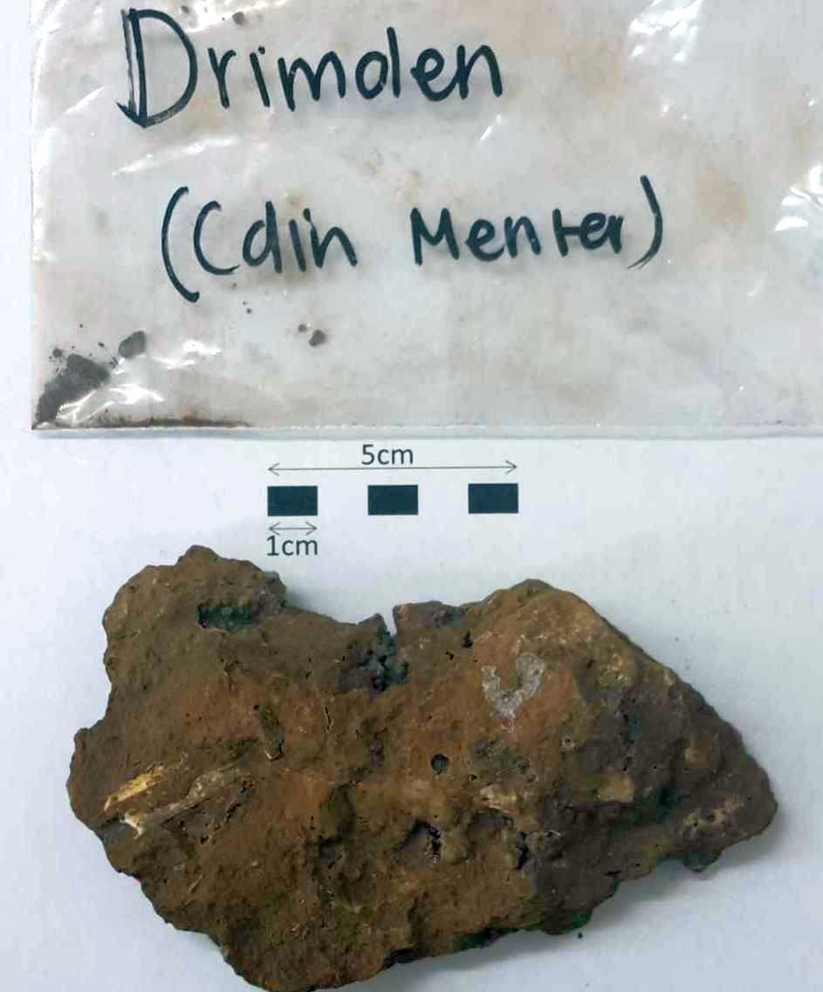 | 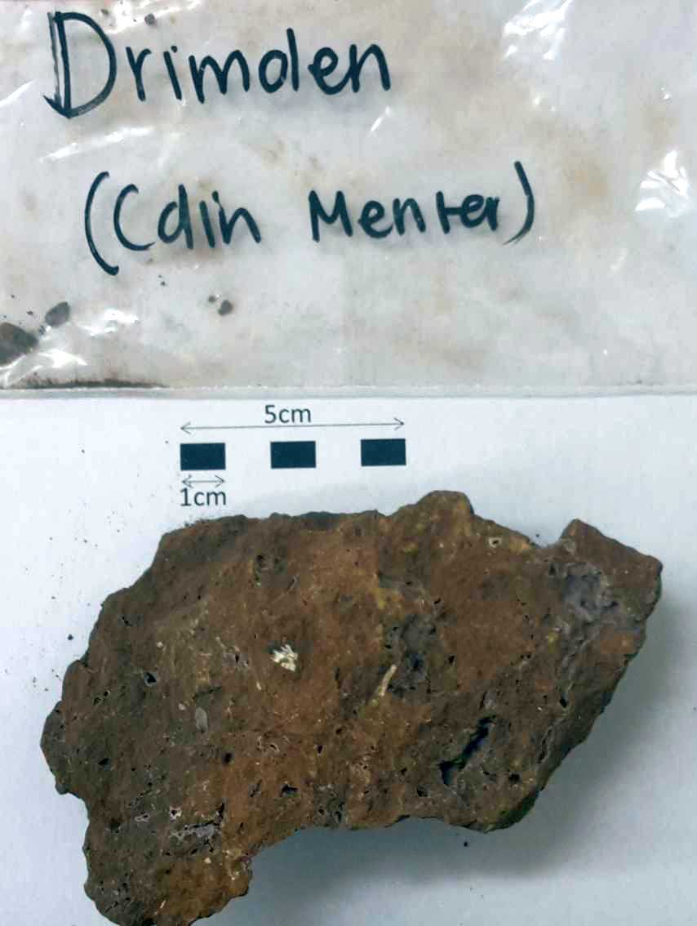
Kromdraai | 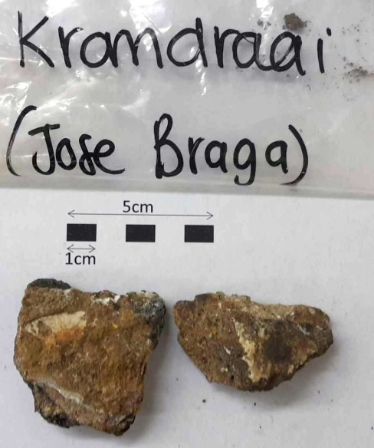 | 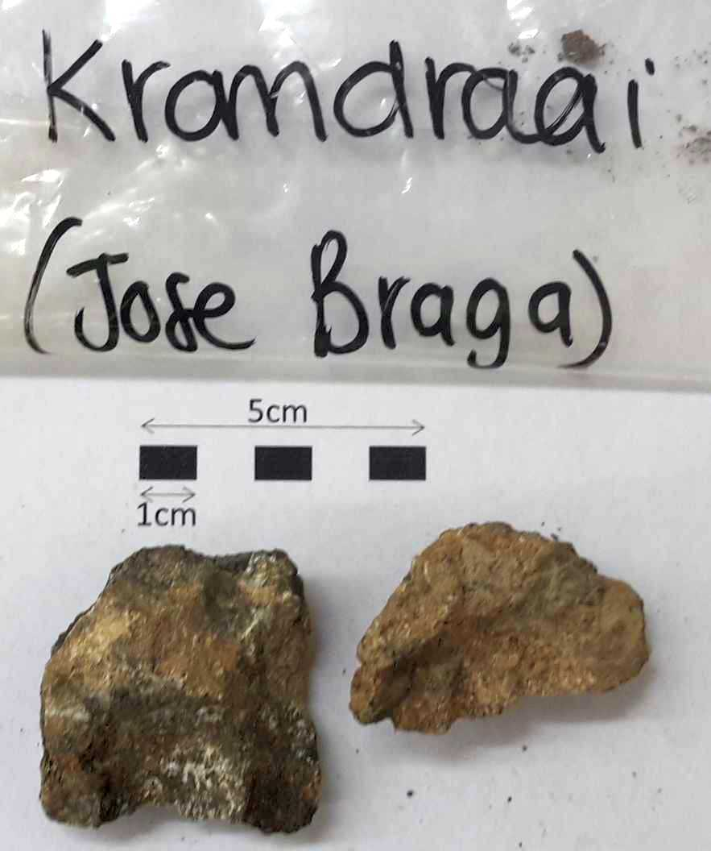
Haasgat | 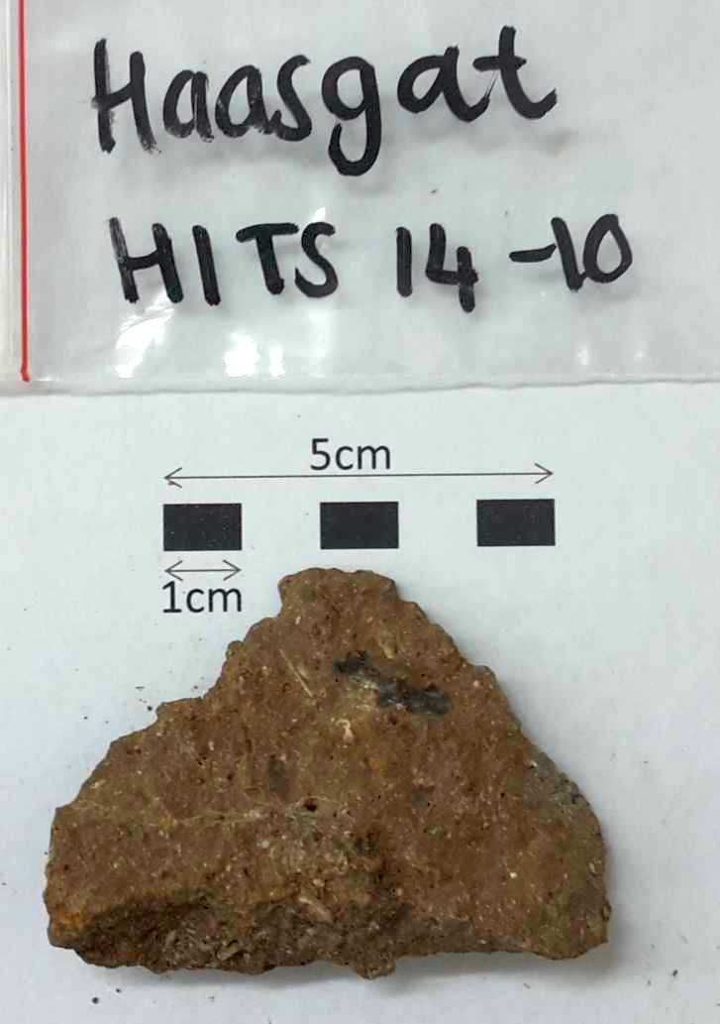 | 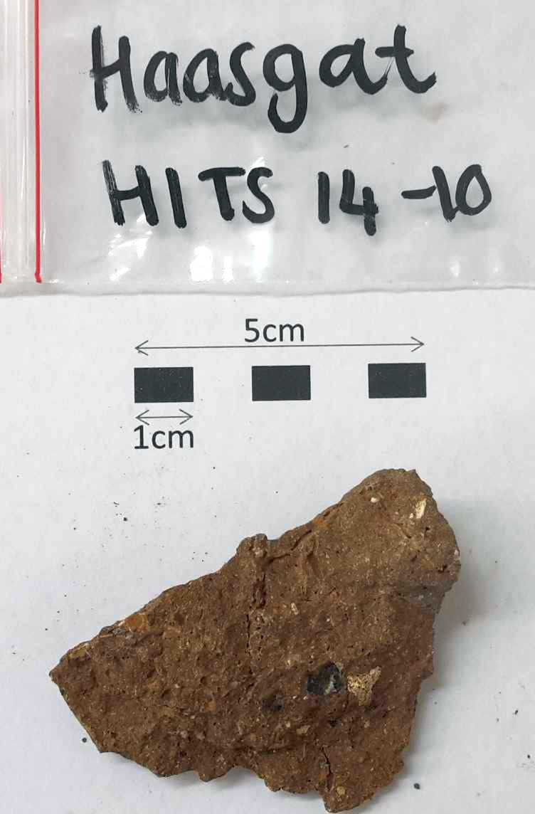
Brad-Pit A | 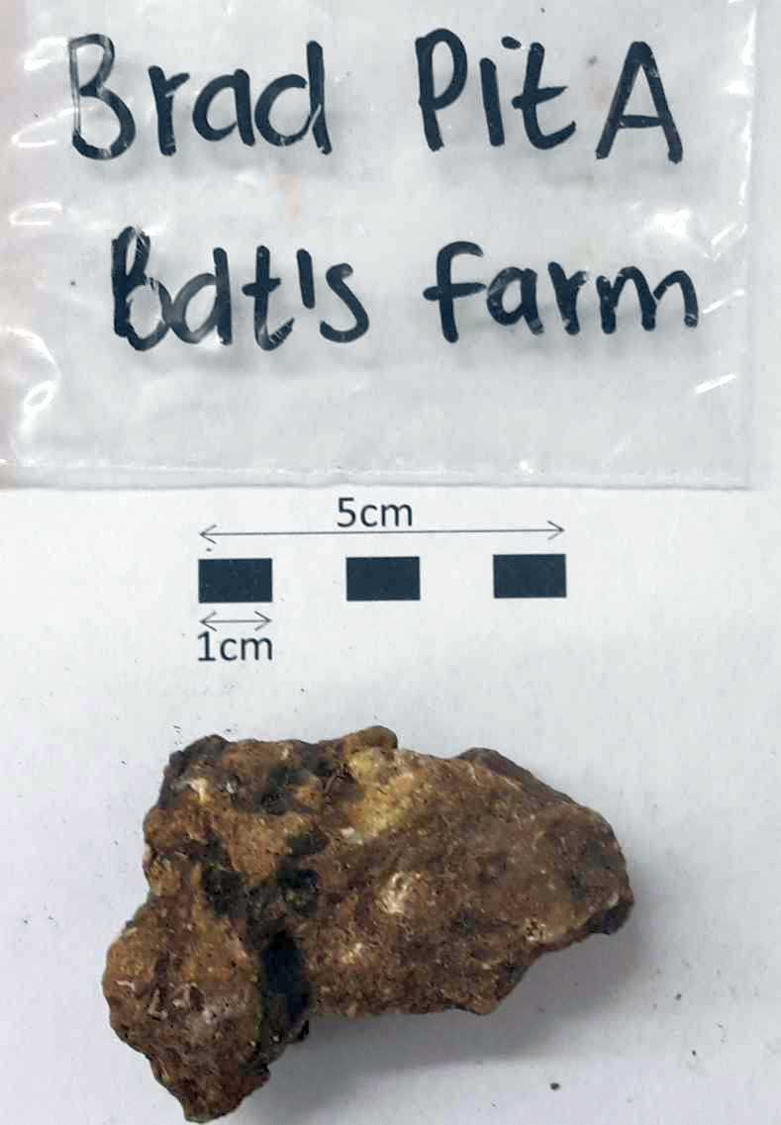 | 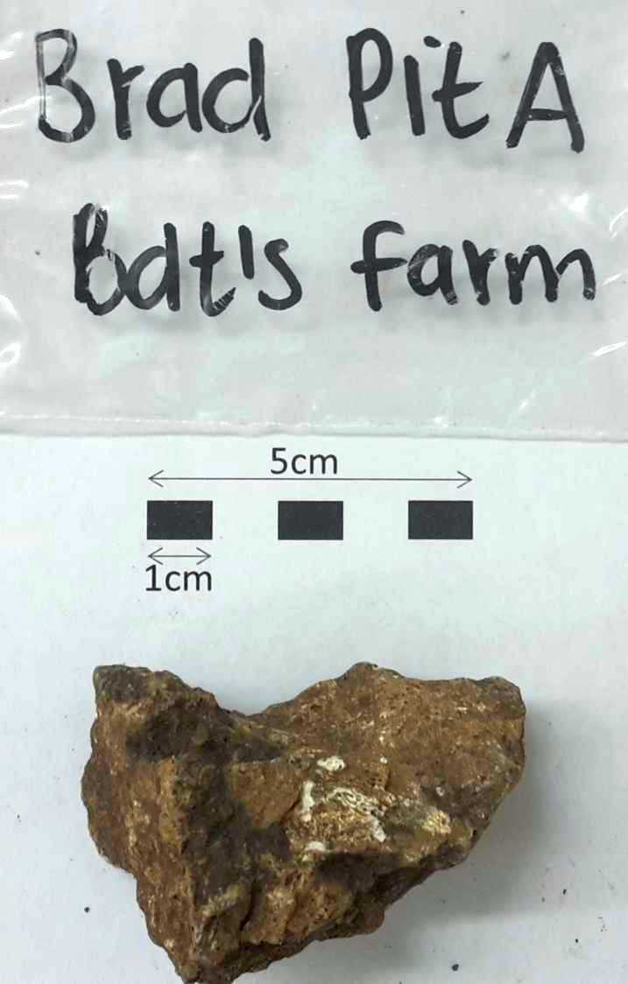

OBJECTIVES:
- Radiation Monitoring:
Determine the natural radioactivity of each of the 5 samples if any
- Neutron Radiography:
Performs Neutron radiography with the highest resolution aiming to:
  - Detect any bone structures in the samples and
  - Virtually extract them from the breccia materials
- Gamma Spectroscopy:
Immediately after NRAD, determine the elemental composition by means of spectroscopy
- Radiation Monitoring:
Determine the natural ½ life of the samples through radiation monitoring at several time intervals.

BEAM TIME REQUESTED: (End of March 2015 : Any days : 22 March – 30 March )
- Neutron radiography: 2 days
  - 4 tomography scans : Full beam
  - Mono-energetic beam (research to find higher contrast in bones and breccia)
- Spectroscopy: 2 days interrupted
- Radiation monitoring: 5 days interrupted.

MATERIALS/ SAMPLES:
These samples originate from the Cradle and are precious artefacts from South Africa and to be handled with care. Overnight safe locking of the samples is important.

