SUBMISSION TO THE GRADING AND DECLARATION REVIEW COMMITTEE – 01 September 2016

SUBMITTED BY: Tsholofelo Phago

UNIT: Grading and Declaration Unit

DATE: 17 August 2016

FILE REF: 9/2/277/019

ENQUIRIES: Heidi Weldon / Tsholofelo Phago

ITEM: Proposal for National Heritage Site Declaration: Sharpeville Massacre Sites

PURPOSE
The submission is made to discuss and recommend approval of Sharpeville Massacre Sites as National Heritage Sites.

BACKGROUND
In 1960, the police at the Sharpeville Police Station opened fire on unarmed peaceful protestors killing 69 black innocent men, women and children and wounding 180. The victims had come to protest peacefully against the tyranny of pass system imposed on all black men and women. The event was organised by the Pan Africanist Congress in the context of increasing, on-going mass action of resistance against Apartheid.

The Massacre that took place on the 21st March 1960 became a critical turning point in the history of South Africa, leading to the banning of liberation movements, including the Pan Africanist Congress and the ANC. It also led to the move away from peaceful resistance to the taking up of arms, which ultimately led to the formation of Umkhonto We Sizwe.. The 21st March is now commemorated as National Human Rights Day and also the United Nation’s International Day for the Elimination of Racial Discrimination.

DISCUSSION

In 2001/02 SAHRA erected a Memorial Garden, a Memorial Boulder and assisted with the tombstones of the 69 graves in commemoration of the 21st March 1960 Massacre. Although SHARA acknowledged the national significance of the site, it was not then graded nor declared.

Sharpeville has also been identified as part of the Liberation Heritage Route and is included in the initial nomination for World Heritage Declaration. Therefore Council graded the Sharpeville Police Station, the Memorial Garden and the graves as Grade 1 sites on 29th April 2016.

Following the grading of the site, public meetings took place with the tenants of the Police Station, the Khulumani Support Group who represent the survivors and families of the victims, strategic stakeholders and the Sharpeville Community. From the initial meeting that took place on 22nd July with the tenants and Khulumani Support Group, there was overall support for the declaration of the sites. Concerns were raised regarding other sites related to the Massacre and history of Shrapeville as well as including the relocation from Topville Location as a precursor to the massacre.
Meetings with the strategic stakeholders and the Sharpeville Community will take place on 26th August 2016.

Formal letters of th notification have also been sent, however the 60days notice period is not yet concluded and to date no responses have been received.

RECOMMENDATION
It is recommended that the Grading and Declaration Review Committee agree to submit a proposal to SAHRA council to approve the declaration.

Contents of submission:
1. Landowner’s Details and Attitude towards Declaration
2. Public Participation and Notification
3. Official Description of the Site
4. Description of the Area to be Declared (Site Boundaries)
5. Conservation Management of the Site
6. Condition Assessment and Potential Threats
7. Site Utilization

1. LANDOWNERS’S DETAILS AND ATTITUDES TOWARDS DECLARATION
The land on which the Police Station and the Memorial Garden occur is owned by the Department of Public Works.
Details: M Dlabantu (Director-General)

Mr M. Dlabantu
Director- General
Department of Public Works
CGO Building
Cnr Bosman and Madiba Str
Pretoria

The 69 graves are owned by the families of the deceased victims and they are represented by Khulumani Support Group.
Details: M Mantsho (Chairperson Khulumani Support Group)

Ms Mary Mantsho
Khulumani Support Group
5058 Sobusa Street
Sharpeville
1928

2. PUBLIC PARTICIPATION AND NOTIFICATION

On the advise from the Sedibeng District Municipality, an initial meeting with the Khulumani Support Group, representing the survivors and families of the victims of the Massacre, and the tenants at the police station was held on the 22nd of July 2016 at the Sharpeville Police Station. The recommendation was based on addressing their concerns independently before presenting to the broader community.

The meeting agreed to the declaration of the three identified sites. However some concerns were raised, such as:

- The maintenance of the graves.
- It was also raised that SAHRA’s Sharpeville Massacre background should include information with regard to the forced relocation of the Sharpeville residents from Topville location by the Apartheid regime and the impact of racial segregation caused by the relocation, as this played an important precursor to the 1960 protest. Therefore it was suggested that this should be captured so as to reflect the emotional damage and suffering by the then Sharpeville community.
- Inclusion of other heritage sites such as the George Thabe Stadium where protestors met the day before and where the Constitution was signed.

A second public meeting with all the strategic stakeholders and community members will be held on the 26th of August 2016 at the Sharpeville Community Hall.

The Sedibeng District Municipality provided a list of all the stakeholders involved and formal notification letters were sent on 5th August 2016.
Interested and Affected Parties: Khulumani Support group
Department of Public Works
Department of Arts and Culture
Sedibeng District Municipality
Emfuleni Local Municipality
Gauteng PHRA
Pan African Congress
Tenants at the Police Station

The 60 days notification period has not yet ended and as yet no formal responses have been received.

3. OFFICIAL DESCRIPTION OF THE SITE
Three sites have been considered for declaration, namely:
- The Memorial Garden on erf 9172; Sharpeville
- The Police Station on erf 9175; Sharpeville
- The 69 graves of the victims in the Phelindaba Cemetery, Theunis Kruger Street Vereeniging.

4. DESCRIPTION OF THE AREA TO BE DECLARED (SITE BOUNDARIES)
The Sharpeville Precinct comprises of three main sites; the Garden of Remebrance Erf 9172, the Police Station Erf 9175 (representing the location where the massacre took place) and the 69 graves of the victims at the Phelindaba Cemetery.

Site name | Erf No/ Farm | Province | Town | Municipalities
 |  |  |  | District Municipality | Local Municipality
Sharpeville Police Station | 9175; Sharpeville | Gauteng | Vereeniging | Sedibeng District Municipality | Emfuleni Local Municipality
Memorial Garden | 9172; Sharpeville | Gauteng | Vereeniging | Sedibeng District Municipality | Emfuleni Local Municipality

Site name | Cemetery | Province | Town | Municipalities
 |  |  |  | District Municipality | Local Municipality
Gravesites of 69 Sharpeville Massacre Victims | Phelindaba Cemetery | Gauteng | Vereeniging | Sedibeng District Municipality | Emfuleni Local Municipality

Plan of the Sharpeville Human Rights Precinct [Source: Google Earth Pro. 2015)] indicating the site for declaration:
1 – Phelindaba Cemetery
37 – Sharpeville Memorial Garden
39 – Sharpeville Police Station
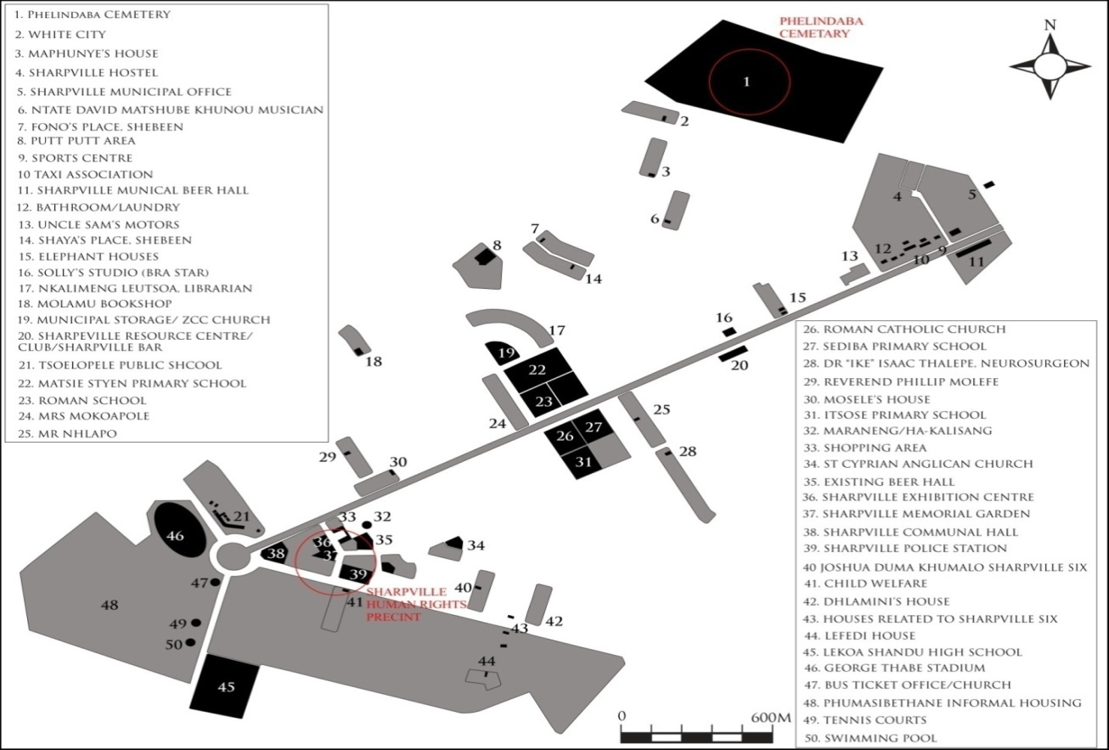

5. CONSERVATION MANAGEMNT OF THE SITE
The Police Station and the Memorial Garden are managed by Sedibeng District Municipality. The Phelindaba cemetery is managed by Emfuleni Local Municipality. A detailed Conservation Management Plan will be developed and a Memorandum of Understanding between SAHRA and the two municipalities will also be developed.

6. CONDITION ASSESSMENT AND POTENTIAL THREATS
Many of the family members raised a concern that the headstones design was designed in such a way they are all similar and look alike but the material used on the original headstone is not durable, and some families have possibly changed their headstones as a result of deteriorating material or for aesthetic reasons. On the graves, due to regular (annual) influx of people to the graves as well as overgrown grass for longer periods of time, the slabs surrounding the graves filled with white pebbles are dismantling as grass push them apart.

The protest route is not well marked and there is an ongoing debate on the exact protest route on the day of 21st March 1960. The old police station is being used as a craft centre warehouse, to stimulate the fading economy of the Sharpeville Township. Its current condition is bad, for example the paint if flaking off and thus maintenance will be necessary.

7. SITE UTALIZATION
The Police Station is utilised as a multipurpose centre such as Sedibeng District Municipality Heritage Offices and is community projects such as an arts and crafts hub with various craft companies renting space.
The graves are visited by the families and also utilized during the annual commemoration event hosted by Sedibeng District Municipality.
The Memorial Garden is a place of commemoration of the Massacre and the victims.

Further development of the precinct is planned as one of the three proposed Urban Framework Precinct Projects with the District Municipality as part of the Sedibeng Municipality Development Strategy.

