**SUBMISSION TO THE SAHRA COUNCIL via HRM COMMITTEE 29 April 2016**

SUBMITTED BY:

UNIT: Burial Grounds and Graves

DATE: 15 March 2016

FILE REF:

ENQUIRIES: Heidi Weldon / Mimi Seetelo

ITEM: Proposed Nomination of Site for Grade 1 Site Status: Gravesite and Chris Hani Memorial and Walk of Remembrance in the Thomas Nkobi Memorial Park; Boksburg; Ekurhuleni

**PURPOSE**

The purpose of this submission is to discuss and recommend Grade 1 approval of Chris Hani’s Gravesite and the Chris Hani Memorial and Walk of Remembrance located in the Thomas Nkobi Memorial Garden, Boksburg; Ekurhuleni.

**BACKGROUND**

Chris Hani was undoubtedly one of the most popular and influential leaders during the armed struggle and transition negotiations in the early 1990s. His gravesite and the Chris Hani Memorial and Walk of Remembrance commemorate his life, work and sacrifice in bringing about a free and a democratic South Africa. His grave and death mark a pivotal point in our history in which the leadership and commitment to peaceful transition was proved.

Ekurhuleni Municipality unveiled the Chris Hani Memorial and Walk of Remembrance, located near his gravesite in the Thomas Nkobi Memorial Garden, on 10th April 2015. The memorial was constructed in honour of the work and role played by Chris Hani in the liberation of South Africa. During the unveiling the President, Mr. Jacob Zuma, announced the grave of Chris Hani as a National Heritage Site. Therefore, the site has been nominated for National Heritage Site declaration in bring effected to the president’s statement.

**DISCUSSION**

Chris Hani was a charismatic leader both in the South African Communist Party and Umkhonto we Sizwe. His dedication to the strategic armed struggle led to structural changes within the ANC through the drafting of the “Hani Memorandum”. Committed to a negotiated transition, he was vital in ensuring that the armed struggle was abandoned.

His assassination almost threw the country into chaos and tested the commitment to a peaceful transition. His death hastened the negotiations and agreement on a date for the first democratic elections.

He was buried in the Thomas Nkobi Memorial Park (formerly known as the South Park Cemetry) in Boksburg. The Chris Hani Memorial and Walk of Remembrance was unveiled in 2015.

The grave and memorial commemorate and honours the role Chris Hani’s life’s work and death had in bringing about a democratic South Africa and are therefore deserving of national acknowledgement and declaration.

**RECOMMENDATION**

It is recommended that Chris Hani’s Grave and the Chris Hani Memorial and Walk of Remembrance are graded as a Grade 1 site.

# Contents of submission:

* 1. 1. Description and Location of the Site
  2. 2. Statement of Significance
  3. 3. Motivation for National Declaration
  4. 4. History of Chris Hani
  5. 5. Indication of the Owner’s Attitude
  6. 6. Indication of Management of the Site
  7. 7. Similar Sites
     1. **Description and Location of the Site:**

Chris Hani’s grave is situated in the “Hero’s Acre” section in the Thomas Thomas Nkobi Memorial Park on Heidelburg Rd; Dawn Park; Boksburg; Ekurhuleni. Chris Hani’s daughter, Nomakhwezi, who was with him when he was shot, is buried alongside him. The start of the memorial and walk are marked by a pathway and two lamp posts a few meters from the grave.

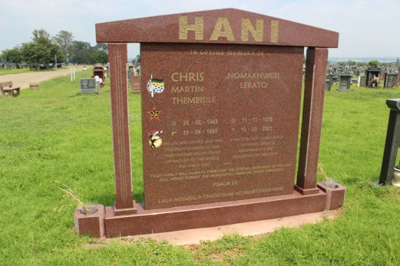 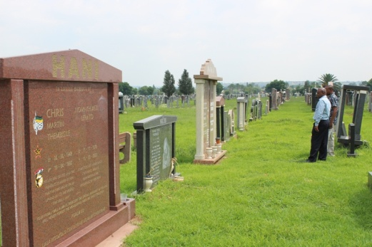

Chris Hani Grave in the Hero’s Acre of Thomas Nkobi Memorial Park

Chris Hani’s grave and tombstone

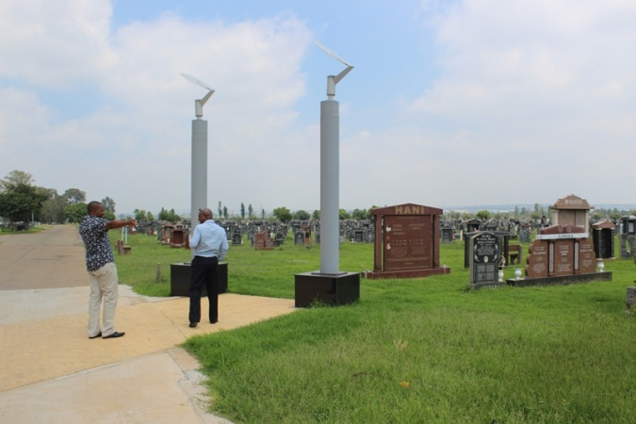 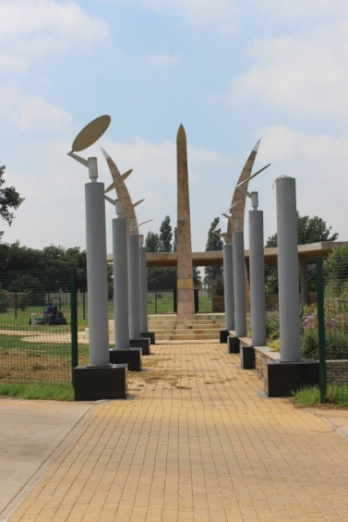



The start of the Chris Hani Memorial and Walk of Remembrance indicated by the pat t and lampposts

The Chris Hani Memorial and Walk of Remembrance is also situated in the cemetery close to his gravesite and stretches about 50m along the cemetery. The design and construction is full of symbolism and representations. The circular memorial is enclosed with four large granite pillars which represent the four pillars that underpinned the struggle. The memorial is situated at a 32 degrees angel from the grave (representing the years Hani was a member of the SACP) and offers a direct visual line to the grave. In the centre of the podium is granite cube bearing a sand blasted profile of Chris Hani on each side.

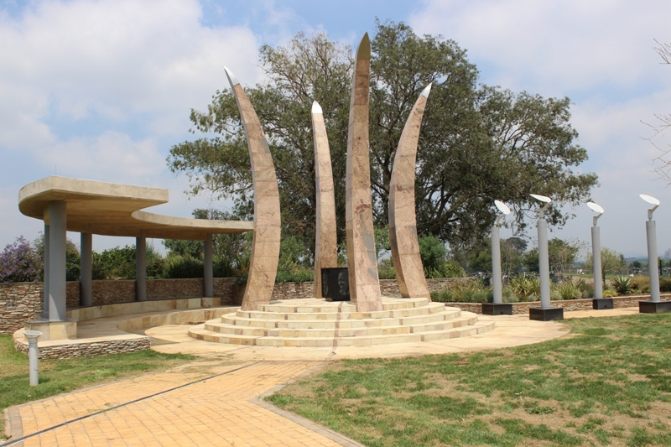

The circular memorial and pillars with cube in the centre

From the memorial, the Walk of Remembrance meanders in curved path to the Wall of Remembrance. The design of the walk is to encourage contemplation and reflection and represents the paths taken by those involved in the struggle.

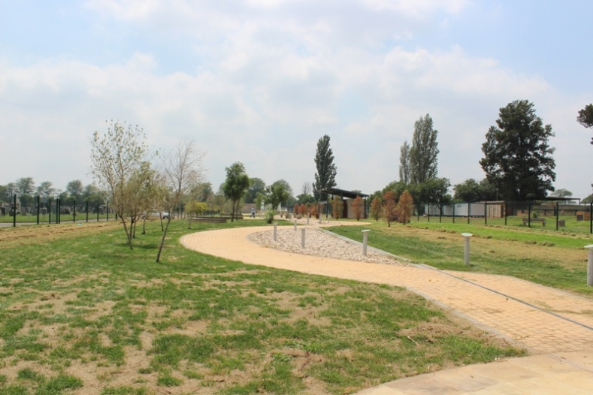

The meandering path of the Walk of Remembrance viewed from the memorial

The elevated concrete podium at the Wall of Remembrance celebrates the lives of the martyrs in the Struggle and gives recognition and tribute to their sacrifice. The solid granite wall shows a map of the walk and its symbolism. Three glass boxes represent democracy, transparency, and inclusivity upon which the names of fallen heroes will be blasted.

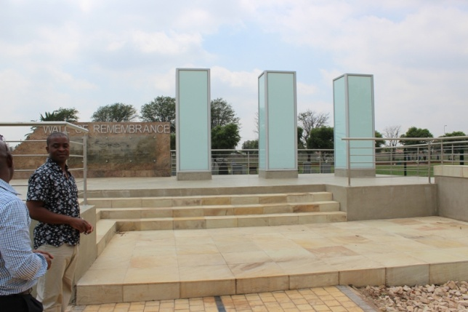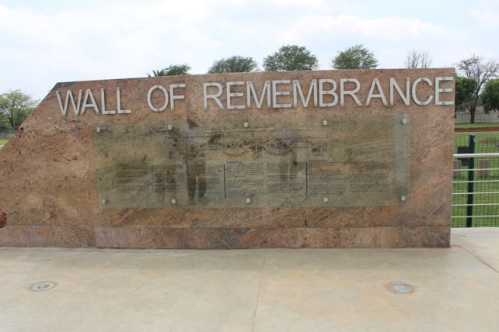

Granite Wall of Remembrance with map of the walk

Elevated concrete podium at the Wall of Remembrance showing the glass boxes

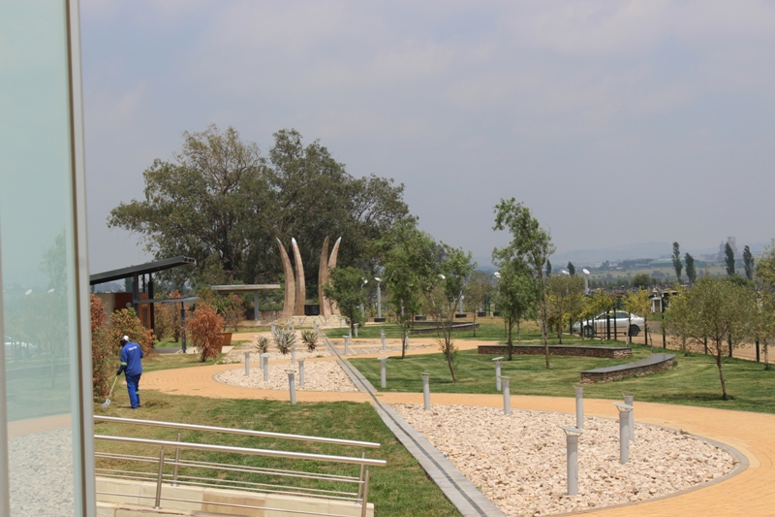

View of the Walk of Remembrance from the Wall of Remembrance towards the Chris Hani Memorial

# Brief Statement of Significance

Chris Hani, a well respected and revered leader of Umkhonto we Sizwe, the South African Communist Party and senior ranking ANC official, played an important role in liberation struggle and the negotiated transition for a free and democratic South Africa. He led the Luthuli Detachment in the Wankie Campaign after the MK had joined forces with the ZAPU.

Unhappy with the lack of support and strategic guidance from the ANC leadership, he was instrumental in the drafting of the “Hani Memorandum: which ultimately led to the Morogoro Conference in 1969, it itself a watershed moment in the history of the Liberation Struggle and bought about strategic structural changes within the ANC. .

Hani was a strong proponent of the peaceful negotiations after the unbanning of liberation movements and played a critical role in the in MK abandoning the armed struggle. His assassination about the country to the brink of civil war that led to Nelson Mandela’s plea, in what is regarded as a “presidential” statement, for calm and for all South Afrcans to stand together in ensuring a peaceful transition. The tensions at the time hastened the CODESA processes and an agreement on a date for the first democratic elections.

Chris Hani gravesite is a constant reminder of this role he played in reshaping the political landscape of South African politics that eventually became a democratic state in 1994.

# Motivation for National Declaration

Chris Hani was a well respected and revered leader of Umkhonto we Sizwe, the South African Communist Party and senior ranking ANC official. He played an important role in the both the armed struggle by bring about strategic structural changes within the Movement and during the post 1990 transitional negotiations. His assassination marked a pivotal point in the history of a democratic South Africa by risking to throw the country into chaos and spearheaded the agreement and announcement of a firm date for the first democratic election.

The Chris Hani Grave Site is a tangible association to the lifework, sacrifice, and role played by Hani, while the Memorial commemorates and honors his work and life and those of other fallen veterans in the struggle for a Free and Democratic South Africa.

Therefore the declaration of the site acknowledges these cultural values of the site in its close association to Chris Hani and the historical event of his assassination.

# History of Chris Hani

Thembsile Chris Hani was born in the rural Cofimvaba region in Eastern Cape on the 28 June 1942. Inspired by the arraignment of the Treason Trialists in 1956, he joined the ANC Youth League in 1957 when he was only 15 years old.

He attended Fort Hare from 1959- 1961 where he became openly involved in the Struggle protesting against the Bantu Education system the Apartheid government was instituting. He was also exposed to Marxism at Fort Hare which deepened his non racial perspective.

In 1961, influenced by leaders such as Govan Mbeki, JB marks, Moses Kotane Bram Fischer and Ray Simons, he joined the underground SACP. A year later in 1962 he joined the fledgling military wing of the ANC, Umkhonto we Sizwe, and this began his long road in the armed struggle. After he was arrested under the “Suppression of Communism” Act and while out on bail pending an appeal, he went into hiding and left South Africa for Military training in the Soviet Union.

He returned to Africa in 1967 as the Political Commissar for the Luthuli Detachment in the joint ANC / ZAPU (Zimbabwe African People’s Union) Wankie Campaign and was present for three battles during the campaign. The campaign was a military failure but provided the much needed propaganda for both South Arica and Zimbabwean struggles. He narrowly escaped into Botswana but was arrested and detained for 2 years. This arrest led to his and others criticism of the ANC Leadership in the Hani Memorandum which then led to the Morogoro conference May 1969. The resolutions of this conference led to the ANC opening membership to non Africans and more strategic leadership, where political policy informed military action and not vice versa.

In 1974 Hani returned to South Africa to build the underground and establish communication and routes inside the country. He subsequently moved to Lesotho and continued this work from there. Following a number of assassination attempts he was moved to Lusaka Zambia in 1982 and elected into the ANC NEC. In his leading position of Political Commissar in Mk he was responsible for suppressing a mutiny by dissident anti-Communist ANC members in the detention camps in Angola in 1983-4. In 1987 he was promoted to Chief of Staff of MK.

When the SACP and ANC were unbanned in 1990, Hani returned to South Africa to play a crucial role in the negotiations. He became known as a charismatic and popular speaker at rallies across the country explaining the process of the negotiations. He stepped down as MK Chief of Staff in support of the negotiation process and played a crucial role in convincing the militants to abandon the armed struggle in favour of the negotiation. He is quoted in a brief autobiography he wrote in 1991:

*“In the current political situation, the decision by our organisation to suspend armed action is correct and is an important contribution in maintaining the momentum, of negotiation”*

On 10th April 1993 he was shot and killed at his home in the newly multi racial suburb of Dawn Park, Boksburg. He was together with this 15year old daughter Nomakhwezi (who was later buried alongside him). A white Afrikaans neighbour who witnessed the shooting memorised the number plate of the car that drove into the Hani driveway and called the police. Later a Polish far-right anti-communist immigrant Janusz Walus was arrested. Clive Derby-Lewis, a senior South African Conservative Party MP and Shadow Minister for Economic Affairs was found to be complicit in the murder by lending Walus his pistol.

Hani’s death sent to the country to the brink of civil war and the tensions across the country was a stern test for the leadership of the ANC in particular who showed that it could hold its followers to the course of negotiations and to the National Party. Mandela made a presidential appeal to the country for calm and collaboration in preventing the achievement of Freedom:

*“Tonight I am reaching out to every South African, black and white, from the very depths of my being. A white man, full or prejudice and hate, came to our country and committed a deed so foul that our while nation now teeters on the brink of disaster. A white woman, of Afrikaner origin, risked her life so that we may know and bring to justice, this assassin. The cold-blooded murder of Chris Hani has sent shock waves throughout the country and the world. .... Now is the time for all South Africans to stand together against those who, from any quarter, wish to destroy what Chris Hani gave his life for – the freedom of all of us.”*

Riots did follow however Hani’s death hastened the CODESA negotiations and within 6 weeks a date for the first democratic elections was set.

# Indication of Owner’s Attitude

The nomination for the site to be declared was submitted by City of Ekurhuleni who owns and manages Thomas Nkobi Memorial Park in Boksburg.

The City of Ekurhuleni have been in discussions with Limpho Hani, Hani’s widow regarding the declaration of the grave, and indications are that the Hani family are in support of the declaration.

* + 1. **Indication of Management of the Site**

Both the gravesite and the Memorial are situated in the Thomas Nkobi Cemetery (formerly South Park Cemetery) and is managed by the City of Ekurhuleni

* + 1. **Similar Sites**

Other declared graves of Founding Fathers (such as Dube, Luthuli, Seme, Sobukwe and Biko) and other stalwarts of the struggle, such as Beyers Naude,