Hammarsdale Main Road 385 (M50) Upgrade – Environmental Assessment and Associated Studies

Introduction
EThekwini Economic Development Unit and Planning Department has appointed WSP to undertake a Basic Assessment for the upgrading and widening of the Main Road 385 (M50) from Anderson Road to Stanley Metheven Drive, in Hammarsdale. We have set aside a small lump sum (equivalent to the average amount usually set aside for this purpose) for the compilation of the Heritage submission (to Amafa) associated with the proposed development. Would you be interested in assisting us with this component of the submission?

Understanding of the Brief
The eThekwini Economic Development Unit and Planning Department has proposed the upgrading and widening of the Main 385 Road (M50) between Anderson Road and Stanley Metheven Drive, Hammarsdale. This includes the construction of an additional lane in both directions, the widening of the bridge over the Sterkspruit River as well as all associated storm water control. The upgrade and expansion has been proposed to meet the increased traffic pressure associated with the construction of numerous new developments in the area.
The proposed development includes: earthwork excavations to design level, import of suitable materials as per the pavement design report, retaining walls, bridge widening, stormwater installation, asphalt sidewalks with barrier/mountable kerbing and ancillary road works.
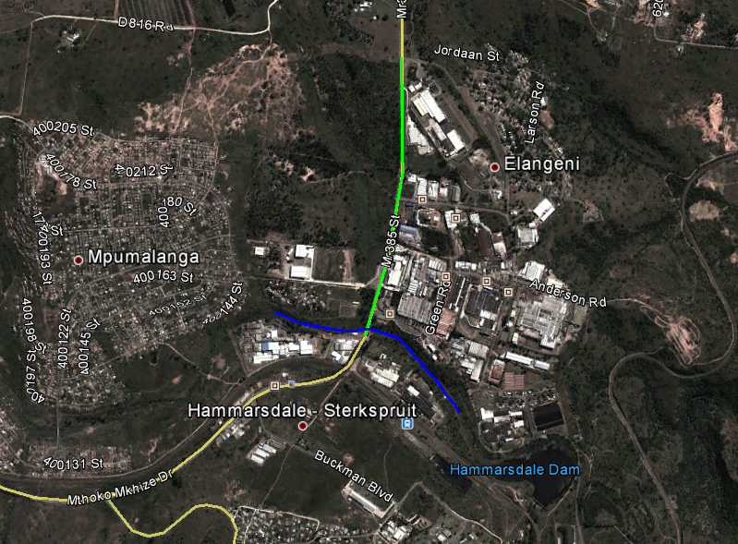
Figure 1: Highlighted in green is the portion of road to be expanded and upgraded; delineated in blue is a portion of the Sterkspruit River.

Legal Interpretation

National Heritage Resources Act (Act 25 of 1999)
A Heritage Impact Assessments (HIA) is likely to be required in terms of the National Environmental Management Act 107 of 1998 as amended (NEMA), in compliance with Section 38 of the National Heritage Resources Act 25 of 1999 as amended (NHRA). Section 38(1) of the NHRA may require such an assessment in case of “the construction of a road, wall, power line, pipeline, canal or other similar form of linear development or barrier exceeding 300m in length”.
It is anticipated that a Phase 1 HIA will be required, in order to identify heritage resources within the footprint of the proposed project and provide recommendations for their management of these resources. The project will have to be registered with Amafa KwaZulu-Natal (provincial heritage agency), and all reports and findings submitted to them for comment and approval.

Timeframe
A maximum of three months is available for the relevant HIA study, but a reduced timeframe would be more favourable. Please indicate your suggested project duration in your acceptance letter (if accepted).

Budget
A sum of R12,000.00 has been set aside for the Heritage Study (including disbursements but excluding VAT).

