SITE INSPECTION REPORT FOR: HELDERFONTEIN GRAVES IN GLENFERNESS RIVERSANDS
Prepared By: Nkosazana Machete (nmachete@sahra.org.za)
HERITAGE PROTECTION UNIT
APP Indicator Number: 2.1
DATE: 15 July 2019

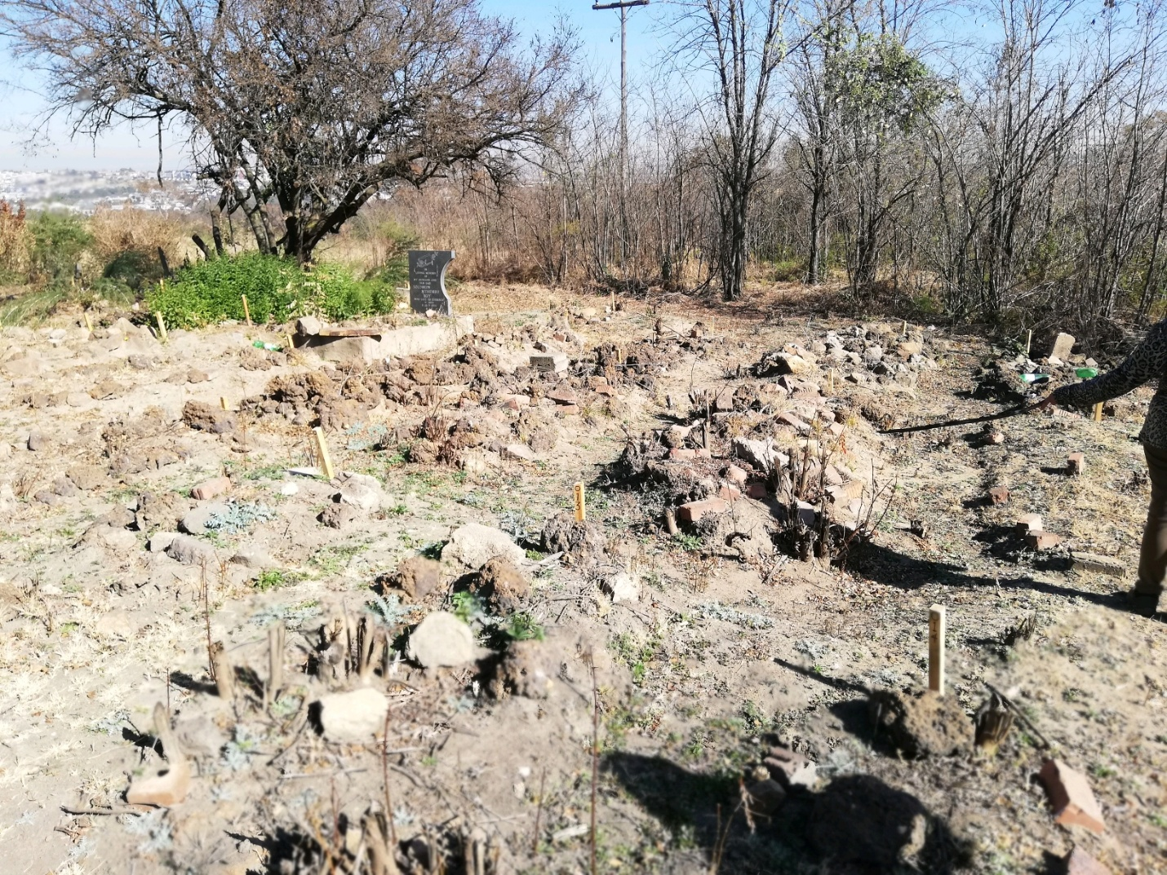

Introduction
The purpose is to give a report on the site inspection meeting that was held at Helderfontein site closer to Glenferness. The meeting was attended by Ms Sonja Bohnsack and HPU officials.
Project background
SAHRA received a complaint from Ms Sonja Bohnsack from Helderfontein. Century developers are in the process of removing graves without following proper procedures. There have not submitted Heritage Impact Assessment (HIA).
Figure 1: The graves

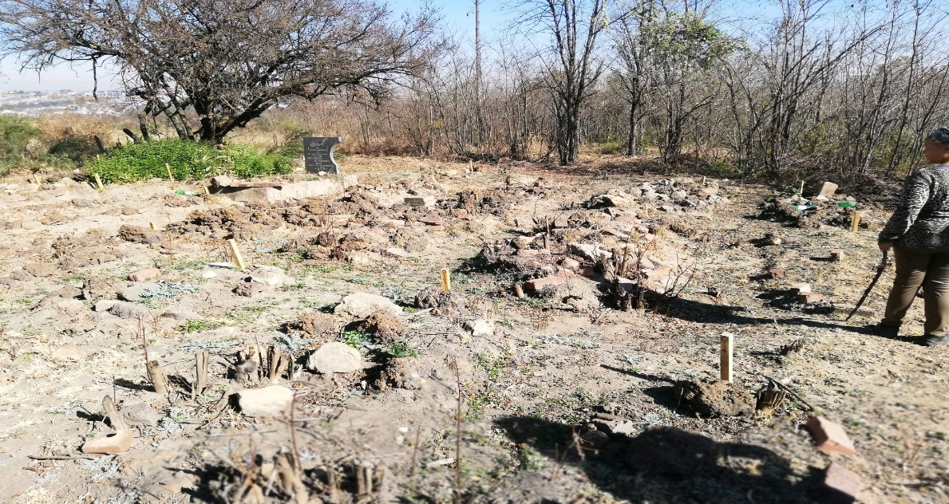

Site Inspection Assessment
On the 10 of July 2019, HPU officials had a site inspection at the mentioned location, with the complaint Ms Sonja Bohnsack. The complaint took SAHRA to the site where they are 56 graves marked which are over 60 years and few graves are below 60 years.
The developers have already placed the notice boards that graves will be removed stating National Heritage Resources Act no.25 of 1999 and Gauteng Provincial Heritage Authority (GPHA) processes that will be followed. The developer has not yet submitted the Heritage Impact Assessment to SAHRA.
Figure 2: Site Notice

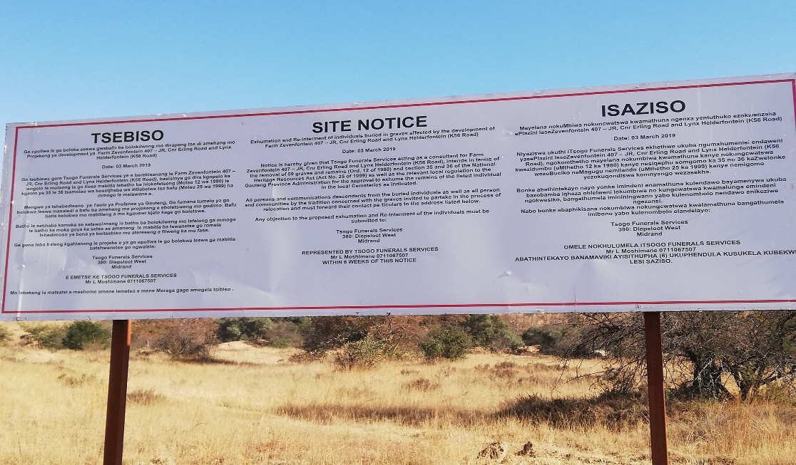

HPU officials observed that the development might continue without SAHRA’s involvement as they have already marked the 56 graves. During inspection SAHRA official discovered that there are 4 other graves that are not marked meaning that there are 60 graves in total not 56 graves marked.

Recommendations
- APM need to contact Century developers to establish if the heritage impact assessment has been submitted to SAHRA
- BGG need to contact Tsogo Funerals Services Mr L. Moshimane 071 1067 507 to find out if there is a permit issued by SAHRA for graves older than 60 years.
- HPU is handing over this report to APM and BGG to continue with the investigations as the matter falls under these two units mandate.
Conclusion
In conclusion the HPU will keep on communicating with the two units concerning this complaint.

Compiled by: Date
N. Q. Machete 15 July 2019

Manager: Nkosazana Machete Executive Officer: Mamakomoreng Nkhasi

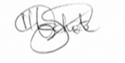
------------------------ -----------------------------
Date: 15 July 2019 Date:

