Non Pareille and Goede Rust, Paarl Farm, Dal Josafat, Paarl

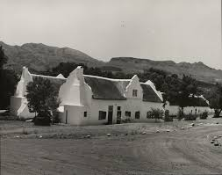

Heritage statement on Lighting to Non Pareille and Goede Rust

CONTENTS

- Introduction
- Location
- Description

- Introduction

The Goede Rust was originally granted in 1693. The farms in this valley were for centuries in the hands of the French Huguenots and their descendants. There are approximately 14 historic buildings in the Cape Dutch or Victorian Style, the most important o Type of site: Farm Complex.

- Location

Dal Josafat farm and is located approximately 8km north east of the Paarl CBD. The area surrounding the property is made up of farms and low cost residential developments in areas known as Groenenheuwel and Mbekweni. The combined site measures 8728m² and boasts a single main building together with a smaller outbuilding. Access to the property can be gained from the Bo Dal Road, an unpaved road in a well maintained condition. The access road is considered to be a low traffic route. The subject property is considered to be in moderate proximity to modern amenities such as banks, schools, places of worship, sports facilities, shopping centres, restaurants and retail facilities all located in the nearby town of Paarl (some 8km away). The Daljosafat Cultural Landscape is significant because of its idyllic setting, rich history associated with living heritage and a distinctive cultural environment. It boats a distinct Cape Vernacular Architecture with an East.

- Description

The Dal Josaphat property currently needs an upgrade on the pole light network to ensure proper visibility on the premises at night. Because of the fact that there are no current road lights next to the property, this needs to be addressed as soon as possible in order to secure the safety and security of the property and the tenants. Several of the pole lights were damaged and some are also outdated and not working. At several places new light poles and lights needs to be erect in order to bring more visibility to that dark areas

