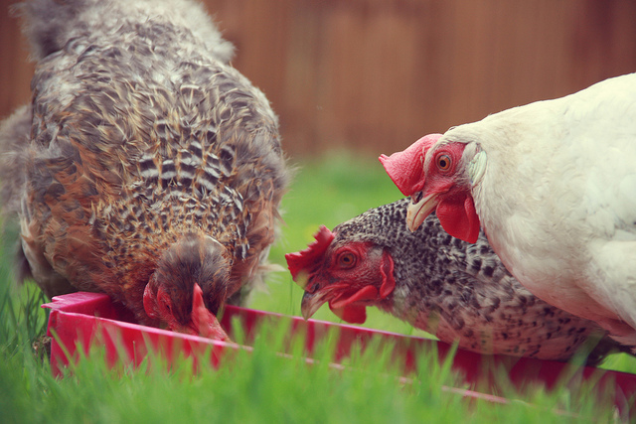
May 2017
CSIR Reference Number: CSIR/IU/02100/IR/2017/0004/A
IMPILO FARM PRODUCE
Basic Assessment
For the expansion of a Chicken Layer Facility on a 8 hectare farm on plot 223 & 224 Withok Estate, Brakpan, Ekurhuleni District, Gauteng.

Basic Assessment for the expansion of a Chicken Layer Facility on a 8 hectare farm on plot 223 & 224 Withok Estate, Brakpan, Ekurhuleni District, Gauteng.

CSIR Reference: CSIR/IU/02100/IR/2017/0004/A
INTRODUCTION TO THE PROPOSED PROJECT
Impilo Farm Produce is a business that is owned by Friendly Ties Management is located in Withok Estates, number 223 & 224 Mans Street, Brakpan, Benoni (Co-ordinates: -26.312285; 28.323044) (Figure 1). Impilo currently has 63 cattle, 16 sheep, 22 goats and 18 pigs (22 piglets). The business recently added two chicken layer facilities that hold 9 000 chickens per facilities.The development triggers listed activities in terms of the Environmental Impact Assessment (EIA) Regulations, Government Regulations (GNR) 326 of 7 April 2017 promulgate under the National Environmental Management Act (NEMA) (Act no 107 of 1998). In terms of these Regulations, a Basic Assessment (BA) should be undertaken for the proposed project. The Council for Scientific and Industrial Research (CSIR) is the Environmental Assessment Practitioner (EAP) who will be managing the process.
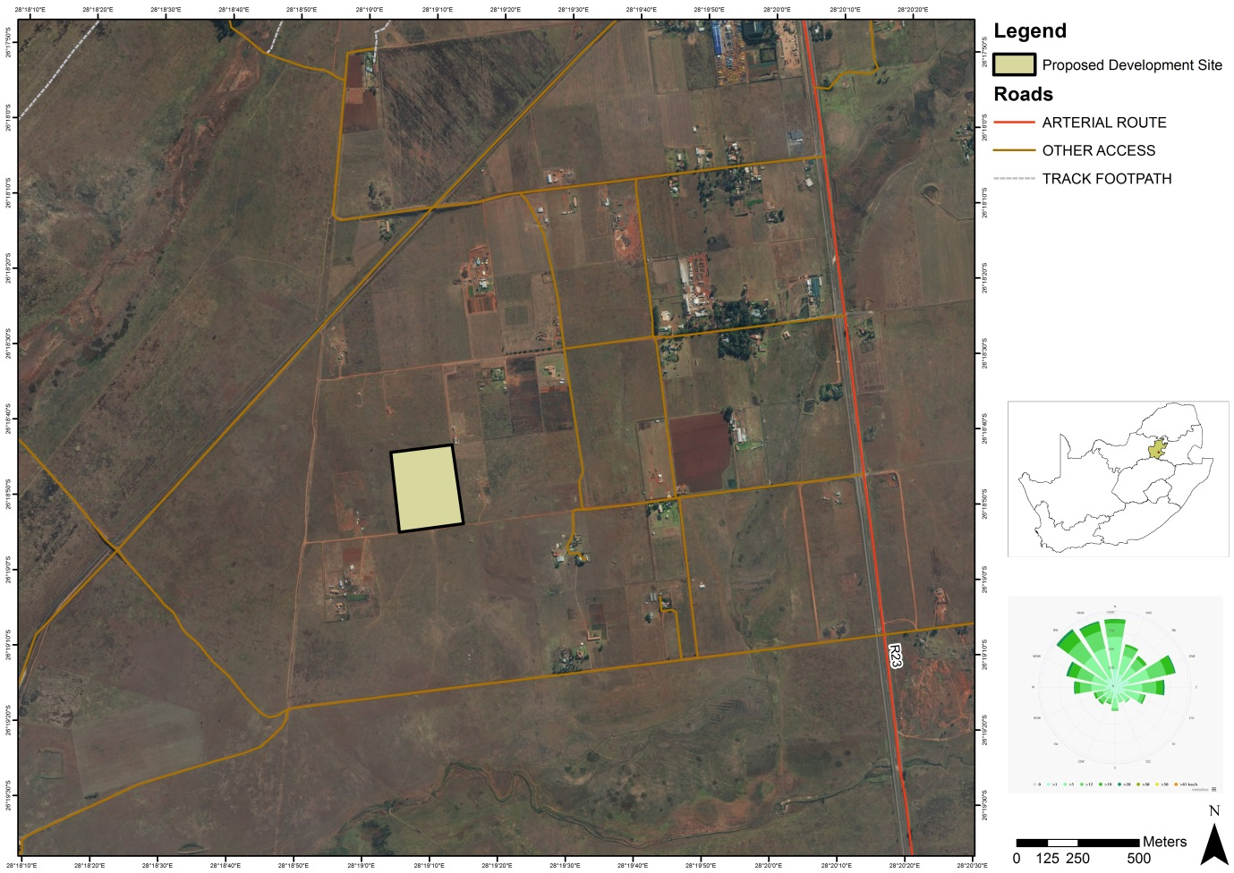
Figure 1. Locality map of where the proposed layer hen enterprise expansion will be constructed.

AIM OF THE DOCUMENT
This Background Information Document (BID) provides potential Interested and Affected Parties (I&APs) with:
- Information on the proposed project;
- A description of the Basic Assessment process to be followed; and
- Details on how to register your interest in the project and receive further information.
As a registered I&AP, there will be opportunities for you to be involved in this Basic Assessment (BA) process through receiving information, contributing issues and commenting on the Final BA Report (BAR). The input from I&APs, together with the information and assessment provided by the EAP and relevant specialists, will be used by the Competent Authority, in this instance the Gauteng Department of Agriculture & Rural Development (GDARD), to determine whether to grant or refuse Environmental Authorisation (EA) for the proposed project.

SUMMARY OF THE BASIC ASSESSMENT PROCESS
In terms of the NEMA EIA Regulations published in GNR 327, 325 and 324 on the 7 April 2017 Government Gazette Number 40772, a BA process is required as the project triggers the following listed activities (detailed in Table 1 below).
Table 1: Listed activities to be triggered
Relevant notice: | Activity No(s) (in terms of the relevant notice) | Description of each listed activity as per the Government Notice:
GNR 327, 7 April 2017 | 5. (ii) | The development and related operation of facilities or infrastructure for the concentration of more than 5 000 poultry per facility situated outside an urban area, excluding chicks younger than 20 days.
GNR 327, 7 April 2017 | 27 | The clearance of an area of 1 hectares or more, but less than 20 hectares of indigenous vegetation, except where such clearance of indigenous vegetation is required for- (i) The undertaking of a linear activity; or (ii) Maintenance purposes undertaken in accordance with a maintenance management plan.
GNR 327, 7 April 2017 | 40 | The expansion and related operation of facilities for the concentration of poultry, excluding chicks younger than 20 days, where the capacity of the facility will be increased by (ii) more than 5 000 poultry per facility situated outside an urban area
GNR 324, 7 April 2017 | 12c | The Clearance of an area of 300 square metres or more of indigenous vegetation except where such clearance of indigenous vegetation is required for maintenance purposes undertaken in accordance with a maintenance management plan.
These listed activities require an environmental authorisation from the Gauteng Department of Agriculture & Rural Development (GDARD ). The BA process that will be undertaken for this project is summarised in the following steps below:
Step 1: Notify Authorities and potential I&APs (30 days) (current stage)
The first stage in the process entails notifying all potential I&APs of the proposed project, by sending out a Background Information Document (BID), and providing I&APs with an opportunity to register as an I&AP. I&APs are required to register their interest on the project database within 30 days (in order to be included from the outset of the BA process) and/or raise issues or concerns.
Step 2: BAR for Public Comment (30 days)
The BA process is undertaken in order to identify and assess potential environmental impacts, both positive and negative, that may be associated with the project. Mitigation and management measures will be identified to reduce potential negative impacts and maximise positive benefits. These mitigation and management measures will be included in the Environmental Management Programme (EMPr) for this project. The BAR will include comments received from all I&APs on this BID and findings of the specialist study. All registered I&APs on the project database will be notified in writing of the 30 day comment period for the BAR.
Step 3: BAR to be submitted to GDARD for decision-making
The BAR will be drafted and will be submitted to GDARD for decision-making. The comments and issues raised will be included in the BAR submitted to GDARD. All I&APs will be providing with written notification whether the project has been granted or refused EA and about the appeal process.
HOW TO GET INVOLVED
- By responding to our invitation for your involvement as advertised in the local newspaper.
- By mailing, emailing or faxing a comment form to the Environmental Assessment Practitioner indicated below.
- By telephonically contacting the Environmental Assessment Practitioner if you have a query, comment, or require further project information.
- By reviewing the various reports and provide comments within the stipulated comment periods provided (i.e. the BID and BAR).
- By attending any meetings, which may be held during the review period.
WHO SHOULD YOU CONTACT?
To register as an I&AP or to comment on the project, please complete the Comment/Registration Form that has been included with this BID and kindly send to the Project Manager, Ms. Rirhandzu Marivate on or before 27 June 2017:
Ms. Rirhandzu Marivate
Email: rmarivate@csir.co.za
Tel: 021-888-2432
Fax: 021-888-2693
Address: CSIR, PO Box 320, Stellenbosch, 7599
Website: http://www.csir.co.za/ems/specialneeds/

