PALAEONTOLOGICAL DESKTOP ASSESSMENT OF THE PROPOSED KRIEL POWER STATION LIME PLANT UPGRADE, MPUMALANGA PROVINCE

CaseID 13369

Client – Eskom Holdings SOC Limited.
EAP – Savannah Environmental (Pty) Ltd.

Issue Date: 22 February 2019
Revision No.: 0.1
Client: Savannah Environmental (Pty) Ltd
PGS Project No: PIA

Declaration of Independence
I, Elize Butler, declare that –
General declaration:
- I act as the independent palaeontological specialist in this application
- I will perform the work relating to the application in an objective manner, even if this results in views and findings that are not favourable to the applicant
- I declare that there are no circumstances that may compromise my objectivity in performing such work;
- I have expertise in conducting palaeontological impact assessments, including knowledge of the Act, Regulations and any guidelines that have relevance to the proposed activity;
- I will comply with the Act, Regulations and all other applicable legislation;
- I will take into account, to the extent possible, the matters listed in section 38 of the NHRA when preparing the application and any report relating to the application;
- I have no, and will not engage in, conflicting interests in the undertaking of the activity;
- I undertake to disclose to the applicant and the competent authority all material information in my possession that reasonably has or may have the potential of influencing - any decision to be taken with respect to the application by the competent authority; and - the objectivity of any report, plan or document to be prepared by myself for submission to the competent authority;
- I will ensure that information containing all relevant facts in respect of the application is distributed or made available to interested and affected parties and the public and that participation by interested and affected parties is facilitated in such a manner that all interested and affected parties will be provided with a reasonable opportunity to participate and to provide comments on documents that are produced to support the application;
- I will provide the competent authority with access to all information at my disposal regarding the application, whether such information is favourable to the applicant or not
- All the particulars furnished by me in this form are true and correct;
- I will perform all other obligations as expected a palaeontological specialist in terms of the Act and the constitutions of my affiliated professional bodies; and
- I realise that a false declaration is an offence in terms of regulation 71 of the Regulations and is punishable in terms of section 24F of the NEMA.

Disclosure of Vested Interest
I do not have and will not have any vested interest (either business, financial, personal or other) in the proposed activity proceeding other than remuneration for work performed in terms of the Regulations;

PALAEONTOLOGICAL CONSULTANT: Banzai Environmental (Pty) Ltd
CONTACT PERSON: Elize Butler
Tel: +27 844478759
Email: elizebutler002@gmail.com
SIGNATURE: 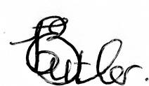

ACKNOWLEDGEMENT OF RECEIPT

Report Title | Palaeontological Desktop Assessment of the proposed Kriel Power Station Lime Plant Upgrade, Mpumalanga Province
Control | Name | Signature | Designation
Author | Elize Butler |  | Palaeontologist
Reviewed | Wouter Fourie |  | Principal Heritage Specialist
Client | Reuben Maroga |  | Environmental Consultant

CLIENT: Savannah Environmental (Pty) Ltd.

CONTACT PERSON: Reuben Maroga
+27 (0)11 656 3237
reuben@savannahsa.com

The heritage impact assessment report has been compiled taking into account the National Environmental Management Act 1998 (NEMA) and Environmental Impact Regulations 2014 as amended, requirements for specialist reports, Appendix 6, as indicated in the table below.

NEMA Regs (2014) - Appendix 6 | Relevant section in report
1. (1) A specialist report prepared in terms of these Regulations must contain-  - details of-  - the specialist who prepared the report; and  - the expertise of that specialist to compile a specialist report including a curriculum vitae; | Page ii of Report – Contact details and company and Appendix A
- a declaration that the specialist is independent in a form as may be specified by the competent authority; | Page ii
- an indication of the scope of, and the purpose for which, the report was prepared; | Section 4 – Objective
(cA) an indication of the quality and age of base data used for the specialist report; | Section 5 – Geological and Palaeontological history
(cB) a description of existing impacts on the site, cumulative impacts of the proposed development and levels of acceptable change; | Section 9
- the date, duration and season of the site investigation and the relevance of the season to the outcome of the assessment; | N/A Desktop Study
- a description of the methodology adopted in preparing the report or carrying out the specialised process inclusive of equipment and modelling used; | Section 7 Approach and Methodology
- details of an assessment of the specifically identified sensitivity of the site related to the proposed activity or activities and its associated structures and infrastructure, inclusive of a site plan identifying site alternatives; | Section 1 and 9
- an identification of any areas to be avoided, including buffers; | Not identified, Section 9
- a map superimposing the activity including the associated structures and infrastructure on the environmental sensitivities of the site including areas to be avoided, including buffers; | Section 5 – Geological and Palaeontological history
- a description of any assumptions made and any uncertainties or gaps in knowledge; | Section 7.1 – Assumptions and Limitation
- a description of the findings and potential implications of such findings on the impact of the proposed activity, including identified alternatives on the environment or activities; | Section 10
- any mitigation measures for inclusion in the EMPr; | Section 11
- any conditions for inclusion in the environmental authorisation; | N/A
- any monitoring requirements for inclusion in the EMPr or environmental authorisation; | N/A
- a reasoned opinion-  - as to whether the proposed activity, activities or portions thereof should be authorised;  (iA) regarding the acceptability of the proposed activity or activities; and  - if the opinion is that the proposed activity, activities or portions thereof should be authorised, any avoidance, management and mitigation measures that should be included in the EMPr, and where applicable, the closure plan; | Section 10
- a description of any consultation process that was undertaken during the course of preparing the specialist report; | Not applicable. A public consultation process was handled as part of the EIA and EMP process.
- a summary and copies of any comments received during any consultation process and where applicable all responses thereto; and | Not applicable.
- any other information requested by the competent authority. | Not applicable.
2) Where a government notice gazetted by the Minister provides for any protocol or minimum information requirement to be applied to a specialist report, the requirements as indicated in such notice will apply. | Section 3 compliance with SAHRA guidelines

EXECUTIVE SUMMARY
Banzai Environmental was appointed by PGS Heritage (Pty) Ltd to conduct the Palaeontological Desktop Assessment (PDA) to assess the proposed Kriel Power Station Lime Plant Upgrade, Mpumalanga Province. The National Heritage Resources Act (No 25 of 1999, section 38), states that a PIA is key to detect the presence of fossil material within the planned development footprint and it is thus necessary to evaluate the effect of the construction on the palaeontological resources.

The proposed Kriel Power Station Lime Plant Upgrade is completely underlain by the Vryheid Formation (Ecca Group, Karoo Supergroup). According to the SAHRIS PalaeoMap a Very High Palaeontological Sensitivity was allocated to this formation.

To date, no Palaeontological impact assessment has been conducted for the upgrade to the existing Lime Softening Plant as the area has been severely modified and disturbed. However, SAHRA (South African Heritage Research Agency) requested this study due to the Very High Palaeontological significant of the Vryheid Formation. Due to the site being highly modified, only a moderate possibility of recovering fossil heritage during the construction phase exists.

It is therefore considered that the construction and operation of the Kriel Power Station Lime Plant Upgrade, Mpumalanga Province is deemed appropriate and feasible and will not lead to detrimental impacts on the palaeontological resources of the area. Thus, the construction and operation of the facility may be authorised as the whole extent of the development footprint is not considered sensitive in terms of palaeontological resources.

In the event that fossil remains are discovered during any phase of construction, either on the surface or exposed by fresh excavations the Chance Find Protocol must be implemented by the ECO in charge of these developments. These discoveries must be secured (preferably in situ) and the ECO ought to alert SAHRA so that appropriate mitigation (e.g. documented, collection or sampling) can be undertaken by a professional palaeontologist.

The specialist would need a collection permit from SAHRA. Fossil material must be curated in an approved collection (museum or university) and all fieldwork and reports should meet the minimum standards for palaeontological impact studies developed by SAHRA.

TABLE OF CONTENT

1 INTRODUCTION 1
2 QUALIFICATIONS AND EXPERIENCE OF THE AUTHOR 7
3 LEGISLATION 7
3.1 National Heritage Resources Act (25 of 1999) 7
4 OBJECTIVE 8
5 GEOLOGICAL AND PALAEONTOLOGICAL HISTORY 8
5.1 Geology 9
5.1.1 Vryheid Formation (Ecca Group Karoo Supergroup) 9
5.2 Palaeontology 9
5.2.1 Vryheid Formation (Ecca Group Karoo Supergroup) 9
6 GEOGRAPHICAL LOCATION OF THE SITE 13
7 Methods 13
7.1 Assumptions and Limitations 13
8 Additional Information Consulted 14
9 IMPACT ASSESSMENT METHODOLOGY 14
9.1 Nature of the impact 14
9.2 Sensitive areas 14
9.3 Geographical extent of impact 14
9.4 Duration of impact 14
9.5 Potential significance of the impact 15
9.6 Severity/benefit scale 15
9.7 Probability of the impact occurring 15
9.8 Intensity 15
10 DAMAGE MITIGATION, REVERSAL AND POTENTIAL IRREVERSIBLE LOSS 15
10.1 Mitigation 15
10.2 Degree of irreversible loss 15
10.3 Degree to which the impact may cause irreplaceable loss of resources 16
10.4 Cumulative impacts 16
10.5 Impact Assessment: 16
10.6 Palaeontological Sensitivity Map 20
11 FINDINGS AND RECOMMENDATIONS 21
12 CHANCE FINdS PROTOCOL 22
12.1 Legislation 22
12.2 Background 22
12.3 Introduction 22
12.4 Chance Finds Procedure 22
13 REFERENCES 23

List of Figures
Figure 1 - Site layout of the proposed Lime Plant upgrades at the Kriel Power Station. Map provided by Savanna Environment. 2
Figure 2: – Environmental Sensitivity and Layout Map of the proposed Lime Plant upgrades at the Kriel Power Station. The proposed development may be located at any position in the low Sensitivity (green) areas. Map provided by Savannah Environmental. 3
Figure 3: – Google Earth Image of the locality of the proposed Lime Plant upgrades at the Kriel Power Station. Map provided by Savannah Environmental. 4
Figure 4: – Substation infrastructure present at the proposed Lime Plant upgrades at the Kriel Power Station. Map provided by Global Geomatrix. 5
Figure 5: – Substation infrastructure present at the proposed Lime Plant upgrades at the Kriel Power Station. Map provided by Global Geomatrix. 6
Figure 6 - Surface geology of the proposed Kriel Power Station Lime Plant upgrade. The proposed development is underlain by the Vryheid Formation of the Ecca Group (Karoo Supergroup). Areas highlighted in white and yellow is opens paces where development might occur. The Vryheid formation has a High Paleontological Significance. Map drawn by QGIS Desktop 2.18.18. 11
Figure 7- Lithostratigraphic (rock-based) and biostratigraphic (fossil-based) subdivisions Beaufort Group of the Karoo Supergroup with rock units and fossil assemblage zones relevant to the present study marked in orange (Modified from Rubidge, 1995). Abbreviations: F. = Formation, M. = Member 12
Figure 6 - Palaeontological sensitivity of area on which the study area lays. Key found below in Table 2 - Key descriptions of SAHRIS palaeontological sensitivity map. 20

List of Tables

Table 1-Impact Assessment Table 18
Table 2 - Key descriptions of SAHRIS palaeontological sensitivity map 20

Appendix A: CV

TERMINOLOGY AND ABBREVIATIONS
Archaeological resources
This includes:
- material remains resulting from human activity which are in a state of disuse and are in or on land and which are older than 100 years including artefacts, human and hominid remains and artificial features and structures;
- rock art, being any form of painting, engraving or other graphic representation on a fixed rock surface or loose rock or stone, which was executed by human agency and which is older than 100 years, including any area within 10m of such representation;
- wrecks, being any vessel or aircraft, or any part thereof, which was wrecked in South Africa, whether on land, in the internal waters, the territorial waters or in the maritime culture zone of the Republic as defined in the Maritimes Zones Act, and any cargo, debris or artefacts found or associated therewith, which is older than 60 years or which SAHRA considers to be worthy of conservation;
- features, structures and artefacts associated with military history which are older than 75 years and the site on which they are found.

Cultural significance
This means aesthetic, architectural, historical, scientific, social, spiritual, linguistic or technological value or significance

Development
This means any physical intervention, excavation, or action, other than those caused by natural forces, which may in the opinion of the heritage authority in any way result in a change to the nature, appearance or physical nature of a place or influence its stability and future well-being, including:
- construction, alteration, demolition, removal or change in use of a place or a structure at a place;
- carrying out any works on or over or under a place;
- subdivision or consolidation of land comprising a place, including the structures or airspace of a place;
- constructing or putting up for display signs or boards;
- any change to the natural or existing condition or topography of land; and
- any removal or destruction of trees, or removal of vegetation or topsoil

Early Stone Age
The archaeology of the Stone Age between 700 000 and 2 500 000 years ago.

Fossil
Mineralised bones of animals, shellfish, plants and marine animals. A trace fossil is the track or footprint of a fossil animal that is preserved in stone or consolidated sediment.

Heritage
That which is inherited and forms part of the National Estate (historical places, objects, fossils as defined by the National Heritage Resources Act 25 of 1999).

Heritage resources
This means any place or object of cultural significance and can include (but not limited to) as stated under Section 3 of the NHRA,
- places, buildings, structures and equipment of cultural significance;
- places to which oral traditions are attached or which are associated with living heritage;
- historical settlements and townscapes;
- landscapes and natural features of cultural significance;
- geological sites of scientific or cultural importance;
- archaeological and palaeontological sites;
- graves and burial grounds, and
- sites of significance relating to the history of slavery in South Africa;

Holocene
The most recent geological time period which commenced 10 000 years ago.

Late Stone Age
The archaeology of the last 30 000 years associated with fully modern people.

Late Iron Age (Early Farming Communities)
The archaeology of the last 1000 years up to the 1800s, associated with iron-working and farming activities such as herding and agriculture.

Middle Stone Age
The archaeology of the Stone Age between 30 000-300 000 years ago, associated with early modern humans.

Palaeontology
Any fossilised remains or fossil trace of animals or plants which lived in the geological past, other than fossil fuels or fossiliferous rock intended for industrial use, and any site which contains such fossilised remains or trace.

Abbreviations | Description
AIA | Archaeological Impact Assessment
ASAPA | Association of South African Professional Archaeologists
CRM | Cultural Resource Management
DEA | Department of Environmental Affairs
DIA | Desktop Impact Assessment
ECO | Environmental Control Officer
EIA practitioner | Environmental Impact Assessment Practitioner
EIA | Environmental Impact Assessment
ESA | Early Stone Age
GPS | Global Positioning System
HIA | Heritage Impact Assessment
I&AP | Interested & Affected Party
LSA | Late Stone Age
LIA | Late Iron Age
MSA | Middle Stone Age
MIA | Middle Iron Age
NEMA | National Environmental Management Act
NHRA | National Heritage Resources Act
PIA | Palaeontological Impact Assessment
PHRA | Provincial Heritage Resources Authority
PSSA | Palaeontological Society of South Africa
SADC | Southern African Development Community
SAHRA | South African Heritage Resources Agency

- INTRODUCTION
(Information provided by Savannah Environmental)
Eskom Holdings SOC Ltd proposes the expansion of its existing Cooling Water (CW) Treatment facility at Kriel Power Station (Figure 1 and Figure 2)Figure 1 - Site layout of the proposed Lime Plant upgrades at the Kriel Power Station. Map provided by Savanna Environment., which falls in the jurisdiction of the Nkangala District Municipality as well as the eMalahleni Local Municipality in Mpumalanga. The proposed development is approximately 34 km north-west of Bethal, 27 km south of Ogies and 8 km west of Kriel (Figure 3). The Kriel Power Station is an Eskom base load, coal-fired power station and consists of six units with a generating capacity of 3600 MW.

The purpose of the proposed expansion is to save water as well as operational and maintenance costs at the station. The upgrade to the existing Lime Softening Plant will add associated infrastructure next to the Cooling Water Treatment Plant, near the southern and northern sections of the cooling towers (Figure 2). The proposed developmental upgrade will be located on the farm Kriel Power Station 65 IS and will be 1.96 ha in extent and within a study area of approximately 700 ha (Figure 1).

The Kriel Station Lime Plant Upgrades will each consist of the following:
- Two clarifiers on each side (north and south) of the station with a capacity of 1750 m³.
- Pipes to link the clarifiers with the existing lime plants
- Dilution water feed pumps.

To date, no Palaeontological impact assessment has been conducted for the upgrade to the existing Lime Softening Plant as the area has been severely modified and disturbed. SAHRA requested this study because the proposed development is underlain by the Very High Palaeontological significant Vryheid Formation. Due to the site being highly modified/disturbed only a moderate possibility of recovering fossil heritage during the construction phase exist. A high prevalence of subsurface infrastructure is present throughout the Kriel Power Station (Figure 4 & Figure 5).

Figure 1 - Site layout of the proposed Lime Plant upgrades at the Kriel Power Station. Map provided by Savanna Environment.
Figure 2 – Environmental Sensitivity and Layout Map of the proposed Lime Plant upgrades at the Kriel Power Station. The proposed development may be located at any position in the low Sensitivity (green) areas. Map provided by Savannah Environmental.

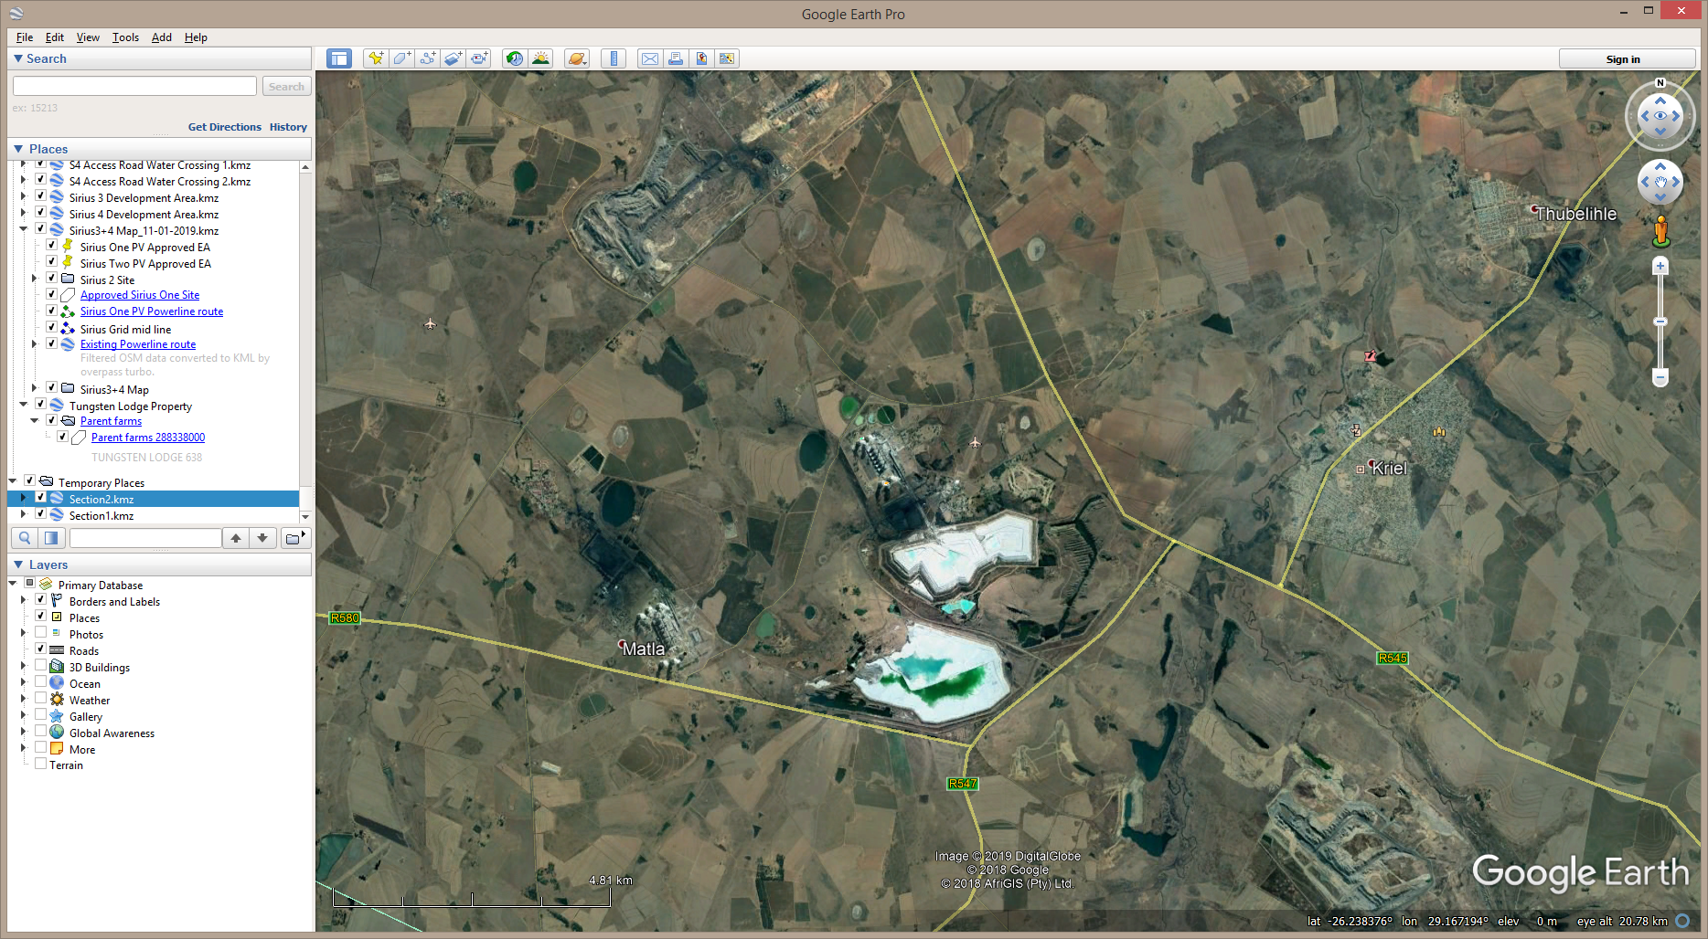

Figure 3 – Google Earth Image of the locality of the proposed Lime Plant upgrades at the Kriel Power Station. Map provided by Savannah Environmental.

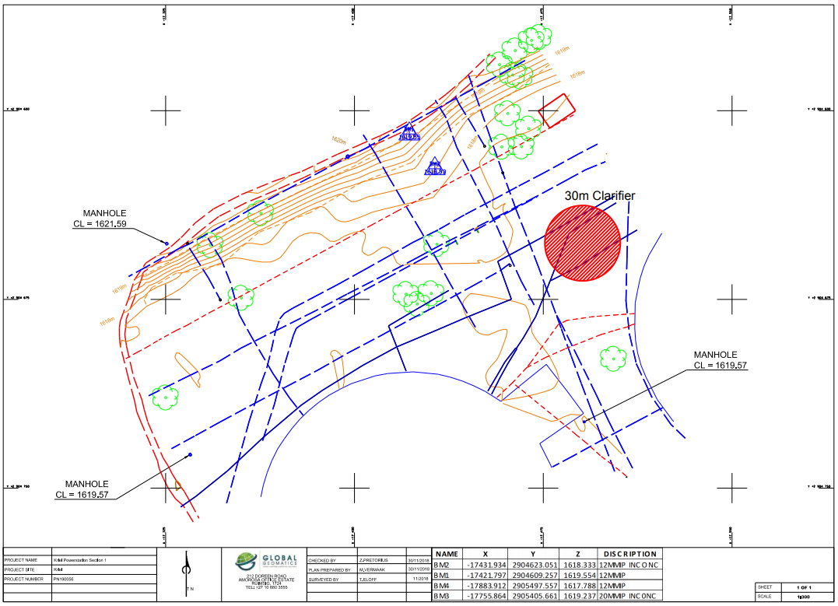

Figure 4 – Substation infrastructure present at the proposed Lime Plant upgrades at the Kriel Power Station. Map provided by Global Geomatrix.

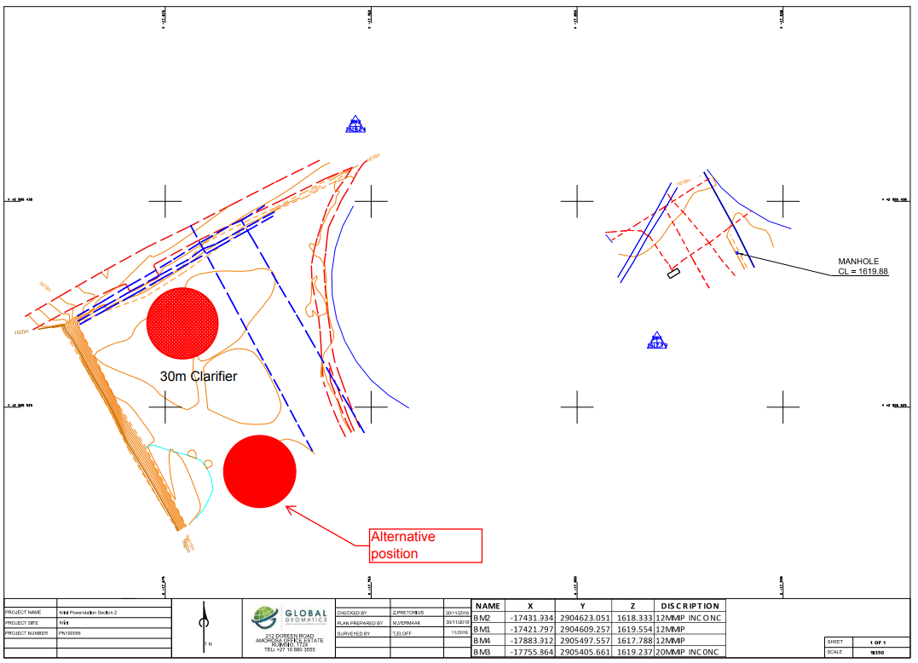
Figure 5 – Substation infrastructure present at the proposed Lime Plant upgrades at the Kriel Power Station. Map provided by Global Geomatrix.

- QUALIFICATIONS AND EXPERIENCE OF THE AUTHOR
The author (Elize Butler) has an MSc in Palaeontology from the University of the Free State, Bloemfontein, South Africa. She has been working in Palaeontology for more than twenty-four years. She has extensive experience in locating, collecting and curating fossils, including exploration field trips in search of new localities in the Karoo Basin. She has been a member of the Palaeontological Society of South Africa for 12 years. She has been conducting PIAs since 2014.

- LEGISLATION
- National Heritage Resources Act (25 of 1999)
Cultural Heritage in South Africa, includes all heritage resources, is protected by the National Heritage Resources Act (Act 25 of 1999) (NHRA). Heritage resources as defined in Section 3 of the Act include “all objects recovered from the soil or waters of South Africa, including archaeological and palaeontological objects and material, meteorites and rare geological specimens”.

Palaeontological heritage is unique and non-renewable and is protected by the NHRA. Palaeontological resources may not be unearthed, broken moved, or destroyed by any development without prior assessment and without a permit from the relevant heritage resources authority as per section 35 of the NHRA.

This Palaeontological Desktop Assessment forms part of the Heritage Impact Assessment (HIA) and adheres to the conditions of the Act. According to Section 38 (1), an HIA is required to assess any potential impacts to palaeontological heritage within the development footprint where:
- the construction of a road, wall, power line, pipeline, canal or other similar form of linear development or barrier exceeding 300 m in length;
- the construction of a bridge or similar structure exceeding 50 m in length;
- any development or other activity which will change the character of a site—
- (exceeding 5 000 m² in extent; or
- involving three or more existing erven or subdivisions thereof; or
- involving three or more erven or divisions thereof which have been consolidated within the past five years; or
- the costs of which will exceed a sum set in terms of regulations by SAHRA or a provincial heritage resources authority
- the re-zoning of a site exceeding 10 000 m² in extent;
- or any other category of development provided for in regulations by SAHRA or a Provincial heritage resources authority.
- OBJECTIVE
The objective of a Palaeontological Desktop Assessment is to determine the impact of the development on potential palaeontological material at the site.

According to the “SAHRA APM Guidelines: Minimum Standards for the Archaeological and Palaeontological Components of Impact Assessment Reports” the aims of the PIA are: 1) to identify the palaeontological status of the exposed as well as rock formations just below the surface in the development footprint 2) to assess the palaeontological importance of the formations 3) to determine the impact on fossil heritage; and 4) to recommend how the developer ought to protect or mitigate damage to fossil heritage.

When a palaeontologist compiles a desktop study, the potentially fossiliferous rocks present within the development are established from 1:250 000 geological maps. The topography of the development is identified by 1:50 000 topography maps and Google Earth Images. Previous palaeontological impact studies in the same region, the PalaeoMap from SAHRIS; and databases of various institutions which identify fossils found in close proximity to the development is used to identify the fossil heritage within each rock. The palaeontological status of each rock component is calculated and the possible impact of the development on fossil heritage is determined by a) the palaeontological importance of the rocks, b) the quantity of bedrock removed and c) the type of development.

When it is determined that the development footprint has a moderate to high sensitivity, a field-based assessment by a palaeontologist is necessary. By using the desktop and the field survey of the exposed rock the impact significance of the planned development is calculated and recommendations for any further studies or mitigation are made. Usually, destructive impacts on palaeontological heritage only occur during the construction phase and the excavations will change the current topography and may destruct or permanently seal-in fossils at or below the ground surface. Fossil Heritage will then no longer be accessible for scientific research.

Mitigation may precede construction or even better occur during construction when potentially fossiliferous bedrock is exposed. Mitigation comprises the collection and recording of fossils. It is important that preceding the excavation of any fossil heritage a permit from SAHRA must be obtained and the material will have to be housed in a permitted institution. When mitigation is applied correctly, a positive impact is possible because our knowledge of local palaeontological heritage may be increased.
- GEOLOGICAL AND PALAEONTOLOGICAL HISTORY
The proposed Lime Plant upgrades at the Kriel Power Station is entirely underlain by the Vryheid Formation (Ecca Group, Karoo Supergroup) (Figure 6 & Figure 7).
- Geology
- Vryheid Formation (Ecca Group Karoo Supergroup)
The stratigraphy of the Vryheid Formation can be described as a succession of five coarsening-upward sequences. A lateral continuity across the entire distal region of the Karoo Basin (Cadle et al., 1982) is displayed in this Formation. In a complete sequence, each of the five coarsening-upward sequences begins with fine-grained marine facies, that grade up into coarser delta front and delta plain-fluvial facies. Numerous coal seams are present in the Vryheid Formation and are mostly associated with the coarser-grained fluvial facies at the top of each sequence. The Vryheid Formation is characterized by light grey, fine to coarse sandstone and siltstone sediments. The dark coloured siltstones can be accredited to the existence of carbon enrichment and coal beds. Infrequent coal seams, deltaic mudrocks and sandstones as well as coastal and fluvial deposits are present in this formation. These sediments were probably deposited on a sandy shoreline that stretched out beyond massive swamplands. In these swamps, plants accumulated and formed the coal deposits that are mined today (Johnson et al, 2006). The Vryheid Formation is known for its coal reserves as most of the economically extracted coal in South Africa occurs in this formation.
- Palaeontology
- Vryheid Formation (Ecca Group Karoo Supergroup)
The Vryheid Formation is palaeontologically well-known for the rich fossil plant assemblages of the famous Glossopteris flora. The Glossopteris flora is the source vegetation for most of the Vryheid Formation coals.

After continental deglaciation, gymnospermous glossopterids came to dominate the peat and non-peat accumulating Permian wetlands (Falcon, 1986; Greb et al., 2006). Flora associated with the Glossopteris flora include lycopods, ferns, cordiatales and other early gymnosperms (Falcon, 1986). To date, no vertebrate fossils have been recorded from the Vryheid Formation.

Bamford (2011) reported that only a small amount of data have been published on the potentially fossiliferous plant deposits of the Vryheid Formation and that most likely, well-preserved material is present around coal mines while in other areas the exposures are poor and of little interest. When plant fossils do occur they are usually abundant.

Various plant fossils described by Bamford (2011) in the Vryheid Formation are Azaniodendron fertile, Annularia sp., Asterotheca spp., Arberia 4 spp., Cyclodendron leslii, Estcourtia sp, Glossopteris > 20 species, Hirsutum 4 spp, Liknopetalon enigmata, Lidgetonnia sp., Noeggerathiopsis sp, Ottokaria 3 spp, Podocarpidites sp, Raniganjia sp, Sphenophyllum hammanskraalensis, Scutum 4 spp. Rare fossil wood is present in this Formation as well as diverse palynomorphs.

This Formation is also characterised by its trace fossil assemblages of the non-marine Mermia Ichnofacies and insect fossils track ways. The Mesosaurus reptile may also be present.

It is important to note that in recent years plant fossils have been under-collected despite continuing mining activities.

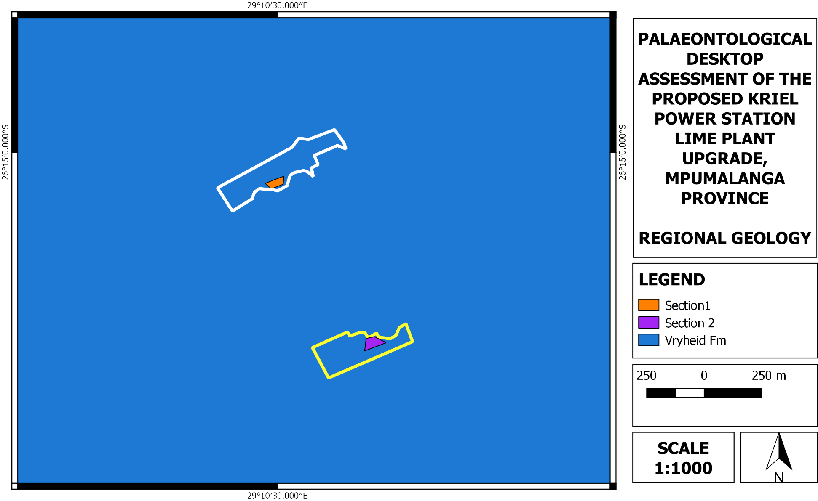
Figure 6 - Surface geology of the proposed Kriel Power Station Lime Plant upgrade. The proposed development is underlain by the Vryheid Formation of the Ecca Group (Karoo Supergroup). Areas highlighted in white and yellow are open spaces where development might occur. The Vryheid formation has a High Paleontological Significance. Map was drawn by QGIS Desktop 2.18.18.

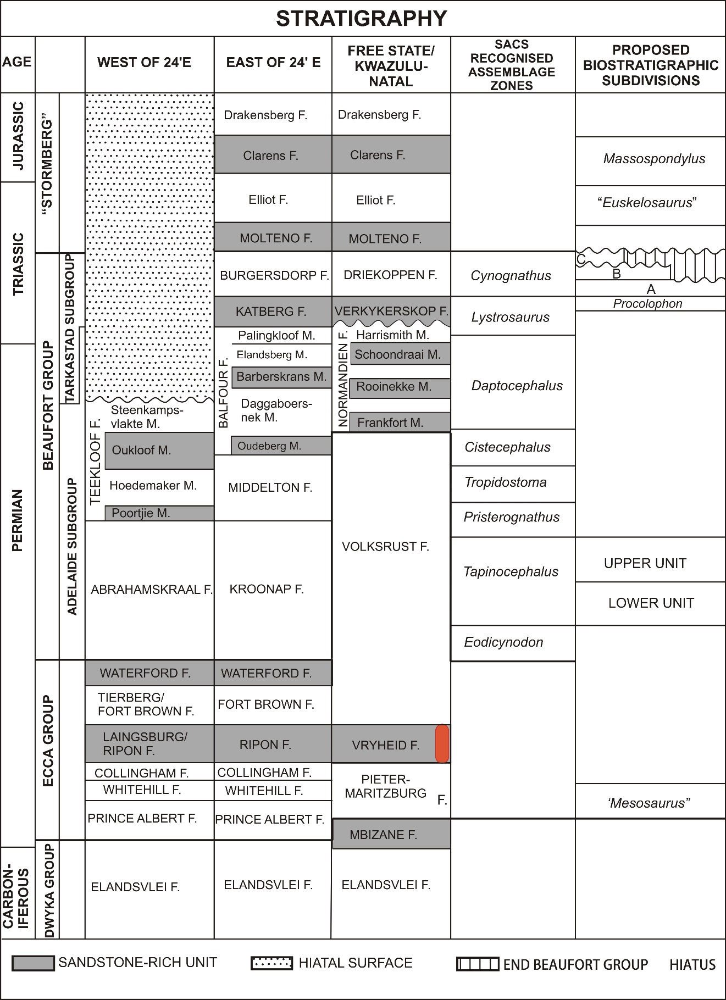
Figure 7 - Lithostratigraphic (rock-based) and biostratigraphic (fossil-based) subdivisions Beaufort Group of the Karoo Supergroup with rock units and fossil assemblage zones relevant to the present study marked in orange (Modified from Rubidge, 1995). Abbreviations: F. = Formation, M. = Member

- GEOGRAPHICAL LOCATION OF THE SITE
Access to the Kriel Power Station is via the R545 and R547 which is located to the north-east and east of the power station. The area surrounding the station is highly industrial and is presently utilized for power generation and coal mine activities. The proposed development at Kriel Power Station falls in the jurisdiction of the Nkangala District Municipality as well as the eMalahleni Local Municipality in Mpumalanga. The proposed development is approximately 34 km north-west of Bethal, 27 km south of Ogies and 8 km west of Kriel.
- Methods
A desktop study was assembled to evaluate the possible risk to palaeontological heritage (this includes fossils as well as trace fossils) in the proposed development area. In compiling the desktop report aerial photos, Google Earth 2018, topographical and geological maps and other reports from the same area as well as the author’s experience were used to assess the proposed development footprint.
- Assumptions and Limitations
The accuracy of Palaeontological Desktop Assessments is reduced by several factors which may include the following: the databases of institutions are not always up to date and relevant locality and geological information were not accurately documented in the past. Various remote areas of South Africa have not been assessed by palaeontologists and data is based on aerial photographs alone. Geological maps concentre on the geology of an area and the sheet explanations were never intended to focus on palaeontological heritage.

Similar Assemblage Zones, but in different areas is used to provide information on the presence of fossil heritage in an unmapped area. Desktop studies of similar geological formations and Assemblage Zones generally assume that exposed fossil heritage is present within the development area. The accuracy of the Palaeontological Impact Assessment is thus improved considerably by conducting a field-assessment.

- Additional Information Consulted
In compiling this report the following sources were consulted:
- The Palaeosensitivity Map from the SAHRIS website.
- 2629 AC Topographical map
- A Google Earth map with polygons of the proposed development was obtained from Savannah Environmental.
- IMPACT ASSESSMENT METHODOLOGY
An assessment of the impact significance of the proposed Kriel Power Station Lime Plant upgrade on local fossil heritage is presented here:
- Nature of the impact
Although minimal, the development will involve excavations into the superficial sediment cover as well as locally into the underlying bedrock. These excavations will modify the existing topography and may disturb damage, destroy or permanently seal-in fossils at or below the ground surface that are then no longer available for scientific research. According to the Geology of the study area, there is a possibility of finding fossil heritage during the construction phase of the project. No impacts are expected to occur during the operation phase.
- Sensitive areas
The development footprint is completely underlain by the Permian Ecca rocks of the Vryheid Formation. Although the Palaeontological Sensitivity of this formation is rated as Very High the severely modified and disturbed area indicates that the likelihood of significant fossil heritage in the development area is considered to be of moderate significance.
- Geographical extent of impact
The impact on fossil materials and thus palaeontological heritage will be limited to the construction phase when new excavations into fresh potentially fossiliferous bedrock take place. The extent of the area affected by this potential impact is restricted to the development footprint and therefore categorized as local.
- Duration of impact
The expected duration of the impact is assessed as potentially permanent to long term. In the absence of mitigation procedures (should fossil material be present within the affected area) the damage or destruction of any palaeontological materials will be permanent.
- Potential significance of the impact
Should the project progress without safety measures the possibility of fossils being present at the proposed development site within the Vryheid Formation the resultant damage, destruction or inadvertent relocation of any affected fossils will be permanent and irreversible. Thus, any fossils occurring within the study area are potentially scientifically and culturally significant and any negative impact on them would be of high significance. In spite of the rare occurrence of fossils, a single fossil can have a huge scientific significance as many fossil taxa are recognised from a solitary fossil.
- Severity/benefit scale
The development of the proposed Kriel Power Station Lime Plant Upgrade is beneficial on not only a local level but regional levels as well. A potential secondary advantage of the construction of the project would be that the excavations may uncover fossils that were hidden beneath the surface exposures and, as such, would have remained unknown to science.
- Probability of the impact occurring
Impacts on palaeontological heritage during the construction phase could potentially occur but are regarded as having a moderate possibility.
- Intensity
The intensity of the impact on fossil heritage is rated as low.
- DAMAGE MITIGATION, REVERSAL AND POTENTIAL IRREVERSIBLE LOSS
- Mitigation
In the event that fossil material exists within the development footprint, any negative impact upon it could be mitigated by surveying, recording, describing and sampling of well-preserved fossils by a palaeontologist. This should place after initial vegetation clearance but before the ground is flattened for construction. Excavation of fossil heritage will need a permit from SAHRA and the material must be housed in a permitted institution. In the event that excavation is impossible or inappropriate, the fossil or fossil locality could be protected and the site of any planned construction moved.
- Degree of irreversible loss
Impacts on fossil heritage are in general irreversible. Well-documented records and additional palaeontological studies of any fossils uncovered during construction would represent a positive impact from a scientific perspective. The possibility of a negative impact on the palaeontological heritage of the area can be reduced by the execution of satisfactory damage mitigation procedures. If damage mitigation is properly undertaken the benefit scale for the project will lie within the beneficial category.
- Degree to which the impact may cause irreplaceable loss of resources
Stratigraphic and geographical distribution of the Vryheid Formation fossils is documented in the literature. It is thus highly possible that fossil material is present in the development area. But due to the site being highly modified only a moderate possibility of recovering fossil heritage during the construction phase exist. However, by taking a precautionary approach, a significant loss of fossil resources is not expected.
- Cumulative impacts
The cumulative effect of the proposed development is considered to be low.
- Impact Assessment:

Direct, indirect and cumulative impacts of the issues identified through the EIA process, as well as all other issues identified due to the amendment, must be assessed in terms of the following criteria:

- The nature, which shall include a description of what causes the effect, what will be affected and how it will be affected.
- The extent, wherein it will be indicated whether the impact will be local (limited to the immediate area or site of development) or regional, and a value between 1 and 5 will be assigned as appropriate (with 1 being low and 5 being high):
- The duration, wherein it will be indicated whether:
  - the lifetime of the impact will be of a very short duration (0–1 years) – assigned a score of 1;
  - the lifetime of the impact will be of a short duration (2-5 years) - assigned a score of 2;
  - medium-term (5–15 years) – assigned a score of 3;
  - long term (> 15 years) - assigned a score of 4; or
  - permanent - assigned a score of 5;
- The consequences (magnitude), quantified on a scale from 0-10, where 0 is small and will have no effect on the environment, 2 is minor and will not result in an impact on processes, 4 is low and will cause a slight impact on processes, 6 is moderate and will result in processes continuing but in a modified way, 8 is high (processes are altered to the extent that they temporarily cease), and 10 is very high and results in complete destruction of patterns and permanent cessation of processes.
- The probability of occurrence, which shall describe the likelihood of the impact actually occurring. Probability will be estimated on a scale of 1–5, where 1 is very improbable (probably will not happen), 2 is improbable (some possibility, but low likelihood), 3 is probable (distinct possibility), 4 is highly probable (most likely) and 5 is definite (impact will occur regardless of any prevention measures).
- the significance, which shall be determined through a synthesis of the characteristics described above and can be assessed as low, medium or high; and
- the status, which will be described as either positive, negative or neutral.
- the degree to which the impact can be reversed.
- the degree to which the impact may cause irreplaceable loss of resources.
- the degree to which the impact can be mitigated.

The significance is calculated by combining the criteria in the following formula:
S = (E+D+M)P
S = Significance weighting
E = Extent
D = Duration
M = Magnitude
P = Probability

The significance weightings for each potential impact are as follows:

- < 30 points: Low (i.e. where this impact would not have a direct influence on the decision to develop in the area),
- 30-60 points: Medium (i.e. where the impact could influence the decision to develop in the area unless it is effectively mitigated),
- > 60 points: High (i.e. where the impact must have an influence on the decision process to develop in the area).

Assessment of impacts must be summarised in the following table format. The rating values as per the above criteria must also be included. The table must be completed and associated ratings for each impact identified during the assessment should also be included.

Table 1-Impact Assessment Table

Nature:
Although minimal, the excavations and ground disturbance during the construction phase will involve excavations into the superficial sediment cover as well as locally into the underlying bedrock. These excavations will modify the current topography and may disrupt, destruct, or permanently seal-in fossils at or below the ground surface that are then no longer accessible for scientific research.

This impact is likely to occur only within the construction phase. No impacts are expected to occur during the operation phase
 | Without mitigation | With mitigation
Extent | Local(1) | Low (1)
Duration | Long term/permanent (5) | Long term/permanent (5)
Magnitude | High (8) | High (8)
Probability | Improbable (2) | Improbable (1)
Significance | Low (28) | Low (14)
Status (positive or negative) | Negative | Neutral
Reversibility | Low | Low
Irreplaceable loss of resources? | Yes | Yes
Can impacts be mitigated? | Yes | Yes
Mitigation:
- If a chance find is made the person responsible for the find must immediately stop working and all work must cease in the immediate vicinity of the find.
- The person who made the find must immediately report the find to his/her direct supervisor which in turn must report the find to his/her manager and the ECO or site manager. The ECO must report the find to the relevant Heritage Agency (South African Heritage Research Agency, SAHRA). (Contact details: SAHRA, 111 Harrington Street, Cape Town. PO Box 4637, Cape Town 8000, South Africa. Tel: 021 462 4502. Fax: +27 (0)21 462 4509. Web: www.sahra.org.za). The information to the Heritage Agency must include photographs of the find, from various angles, as well as the GPS coordinates.
- A preliminary report must be submitted to the Heritage Agency within 24 hours of the find and must include the following: 1) date of find; 2) a description of the discovery and a 3) description of the fossil and its context (depth and position of the fossil), GPS coordinates.
- Photographs (the more the better) of the discovery must be of high quality, in focus, accompanied by a scale. It is also important to have photographs of the vertical section (side) where the fossil was found.

Upon receipt of the preliminary report the Heritage Agency will inform the ECO (site manager) whether a rescue excavation or rescue collection by a palaeontologist is necessary.

- The site must be secured to protect it from any further damage. No attempt should be made to remove material from their environment. The exposed finds must be stabilized and covered by a plastic sheet or sand bags. The Heritage agency will also be able to advice on the most appropriate method of protection of the find.
- In the event that the fossil cannot be stabilized the fossil may be collected with extreme care by the ECO (site manager). Fossils finds must be stored in tissue paper and in an appropriate box while due care must be taken to remove all fossil material from the rescue site.
- Once Heritage Agency have issued written authorization, the developer may continue with the development.
Cumulative impacts:
“The cumulative effect of the proposed development is considered to be moderate.

Residual Risks:
Loss of fossil Heritage

- Palaeontological Sensitivity Map

Figure 8 - Palaeontological sensitivity of area on which the study area lays. Key found below in Table 2 - Key descriptions of SAHRIS palaeontological sensitivity map.

Table 2 - Key descriptions of SAHRIS palaeontological sensitivity map
Colour | Sensitivity | Required Action
RED | VERY HIGH | field assessment and protocol for finds is required
ORANGE/YELLOW | HIGH | desktop study is required and based on the outcome of the desktop study, a field assessment is likely
GREEN | MODERATE | desktop study is required
BLUE | LOW | no palaeontological studies are required however a protocol for finds is required
GREY | INSIGNIFICANT/ZERO | no palaeontological studies are required
WHITE/CLEAR | UNKNOWN | These areas will require a minimum of a desktop study. As more information comes to light, SAHRA will continue to populate the map.

- FINDINGS AND RECOMMENDATIONS
The proposed Kriel Power Station Lime Plant Upgrade is completely underlain by the Vryheid Formation (Ecca Group, Karoo Supergroup). According to the SAHRIS PalaeoMap a Very High Palaeontological Sensitivity was allocated to this formation.

To date, no Palaeontological impact assessment has been conducted for the upgrade to the existing Lime Softening Plant as the area has been severely modified and disturbed. However, SAHRA (South African Heritage Research Agency) requested this study due to the Very High Palaeontological significant of the Vryheid Formation. Due to the site being highly modified/heavy only a moderate possibility of recovering fossil heritage during the construction phase exist.

It is therefore considered that the construction and operation of the Kriel Power Station Lime Plant Upgrade, Mpumalanga Province is deemed appropriate and feasible and will not lead to detrimental impacts on the palaeontological resources of the area. Thus, the construction and operation of the facility may be authorised as the whole extent of the development footprint is not considered sensitive in terms of palaeontological resources.

In the event that fossil remains are discovered during any phase of construction, either on the surface or exposed by fresh excavations, the Chance Find Protocol must be immediately implemented by the ECO in charge of these developments. These discoveries must be secured (preferably in situ) and the ECO ought to alert SAHRA so that appropriate mitigation (e.g. recording, sampling or collection) can be undertaken by a professional palaeontologist.

The specialist would need a collection permit from SAHRA. Fossil material must be curated in an approved collection (museum or university) and all fieldwork and reports should meet the minimum standards for palaeontological impact studies developed by SAHRA.

- CHANCE FINdS PROTOCOL
- Legislation
Cultural Heritage in South Africa (includes all heritage resources) is protected by the National Heritage Resources Act (Act 25 of 1999) (NHRA). According to Section 3 of the Act all Heritage resources include “all objects recovered from the soil or waters of South Africa, including archaeological and palaeontological objects and material, meteorites and rare geological specimens”.

Palaeontological heritage is unique and non-renewable and is protected by the NHRA and are the property of the State. It is thus the responsibility of the State to manage and conserve fossils on behalf of the citizens of South Africa. Palaeontological resources may not be excavated, broken, moved, or destroyed by any development without prior assessment and without a permit from the relevant heritage resources authority as per section 35 of the NHRA.
- Background
A fossil is the naturally preserved remains (or traces) of plants or animals embedded in rock. These plants and animals lived in the geologic past millions of years ago. Fossils are extremely rare and irreplaceable. By studying fossils it is possible to determine the environmental conditions that existed in a specific geographical area millions of years ago.
- Introduction
This informational document is intended for workmen and foremen on construction sites. It describes the actions to be taken when mining or construction activities accidentally uncovers fossil material.

It is the responsibility of the Environmental Control Officer (ECO) of the project to train the workmen and foremen in the procedure to follow when a fossil is accidentally uncovered. In the absence of the ECO a member of the staff must be appointed to be responsible for the proper implementation of the chance find protocol as not to compromise the conservation of fossil material.
- Chance Finds Procedure
- If a chance find is made the person responsible for the find must immediately stop working and all work must cease in the immediate vicinity of the find.
- The person who made the find must immediately report the find to his/her direct supervisor which in turn must report the find to his/her manager and the ECO or site manager. The ECO must report the find to the relevant Heritage Agency (South African Heritage Research Agency, SAHRA). (Contact details: SAHRA, 111 Harrington Street, Cape Town. PO Box 4637, Cape Town 8000, South Africa. Tel: 021 462 4502. Fax: +27 (0)21 462 4509. Web: www.sahra.org.za). The information to the Heritage Agency must include photographs of the find, from various angles, as well as the GPS co-ordinates.
- A preliminary report must be submitted to the Heritage Agency within 24 hours of the find and must include the following: 1) date of find; 2) a description of the discovery and a 3) description of the fossil and its context (depth and position of the fossil), GPS co-ordinates.
- Photographs (the more the better) of the discovery must be of high quality, in focus, accompanied by a scale. It is also important to have photographs of the vertical section (side) where the fossil was found.
Upon receipt of the preliminary report the Heritage Agency will inform the ECO (site manager) whether a rescue excavation or rescue collection by a palaeontologist is necessary.

- The site must be secured to protect it from any further damage. No attempt should be made to remove material from their environment. The exposed finds must be stabilized and covered by a plastic sheet or sand bags. The Heritage agency will also be able to advice on the most suitable method of protection of the find.
- In the event that the fossil cannot be stabilized the fossil may be collected with extreme care by the ECO (site manager). Fossils finds must be stored in tissue paper and in an appropriate box while due care must be taken to remove all fossil material from the rescue site.
- Once Heritage Agency have issued written authorization, the developer may continue with the development.

- REFERENCES
ALMOND, J., PETHER, J, and GROENEWALD, G. 2013. South African National Fossil Sensitivity Map. SAHRA and Council for Geosciences. Schweitzer et al. (1995) pp p288.

BAMFORD M. 2011. Desktop study Palaeontology Ermelo to Empangeni – Eskom powerline. Internal report Bernard Price Institute for Palaeontological Research, University of the Witwatersrand.

CADLE, A.B., 1974. A subsurface sedimentological investigation of parts of the Ecca and Beaufort Groups in the north-eastern Karoo Basin. Unpublished MSc Thesis, University of Natal,
Pietermaritzburg, 144 pp.

DU TOIT, A. 1954. The geology of South Africa. xii + 611pp, 41 pls. Oliver & Boyd, Edinburg.

FALCON, R.M.S., 1986c. A brief review of the origin, formation, and distribution of coal in southern Africa, in: Anhaesser, C.R., Maske, S. (Eds.), Mineral Deposits of Southern Africa, Vol. II, Geological Society of South Africa, Johannesburg, pp. 1879–1898.

GREB, S.F., DIMICHELE, W.D., GASTALDO, R.A., 2006. Evolution of wetland types and the importance of wetlands in Earth history, in: DiMichele, W.A., Greb, S. (Eds), Wetlands through Time. Geological Society of America, Special Publication 399, 1–40.

GROENEWALD, G H., GROENEWALD, S.M. AND GROENEWALD, D.P. 2014. Palaeontological Heritage of the Free State, Gauteng, Limpopo, Mpumalanga and North West Provinces. Internal Palaeotechnical Reports, SAHRA.

JOHNSON, M.R., VAN VUUREN, C.J., VISSER, J.N.J., COLE, D.I., De V. WICKENS, H., CHRISTIE, A.D.M., ROBERTS, D.L. & BRANDL, G. 2006. Sedimentary rocks of the Karoo Supergroup. In: Johnson, M.R., Anhaeusser, C.R. & Thomas, R.J. (Eds.). The geology of South Africa, pp. 461-499. Geological Society of South Africa, Marshalltown.

KENT, L. E., 1980. Part 1: Lithostratigraphy of the Republic of South Africa, South West Africa/Namibia and the Republics of Bophuthatswana, Transkei and Venda. SACS, Council for Geosciences, Pp 535-574.

MACRAE, C. 1999. Life etched in stone. Fossils of South Africa. 305 pp. The Geological
Society of South Africa, Johannesburg.

SNYMAN, C.P. 1996. Geologie vir Suid-Afrika, Departement Geologie, Universiteit van Pretoria, Pretoria, Volume 1, Pp 513.

VAN DER WALT, M., DAY, M., RUBIDGE, B. S., COOPER, A. K. & NETTERBERG, I., 2010. Utilising GIS technology to create a biozone map for the Beaufort Group (Karoo Supergroup) of South Africa. Palaeontologia Africana, 45: 1-5.

Savannah Environmental (2019) Environmental Basic Assessment Report for the Kriel Power Station Lime Plant Upgrade, Mpumalanga.

Appendix A – Elize Butler CV

CURRICULUM VITAE
ELIZE BUTLER
PROFESSION: Palaeontologist
YEARS’ EXPERIENCE: 26 years in Palaeontology

EDUCATION: B.Sc Botany and Zoology, 1988
University of the Orange Free State

B.Sc (Hons) Zoology, 1991
University of the Orange Free State

Management Course, 1991
University of the Orange Free State

M. Sc. Cum laude (Zoology), 2009
University of the Free State

Dissertation title: The postcranial skeleton of the Early Triassic non-mammalian Cynodont Galesaurus planiceps: implications for biology and lifestyle

Registered as a PhD fellow at the Zoology Department of the UFS 2013 to current
Dissertation title: A new gorgonopsian from the uppermost Daptocephalus Assemblage Zone, in the Karoo Basin of South Africa

MEMBERSHIP
Palaeontological Society of South Africa (PSSA) 2006-currently

EMPLOYMENT HISTORY
Part time Laboratory assistant Department of Zoology & Entomology University of the Free State Zoology 1989-1992

Part time laboratory assistant Department of Virology
University of the Free State Zoology 1992

Research Assistant National Museum, Bloemfontein 1993 – 1997

Principal Research Assistant National Museum, Bloemfontein
and Collection Manager 1998–currently

TECHNICAL REPORTS
Butler, E. 2014. Palaeontological Impact Assessment for the proposed upgrade of existing water supply infrastructure at Noupoort, Northern Cape Province. 2014. Bloemfontein.
Butler, E. 2015. Palaeontological impact assessment of the proposed consolidation, re-division and development of 250 serviced erven in Nieu-Bethesda, Camdeboo local municipality, Eastern Cape. Bloemfontein.
Butler, E. 2015. Palaeontological impact assessment of the proposed mixed land developments at Rooikraal 454, Vrede, Free State. Bloemfontein.
Butler, E. 2015. Palaeontological exemption report of the proposed truck stop development at Palmiet 585, Vrede, Free State. Bloemfontein.
Butler, E. 2015. Palaeontological impact assessment of the proposed Orange Grove 3500 residential development, Buffalo City Metropolitan Municipality East London, Eastern Cape. Bloemfontein.
Butler, E. 2015. Palaeontological Impact Assessment of the proposed Gonubie residential development, Buffalo City Metropolitan Municipality East London, Eastern Cape Province. Bloemfontein.
Butler, E. 2015. Palaeontological Impact Assessment of the proposed Ficksburg raw water pipeline. Bloemfontein.
Butler, E. 2015. Palaeontological Heritage Impact Assessment report on the establishment of the 65 mw Majuba Solar Photovoltaic facility and associated infrastructure on portion 1, 2 and 6 of the farm Witkoppies 81 HS, Mpumalanga Province. Bloemfontein.
Butler, E. 2015. Palaeontological Impact Assessment of the proposed township establishment on the remainder of portion 6 and 7 of the farm Sunnyside 2620, Bloemfontein, Mangaung metropolitan municipality, Free State, Bloemfontein.
Butler, E. 2015. Palaeontological Impact Assessment of the proposed Woodhouse 1 photovoltaic solar energy facilities and associated infrastructure on the farm Woodhouse729, near Vryburg, North West Province. Bloemfontein.
Butler, E. 2015. Palaeontological Impact Assessment of the proposed Woodhouse 2 photovoltaic solar energy facilities and associated infrastructure on the farm Woodhouse 729, near Vryburg, North West Province. Bloemfontein.
Butler, E. 2015.Palaeontological Impact Assessment of the proposed Orkney solar energy farm and associated infrastructure on the remaining extent of Portions 7 and 21 of the farm Wolvehuis 114, near Orkney, North West Province. Bloemfontein.
Butler, E. 2015. Palaeontological Impact Assessment of the proposed Spectra foods broiler houses and abattoir on the farm Maiden Manor 170 and Ashby Manor 171, Lukhanji Municipality, Queenstown, Eastern Cape Province. Bloemfontein.
Butler, E. 2016. Palaeontological Impact Assessment of the proposed construction of the 150 MW Noupoort concentrated solar power facility and associated infrastructure on portion 1 and 4 of the farm Carolus Poort 167 and the remainder of Farm 207, near Noupoort, Northern Cape. Prepared for Savannah Environmental. Bloemfontein.
Butler, E. 2016. Palaeontological Impact Assessment of the proposed Woodhouse 1 Photovoltaic Solar Energy facility and associated infrastructure on the farm Woodhouse 729, near Vryburg, North West Province. Bloemfontein.
Butler, E. 2016. Palaeontological Impact Assessment of the proposed Woodhouse 2 Photovoltaic Solar Energy facility and associated infrastructure on the farm Woodhouse 729, near Vryburg, North West Province. Bloemfontein.
Butler, E. 2016. Proposed 132kV overhead power line and switchyard station for the authorised Solis Power 1 CSP project near Upington, Northern Cape. Bloemfontein.
Butler, E. 2016. Palaeontological Impact Assessment of the proposed Senqu Pedestrian Bridges in Ward 5 of Senqu Local Municipality, Eastern Cape Province. Bloemfontein.

Butler, E. 2016. Recommendation from further Palaeontological Studies: Proposed Construction of the Modderfontein Filling Station on Erf 28 Portion 30, Founders Hill, City Of Johannesburg, Gauteng Province. Bloemfontein.
Butler, E. 2016. Recommendation from further Palaeontological Studies: Proposed Construction of the Modikwa Filling Station on a Portion of Portion 2 of Mooihoek 255 Kt, Greater Tubatse Local Municipality, Limpopo Province. Bloemfontein.
Butler, E. 2016. Recommendation from further Palaeontological Studies: Proposed Construction of the Heidedal filling station on Erf 16603, Heidedal Extension 24, Mangaung Local Municipality, Bloemfontein, Free State Province. Bloemfontein.
Butler, E. 2016. Recommended Exemption from further Palaeontological studies: Proposed Construction of the Gunstfontein Switching Station, 132kv Overhead Power Line (Single Or Double Circuit) and ancillary infrastructure for the Gunstfontein Wind Farm Near Sutherland, Northern Cape Province. Bloemfontein.
Butler, E. 2016. Palaeontological Impact Assessment of the proposed Galla Hills Quarry on the remainder of the farm Roode Krantz 203, in the Lukhanji Municipality, division of Queenstown, Eastern Cape Province. Bloemfontein.

Butler, E. 2016. Chris Hani District Municipality Cluster 9 water backlog project phases 3a and 3b: Palaeontology inspection at Tsomo WTW. Bloemfontein.
Butler, E. 2016. Palaeontological Impact Assessment of the proposed construction of the 150 MW Noupoort concentrated solar power facility and associated infrastructure on portion 1 and 4 of the farm Carolus Poort 167 and the remainder of Farm 207, near Noupoort, Northern Cape. Bloemfontein.
Butler, E. 2016. Palaeontological Impact Assessment of the proposed upgrading of the main road MR450 (R335) from the Motherwell to Addo within the Nelson Mandela Bay Municipality and Sunday’s river valley Local Municipality, Eastern Cape Province. Bloemfontein.
Butler, E. 2016. Palaeontological Impact Assessment construction of the proposed Metals Industrial Cluster and associated infrastructure near Kuruman, Northern Cape province. Savannaha South Africa. Bloemfontein.
Butler, E. 2016. Palaeontological Impact Assessment for the proposed construction of up to a 132kv power line and associated infrastructure for the proposed Kalkaar Solar Thermal Power Plant near Kimberley, Free State and Northern Cape Provinces. Bloemfontein.
Butler, E. 2016. Palaeontological Impact Assessment of the proposed development of two burrow pits (DR02625 and DR02614) in the Enoch Mgijima Municipality, Chris Hani District, Eastern Cape.

Butler, E. 2016. Ezibeleni waste Buy-Back Centre (near Queenstown), Enoch Mgijima Local Municipality, Eastern Cape. Bloemfontein.

Butler, E. 2016. Palaeontological Impact Assessment for the proposed construction of two 5 Mw Solar Photovoltaic Power Plants on Farm Wildebeestkuil 59 and Farm Leeuwbosch 44, Leeudoringstad, North West Province. Bloemfontein.

Butler, E. 2016. Palaeontological Impact Assessment for the proposed development of four Leeuwberg Wind farms and basic assessments for the associated grid connection near Loeriesfontein, Northern Cape Province. Bloemfontein.

Butler, E. 2016. Palaeontological impact assessment for the proposed Aggeneys south prospecting right project, Northern Cape Province. Bloemfontein.

Butler, E. 2016. Palaeontological impact assessment of the proposed Motuoane Ladysmith Exploration right application, Kwazulu Natal. Bloemfontein.

Butler, E. 2016. Palaeontological impact assessment for the proposed construction of two 5 MW solar photovoltaic power plants on farm Wildebeestkuil 59 and farm Leeuwbosch 44, Leeudoringstad, North West Province. Bloemfontein.

Butler, E. 2016: Palaeontological desktop assessment of the establishment of the proposed residential and mixed use development on the remainder of portion 7 and portion 898 of the farm Knopjeslaagte 385 Ir, located near Centurion within the Tshwane Metropolitan Municipality of Gauteng Province. Bloemfontein.

Butler, E. 2017. Palaeontological impact assessment for the proposed development of a new cemetery, near Kathu, Gamagara local municipality and John Taolo Gaetsewe district municipality, Northern Cape. Bloemfontein.

Butler, E. 2017. Palaeontological Impact Assessment Of The Proposed Development Of The New Open Cast Mining Operations On The Remaining Portions Of 6, 7, 8 And 10 Of The Farm Kwaggafontein 8 In The Carolina Magisterial District, Mpumalanga Province. Bloemfontein.

Butler, E. 2017. Palaeontological Desktop Assessment for the Proposed Development of a Wastewater Treatment Works at Lanseria, Gauteng Province. Bloemfontein.

Butler, E. 2017. Palaeontological Scoping Report for the Proposed Construction of a Warehouse and Associated Infrastructure at Perseverance in Port Elizabeth, Eastern Cape Province.

Butler, E. 2017. Palaeontological Desktop Assessment for the Proposed Establishment of a Diesel Farm and a Haul Road for the Tshipi Borwa mine Near Hotazel, In the John Taolo Gaetsewe District Municipality in the Northern Cape Province. Bloemfontein.

Butler, E. 2017. Palaeontological Desktop Assessment for the Proposed Changes to Operations at the UMK Mine near Hotazel, In the John Taolo Gaetsewe District Municipality in the Northern Cape Province. Bloemfontein.

Butler, E. 2017. Palaeontological Impact Assessment for the Development of the Proposed Ventersburg Project-An Underground Mining Operation near Ventersburg and Henneman, Free State Province. Bloemfontein.

Butler, E. 2017. Palaeontological desktop assessment of the proposed development of a 3000 MW combined cycle gas turbine (CCGT) in Richards Bay, Kwazulu-Natal. Bloemfontein.

Butler, E. 2017. Palaeontological Impact Assessment for the Development of the Proposed Revalidation of the lapsed General Plans for Elliotdale, Mbhashe Local Municipality. Bloemfontein.

Butler, E. 2017. Palaeontological assessment of the proposed development of a 3000 MW Combined Cycle Gas Turbine (CCGT) in Richards Bay, Kwazulu-Natal. Bloemfontein.

Butler, E. 2017. Palaeontological Impact Assessment of the proposed development of the new open cast mining operations on the remaining portions of 6, 7, 8 and 10 of the farm Kwaggafontein 8 10 in the Albert Luthuli Local Municipality, Gert Sibande District Municipality, Mpumalanga Province. Bloemfontein.

Butler, E. 2017. Palaeontological Impact Assessment of the proposed mining of the farm Zandvoort 10 in the Albert Luthuli Local Municipality, Gert Sibande District Municipality, Mpumalanga Province. Bloemfontein.

Butler, E. 2017. Palaeontological Desktop Assessment for the proposed Lanseria outfall sewer pipeline in Johannesburg, Gauteng Province. Bloemfontein.

Butler, E. 2017. Palaeontological Desktop Assessment of the proposed development of open pit mining at Pit 36W (New Pit) and 62E (Dishaba) Amandelbult Mine Complex, Thabazimbi, Limpopo Province. Bloemfontein.

Butler, E. 2017. Palaeontological impact assessment of the proposed development of the sport precinct and associated infrastructure at Merrifield Preparatory school and college, Amathole Municipality, East London. PGS Heritage. Bloemfontein.

Butler, E. 2017. Palaeontological impact assessment of the proposed construction of the Lehae training and fire station, Lenasia, Gauteng Province. Bloemfontein.

Butler, E. 2017. Palaeontological Desktop Assessment of the proposed development of the new open cast mining operations of the Impunzi mine in the Mpumalanga Province. Bloemfontein.

Butler, E. 2017. Palaeontological Desktop Assessment of the construction of the proposed Viljoenskroon Munic 132 KV line, Vierfontein substation and related projects. Bloemfontein.
Butler, E. 2017. Palaeontological Desktop Assessment of the proposed rehabilitation of 5 ownerless asbestos mines. Bloemfontein.

Butler, E. 2017. Palaeontological Desktop Assessment of the proposed development of the Lephalale coal and power project, Lephalale, Limpopo Province, Republic of South Africa. Bloemfontein.

Butler, E. 2017. Palaeontological Impact Assessment of the proposed construction of a 132KV powerline from the Tweespruit distribution substation (in the Mantsopa local municipality) to the Driedorp rural substation (within the Naledi local municipality), Free State province. Bloemfontein.
Butler, E. 2017. Palaeontological Desktop Assessment of the proposed development of the new coal-fired power plant and associated infrastructure near Makhado, Limpopo Province. Bloemfontein.

Butler, E. 2017. Palaeontological Impact Assessment of the proposed construction of a Photovoltaic Solar Power station near Collett substation, Middelberg, Eastern Cape. Bloemfontein.

Butler, E. 2017. Palaeontological Impact Assessment for the proposed township establishment of 2000 residential sites with supporting amenities on a portion of farm 826 in Botshabelo West, Mangaung Metro, Free State Province. Bloemfontein.

Butler, E. 2017. Palaeontological Desktop Assessment for the proposed prospecting right project without bulk sampling, in the Koa Valley, Northern Cape Province. Bloemfontein.

Butler, E. 2017. Palaeontological Desktop Assessment for the proposed Aroams prospecting right project, without bulk sampling, near Aggeneys, Northern Cape Province. Bloemfontein.

Butler, E. 2017. Palaeontological Impact Assessment of the proposed Belvior aggregate quarry II on portion 7 of the farm Maidenhead 169, Enoch Mgijima Municipality, division of Queenstown, Eastern Cape. Bloemfontein.

Butler, E. 2017. PIA site visit and report of the proposed Galla Hills Quarry on the remainder of the farm Roode Krantz 203, in the Lukhanji Municipality, division of Queenstown, Eastern Cape Province. Bloemfontein.

Butler, E. 2017. Palaeontological Impact Assessment of the proposed construction of Tina Falls Hydropower and associated power lines near Cumbu, Mthlontlo Local Municipality, Eastern Cape. Bloemfontein.

Butler, E. 2017. Palaeontological Desktop Assessment of the proposed construction of the Mangaung Gariep Water Augmentation Project. Bloemfontein.

Butler, E. 2017. Palaeontological Impact Assessment of the proposed Belvoir aggregate quarry II on portion 7 of the farm Maidenhead 169, Enoch Mgijima Municipality, division of Queenstown, Eastern Cape. Bloemfontein.

Butler, E. 2017. Palaeontological Impact Assessment of the proposed construction of the Melkspruit-Rouxville 132KV Power line. Bloemfontein.
Butler, E. 2017 Palaeontological Desktop Assessment of the proposed development of a railway siding on a portion of portion 41 of the farm Rustfontein 109 is, Govan Mbeki local municipality, Gert Sibande district municipality, Mpumalanga Province. Bloemfontein.

Butler, E. 2017. Palaeontological Impact Assessment of the proposed consolidation of the proposed Ilima Colliery in the Albert Luthuli local municipality, Gert Sibande District Municipality, Mpumalanga Province. Bloemfontein.

Butler, E. 2017. Palaeontological Desktop Assessment of the proposed extension of the Kareerand Tailings Storage Facility, associated borrow pits as well as a storm water drainage channel in the Vaal River near Stilfontein, North West Province. Bloemfontein.

Butler, E. 2017. Palaeontological Desktop Assessment of the proposed construction of a filling station and associated facilities on the Erf 6279, district municipality of John Taolo Gaetsewe District, Ga-Segonyana Local Municipality Northern Cape. Bloemfontein.

Butler, E. 2017. Palaeontological Desktop Assessment of the proposed of the Lephalale Coal and Power Project, Lephalale, Limpopo Province, Republic of South Africa. Bloemfontein.

Butler, E. 2017. Palaeontological Desktop Assessment of the proposed Overvaal Trust PV Facility, Buffelspoort, North West Province. Bloemfontein.

Butler, E. 2017. Palaeontological Impact Assessment of the proposed development of the H2 Energy Power Station and associated infrastructure on Portions 21; 22 And 23 of the farm Hartebeestspruit in the Thembisile Hani Local Municipality, Nkangala District near Kwamhlanga, Mpumalanga Province. Bloemfontein.

Butler, E. 2017. Palaeontological Impact Assessment of the proposed upgrade of the Sandriver Canal and Klippan Pump station in Welkom, Free State Province. Bloemfontein.

Butler, E. 2017. Palaeontological Impact Assessment of the proposed upgrade of the 132kv and 11kv power line into a dual circuit above ground power line feeding into the Urania substation in Welkom, Free State Province. Bloemfontein.

Butler, E. 2017. Palaeontological Desktop Assessment of the proposed Swaziland-Mozambique border patrol road and Mozambique barrier structure. Bloemfontein.

Butler, E. 2017. Palaeontological Impact Assessment of the proposed diamonds alluvial & diamonds general prospecting right application near Christiana on the remaining extent of portion 1 of the farm Kaffraria 314, registration division HO, North West Province. Bloemfontein.

Butler, E. 2017. Palaeontological Desktop Assessment for the proposed development of Wastewater Treatment Works on Hartebeesfontein, near Panbult, Mpumalanga. Bloemfontein.

Butler, E. 2017. Palaeontological Desktop Assessment for the proposed development of Wastewater Treatment Works on Rustplaas near Piet Retief, Mpumalanga. Bloemfontein.

Butler, E. 2018. Palaeontological Impact Assessment for the Proposed Landfill Site in Luckhoff, Letsemeng Local Municipality, Xhariep District, Free State. Bloemfontein.

Butler, E. 2018. Palaeontological Impact Assessment of the proposed development of the new Mutsho coal-fired power plant and associated infrastructure near Makhado, Limpopo Province. Bloemfontein.

Butler, E. 2018. Palaeontological Impact Assessment of the authorisation and amendment processes for Manangu mine near Delmas, Victor Khanye local municipality, Mpumalanga. Bloemfontein.

Butler, E. 2018. Palaeontological Desktop Assessment for the proposed Mashishing township establishment in Mashishing (Lydenburg), Mpumalanga Province. Bloemfontein.

Butler, E. 2018. Palaeontological Desktop Assessment for the Proposed Mlonzi Estate Development near Lusikisiki, Ngquza Hill Local Municipality, Eastern Cape. Bloemfontein.

Butler, E. 2018. Palaeontological Phase 1 Assessment of the proposed Swaziland-Mozambique border patrol road and Mozambique barrier structure. Bloemfontein.

Butler, E. 2018. Palaeontological Desktop Assessment for the proposed electricity expansion project and Sekgame Switching Station at the Sishen Mine, Northern Cape Province. Bloemfontein.

Butler, E. 2018. Palaeontological field assessment of the proposed construction of the Zonnebloem Switching Station (132/22kV) and two loop-in loop-out power lines (132kV) in the Mpumalanga Province. Bloemfontein.

Butler, E. 2018. Palaeontological Field Assessment for the proposed re-alignment and de-commisioning of the Firham-Platrand 88kv Powerline, near Standerton, Lekwa Local Municipality, Mpumalanga province. Bloemfontein.

Butler, E. 2018. Palaeontological Desktop Assessment of the proposed Villa Rosa development In the Buffalo City Metropolitan Municipality, East London. Bloemfontein.

Butler, E. 2018. Palaeontological field Assessment of the proposed Villa Rosa development In the Buffalo City Metropolitan Municipality, East London. Bloemfontein.

Butler, E. 2018. Palaeontological desktop assessment of the proposed Mookodi – Mahikeng 400kV line, North West Province. Bloemfontein.

Butler, E. 2018. Palaeontological Desktop Assessment for the proposed Thornhill Housing Project, Ndlambe Municipality, Port Alfred, Eastern Cape Province. Bloemfontein.

Butler, E. 2018. Palaeontological desktop assessment of the proposed housing development on portion 237 of farm Hartebeestpoort 328. Bloemfontein.

Butler, E. 2018. Palaeontological desktop assessment of the proposed New Age Chicken layer facility located on holding 75 Endicott near Springs in Gauteng. Bloemfontein.

Butler, E. 2018 Palaeontological Desktop Assessment for the development of the proposed Leslie 1 Mining Project near Leandra, Mpumalanga Province. Bloemfontein.

Butler, E. 2018. Palaeontological field assessment of the proposed development of the Wildealskloof mixed use development near Bloemfontein, Free State Province. Bloemfontein.

Butler, E. 2018. Palaeontological Field Assessment of the proposed Megamor Extension, East London. Bloemfontein.

Butler, E. 2018. Palaeontological Impact Assessment of the proposed diamonds Alluvial & Diamonds General Prospecting Right Application near Christiana on the Remaining Extent of Portion 1 of the Farm Kaffraria 314, Registration Division HO, North West Province. Bloemfontein.

Butler, E. 2018. Palaeontological Impact Assessment of the proposed construction of a new 11kV (1.3km) Power Line to supply electricity to a cell tower on farm 215 near Delportshoop in the Northern Cape. Bloemfontein.

Butler, E. 2018. Palaeontological Field Assessment of the proposed construction of a new 22 kV single wood pole structure power line to the proposed MTN tower, near Britstown, Northern Cape Province. Bloemfontein.

Butler, E. 2018. Palaeontological Exemption Letter for the proposed reclamation and reprocessing of the City Deep Dumps in Johannesburg, Gauteng Province. Bloemfontein.
Butler, E. 2018. Palaeontological Exemption letter for the proposed reclamation and reprocessing of the City Deep Dumps and Rooikraal Tailings Facility in Johannesburg, Gauteng Province. Bloemfontein.

Butler, E. 2018. Proposed Kalabasfontein Mine Extension project, near Bethal, Govan Mbeki District Municipality, Mpumalanga. Bloemfontein.

Butler, E. 2018. Palaeontological Desktop Assessment for the development of the proposed Leslie 1 Mining Project near Leandra, Mpumalanga Province. Bloemfontein.

Butler, E. 2018. Palaeontological Desktop assessment of the Proposed New Age Chicken Layer Facility located on Holding 75 Endicott near Springs in Gauteng. Bloemfontein.

Butler, E. 2018. Palaeontological Desktop Assessment of the proposed Mookodi – Mahikeng 400kV Line, North West Province. Bloemfontein.

Butler, E. 2018. Environmental Impact Assessment (EIA) for the Proposed 325mw Rondekop Wind Energy Facility between Matjiesfontein and Sutherland in the Northern Cape Province.

Butler, E. 2018. Palaeontological Impact Assessment of the proposed construction of the Tooverberg Wind Energy Facility, and associated grid connection near Touws River in the Western Cape Province. Bloemfontein.

CONFERENCE CONTRIBUTIONS
NATIONAL
PRESENTATION
Butler, E., Botha-Brink, J., and F. Abdala. A new gorgonopsian from the uppermost Dicynodon Assemblage Zone, Karoo Basin of South Africa.18 the Biennial conference of the PSSA 2014.Wits, Johannesburg, South Africa.

InternaTional
Attended the Society of Vertebrate Palaeontology 73th Conference in Los Angeles, America. October 2012.

CONFERENCES: POSTER PRESENTATION
NATIONAL
Butler, E., and J. Botha-Brink. Cranial skeleton of Galesaurus planiceps, implications for biology and lifestyle. University of the Free State Seminar Day, Bloemfontein. South Africa. November 2007.
Butler, E., and J. Botha-Brink. Postcranial skeleton of Galesaurus planiceps, implications for biology and lifestyle.14th Conference of the PSSA, Matjesfontein, South Africa. September 2008:
Butler, E., and J. Botha-Brink. The biology of the South African non-mammaliaform cynodont Galesaurus planiceps.15th Conference of the PSSA, Howick, South Africa. August 2008.

InternaTIONAL VISITS
Natural History Museum, London July 2008
Paleontological Institute, Russian Academy of Science, Moscow November 2014

Unless otherwise stated, all definitions are from the 2014 EIA Regulations (as amended on 07 April 2017), GNR 326.

