

Emvelo Quality and Environmental consultant (PTY) Ltd

Promenade Building, 1st Floor, Unit D2, 24 Lira Link CBD,

Richards Bay, 3900. P.O. Box 101672, Meerensee, 3901

Tel: 035 789 0632, Cell: (078) 2849 332 Fax: 086 577 5220,

email: info@emveloconsultants.co.za

**November 2019**

**Prepared by:**

**Emvelo Quality and Environmental Consultant (PTY) Ltd**

**On Behalf of**



**Newcastle Local Municipality**

**BACKGROUND INFORMATION DOCUMENT**

**THE PROPOSED DEVELOPMENT OF KWAMATHUKUZA PHASE 2 HOUSING UNITS WITHIN NEWCASTLE LOCAL MUNICIPALITY, AMAJUBA DISTRICT, KWAZULU-NATAL**

**INTRODUCTION**

The Newcastle Local Municipality proposes to construct low- income housing units in KwaMathukuza, Newcastle, KwaZulu-Natal. As a result, an environmental impact assessment (EIA) has commenced, assisting the Local Municipality in identifying all potential adverse environmental consequences of the project, their extent, significance and to ensure that the environmental management requirements are adequately implemented.

The purpose of this Background information document is to provide Interested and Affected Party (I&AP) with a brief description of the EIA process to be undertaken and to obtain comments and contributions from I&AP’s with regards to the potential impacts to the environment by the proposed project.

**PROJECT DESCRIPTION**

The proposed development project entails the construction of 227 low- income housing units. Each erf (yard) size is estimated to be approximately 250m² to 300m² with slightly larger erven along the main peripheral roads. The house size to be 40 m2

Furthermore, the project involves the demolishing of the existing transit camp and the subsequent relocation of those occupants to the newly developed housing units.

The internal road reserves will be 10 meters wide and all bulk services including electrical, water, waste and sewage will be connected from the existing municipal system as per development of Phase 1.

This development will take place on the remainder of erven 814 and 815 in KwaMathukuza, Newcastle, KwaZulu-Natal

**WHAT IS AN ENVIRONMENTAL IMPACT ASSESSMENT?**

An EIA is an effective planning and decision-making tool, which allows for the identification of potential adverse environmental consequences of a proposed project, and its management through the planning process.

In terms of the National Environmental Management Act, 1998 (Act No.107 of 1998) as amended, as read with the Environmental Impact Assessment (EIA) Regulations of 07 April 2017 , an Environmental Authorization must be obtained from the relevant decision-making authority, the Department of Economic Development, Tourism and Environmental Affairs (DEDTEA), prior to the commencement of any of the listed activities that may result in adverse negative impacts on the environment. Thus, an environmental impact assessment is required. A provision in the EIA Regulations is made for two forms of assessment: Basic Assessment and Scoping & EIA. The EIA regulations specify that: Activities identified in Listing Notice 1 and 3 (GNR 327 and 324 of 2017) requires Basic Assessment; Activities identified in Listing Notice 2 (GNR 325 of 2017) are subject to a Scoping and EIA. This application will follow a Basic Assessment process.

**WHAT IS PUBLIC PARTICIPATION?**

Public participation is the process that promotes information sharing, consultation and active involvement amongst stakeholders and all interested and affected parties. During the Public Participation Process, input from the proponent, technical experts, government authorities and the general public will be gathered to result in a better understanding of the project for all involved thus ensuring informed decision-making throughout the process.

**LISTED ACTIVITIES TRIGGERED BY THIS PROJECT**

The proposed project triggers the following listed activities in Listing Notices of (GNR 983).

**Table 1: Listed Activities**

|  |  |  |
| --- | --- | --- |
| **LISTING NOTICE** | **ACTIVITIES** | **DESCRIPTION OF ACTIVITY** |
| 1 | 27 | The clearance of an area of 1 hectare or more, but less than 20 hectares of indigenous  vegetation, except where such clearance of indigenous vegetation is required for   1. the undertaking of a linear activity; or 2. maintenance purposes undertaken in accordance with a maintenance management plan. |

**ENVIRONMENTAL IMPACT ASSESSMENT PROCESS**

In terms of the Environmental Impact Assessment (EIA) regulations, an independent Environmental Assessment Practitioner must be appointed to conduct the EIA. Therefore, Emvelo Consultant has been appointed to conduct the EIA. Emvelo will identify and assess the potential environmental impacts associated with the proposed activity by conducting an objective and independent EIA in which all the relevant information and opinions of Interested and Affected Parties (IAPs) will be collected and passed on to the Department of Economic Development Tourism and Environmental Affairs (EDTEA). In this way, an informed decision-making process can take place.

**REGISTRATION OF INTERESTED AND AFFECTED PARTIES.**

Any person, company, authority or other entity that might be directly or indirectly affected by the proposed activity is invited to register as an I&AP, in order to assist the EAP in identifying possible environmental, economic and social impacts of the proposed development and to make suggestions for mitigations. These comments will be included as part of the Basic Assessment Report which will be submitted to the Department of Economic Development, Tourism and Environmental Affairs (EDTEA) for consideration.

I&APs may forward their written comments along with their contact details within 14 days from receiving the document to Phumzile Lembede

Postal address; P. O. Box 101672, Meerensee, Tel: 035 789 0632, Cell: (078) 2849 332, Fax: 086 577 5220, email: [info@emveloconsultants.co.za](mailto:info@emveloconsultants.co.za).

**APPENDIX A**

**LOCALITY MAP**

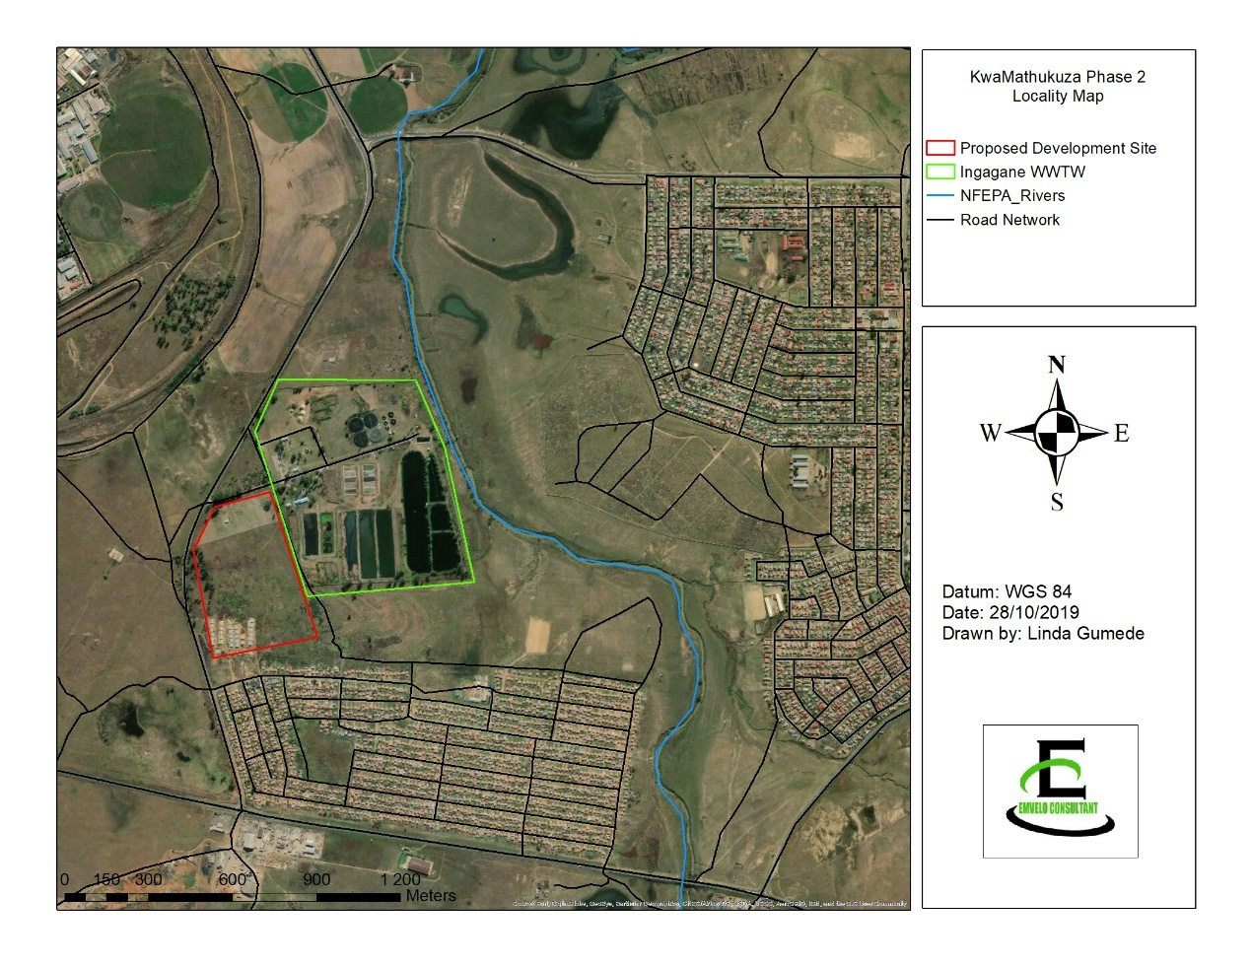



**Emvelo Quality and Environmental Consultant (PTY) Ltd** Promenade Building, 1st Floor, Unit D2, 24 Lira Link CBD, Richards Bay, 3900.

REGISTRATION AND COMMENT FORM

**THE PROPOSED DEVELOPMENT OF KWAMATHUKUZA PHASE 2 HOUSING UNITS WITHIN NEWCASTLE LOCAL MUNICIPALITY, AMAJUBA DISTRICT, KWAZULU-NATAL.**

I wish to register as an interested and affected party and/ or bring to the attention Emvelo Consultant the following information.

|  |  |  |
| --- | --- | --- |
| **Personal Information** | | |
| Name and Surname |  | |
| Company /organization |  | |
| Physical Address |  | |
|  | |
| Postal address |  | |
| Telephone: | | Cell: |
| Email: |  | |
| **Comments** | | |
|  | | |

Signature Date