

**SUBMISSION TO THE SAHRA COUNCIL**

**(via HRM Sub Committee) 15Nov 2014**

SUBMITTED BY: Heidi Weldon on behalf of Grading and Declaration Unit

DATE: 29 October 2014

RE: Grading of the Liberation Heritage Route Sites associated to Nelson Mandela

**PURPOSE**

The submission is made to discuss and recommend the approval of Grade 1 Status to the following sites associated to the Liberation Heritage Route (LHR) and Nelson Mandela:

* Liliesleaf Farm
* Constitutional Hill Precinct
* Palace of Justice
* Healdtown
* Mqhekezweni

**BACKGROUND**

The Liberation Heritage Route project is a national memory project that recognizes places associated to the struggle for democratic South Africa. In commemoration and celebration of the Liberation Struggle, South Africa through its relevant departmental role-players has been busy with nominating sites related to the Struggle for World Heritage Declaration as part of a greater African Liberation project. The World Heritage Convention requires that sites are protected at the highest national level possible and therefore the site must be declared nationally for inclusion in the world nomination list.

With the passing of Nelson Mandela in December 2013, there have been discussions at ministerial level regarding the national and international recognition of the Former President’s legacy by declaring sites related to him both as National and World Heritage Sites.

The NHC, who have been driving the LHR project, have appointed a service provider to assist in research, selection of sites and drafting of nomination dossiers. The initial site list has been finalized and nominations received.

Through the co-operation between NHC and SAHRA, it was agreed that the sites nominated would receive urgent attention by SAHRA in order to have the sites declared in time for the nomination process at the World Heritage Convention in April 2015. Therefore, the sites are submitted together for grading as Grade 1 sites in order for the public participation and development of Conservation Management Plans to commence soonest.

**DISCUSSION:**

**Lilliesleaf Farm**

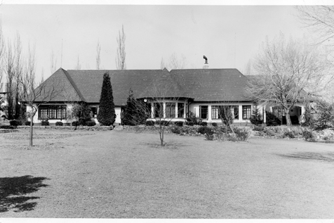

Statement of Significance:

Liliesleaf Farm represents two pivotal points in South Africa’s History and the Liberation Struggle. The purchase of the property by the South African Communist Party as a “safe house” for political activists coincided with the shift within the liberation movement, from passive resistance to a more aggressive armed response and formation of uMkhonto we Sizwe (MK). Liliesleaf subsequently became the headquarters of MK and a crucible for the Liberation Struggle. The eventual police raid in July 1963 led to the capture of prominent leaders of the struggle and the famous Rivonia Trial (which in turn is an important moment in our history). The trial resulted in the conviction and life imprisonment of these important leaders such as Nelson Mandela, Walter Sisulu, Govan Mbeki, Ahmed Kathrada, Denis Goldberg, Raymond Mhlaba, Elias Motsoeledi and Andrew Mlangeni.

Brief History

After the banning of the South African Communist Party in 1950, Bram Fischer ordered Michael Harmel and Amhed Kathrada to find a property to be used as a “safe house” from which the organization could continue to operate. This safe house was to function as the head quarters for the Communist Party leadership with only those within the central committee or secretariat were aware of its existence.

In August 1961, a remote farm in the quiet small holdings suburb of Rivonia was purchased through the front company, Navian (Pty) Ltd. Harold Wolpe and his firm assisted in the purchase with funds supposedly from Moscow through Zurich and into his law firm’s account.

Nelson Mandela at the time was operating underground and was in search of a place to hide out. He moved to Liliesleaf in October 1961 under the alias of David Motsamayi, the caretaker until the “owners” moved in. Arthur Goldreich and his family moved in in the December of that year as the front White Family. The Goldreichs rented the property from Navian at a mere R100 per month.

The property was purchased at a time that the ANC had moved away from its policy of passive resistance to a more aggressive military response. It was here that Nelson Mandela and the High Command formulated uMkhonto we Sizwe’s strategy and in essence t became the headquarters for the high command of MK.

Mandela then left the country in 1962 on a 6 month journey through Africa for training and campaigning for MK. Shortly after his returned he was arrested just outside Howick on his return from briefing Chief Luthuli on his trip. He was serving a 5 year sentence for having left the country illegally when the police unexpectedly raided the farm in July 1963.

By mid 1963 concern regarding the safety of Liliesleaf was increasing and it was decided that a last meeting to discuss a draft of “Operation Mayibuye” and the recently passed 90 Day Detention law would be held before moving the safehouse.

On the 11th July 1963, a laundry van drove up the drive way to the farm under the pretence of looking for business, when policeman and a police dog suddenly emerged from the van. When police charged into the thatched cottage at the back of the main house, 6 members of the High Command were discussing “Operation Mayibuye”, Walter Sisulu, Govan Mbeki, Raymond Mhlaba, Lionel “Rusty” Bernstein, Bob Hepple and Ahmed Kathrada and were all arrested. Denis Goldberg was arrested in lounge of the main house. Later Arthur and his wife Hazel Goldreich were also arrested.

This was a victorious moment for the Apartheid government as almost the entire high command of MK was on the farm and arrested. The police found extensive evidence to convict those arrested including the draft plan of “Operation Mayibuye”, and the writings and journals of Mandela, Mbeki, Sisulu and others. These discoveries led to the famous Rivonia Trial.

All were held under the 90 days detention law in which a person could be held in custody for 90 days without trial or sentencing. This gave the police enough time to properly formulate the charges against them.

The raid at Liliesleaf was a massive blow to the liberation movement; however the subsequent Rivonia Trial was used as a platform to strengthen their fight which propelled Apartheid and the Liberation Struggle onto the International landscape.

Location:

7 George Street, Rivonia, Sandton, Johannesburg (26º32’38”S; 28º3’13”E)

**Palace of Justice**

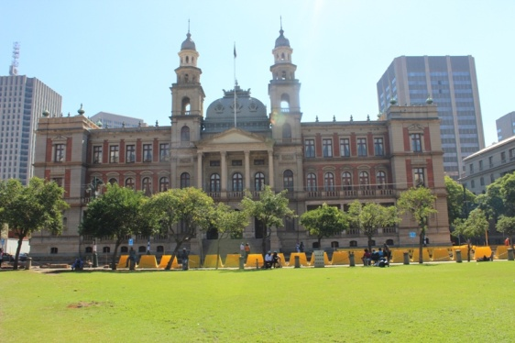

Statement of Significance:

The Palace of Justice represents the legal justice system of oppression. The courtrooms built in the late 1890s by the Zuid Afrikaanse Republiek were used as a British Military hospital during the South African War. The building was completed after the War and utilized as a high court as intended, often imposing the justice system of oppression through the many political trials that took place here with the most notable being the Rivonia Trial. This trial has been considered the one that changed South Africa. The trial marked a pivotal moment and a turning point in the Struggle as it resulted in the imprisonment of prominent the Liberation Struggle leaders, such as Nelson Mandela, Walter Sisulu, Govan Mbeki, Raymond Mhlaba, Lionel “Rusty” Bernstein, and Ahmed Kathrada. It was from the courtroom here that Mandela made his famous Speech from the Dock in which he confirmed his and many other’s conviction to the liberation of South Africa. The defendants knowing that their convictions could result in the death penalty, turned the trial into a platform to highlight the injustices of the Apartheid system and thus through the efforts of OR Tambo and other abroad thrust the Struggle onto the international front. Graffiti on the walls of the holding cells gives haunting evidence to trials held here and the documents the convictions of activists tried and sentenced here.

History:

In 1893 the ZAR government sought a new building to house the Supreme Court. The building was designed by Sytze Wierda the head of Department of Public Works and contracted to John Munro, Pretoria’s leading builder at the time. Building started 1895 and was completed in 1901 and stands on what was originally two erven, namely one on which MW Pretorius had an official residence and the other on which the first Government School was built in 1859.. During the Anglo-Boer War when Britain annexed Pretoria the building was converted and utilized as a Military Hospital.

After the war the building was used as a supreme court and number of political trials took place, most notably the Rivonia Trial. The Rivonia Trial was a pivotal turning point in the country’s history, a blow to the liberation movement and victory for the Apartheid government. The trail resulted in the imprisonment of the prominent leaders of the movement. It was during this trial that Nelson Mandela his gave famous Speech from Dock.

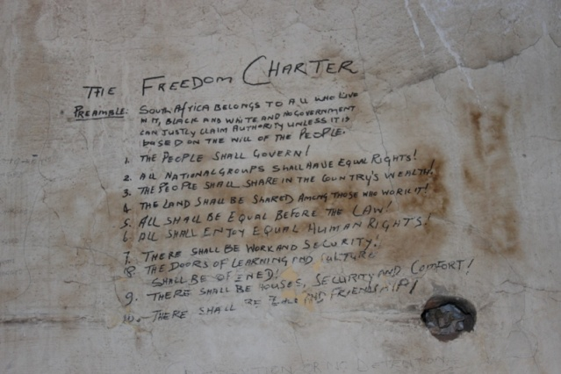When the new high court buildings were completed across the road in 19** the building was abandoned and vandalized. Through a massive restoration project, the building was restored and functional again as court. The graffiti in holding cell has not been touched. However, the site is under threat due to lack of maintenance. This is again due to the perception that nothing can be done to the building as it is considered to be a heritage site. The most concerning is the graffiti on the holding cells as the paint is peeling caused by large scale damp problems.

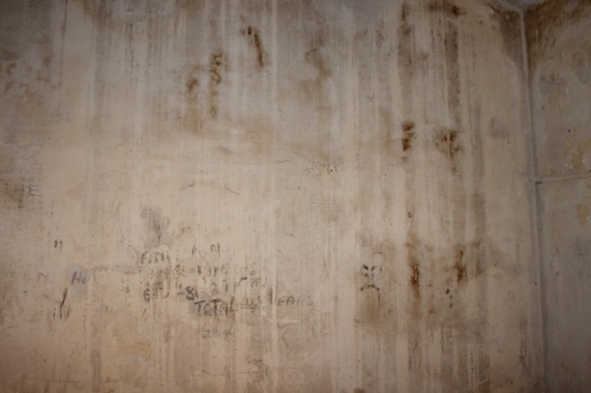  
Examples of Graffiti in the Holding Cell and the damage caused by the damp problem

Location:

Corner Madiba and Palace Streets, Church Square, Pretoria; Erf 3511 Pretoria; (25o44'44.62" S, 28o11'15.52" E)

**Constitutional Hill**

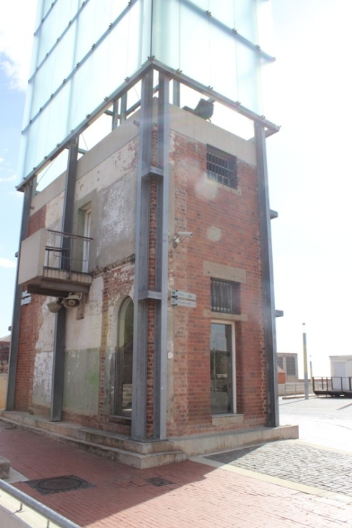

Statement of Significance:

Constitutional Hill has witnessed over a century of South Africa’s history and liberation struggle. It symbolizes the control oppressive governments tried to enforce through harsh imprisonments to those who opposed and resisted their policies. Soldiers fought here defending their land in the Anglo-Boer War in the early 1900s, passive resistors, Pro –Nazi Boers opposing South Africa’s involvement in the World Wars on the side of the British, activist and political prisoners resisting the oppressive Apartheid regime were all imprisoned here. Notable imprisonments include the 156 Treason Trialists in 1956 and youth arrested during the 1976 Soweto Uprising among the thousands detained for contravening suppressive apartheid laws. With one of the awaiting trial blocks converted to the Constitutional Court of South Africa, Constitutional Hill is uniquely positioned as a place where both the difficulties of the past and possibilities of the future can be experienced.

Brief History

The history of Constitutional Hill precinct is complex, dating back to 1892 when a small prison was built under Paul Kruger’s Zuid Afrikaanse Republiek. After the Jameson Raid in 1896 the ramparts converting the small prison into a formidable fort were built and the site was used as a military defiance for the duration of the South African War (1899 – 1902). The fort was built using convict labour and artisans sworn to secrecy. After the war it again functioned as a prison with the so-called ”Natives’ Section” and isolation cells (known as Section 4 and 5), the Women’s Jail and Awaiting Trial Blocks added during the 20th Century. The buildings were collectively referred to as the Fort, Number 4 or Drill Hall. The prison impacted deeply of many South Africans as thousands of ordinary people were detained here under the various suppressive apartheid laws such as Pass Laws. This prison notorious for the injustice and harsh treatment of prisoners would incarcerate many high profile leaders associated to various revolts, strikes and uprisings ranging from Prisoners of War in the South African war to Gandhi and his Passive Resistance Movement to Pro-Nazi Boer resistors, Labour Union leaders in mining strikes and scores of Liberation Activists.

Constitutional Hill was declared a nation National Monument under old NMC legislation on 27 November 1964 and continued to function as a Prison, until 1987 when it then neglected and vandalized.

After the democratic elections, the new Government searched for a site for the new Constitutional Court, the highest court in South Africa on constitutional matters. The site of the Old Fort Prison was chosen and the new precinct is now managed by Blue IQ and Johannesburg Development Agency. The prisons have been converted to exhibitions which showcase the injustices of the past and with the Constitutional Court symbolizes the healing of these autrocities and hope for the future.

Location:

11 Kotze Street, Braamfontein, Johannesburg; Erf - 418/53 – IR ( 26º11’23,31”S; 28º2’34,79”E)

**Healdtown Comprehensive High School and Methodist Church:**



Statement of Significance:

Aside from being the high school in which Nelson Mandela’s awareness of race relations and African assertiveness awakened, it is a mission school that presents a powerful intersection of the African and European civilizations on the Eastern Frontier. It is also alumni to many African leaders who caused change in the colonial setup.

Brief History:

The history of Healdtown is closely linked with that of the Fingo people. In the late 1820s and early 1830s various groups of people migrated from parts of present day KwaZulu-Natal southwards reaching the Eastern Cape at the time of King Hinsta of the amaGcaleka (eastern Xhosa). The identity and origins of the migrants remain an area of disagreement amongst historians and other scholars. What is generally accepted is that they included the amaHlubi, Abambo, amaZizi, amaNgwane, amongst other clans. The Xhosa referred to them as amaFengu - a people in search of land – the very commodity that was becoming scarce in Colonial Cape. The colonialists referred to them as Fingoes. Many Fingoes collaborated with the British against the Xhosa during the Frontier Wars. In 1848 Methodist minister Reverend John Ayliff arrived as the first missionary in the area and to the Fingo people. He called people living in the Fort Beaufort area to lived together in one place

Rev Ayliff believed that religion and education went hand in hand. The school was erected in the early 1850s by the Methodist Church. The name Healdtown comes from the English Merchant James Heald who generously gave to the Methodist Church. Ayliff became the head of the Industrial Institution when first classes were offered in 1853. The main purpose of the mission was to offer spiritual and educational development. Its motto was “They will rise on wings like eagles”.

By 1885 Healdtown was operating three schools – the Teacher’s Training College, Boarding High School and Practicing School for primary teachers with about 1200 students in total. Together with Lovedale Missionary Institution, Healdtown became one of the largest and most influential schools in southern Africa. Pupils from all over the continent (Kenya, Zaire, Botswana, Zimbabwe and Lesotho) and some prominent South African leaders having attended school here. Rev Seth Mokitimi, who become the first Black man to be elected to the high office of the President of the Methodist Conference, taught at Healdtown and made a lasting impression on Nelson Mandela

“ Rev Mokitimi impressed us for another reason; he stood up to Dr Wellington ….we had never seen anyone, much less a black man stand up to Dr Wellington… black man did not have to defer automatically to a white, however senior he was”

The Mission Schools, although entirely unintended, played a crucial role as agents of political and social change in the Eastern Cape (due to the high concentration of the schools in the area). The cluster of Healdtown, Lovedale, St Matthews and Fort Hare consistently delivered over many decades, the highest number of well-educated black students in southern Africa – and consequently black intellectuals who understood the nature of and necessity for human rights and dignity and who would lead their own people’s resistance to oppression.

In 1956, the passing of the Bantu Education Act forced the Methodist Church to hand over control of education at Healdtown to South Africa’s National Department of Education. In 1968, the last Methodist governor of the school, Sir Stanley Pitts, left and the buildings began to fall into disrepair. In the 1970, the Ciskei government leased Healdtown buildings from the Methodist Church – in one instance for the use of the Ciskei Department of Education. Still an educational institution, it nonetheless became a target for vandalism with windows being smashed and valuable wooden floors, roof beams and door and window frames being looted. Finally, during the nationwide political protests that followed the 1976 Soweto riots, most of the Healdtown buildings were burned down by unknown arsonists. The Methodist Church and the Ciskei government could not agree on the future of the school and the cost of restoring it – resulting in the school finally being closed by the government in 1978. Then, in 1994, Healdtown was re-opened as a comprehensive school. Though the Methodist Church still owns the buildings, the government provides the teaching and non-teaching staff.

Healdtown has been associated to some prominent people either as graduates or staff of the institutions, notably: John Jabavu, founder and editor of Imvo Zabantusundu (established in 1884); Dr Seetsile Modiri Molema, author of the Bantu Past and Present and former treasurer-general of the ANC; Dr Zola Skweyiya, former Minister of Social Development in South Africa; Dr Nelson Mandela, first president of democratic South Africa and Nobel Iaureate; Silas Kanunu, former president of the South Africa Rugby Football Union and prominent human rights lawyer in the Eastern Cape; Govan Mbeki, leader of the ANC and author of the seminal work The Peasants’ Revolt which gave the best contemporary account of one of the major actions against apartheid in rural eastern Transkei; Professor M Sobukwe, former member of the ANC and founder of the Pan Africanist Congress of Azania; also the first African professor at the then mostly white University of the Witwatersrand; Revered Seth Mokitimi, as mentioned earlier. The missionaries who so ably steered Healdtown through its illustrious and often turbulent history after Revered Ayliff include Reverend Gottlieb Schreiner, father of Olive Schreiner, William Imprey, Revered George Chapman, Revered Robert Lamplough and Reverend R.F. Homabrook

Location:

Fort Beaufort; Amathole District

**Mqhekezweni**

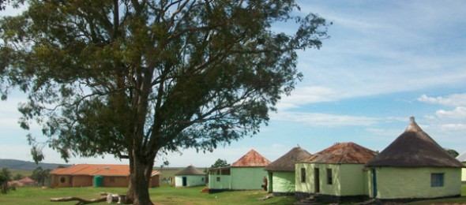

Statement of Signficance:

Mqhekezweni was the capital of Thembuland when Regent Jongintaba Dalindyebo was head of the Thembu Nation. It is still today the great place of senior Thembu Royal Family and bears physical evidence of the when the buildings there were the most grandiose in area at the time of Mandela stay there. It is a site where the values of Ubuntu, leadership, participatory citizenship and active democracy were exhibited. It was here where Nelson Mandela was exposed to these values and experienced them in action. This had a great influence on him as a child and later on in his leadership approach within the struggle but most importantly as President of the South Africa.

Brief History:

By the 18th Century the abaThembu were well established kingdom under the rule of King Ngubencuka. During his rule from 1800 – 1830, he established a unified Thembuland. As is customary among abaThembu, ruling lineage is traced through the Right Hand House. Therefore, Ngubencuka’s eldest son from the Right Hand house, Mthikrakra inherited the Chieftaincy. The ruling baton was then passed to Ngangelizwe Mthikrakra and then to Paramount Chief King Dalindyebo Ngongelizwe. Ngongelizwe had two sons, Jongelizwe (the rightful heir) and Jongintaba. However, Jongelizwe passed away before the birth of his heir King Sabata Dalindyebo. Therefore, Regent Jongintaba stepped in on behalf of Sabata until he became of age. During this time Mqhekezweni became the Great Place.

From the lineage of the Left Hand House, Ngubencuka had two sons Simakade (the eldest) and Mandela. Mandela was local chief of Mvezo and councilor to the Monarch. His son Chief Mphakanyiswa Mandela was Nelson Mandela’s father. When he died in 1928, he had already lost his chieftaincy and Nelson was staying in Qunu with his mother. Shortly after his father’s death Nelson was taken to Mqhekezweni to stay with the Regent at the Great Place. Here he grew up with his cousin, Justice during which he was initiated and circumcised. Growing up under the tutelage and guidance of the Regent, he was exposed the democratic leadership of his uncle. The active participation and values of Ubuntu greatly impressed the young Mandela and influenced his leadership both within the Struggle and as President of the country.

Location:

Mqhekezweni Great Place, Mthatha, King Sabata Dalindyebo Municipality (31º48’36”S; 28º33’7.54” E)

**Motivation for Declaration:**

The activities and events that took place at these sites signify highly significant moments in the history of South Africa. These sites associated to the LHR and Nelson Mandela played a significant role in the liberation struggle and history of South Africa. The declaration of these buildings commemorates the achievements and contributions that were made through the events and actions that took place at these building.

The cultural value of these sites are in the association they have to prominent leaders and most important to pivotal moments in our history such as the arrest and sentencing of prominent leaders, the incarceration of freedom fighters and interaction of traditional beliefs and those of colonialism. These places have all played a significant role in the liberation struggle and history of South Africa and the declaration of these sites will commemorate these sacrifices made to freedom in South Africa.

**Recommendation:**

It recommended that Grade 1 status for all the above sites are approved.