Application Form 302
FOR OFFICIAL USE ONLY:
File No.:
Date received: ......................................................................................
Date approved:.....................................................................................
Applicant: ............................................................................................
Site / Object: .......................................................................................
Permit No.: .........................................................................................
SOUTH AFRICAN HERITAGE RESOURCES AGENCY
111 HARRINGTON STREET, CAPE TOWN, 8001
PO BOX 4637, CAPE TOWN, 8000
TEL: 021 462 4502 FAX: 021 462 4509
APPLICATION FOR PERMIT:
ARCHAEOLOGICAL AND PALAEONTOLOGICAL SITES AND METEORITES
Please note: Permit Applications expire one year after the date of receipt.
In terms of Section 35 (4) of the National Heritage Resources Act, 1999 (Act No. 25 of 1999) no person may, without a permit issued by the relevant heritage resources authority, destroy, damage, excavate, alter, deface or otherwise disturb any archaeological or palaeontological site or material or any meteorite; or bring onto, or use at an archaeological or palaeontological site any excavation equipment or any equipment that assists in the detection or recovery of metals or archaeological and palaeontological material or objects, or use such equipment for the recovery of meteorites.
Other application forms are available for shipwrecks (303), heritage objects , export of archaeological and palaeontological material (304); burials (305), the built environment and landscape (307) or the registration of private collections (402).
Applicants are advised that without full details no permit may be issued.
A. APPLICANT’S DETAILS
1. Name and address of applicant: Frans Roodt. PO BOX 1600, Polowane, 0700
...................................................................................................................................................................................
Phone: (H) 051- 225 7075 (W) 051- 225 7075 (Cell) 083 770 2131
Fax: 0866 709 130 E-mail: hr19@mweb.co.za or frans.roodt@ul.ac.za
Identity number of applicant (or passport): 540424 5035 083
2. Academic qualifications of applicant: MA Archaeology (UP)

3. Previous relevant experience of applicant ………………………………………………………………………. ………………….......................................................................................................................................................

4. Name and address of a person who can serve as a reference, i.e. a qualified archaeologist, palaeontologist or
geologist, as relevant: Prof Tom Huffman University of the Witwatersrand
...................................................................................................................................................................................
5. Name and address of the South African scientific institution with which the applicant collaborates: Polokwane Museums, PO Box 111, Polokwane, 0700

6. Name and address of the South African scientific institution that will curate the material recovered:
Polokwane Museums, PO Box 111, Polokwane, 0700
B. DETAILS OF SITE(S) OR OBJECT(S)
7. Name(s) of site: Unknown ……………………………………………………………………………………….

Application Form 302
- Nature of site or object(s) e.g. archaeological, palaeontological, meteorite*: Unidentified site (see attached report, Site 6)...........
* Please supply a short description of the site, including, type and approximate date on a separate sheet of paper

9. Period, era, age or date of site or object(s) *: Unknown.............................................................................................
....................................................................................................................................................................................
10. Geographical situation of site / object MARK POSITION OF SITE ON A PHOTOSTAT OF A 1:10 000 or 1:50 000 MAP:
Province: Limpopo Magisterial district: Vhembe 1: 50 000 Map number: 2330 CC
Latitude & Longitude: S22º 50’ 45.8” E30º 03’ 50.0” Recording method (GPS, Trig., Other) : GPS
Farm Name and No.: M’pefu 202 MT. / Town : . HaMatidza & HaRabali
Nearest Town: Makhado / Louis Trichardt. . . . . . . . . . . . . . . . . . . . . / Street address & Erf # ...............................................................
11. If it is a national or provincial heritage site / object, the number and date of the notice in the Government Gazette.N/A....................................................................................................................................................................

C. PURPOSE OF APPLICATION
12. Purpose of and reasons for application* (See Phase 1 Report ESKOM POWER LINE: PARADISE SUBSTATION TO THE PROPOSED MAKHADO COLLIERY)
* Limited test excavations to identify the extent and significance of the site as per APM review comment dated 30 May 2012..
13 Nature of activity. Please circle the appropriate activities below
Destruction or Damage* for: Analysis / Dating / Restoration / Security / Other*
Excavation or disturbance* CRM Application for development.
Alteration* Removal from original site* Exhumation and re-interment*
Explore with a metal detector or other equipment**
Other (e.g. removal of graffiti at rock art site)*
Please supply extra details on a separate sheet of paper*:
*A pylon supporting the transmission line is to be erected on the unidentified archaeological site numbered site 6 in the attached report. The aim is to excavate limited test pits or shovel pit testing to identify the extent and significance of the site. Further mitigation if required or management plan will be based on these results.

14. Period for which permit is required. Permits are not normally issued for periods longer than three years:
From: 13 July 2012. To 31 March 2012
15. Have you consulted the landowner about this project? Please supply documentation. See attached letter (Annexure A) Kindly note that this is community land and the attached letter from the Traditional Council serves this purpose. Their permission for excavations means “archaeological excavations” although not clearly stated and therefore the letter was addressed to the heritage specialist (Frans) as the permit applicant.

16. Institutional support (as relevant):
I, .....N/A................................................................................. Head of ...................................................................................... (South African Institution) where the applicant will be based while undertaking this project, hereby state that I support the application. Signature:................................................................................................. Date:.............................................................
I, Hermanus Stefanus Bosman Head of POLOKWANE CULTURAL SERVICES
(institution) hereby undertake to store in our institution the material and records from this project once completed.
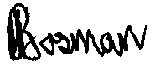
Signature: Date: 13 July 2012

I, Frans Roodt undertake strictly to observe the terms, conditions, restrictions, regulations and guidelines under which the Council may issue the permit to me.
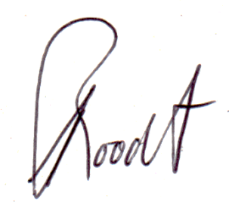
Signature: ............ .........................................Place: Polokwane (APPLICANT) Date: 13 July 2012
Annexure A.

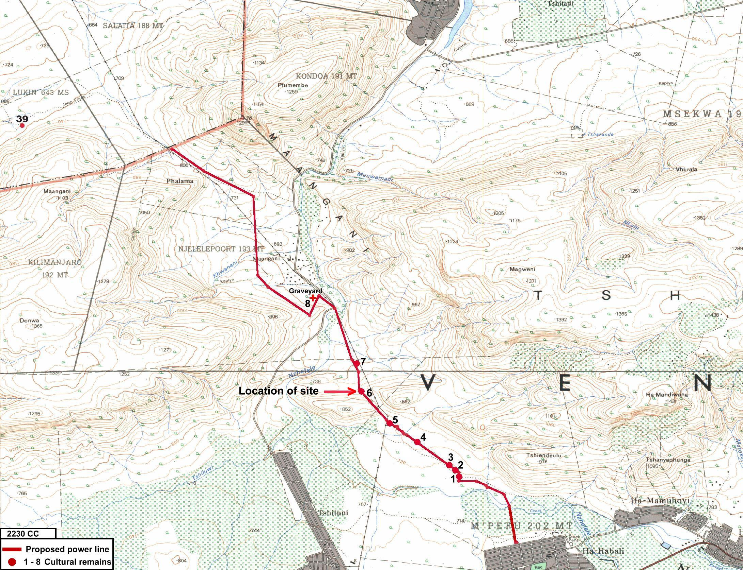
Locality map.

