**Mhwayi Project**

MV to share LV Line along the route

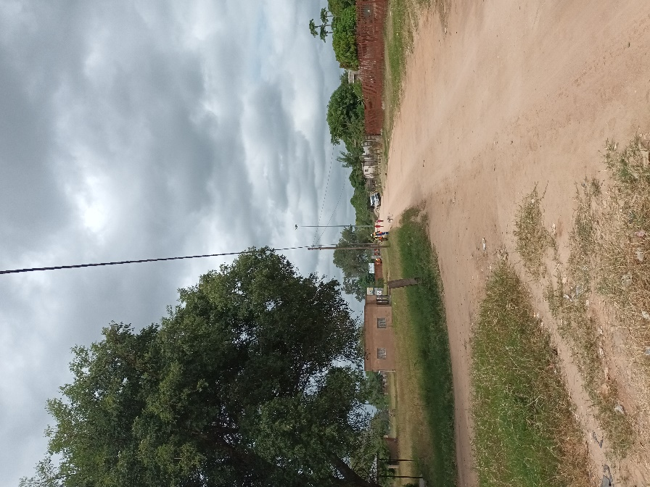

Line along route

Tie-off pole position

Existing 25KVA structure

Marula Tree to be trimmed along route.

Along route

New 50kva out-off line TRF tie off point.

Pole with number

Pole with number

